

**UNIVERSITI TEKNOLOGI MARA   
PERLIS**

**CSC305  
PROGRAMMING PARADIGMS**

Mini Project

Prepared for:  
Madam Hawa

Prepared by:

|  |  |  |
| --- | --- | --- |
| MUHAMMAD NUR HIDAYAT | - | RCS1105H |
| MUHAMMAD SAIFUL ASYRAF | - | RCS1105H |
| AINAA NASUHA | - | RCS1105H |
| NAZATUL SHAHIRA | - | RCS1105H |

Table of Contents

**1.0** **Introduction** 3

**2.0** **Source Code** 4

2.1 Library Imports 4

2.2 Declarations 4

2.3 Definitions 5

2.4 Main Part of the Program 10

**3.0** **User Manual** 12

3.1 The First Impression 12

3.2 Using Offline Convert 12

3.3 Using Online Convert 13

3.4 The Info Button 15

3.5 The Exit Button 15

# **Introduction**

Many of us are wondering how much is our money values at foreign countries especially Asian countries, so we have decided to make a simple system written in Python to make it easy to see how much does our money values in those countries. Our system name is “Ringgit Malaysia to Foreign Currency Converter”. This system is written in Python version 2.7, specifically version 2.7.12 released on 25th June 2016, rather than Python version 3.5 because most of user who installed Python will install version 2.7 as it is the stable version, plus some current Linux distributions and Macs are still using 2.x as default although Python 3 ships with many of them.

This system will by default calculates currency based on user input and predefined currency in offline mode where it can be used as references. However, user can change to online mode where the system will send user input to Google Finance and retrieve the converted currency.

This system implements Tkinter, urllib, and HTMLParser libraries which is available in Python 2.7.12. Tkinter library is used to display graphical user interface (GUI) for the system, urllib library is used to send user input to Google Finance and fetch the resulting website whereas HTMLParser library is used to interpret the result website and convert the fetched website into basic HTML syntaxes so that it can be further broken down to elements as we just need the resulting currency information.

# **Source Code**

## Library Imports

**from** Tkinter **import** Tk**,** StringVar

**import** tkMessageBox

**import** ttk

**from** Tkinter **import** **\***

**from** HTMLParser **import** HTMLParser

**import** urllib

## THIS PYTHON CODE IS WRITTEN IN PYTHON 2.7.12, PLEASE CONVERT IT TO PYTHON 3 USING

## ONLINE CONVERTER FIRST IF YOU'RE USING PYTHON 3.x BECAUSE A LOT OF LIBRARY HAS BEEN

## CHANGED SINCE PYTHON 3 CAME OUT. THANK YOU. -warned by Hidayat-

## Declarations

#### -- (1) DECLARATIONS -- ###

##---------------Declare the container

root **=** Tk**()** ## Declare GUI object

winwidth **=** 620 ## Declare window width

winheight **=** 310 ## Declare window height

screenwidth **=** root**.**winfo_screenwidth**()** ## Get current display screen width

screenheight **=** root**.**winfo_screenheight**()** ## Get current display screen height

coorx **=** **(**screenwidth**/**2**)** **-** **(**winwidth**/**2**)** ## Calculate x-coordinate for center position

coory **=** **(**screenheight**/**2**)** **-** **(**winheight**/**2**)** ## Calculate y-coordinate for center position

root**.**title**(**"Ringgit Malaysia to Foreign Currency Converter"**)** ## Declare main title

root**.**geometry**(**'%dx%d+%d+%d' **%** **(**winwidth**,**winheight**,**coorx**,**coory**))** ## Window size & position

root**.**configure**(**background**=**'grey'**)** ## Declare main background

##[1]---------------Declare the frames inside container

TopMainFrame **=** Frame**(**root**,** width**=**620**,** height**=**60**,** bg**=**"grey"**,** bd**=**8**)**

TopMainFrame**.**pack**(**side**=**TOP**)**

CenterMainFrame **=** Frame**(**root**,** width**=**620**,** height**=**150**,** bg**=**"white"**,** bd**=**8**,** relief**=**"ridge"**)**

CenterMainFrame**.**pack**(**side**=**TOP**,** expand**=**TRUE**)**

BottomMainFrame **=** Frame**(**root**,** width**=**620**,** height**=**100**,** bg**=**"grey"**,** bd**=**8**,** relief**=**"ridge"**)**

BottomMainFrame**.**pack**(**side**=**BOTTOM**)**

##[1]---------------Declare values needed to use

uservalue **=** StringVar**()** ## To store value of country selected

convertvalue **=** DoubleVar**()** ## Value of money to be convert

resultvalue **=** DoubleVar**()** ## Store result of converted money

convertonline **=** StringVar**()**## Value for passing money value

convertonline **=** '0' ## Set default value

## Definitions

#### -- (2) DEFINITIONS -- ####

##[2]---------------Define convert resultvalue function

**def** conCurrency**():**

**if** **(**convertonline **==**'0'**):**

**if(**uservalue**.**get**()==**"Select country or region"**):**

tkMessageBox**.**showinfo**(**"Select country first!"**,**"Please select country"**+**

" or region to convert first.\nThank you."**)**

**elif(**uservalue**.**get**()==**"Brunei"**):**

convert1**=**float**(**convertvalue**.**get**()** **\*** 0.33**)**

convert2 **=** "B$ " **+** str**(**convert1**)**

resultvalue**.**set**(**convert2**)**

**elif(**uservalue**.**get**()==**"Cambodia"**):**

convert1**=**float**(**convertvalue**.**get**()** **\*** 994**)**

convert2 **=** str**(**convert1**)** **+** " " **+** u'\u17db'

resultvalue**.**set**(**convert2**)**

**elif(**uservalue**.**get**()==**"China"**):**

convert1**=**float**(**convertvalue**.**get**()** **\*** 1.62**)**

convert2 **=** u'\u00a5' **+** " " **+** str**(**convert1**)**

resultvalue**.**set**(**convert2**)**

**elif(**uservalue**.**get**()==**"East Timor"**):**

convert1**=**float**(**convertvalue**.**get**()** **\*** 0.24**)**

convert2 **=** "$ " **+** str**(**convert1**)**

resultvalue**.**set**(**convert2**)**

**elif(**uservalue**.**get**()==**"Hong Kong"**):**

convert1**=**float**(**convertvalue**.**get**()** **\*** 1.88**)**

convert2 **=** "HK$ " **+** str**(**convert1**)**

resultvalue**.**set**(**convert2**)**

**elif(**uservalue**.**get**()==**"India"**):**

convert1**=**float**(**convertvalue**.**get**()** **\*** 16.17**)**

convert2 **=** u'\u20b9'**+**" " **+** str**(**convert1**)**

resultvalue**.**set**(**convert2**)**

**elif(**uservalue**.**get**()==**"Indonesia"**):**

convert1**=**float**(**convertvalue**.**get**()** **\*** 3168**)**

convert2 **=** "Rp. " **+** str**(**convert1**)**

resultvalue**.**set**(**convert2**)**

**elif(**uservalue**.**get**()==**"Japan"**):**

convert1**=**float**(**convertvalue**.**get**()** **\*** 25**)**

convert2 **=** u'\u00a5' **+** " " **+** str**(**convert1**)**

resultvalue**.**set**(**convert2**)**

**elif(**uservalue**.**get**()==**"Kuwait"**):**

convert1**=**float**(**convertvalue**.**get**()** **\*** 0.073**)**

convert2 **=** str**(**convert1**)** **+** " " **+** u'\u0643' **+** "." **+** u'\u062f'

resultvalue**.**set**(**convert2**)**

**elif(**uservalue**.**get**()==**"Laos"**):**

convert1**=**float**(**convertvalue**.**get**()** **\*** 1966**)**

convert2 **=** u'\u20ad' **+** " " **+** str**(**convert1**)**

resultvalue**.**set**(**convert2**)**

**elif(**uservalue**.**get**()==**"Macao"**):**

convert1**=**float**(**convertvalue**.**get**()** **\*** 1.94**)**

convert2 **=** "MOP$ " **+** str**(**convert1**)**

resultvalue**.**set**(**convert2**)**

**elif(**uservalue**.**get**()==**"Myanmar"**):**

convert1**=**float**(**convertvalue**.**get**()** **\*** 301**)**

convert2 **=** "K " **+** str**(**convert1**)**

resultvalue**.**set**(**convert2**)**

**elif(**uservalue**.**get**()==**"Philippines"**):**

convert1**=**float**(**convertvalue**.**get**()** **\*** 11.66**)**

convert2 **=** u'\u20b1'**+**" " **+** str**(**convert1**)**

resultvalue**.**set**(**convert2**)**

**elif(**uservalue**.**get**()==**"Saudi Arabia"**):**

convert1**=**float**(**convertvalue**.**get**()** **\*** 0.91**)**

convert2 **=** str**(**convert1**)** **+** " " **+** u'\ufdfc'

resultvalue**.**set**(**convert2**)**

**elif(**uservalue**.**get**()==**"Singapore"**):**

convert1**=**float**(**convertvalue**.**get**()** **\*** 0.33**)**

convert2 **=** "S$ " **+** str**(**convert1**)**

resultvalue**.**set**(**convert2**)**

**elif(**uservalue**.**get**()==**"South Korea"**):**

convert1**=**float**(**convertvalue**.**get**()** **\*** 268**)**

convert2 **=** u'\u20a9' **+** " " **+** str**(**convert1**)**

resultvalue**.**set**(**convert2**)**

**elif(**uservalue**.**get**()==**"Taiwan"**):**

convert1**=**float**(**convertvalue**.**get**()** **\*** 7.6**)**

convert2 **=** str**(**convert1**)** **+** " " **+** u'\u5713'

resultvalue**.**set**(**convert2**)**

**elif(**uservalue**.**get**()==**"Thailand"**):**

convert1**=**float**(**convertvalue**.**get**()** **\*** 8.4**)**

convert2 **=** u'\u0e3f' **+** " " **+** str**(**convert1**)**

resultvalue**.**set**(**convert2**)**

**elif(**uservalue**.**get**()==**"United Arab Emirates"**):**

convert1**=**float**(**convertvalue**.**get**()** **\*** 0.89**)**

convert2 **=** str**(**convert1**)** **+** " " **+** u'\u062f' **+** "." **+** u'\u0673'

resultvalue**.**set**(**convert2**)**

**elif(**uservalue**.**get**()==**"United Kingdom"**):**

convert1**=**float**(**convertvalue**.**get**()** **\*** 0.19**)**

convert2 **=** u'\u00a3' **+** " " **+** str**(**convert1**)**

resultvalue**.**set**(**convert2**)**

**elif(**uservalue**.**get**()==**"United States of America"**):**

convert1**=**float**(**convertvalue**.**get**()** **\*** 0.24**)**

convert2 **=** "$ " **+** str**(**convert1**)**

resultvalue**.**set**(**convert2**)**

**elif(**uservalue**.**get**()==**"Vietnam"**):**

convert1**=**float**(**convertvalue**.**get**()** **\*** 5407**)**

convert2 **=** u'\u20ab' **+** " " **+** str**(**convert1**)**

resultvalue**.**set**(**convert2**)**

**elif** **(**convertonline **==**'1'**):**

**global** towardcon**,** currencyused

**if(**uservalue**.**get**()==**"Select country or region"**):**

tkMessageBox**.**showinfo**(**"Select country first!"**,**"Please select country or region"**+**

" to convert first.\nThank you."**)**

**elif(**uservalue**.**get**()==**"Brunei"**):**

towardcon**=**'BND'

currencyused **=** 'B$ '

onlineConvert**()**

**elif(**uservalue**.**get**()==**"Cambodia"**):**

towardcon **=** 'KHR'

currencyused **=** " " **+** u'\u17db'

onlineConvert**()**

**elif(**uservalue**.**get**()==**"China"**):**

towardcon **=** 'CNY'

currencyused **=** u'\u00a5'**+**" "

onlineConvert**()**

**elif(**uservalue**.**get**()==**"East Timor"**):**

towardcon **=** 'USD'

currencyused **=** "$ "

onlineConvert**()**

**elif(**uservalue**.**get**()==**"Hong Kong"**):**

towardcon **=** 'HKD'

currencyused **=** "HK$ "

onlineConvert**()**

**elif(**uservalue**.**get**()==**"India"**):**

towardcon **=** 'INR'

currencyused **=** u'\u20b9'**+**" "

onlineConvert**()**

**elif(**uservalue**.**get**()==**"Indonesia"**):**

towardcon **=** 'IDR'

currencyused **=** "Rp. "

onlineConvert**()**

**elif(**uservalue**.**get**()==**"Japan"**):**

towardcon **=** 'JPY'

currencyused **=** u'\u00a5'**+**" "

onlineConvert**()**

**elif(**uservalue**.**get**()==**"Kuwait"**):**

towardcon **=** 'KWD'

currencyused **=** " " **+** u'\u0643' **+** "." **+** u'\u062f'

onlineConvert**()**

**elif(**uservalue**.**get**()==**"Laos"**):**

towardcon **=** 'LAK'

currencyused **=** u'\u20ad'**+**" "

onlineConvert**()**

**elif(**uservalue**.**get**()==**"Macao"**):**

towardcon **=** 'MOP'

currencyused **=** "MOP$ "

onlineConvert**()**

**elif(**uservalue**.**get**()==**"Myanmar"**):**

towardcon **=** 'MMK'

currencyused **=** "K "

onlineConvert**()**

**elif(**uservalue**.**get**()==**"Philippines"**):**

towardcon **=** 'PHP'

currencyused **=** u'\u20b1'**+**" "

onlineConvert**()**

**elif(**uservalue**.**get**()==**"Saudi Arabia"**):**

towardcon **=** 'SAR'

currencyused **=** " " **+** u'\ufdfc'

onlineConvert**()**

**elif(**uservalue**.**get**()==**"Singapore"**):**

towardcon **=** 'SGD'

currencyused **=** "S$ "

onlineConvert**()**

**elif(**uservalue**.**get**()==**"South Korea"**):**

towardcon **=** 'KRW'

currencyused **=** u'\u20a9' **+** " "

onlineConvert**()**

**elif(**uservalue**.**get**()==**"Taiwan"**):**

towardcon **=** 'TWD'

currencyused **=** " " **+** u'\u5713'

onlineConvert**()**

**elif(**uservalue**.**get**()==**"Thailand"**):**

towardcon **=** 'THB'

currencyused **=** u'\u0e3f' **+** " "

onlineConvert**()**

**elif(**uservalue**.**get**()==**"United Arab Emirates"**):**

towardcon **=** 'AED'

currencyused **=** " " **+** u'\u062f' **+** "." **+** u'\u0673'

onlineConvert**()**

**elif(**uservalue**.**get**()==**"United Kingdom"**):**

towardcon **=** 'GBP'

currencyused **=** u'\u00a3' **+** " "

onlineConvert**()**

**elif(**uservalue**.**get**()==**"United States of America"**):**

towardcon **=** 'USD'

currencyused **=** "$ "

onlineConvert**()**

**elif(**uservalue**.**get**()==**"Vietnam"**):**

towardcon **=** 'VND'

currencyused **=** u'\u20ab' **+** " "

onlineConvert**()**

##[2]---------------Define link parser to convert rich page website into just HTML

**class** **LinksParser(**HTMLParser**):**

**def** __init__**(**self**):**

HTMLParser**.**__init__**(**self**)**

self**.**recording **=** 0

self**.**data **=** **[]**

**def** handle_starttag**(**self**,** tag**,** attributes**):**

**if** tag **!=** 'span'**:**

**return**

**if** self**.**recording**:**

self**.**recording **+=** 1

**return**

**for** name**,** value **in** attributes**:**

**if** name **==** 'class' **and** value **==** 'bld'**:**

**break**

**else:**

**return**

self**.**recording **=** 1

**def** handle_endtag**(**self**,** tag**):**

**if** tag **==** 'span' **and** self**.**recording**:**

self**.**recording **-=** 1

**def** handle_data**(**self**,** data**):**

**if** self**.**recording**:**

self**.**data**.**append**(**data**)**

separator **=** ' '

text **=** self**.**data**[**0**]**

text2 **=** text**.**split**(**separator**,** 1**)[**0**]**

**if(**currencyused**==**" "**+**u'\u17db'**)or(**currencyused**==**" "**+**u'\u5713'**)or**

**(**currencyused**==**" "**+**u'\ufdfc'**)or(**currencyused**==**" "**+**u'\u0643'**+**"."**+**u'\u062f'**)or**

**(**currencyused**==**" "**+**u'\u062f'**+**"."**+**u'\u0673'**):**

text3**=**text2**+**currencyused

**else:**

text3**=**currencyused**+**text2

resultvalue**.**set**(**text3**)**

##[2]---------------Define function for online conversion using google

**def** onlineConvert**():**

**try:**

p **=** LinksParser**()**

f **=** urllib**.**urlopen**(**"https://www.google.com/finance/converter?a="**+**

str**(**convertvalue**.**get**())+**"&from=MYR&to="**+**str**(**towardcon**))**

html **=** f**.**read**()**

p**.**feed**(**html**)**

p**.**close**()**

**except** Exception **as** e**:**

tkMessageBox**.**showinfo**(**"No internet"**,**"This program can't connect to fetch conversion.

Please make sure you're connected to the internet and try

again."**)**

##[2]---------------Define ask box when user click offline button

**def** ClickOffline**():**

AskOffline**=**tkMessageBox**.**askyesno**(**"Switch to Offline mode"**,**"Do you want to switch back"**+**

" to offline mode?\n\n"**+**

"Offline mode conversion might not be accurate, it is"**+**

"only for refference."**)**

**if** AskOffline**>**0**:**

MakeItOffline**()**

**return**

##[2]---------------Define what to do for offline button action

**def** MakeItOffline**():**

**global** convertonline

convertonline **=**'0'

btnOnline**[**'state'**]=**'normal'

btnOffline**[**'state'**]=**'disabled'

##[2]---------------Define ask box when user click online button

**def** ClickOnline**():**

AskOnline**=**tkMessageBox**.**askyesno**(**"Switch to Online mode"**,**"Do you want to switch to"**+**

"online mode?\n\n"**+**

"Online mode requires internet connection, please"**+**

"ensure you're connected to the internet.\n\n"**+**

"The program might freeze for a while when it is"**+**

"fetching conversion especially on slow internet, "**+**

"so please be patient and wait this program fetch"**+**

" the conversion."**)**

**if** AskOnline**>**0**:**

MakeItOnline**()**

**return**

##[2]---------------Define what to do for online button action

**def** MakeItOnline**():**

**global** convertonline

convertonline**=**'1'

btnOnline**[**'state'**]=**"disabled"

btnOffline**[**'state'**]=**"normal"

##[2]---------------Define what to do for info button action

**def** ShowInfo**():**

tkMessageBox**.**showinfo**(**"RCS1105H Python Mini Project"**,**"CSC305 - PROGRAMMING PARADIGMS"**+**

" - MINI PROJECT\n"**+**

"Ringgit Malaysia to Foreign Currency Converter\n"**+**

"Version: 3.2 (r160925)\n\n"**+**

"Group: RCS1105H\n\n"**+**

"Members:\n"**+**

" Ainaa Nasuha\n"**+**

" Nazatul Shahira\n"**+**

" Muhammad Saiful Asyraf\n"**+**

" Muhammad Nur Hidayat\n\n\n"**+**

"This python programme was created from the scratch by referring"**+**

" official documentation. "**+**

"Whenever we are stuck, we will look the problem in"**+**

" StackOverflow, so thanks them too! ^_^\n\n"**+**

"(C) 2016 Hidayat, Asyraf, Ainaa, Nazatul." **+**

" Part of rights reserved.\n"**+**

"Google currency data fetched in online mode is"**+**

" copyrighted by (C) Google, inc. "**+**

"and we believe its usage falls under fair use"**+**

" since it is published online."**)**

##[2]---------------Define what to do for exit button action

**def** AskExit**():**

AskExit**=**tkMessageBox**.**askyesno**(**"Exit System"**,**"Do you want to quit?"**)**

**if** AskExit**>**0**:**

root**.**destroy**()**

**return**

##[2]---------------Define what to do for reset button action

**def** Reset**():**

uservalue**.**set**(**"Select country or region"**)**

convertvalue**.**set**(**"0.0"**)**

resultvalue**.**set**(**"0.0"**)**

## Main Part of the Program

#### -- (3) MAIN CLASS OF THE PROGRAM -- ####

##[3]---------------Put buttons into top frames

btnOnline **=** Button**(**TopMainFrame**,** state**=**'normal'**,** text**=**'Online Convert'**,** padx**=**2**,** pady**=**2**,**

bd**=**3**,** bg**=**"grey"**,** fg**=**"black"**,** activebackground**=**"grey"**,** font**=(**'impact'**,**

20**,** 'normal'**),** width**=**16**,** height**=**1**,** command**=**ClickOnline**,** relief**=**"raise"**)**

btnOnline**.**grid**(**row**=**0**,**column**=**0**)**

btnOffline **=** Button**(**TopMainFrame**,** state**=**'disabled'**,** text**=**'Offline Convert'**,** padx**=**2**,** pady**=**2**,**

bd**=**3**,** bg**=**"grey"**,** fg**=**"black"**,** activebackground**=**"grey"**,** font**=(**'impact'**,**

20**,** 'normal'**),** width**=**16**,** height**=**1**,** command**=**ClickOffline**,** relief**=**"raise"**)**

btnOffline**.**grid**(**row**=**0**,**column**=**1**)**

btnInfo **=** Button**(**TopMainFrame**,** text**=**'Info'**,** padx**=**2**,** pady**=**2**,** bd**=**3**,** bg**=**"grey"**,** fg**=**"black"**,**

activebackground**=**"grey"**,** font**=(**'impact'**,** 20**,** 'normal'**),** width**=**6**,** height**=**1**,**

command**=**ShowInfo**,** relief**=**"raise"**)**

btnInfo**.**grid**(**row**=**0**,**column**=**2**)**

##[3]---------------Put text into center frame

lblRinggit**=** Label **(**CenterMainFrame**,**font**=(**'arial'**,**16**,**'bold'**),** text**=**'Ringgit Malaysia RM'**,**

padx**=**2**,** pady**=**2**,** bd**=**1**,** fg**=**"black"**,** bg**=**"white"**,** width**=**20**)**

lblRinggit**.**grid**(**row**=**0**,**column**=**0**)**

##[3]---------------Put user input textbox into center frame

EntCurrency **=** Entry**(**CenterMainFrame**,**font**=(**'arial'**,**16**,**'bold'**),** textvariable**=**convertvalue**,**

bd**=**1**,** fg**=**"orange"**,** width**=**22**,** justify**=**'center'**)**

EntCurrency**.**grid**(**row**=**0**,**column**=**1**)**

##[3]---------------Put drop down combobox into center frame

box **=** ttk**.**Combobox**(**CenterMainFrame**,**textvariable**=**uservalue**,** state**=**'readonly'**,**

font**=(**'arial'**,**16**,**'bold'**),** width**=**22**)**

box**[**'values'**]** **=** **(**'Select country or region'**,**'Brunei'**,**'Cambodia'**,**'China'**,**'East Timor'**,**

'Hong Kong'**,**'India'**,**'Indonesia'**,**'Japan'**,**'Kuwait'**,**'Laos'**,**'Macao'**,**'Myanmar'**,**

'Philippines'**,**'Saudi Arabia'**,**'Singapore'**,**'South Korea'**,**'Taiwan'**,**'Thailand'**,**

'United Arab Emirates'**,**'United Kingdom'**,**'United States of America'**,**

'Vietnam'**)**

box**.**current**(**0**)**

box**.**grid**(**row**=**1**,** column**=**0**)**

##[3]---------------Put the converted currency text into the center frame

lblCurrency **=** Label**(**CenterMainFrame**,**font**=(**'arial'**,**16**,**'bold'**),** textvariable**=**resultvalue**,**

bd**=**1**,** width**=**20**,** bg**=**'white'**,** fg**=**"green"**,** padx**=**2**,** pady**=**2**,** relief**=**'sunken'**)**

lblCurrency**.**grid**(**row**=**1**,**column**=**1**)**

##[3]---------------Put the buttons into bottom frame

btnConvert **=** Button**(**BottomMainFrame**,** text**=**'Convert'**,** padx**=**2**,** pady**=**2**,** bd**=**3**,** bg**=**"white"**,**

fg**=**"black"**,** activebackground**=**"grey"**,** font**=(**'impact'**,** 20**,** 'normal'**),**

width**=**12**,** height**=**1**,** command**=**conCurrency**,**

relief**=**"raise"**).**grid**(**row**=**0**,**column**=**1**)**

btnReset **=** Button**(**BottomMainFrame**,** text**=**'Reset'**,** padx**=**2**,** pady**=**2**,** bd**=**3**,** bg**=**"white"**,**

fg**=**"black"**,** activebackground**=**"grey"**,** font**=(**'impact'**,** 20**,** 'normal'**),** width**=**12**,** height**=**1**,** command**=**Reset**,** relief**=**"raise"**).**grid**(**row**=**0**,**column**=**2**)**

btnExit **=** Button**(**BottomMainFrame**,** text**=**'Exit'**,** padx**=**2**,** pady**=**2**,** bd**=**3**,** bg**=**"white"**,** fg**=**"black"**,**

activebackground**=**"grey"**,** font**=(**'impact'**,** 20**,** 'normal'**),** width**=**12**,** height**=**1**,**

command**=**AskExit**,** relief**=**"raise"**).**grid**(**row**=**0**,**column**=**3**)**

##[3]---------------Make sure program GUI continues to run unless exited

root**.**mainloop**()**

# **User Manual**

## The First Impression

The first time user run this system, a graphical user interface (GUI) will be loaded in the middle of the screen and the window presented is the offline convert mode of the system.

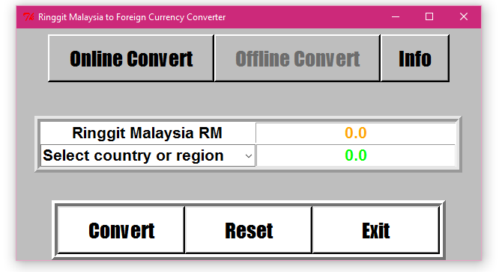  
Figure 1 – The first impression.

## Using Offline Convert

In offline mode, we have defined the currency exchange value and it can show estimated currency exchange. User will need to write the money value in Ringgit Malaysia (RM) at the orange text place, then select the country or region where the user wants to view that country’s value from the drop down box, and then click the “Convert” button. The resulting country’s currency value will be displayed along with their currency symbol at the green text place. To change to other country or to change value, user can just select new country and write new value at orange text place. However, to avoid confusion, we have also put the “Reset” button where it will erase previous currency conversion and reset it become normal again.

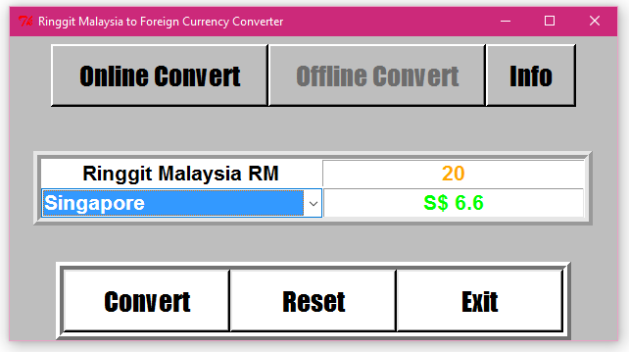  
Figure 2 – Using offline convert.

## Using Online Convert

In online mode, the value user input will be send to Google Finance and resulting currency value will be fetched from them and be displayed as usual. User will need to click on the “Online Convert” button and a prompt will be displayed to make sure the user is connected to the internet before continuing it.

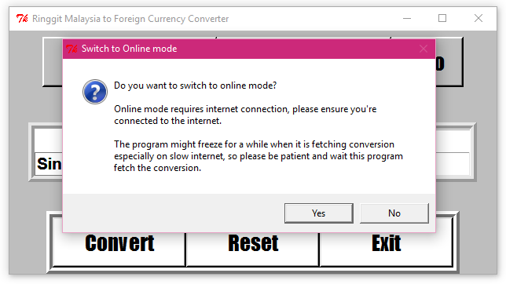  
Figure 3.1 – Prompting user to make sure user is connected to the internet.

After clicking “Yes”, user will be brought back to the same window but now the “Online Convert” button could not be clicked as it is now in online convert mode. The way to use online mode convert is the same as offline mode, where the user need to write the money value in RM at the orange text place, select the country or region where the user wants to view that country’s value from the drop down box, and click the “Convert” button, the difference is that the displayed value is no longer calculated from predefined currency value but it is now fetched from Google Finance website, which is using the latest currency exchange. To change to other country or to change value, user can just select new country and write new value at orange text place. However, to avoid confusion, we have also put the “Reset” button where it will erase previous currency conversion and reset it become normal again.

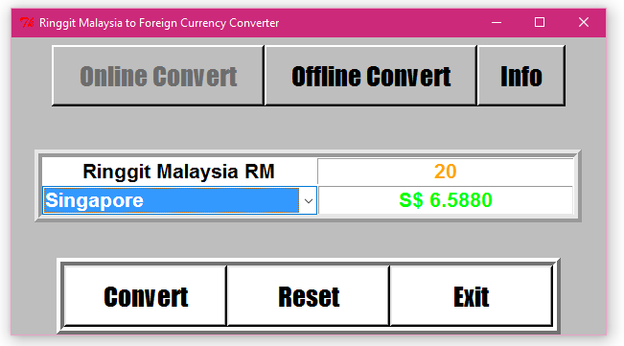  
Figure 3.2 – Using online convert

User will be able to go back to offline mode by clicking the button “Offline Convert” but user will be prompt again, this time to warn that offline mode conversion might not be accurate because there would be no reason for user to switch back to offline mode from online mode unless there is problem in internet connection.

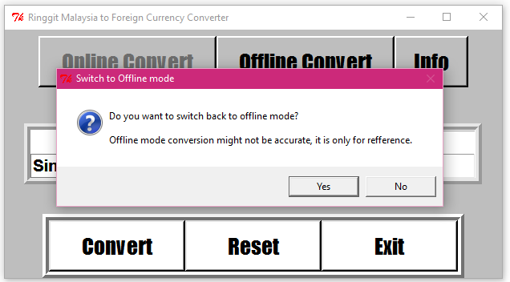  
Figure 3.3 – Prompting user to warn the offline mode conversion might not be accurate.

While user is using online mode, if internet has been automatically disconnected which is quite common in machine running Windows 10 connecting to wireless networks as there is problems in Windows 10 wireless network software, then the program will prompt user that there is no internet detected.

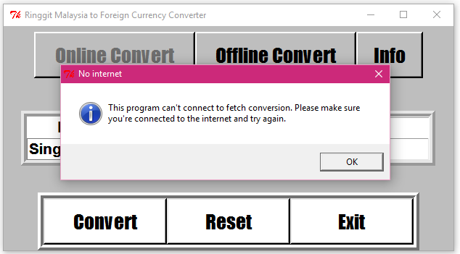  
Figure 3.4 – Prompting user to make sure user is connected to internet and try again to convert.

## The Info Button

The “Info” button is always available regardless of the convert mode. The button, when clicked by user, will show an information box containing the system information and our names as the coder, with copyright information.

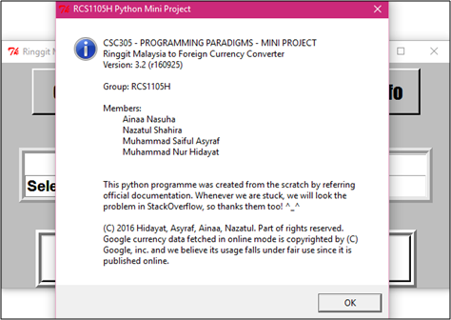  
Figure 4 – The info button will display this information box.

## The Exit Button

The “Exit” button is always available regardless of the convert mode too. When user click the button, there will be a prompt asking user if they really want to exit the system. The system will be closed when user clicked “Yes” at the prompt, but it will go back to the system if user clicked “No” at the prompt.

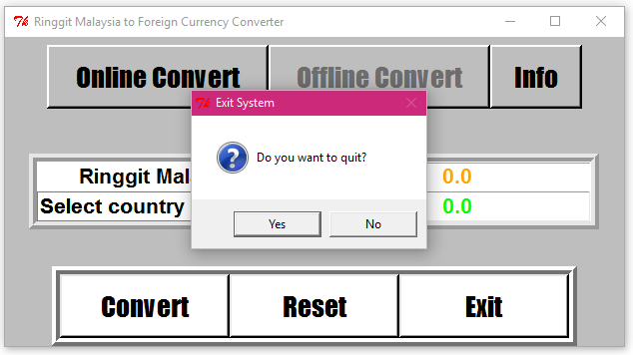  
Figure 5 – Prompting the user if they really want to exit.