**Pace Makers Running Company**

**Executive Summary**

Established in 2015, Pace Makers exists and operates for the sole purpose of impacting community health on a national level. We believe everyone deserves to live a heart-healthy life. Our mission is to prevent heart disease by bringing awareness, ensuring quality care, and advancing science and rid the world of heart disease.

Located in Potomac, Maryland, Pace Makers employs multiple strategies to inform as many citizens as possible on the dangers of cardiovascular and other related chronic diseases. They also facilitate practices in prevention and self-care, as well as, teaching the importance of making better lifestyle choices and engaging in physical activity.

Pace Makers accomplishes this by hosting walking/running races and uses these events as a platform to raise awareness and educate community members on how they can achieve a heart-healthy lifestyle and improve their overall quality of life.

To date, Pace Makers has successfully hosted three major races and two awareness campaigns, reaching over 15,000 people. To gain more exposure and expand its reach, leadership employs online marketing campaigns—reaching over 100K people each year—in addition to various outreach efforts that have made a positive impact for over one million people in the mid-Atlantic region.

**Organization History**

Pace Makers was born from a team of three with a passion for health, happiness, and the desire to help those who are at most risk for heart disease. The Foundation found its roots when Nicole and Alex’s father was taken to the hospital for shortness of breath. Little did they know, his heart had three blockages. He underwent an emergency triple by-pass and a mitral valve replacement procedure. During surgery, he had five mini-strokes and was placed on life support. He was in a coma for a week and once he finally woke up, he had to learn how to talk and walk again. His hospital stay was a long and arduous three months until he was finally released and able to go home. Nicole and Alex attended every rehab session and never left his bed side. They were their father’s biggest cheerleaders as they watched him slowly regain his strength and take back his life. This terrifying experience is the reason why this team is so passionate about heart health. They don’t want others to go through a similar experience or lose a loved one needlessly. Pace Makers aims to rid heart disease one race at a time.

**Need Statement**

Centers for Disease Control and Prevention report that heart disease is the leading cause of death for both men and women. In the United States, someone has a heart attack every 40 seconds, and 1 in every 4 Americans die each year from heart disease, costing the U.S. $200 billion per year in health care services, medications, and lost productivity.

Risk factors associated with heart disease include high blood pressure, high LDL cholesterol, and smoking. Unfortunately, half of Americans have at least one of these three risk factors.

High blood pressure is a common and dangerous condition proven to increase the risk of heart disease and stroke. Approximately 1 of 3 U.S. adults—or about 75 million people—have high blood pressure and only about half of these people have their high blood pressure under control. High blood pressure diagnoses are also increasing rapidly among youth.

Other medical conditions and lifestyle choices can put people at a higher risk for heart disease, including poor nutrition, diabetes, obesity, and physical inactivity. Insufficiently active people have a 20% to 30% increased risk of death compared to people who exercise. The result is over $3 trillion in annual healthcare expenditures.

Obesity—also a known risk factor for heart disease—is a direct result of increases in high blood pressure and body mass index or BMI. Current data indicates that over 93 million U.S. adults, and almost 14 million children and adolescents are obese. Obesity is also a growing threat to national security—over 27% of young adults are too overweight to serve in our military with 15,000 potential recruits failing their physicals every year because they are unfit. More than 80% of adults and adolescents do not meet the guidelines for both aerobic and strengthening activities. America’s health care system incurs $147 billion a year in costs related to obesity.

In response to America’s health-related epidemic, efforts in research and development have also identified lifestyle choices that can prevent or even reverse heart disease.

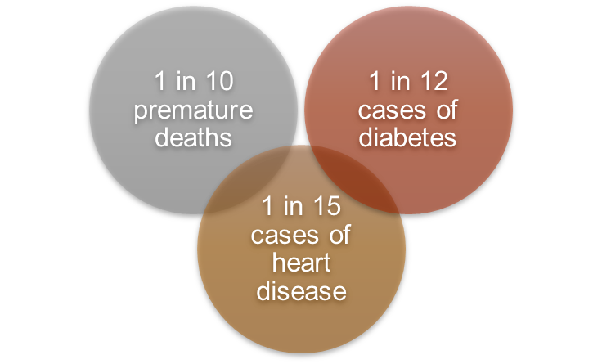Research shows that to protect your heart, weight loss is critical for those who are overweight or obese. Regular physical activity of moderate intensity – such as walking, cycling, or doing sports – has significant benefits for health. By becoming more active, people can easily achieve the recommended activity goals while diminishing associated risk factors mentioned previously. In addition to the prevention of disease, physical activity has numerous benefits in terms of health equity, including:

Engaging in physical activity may prevent heart disease, diabetes, and premature death.

* Lowered risk of depression, obesity, high blood pressure, stroke, arthritis, and falling
* Promotes favorable body composition or BMI
* Improved attention in children and academic performance
* Improves aerobic fitness, muscular fitness, bone health, mental health, cognitive function, sleep, balance, and joint mobility

**Program/Project Description**

Pace Makers has launched a new initiative called *Get Your Heart On* that will reach American citizens from coast to coast. It is the leadership’s vision to create sustainable solutions and a model of engagement that is adaptable to other communities and scalable on a global level. The campaign will utilize a three-pronged approach to reaching those at most risk:

1. Promoting education and awareness on heart disease and related chronic disorders, and fostering lifestyle choices that will reverse heart disease and improve health and well-being. Promotion efforts will focus on creating and distributing marketing collateral through diverse methods including, internet and online social media, print materials, agency-sponsored events, other traditional forms of messaging and its branded race events.
2. A call to action that includes a heart-healthy challenge to engage people in physical activity over seven days to increase cardio and promote healthier eating habits.
3. Pace Makers will host 30 community race events that will combine education and awareness efforts designed to reach up to 5,000 community members per race and provide opportunities for physical activity designed, both now and in the future.

Race to End Heart Disease

Pace Makers firmly believes that awareness is the key to understanding heart disease and why it occurs. Pace Makers works to equip people with the tools and knowledge to make positive changes in their lifestyle patterns to reduce risk factors and improve health equity.

Much of the Pace Makers activity is centered around its races with the whole premise being to walk and/or run to put an end to heart disease. Its intent is two-fold: bring awareness to the forefront and to get people physically active.

At each event, Pace Makers strive to provide a unique and rewarding experience that gets people excited about the race itself and the cause behind it. To do this, Pace Makers focuses on customization of its race design that will influence people in a fun, positive, memorable way and promote positive emotions towards physical activity.

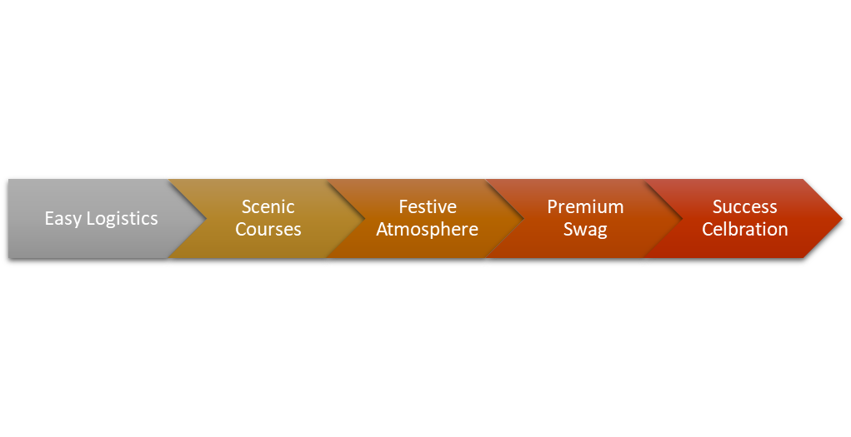Customized Race Design

Pace Makers caters not only to individuals and teams, but also hosts corporate events to promote active workplaces along with team building, interpersonal communication, and leadership development.

Education = Action

Pace Makers works in community centers, churches, local clinic, and schools to educate people about heart disease. Pace Makers prints and distributes materials, trains community educators, and funds programs that support heart health and heart patients by providing information about community resources to ensure they follow up with their care.

The Heart Challenge

Along with Pace Makers ongoing heart challenge to get people moving, the organization promotes American Heart Association’s *Life’s Simple 7* which provides people with a checklist that will alert them to potential risk factors as well as ways they can reduce their risk and improve their health. These include:

* Manage Blood Pressure
* Control Cholesterol
* Reduce Blood Sugar
* Get Active
* Eat Better
* Lose Weight
* Stop Smoking

The success of Life’s Simple 7 is that any person can make these changes, the steps are not expensive to take, and even modest improvements to one’s health will make a big difference.

**Direct Beneficiaries**

Heart disease has the potential to impact millions of Americans. Chronic conditions like heart disease have reached epidemic proportions. Pace Makers intends to target and reach those who are at greatest risk, including children, adolescents, adults, and the elderly. Those who are of African-American, Caucasian, and Native American ethnicities as well as those facing food insecurity, poverty, and other socio-economic factors that create barriers to health and well-being are also targeted. Pace Makers establishes ongoing and robust awareness campaigns to educate people on how they can develop a healthy lifestyle and be heart strong.

Pace Makers provides direct services to those with few resources, including the uninsured, underinsured, and low-income men and women who are unable to access the vital care they need. These services include health screenings and other direct support services.

Communities that adopt heart-healthy practices can also benefit economically, such as:

* Increased levels of economic activity and employment
* Increase in property values
* Neighborhood revitalization
* Reduction in healthcare costs

The Pace Makers Running Company contributes a significant portion of its funding to support John Hopkins Research for Heart Disease and other various local hospital’s Cardiac Units through direct donation, additional donation opportunities, and matching gifts. Funds are also designated towards research and development to facilitate improvements in cardiac surgery and post-op care.

**Qualifications/Experience in Focus Area**

Executive Staff:

Alex Hu

Driven by social impact and community outreach, Alex is developing his passion for quality and standard. He wants each member of The Pace Makers Running Community to enjoy a memorable race event with a life-changing sensory experience. Audio, Visual, Kinesthetic-he covers all the bases in entertainment and empowerment. Alex also oversees campaign fundraising efforts.

Nicole Hu

An avid runner and an International Business major with a thirst for all thing’s growth, Nicole has a passion for setting things in motion; be it businesses, attitudes, or warm bodies. Her goal is to meet 5,000 runners this year and congratulate them on their commitment to health. Nicole is in charge of the daily operations of the organization and has more than seven years’ experience in race coordination and implementation.

Julie Hairston

As a fitness instructor and business major, Julie leads the team to make a difference in the lives of everyone they meet. Julie was instrumental in the founding years of Envision-U and The 45 Day Challenge (a motivational program that now sets the pace in many Fortune 500 companies). She is determined to make a power walking difference and plans to get to know all 5,000 runners this year!

Board Members:

* Soban Ansari, Allstate Financial Analyst, Fundraising
* Bob Steinberg, COO of the Better Business Bureau, Fundraising and Marketing
* Debbie Moore, CEO of Cyber Zephyr, Gala Specialist
* Dr. Healy, Cardiologist at John Hopkins, Medical Advisor

**Collaboration/Partners**

Pace Makers believes that partnerships are essential to creating successful outcomes and avoiding duplication of services and that together, more can be accomplished and with greater impact. To that end, Pace Makers leadership has engaged several partners across a variety of sectors including, health organizations, NGO’s, charities, governments, businesses, and individuals who are passionate about bringing heart disease to an end and whose mission and overall strategy aligns with that of Pace Makers. Current partnerships include:

* American Heart Association
* John Hopkins Cardiac Unit
* Megamart
* Board Men
* Ashburn Chiropractic and Rehab Center
* Ezzey Digital Marketing
* Fit Life City
* FXA Sports
* Old Ox Brewery
* Golds Gym
* Star Centric
* Reston Shirt
* Pleasant Valley Landscapes
* Wegmans - in-kind donations
* Top Golf
* National Conference Center
* Tarara Winery

**Budget Narrative**

Pace Makers is requesting $$$ for its 2019 fiscal calendar year. The total budget for the project including the cost to manage current operations and support its newest initiative efforts is $50,000 of which $5,000 has been raised by various fundraising efforts. If awarded, funds will be used to subsidize awareness campaigns, general operating support, and heart disease research.

[Or]

Pace Makers is specifically seeking $50,000 to support its 2019 heart disease awareness campaign *Get Your Heart On* to reach over 50 million people nationwide and an additional $$$ to expand its reach with 30 new strategically located races throughout the country in effort to increase awareness, draw in more donors, and affect positive lifestyles in communities across the nation.

**Revenue Sources**

The majority of Pace Makers revenue comes from its community and corporate events as well as fundraising efforts through special events. Executive leadership works diligently to ensure that all its resources are used ethically and to make the most significant impact on reversing heart disease. To date, Pace Makers has succeeded in garnering $5,000 through fundraising efforts and cultivating its member donor base.

**Expenses**

The pie chart below provides a breakdown of expenditures that Pace Makers incurs to provide its programming, education, and services. Over 80% of its revenue is allocated towards programming and direct services, which includes research and development, leaving less than 20% towards its administrative, fundraising, and advertising costs.

Hi Patrick,

Please see below and attached for the info you requested. You can see attached for some more info I have complied.

We are requesting $250,000 but the more money we can get the better. If you come across other attributes that organizations are looking to fund we are open to helping in more ways to better serve our community. Please keep this in mind while writing the grant proposals.

Basic Information Sections

Briefly describe your organization through the following prompts:

1.Official Organization Name: The Pace Makers Foundation

2.Project location, office location: 9812 Falls Road #168 Potomac, MD 20854

3.When Founded:2015

4.501c3 Status: Tax Exempt 501 c 3

5.Contact details

Contact Person: Nicole Hu

Work number: 703.508.7725

Role in organization: CFO

Work email: [Nicole@nicolehuu.com](mailto:Nicole@nicolehuu.com)

Organization Contact details:

Email: [Nicole@nicolehuu.com](mailto:Nicole@nicolehuu.com)

Phone: 703.508.7725

Website:[www.pacemakersrun.org](http://www.pacemakersrun.org/)

6.Team: How many permanently employed staff do you have or

volunteers: 5

7.Board members/Committee members: 4

8.Mission/Vision of your organization : either one will do:

9.Target audience: Everyone that has a heart, or anyone that has been affected by heart disease.

Who do your heart project target (e.g young adults, the elderly,

infants, teenagers etc)

10.What problem are you trying to solve? We are looking to reverse the trend of heart disease as the number one cause of death on a global spectrum.