**MATHEMATICS**

1. Copy the numbers 1-10.

| 1 | 2 | 3 | 4 | 5 | 6 | 7 | 8 | 9 | 10 |
| --- | --- | --- | --- | --- | --- | --- | --- | --- | --- |
|  |  |  |  |  |  |  |  |  |  |

1. Match the numbers.

1 5

2 4

3 2

4 3

5 1

1. Count and write.







1. Add

3+2=

2+2=

3+1=

4+2=

**LANGUAGE**

1. Fill in the missing sounds.

| A |  |  | D |  |  |  | H |  |  |  | L | M |
| --- | --- | --- | --- | --- | --- | --- | --- | --- | --- | --- | --- | --- |
|  | O | P |  |  | S | T | U |  |  | X | Y |  |

1. Match

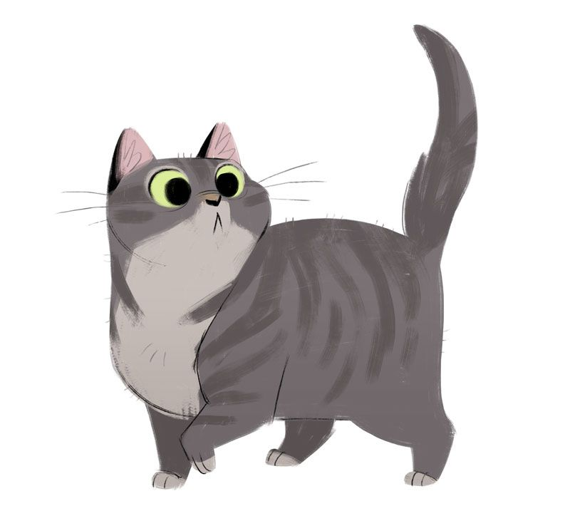 cup

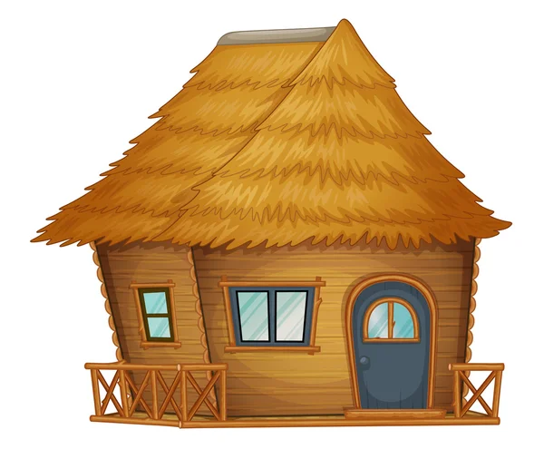 cat

 Hut

1. Fill in the missing vowels. (a,e,i,o,u)

H__n P__g __sk __xe

M__t P__n __m H__t

1. Fill in (a,e,i,o,u)

__gg

H__t

N__t

**ENVIRONMENTAL**

1. Color and name the pictures.

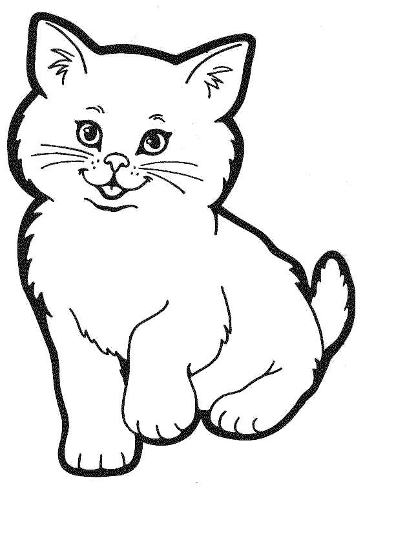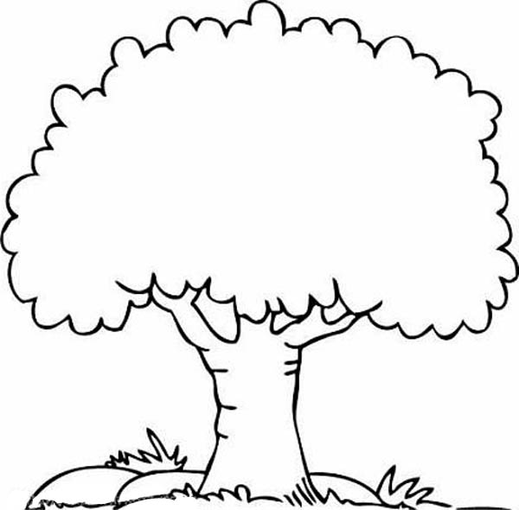

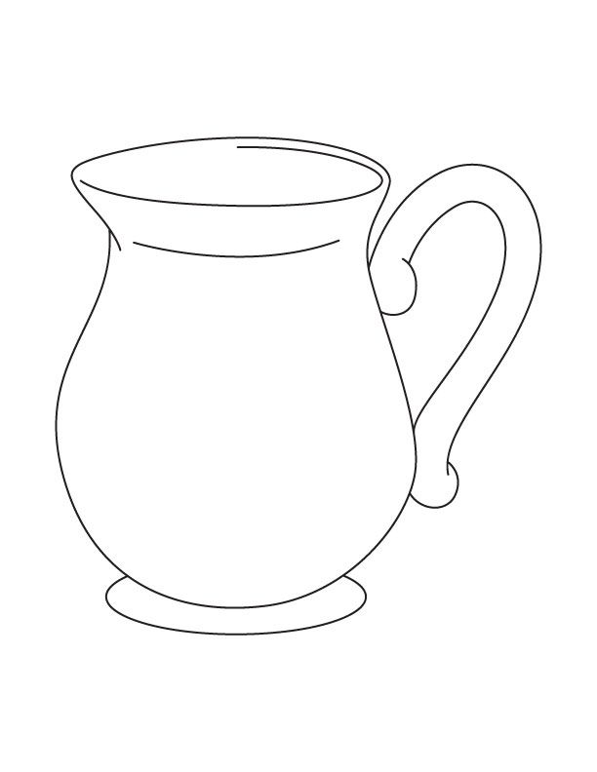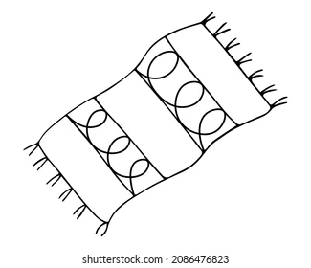

1. Color the weather symbols



