EAX = 00000047 EBX = 00705000 ECX = 00BB10AA EDX = 00BB10AA ESI = 00BB10AA EDI = 00BB10AA EIP = 00BB3665 ESP = 008FFBA0 EBP = 008FFBAC EFL = 00000246

EAX = 00000047 EBX = 00000039 ECX = 00000060 EDX = 00BB10AA ESI = 00BB10AA EDI = 00BB10AA EIP = 00BB366F ESP = 008FFBA0 EBP = 008FFBAC EFL = 00000246

EAX = 00000080 EBX = 00000039 ECX = 00000060 EDX = 00BB10AA ESI = 00BB10AA EDI = 00BB10AA EIP = 00BB3671 ESP = 008FFBA0 EBP = 008FFBAC EFL = 00000212

EAX = 000000E0 EBX = 00000039 ECX = 00000060 EDX = 00BB10AA ESI = 00BB10AA EDI = 00BB10AA EIP = 00BB3673 ESP = 008FFBA0 EBP = 008FFBAC EFL = 00000202

EAX = 000000E0 EBX = 00000085 ECX = 00000060 EDX = 00BB10AA ESI = 00BB10AA EDI = 00BB10AA EIP = 00BB3678 ESP = 008FFBA0 EBP = 008FFBAC EFL = 00000202

EAX = 000000E0 EBX = 00000085 ECX = 00000064 EDX = 00BB10AA ESI = 00BB10AA EDI = 00BB10AA EIP = 00BB367D ESP = 008FFBA0 EBP = 008FFBAC EFL = 00000202

EAX = 00000165 EBX = 00000085 ECX = 00000064 EDX = 00BB10AA ESI = 00BB10AA EDI = 00BB10AA EIP = 00BB367F ESP = 008FFBA0 EBP = 008FFBAC EFL = 00000206

EAX = 000001C9 EBX = 00000085 ECX = 00000064 EDX = 00BB10AA ESI = 00BB10AA EDI = 00BB10AA EIP = 00BB3681 ESP = 008FFBA0 EBP = 008FFBAC EFL = 00000206

EAX = 000001C9 EBX = 00000085 ECX = 00000064 EDX = 00BB10AA ESI = 00BB10AA EDI = 00BB10AA EIP = 00BB3686 ESP = 008FFBA0 EBP = 008FFBAC EFL = 00000206









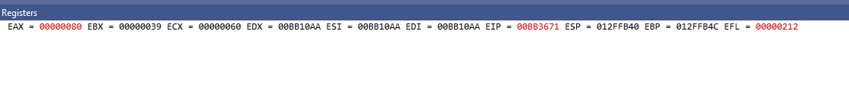

INCLUDE Irvine32.inc

.code

main PROC

mov eax, 47h

mov ebx, 39h

mov ecx, 60h

add eax, ebx

add eax, ecx

mov ebx, 85h

mov ecx, 64h

add eax, ebx

add eax, ecx

call DumpRegs

exit

main ENDP

END main