AIR QUALITY · MACHINE LEARNING · KARACHI
KARACHI AQI
PREDICTOR
Machine Learning–Based 3-Day Air Quality Forecasting & Monitoring System

A complete end-to-end project for forecasting Karachi air quality, combining machine
learning, environmental data, live AQI context, a FastAPI prediction service,
and an interactive Streamlit dashboard.
MADE BY
MUHIB RASHID

LinkedIn: Muhib Rashid
Github: @Muhib8604

PROJECT REPORT
2026

01 Project at a Glance
THE IDEA IN ONE SENTENCE
Karachi AQI Predictor turns environmental and historical AQI data into a 3-day forecast, then presents the result in a user-friendly monitoring dashboard alongside a live station reading.

3-Day  Forecast | Live  AQI | FastAPI  Service | Streamlit  Dashboard

- Forecasts the next three days of AQI.
- Uses weather and pollutant context.
- Retrieves a live AQI station value.
- Compares live conditions with the model forecast.
- Provides charts, cards, alerts, health guidance and CSV export.
02 What Problem Does It Solve?
Air quality changes continuously. A single current AQI value tells a user what the air is like now, but not what may happen over the next few days. This project addresses that gap by combining recent AQI behavior with environmental variables and machine learning.
WHAT A USER CAN UNDERSTAND IMMEDIATELY
Current situation → 3-day outlook → environmental context → severity → alerts → downloadable forecast.

03 How the Complete System Works
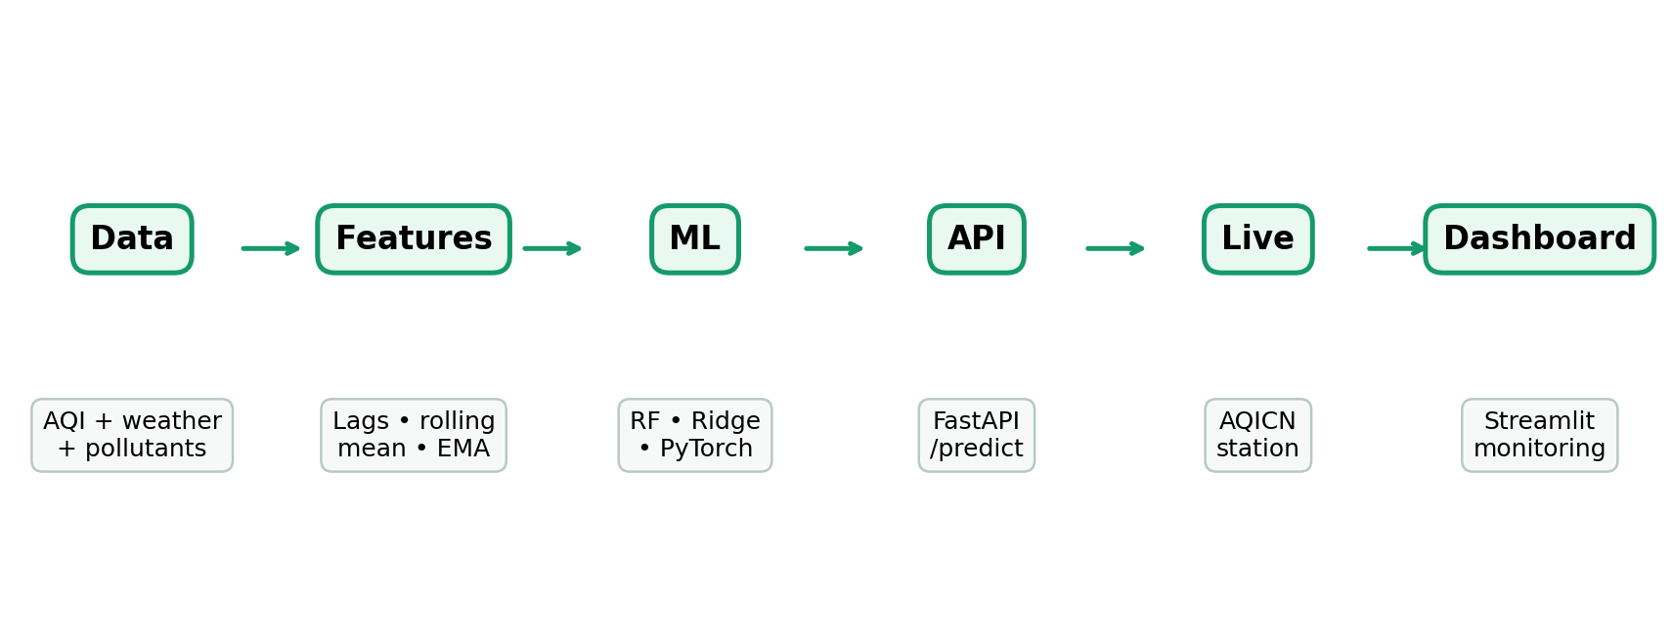
Figure 1 — End-to-end architecture of the completed project.
The system is intentionally separated into stages. Data and features feed the trained models; the backend handles inference and live AQI retrieval; the Streamlit application turns the returned JSON into a monitoring experience.
04 Data & Environmental Inputs
The final feature set contains 11 direct environmental variables:
Category | Variables | What they represent
Weather | Temperature, humidity, wind speed, pressure, rain | Atmospheric conditions influencing pollution dispersion.
Particles | PM2.5, PM10 | Particulate pollution.
Gases | Ozone, carbon monoxide, nitrogen dioxide, sulphur dioxide | Gaseous pollutants associated with air-quality conditions.

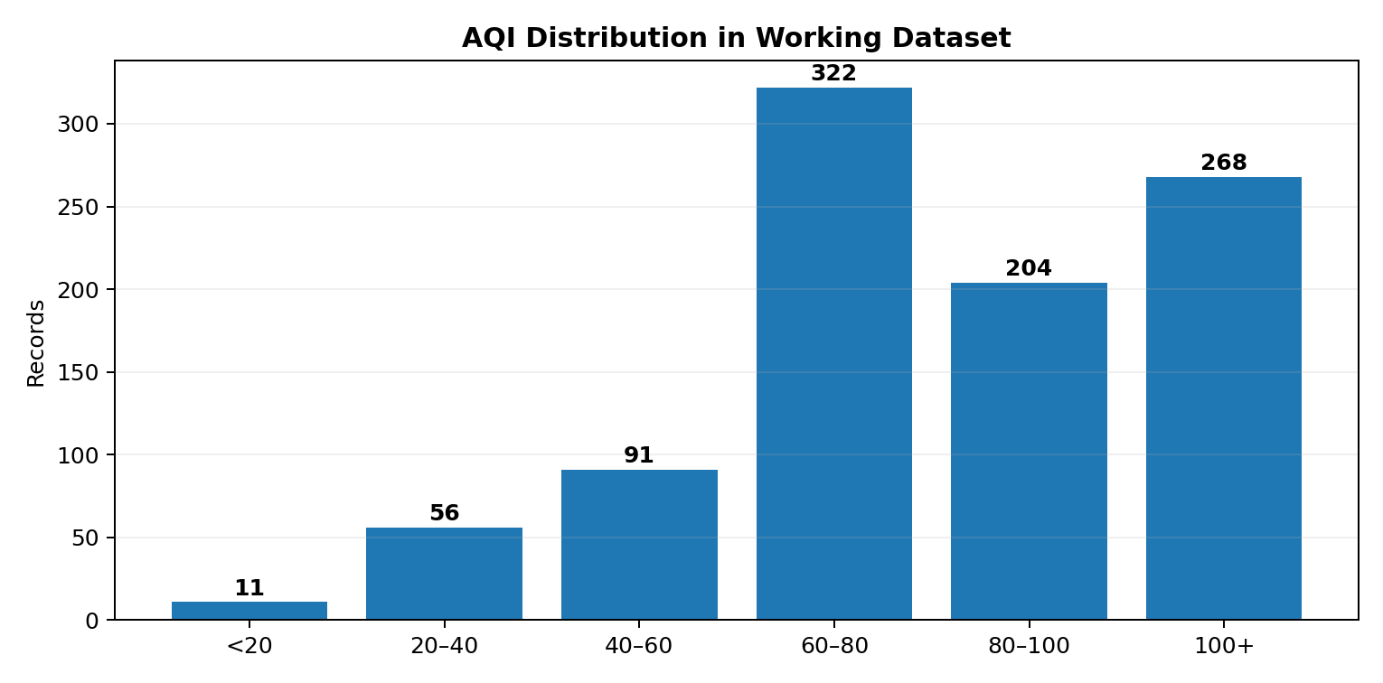
Figure 2 — AQI distribution from the working dataset/run.
952  Records | 87.997  Mean AQI | 36.545  Std Dev | 11  Minimum | 79.625  Median | 214.625  Maximum

05 Feature Engineering
The model is given more information than only the current environmental snapshot. Recent AQI behavior is represented using lagged and smoothed features.
Feature | Example | Purpose
Lag | AQI lag 1 / lag 2 | Captures recent direction and level.
Rolling statistic | 3-point rolling mean | Reduces short-term noise.
EMA | 3-point EMA | Gives more weight to recent AQI observations.

EXAMPLE FROM THE FINAL RUN
Today's AQI = 53.00 | Lag 1 = 25.95 | Lag 2 = 32.37 | Rolling mean = 31.00 | EMA = 38.77

06 Machine Learning
The project evaluates multiple model families rather than assuming one algorithm will always perform best. The documented candidates are Random Forest, Ridge regression and a PyTorch neural-network model. The model manifest records the selected model and evaluation metrics for each forecast horizon.
📅 Forecast horizons
- Day 1 produces the first forecast.
- Day 2 and Day 3 use their horizon-specific trained models and the project's configured target/delta logic.
- Each horizon can retain its own model type and evaluation metrics.
📐 Evaluation metrics
- MAE: average absolute AQI error; easy to interpret in AQI points.
- RMSE: emphasizes larger errors more strongly.
- R²: measures explained variance relative to the target.
07 The Live-AQI Problem & Its Solution
During development, an important practical issue appeared: the live station could be in the 20–30 AQI range while the raw forecast was substantially higher. A live-AQI anchoring layer was therefore added without replacing the trained model. The model still generates the forecast; the correction layer pulls it toward the live observation.
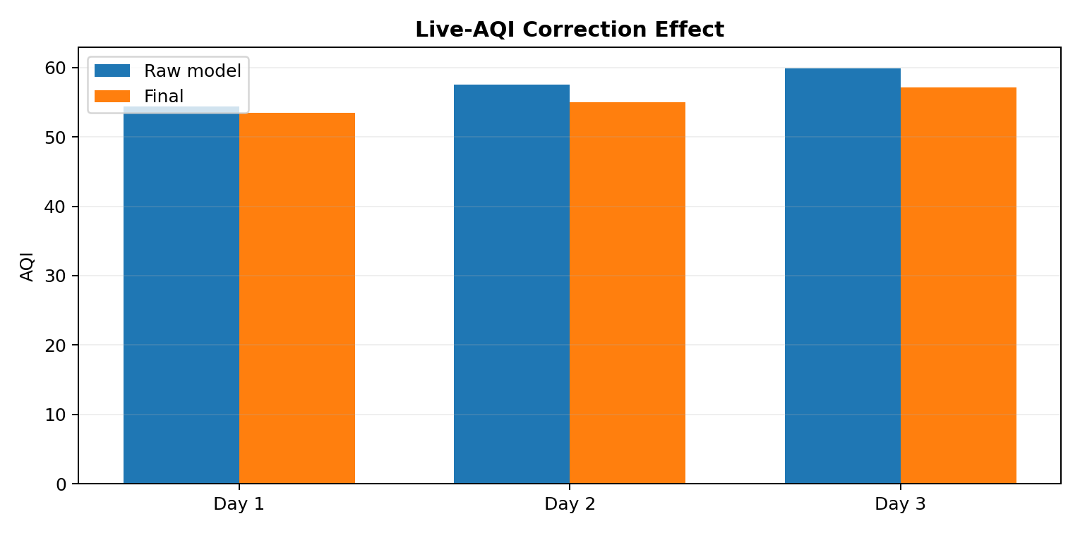
Figure 3 — Example of raw model output versus the corrected forecast.
This makes the forecast less likely to show an unrealistic immediate jump when the current station is significantly cleaner. The correction strength controls how strongly the live reading influences the final value.
08 Final Forecast Example
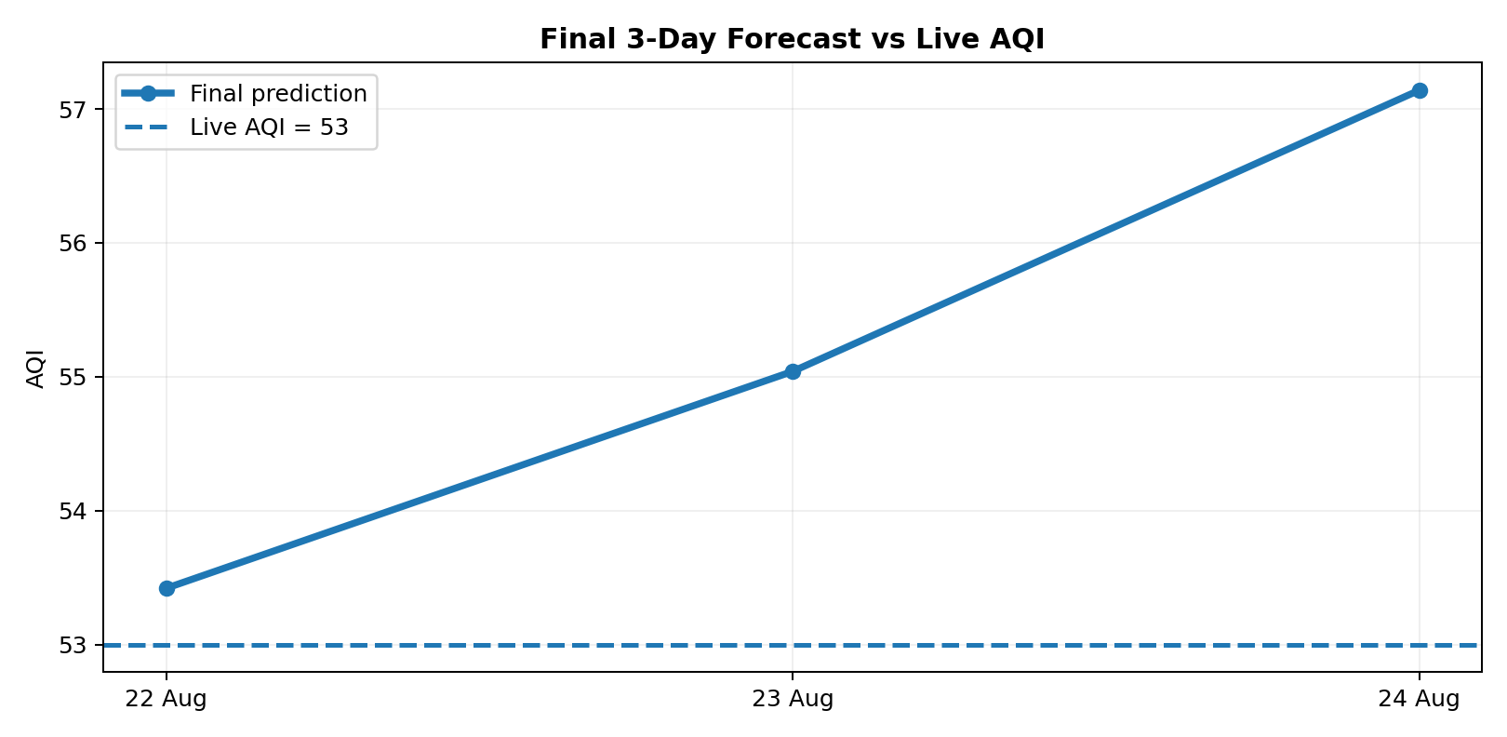
Figure 4 — Final observed forecast compared with the live AQI reading of 53.
Day | Raw | Final | Live AQI
Day 1 | 54.41 | 53.42 | 53.00
Day 2 | 57.53 | 55.04 | 53.00
Day 3 | 59.90 | 57.14 | 53.00

Average final forecast AQI: 55.20

09 FastAPI Backend
FastAPI provides the prediction service. The Streamlit frontend calls the backend's /predict endpoint instead of loading and executing the model directly inside the dashboard.
- Loads trained model artifacts and feature metadata.
- Prepares prediction inputs.
- Retrieves live AQI station information.
- Runs the 3-day inference process.
- Returns structured JSON containing forecasts, environmental values, model names and live station metadata.
10 Streamlit Monitoring Dashboard
The dashboard is designed as a monitoring product, not merely a printout of model predictions.
- Live status badge and monitoring indicator.
- Location and model-performance sidebar.
- Live station vs Day 1 forecast comparison.
- Day 1 AQI gauge and AQI category.
- 3-day forecast trend with live-AQI reference line.
- Forecast cards with weather and pollutant context.
- PM2.5 and PM10 charts.
- Temperature, humidity, wind-speed and pressure trends.
- Pollutant radar and limit bars.
- Average, maximum, minimum and backend-average summary metrics.
- Location map.
- Detailed forecast table and CSV download.
- Health guidance based on AQI severity.
- Configurable hazard threshold, toast/banner alerts and alert history.
11 AQI Visual Language
The interface uses severity bands so the meaning of a number is immediately visible.
Good | Moderate | USG | Unhealthy | Very Unhealthy | Hazardous

12 Alerts & Logging
The dashboard allows a user to select a hazard threshold. If any forecast meets or exceeds that threshold, a warning banner and optional toast can be shown. Triggered alerts are stored in alert_log.csv so the monitoring history can be reviewed later.
13 Health Guidance
The forecast is translated into a simple AQI status and general outdoor-activity guidance. This makes the technical prediction more actionable for a normal user.
14 Deployment
The completed architecture separates the backend from the frontend. FastAPI serves the prediction endpoint, while Streamlit consumes that service over HTTP. The frontend reads the backend URL through BACKEND_URL and uses caching to reduce unnecessary repeated requests. A manual Refresh Forecast control allows the user to clear the cached result and request a fresh prediction.
15 Key Challenges Solved
- Connecting trained model artifacts with the inference layer.
- Maintaining horizon-specific model information through the manifest.
- Handling live AQI retrieval and station identification.
- Reducing unrealistic divergence between live AQI and model forecasts.
- Converting backend JSON into an interactive dashboard.
- Adding alert persistence, threshold monitoring and export.
- Separating model serving from the dashboard for deployment.
16 Limitations
- A single station does not represent every part of Karachi.
- Future AQI accuracy depends on the quality of environmental and historical inputs.
- External live-AQI services can become unavailable or change values.
- Forecast uncertainty increases with horizon.
- Live anchoring improves practical behavior but should not be confused with a replacement for model validation.
17 Future Enhancements
- Combine multiple Karachi AQI stations.
- Show prediction ranges/confidence intervals.
- Track forecast-vs-actual error automatically.
- Automate periodic retraining.
- Add model drift monitoring.
- Allow station/location selection.
- Expand the model comparison and time-series approaches.
18 Conclusion
Karachi AQI Predictor is a complete end-to-end machine-learning application. It brings together environmental data, feature engineering, trained forecasting models, live AQI information, a FastAPI backend and an interactive Streamlit dashboard. The final system does more than produce an AQI number: it explains the forecast through environmental context, compares it with live conditions, highlights hazards, keeps alert history and provides downloadable results.
FINAL PROJECT OUTCOME
A technical ML model was transformed into a usable monitoring application that a non-technical user can open, understand and interact with.

APPENDIX — MAIN COMPONENTS
Component | Role | Purpose
training_pipeline.py | Training | Data preparation, candidate training/evaluation and artifact generation.
predict.py | Inference | Loads model artifacts and generates Day 1/2/3 predictions.
model_definition.py | Model | Defines the PyTorch network where applicable.
FastAPI backend | Serving | Exposes /predict and live-AQI integration.
Streamlit dashboard | UI | Visualizes forecasts, context, alerts and summaries.
model_manifest.json | Metadata | Stores horizon-specific model information and metrics.
model_features.pkl | Features | Stores expected model feature columns.
alert_log.csv | Monitoring | Stores triggered forecast alerts.

PROJECT OVERVIEW
A walkthrough of the live Streamlit dashboard, screen by screen.
🖥️ Dashboard Overview
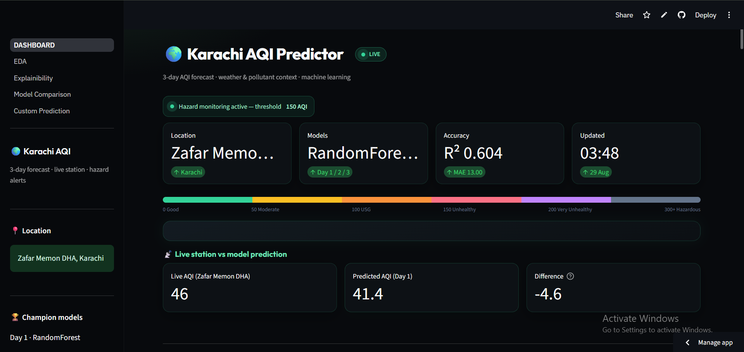
Live status header — location, champion model, R² accuracy, last-updated time, and the AQI severity scale.
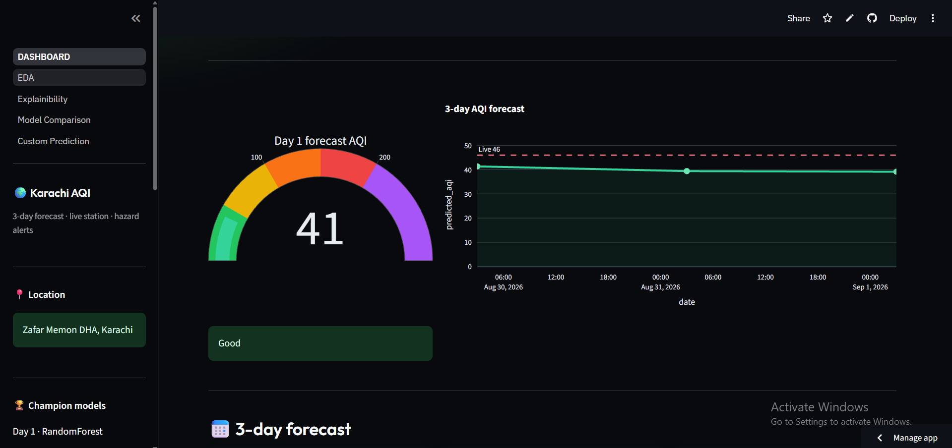
Day 1 forecast gauge alongside the 3-day AQI trend line plotted against the live station reading.
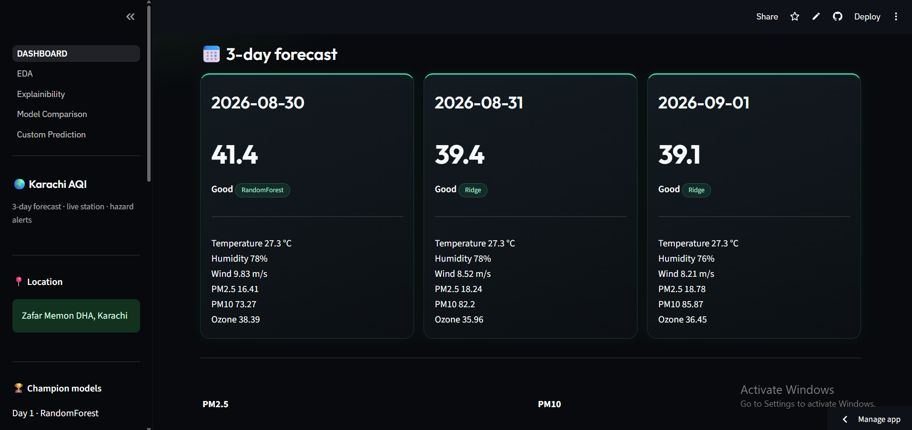
3-day forecast cards — predicted AQI, category and full weather/pollutant context for each day.
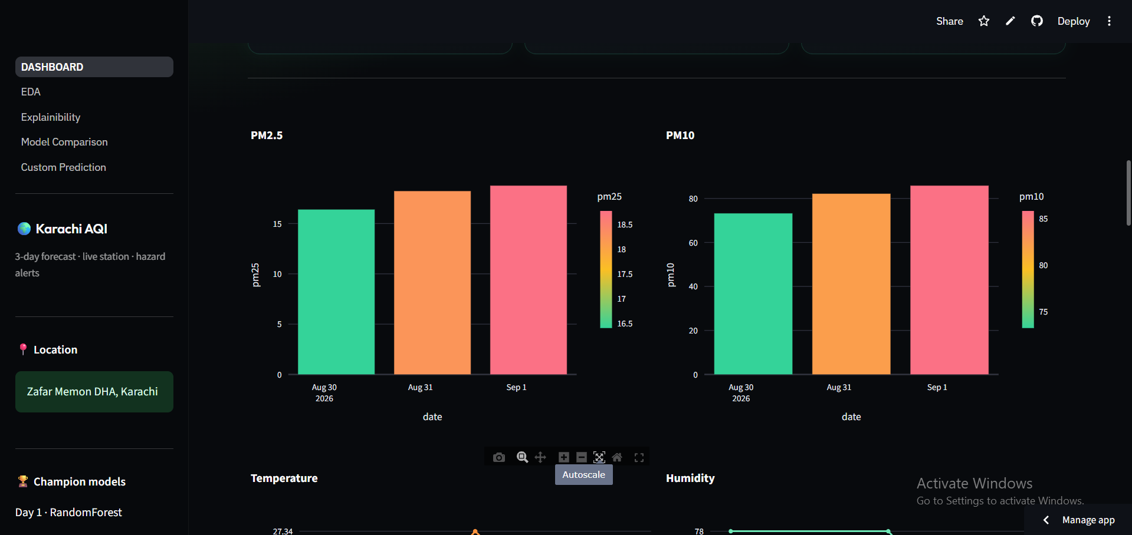
PM2.5 and PM10 trend charts across the 3-day forecast window.
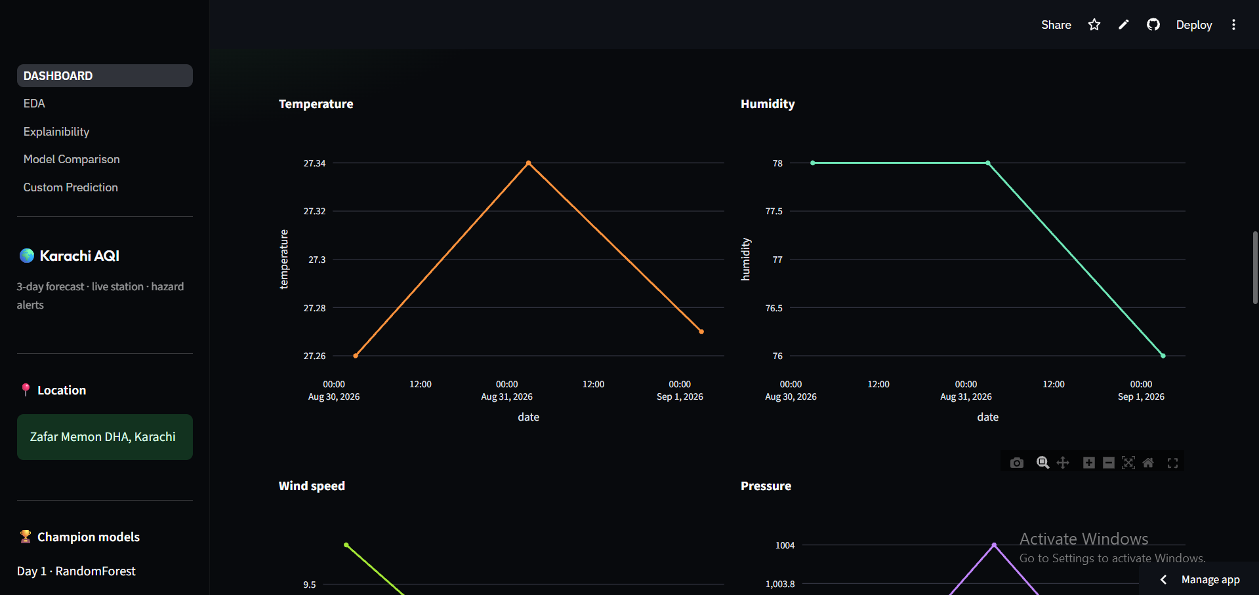
Temperature and humidity trend charts across the 3-day forecast window.
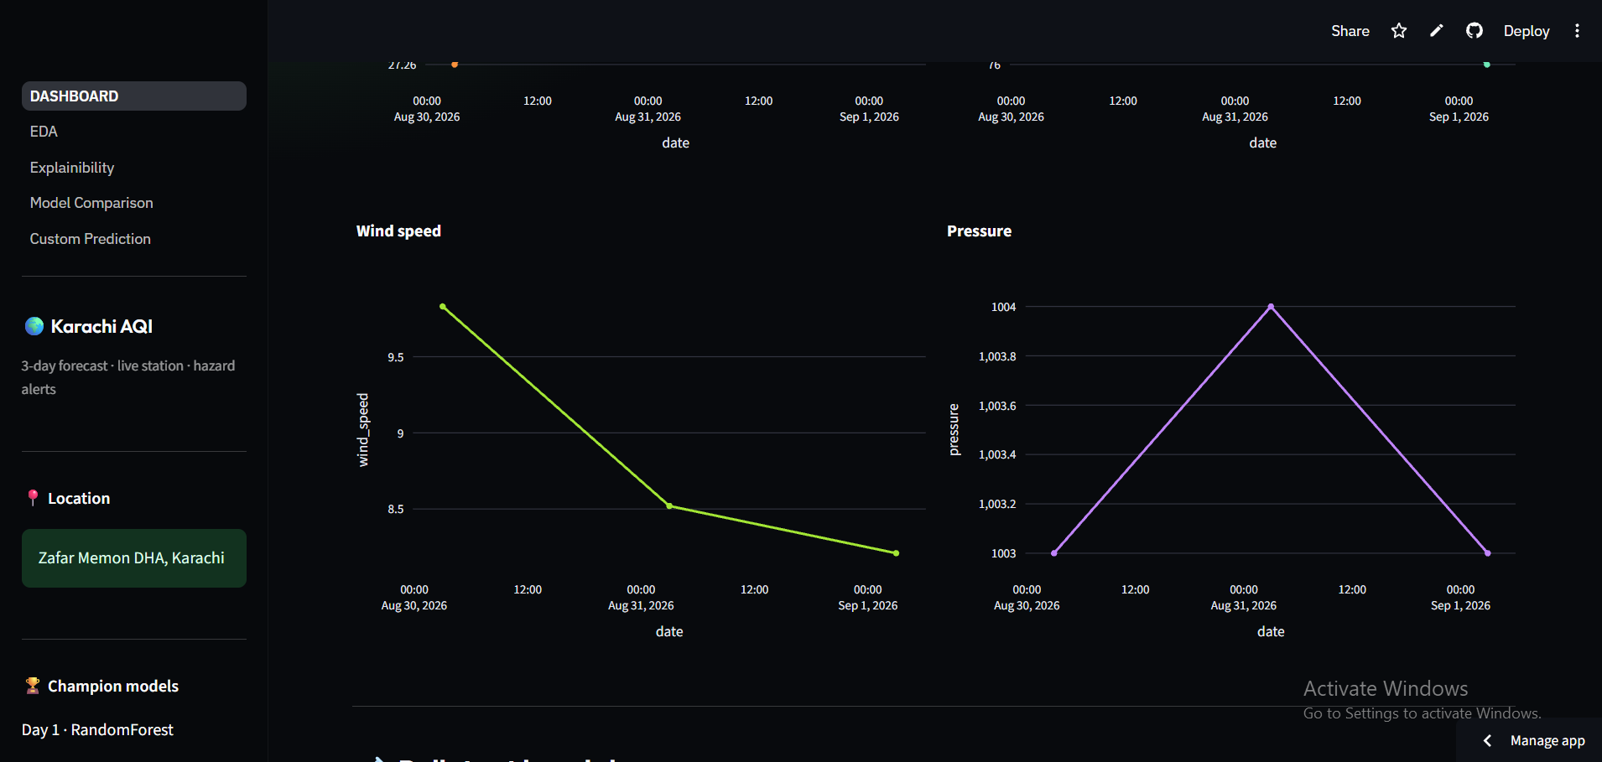
Wind speed and pressure trend charts across the 3-day forecast window.
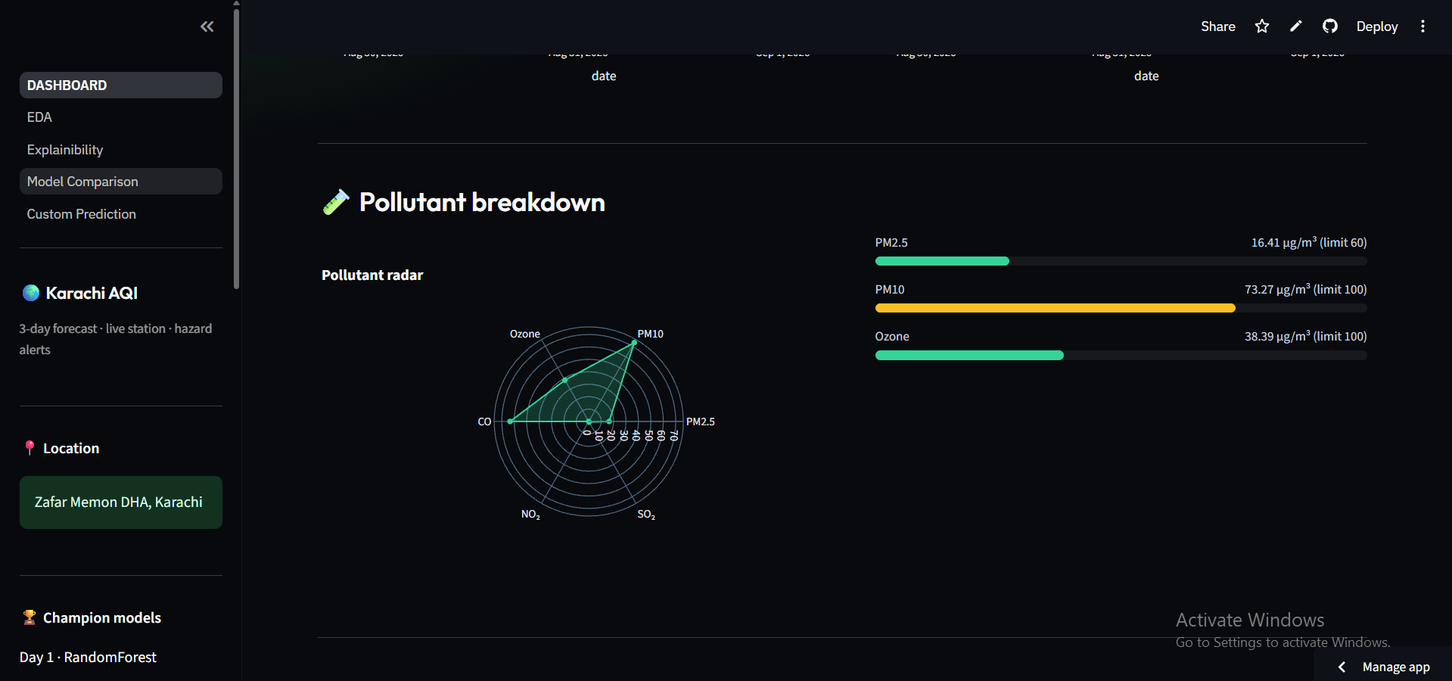
Pollutant radar and limit bars comparing PM2.5, PM10 and ozone against safe limits.
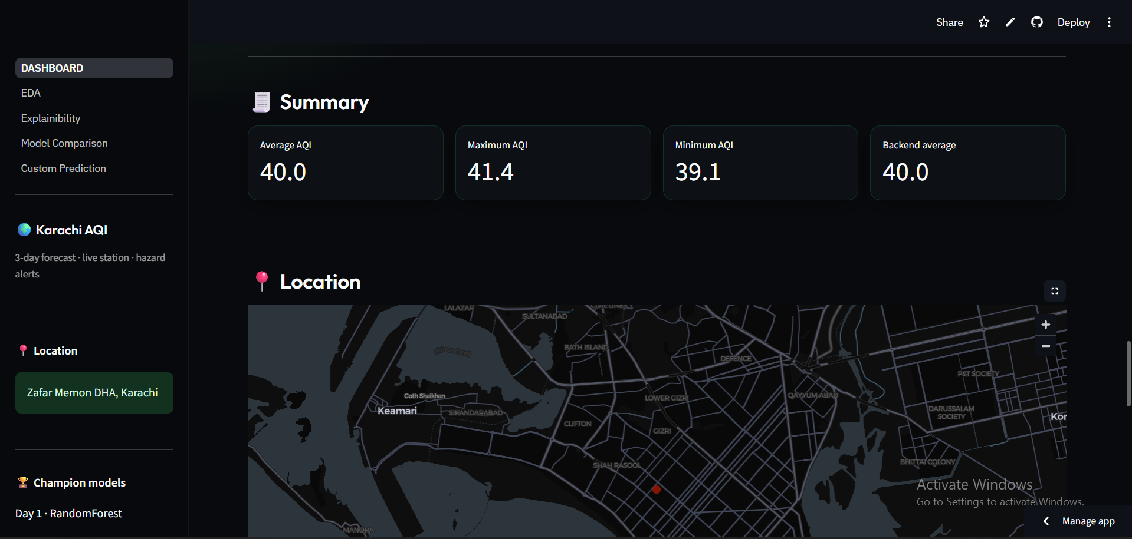
Summary metrics (average / max / min / backend average) with a live location map.
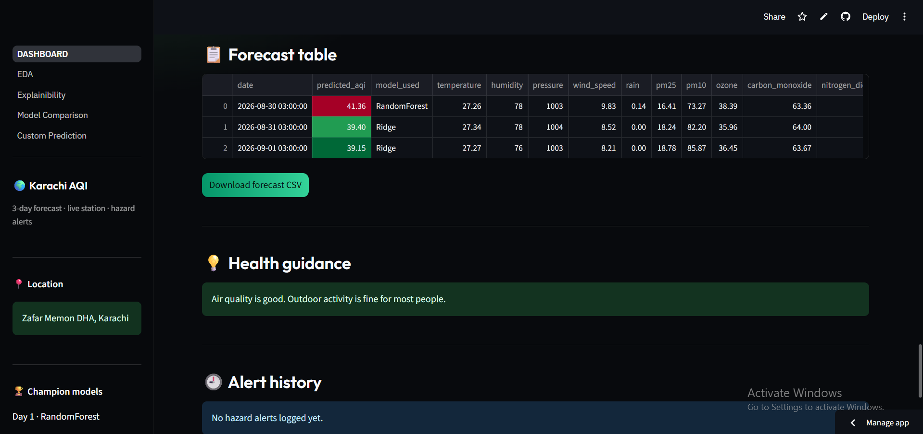
Detailed forecast table with CSV export, health guidance, and the alert history log.
📊 Exploratory Data Analysis
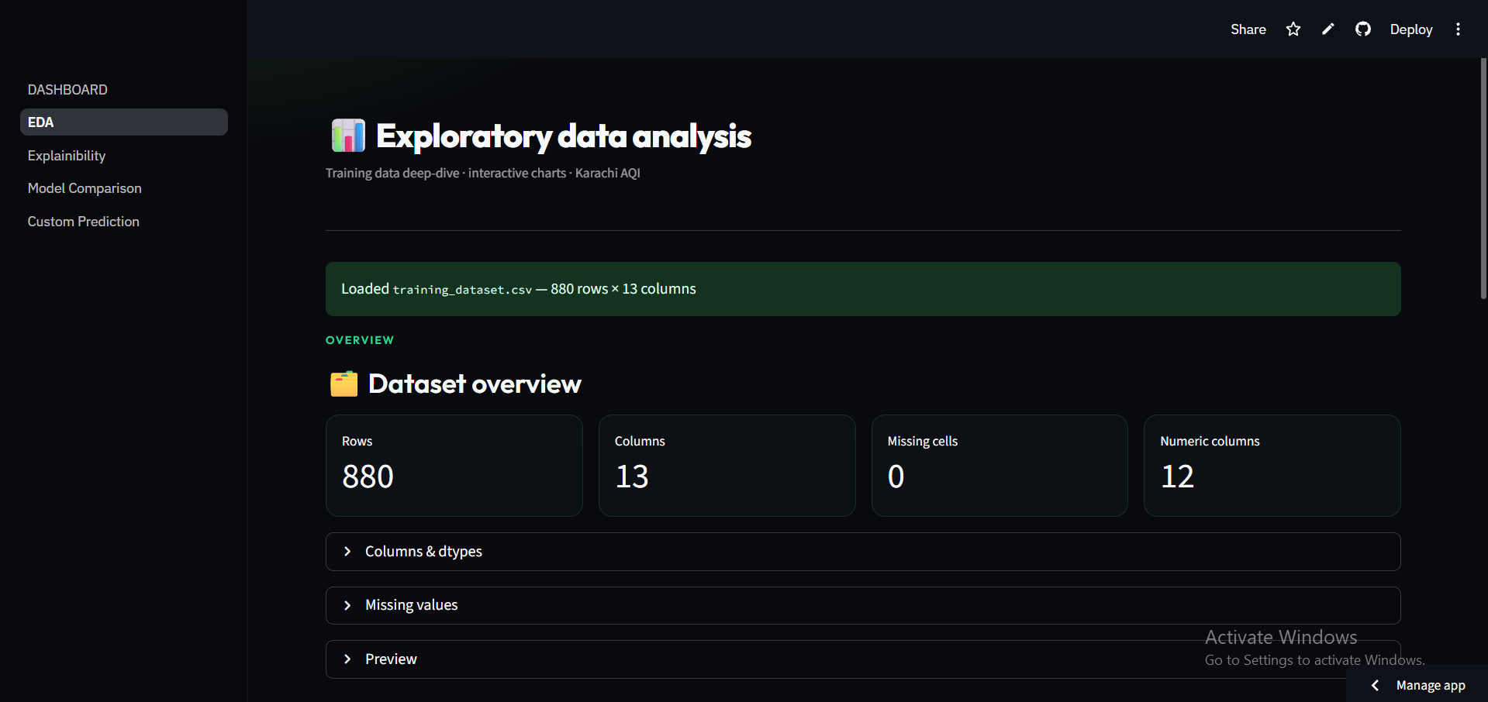
EDA landing view — dataset overview: 880 rows × 13 columns, zero missing cells, 12 numeric columns.
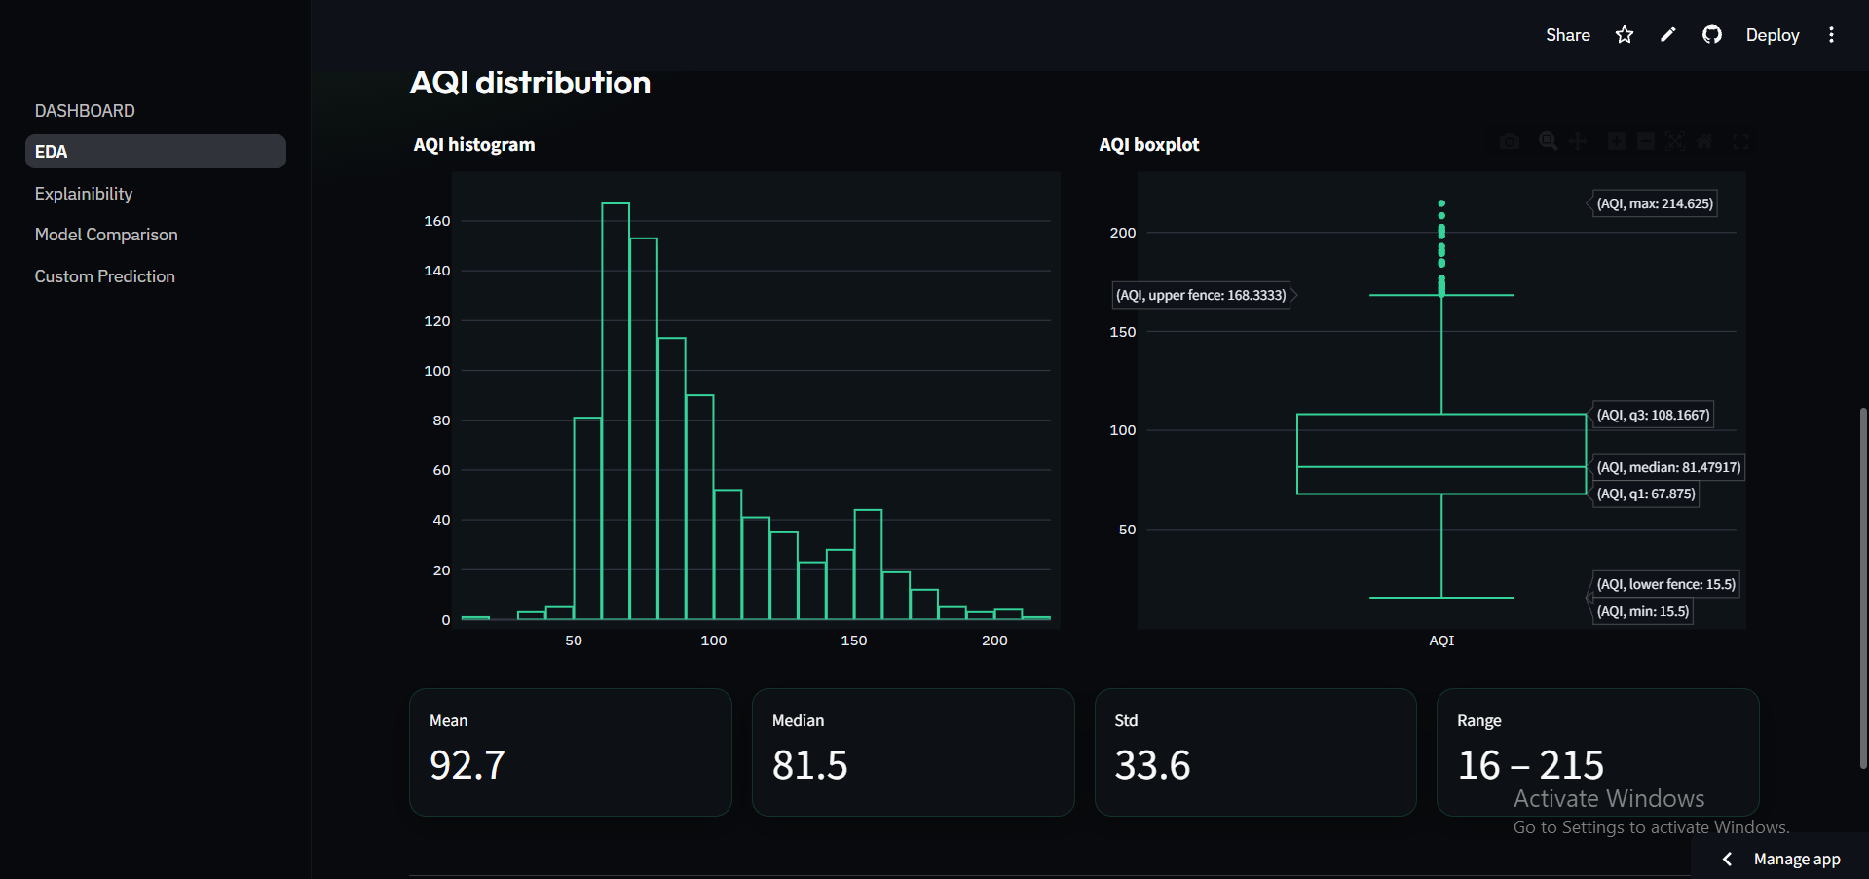
AQI distribution — histogram and boxplot with mean, median, standard deviation and range.
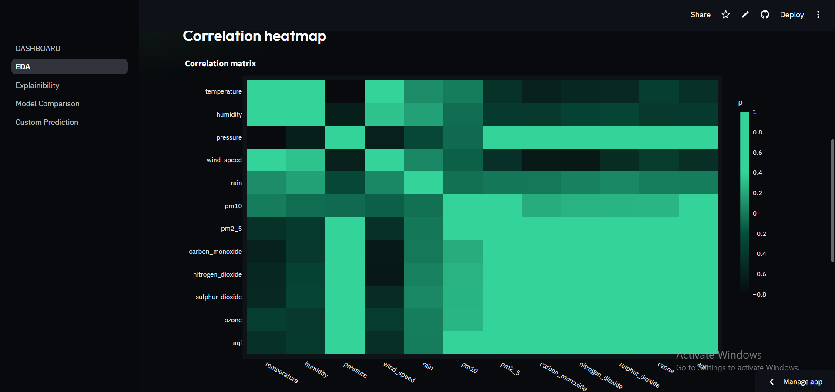
Correlation heatmap across all weather, pollutant and AQI variables.
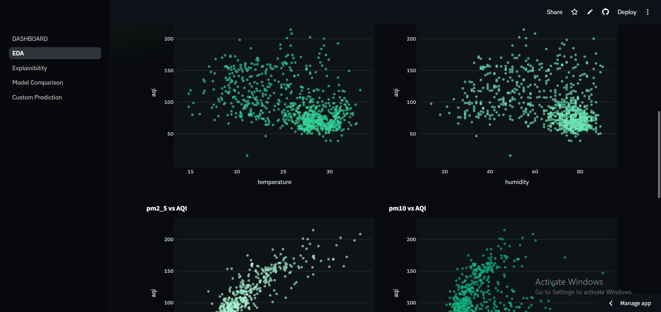
Feature distributions and AQI-vs-feature relationships (continued from the tabbed EDA view).
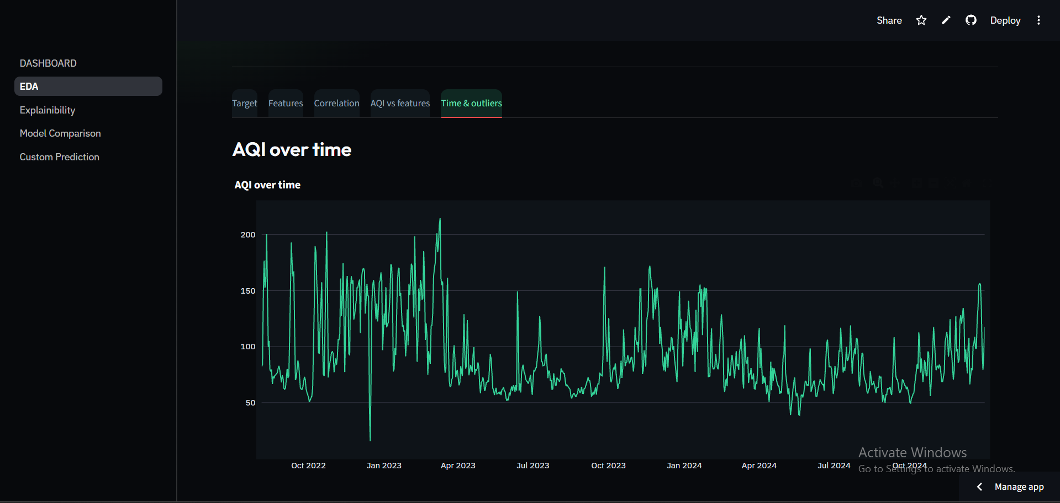
AQI over time — the full historical series from October 2022 through 2024.
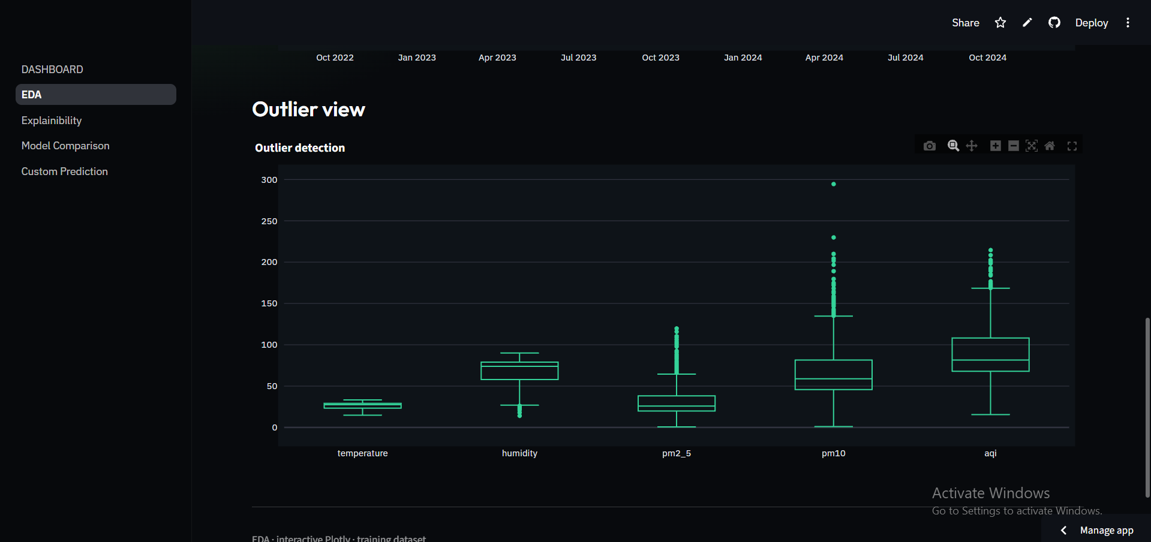
Outlier view — boxplots flagging extreme values across temperature, humidity, PM2.5, PM10 and AQI.
🔍 Model Explainability (SHAP)
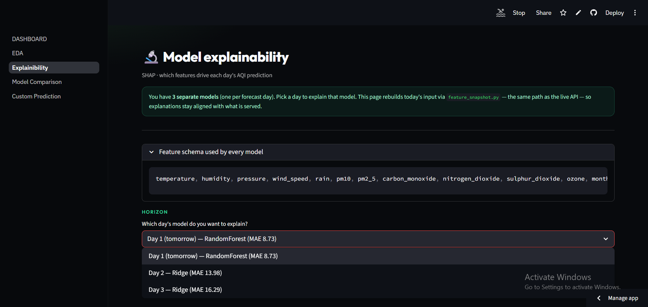
Explainability landing view — pick any of the 3 horizon-specific models to inspect, with the full feature schema shown for transparency.
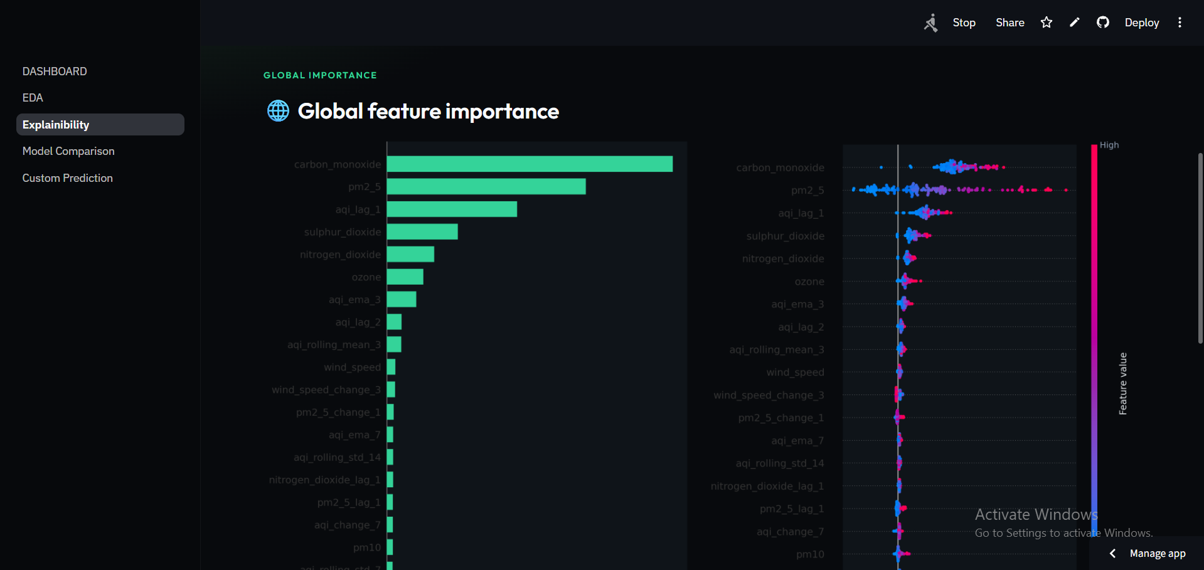
Global feature importance — mean SHAP impact per feature (left) and the SHAP beeswarm plot showing how each feature's value pushes predictions up or down (right).
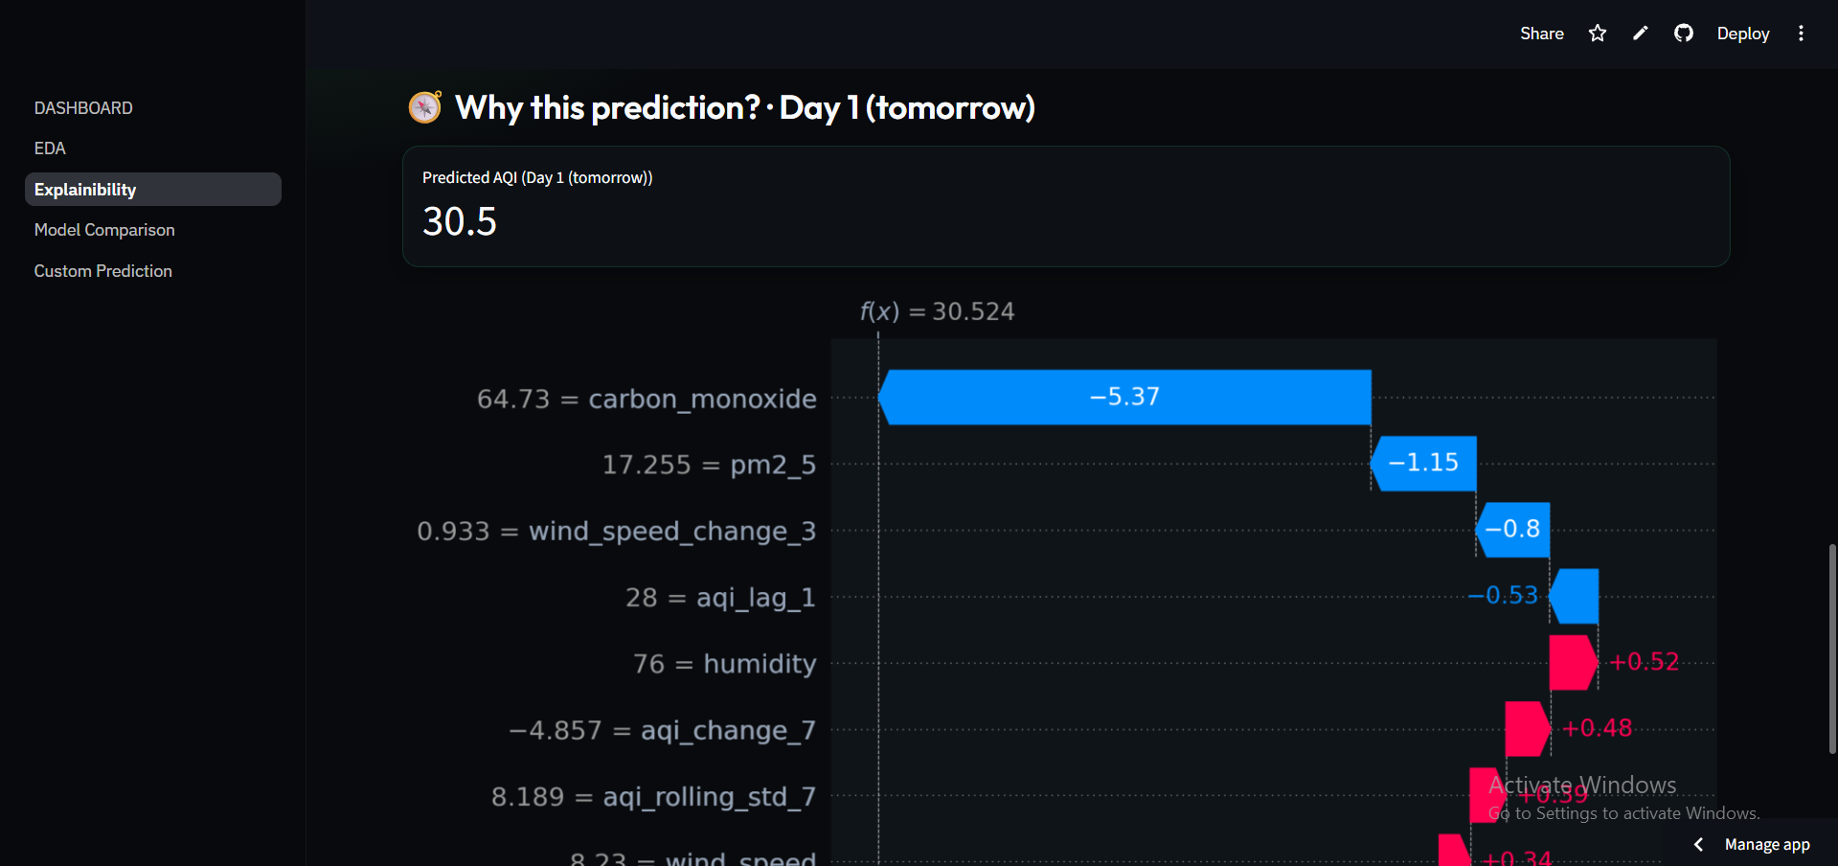
SHAP waterfall for a Day 1 prediction — showing exactly which features pushed that specific forecast up or down.
🏆 Model Comparison
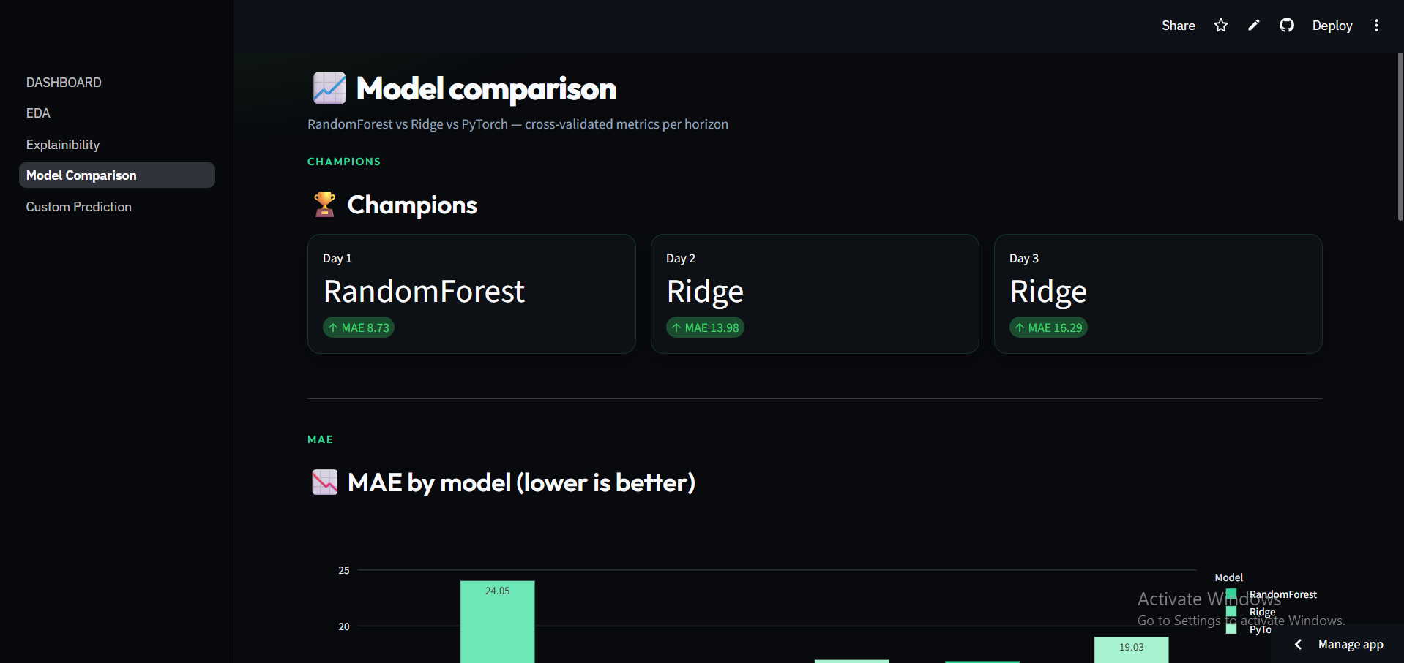
Champion models per horizon, with MAE by model bar chart (lower is better).
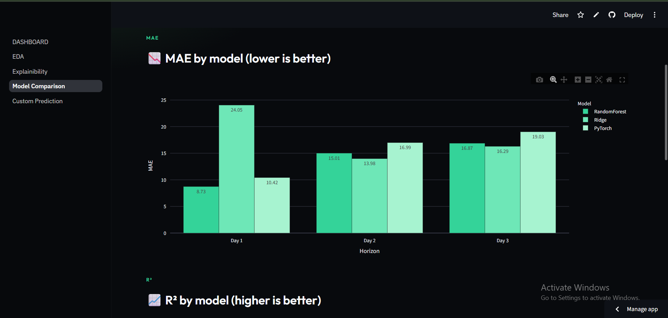
MAE by model across all three forecast horizons.
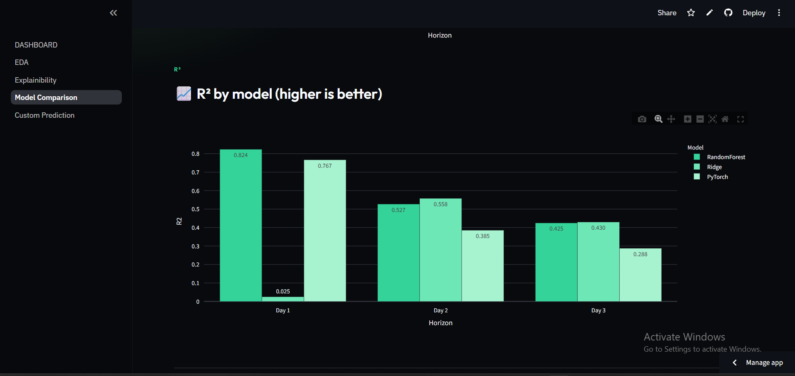
R² by model across all three forecast horizons (higher is better).
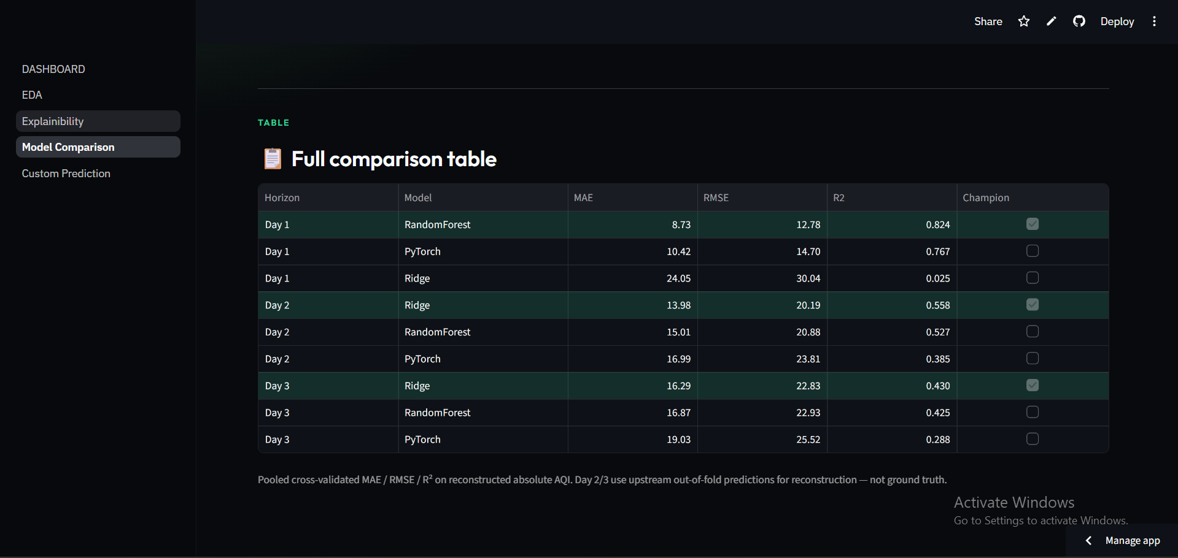
Full comparison table — MAE, RMSE and R² for every model and horizon, with the champion flagged.
🧪 Custom Prediction Lab
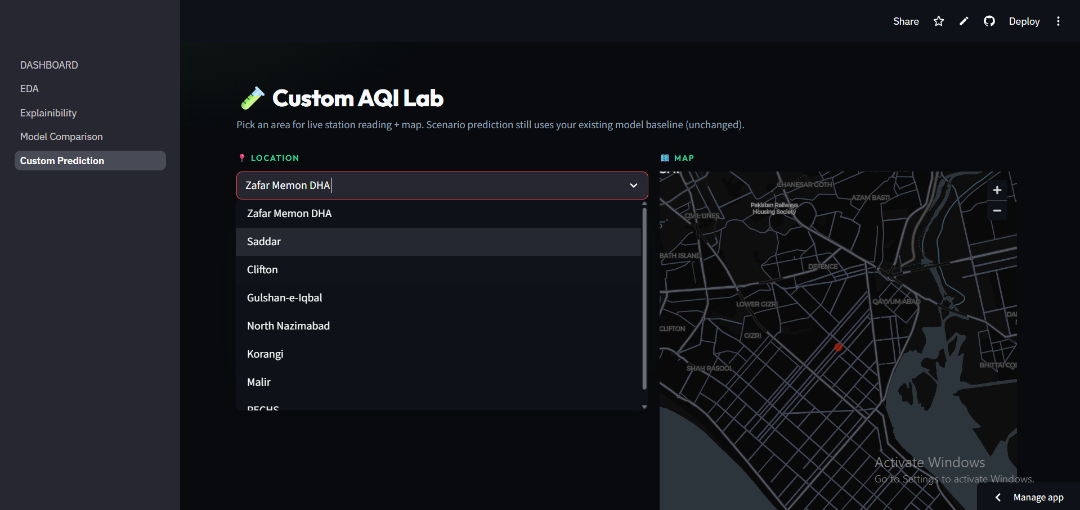
Custom AQI Lab — pick any Karachi location for its live reading and map view.
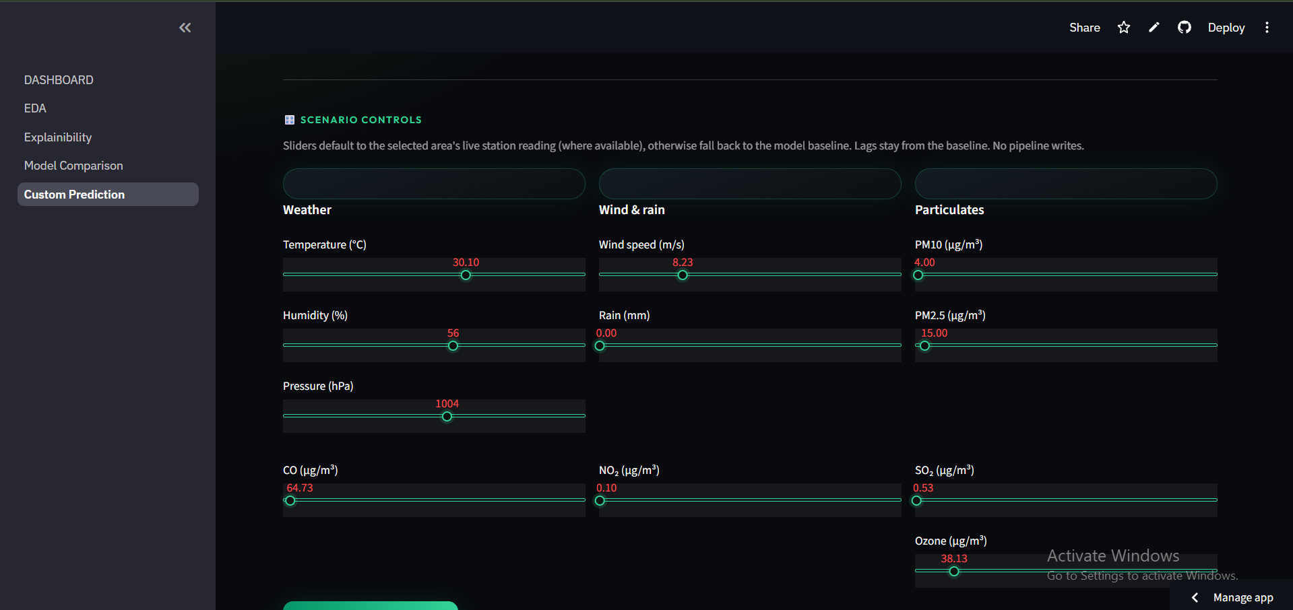
Scenario controls — sliders for weather, wind/rain and particulate inputs.
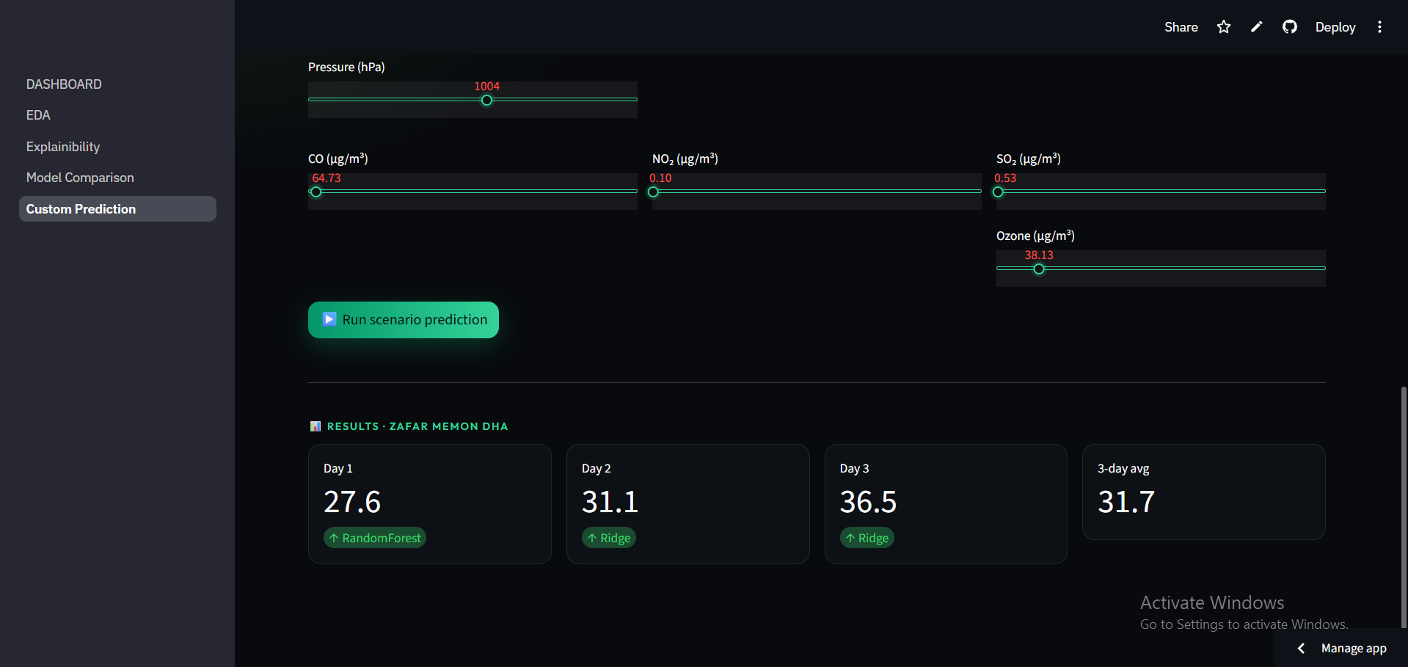
Scenario result — a fresh 3-day prediction generated from the custom input values.

