**OPERATING SYSTEM ASSIGNMENT # 2**

**TASK 1 REPORT**

**GROUP MEMBERS:**

* Muhibullah Sherwani
* Faraz Ahmed
* Faris Jamil

Class ID: 101348

Date: 21-April-2019

**TASK 1 CODE EXPLANATION:**

**Client.h**

#include <unistd.h>

#include <stdlib.h>

#include <stdio.h>

#include <string.h>

#include <fcntl.h>

#include <limits.h>

#include <sys/types.h>

#include <sys/stat.h>

#define SERVER_FIFO_NAME "/tmp/serv_fifo"

#define CLIENT_FIFO_NAME "/tmp/cli_%d_fifo"

#define BUFFER_SIZE 20

struct data_to_pass_st {

// Client Process ID

pid_t client_pid;

// Data Storage Buffer Size

char some_data[BUFFER_SIZE - 1];

};

**Server.c**

#include "client.h"

#include <ctype.h>

int main()

{

// initialize server and client FIFO

int server_fifo_fd, client_fifo_fd;

// struct create to get client pid and BufferSize from client.h

struct data_to_pass_st my_data;

int read_res;

// client FIFO string size

char client_fifo[256];

// temporary var use for data save

char *tmp_char_ptr;

// create server FIFO name and set read only

mkfifo(SERVER_FIFO_NAME, 0777);

// open server FIFO and set Read Only

server_fifo_fd = open(SERVER_FIFO_NAME, O_RDONLY);

if (server_fifo_fd == -1)

{

fprintf(stderr, "Server fifo failure\n");

exit(EXIT_FAILURE);

}

sleep(10); /* lets clients queue for demo purposes */

do {

read_res = read(server_fifo_fd, &my_data, sizeof(my_data));

if (read_res > 0)

{

// Getting Data from server FIFO to client FIFO

tmp_char_ptr = my_data.some_data;

while (*tmp_char_ptr)

{

// changing message LowerCase to UpperCase

*tmp_char_ptr = toupper(*tmp_char_ptr);

tmp_char_ptr++;

}

// Concatenate the Client FIFO Name with Client Process ID

sprintf(client_fifo, CLIENT_FIFO_NAME, my_data.client_pid);

// Open Client FIFO and set Write only

client_fifo_fd = open(client_fifo, O_WRONLY);

// check FIFO value != -1 then write data and close it

if (client_fifo_fd != -1)

{

write(client_fifo_fd, &my_data, sizeof(my_data));

close(client_fifo_fd);

}

}

}

// prints all output results and then Shutdown the server FIFO

while (read_res > 0) ;

close(server_fifo_fd);

// Remove Server FIFO from File System

unlink(SERVER_FIFO_NAME);

exit(EXIT_SUCCESS);

}

**Client.c**

#include "client.h"

#include <ctype.h>

int main()

{

// initialize server and client FIFO

int server_fifo_fd, client_fifo_fd;

// struct create to get client pid and BufferSize from client.h

struct data_to_pass_st my_data;

int times_to_send;

// client FIFO string size

char client_fifo[256];

// create server FIFO name and set Write only

server_fifo_fd = open(SERVER_FIFO_NAME, O_WRONLY);

// If Server FIFO equals to -1

if (server_fifo_fd == -1)

{

fprintf(stderr, "Sorry, no server\n");

exit(EXIT_FAILURE);

}

// Getting Client Process ID

my_data.client_pid = getpid();

// Concatenate the Client FIFO Name with Client Process ID

sprintf(client_fifo, CLIENT_FIFO_NAME, my_data.client_pid);

// Make client Pipe and set to read only in condition

if (mkfifo(client_fifo, 0777) == -1)

{

fprintf(stderr, "Sorry, can’t make %s\n", client_fifo);

exit(EXIT_FAILURE);

}

// Client sents data to server 5 times

for (times_to_send = 0; times_to_send < 5; times_to_send++)

{

// Client Data and Client ID in my_data

sprintf(my_data.some_data, "GetOSMessage from %d", my_data.client_pid);

printf("%d sent By: %s, ", my_data.client_pid, my_data.some_data);

write(server_fifo_fd, &my_data, sizeof(my_data));

// Client FIFO open and sets Read only

client_fifo_fd = open(client_fifo, O_RDONLY);

// If Client FIFO value != -1

if (client_fifo_fd != -1)

{

// Read message from server pipe and sent to client

if (read(client_fifo_fd, &my_data, sizeof(my_data)) > 0)

{

printf("received By: %s\n", my_data.some_data);

}

// Close client FIFO

close(client_fifo_fd);

}

}

// Close Server FIFO

close(server_fifo_fd);

// Unlink Client FIFO from System File

unlink(client_fifo);

exit(EXIT_SUCCESS);

}

**TASK 1 CODE EXCECUTION SCREENSHOTS:**

**SERVER FIFO CREATES:**

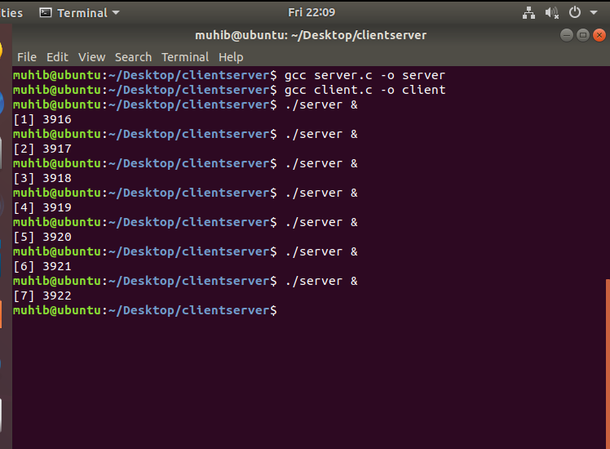

**CLIENT RUNS WITHOUT SERVER STARTS:**

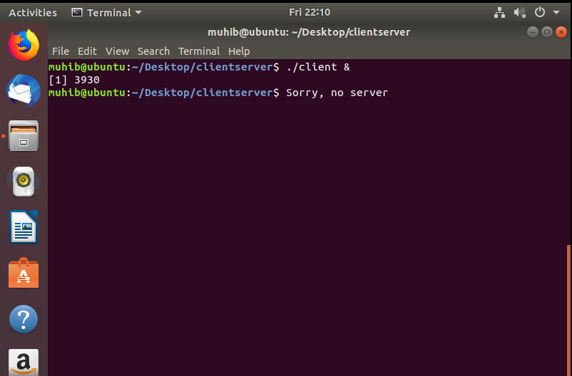

**CLIENT SENTS MESSAGE 5 TIMES:**

