**OPERATING SYSTEM ASSIGNMENT # 3**

**REPORT**

**GROUP MEMBERS:**

* Muhibullah Sherwani
* Faraz Ahmed
* Faris Jamil

Class ID: 101348

Date: 27-April-2019

**CODE EXPLANATION:**

**ChatServer.c**

#include <sys/types.h>

#include <sys/ipc.h>

#include <sys/sem.h>

#include <sys/shm.h>

#include<stdio.h>

#include<string.h>

#include<errno.h>

#include<stdlib.h>

#define BUF_SIZE 1024

#define SHM_KEY 0x1234

// Creation Of Shared Memory

int shmget(key_t key, size_t size, int shmflg)

// Creation Of Semaphores

int semget(key_t key, int num_sems, int sem_flags);

// Deletion Of Shared Memory

if (shmdt(shared_memory) == -1) {

fprintf(stderr, “shmdt failed\n”);

exit(EXIT_FAILURE);

}

if (shmctl(shmid, IPC_RMID, 0) == -1) {

fprintf(stderr, “shmctl(IPC_RMID) failed\n”);

exit(EXIT_FAILURE);

}

exit(EXIT_SUCCESS);

}

// Deletion Of Semaphores

void remove_semaphore() {

int semid;

int retval;

semid = semget(SEM_KEY, 1, 0);

if (semid < 0) {

perror("Remove Semaphore: Semaphore GET: ");

return;

}

retval = semctl(semid, 0, IPC_RMID);

if (retval == -1) {

perror("Remove Semaphore: Semaphore CTL: ");

return;

}

return;

}

// Reading Message from message board

struct shmseg {

int cnt;

int complete;

char buf[BUF_SIZE];

};

int shmid;

struct shmseg *shmp;

shmid = shmget(SHM_KEY, sizeof(struct shmseg), 0644|IPC_CREAT);

if (shmid == -1) {

perror("Shared memory");

return 1;

}

// Attach to the segment to get a pointer to it.

shmp = shmat(shmid, NULL, 0);

if (shmp == (void *) -1) {

perror("Shared memory attach");

return 1;

}

/* Transfer blocks of data from shared memory to stdout*/

while (shmp->complete != 1) {

printf("segment contains : \n\"%s\"\n", shmp->buf);

if (shmp->cnt == -1) {

perror("read");

return 1;

}

printf("Reading Process: Shared Memory: Read %d bytes\n", shmp->cnt);

sleep(3);

}

printf("Reading Process: Reading Done, Detaching Shared Memory\n");

if (shmdt(shmp) == -1) {

perror("shmdt");

return 1;

}

printf("Reading Process: Complete\n");

return 0;

// Writing Message to Message board

int fill_buffer(char * bufptr, int size);

/* Transfer blocks of data from buffer to shared memory */

bufptr = shmp->buf;

spaceavailable = BUF_SIZE;

for (numtimes = 0; numtimes < 5; numtimes++) {

shmp->cnt = fill_buffer(bufptr, spaceavailable);

shmp->complete = 0;

printf("Writing Process: Shared Memory Write: Wrote %d bytes\n", shmp->cnt);

bufptr = shmp->buf;

spaceavailable = BUF_SIZE;

sleep(3);

}

printf("Writing Process: Wrote %d times\n", numtimes);

shmp->complete = 1;

if (shmdt(shmp) == -1) {

perror("shmdt");

return 1;

}

if (shmctl(shmid, IPC_RMID, 0) == -1) {

perror("shmctl");

return 1;

}

printf("Writing Process: Complete\n");

return 0;

}

int fill_buffer(char * bufptr, int size) {

static char ch = 'A';

int filled_count;

//printf("size is %d\n", size);

memset(bufptr, ch, size - 1);

bufptr[size-1] = '\0';

if (ch > 122)

ch = 65;

if ( (ch >= 65) && (ch <= 122) ) {

if ( (ch >= 91) && (ch <= 96) ) {

ch = 65;

}

}

filled_count = strlen(bufptr);

printf("buffer count is: %d\n", filled_count);

printf("buffer filled is:%s\n", bufptr);

ch++;

return filled_count;

}

// Creating Client List

int running = 1;

**ClientChat.c**

#include <sys/types.h>

#include <sys/ipc.h>

#include <sys/sem.h>

#include <sys/shm.h>

#include<stdio.h>

#include<string.h>

#include<errno.h>

#include<stdlib.h>

#define BUF_SIZE 1024

#define SHM_KEY 0x1234

// Creaton Of Shared Memory

int shmget(key_t key, size_t size, int shmflg)

// Creation Of Semaphore

int semget(key_t key, int num_sems, int sem_flags);

// Changing Value of Semaphore

int semop(int sem_id, struct sembuf *sem_ops, size_t num_sem_ops);

// Deletion Of Shared Memory

if (shmdt(shared_memory) == -1) {

fprintf(stderr, “shmdt failed\n”);

exit(EXIT_FAILURE);

}

if (shmctl(shmid, IPC_RMID, 0) == -1) {

fprintf(stderr, “shmctl(IPC_RMID) failed\n”);

exit(EXIT_FAILURE);

}

exit(EXIT_SUCCESS);

}

// Deletion Of Semaphores

void remove_semaphore() {

int semid;

int retval;

semid = semget(SEM_KEY, 1, 0);

if (semid < 0) {

perror("Remove Semaphore: Semaphore GET: ");

return;

}

retval = semctl(semid, 0, IPC_RMID);

if (retval == -1) {

perror("Remove Semaphore: Semaphore CTL: ");

return;

}

return;

}

**CODE EXCECUTION SCREENSHOT:**

Note: Errors in code execution but we done some code explanation

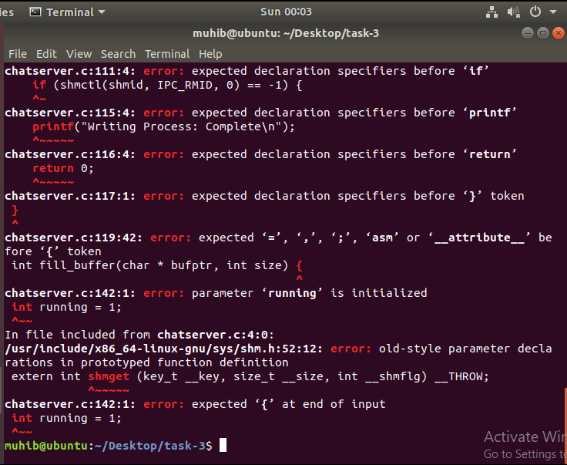

**MANUALLY CODE EXCECUTION SCREENSHOT:**

