Muhideen Mustapha
QuestLab User Guide
Table of Contents
- Introduction
- Roles and Access
- Getting Started
- Features and Workflows
- Troubleshooting

1. Introduction
QuestLab connects abstract learning with hands-on experience. Users can create, discover, and complete interactive learning quests that blend creativity and experimentation.

2. Roles and Access
Role | Description
Creator (Educator) | Creates and publishes quests
Quester (Learner) | Discovers and completes quests
Both (Educator & Learner) | Create & Publish, Discover & Complete quests
Guest | Browses public quests only

3. Getting Started
- Launch QuestLab in your browser.
- Register
  - Create multiple accounts (For Learner, Educator, and Both)
  - Then Log in, with one of those accounts
- Access your Dashboard to view quests or create new ones based on the roles and access

4. Features and Workflows
4.1 Create a Learning Quest
- On the homepage, Click Create New Quest.
- Enter title, description, and tags.
- Add one or more tasks with prompts and instructions.
- Publish when ready.
Result: Quest appears in public gallery.

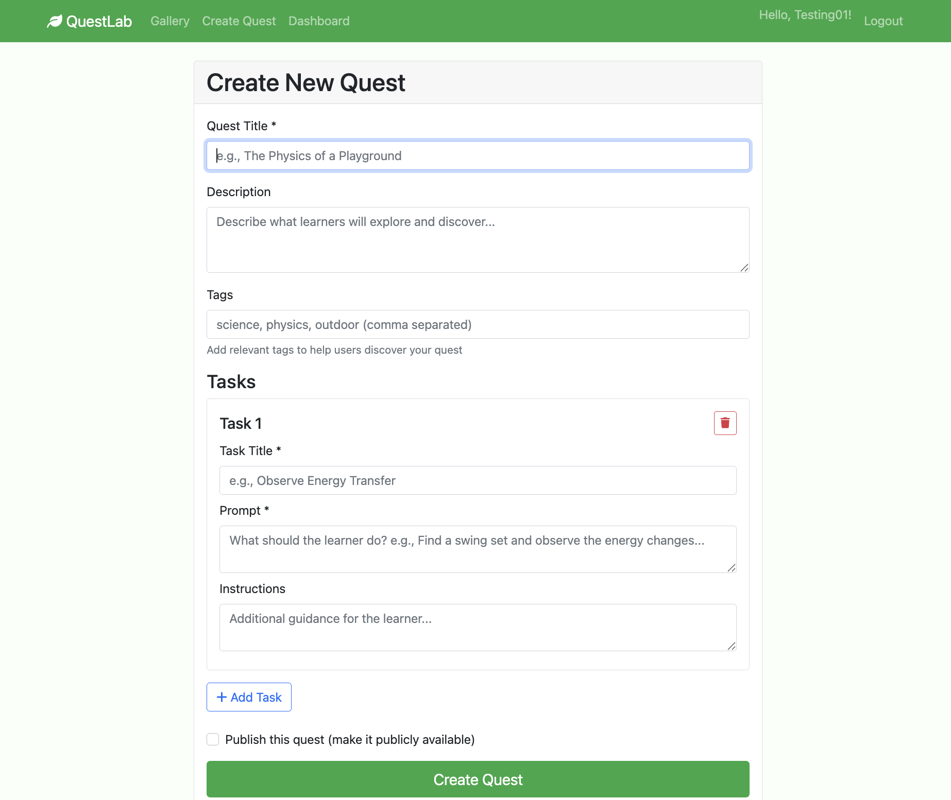
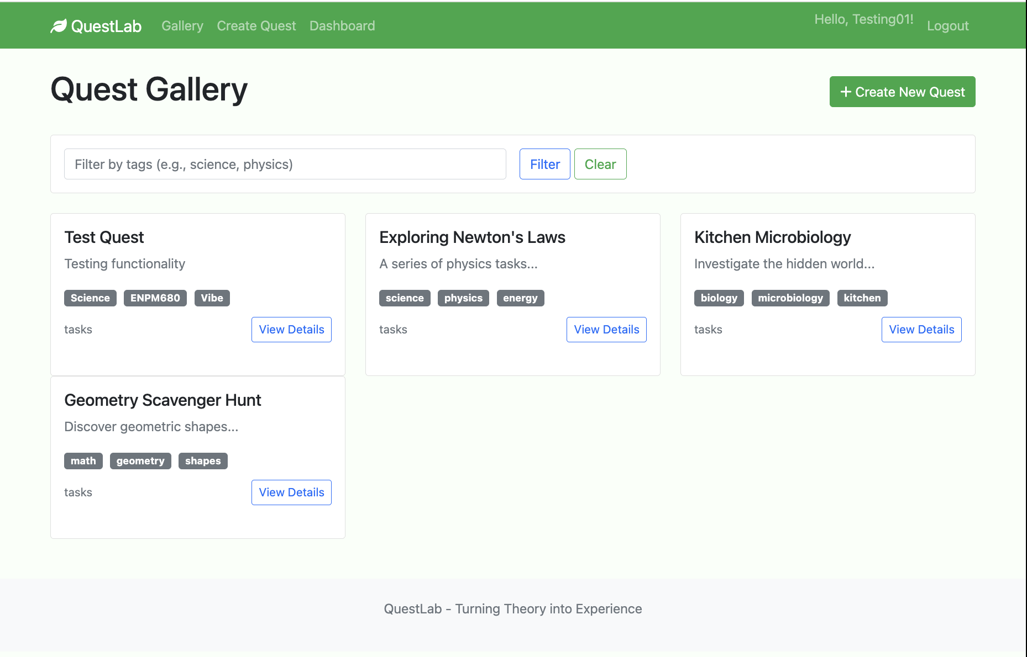
4.2 Discover and Begin a Quest
- Go to the Quest Gallery.
- Filter by tags or keywords.
- Select a quest to view details.
- Click Begin This Quest.
Result: Quest marked In Progress.
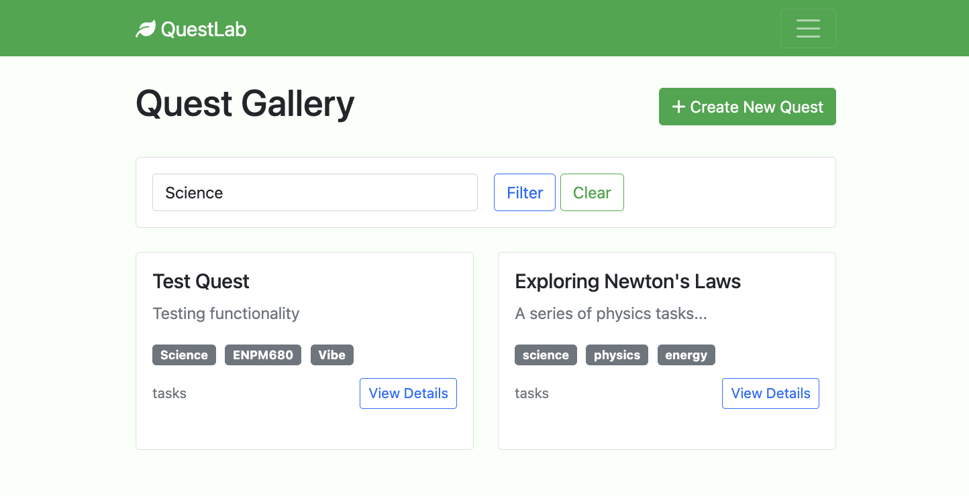

4.3 Submit and Reflect on Tasks
- Click on any quest of interest(view details) in the Quest gallery
- Click on Begin Quest or go to any specific task of interest.
- Upload a photo/video and add reflection text.
- Click Submit Task.
- After submission you can check other people’s submission by clicking on View Submissions to reflect again on the tasks.
Result: System validates file, analyzes text, and provides AI-generated feedback.
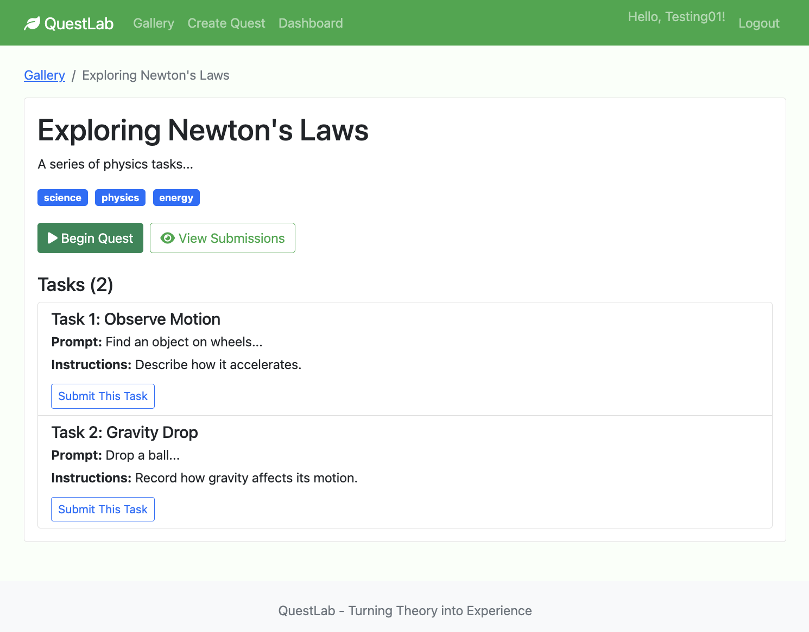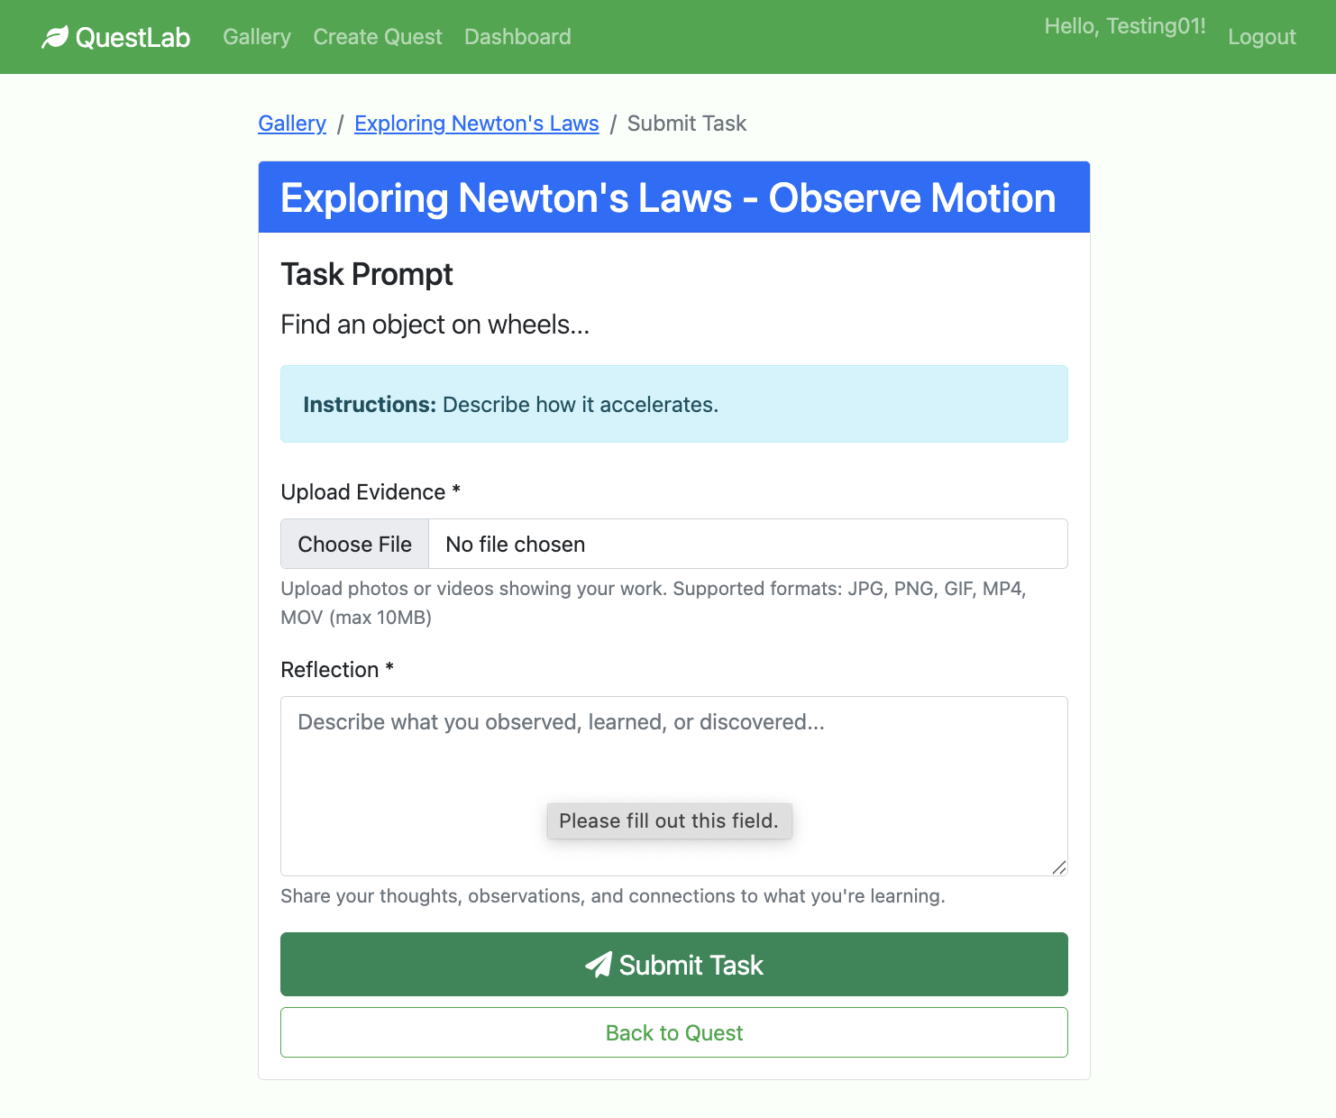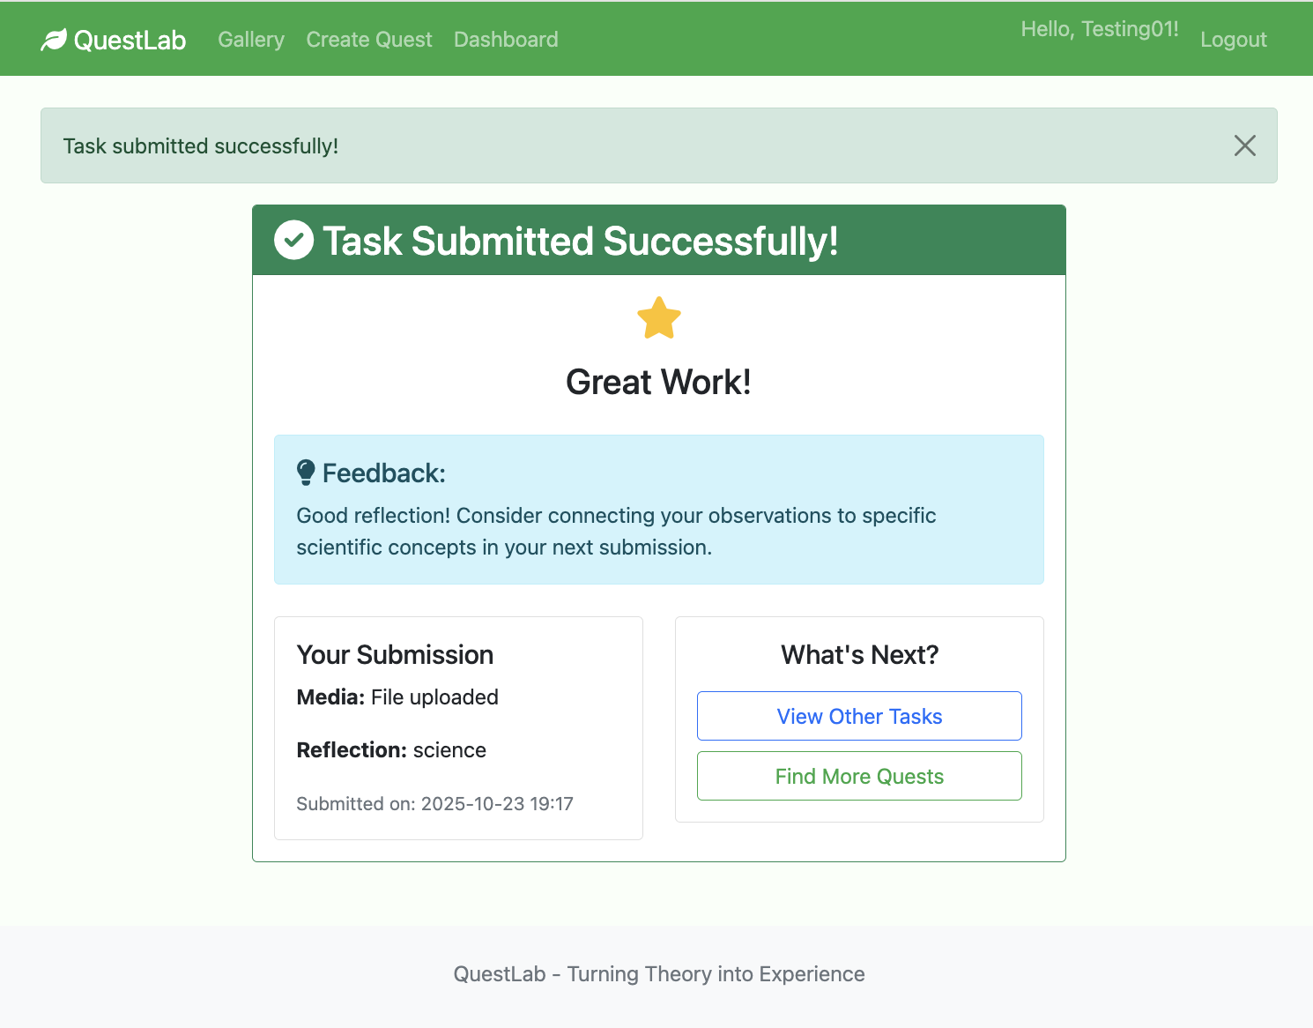
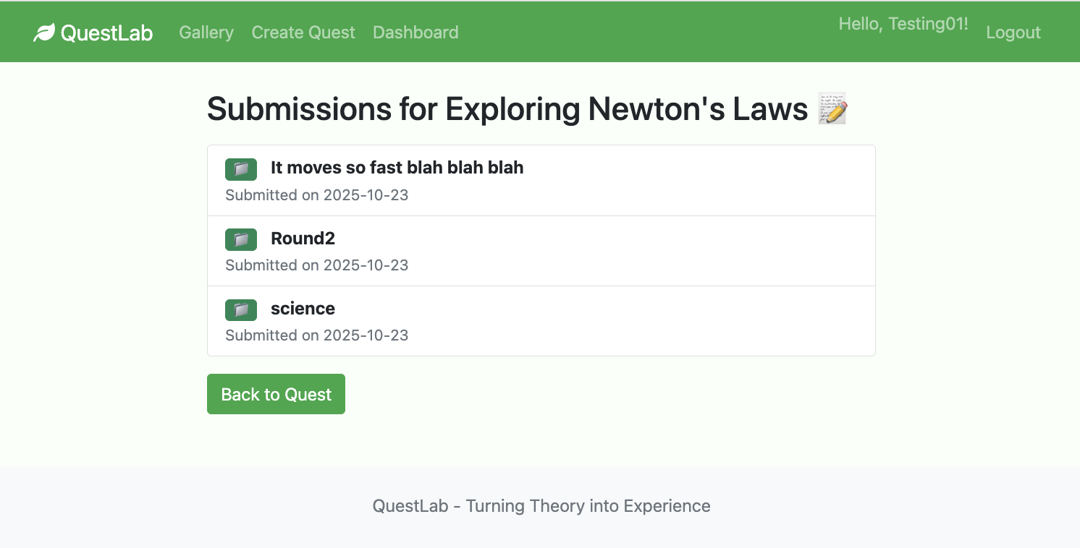

4.4 Track Your Progress
- Open Dashboard
- View in progress, completed,
- Resume or review submissions.
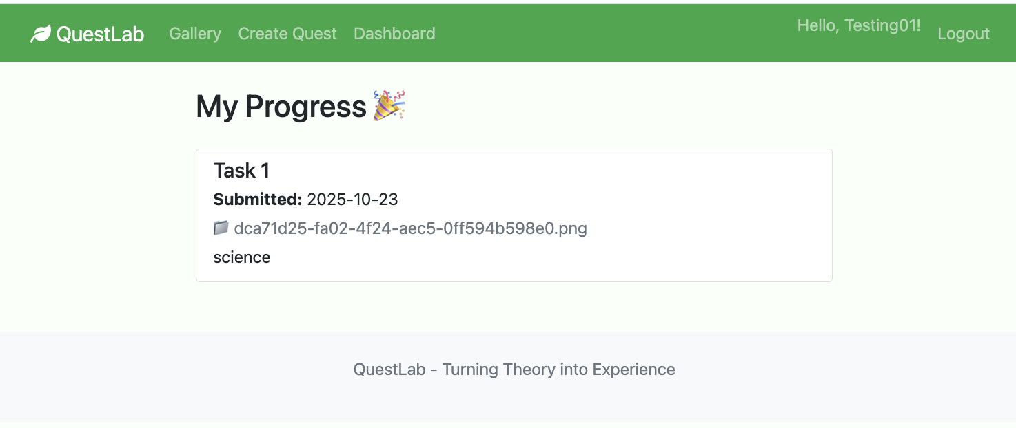

5. Troubleshooting
Issue | Cause | Solution
App won't start | Missing dependencies | Run pip install -r requirements.txt
Import errors | Virtual environment inactive | source venv/bin/activate
Upload errors | Invalid file or >10MB | Check file extension/size
Database missing | Not initialized | Run db.create_all()
Tests fail | Schema mismatch | Recreate database

