MediMind AI – Smart Health Consultant

Ms. S. Geeviga, M.E.,¹
Artificial Intelligence and Data Science
Coimbatore Institute of Engineering and Technology
Coimbatore, Tamilnadu
geeviga.s@cietcbe.edu.in

Ms. Tania Thomas⁴
Artificial Intelligence and Data Science
Coimbatore Institute of Engineering and Technology
Coimbatore, Tamilnadu
taniathomas7902@gmail.com
Mr. Muhilan G.R²
Artificial Intelligence and Data Science
Coimbatore Institute of Engineering and Technology
Coimbatore, Tamilnadu
muhilanguru0088@gmail.com

Mr. Vikash V.R⁵
Artificial Intelligence and Data Science
Coimbatore Institute of Engineering and Technology
Coimbatore, Tamilnadu
vikashvadivel1024@gmail.com
Ms. Nagamani A³
Artificial Intelligence and Data Science
Coimbatore Institute of Engineering and Technology
Coimbatore, Tamilnadu
mnagu9477@gmail.com

Abstract— MediMind AI is a health consultation web application that utilizes artificial intelligence to simulate a doctor and patient conversation and produce real-time medical reports. The application allows users to converse about symptoms via a chat system, and the application, powered by sophisticated language models, produces context-specific medical advice and dynamically generates structured medical reports. The application provides multiple health consultation options, is built using React and TypeScript, and utilizes Firebase for backend functionality. MediMind AI improves the availability of initial healthcare services, reduces manual entry of data, and allows users to download their medical reports.
Keywords— healthcare, artificial intelligence, medical consultation, language models, web application.

Introduction
There is an increasing need for accessible healthcare solutions, leading to a pressing need for trustworthy and intelligent systems that can be used for preliminary medical consultations. Conventional healthcare systems tend to have limitations such as long waiting lines, a lack of doctor availability, and the time taken for medical documentation. MediMind AI solves these problems by using an AI-based web application that can mimic doctor-patient conversations and produce real-time medical reports. The system uses the power of advanced language models combined with the simplicity of a web application to provide context-based medical advice and automatically produce medical reports.

RELATED WORK
The current state-of-the-art AI-based healthcare consultation systems are mainly focused on automating medical consultations, symptom analysis, and simple virtual consultations using conversational AI. These systems are intended to increase accessibility, decrease the doctor’s workload, and facilitate the exchange of health-related data. Although they have shown success in patient engagement and simple diagnostic support, most current systems fail to integrate deeply in terms of report generation, user personalization, and multi-modal consultations.

A. AI – Assisted E-Consult Platform
This system was developed as a digital interface connecting patients, doctors, and healthcare institutions. It uses deep learning-based chatbots for symptom analysis and appointment scheduling. It increases accessibility by minimizing consultation delays but suffers from the drawback of high computational resource needs and poor personalization in terms of user experience.

B. Doctor AI – Healthcare Chatbot
The Doctor AI system uses NLP and ML algorithms to analyze the symptoms entered by the user and provide accurate, real-time health advice. It consists of components for the analysis of medical terminology, intent analysis, and dialogue management. Although accurate and organized, the system is largely a question-and-answer system and lacks overall report generation and backend support, which is common in more contemporary frameworks.

C. AI-Based Virtual Clinic for Rural India
This project combines AI-based diagnostic algorithms with telemedicine systems to facilitate rural healthcare. It allows for remote consultations, electronic prescription, and biometric authentication for secure access. Although it has shown excellent results in terms of user satisfaction and accessibility, the system’s functionality is largely restricted to location-based consultations without dynamic, automated health reporting.

D. AI-Powered Health Chatbot Architecture
A generic architecture has been defined by several IEEE publications, which outline the overall components of the system: user interface, NLP module, data management, and integration with the medical knowledge base. These systems are largely designed for text analysis and response accuracy and provide a starting point for virtual medical assistants but are not overall multi-modal systems.

E. Online Doctor Consultation system
Online AI system offering automated medicine suggestions and health advice via online chat interaction. It enhances the diagnosis process with data-driven predictive analysis but is still limited by a lack of interoperability and report formatting.

PROPOSED SYSTEM
The proposed system, MediMind AI, is designed to offer a holistic AI-driven health consultation platform that can simulate doctor-patient conversations, produce real-time medical reports, and facilitate hybrid health consultation models for flexible healthcare access. The system targets filling the accessibility divide in primary health consultations with intelligent automation and intuitive design.

A. System Overview
MediMind AI combines artificial intelligence, web development, and cloud computing to offer dynamic and responsive health interactions. The system’s chatbot facilitates natural language conversations with users through a chat interface, understands symptoms in context, and automatically produces structured medical summaries and reports. It facilitates two health consultation models:
AI Mode: Fully automated AI-assisted health consultation for symptom analysis and medical advice.
Human Mode: Hybrid health consultation model for human professionals to review and refine AI suggestions for enhanced accuracy.

B. System Design and Architecture
- Interface Layer: This layer, designed using React and TypeScript, offers a responsive chat interface for users to engage with the system naturally. The interface allows text and voice conversations, multilingual responses, and user input and chat visualization.
- AI Processing Layer: The Language Model Integration is the heart of the system. It facilitates natural language understanding (NLU) for symptom interpretation and natural language generation (NLG) for medically valid responses. This layer dynamically processes user input and provides health insights.
- Backend and Database Layer: Firebase is responsible for user authentication, database storage, and system security. It provides encrypted data processing, session handling, and secure communication between the AI engine and the frontend.
- Consultation and Report Module: The AI module functions in two consultation modes based on user input: AI and Human-assisted modes. The system generates a structured medical report based on each conversation, which can be exported as a PDF.
- Testing and Feedback Layer: Prior to deployment, the system integrates and tests all modules for response quality, system stability, and report validity. Continuous feedback improves the AI model for better accuracy and user interaction.
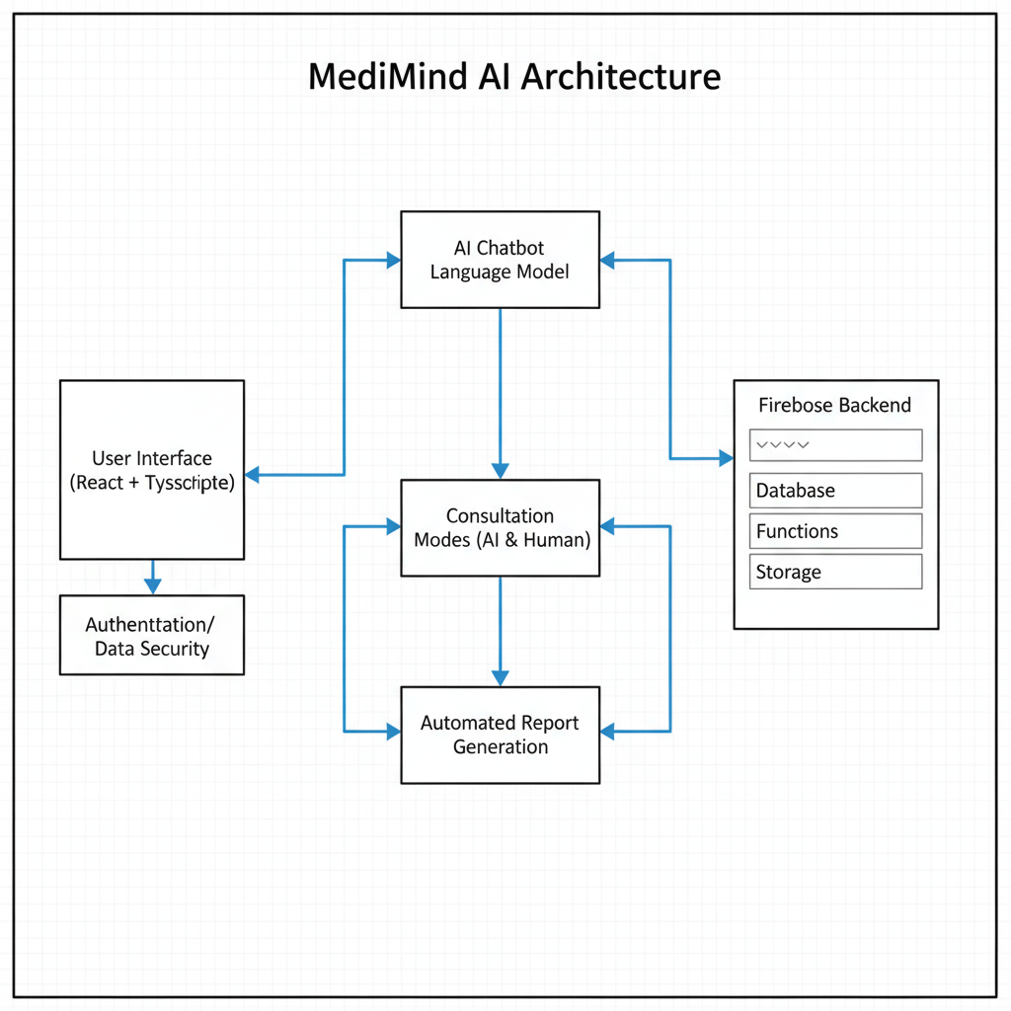

C. Methodology
The creation of MediMind AI utilized a modular, step-by-step approach to the development, training, and integration of an AI-assisted health consultation system. This includes steps in data acquisition, chatbot development, report generation, optimization, and deployment.
Module 1: Data Acquisition and Preprocessing
A medical knowledge base was acquired, comprising symptom-disease matrices, medical guidelines, and treatment matrices. The raw data was cleaned, normalized, and encoded for compatibility with the model. Data preprocessing ensured that only valid and pertinent medical data was utilized for AI training and response generation.
Module 2: Chatbot and Frontend Development
An AI-assisted chatbot was developed to mimic doctor-patient conversations through interactive dialogue systems. The chatbot employs NLP and ML algorithms to analyze medical-related queries and provide context-specific responses. The frontend, developed using React and TypeScript, emphasizes usability, responsiveness, and support for multilingual text entry, providing a seamless and accessible consultation experience.
Module 3: Basic Report Generation & Firebase integration
Early development involved the processing of conversational data from the chatbot to generate basic medical reports to summarize symptoms and key discussion points from each consultation. Firebase was integrated for:
- User authentication, for secure login functionality.
- Session management, for seamless chatbot interaction.
- Database storage, for healthcare history retrieval and report management.
Module 4: Real-Time report Generator with Export
This phase further improved the report generator for real-time structured PDF generation, automatically summarizing diagnostic insights into formatted reports. To make it more accessible, multilingual support (Tamil/English) and voice input/output functionality were incorporated, meeting the latest standards of inclusivity in AI healthcare applications.
Module 5: AI Optimization and Security
The AI system was optimized for better accuracy, context, and hallucination prevention. Robust security measures were incorporated for safe and responsible AI output. Encryption and privacy regulations were also implemented, meeting similar standards for handling medical data as HIPAA and GDPR regulations.
Module 6: System Integration and Deployment
The complete integrated system combined the frontend, backend, and AI components into a single cloud-based platform. Deployment on Firebase Hosting (or alternatively on AWS) provides scalability and worldwide accessibility. Pilot implementation was done to evaluate the efficiency of the chatbot, accuracy of reports, and user satisfaction. Usability and performance analysis of the system was also recorded for further improvement.

IMPLEMENTATION AND EXPERIMENTAL SETUP
The system implementation combines multiple tools and technologies in the frontend, backend, and AI processing components to develop a scalable and efficient AI healthcare chatbot.

A. User Interface

The frontend is built using React, a JavaScript library for creating interactive UIs, and TypeScript, which adds static typing for improved code quality and maintainability. This interface supports web and mobile platforms, allowing users to enter medical symptoms in a natural way through chat or voice interfaces.

B. User Input Layer
This layer receives symptom data from users through text and speech interfaces, preprocessing raw user input for the AI engine.

C. NLP & AI Engine
The conversational intelligence engine is driven by state-of-the-art language models such as GPT, BERT, or T5 (transformer models designed for natural language processing tasks). These models process and understand user inputs, simulating a medical consultation by providing context-specific answers based on extensive medical knowledge.

D. Symptom Analysis Module + Knowledge Base
This module utilizes carefully constructed medical knowledge bases that contain symptom-disease correlations and medical protocols. It analyzes user input in-depth to determine possible medical conditions or advice, improving the accuracy of responses.

E. Report Generation Engine
One of the most important functionalities of the system is the capability to generate real-time medical reports that record the conversation flow. These reports can be saved in PDF format for user or medical reference.

F. Firebase Backend
One of the most important aspects of the system is its capability to generate real-time medical reports that include the conversation details. The medical reports can be saved in PDF format for the user’s reference.

G. Output to User
Lastly, the system displays the generated responses and medical reports to the user, which supports multiple languages to accommodate different demographics of users.

Datasets and Experimental Setup
- The AI models were fine-tuned and tested using medical datasets that include descriptions of symptoms and corresponding diseases obtained from medical guidelines and open-source medical repositories.
- Experimental test scenarios include user interactions with different levels of symptom complexity to evaluate the responsiveness of the chatbot system, accuracy of medical reports, and system robustness.
- User pilot testing was done to obtain usability feedback, which helped in making improvements.

- Example of a figure caption. (figure caption)

OUTCOME

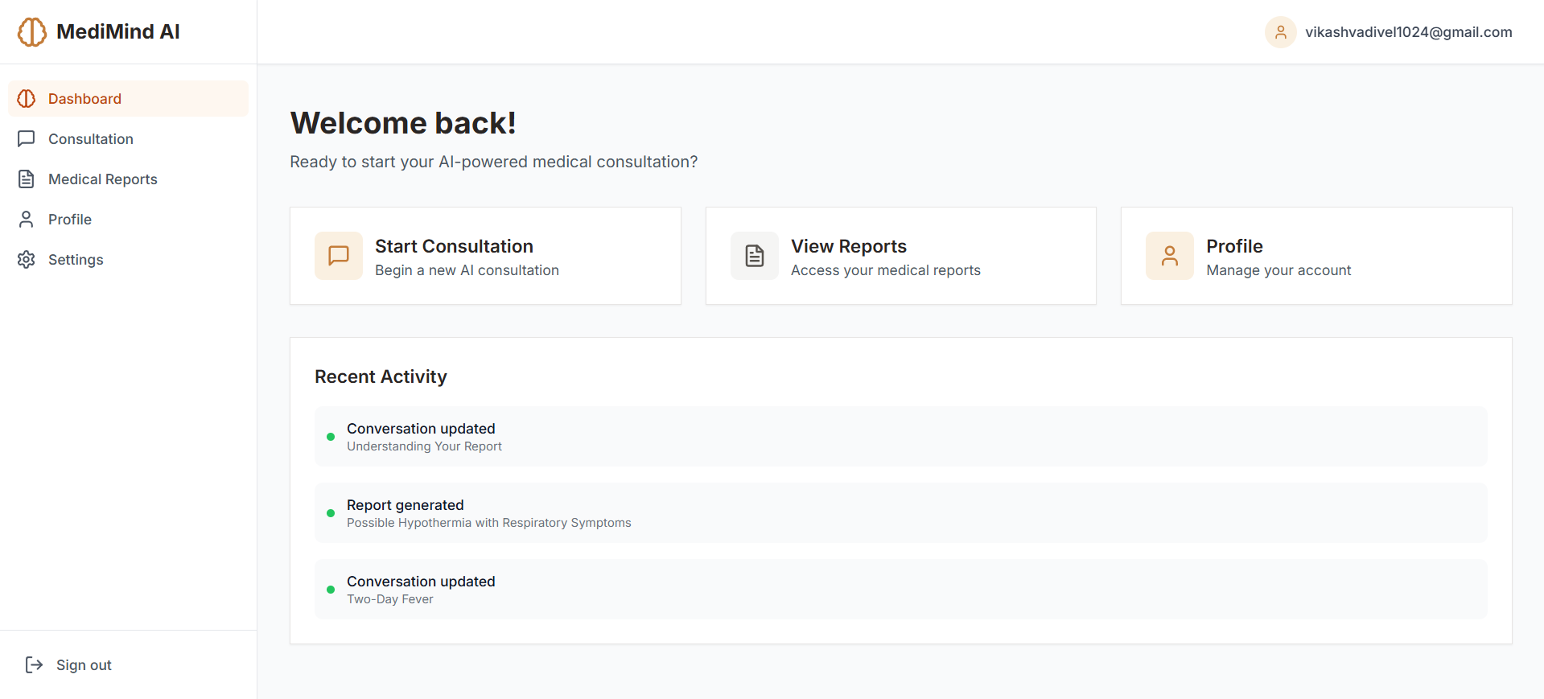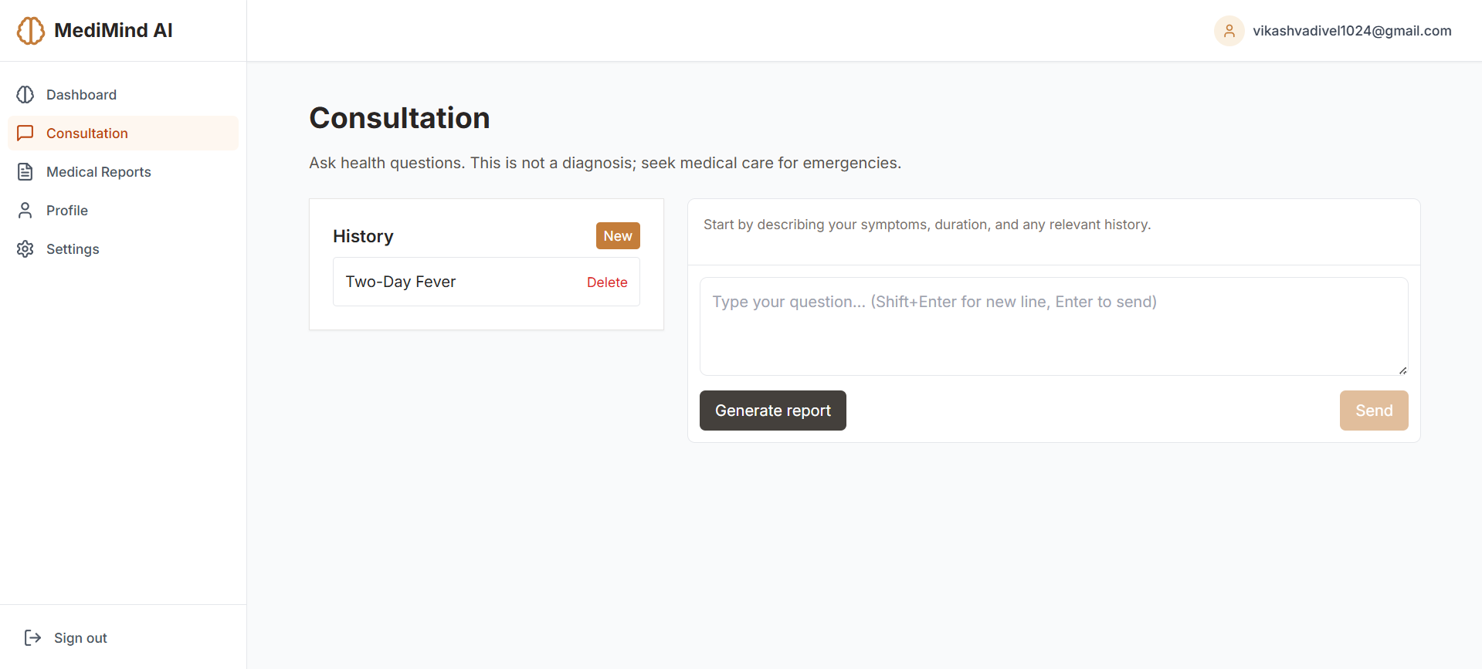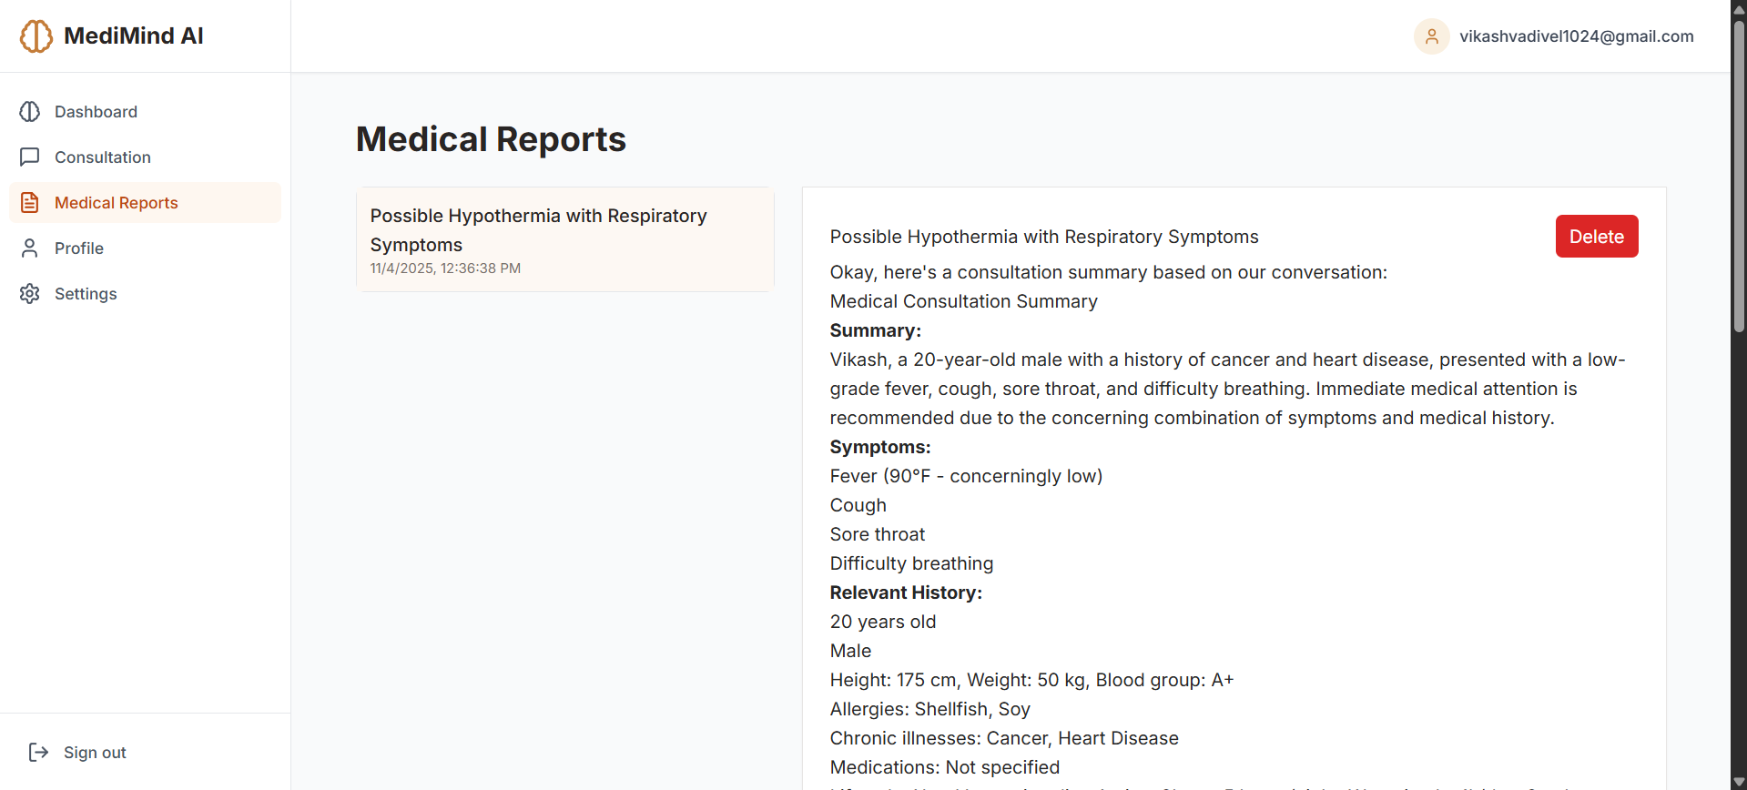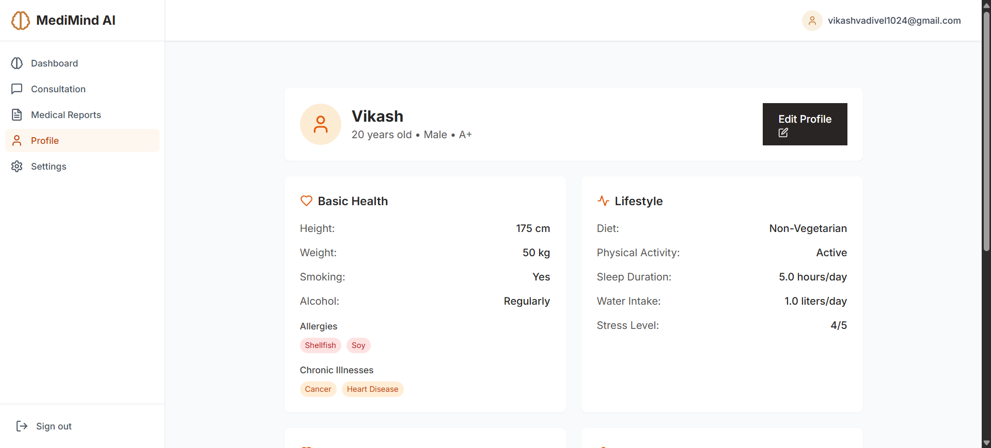

The MediMind AI dashboard is an intuitive and modern interface for conducting AI-assisted medical consultations. Users can initiate consultations, access in-depth medical reports, and control their health profiles with ease. The dashboard is a perfect organizer of medical history, symptoms, and lifestyle information, providing a seamless and professional medical experience.

ACKNOWLEDGMENT
The authors would like to thank the faculty and management of Coimbatore Institute of Engineering and Technology, Coimbatore, Tamil Nadu, for their support and assistance throughout this project. Special thanks are due to Ms. S. Geeviga, M.E., for her academic supervision and technical assistance. The authors would also like to thank all participants and peers in the Department of Artificial Intelligence and Data Science for their encouragement and feedback during the development and testing phases.

REFERENCES
- H. Wang, X. Du, Y. Huang, H. Qin, Y. Zhang, and R. Zhang, "ReActMed: A thought-enhanced medical large language model via instruction-tuning and self-healing," arXiv preprint arXiv:2405.18346, pp. 1–17, 2024.[9]

- J. Lee, J. Han, D. Park, and Y. Kim, "MedChatBot: A transformer-based conversational agent for preliminary diagnosis," Computers in Biology and Medicine, vol. 170, p. 107601, 2024.

- R. Patel, A. Kumar, and P. Gupta, "Real-time AI-powered medical report generator using LLMs," International Journal of Innovative Technology and Exploring Engineering (IJITEE), vol. 13, no. 2, pp. 89–93, 2024.

- S. Nair and M. Rajan, "Enhancing healthcare chatbots with real-time symptom analysis using GPT models," International Journal of Advanced Computer Science and Applications (IJACSA), vol. 14, no. 7, pp. 145–152, 2023.[10]

- Q. Zhao, Z. Lin, and S. Huang, "A context-aware multilingual medical chatbot using BERT and T5," in Proceedings of the IEEE EMBC Conference, 2023, pp. 1295–1300.

- R. Fernandez and K. Latha, "Voice-enabled diagnosis chatbot using NLP and Firebase integration," in International Conference on Smart Systems and Advanced Computing (ICSSAC), 2022, pp. 233–239.

- M. Barreda, "Transforming healthcare with chatbots: Uses and innovations," Journal of Medical Internet Research, vol. 27, no. 3, p. e11915287, Mar. 2025.

- G. Baek, S. Kim, and J. Park, "AI chatbots for psychological health for health professionals: Scoping review," JMIR Human Factors, vol. 12, e67682, Mar. 2025.

- P. Tanwar, S. Jain, and U. Chouhan, "AI based chatbot for healthcare using machine learning," in 2023 International Conference on Advances in Computation, Communication and Information Technology (ICAICCIT), pp. 1–7, Nov. 2023.

- R. Surve, K. Deshmukh, and S. Pawar, "HealthCare chatbot using machine learning and NLP," in 2023 International Conference on Innovative Computing and Communication (ICICC), pp. 456–462, 2023.

- R. S. Aoyon and S. Iqbal, "A chatbot-based auto-improving health care assistant," in 2023 IEEE International Conference on Smart Computing and Communications (ICSCC), pp. 129–134, 2023.

- A. Mehta, P. Agrawal, and S. Gupta, "Artificial intelligence powered chatbot for mental health care: Literature survey and case study," in 2022 International Conference on Data Science and Information Technology, pp. 235–240, 2022.[11]

- A. Khamaj and M. Alshammari, "AI-enhanced chatbot for improving healthcare usability and accessibility," Journal of Taibah University Medical Sciences, vol. 20, no. 2, pp. 67–73, 2025.

- S. Prakasam, L. Kumari, and R. S. Singh, "Design and development of AI-powered healthcare diagnostic chatbot," in 2023 IEEE International Conference on Artificial Intelligence and Data Engineering (AIDE), pp. 78–83, 2023.

- X. Luo, Y. Wang, J. Li, and X. Fan, "Pre-trained language models in medicine: A survey," Artificial Intelligence in Medicine, vol. 153, p. 102525, 2024.

- SH. Alqaidi, S. Alanazi, and M. Ghaleb, "Network-integrated medical chatbot for enhanced patient support: Framework, application design, and deployment," Intelligent Systems with Applications, vol. 18, p. 100239, 2024.

- S. D. Gharge and P. S. Patil, "Chat-bot health-care application using artificial intelligence," in 2024 International Conference on Artificial Intelligence and Data Engineering (AIDE), pp. 1–5, 2024.

- C. Chakraborty and S. S. Biswas, "Overview of chatbots with special emphasis on artificial intelligence in healthcare," Frontiers in Artificial Intelligence, vol. 6, p. 10644239, Oct. 2023.

- N. V. Shinde, A. Akhade, P. Bagad, H. P. Bhavsar, S. K. Wagh, and A. Kamble, "Healthcare chatbot system using artificial intelligence," in 2021 International Conference on Trends in Electronics and Informatics (ICOEI), pp. 1–8, May 2021.

- A. Ramamurthi, B. Sivakumar, R. K. Gupta, and J. D. Mummadi, "From ChatGPT to treatment: The future of AI and large language models in medicine," Cancers, vol. 15, no. 20, p. 5131, Oct. 2023.

- S. Aggarwal, R. Laranjo, and P. Oh, "AI chatbots for healthcare: Definition, applications, and impact," Digital Health Review, vol. 6, pp. 305–315, 2024.

- T. Bhuvanesh, K. Rekik, and S. Hasnain, "Medical chatbot for symptom assessment and disease classification," Computers in Biology and Medicine, vol. 162, pp. 700–709, 2024.

- S. Srivastava, A. Bhangdia, and R. Pivithuru, "Medibot: Engaging patients in medical queries through conversational AI," in 2023 IEEE International Conference on e-Health Networking, Application & Services (Healthcom), pp. 345–352, 2023.

IEEE conference templates contain guidance text for composing and formatting conference papers. Please ensure that all template text is removed from your conference paper prior to submission to the conference. Failure to remove template text from your paper may result in your paper not being published.
We suggest that you use a text box to insert a graphic (which is ideally a 300 dpi TIFF or EPS file, with all fonts embedded) because, in an MSW document, this method is somewhat more stable than directly inserting a picture.
To have non-visible rules on your frame, use the MSWord “Format” pull-down menu, select Text Box > Colors and Lines to choose No Fill and No Line.

