**Model performance:**

**The Random Forest model** far outperformed the other approaches on the test and validation sets.

* Random Forest: MAE = 14.22

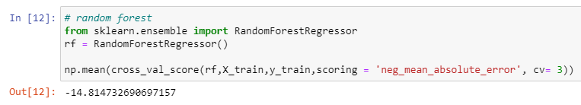

* Linear Regression: MAE = 20.86

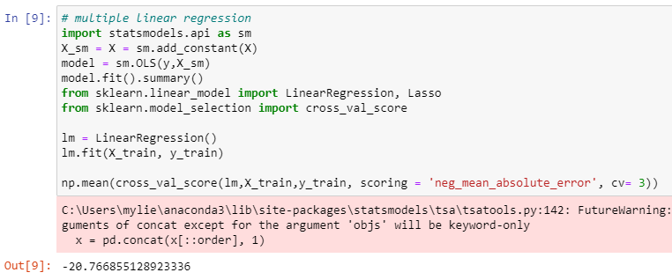

* Ridge Regression: MAE = 19.25

