Assignment 
Assignment # : 11
Topic : Inheritance, Polymorphism and Abstraction
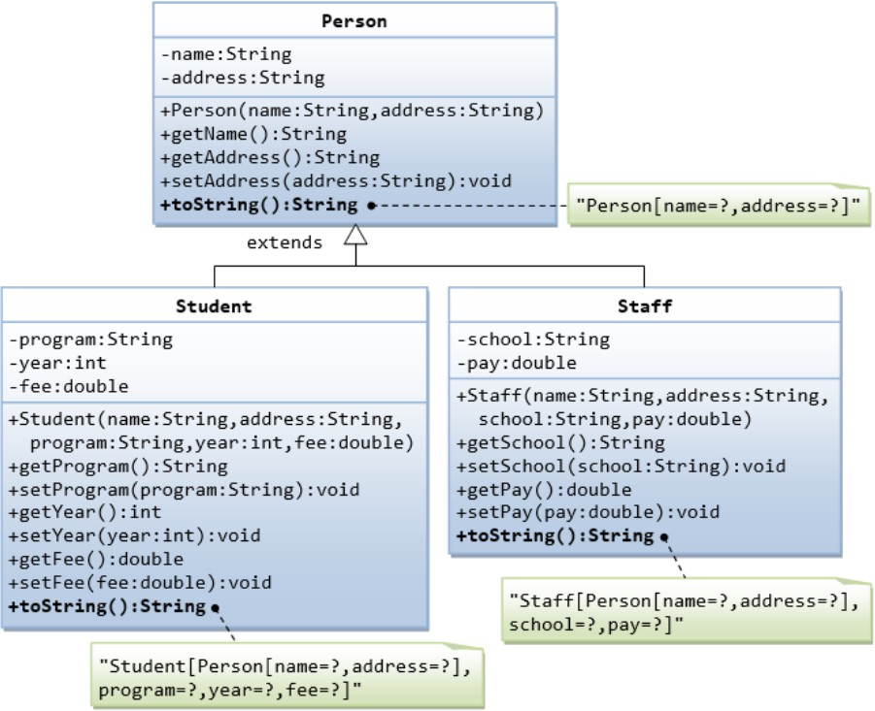
- Implement the following class hierarchy and display the details of student and staff Object.

package Handson6;
class Person {
private String name;
private String address;

public Person(String name, String address) {
this.name = name;
this.address = address;
}
public String getName() {
return name;
}
public String getAddress() {
return address;
}
public void setAddress(String address) {
this.address = address;
}

public String toString() {
return "Person[name=" + name + ",address=" + address + "]";
}
}
class Student extends Person {

String program;
int year;
double fee;

public Student(String name, String address, String program, int year, double fee) {
super(name, address);
this.program = program;
this.year = year;
this.fee = fee;
}

public String toString() {
return "Student[" + super.toString() +
",program=" + program +
",year=" + year +
",fee=" + fee + "]";
}
}
class Staff extends Person {
String school;
double pay;
public Staff(String name, String address, String school, double pay) {

super(name, address);
this.school = school;
this.pay = pay;
}
public String toString() {
return "Staff[" + super.toString() +
",school=" + school +
",pay=" + pay + "]";
}
}
public class PersonDemo {
public static void main(String[] args) {
Student s = new Student("Muhindhar", "Salem", "ECE", 3, 50000);
Staff st = new Staff("Muthu", "Chennai", "KIOT", 40000);
//System.err.println("Person 1 Details");
System.out.println(s);
// System.err.println("Person 2 Details");
System.out.println(st);
}
}

- Write an interface called Movable, which contains abstract methods moveUp(),
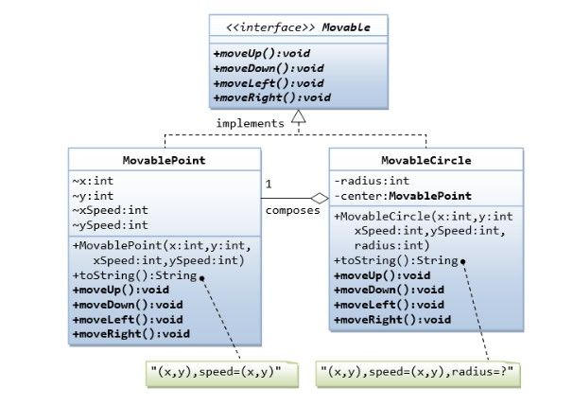
moveDown (), moveLeft() and moveRight(), as shown in the class diagram. Also write the implementation classes called MovablePoint and MovableCircle.Test the classes for the implemented classes.

package Handson6;
interface Movable{
void moveUp();
void moveDown ();
void moveLeft();
void moveRight();
}
class MovablePoint implements Movable{
int x;
int y;
int xspeed;
int yspeed;

public MovablePoint(int x, int y, int xspeed, int yspeed) {
super();
this.x = x;
this.y = y;
this.xspeed = xspeed;
this.yspeed = yspeed;
}
public void moveUp() {
y = y - yspeed;
}
public void moveDown() {
y = y+yspeed;
}
public void moveLeft() {
x = x-xspeed;
}
public void moveRight() {
x = x+xspeed;
}
@Override
public String toString() {
return "MovablePoint [x=" + x + ", y=" + y + ", xspeed=" + xspeed + ", yspeed=" + yspeed + "]";
}
}

class MovableCircle implements Movable{
int radius;
MovablePoint center;

public MovableCircle(int x, int y, int xspeed, int yspeed, int radius, MovablePoint center) {
super();

this.radius = radius;
}
public void moveUp() {
center.moveUp();
}

public void moveDown() {
center.moveDown();
}

public void moveLeft() {
center.moveLeft();
}

public void moveRight() {
center.moveRight();
}
public String toString() {
return center.toString() + ", radius=" + radius;
}

}

public class TsetMovable {
public static void main(String[] args) {

MovablePoint p = new MovablePoint(5,5,2,3);

System.out.println("Before Move: " + p);

p.moveRight();
p.moveDown();

System.out.println("After Move: " + p);

MovableCircle c = new MovableCircle(10,10,1,1,5,null);

System.out.println("Circle Before Move: " + c);

c.moveLeft();
c.moveUp();

System.out.println("Circle After Move: " + c);
}
}

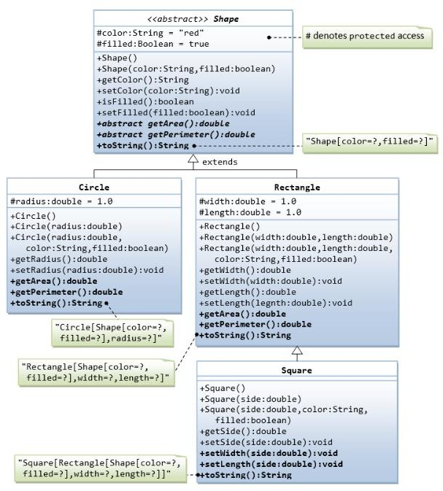
3. Implement the below calss hierarcy and test the classes for methods implemented.

package Handson6;
abstract class shape{
protected String color = "red";
protected boolean filled = true;

public shape() {}

public shape(String color, boolean filled) {
super();
this.color = color;
this.filled = filled;
}
public String getColor() {
return color;
}

public void setColor(String color) {
this.color = color;
}
public boolean isFilled() {
return filled;
}
public void setFilled(boolean filled) {
this.filled = filled;
}
public abstract double getArea();
public abstract double getPerimeter();

@Override
public String toString() {
return "shape [color=" + color + ", filled=" + filled + "]";
}
}
class circle extends shape{
protected double radius = 1.0;
protected circle() {};
public circle(double radius) {
this.radius = radius;
}
public circle(double radius, String color, boolean filled) {
super(color, filled);
this.radius = radius;
}
@Override
public double getArea() {
// TODO Auto-generated method stub
return Math.PI * radius * radius;
}
@Override
public double getPerimeter() {
// TODO Auto-generated method stub
return 2 * Math.PI * radius;
}
@Override
public String toString() {
return "circle [radius=" + radius + "]";
}
}

class rectangle extends shape{
protected double width = 1.0;
protected double length = 1.0;

public rectangle() {};

public rectangle(double width, double length) {
this.width = width;
this.length = length;
}
public rectangle(double width, double length, String color, boolean filled) {
super(color, filled);
this.width = width;
this.length = length;
}

public double getWidth() {
return width;
}
public void setWidth(double width) {
this.width = width;
}

public double getLength() {
return length;
}
public void setLength(double length) {
this.length = length;
}

public double getArea() {
return width * length;
}

public double getPerimeter() {
return 2 * (width + length);
}

public String toString() {
return "Rectangle[" + super.toString() +
",width=" + width + ",length=" + length + "]";
}
}
class Square extends rectangle {

public Square() {}

public Square(double side) {
super(side, side);
}

public Square(double side, String color, boolean filled) {
super(side, side, color, filled);
}

public double getSide() {
return width;
}

public void setSide(double side) {
this.width = side;
this.length = side;
}

public void setWidth(double side) {
this.width = side;
this.length = side;
}

public void setLength(double side) {
this.width = side;
this.length = side;
}

public String toString() {
return "Square[" + super.toString() + "]";
}
}

public class Shapes {

public static void main(String[] args) {
// TODO Auto-generated method stub
circle c = new circle(5, "blue", true);
System.out.println(c);
System.out.println("Area: " + c.getArea());
System.out.println("Perimeter: " + c.getPerimeter());

rectangle r = new rectangle(4, 6, "green", false);
System.out.println("\n" + r);
System.out.println("Area: " + r.getArea());
System.out.println("Perimeter: " + r.getPerimeter());

Square s = new Square(3, "yellow", true);
System.out.println("\n" + s);
System.out.println("Area: " + s.getArea());
System.out.println("Perimeter: " + s.getPerimeter());
}

}

  - Banking:
All the banks operating in India are controlled by RBI. RBI has set a well-defined guideline (e.g. minimum interest rate, minimum balance allowed, maximum withdrawal limit etc) which all banks must follow. For example, suppose RBI has set minimum interest rate applicable to a saving bank account to be 4% annually; however, banks are free to use 4% interest rate or to set any rates above it.
Write a JAVA program to implement bank functionality in the above scenario and demonstrate the dynamic polymorphism concept. Note: Create few classes namely Customer, Account, RBI (Base Class) and few derived classes (SBI, ICICI, PNB etc). Assume and implement required member variables and functions in each class.

Hint:
Class Customer
{
//Personal Details ...
// Few functions ...
}
Class Account
{
// Account Detail ...
// Few functions ...
}
Class RBI
{
Customer c; //hasA relationship Account a; //hasA relationship
..
Public double GetInterestRate() { } Public double GetWithdrawalLimit() { }
}
Class SBI extends class RBI
{
//Use RBI functionality or define own functionality.
}
Class ICICI extends RBI
{
//Use RBI functionality or define own functionality.
}

package Handson6;
class customer{
String name;
String city;
public customer(String name, String city) {
super();
this.name = name;
this.city = city;
}
@Override
public String toString() {
return "customer [name=" + name + ", city=" + city + "]";
}
}

class account{
int accno;
double bal;
public account(int accno, double bal) {
super();
this.accno = accno;
this.bal = bal;
}
@Override
public String toString() {
return "account [accno=" + accno + ", bal=" + bal + "]";
}
}
class rbi{
customer c;
account a;
rbi(customer c, account a) {
this.c = c;
this.a = a;
}
public double getInterestRate() {
return 4.0;
}

public double getWithdrawalLimit() {
return 50000;
}

public void display() {
System.out.println(c);
System.out.println(a);
}
}
class sbi extends rbi {

sbi(customer c, account a) {
super(c, a);
}

@Override
public double getInterestRate() {
return 5.5;
}

@Override
public double getWithdrawalLimit() {
return 100000;
}
}
class icici extends rbi {

icici(customer c, account a) {
super(c, a);
}

@Override
public double getInterestRate() {
return 6.0;
}

@Override
public double getWithdrawalLimit() {
return 150000;
}
}
class pnb extends rbi {

pnb(customer c, account a) {
super(c, a);
}

@Override
public double getInterestRate() {
return 4.5;
}

@Override
public double getWithdrawalLimit() {
return 75000;
}
}

public class Banking {

public static void main(String[] args) {
// TODO Auto-generated method stub
customer cust = new customer("Muhindhar", "Salem");
account acc = new account(12345, 50000);

rbi bank;

bank = new sbi(cust, acc);
System.out.println("\n--- SBI ---");
bank.display();
System.out.println("Interest Rate: " + bank.getInterestRate());
System.out.println("Withdrawal Limit: " + bank.getWithdrawalLimit());

bank = new icici(cust, acc);
System.out.println("\n--- ICICI ---");
bank.display();
System.out.println("Interest Rate: " + bank.getInterestRate());
System.out.println("Withdrawal Limit: " + bank.getWithdrawalLimit());

bank = new pnb(cust, acc);
System.out.println("\n--- PNB ---");
bank.display();
System.out.println("Interest Rate: " + bank.getInterestRate());
System.out.println("Withdrawal Limit: " + bank.getWithdrawalLimit());

}

}

  - Painting Shapes:
Develop a class hierarchy of shapes and write a program that computes the amount of paint needed to paint different objects. The hierarchy will consist of a parent class Shape with three derived classes - Sphere, Rectangle, and Cylinder. For the purposes of this exercise, the only attribute a shape will have is a name and the method of interest will be one that computes the area of the shape (surface area in the case of three-dimensional shapes). Do the following.
- Write an abstract class Shape with the following properties:
  - An instance variable shapeName of type String
  - An abstract method area()
  - A toString method that returns the name of the shape
- The file Sphere.java contains a class for a sphere which is a descendant of Shape. A sphere has a radius and its area (surface area) is given by the formula 4*PI*radius^2. Define similar classes for a rectangle and a cylinder. Both the Rectangle class and the Cylinder class are descendants of the Shape class. A rectangle is defined by its length and width and its area is length times width. A cylinder is defined by a radius and height and its area (surface area) is PI*radius^2*height. Define the toString method in a way similar to that for the Sphere class.
- The file Paint.java contains a class for a type of paint (which has a "coverage" and a method to compute the amount of paint needed to paint a shape). Correct the return statement in the amount method so the correct amount will be returned. Use the fact that the amount of paint needed is the area of the shape divided by the coverage for the paint. (NOTE: Leave the print statement - it is there for illustration purposes, so you can see the method operating on different types of Shape objects.)
- The file PaintThings.java contains a program that computes the amount of paint needed to paint various shapes. A paint object has been instantiated.
Add the following to complete the program:
  - Instantiate the three shape objects: deck to be a 20 by 35 foot rectangle, bigBall to be a sphere of radius 15, and tank to be a cylinder of radius 10 and height 30.
  - Make the appropriate method calls to assign the correct values to the three amount variables.
  - Run the program and test it. You should see polymorphism in action as the amount method computes the amount of paint for various shapes

