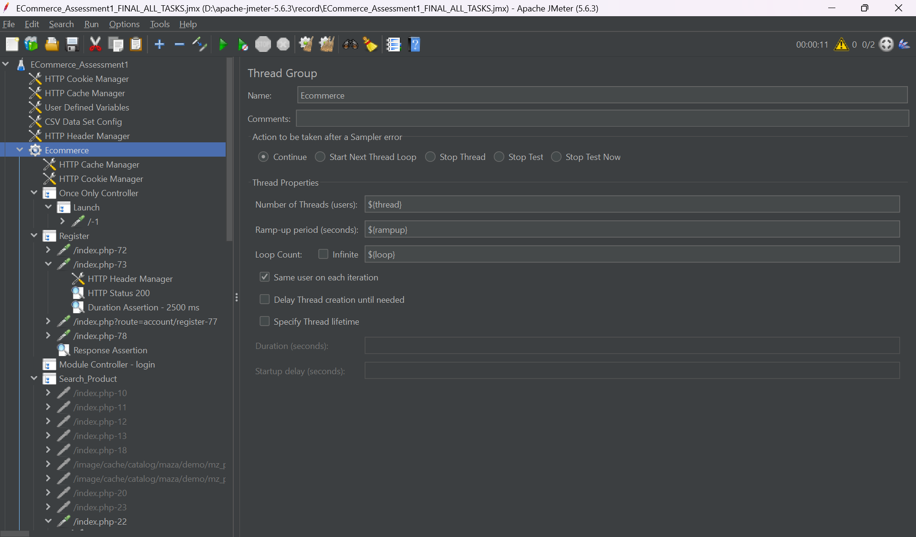
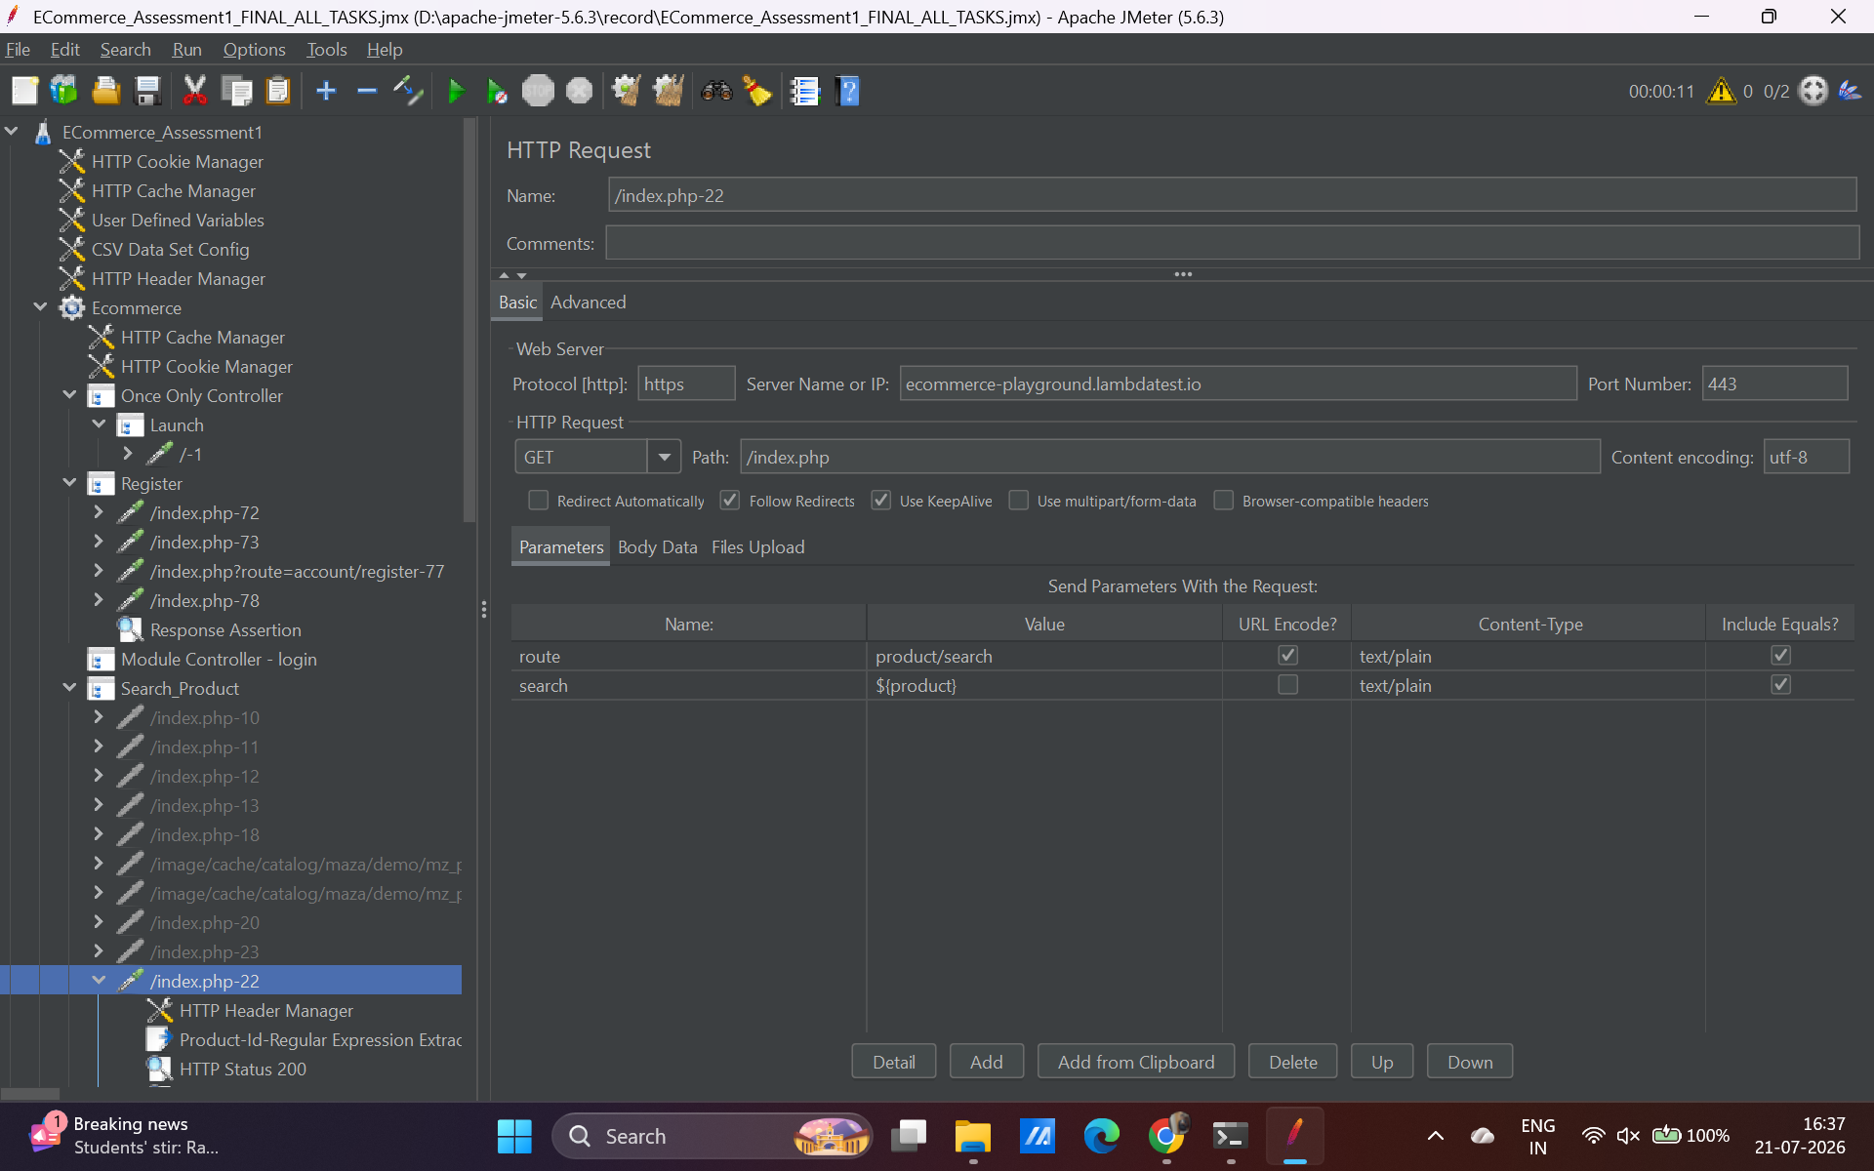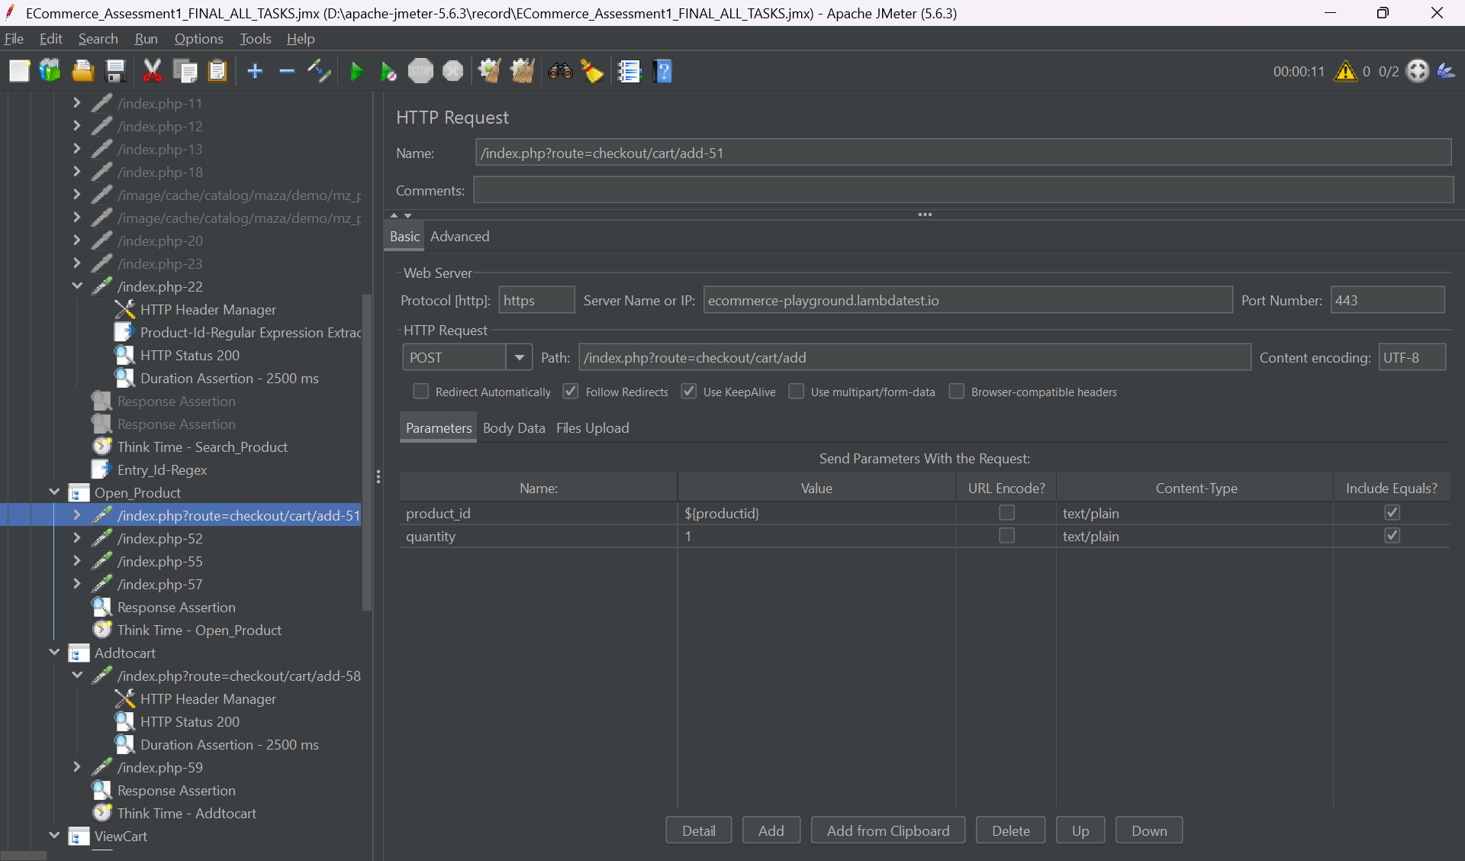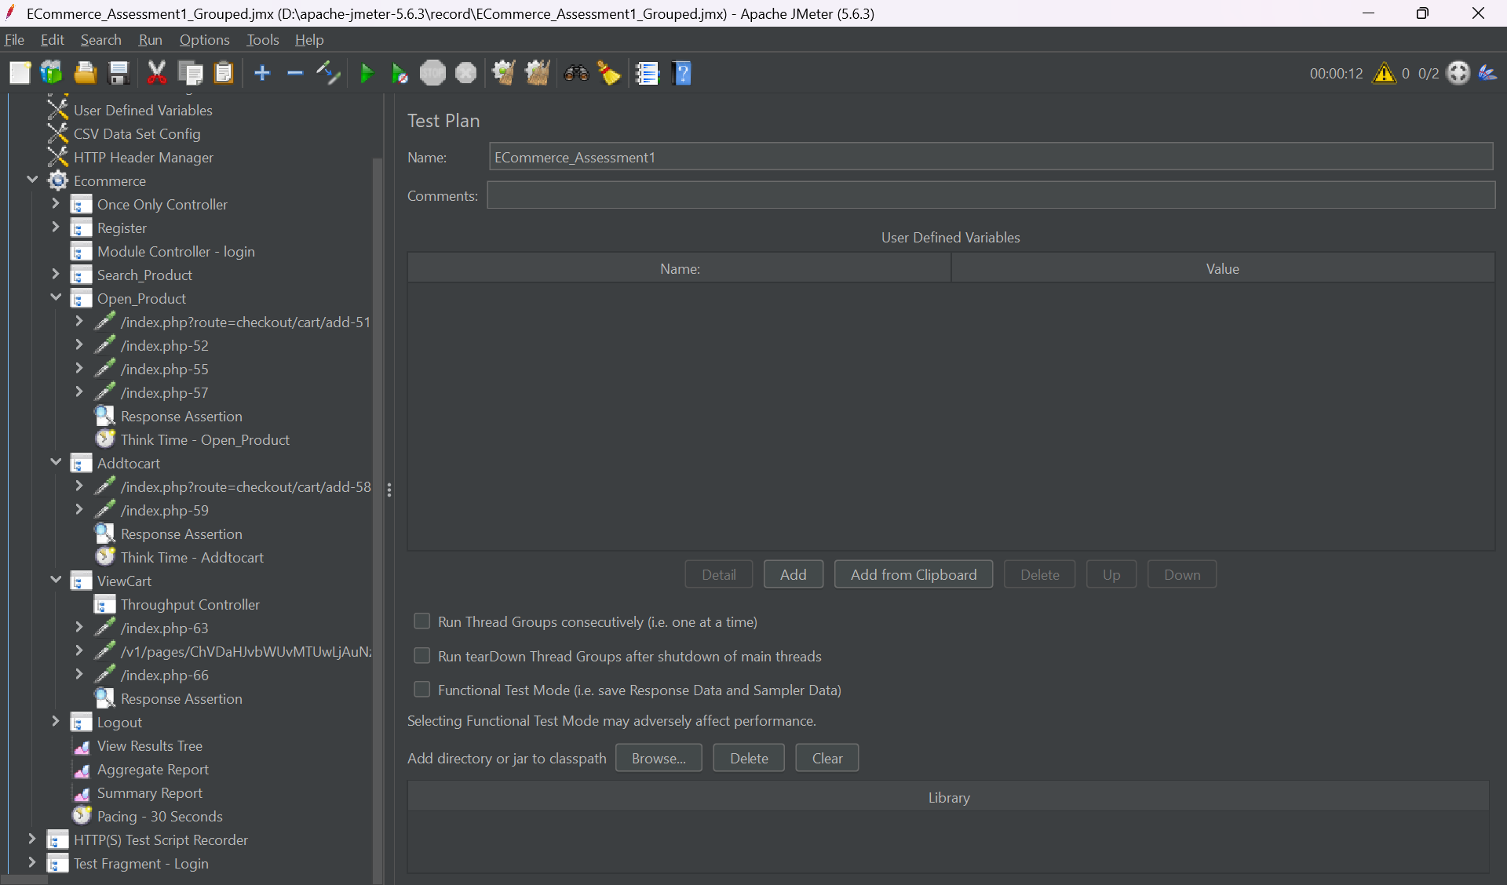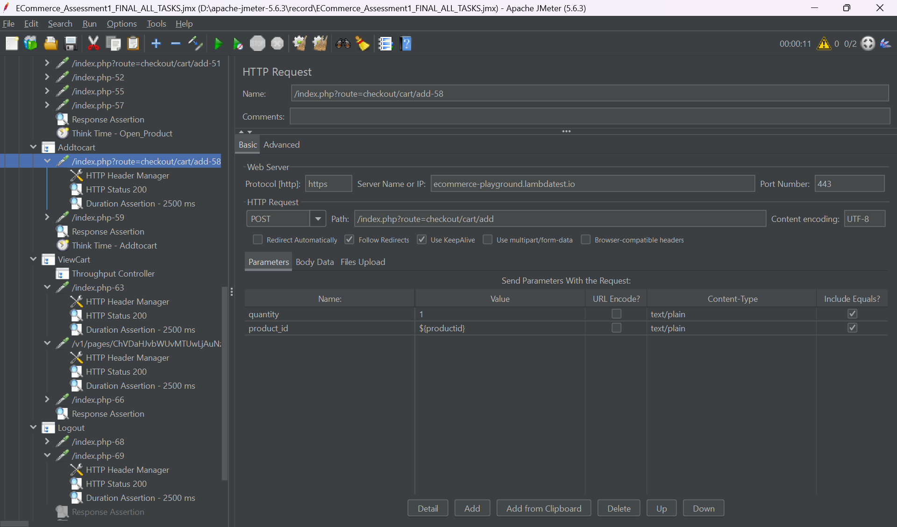

1 Which request/transaction has the Highest response time, and what is its value?
Open_Product – 2697ms
2 Which request/transaction has the Lowest response time, and what is its value?
Addtocart – 592 ms
3 Which request/transaction has the Maximum Throughput (requests/sec), and what is its value?
Launch, Register, Login, Search_Product, and Addtocart, 0.057 requests/sec
4 What is the overall Error % for the test run? List any failing requests.
5.56%.
5 What is the Average response time across all samples?
1430ms
6 What is the Median response time?
1454ms
7 What is the 90th Percentile response time?
1884ms
8 What is the 95th Percentile response time?
2023ms

