LAPORAN KELOMPOK 3

* Idris Syahrudin
* Muhamad Jati Wasesa
* Hardi wirkan
* Dimas Aditya Putranto
* Dzaky Awaludin Malik

PENJUALAN KENDARAAN

Langkah-Langkah Praktikum Beserta Outputnya

* Membuat database

create database Kelompok3;

* Masuk ke database

use Kelompok3;

* Buat table kendaraan

CREATE TABLE `kelompok3`.`kendaraan` (

`id_kendaraan` INT NOT NULL,

`jenis_kendaraan` VARCHAR(45) NULL,

`merk` VARCHAR(45) NULL,

`model` VARCHAR(45) NULL,

`tahun_produksi` VARCHAR(45) NULL,

`warna` VARCHAR(45) NULL,

`harga` VARCHAR(45) NULL

);

* Mengisi table

INSERT INTO `kendaraan` (`id_kendaraan`,`jenis_kendaraan`,`merk`,`model`,`tahun_produksi`,`warna`,`harga`) VALUES ('22001','mobil','toyota','coroa cros',2015,'hitam',200000000),

('22002','mobil','honda','VR-V',2018,'hitam',190000000),

('22003','mobil','nissan','X-Trail',2020,'puth',180000000),

('22004','motor','suzuki','Gixxer SF 250',2021,'biru',30000000);

Output

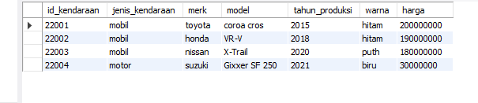

* Buat tabel costumer

CREATE TABLE `kelompok3`.`costumer` (

`id_costumer` INT NOT NULL,

`nama` VARCHAR(45) NULL,

`alamat` VARCHAR(45) NULL,

`no_hp` VARCHAR(45) NULL,

PRIMARY KEY (`id_costumer`)

);

INSERT INTO `costumer` (`id_sales`,`nama`,`alamat`,`no_hp`) VALUES ('SL001','Ahmad','Cikarang','0812345678'),

('SL002','Salahuddin','Bekasi','0813456789'),

('SL003','Sulaiman','Cibitung','0811345678'),

('SL004','Farizi','Karawang','0814567890');

Output

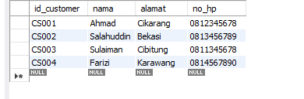

* Buat table sales

CREATE TABLE `kelompok3`.`sales` (

`id_sales` INT NOT NULL,

`nama` VARCHAR(45) NULL,

`alamat` VARCHAR(45) NULL,

`no_hp` VARCHAR(45) NULL,

PRIMARY KEY (`id_sales`)

);

INSERT INTO `sales` (`id_sales`,`nama`,`alamat`,`no_hp`) VALUES ('SL001','Ahmad','Cikarang','0812345678'),

('SL002','Salahuddin','Bekasi','0813456789'),

('SL003','Sulaiman','Cibitung','0811345678'),

('SL004','Farizi','Karawang','0814567890')

Output

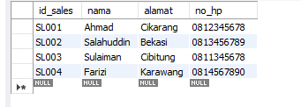

* Buat table transaksi

CREATE TABLE `kelompok3`.`transaksi` (

`id_transaksi` INT NOT NULL,

`id_kendaraan` VARCHAR(45) NULL,

`id_customer` VARCHAR(45) NULL,

`id_sales` VARCHAR(45) NULL,

`tgl_transaksi` VARCHAR(45) NULL,

`harga_penjualan` VARCHAR(45) NULL,

PRIMARY KEY (`id_transaksi`)

);

INSERT INTO `transaksi` (`id_transaksi`, `id_kendaraan`, `id_customer`, `id_sales`, `tgl_transaksi`, `harga_penjualan`) VALUES ('331', '22001', '11001', '111', '01-05-2023', '200000000'),

('332', '22003', '11003', '112', '02-08-2023', '180000000'),

('333', '22004', '11003', '113', '02-09-2023', '180000000'),

('334', '22005', '11004', '114', '09-09-2023', '30000000');

Output

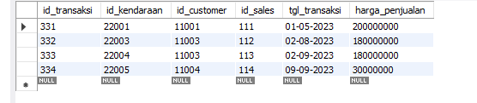

* Buat tabel laporan_transaksi

CREATE TABLE `kelompok3`.`lapoaran_transaksi` (

`id_laporan` INT NOT NULL,

`id_transaksi` INT NOT NULL,

`nama_pelapor` VARCHAR(45) NULL,

`tgl_laporan` VARCHAR(45) NULL,

`keterangan` TEXT NULL,

PRIMARY KEY (`id_laporan`, `id_transaksi`)

);

INSERT INTO `lapoaran_transaksi` (`id_laporan`, `id_transaksi`, `nama_pelapor`, `tgl_laporan`, `keterangan`) VALUES ('1231', '331', 'Rasyid', '02-05-2023', 'dalam keadaan baik'),

('1233', '332', 'Michele', '03-08-2023', 'perlu melakukan service'),

('1232', '334', 'Jordan', '10-19-2023', 'kendaraan dengan kilometer rendah'),

('1234', '333', 'Adam', '03-09-2023', 'kendaraan memiliki cat baru');

Output

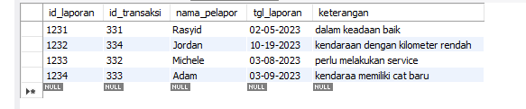

Praktikum

* Mengganti harga awal kendaraan

update kendaraan set harga=198000000 where id_kendaraan=22001;

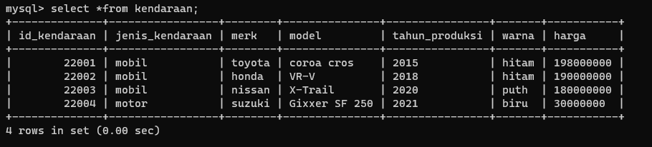Output

* Delete 1 data kendaraan

delete from kendaraan where id_kendaraan=22005;

* Join tabel

select transaksi.id_transaksi, kendaraan.id_kendaraan,tgl_transaksi,kendaraan.harga, jenis_kendaraan, keterangan from transaksi

join kendaraan on transaksi.id_kendaraan=kendaraan.id_kendaraan

join costumer on transaksi.id_costumer=costumer.id_costumer

join sales on transaksi.id_sales=sales.id_sales

right JOIN laporan_transaksi on transaksi.id_transaksi=laporan_transaksi.id_transaksi;

Output



**ERD**

**PENJUALAN KENDARAAN**

