**Tasks:**

1. **Student Table**

**(Handle Duplicated Data)**

1. **Slider**

# Typing Window

# Form Validation (Reset with JS not with HTML Form)

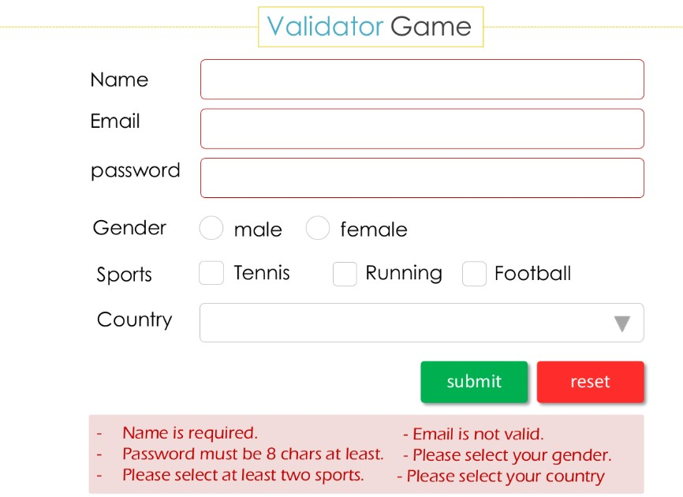

# Traffic Game

1. **Event Object**

**6.1. Alert ASCII Code of any key pressed and detect whether it is alt key or ctrl key or shift key**

**6.2. Prevent context menu from being displayed by preventing from mouse right click from its action.**

**Note: context menu is the menu displayed when mouse right button is clicked**

# Flying Window Bouns

