**Introduction**

This is analysis project by RevoU Mini Course Data Analytics case study. In this case study, I will perform main responsibility of a data analyst.

**Scenario**

On this case study intructions, you become junior data analyst on distributor of liquor in iowa city, by looking the data then you asked to point down 3 point that you think important to shown and give insight by that data to the stakeholder.

**Point To Analyze**

1. Which category have the most selling product ?
2. Which city have the most bottle sold product ?
3. By the trend of total sale, how iowa liquor sale can increase product sales ?

**Data Source**

Data of Iowa liquor sales available on google cloud and can be access by BigQuery. The data have 23 columns containing information related to invoice, store name, store location, products, amount of sale, etc. name file on BigQuery is bigquery-public-data.iowa_liquor_sales. Next this data will be organized on BigQuery.

**Process**

First, I make measure plan by looking the point that want be solved and analyze which data from dataset that need for solved the point. From that I consider to use column date,city, category_name, bottles_sold and sale_dollars.

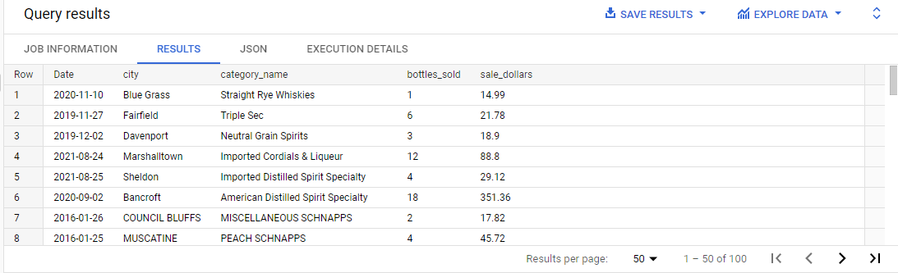

**Data Cleaning**

Next step is cleaning the data. First, I want to see every column to see if list down anything to be cleaned.

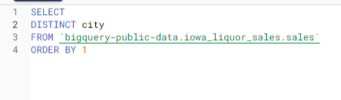

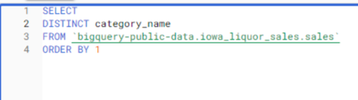

From the colomn city and category_name we have to fix the uppercase-lowercase those columns.

**Data to Analyze**

After search what column data to cleaning, the next step is colleting data to analyze, I use some query to get the clean data for analyze

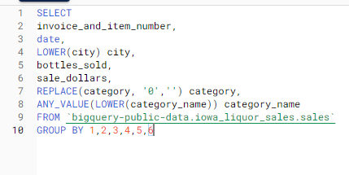

After performing that query and get the data, now time for analyze and make some presentation about insight we get from data. We explore the data result from that quey using google data studio and make some chart and insight.

**Analysis and Insight**

First, to see most selling product we use category_name and bottles_sold column.

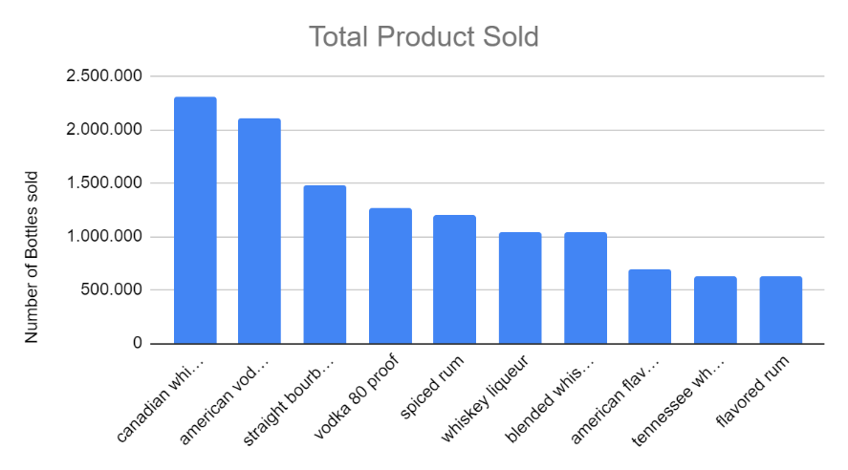

From the chart we know that :

* There are top 10 product that already cross 600.000 bottles sold.
* Canadian whiskies (2.304.010 bottles sold) and American vodka (2.105.496 bottles sold) is the most sales products.

Second, by using city and bottles_sold coloum to see which city have the top selling.

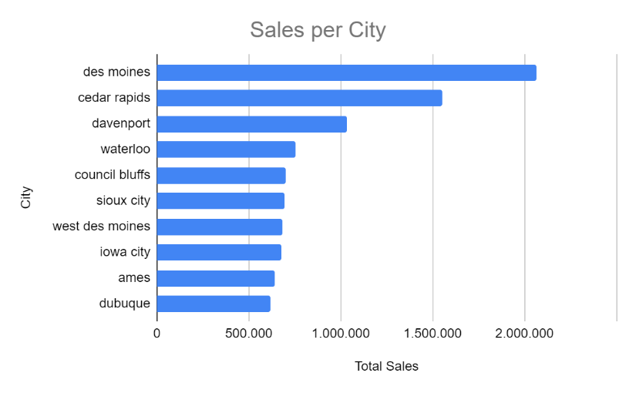

As we can see on the chart :

* Same as Product sales, there are top 10 cities that have total sales above 600.000 bottles sold.
* There only one city (des moines) that already cross 2 million bottles sold.
* Iowa city as base of iowa liquor sale on 8th rank with 676.270 bottles sold.

And last to see trend of selling iowa liquor sale we use date(year) and sale_dollars column.

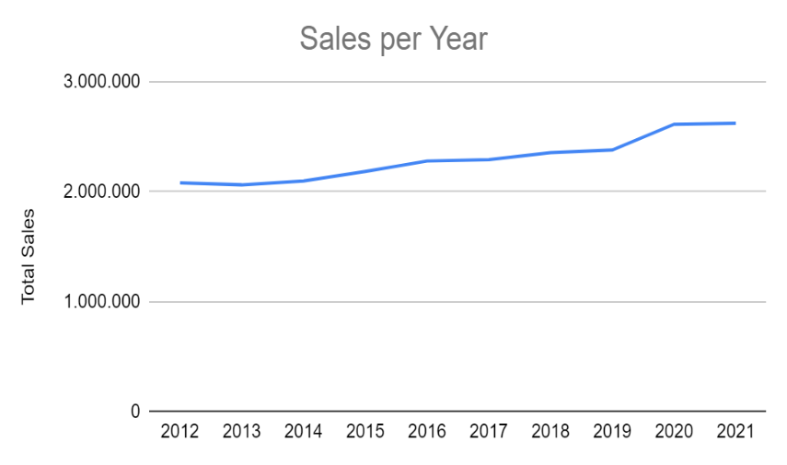

We can get some information from the chart like:

* In the past 10 years total sales of iowa liquor sales have increased.
* On 2020 have a very significantly increased of total sales but in the 2021 there is almost no improvement.

**Conclusion**

According to previous data, my suggestion to answer the second question which is increase product sales of iowa liquor sales are:

* We can make promotion bundling on the top 10 highest product sale with the products that have low sales rate to increase product knowledge and product sales.
* We can prioritize iowa city as base of iowa liquor sale by add more marketing and reach out more store.
* Grabbing data marketing, sales, etc from 2020 (year that have most improvement of sales) so we can learn and modify the strategy to apply for the future.