

HarvestShelf AI: A Smartphone-Based Offline System for Visible Freshness Triage of Tomatoes and Green Bananas in Rwandan Markets
BSc. in Software Engineering
Sage Muhodari
Supervisor: Tunde Isiaq Gbadamosi
Date: October 2026

Table of Contents
List of Tables 4
List of Figures 5
List of Acronyms/Abbreviations 6
ABSTRACT 7
CHAPTER ONE: INTRODUCTION 8
1.1 Introduction and Background 8
1.2 Problem Statement 10
1.3 Project’s Main Objective 11
1.3.1 List of the Specific Objectives 11
1.4 Research Questions 12
1.5 Project Scope 12
1.6 Significance and Justification 13
1.7 Research Budget 14
1.8 Research Timeline 14
CHAPTER TWO: LITERATURE REVIEW 15
2.1 Introduction 15
2.2 Concepts, Opinions, and Ideas from Authors/Experts 16
2.3 Overview of Existing System(s) 16
2.4 Review of Related Work 17
2.4.1 Expanded Evidence Base for the Problem 18
2.4.2 Freshness and Ripeness Classification Studies 19
2.4.3 Offline Smartphone AI in African Field Conditions 21
2.4.4 Why the Proposed Approach Should Work 22
2.4.5 Comparative Analysis and Uniqueness of HarvestShelf AI 23
2.4.6 Summary of Reviewed Literature 24
2.5 Strengths and Weaknesses of the Existing System(s) 26
2.6 General Comment and Conclusion 26
CHAPTER THREE: SYSTEM ANALYSIS AND DESIGN 27
3.1 Introduction 27
3.2 Research Design (including the development model used) 27
3.3 Functional and Non-Functional Requirements 28
3.4 System Architecture 28
3.4.1 Model and Library Decision 30
3.4.2 System and Technology Stack 30
3.4.3 Data Definition and Acquisition 31
3.4.4 Machine Learning Training Pipeline 32
3.4.5 Model Comparison 32
3.5 UML Diagrams 33
3.6 Development Tools 37
3.7 Data Collection, Sampling, Labeling, and Evaluation Plan 38
3.8 Ethics and Risk Management 40
References (APA Format) 41

List of Tables
Table 1: Research budget
Table 2: Research timeline
Table 3: Existing systems and HarvestShelf AI gap
Table 4: Expanded evidence base for the HarvestShelf AI problem
Table 5: Comparison of HarvestShelf AI with related studies and systems
Table 6: Summary of reviewed literature, grouped by theme
Table 7: Strengths and weaknesses of existing systems
Table 8: Development tools and libraries

List of Figures
Figure 1: Research timeline Gantt chart
Figure 2: Proposed design-science development model
Figure 3: HarvestShelf AI offline-first mobile system architecture
Figure 4: Machine-learning training and Android deployment pipeline
Figure 5: UML use-case diagram
Figure 6: UML class diagram
Figure 7: Entity relationship diagram for local SQLite storage
Figure 8: Sequence diagram for produce image triage
Figure 9: Activity diagram for the triage decision logic
Figure 10: Low-fidelity screen designs
Figure 11: UML deployment diagram

List of Acronyms/Abbreviations
Acronym | Meaning
AI | Artificial Intelligence
API | Application Programming Interface
CI | Confidence Interval
CNN | Convolutional Neural Network
CSAM | Commodity Systems Assessment Methodology
CV | Computer Vision
ERD | Entity Relationship Diagram
FAO | Food and Agriculture Organization of the United Nations
GSMA | Global System for Mobile Communications Association
JSON | JavaScript Object Notation
MINAGRI | Ministry of Agriculture and Animal Resources
MVP | Minimum Viable Product
NAEB | National Agricultural Export Development Board
NISR | National Institute of Statistics of Rwanda
PHL | Post-harvest Loss
RAM | Random-Access Memory
RWF | Rwandan Franc
SQLite | Structured Query Language Lite
SUS | System Usability Scale
SVM | Support Vector Machine
TFLite | TensorFlow Lite
UC Davis | University of California, Davis
UML | Unified Modeling Language
YOLO | You Only Look Once (object-detection model)

ABSTRACT
Fresh-produce sellers in Rwandan markets decide every day which tomatoes and green bananas to sell at full price, sell quickly, discount, or remove, and they make these calls by eye, often in a hurry and in poor light. Rwandan studies report avoidable post-harvest losses across tomatoes, bananas, and vegetables, yet existing computer-vision tools serve exporters and packhouses, depend on an internet connection, and overlook small sellers. This project proposes HarvestShelf AI, an offline Android app that sorts a phone photo of produce into one of five actions: Fresh, Sell Soon, Discount Today, Spoilage Risk, or Uncertain. The study follows a design-science approach. About 2,400 images will be collected purposively from at least three markets in Nyabihu and Rusizi districts and labeled by two independent labelers. EfficientNet-Lite0 will be fine-tuned through transfer learning and benchmarked against MobileNetV3-Small, MobileNetV2, ResNet-50, and classical machine-learning baselines, then deployed with TensorFlow Lite in a Flutter app that stores scan history in SQLite. The prototype is expected to reach a macro-F1 score of at least 0.80, a Spoilage Risk recall of at least 0.85, an inference time under one second per photo, and a System Usability Scale score of at least 68 from at least 15 sellers, and an improvement of at least 15 percentage points in sellers’ agreement with expert labels when they sort produce with the app. The study hypothesizes that an offline smartphone classifier trained on local market images can judge visible produce condition accurately and quickly enough to make sellers’ selling decisions more consistent. The app judges only visible condition and does not certify food safety.

CHAPTER ONE: INTRODUCTION

1.1 Introduction and Background
Fresh fruits and vegetables matter in Rwanda. They feed families, keep small businesses running, and fill local markets every day. Yet their value can drop within hours once they are bruised, overripe, wilted, or starting to rot. In open markets, sellers judge freshness the way they always have: by looking, touching, smelling, and bargaining with buyers. These skills are real, but they are hard to apply consistently when produce changes slowly through the day, when the light is poor, or when there is a large pile to sort before customers arrive.
This is not a problem limited to one district or one crop. The World Bank’s food-loss study for Rwanda found heavy losses in horticulture, with tomato losses reported as high as 49%, linked to weak cold chains, poor packaging, and rough handling (World Bank, 2020, 2024). A UC Davis assessment found that 56% of tomatoes were discarded somewhere between the farm and the retail market, with damage recorded at every stage (University of California, Davis Horticulture Innovation Lab, 2016a). Another study of Rwanda’s tomato chain reported losses of 50% to 60%, starting with poor-quality seed and continuing through rough handling and unsuitable packaging (Kitinoja et al., 2019). Bananas tell a similar story: every sampled cooking banana showed damage by the time it reached the retail market, cutting its market value by an estimated 22% to 30% even though none of it was thrown away (University of California, Davis Horticulture Innovation Lab, 2016b). These figures differ because the studies measure different things: the World Bank gives an upper estimate across the whole horticulture chain, the UC Davis figure counts tomatoes discarded at any stage from farm to retail, Kitinoja et al. trace losses back to poor seed, and Gisubizo et al. (2026) rely on farmers’ own reports from one district. None of them isolates the loss that happens at the market stall itself, so this proposal uses them to show that the problem is large and widespread, not to estimate how much a stall-level tool could save.
Other crops face the same pressure. In Kamonyi District, Gisubizo et al. (2026) reported average post-harvest losses of 34.7% for tomatoes, 28.3% for leafy greens, and 19.6% for carrots. Sellers of carrots and cabbages from Rubavu District named poor handling and packaging, lack of storage, fast spoilage, weak market links, and poor logistics among their biggest risks (Kubwimana, 2020). NAEB’s Smart Food Value Chain Management Project is working to cut both the quantity and the quality losses of chili and onion in several districts (NAEB, 2026). These studies measure different things, but together they point to the same conclusion: keeping produce fresh and sorting it well is a shared challenge across Rwanda’s horticulture.
Many people feel the effects. Market sellers, most of them small traders, lose income every time produce has to be discounted or thrown away. Buyers and households end up with lower-quality food, and farmers and cooperatives earn less when their produce is rejected or sold cheaply further down the chain (Kubwimana, 2020; University of California, Davis Horticulture Innovation Lab, 2016a). Market managers and agricultural extension workers also gain from simple habits that reduce waste. At the same time, smartphone access is still limited and uneven: only 34.4% of Rwandan households own a smartphone, 61.9% in urban areas against 22.9% in rural areas, and 26.1% in Nyabihu against 40.6% in Rusizi (National Institute of Statistics of Rwanda [NISR], 2025b, Table A5.19). The same survey round reports wider household access to utilities and communication services in more detail (NISR, 2025a). Any tool meant for these sellers must therefore work on an ordinary Android phone, with or without an internet connection.
This study is set in two districts of Rwanda’s Western Province. Nyabihu is a mainly agricultural highland district (Ministry of Agriculture and Animal Resources [MINAGRI], n.d.), while Rusizi, on the border with the Democratic Republic of the Congo, has busy markets where vegetables and other foods are sold to cross-border buyers (The New Times, 2011; TradeMark Africa, 2019). One is a cool farming area and the other a warmer trading hub, so a tool that works in both is more likely to work in other Rwandan markets.
Traditionally, sellers judge quality by looking, touching, and smelling, then sort produce by hand into piles for full price, quick sale, or removal, and training manuals for Rwanda teach the same manual grading and color sorting (University of California, Davis Horticulture Innovation Lab, 2016c). Software approaches have started to change this elsewhere. Commercial computer-vision platforms such as Clarifruit, AgShift, and OneThird grade produce or predict shelf life for exporters and packhouses (AgShift, 2026; Clarifruit, 2026; OneThird, 2026), and offline phone apps such as PlantVillage Nuru have helped farmers in Tanzania recognize crop disease (Mrisho et al., 2020). None of these, however, is built for a small market seller who needs a quick, offline answer about whether to sell, discount, or remove produce.
Direct evidence about how sellers make these decisions at the stall is still thin: the studies above measure losses along the chain, not the moment a seller decides to keep, discount, or remove an item. For this reason, Month 1 includes short, informal conversations with three to five tomato and banana sellers in each district to confirm how they currently sort produce, which words they use for each condition, and whether the four selling actions match their practice (Section 3.7).
HarvestShelf AI is designed with these realities in mind. It is not meant to replace the seller’s experience or a laboratory test. Instead, it acts like a second pair of eyes: from a single phone photo, it offers a quick, consistent suggestion about what to do next with the produce, whether to keep selling it normally, sell it soon, discount it today, remove it from normal sale, or retake the photo if the result is unclear.

1.2 Problem Statement
Small fresh-produce sellers in Rwandan markets have no consistent, affordable, offline way to sort produce by its visible condition and decide how urgently it should be sold. Today, the choice to keep, discount, or remove produce rests on individual judgment made during busy trading hours, and these quick calls contribute to quality and value losses that could be avoided. Three sub-problems show why this matters.
First, produce loses value fast when damage is not spotted and acted on early. Rwandan studies document losses in tomatoes, green bananas, carrots, cabbages, leafy greens, chili, and onions, not just in one crop or one district (Gisubizo et al., 2026; Kubwimana, 2020; NAEB, 2026; University of California, Davis Horticulture Innovation Lab, 2016a, 2016b; World Bank, 2020). A visible change in quality can lower the price, make produce harder to sell, and turn food into waste, and post-harvest guidance advises separating damaged or decaying items early so that they do not affect the healthy produce around them (FAO, n.d.; Kader, 2003). A phone photo can help sellers notice these visible warning signs sooner, but it cannot detect hidden infection or guarantee that food is safe (Section 2.4.1).
Second, sellers and other small traders face real challenges in sorting, grading, handling, and storing produce consistently. Studies of carrot and cabbage marketing in Rwanda identify poor handling, packaging, storage, and fast spoilage as key risks (Kubwimana, 2020). A UC Davis training manual for Rwanda notes that a lack of knowledge about proper harvesting and handling leads to wasted fruits and vegetables, and it lists grading, color sorting, cleaning, packaging, and food-safety checks as core parts of quality management (University of California, Davis Horticulture Innovation Lab, 2016c). HarvestShelf AI responds with a practical offline assistant that supports consistent sorting while respecting the seller’s own experience.
Third, the tools that already exist were built for someone else. Commercial computer-vision systems mostly serve exporters, packhouses, large retailers, or sensor-based shelf-life prediction, not small market sellers. Public image datasets also serve other purposes: PlantVillage focuses on leaf disease, Fruits-360 on recognizing which fruit is in a picture, and most fresh-or-rotten datasets use clean, studio-style photos rather than real Rwandan market scenes. What is missing is a small, locally grounded, offline Android prototype that tests freshness sorting for a few carefully chosen crops.
To address these three problems, this work introduces HarvestShelf AI, an offline Android application that contains four parts the project aims to implement: an on-device image classifier trained on local photos of tomatoes and green bananas; a decision mapper that turns each prediction into a clear selling action (Fresh, Sell Soon, Discount Today, or Spoilage Risk); an Uncertain option that asks for a new photo instead of guessing when the image is unclear; and a local scan history that lets sellers review past decisions without an internet connection.

1.3 Project’s Main Objective
To design, develop, and evaluate an offline Android computer-vision prototype that supports visible freshness triage and simple selling-priority decisions for tomatoes and green bananas in Rwandan market conditions.

1.3.1 List of the Specific Objectives
- To produce, by the end of Month 1, a requirements specification for tomatoes and green bananas, grounded in the literature review and in short conversations with three to five sellers in each district, that defines the four selling actions and the functional and non-functional requirements in Section 3.3.
- To produce, by the end of Month 2, a visible-condition labeling guide that two independent labelers apply with a Cohen’s kappa of at least 0.70 on a 20% double-labeled sample, and a labeled dataset of at least 300 usable images per action category per crop (about 2,400 images).
- To develop, by the end of Month 4, a functional offline Android prototype that captures or selects a produce image, checks its quality, runs an on-device TensorFlow Lite model in under one second per image (median of at least 50 runs) on a mid-range phone with 3–4 GB RAM, applies clear decision rules, and stores scan history locally without internet access.
- To evaluate the prototype in Month 5 and report the results in Month 6, targeting a macro-F1 score of at least 0.80 and a Spoilage Risk recall of at least 0.85 on an untouched test set, and a mean System Usability Scale (SUS) score of at least 68 from at least 15 sellers. To check that the real problem is reduced, the same sellers will sort matched sets of produce with and without the app, targeting a mean improvement of at least 15 percentage points in agreement with expert labels (study design in Section 3.7).

1.4 Research Questions
- Which visible signs do sellers and post-harvest experts use to tell the four selling actions apart for tomatoes and green bananas, and how consistently can two independent labelers apply them (target Cohen’s kappa of at least 0.70)? (Objectives 1 and 2)
- Which candidate model (EfficientNet-Lite0, MobileNetV3-Small, MobileNetV2, ResNet-50, or a classical SVM or Random Forest baseline), combined with which confidence threshold, gives the best balance of macro-F1, Spoilage Risk recall, model size, and on-device inference time on a 3–4 GB Android phone? (Objective 3)
- To what extent does the prototype meet planned targets for macro-F1, Spoilage Risk recall, on-device inference time, usability, and improvement in sellers' sorting agreement with expert labels for the selected produce types? (Objective 4)
Working hypothesis: an offline classifier fine-tuned on local market images can reach the technical targets above and, when used by sellers, raise their agreement with expert sorting by at least 15 percentage points compared with sorting by eye alone.

1.5 Project Scope
The project will build a minimum viable prototype, a first working version, for two types of produce: tomatoes and green (cooking) bananas. Both have Rwanda-specific post-harvest studies, and both change in ways an ordinary phone camera can capture. A third crop such as leafy greens, carrots, or cabbage is a stretch goal only: it will be considered after the two-crop targets are met and only if at least 300 images per action category can be collected for it, and it is not included in the data plan or the budget.
The app judges only what it can see. It will not estimate shelf life in days, detect invisible contamination, guarantee food safety, predict internal damage, or replace official inspection. Its advice on selling priority comes from visible patterns in the photo and a confidence threshold. If a photo is blurred, too dark, or shows a crop the app does not support, it will report Uncertain and ask for another photo.
The technology is kept deliberately simple. The prototype runs on Android, carries its model inside the app, stores history on the phone, and uses no cloud servers, online dashboards, live APIs, or model downloads. The internet will be used during research and model training on the developer’s computer, but the finished app will never need it to scan produce.
The geographical scope covers selected fresh-produce markets in Nyabihu District and Rusizi District in Rwanda’s Western Province, where images will be collected and user testing will take place. The two districts were chosen because both have active markets where fresh produce is transported, stored, and sold, and both can be reached within the project budget. Rusizi has cross-border markets that serve traders from the Democratic Republic of the Congo, including a cross-border market with 186 trading spaces completed in 2019 (TradeMark Africa, 2019), and Kamembe market sells vegetables and other foods to Congolese buyers (The New Times, 2011). Nyabihu is a mainly agricultural district and a site of the Ministry of Agriculture and Animal Resources' Sustainable Agriculture Intensification and Food Security Project (MINAGRI, n.d.). Neither district is a leading tomato-growing area, so tomatoes and bananas will be photographed at the point of sale in these markets, after transport and handling; this matches the selling situation the app is designed for. The districts were also selected for practical access within the study period and budget. The time scope is six months, following the timeline in Table 2. Results from these two districts will show whether the approach is feasible, but they will not be presented as representative of all Rwandan markets.

1.6 Significance and Justification
For sellers, the app offers faster and more consistent sorting decisions. Instead of relying only on memory or bargaining, a seller can scan an item and quickly see whether it should stay at full price, be sold soon, be discounted, or be removed from normal sale. The stakes are concrete: if green bananas lose 22% to 30% of their market value through damage by the time they reach retail (University of California, Davis Horticulture Innovation Lab, 2016b), a seller loses roughly RWF 2,200 to 3,000 of every RWF 10,000 of stock, so even a small share of that value recovered through earlier, more consistent sorting matters for a small trader’s daily income.
For software engineering, the project shows how mobile computer vision can be designed around real-world limits: weak connectivity, low-cost phones, small datasets, and users who need clear, simple guidance. Its value does not depend on building a perfect model, but on showing whether a practical offline workflow can be built and tested honestly.
For Rwanda’s markets, the project links food-loss concerns with the growing use of mobile phones, while respecting the fact that smartphone and internet access are still uneven. Working offline is therefore not just a technical preference; it is what makes the app usable for the people it is meant to serve. Testing in Nyabihu and Rusizi districts also brings evidence from markets outside Kigali, where connectivity and technical support are harder to find.

1.7 Research Budget
Table 1: Research budget
Budget item | Estimated cost (RWF) | Reason
Transport to markets and field visits | 120,000 | Travel for data collection and user feedback
Produce samples for controlled photos | 100,000 | Buying small quantities at different visible stages
Participant appreciation | 180,000 | Small compensation for seller testing time (18 sellers × RWF 10,000)
Android test device support | 250,000 | Low-cost Android phone or device repairs if needed
Printing and binding | 50,000 | Proposal, consent forms, final report
Development data/electricity | 80,000 | Used during training and research, not required by the final app
Contingency | 40,000 | Unexpected field or printing costs
Total | 820,000 | Estimated student project budget

1.8 Research Timeline
Table 2: Research timeline
Period | Main activities
Month 1 | Literature review, requirements, ethics approval, seller conversations, draft labeling guide
Month 2 | Image collection, kappa pilot and final labeling guide, labeling, dataset cleaning
Month 3 | Fill any data shortfall; model training, comparison, threshold tuning, test-set evaluation
Month 4 | Android prototype: camera/gallery workflow, quality check, on-device model, local storage
Month 5 | Usability test and with/without-app agreement study with at least 15 sellers; model refinement
Month 6 | Final analysis, report writing, presentation preparation
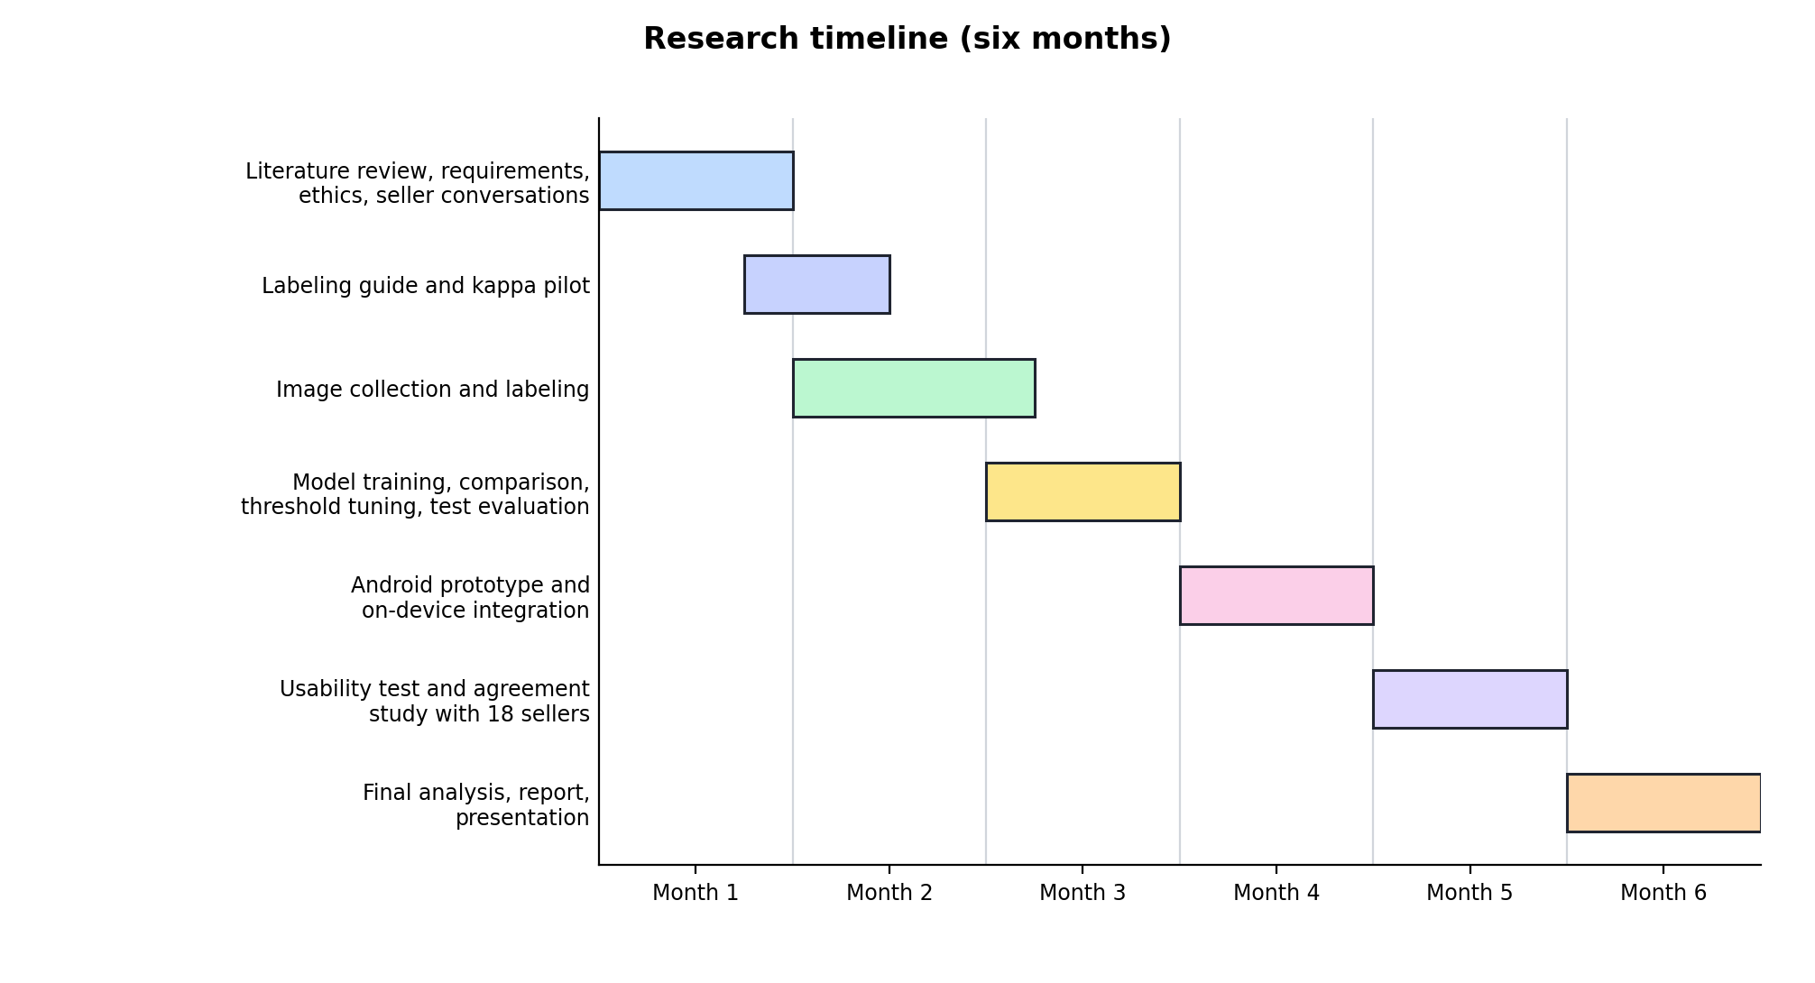
Figure 1: Research timeline Gantt chart

CHAPTER TWO: LITERATURE REVIEW

2.1 Introduction
This chapter looks at what is already known and what has already been built. It covers evidence on post-harvest loss in Rwanda, how produce quality declines, mobile computer vision, freshness assessment, lightweight image-recognition models, and commercial quality-control systems. Along the way, it separates three tasks that are often confused: recognizing which fruit or vegetable is in a photo, detecting plant disease, and judging visible freshness. Only the last is the focus of HarvestShelf AI, and the chapter ends by pinpointing the gap this project fills. The search focused on software-related literature: studies of computer-vision and deep-learning systems for produce quality, lightweight models that run on phones, offline mobile AI used in African field conditions, and usability evaluation, together with technical documentation and commercial quality-control platforms. A structured narrative review was used. Sources were found through Google Scholar and indexed platforms including ScienceDirect, MDPI, Frontiers, PubMed Central, ACM Digital Library, arXiv, NeurIPS proceedings, and the Directory of Open Access Journals, using search terms such as “fruit freshness classification,” “spoilage detection deep learning,” “mobile computer vision agriculture,” “TensorFlow Lite offline,” “ripeness classification,” “neural network calibration,” and “post-harvest loss Rwanda.” Papers were purposively sampled: a source was kept only if it dealt with produce condition, mobile or offline AI, model design, user evaluation, or Rwandan post-harvest context, and most were published between 2016 and 2026, with five older foundational sources on handling, usability, design for low-literacy users, and statistics. In total, 54 sources were retained, and all of them are cited in this proposal.

2.2 Concepts, Opinions, and Ideas from Authors/Experts
Post-harvest loss refers to a measurable reduction in the quantity or quality of food between harvest and consumption. Quality loss matters as much as physical loss: the UC Davis green-banana assessment found that produce can lose 22% to 30% of its market value through damage even when none of it is discarded (University of California, Davis Horticulture Innovation Lab, 2016b). Experts in post-harvest handling stress that sorting and grading are basic tools for limiting this loss, because removing damaged or decaying items protects the rest of the lot (FAO, n.d.; Kader, 2003).
In this proposal, visible freshness triage means sorting produce into action categories based only on what can be seen in a photograph, such as color, bruising, mold-like marks, and wilting. This is different from food-safety testing and from shelf-life prediction. Reviews of computer vision for fruit and vegetable quality agree that appearance strongly affects market value and consumer choice, and that manual sorting is slow, subjective, and inconsistent, which is the main argument for automated visual grading (Bhargava & Bansal, 2021).
Two technical concepts support the proposed solution. Transfer learning means starting from a network trained on a large general image dataset and fine-tuning it on a smaller task-specific dataset, which is useful when only a few thousand local images can be collected. On-device inference means running the trained model directly on the phone, so images do not have to be sent to a server; TensorFlow Lite was designed for this kind of mobile deployment (Google TensorFlow, 2026).

2.3 Overview of Existing System(s)
Commercial produce-quality systems do exist, but they are built mainly for packhouses, exporters, retailers, and supply-chain companies. Clarifruit (2026) and similar platforms standardize quality control across commercial supply chains. OneThird (2026) predicts shelf life to help produce businesses cut food loss. Intello Labs (2026) and AgShift (2026) use image-based inspection for agribusiness. These systems prove that computer vision is useful for judging produce quality, but none of them is a low-cost, offline phone assistant for a small market seller.
Table 3: Existing systems and HarvestShelf AI gap
Existing system | Main focus | Gap addressed by HarvestShelf AI
Clarifruit / Clarifresh | Quality-control support for commercial produce supply chains | HarvestShelf AI is a seller-facing phone prototype, not a packhouse quality platform.
OneThird | Shelf-life prediction and produce decisions for business users | HarvestShelf AI will not claim exact shelf-life prediction; it gives visible triage actions.
Intello Labs | Computer-vision quality assessment for fresh produce supply chains | HarvestShelf AI focuses on local offline use with ordinary Android phones.
AgShift | Quality inspection and analytics for food supply chains | HarvestShelf AI avoids cloud analytics and targets a small MVP.
GoMicro (Fruitnet, n.d.) | Phone-based quality/grading tools for agricultural products | HarvestShelf AI is scoped to selected Rwandan market produce and local scan history.

2.4 Review of Related Work
Running image recognition on a phone has become realistic thanks to lightweight convolutional neural networks (CNNs), a type of AI model that learns to recognize visual patterns. MobileNet was introduced as a family of efficient models for mobile vision, using a technique called depthwise separable convolutions to save computing power (Howard et al., 2017), and MobileNetV3 was later tuned specifically for phone processors (Howard et al., 2019). Because MobileNet is a general-purpose image classifier, it can be retrained to recognize fruits and vegetables when enough labeled examples are available.
EfficientNet and its mobile version, EfficientNet-Lite, are also relevant because they strike a good balance between accuracy and model size. EfficientNet grows a network’s depth, width, and image resolution together so that accuracy improves without wasting computing power, and the Lite versions were prepared for phones and other small devices (Tan & Le, 2019; Google, 2020). This project will use EfficientNet-Lite0 as its main model because it is designed for mobile use and converts easily to TensorFlow Lite. MobileNetV3-Small will serve as a baseline for comparison, since it is lighter and may run faster on low-end phones.
The literature also carries a warning about overclaiming. A phone photo can show color, texture, bruises, mold-like marks, and wilting, but it cannot reliably reveal every food-safety hazard, hidden infection, internal bruising, or exactly how long produce will last. Some infections take hold before they can be seen at all. For this reason, HarvestShelf AI treats its output as advice, not a verdict: it shows a confidence score, includes an Uncertain option, and reminds users that it judges visible condition only.

2.4.1 Expanded Evidence Base for the Problem
Seen side by side, the sources in Table 4 show that the problem does not rest on a single study from Kamonyi. Tomatoes stand out because several Rwandan studies record heavy losses, but green bananas, carrots, cabbages, leafy greens, chili, and onions also appear in local post-harvest and market-risk evidence. The studies use different methods and cover different areas, so they should not be read as one set of national statistics. What they do justify is a narrow, evidence-based prototype that starts with crops where both local relevance and visible deterioration are well documented.
The evidence also calls for careful wording about damaged produce. It is accurate to say that keeping damaged and healthy produce together can raise the risk of quality decline, through contamination, moisture, wounds, ethylene, or contact-based spread of disease, depending on the crop and how it is stored. It is not accurate to say that one damaged item automatically spoils everything around it. HarvestShelf AI should therefore encourage early separation and sensible selling decisions, while making clear that its advice is based only on what the image shows.
Table 4: Expanded evidence base for the HarvestShelf AI problem
Evidence area | Source and scope | Key finding used in this proposal | How it affects HarvestShelf AI
Tomatoes in Rwanda | UC Davis Horticulture Innovation Lab tomato assessment; Rwanda farm-to-market chain | Reported 56% of tomatoes discarded across farm, collection, wholesale, and retail stages, with damage and defects reducing value. | Keeps tomatoes as a strong MVP crop and supports action categories such as Sell Soon and Discount Today.
Green bananas/cooking bananas | UC Davis Horticulture Innovation Lab green-banana assessment; 10 farms and 10 markets | Reported that all sampled green bananas had damage by retail, creating an estimated 22% to 30% market-value loss even when discarded quantity was reported as 0%. | Supports adding bananas as the second crop and focusing on visible quality, not only full spoilage.
Multiple vegetables in Kamonyi | Gisubizo et al. (2026); Kamonyi District, 384 farmers | Reported average losses of 34.7% for tomatoes, 28.3% for leafy greens, and 19.6% for carrots. | Keeps Kamonyi evidence but uses it as one district-level study, not the only proof.
Carrots and cabbages | Kubwimana (2020); carrots and cabbages from Rubavu District supplied across Rwanda | Identified poor handling and packaging, lack of storage, high perishability, logistics, and market communication as key marketing risks. | Supports the claim that sorting and handling challenges affect other vegetables beyond tomatoes.
Chili and onion value chains | NAEB Smart Food Value Chain Management Project; Bugesera, Nyagatare, Rulindo, and Rubavu cooperatives | Project objective includes reducing post-harvest losses of chili and onion in both quantity and quality through post-harvest management and technologies. | Shows that Rwanda institutions also treat horticulture post-harvest loss as a multi-crop issue.
Damaged/decaying produce near fresh produce | FAO small-scale postharvest handling guidance | States that sorting out damaged or decaying produce helps limit contamination of the remaining healthy produce. | Justifies a visible triage tool that encourages early separation of risky items.
Microbial transfer and hidden early infection | Kader/FAO post-harvest quality guidance; Sbodio et al. (2024) | FAO describes transfer of microorganisms from infected to healthy produce within a lot; Sbodio et al. simulated contact-based fungal spread from infected fruit to adjacent healthy fruit and noted early infections can be detected before naked-eye visibility. | Supports caution: a phone image can help identify visible signs but cannot guarantee food safety or hidden decay detection.
Ripening and ethylene effects | Kader/FAO and UC Davis Postharvest Research and Extension Center | Ethylene exposure can accelerate ripening, yellowing, softening, susceptibility to disease, and reduced post-harvest life in sensitive crops. | Supports keeping mixed-stock guidance simple, such as separating items with clear visible decline from fresh stock when possible.
Seller knowledge and grading challenge | UC Davis Rwanda training manual; Kubwimana (2020) | Rwanda training materials note that lack of knowledge of proper harvesting and handling can waste fruits and vegetables, while the Rubavu marketing study highlights poor handling and storage risks. | Avoids saying sellers are unaware of obvious rot; instead the app supports consistency, training, and earlier visible sorting.

2.4.2 Freshness and Ripeness Classification Studies
Several studies have tested deep learning directly on produce freshness, which is closer to this project than produce-type recognition or leaf disease detection. Palakodati et al. (2020) trained a convolutional neural network on 5,989 images of fresh and rotten apples, bananas, and oranges and reported 97.82% test accuracy, higher than the transfer-learning models they compared, where VGG16 reached 89.42%. Sultana et al. (2022) published a fresh and rotten fruit dataset intended for machine-based quality evaluation, showing growing interest in shared freshness datasets. Mukhiddinov et al. (2022) used an improved YOLOv4 detector to recognize five fruits and five vegetables and label each as fresh or rotten across 20 classes; their improved model reached 50.4% average precision compared with 49.3% for the original YOLOv4, which shows that the task becomes much harder when many crops, backgrounds, and real-world images are mixed. Ripeness studies go further than a binary label: Mazen and Nashat (2019) classified bananas into four ripening stages from color, brown-spot development, and texture features with 97.75% accuracy, and Zhang et al. (2018) used a CNN to grade tomatoes by maturity level for a harvesting robot, reaching 91.9% average accuracy with limited training data. For bananas specifically, a systematic review of 35 ripeness-detection studies found that convolutional neural networks performed well when large datasets were available, but identified limited data availability as a major weakness of the field (Baglat et al., 2023). Tomato-specific work points the same way: Begum and Hazarika (2025) trained a CNN on only 810 tomato images to separate edible from spoilt fruit and reported 95% accuracy on their confusion matrix, although recall for spoilt tomatoes was lower, at 87%. This shows that a useful freshness model can be built from a few hundred images per class, similar in size to the dataset planned for this project, while also reminding us that catching every spoilt item is the hardest part.
Taken together, these studies show three things. First, very high accuracy is usually reported on clean, controlled images with few classes, and performance drops when images are more varied. Second, freshness studies mostly use a binary fresh-or-rotten label, and the ripeness studies that do grade produce describe biological stages for harvesting or sorting, not selling decisions: a fully ripe tomato is a normal Fresh item for a seller, while an overripe one may need a same-day discount. HarvestShelf AI therefore maps visible condition to selling actions rather than to ripeness stages. Third, none of the reviewed studies used images from Rwandan markets or tested an offline model on a low-cost phone with sellers. HarvestShelf AI therefore aims to fill a practical gap: graded, action-oriented triage, local images, and on-device evaluation, rather than simply chasing a higher accuracy figure.

2.4.3 Offline Smartphone AI in African Field Conditions
The strongest evidence that HarvestShelf AI can work comes from projects that have already put offline AI models into the hands of African farmers. Ramcharan et al. (2019) built a cassava disease detector using a MobileNet-based model, the same family chosen as this project’s baseline, and ran it offline on an ordinary Samsung Galaxy S5 in Tanzania, where each image took only 50 to 200 milliseconds to process. The study also carries an honest warning: for clear symptoms, the F1 score fell from 0.79 on the test set to 0.54 on new field images, mainly because the model missed more cases in real conditions. This gap between laboratory and field results is exactly why HarvestShelf AI will test its model on images from separate collection days and with real sellers, not only on a held-out slice of the training data.
A follow-up evaluation of the same app, PlantVillage Nuru, compared it directly with people in Tanzania and Kenya (Mrisho et al., 2020). Working offline, the app identified cassava disease symptoms with about 65% accuracy, compared with 40% to 58% for agricultural extension agents and 18% to 31% for farmers, and its accuracy rose to between 74% and 88% when several leaves per plant were assessed. In other words, even an imperfect phone model gave more consistent judgments than many trained people, which is the same consistency argument HarvestShelf AI makes for market sellers. Closer to the produce in this project, Elinisa and Mduma (2024) trained a CNN on 27,360 banana leaf and stalk images collected with mobile phones on Tanzanian farms, reached 91.17% accuracy, and built it into a mobile app that returns a result in under five seconds. They also added an extra class of non-banana images so that the app could reject photos it should not judge, an idea that closely matches HarvestShelf AI’s Uncertain category.
These projects matter because the conditions they faced are close to those in Rwandan markets: mid-range phones, unreliable internet, changing light, and users with little technical training. GSMA (2024) puts mobile internet penetration in Sub-Saharan Africa at only around 27%, which helps explain why the successful tools above were designed to work offline. Together, these studies show that an offline, phone-based image model is not a speculative idea in East Africa; it has been built, deployed, and compared against human performance. What has not yet been done is to apply the same approach to post-harvest freshness decisions at the point of sale.

2.4.4 Why the Proposed Approach Should Work
Read as a whole, the literature supports six design choices that give HarvestShelf AI a realistic chance of success.
First, transfer learning makes small local datasets workable. A survey of 40 deep-learning studies in agriculture found that deep learning generally outperformed traditional image-processing methods (Kamilaris & Prenafeta-Boldú, 2018), and tomato and fruit studies have reached useful accuracy with a few hundred to a few thousand images (Begum & Hazarika, 2025; Palakodati et al., 2020).
Second, lightweight models run comfortably on ordinary phones. MobileNet and EfficientNet-Lite were designed for mobile devices (Howard et al., 2019; Tan & Le, 2019), and a MobileNet-based model has already processed field images in 50 to 200 milliseconds on a modest smartphone in Tanzania (Ramcharan et al., 2019), well within this project’s target of under one second.
Third, collecting images in the same markets where the app will be used tackles the main reason models fail in practice. Ramcharan et al. (2019) saw performance drop when moving from test images to real field images, and Mukhiddinov et al. (2022) showed that varied, real-world images are much harder than clean ones. Training and testing on Rwandan market photos addresses this directly.
Fourth, allowing the model to say Uncertain reduces costly mistakes. Research on selective classification shows that a model which declines low-confidence cases can keep its error rate much lower on the cases it does answer (Geifman & El-Yaniv, 2017), and Elinisa and Mduma (2024) added a rejection class to their banana app for the same reason. Deep networks also tend to be over-confident, so a raw softmax score should not be read as a probability without checking it (Guo et al., 2017), although the maximum softmax score remains a simple, useful signal for spotting misclassified and out-of-distribution inputs (Hendrycks & Gimpel, 2017). HarvestShelf AI therefore tunes its confidence threshold on the validation set, checks calibration with a reliability plot, and adds an explicit unusable class for unsupported produce, rather than relying on the score alone.
Fifth, judging the app against both technical metrics and real users reflects best practice in the field. The Nuru evaluation measured the app against the farmers and extension agents it was meant to help (Mrisho et al., 2020), and HarvestShelf AI will likewise combine macro-F1 and recall with task tests and SUS scores from sellers.
Sixth, the result screen must work for users with little formal education or technical training. Medhi et al. (2007) found that low-literacy users strongly preferred text-free interfaces built on consistent icons, color, and voice over text-based ones. HarvestShelf AI follows this by pairing every action with a fixed color, an icon, and one short word, in English or Kinyarwanda.

2.4.5 Comparative Analysis and Uniqueness of HarvestShelf AI
Table 5 compares HarvestShelf AI with the most relevant studies and systems across six features that matter for small market sellers. Each feature already exists somewhere in the literature, but no single study or product combines them.
Table 5: Comparison of HarvestShelf AI with related studies and systems
Study or system | Task | Runs offline on a phone | Local African data | Graded selling actions | Uncertain or reject option | Tested with end users
Palakodati et al. (2020) | Fresh or rotten fruit | Not tested on a phone | No (public images) | No | No | No
Mukhiddinov et al. (2022) | Fresh or rotten fruit and vegetables (20 classes) | Not tested on a phone | No (web and Kaggle images) | No | No | No
Begum & Hazarika (2025) | Edible or spoilt tomatoes | Not tested on a phone | No (India) | No | No | No
Ramcharan et al. (2019) | Cassava disease | Yes | Yes (Tanzania) | No | No | Field test
Mrisho et al. (2020) | Cassava disease (PlantVillage Nuru) | Yes | Yes (Tanzania, Kenya) | No | No | Yes, compared with farmers and extension agents
Elinisa & Mduma (2024) | Banana disease | Mobile app (offline use not stated) | Yes (Tanzania) | No | Yes (non-banana class) | Not reported
Commercial platforms (Clarifruit, OneThird, Intello Labs, AgShift) | Post-harvest quality inspection | Mostly cloud-based | No | Partly (commercial grading) | Not reported | Business users
HarvestShelf AI (proposed) | Post-harvest selling triage for tomatoes and bananas | Yes | Yes (Rwanda) | Yes (four actions) | Yes (Uncertain) | Yes (at least 15 sellers)

This combination is what makes the project unique. Freshness studies such as Palakodati et al. (2020) and Begum and Hazarika (2025) prove that spoilage can be recognized from images, but they stop at a fresh-or-rotten label on clean photos and were never tested with sellers. African field projects such as PlantVillage Nuru and the Tanzanian banana app prove that offline phone models can work for farmers, but they focus on plant disease in the field, not on the quality of produce after harvest (Elinisa & Mduma, 2024; Mrisho et al., 2020; Ramcharan et al., 2019). Commercial platforms do judge post-harvest quality, but they serve packhouses and exporters through paid, often cloud-based services. HarvestShelf AI sits in the space between these three groups: it applies proven offline mobile AI to post-harvest produce, replaces the simple fresh-or-rotten label with four graded selling actions plus an honest Uncertain option, is trained on images from Rwandan markets, and is evaluated with the sellers who would actually use it. Among the studies and systems reviewed here, none brings all of these elements together for small fresh-produce sellers in Rwanda.

2.4.6 Summary of Reviewed Literature
Table 6: Summary of reviewed literature, grouped by theme
Source / area | Main point | Use in this project
Post-harvest loss and handling in Rwanda
Gisubizo et al. (2026) | Rwanda vegetable post-harvest losses | Shows why perishable vegetables are a serious local problem.
World Bank (2020, 2024) | Rwanda food-loss and economic evidence | Shows horticulture losses are a wider national value-chain concern, with tomatoes used as a high-loss example.
UC Davis Horticulture Innovation Lab (2016a, 2016b) | Tomato and green-banana loss assessments in Rwanda | Supports tomatoes and bananas as the first two MVP produce types.
Kubwimana (2020) | Carrot and cabbage marketing risks in Rwanda | Shows poor handling, packaging, storage, and perishability risks beyond tomatoes.
FAO / Kader post-harvest guidance | Decay control, microbial transfer, ethylene, and sorting | Supports the argument that damaged produce should be separated and that quality decline can spread under some conditions.
Sbodio et al. (2024) | Contact-based post-harvest fungal infection research | Supports careful wording on damaged produce affecting nearby produce while avoiding exaggerated claims.
UC Davis Rwanda training manual | Post-harvest handling and quality grading guidance | Supports the need for simple user guidance and consistent visible sorting.
Freshness and ripeness classification from images
Palakodati et al. (2020) | CNN fresh/rotten fruit classification; 97.82% accuracy on six classes | Shows high accuracy is possible on clean images with few classes.
Mukhiddinov et al. (2022) | Improved YOLOv4 freshness detection; 20 classes, 50.4% average precision | Shows performance falls on varied real-world images; supports collecting local data.
Begum & Hazarika (2025) | CNN for edible versus spoilt tomatoes using 810 images | Shows small tomato datasets can work; catching spoilt items is the hardest part.
Mazen & Nashat (2019) | Banana ripeness graded into four stages; 97.75% accuracy | Shows graded labels are learnable; HarvestShelf AI grades selling actions, not ripeness stages.
Zhang et al. (2018) | CNN tomato maturity classification; 91.9% average accuracy | Supports graded tomato categories learned from limited data.
Baglat et al. (2023) | Systematic review of 35 banana ripeness-detection studies | Confirms CNN suitability and limited data as the main weakness; supports bananas as an MVP crop.
Bhargava & Bansal (2021) | Review of computer vision for fruit and vegetable quality | Shows manual sorting is slow and inconsistent; supports automated visual triage.
Kamilaris & Prenafeta-Boldú (2018) | Survey of 40 deep-learning studies in agriculture | Confirms deep learning generally outperforms traditional image processing.
Public image datasets
Mohanty et al. (2016) | PlantVillage leaf disease dataset | Useful background, but not a direct market freshness dataset.
Mureșan & Oltean (2018) | Fruits-360 produce recognition dataset | Useful for produce type recognition, but not enough for freshness triage.
Sultana et al. (2022) | Public fresh and rotten fruit dataset | Possible comparison or pre-training data, but not Rwandan market images.
Offline mobile AI in African field conditions
Ramcharan et al. (2019) | Offline MobileNet-based cassava disease detector on a smartphone in Tanzania | Shows offline phone inference is fast enough; warns that accuracy drops from lab to field.
Mrisho et al. (2020) | PlantVillage Nuru compared with farmers and extension agents | Shows a phone model can be more consistent than people; supports testing with real users.
Elinisa & Mduma (2024) | Mobile CNN for banana disease in Tanzania with a reject class | Supports the Uncertain category and collecting local images with phones.
GSMA (2024) | Mobile internet penetration in Sub-Saharan Africa | Supports the offline-first design for low-connectivity users.
Mobile models and development tools
Howard et al. (2017, 2019) | MobileNet and MobileNetV3 | Supports mobile-friendly baseline models; general-purpose image classifiers.
Tan & Le (2019); Google (2020) | EfficientNet and EfficientNet-Lite | Supports primary mobile image-classification backbone.
Google AI Edge (2026); Google TensorFlow (2026) | On-device inference and model conversion | Supports offline deployment on Android.
Flutter (2026); pub.dev (2026a, 2026b) | Flutter, camera, image_picker, sqflite, tflite_flutter | Supports mobile UI, image input, local storage, and TFLite inference.
Uncertainty, usability, and evaluation
Geifman & El-Yaniv (2017) | Selective classification with a reject option | Justifies returning Uncertain on low-confidence images to reduce errors.
Guo et al. (2017) | Modern neural networks are often over-confident | Justifies tuning the confidence threshold on validation data and checking calibration.
Hendrycks & Gimpel (2017) | Softmax baseline for misclassified and out-of-distribution inputs | Supports the Uncertain rule and the unusable class for unsupported produce.
Medhi et al. (2007) | Text-free interfaces for low-literacy users | Supports result screens built on color, icon, and one short word.
Wilcoxon (1945) | Signed-rank test for paired comparisons | Used to test the with/without-app agreement difference for 15 sellers.
Read by theme, Table 6 shows where the evidence is strong and where it is thin. The Rwandan post-harvest studies establish that losses are large and affect many crops, but none measures the decision made at the market stall. The classification studies show that freshness and ripeness can be learned from images, but almost all use clean photographs and binary or biological labels. The African field deployments show that offline phone models work and can be more consistent than people, but only for plant disease. The uncertainty and usability sources explain how to make such a tool honest about its limits and usable by sellers. No single theme covers graded selling decisions at the point of sale, which is the gap HarvestShelf AI addresses.

2.5 Strengths and Weaknesses of the Existing System(s)
Table 7: Strengths and weaknesses of existing systems
System or resource type | Strength | Weakness for this proposal
Commercial quality-control platforms | Often accurate and designed for real produce inspection | Built for packhouses, exporters, and retailers and mostly delivered as paid or cloud services (AgShift, 2026; Clarifruit, 2026; OneThird, 2026), not for small market sellers
Plant disease datasets and models | Large image collections and strong research base | Disease labels do not equal fruit or vegetable freshness labels (Mohanty et al., 2016)
Produce type recognition datasets | Useful for learning fruit/vegetable visual features | Do not directly teach Fresh, Sell Soon, Discount Today, or Spoilage Risk (Mureșan & Oltean, 2018)
Mobile CNN architectures | Can run on phones and support offline use | Need local fine-tuning and testing to avoid weak real-world performance (Ramcharan et al., 2019)

2.6 General Comment and Conclusion
The reviewed work, including offline field deployments in Tanzania and Kenya, shows that judging produce and crop condition on an ordinary phone is technically feasible, but also that models trained on clean images lose accuracy on real-world photos (Mukhiddinov et al., 2022; Ramcharan et al., 2019) and that data for graded, local conditions is scarce (Baglat et al., 2023). The gap identified in Section 2.4.5 therefore turns into three design commitments: collect and label local market images, map visible condition to graded selling actions with an honest Uncertain option, and evaluate on an ordinary Android phone with real sellers. Starting with two crops and testing carefully before expanding keeps the project realistic.

CHAPTER THREE: SYSTEM ANALYSIS AND DESIGN

3.1 Introduction
This chapter explains how HarvestShelf AI will be designed, built, and tested. It covers the research approach, requirements, system architecture, UML diagrams, development tools, model choice, data plan, and evaluation method. One rule runs through every design decision: the app must work without internet, from taking the photo to showing the result and saving the history.

3.2 Research Design (including the development model used)
The study follows a design-science approach, which suits projects whose main output is a working piece of technology that must be designed, built, and evaluated. The process begins by understanding the problem and reviewing related work. It then defines the requirements, builds a prototype, tests it both technically and with real users, and improves the design based on what is learned.
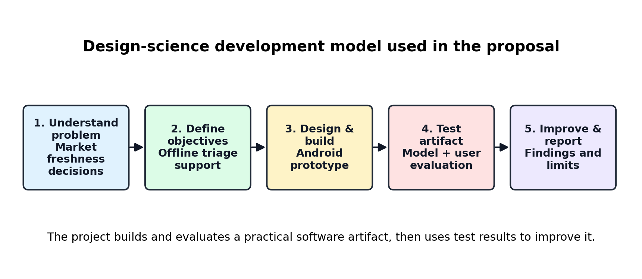
Figure 2: Proposed design-science development model
This approach fits well because the key question is not only whether a computer can classify produce images, but whether a practical offline tool can genuinely help sellers make decisions in a real market. Each round of development will therefore check both the model’s accuracy and the user’s experience.

3.3 Functional and Non-Functional Requirements
The requirements below were derived from the problem statement, the objectives, and the limits of what a phone image can show. Functional requirements describe what the prototype must do:
FR1: The seller can capture a produce photo with the camera or select one from the gallery.
FR2: The app checks image quality and returns Uncertain for images that are too dark or blurred; photos of unsupported produce are caught by the model’s unusable class and also return Uncertain.
FR3: The app runs the bundled TensorFlow Lite model on the phone and returns a predicted class and confidence score.
FR4: The app maps the result to one action category (Fresh, Sell Soon, Discount Today, Spoilage Risk, or Uncertain) and shows short guidance text.
FR5: The app saves every scan, including Uncertain results (produce type if known, category, confidence, and time), in local SQLite storage and lets the seller view past scans.
FR6: The researcher can export an anonymous test log for evaluation.
Non-functional requirements describe how well the prototype must work:
NFR1 (Offline operation): scanning, results, and history must work with no internet connection.
NFR2 (Performance): inference should take less than one second per image on a mid-range Android phone with 3–4 GB RAM.
NFR3 (Usability): result screens use simple action words and colors, with a target mean SUS score of at least 68, close to the average of about 70 reported across many SUS studies (Bangor et al., 2009).
NFR4 (Size): the installed app should be smaller than 50 MB so that it fits on low-storage phones.
NFR5 (Privacy): no images or personal data leave the phone during use.
NFR6 (Reliability): low-confidence or poor-quality images must return Uncertain rather than a guessed category.

3.4 System Architecture
Figure 3 shows the system architecture, which is kept intentionally simple. The seller takes a photo or picks one from the phone’s gallery. The app first checks that the photo is bright and sharp enough to judge, then crops and resizes it and runs the TensorFlow Lite model stored inside the app. The model has nine output classes: the four actions for each of the two crops, plus an unusable class for unsupported produce and unusable photos. A decision mapper then combines the model’s predicted class and confidence score with stored guidance rules and turns them into a practical action: Fresh, Sell Soon, Discount Today, Spoilage Risk, or Uncertain. Uncertain is returned whenever the photo fails the quality check, the top class is unusable, or the confidence is below a threshold tuned on the validation set, and every scan, including Uncertain ones, is saved to the history. The model file and the guidance rules (a small JSON file) are packaged with the app, and scan history is saved in a local SQLite database. When the app first opens, the guidance file is loaded into the GUIDANCE_RULE table, so that each saved scan can be linked to the rule behind its advice (Figure 7). Example guidance includes: for Sell Soon, place the item at the front of the stall and sell it first; for Discount Today, lower the price for a same-day sale; and for Spoilage Risk, remove it from normal sale and keep it away from fresh stock. No internet connection is used at any point while scanning or saving results.
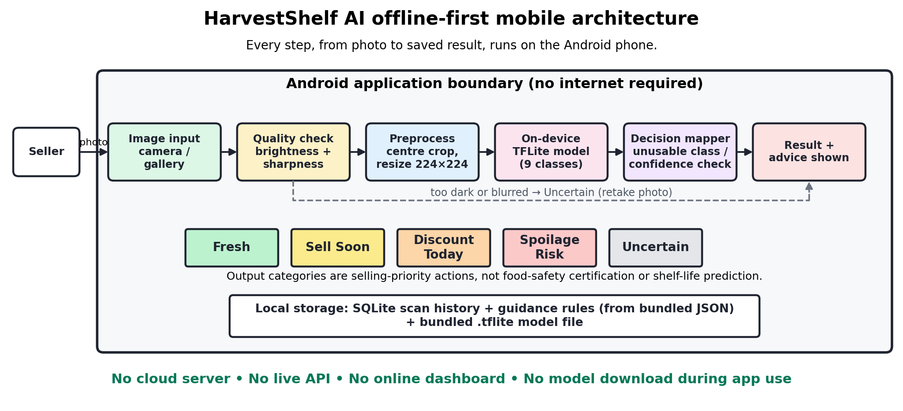
Figure 3: HarvestShelf AI offline-first mobile system architecture
The architecture also keeps training and everyday use apart. Training happens on the developer’s computer, where local images are labeled, split into groups, used to fine-tune the model, and evaluated. Only the final, tested model is converted to TensorFlow Lite and packed into the Android app, so seller photos never need to be sent to a server.
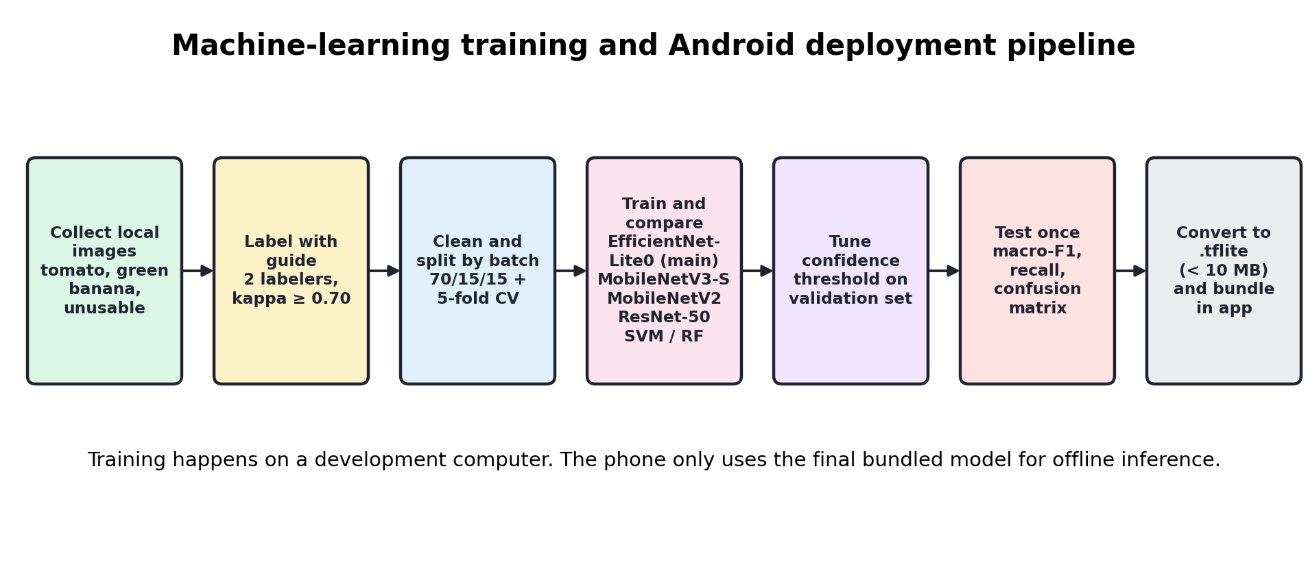
Figure 4: Machine-learning training and Android deployment pipeline

3.4.1 Model and Library Decision
The main model candidate is EfficientNet-Lite0, fine-tuned on the project’s own images. It was chosen because it is built for phones and small devices and offers a good balance between accuracy and size, and Google’s LiteRT tooling documents how to retrain image classifiers of this kind and convert them for Android (Google AI Edge, 2026). MobileNetV3-Small will serve as the baseline. The final choice between the two will rest on the project’s own results: macro-F1 score, recall for each category, model size, and how fast each runs on a real Android phone.
A dataset with fruits or plants in its name is not automatically right for this project. PlantVillage is about leaf disease (Mohanty et al., 2016), and Fruits-360 is about identifying which fruit is in a picture (Mureșan & Oltean, 2018). Both are useful for background and for pre-training ideas, but neither can replace real market images for freshness sorting. The project will therefore collect and label its own local images for the chosen crops and action categories.

3.4.2 System and Technology Stack
The system uses a modular, layered stack so that data flows cleanly from the camera to a saved result. Because sellers work on phones and often without internet, each layer is adapted to an offline mobile setting:
Frontend and input layer: a Flutter (Dart) Android app with screens for taking or choosing a photo, viewing the result and advice, and browsing scan history. A web dashboard is not needed in this version because every user works on a phone.
Logic layer (in place of a backend API): an on-device service layer that checks image quality, runs the TensorFlow Lite model, and applies the decision mapper. A FastAPI or Flask server was considered but left out, so the app never depends on a network connection.
Database layer: SQLite, accessed through sqflite, stores scan records and guidance rules (Figure 7). PostgreSQL and vector databases such as Pinecone or Milvus are not used, because the app keeps only a few thousand small records on one phone and performs no similarity search.
Infrastructure: model training runs inside a Docker container on the development computer, so the same environment and library versions can be rebuilt at any time. The trained model is then packaged inside the Android app, so no server needs to be deployed.
The app will be built with Flutter (Flutter, 2026) for the user interface, the camera or image_picker package to capture or choose photos, the image package to resize and prepare them, tflite_flutter (pub.dev, 2026b) to run the model, path_provider to manage local file paths, and sqflite (pub.dev, 2026a) to store scan records. All of these work fully offline on Android. Server-based options such as FastAPI, MongoDB, cloud dashboards, and online APIs are deliberately left out of this first version, because they would make the app depend on an internet connection.

3.4.3 Data Definition and Acquisition
Data sources: the project uses a single primary source, supported by secondary sources for background only. The primary source is the project’s own photographs of tomatoes and green bananas, taken at stalls in at least three markets in Nyabihu and Rusizi on at least five different days. Public datasets such as Fruits-360 and PlantVillage are used only for background reading and comparison, not to train the final model, because they show studio images or leaf disease rather than market produce.
Data volume: the target is about 2,400 labeled images, or roughly 300 images for each of the four action categories per crop, plus extra Uncertain examples (Section 3.7). At about 2 to 4 MB per phone photo, the raw image set is expected to take roughly 5 to 10 GB of storage, and a metadata sheet will hold one row per image.
Provenance and privacy: for every image, the metadata sheet records the market, date, crop, phone model, and the labels given by each labeler, so each image can be traced back to where it came from. Photos will show produce only, not people’s faces; sellers will give informed consent before photos are taken at their stalls, and the app itself stores no personal data. Any public dataset used for comparison will be used under its published license terms.

3.4.4 Machine Learning Training Pipeline
The pipeline in Figure 4 gives a repeatable path from raw photos to a model the phone can run.
Input: raw, unstructured market photos together with their metadata and the two labelers’ labels.
Quality phase: blurred, very dark, and duplicate photos are removed or moved to the Uncertain class; images where the two labelers disagree are checked against the labeling guide and dropped if the disagreement cannot be settled; class balance is checked; and data is split by batch (one item or lot photographed on one day) so near-identical photos never appear in both training and test sets. Augmentation such as rotation, flipping, and brightness changes is applied to the training set only. Grouped 5-fold cross-validation over the training and validation batches is used only to compare candidate models with a stable estimate despite the small dataset; the fixed 70/15/15 split then trains the final model, tunes its confidence threshold on the validation part, and evaluates it once on the untouched test part.
Expected output: a quantized TensorFlow Lite model small enough to bundle inside the app (target under 10 MB), together with a confusion matrix, recall for each category, macro-F1, and the measured inference time on a low-cost Android phone.

3.4.5 Model Comparison
No model is picked by default. All candidates below will be trained and tested on the same data split and judged on the same metrics:
- EfficientNet-Lite0 (main candidate): built for phones, with a strong balance between accuracy and model size.
- MobileNetV3-Small (lightweight baseline): the smallest and fastest option, showing whether an even lighter model is good enough.
- MobileNetV2: widely used in earlier mobile plant and produce studies, so results can be compared with published work.
- ResNet-50 (accuracy reference): too large for low-cost phones, but it shows the best accuracy this data can support.
- Support Vector Machine (SVM) and Random Forest on hand-crafted color and texture features: classical baselines that show whether deep learning is really needed for this task.
The chosen model will be the one with the best macro-F1 and Spoilage Risk recall that still runs in under one second per photo on a low-cost Android phone; if two models perform about the same, the smaller one wins. Large language models and reinforcement-learning policies are not compared, because this is an image-classification task rather than a text-generation or sequential decision-making problem.

3.5 UML Diagrams
The diagrams below show how the prototype behaves and how its local data is organized. They deliberately cover only the offline mobile system, so that no cloud services or extra sensors creep into the design. Figures 5 to 8 show the use cases, the main classes, the local database, and the sequence of steps in a typical scan. Figure 9 shows the decision logic as an activity diagram, Figure 10 sketches the three main screens, and Figure 11 is a deployment diagram showing what runs on the developer’s computer and what is installed on the phone.
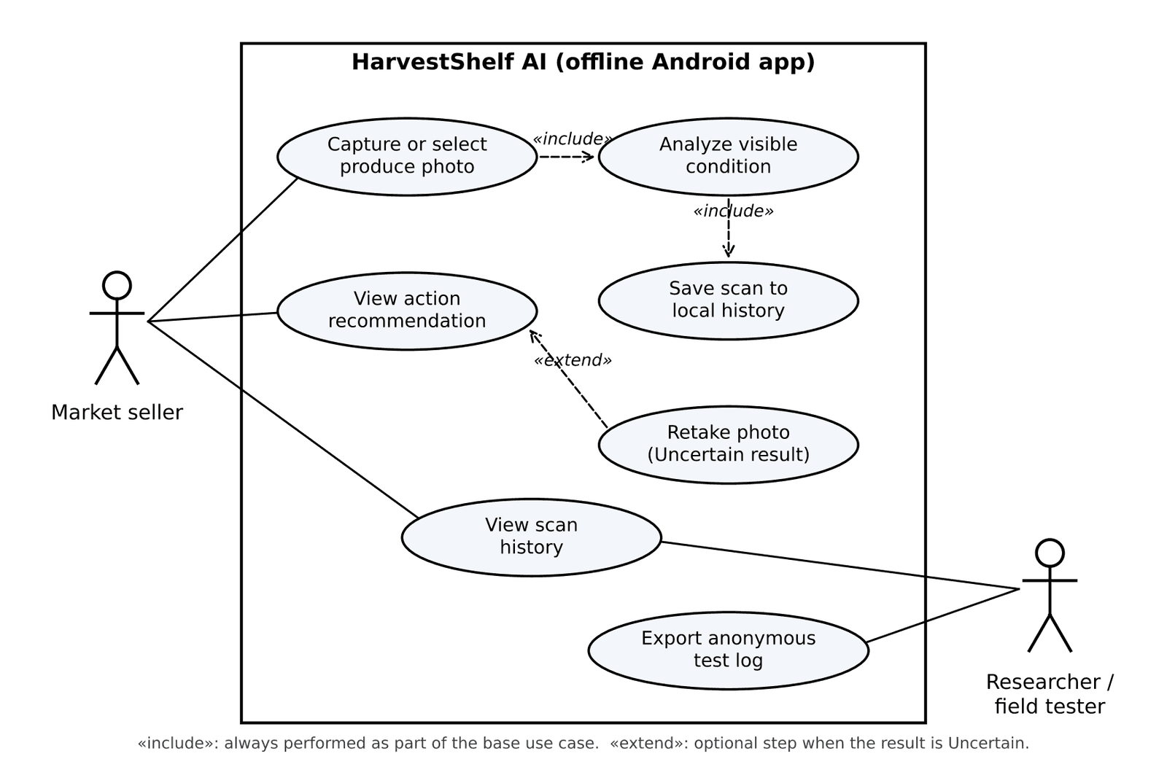
Figure 5: UML use-case diagram
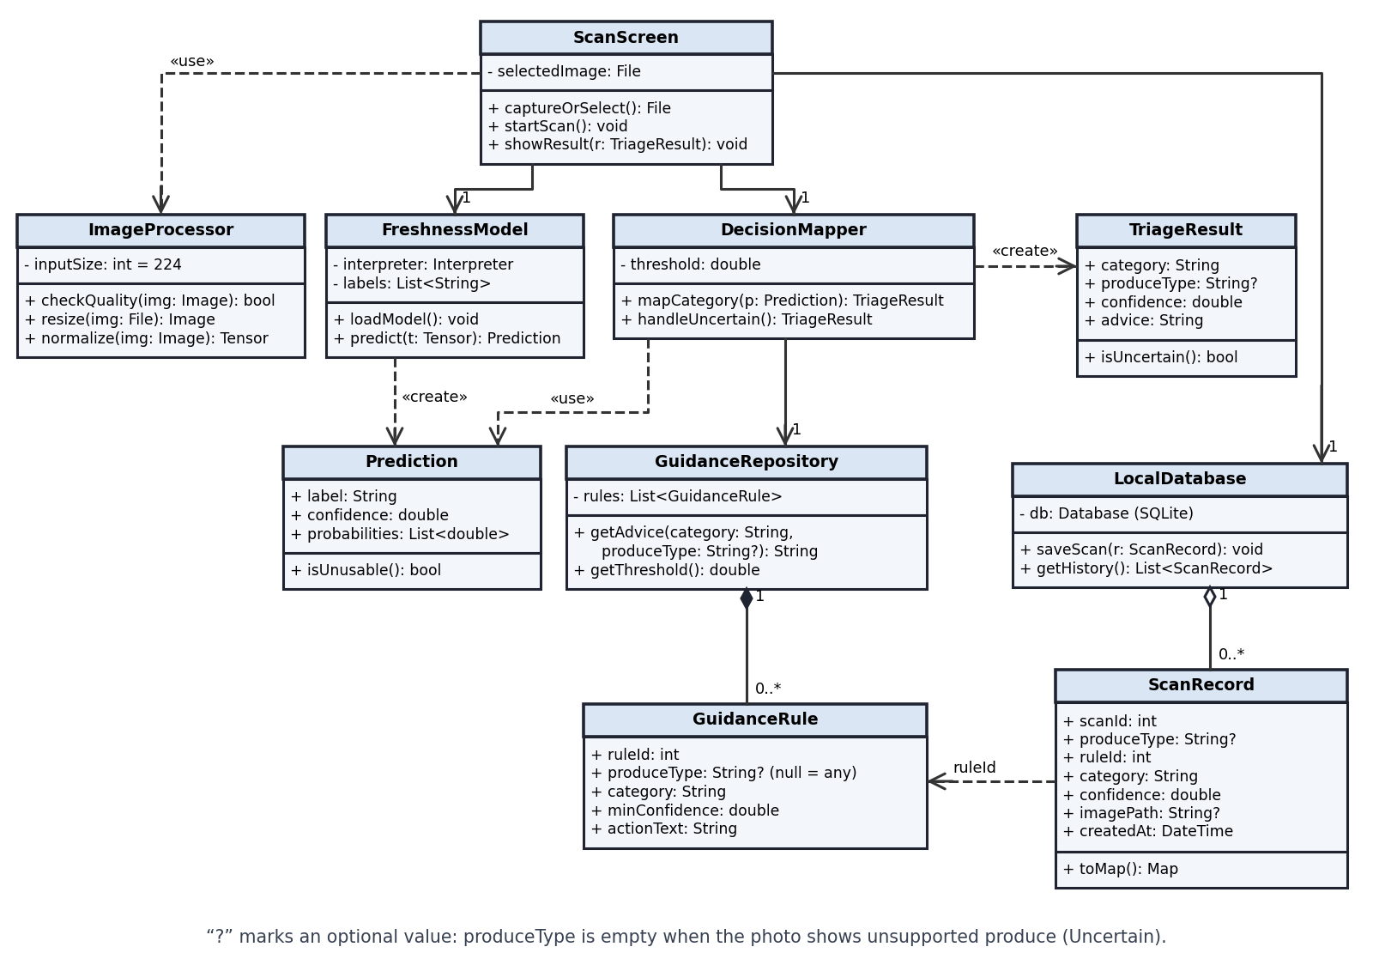
Figure 6: UML class diagram
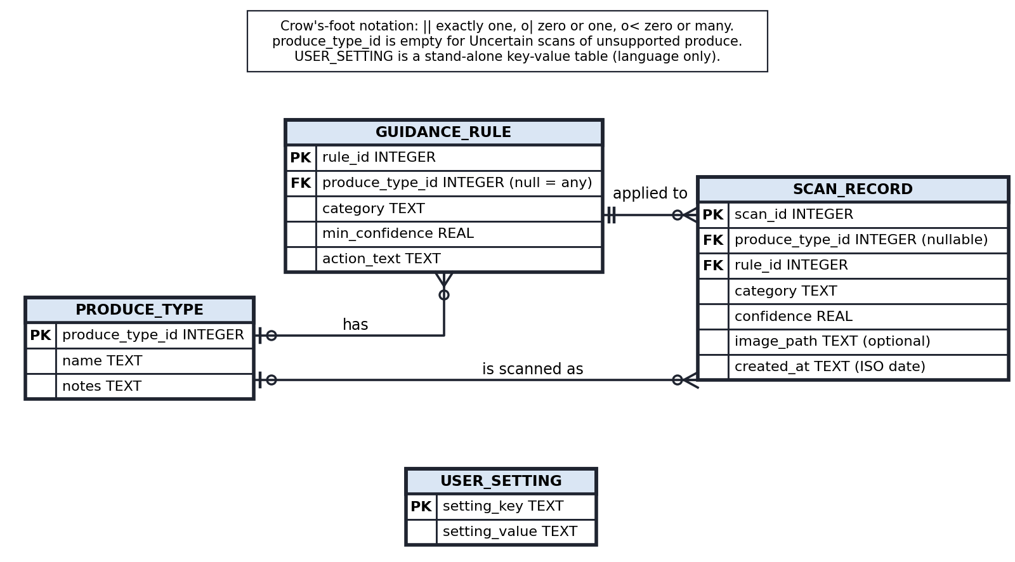
Figure 7: Entity relationship diagram for local SQLite storage
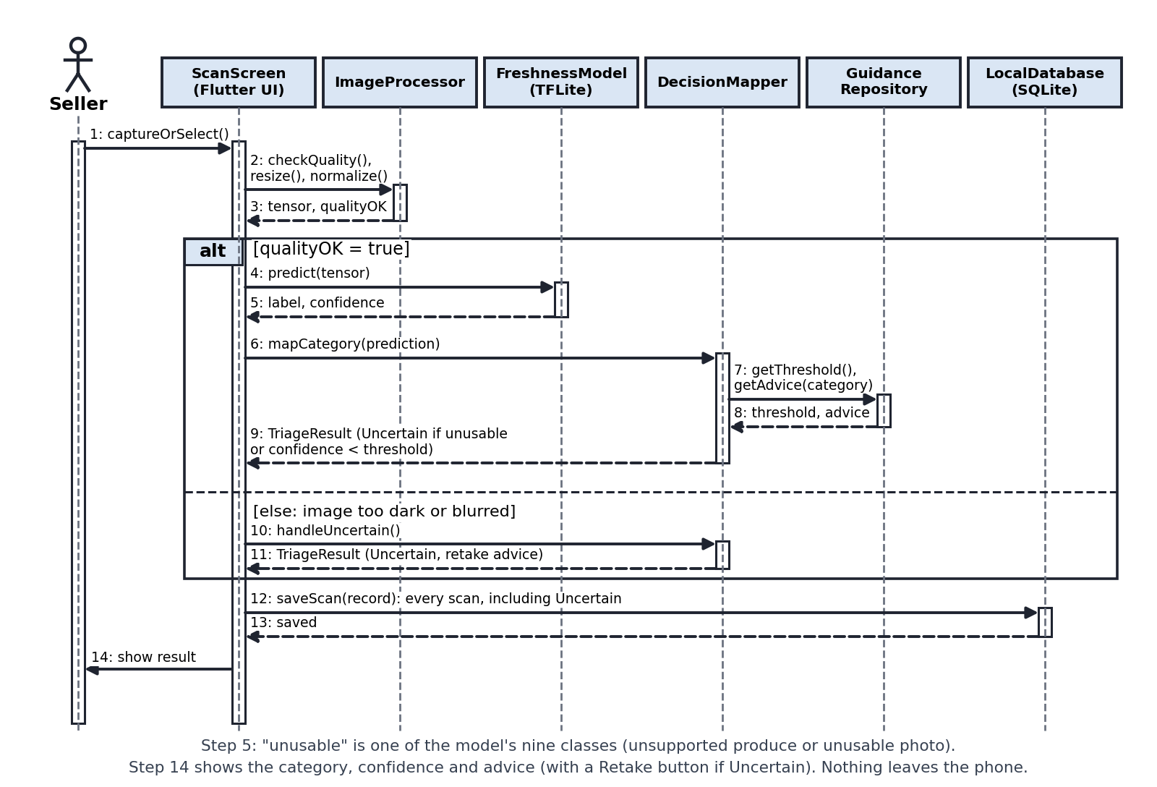
Figure 8: Sequence diagram for produce image triage
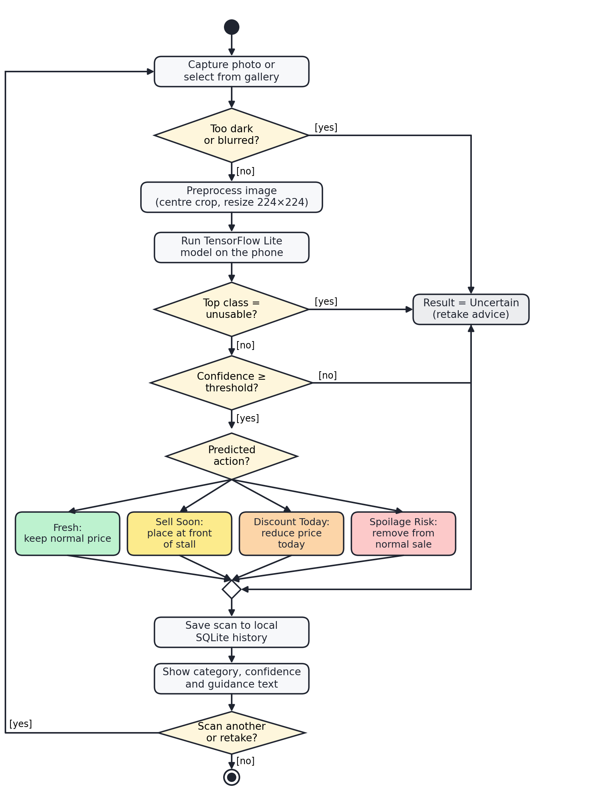
Figure 9: Activity diagram for the triage decision logic
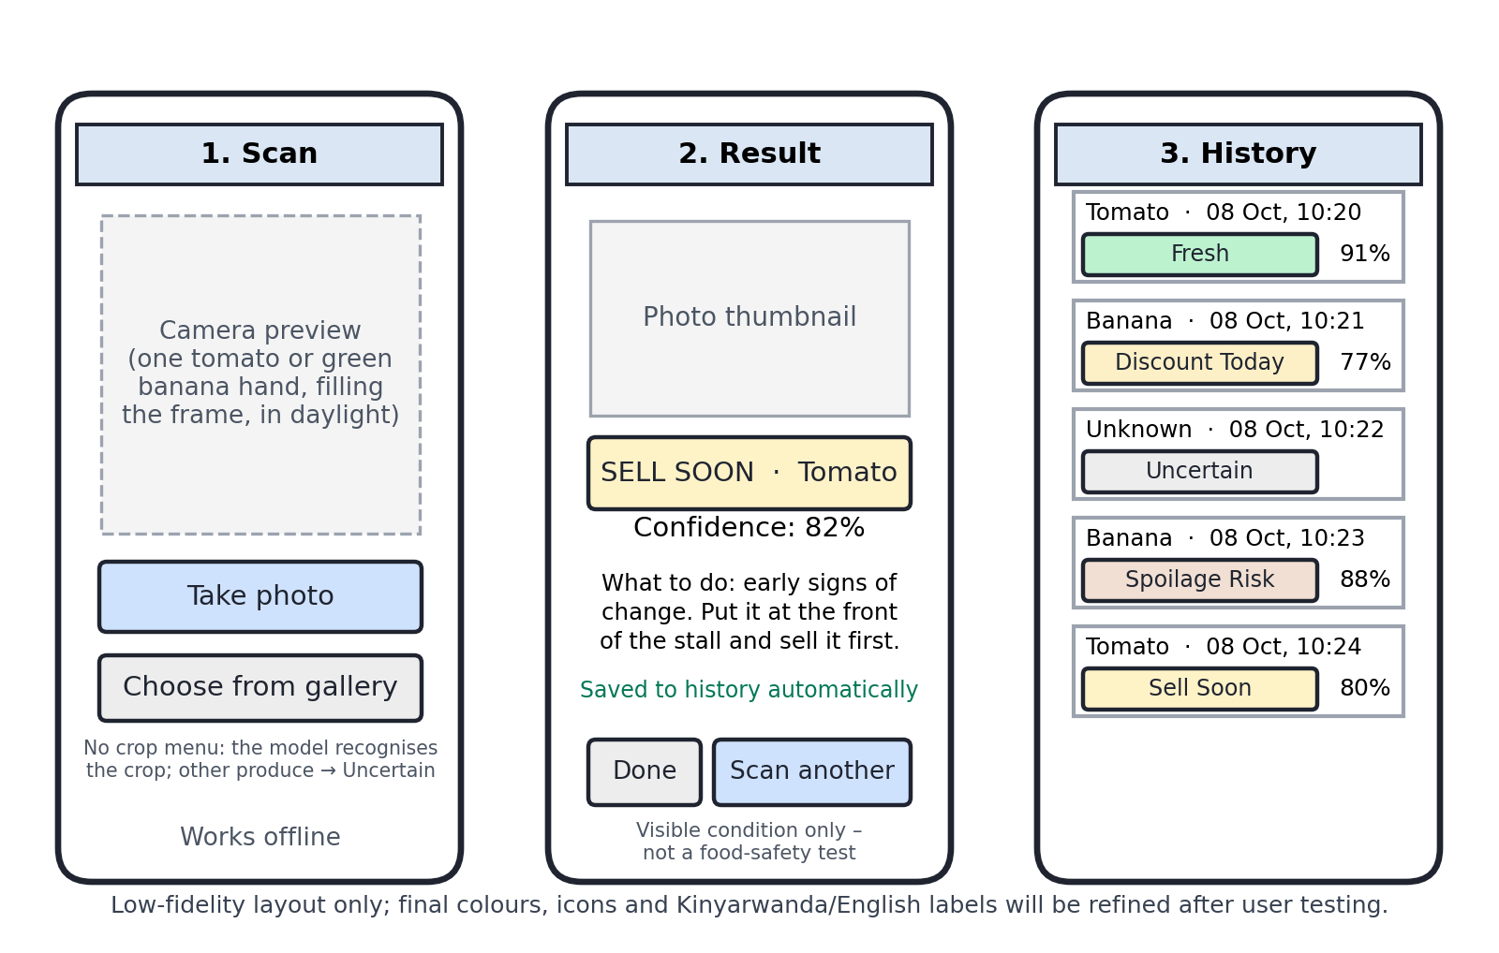
Figure 10: Low-fidelity screen designs
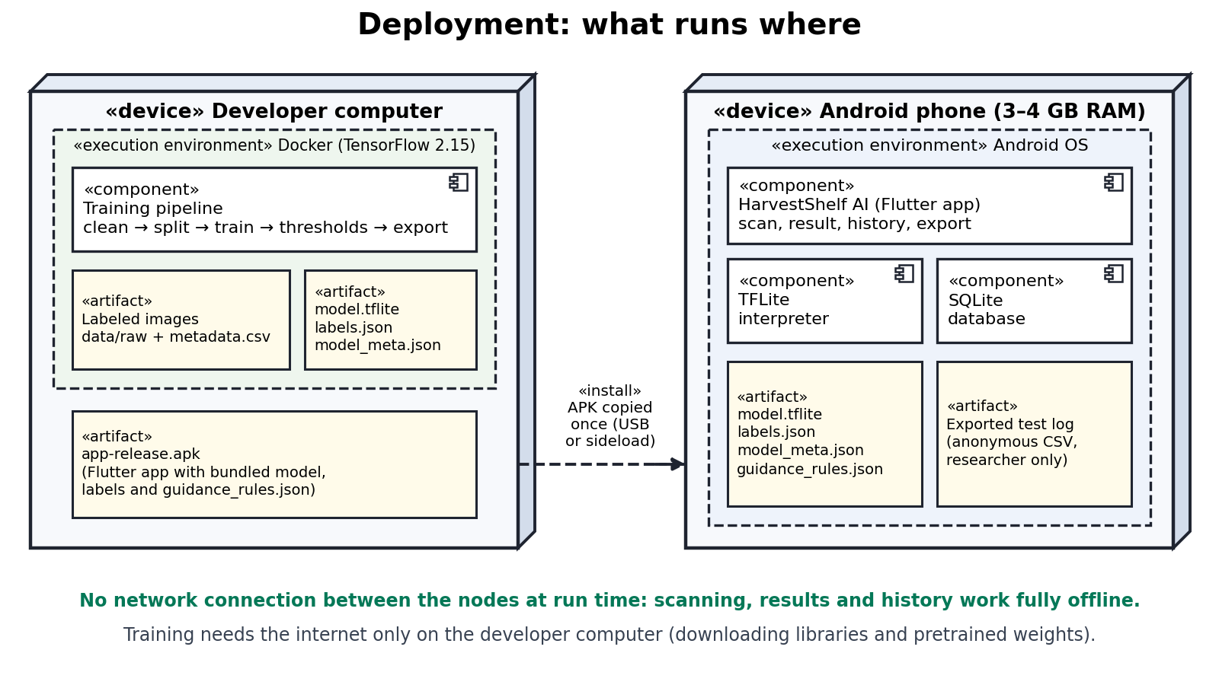
Figure 11: UML deployment diagram

3.6 Development Tools
Table 8: Development tools and libraries
Tool / library | Purpose | Reason for selection
Flutter / Dart | Mobile interface and navigation | Suitable for Android UI and later cross-platform reuse; no internet required for runtime.
camera or image_picker | Image capture or gallery selection | Allows the seller to take or select a produce photo.
image package | Local preprocessing | Used for resizing, normalization, and format preparation before inference.
TensorFlow / Keras | Training and fine-tuning | Used on the development computer to train and compare models.
TensorFlow Lite / tflite_flutter | On-device inference | Runs the bundled model on Android without sending images to a server.
sqflite / SQLite | Local database | Stores scan metadata, confidence, category, and timestamps on the phone.
path_provider | App file paths | Stores optional image copies and local assets safely.
Python notebooks | Experiment tracking | Used during training, metrics calculation, and confusion matrix reporting.

3.7 Data Collection, Sampling, Labeling, and Evaluation Plan
Data collection will be small but carefully organized. It will start with tomatoes and green (cooking) bananas, since both have Rwanda-specific loss evidence and visible signs of quality change. A third crop is a stretch goal only (Section 1.5). Photos will be taken in real market conditions, either with the seller’s permission or using produce bought for the purpose. Because Discount Today and Spoilage Risk items are rare at any one stall, small batches of tomatoes and green bananas will also be bought, kept under normal stall conditions, and photographed once a day until they spoil, so that one purchase covers all four categories; each item on each day is recorded as one batch (budget line “Produce samples” in Table 1). A written label guide will define each category before labeling begins: Fresh means normal selling quality; Sell Soon means early visible change but still clearly usable; Discount Today means a clear decline that calls for a quick sale; Spoilage Risk means visible mold-like marks, severe bruising, rot, or unacceptable deterioration; and Uncertain is used when the image is unclear or unsupported, or the model is not confident enough.
Images will be divided into training and test groups by batch, where a batch is one item or lot photographed on one day at one stall, rather than at random. This prevents data leakage, a common trap where nearly identical photos end up in both groups and make the model look better than it really is. Simple augmentation, such as changing brightness, rotating, or cropping images, may be used during training, but the test set will stay untouched until the final evaluation.
The sampling strategy is purposive, because the study needs images and participants that match the selected produce types and market setting rather than a statistically representative national sample. Images will be collected from at least three market sites across Nyabihu and Rusizi districts on at least five different days, so that the dataset covers different lighting, backgrounds, varieties, and stages of deterioration. The target is at least 300 usable images per action category for each produce type, giving roughly 2,400 labeled images for tomatoes and green bananas combined; Uncertain examples will include blurred, dark, and unsupported images. Images will be split into about 70% training, 15% validation, and 15% testing by batch. With at least three markets, at least five collection days, and several stalls or purchased lots per visit, at least 60 batches are expected, enough for every split to contain whole batches from each category. A few hundred labeled images per class is a practical starting point when fine-tuning a pretrained network with transfer learning, because mainly the final layers must adapt to the new classes; the target will be raised if validation results show that the model needs more data. For comparison, Palakodati et al. (2020) used about 1,000 images per class across six fresh and rotten classes, so the 300-image minimum is treated as a floor rather than an ideal. Collection will be planned as at least two visits to each district during Month 2, and any shortfall will be filled at the start of Month 3.
To make labels reliable, two labelers will independently label a sample of at least 20% of the images using the written label guide, and agreement will be measured with Cohen’s kappa. A kappa of at least 0.70 will be required before the full dataset is labeled; disagreements will be discussed and the guide will be updated.
For user evaluation, 18 fresh-produce sellers will be recruited purposively from the same markets, so that at least 15 complete both sessions, including sellers of different ages and levels of smartphone experience. Fifteen participants is a typical size for a formative usability test of a prototype: Nielsen and Landauer (1993) showed that most usability problems are found with a small number of test users, so this sample is large enough to reveal the most common usability problems and to report a meaningful SUS average, while remaining feasible within the participant appreciation budget in Table 1. Inclusion criteria are that the participant sells tomatoes or bananas, uses an Android phone, and gives informed consent. Each participant will complete a short set of scanning tasks while task success rate and time on task are recorded, followed by the ten-item System Usability Scale (SUS) questionnaire and two open questions about the clarity of the result screen. SUS scores will be calculated with the standard scoring method and reported as a mean and range, task success rate and time on task will be summarized descriptively, and answers to the open questions will be grouped into common themes.
Agreement study (Objective 4). To test whether the app reduces the real problem, the same sellers will sort produce with and without the app. Two reference labelers, an agricultural extension officer and an experienced produce wholesaler, will first label every item independently with the labeling guide and agree on a consensus label for each, which serves as the expert label. Two matched sets of 20 items (10 tomatoes and 10 green-banana hands each, with the same mix of expert labels) will be prepared from the purchased batches. Each seller will sort one set by eye and the other with the app, with the order of the two conditions and the assignment of sets counterbalanced across sellers, so that learning and set difficulty do not favor either condition. For each seller and condition, agreement is the percentage of items whose action matches the expert label. The paired difference (with the app minus without) will be reported as a mean with a 95% confidence interval and tested with a Wilcoxon signed-rank test (Wilcoxon, 1945), which suits a small number of paired observations without assuming normality. A simulation of this test shows that, if the improvement varies between sellers with a standard deviation of 20 percentage points, 18 sellers give about 83% power to detect the 15-point target at a two-sided significance level of 0.05, and 15 sellers about 74%; the achieved number of sellers and the observed variation will be reported with the result. The target is met if the mean improvement is at least 15 percentage points.
The technical evaluation will report accuracy, macro-F1 (an average score that treats every category equally, even rare ones), precision and recall for each category, a confusion matrix showing which categories get mixed up, a reliability plot showing whether confidence scores can be trusted, the model’s size, and how long it takes to process a photo. Inference time will be measured in a release build on at least one Android phone with 3–4 GB RAM, as the median and 95th percentile of at least 50 timed runs on test images after two warm-up runs. Macro-F1 and per-category recall matter most because some categories may have fewer images, and because missing a Spoilage Risk item is more serious than confusing two similar selling categories.

3.8 Ethics and Risk Management
The project will seek its own ethics approval, since it is a new study and cannot rely on approval given to a different project. Participants will be told clearly what data is collected, how their images will be used, and that the prototype is not a food-safety certification tool. Personal data will be avoided wherever possible: if a seller’s face or shop identifiers appear in a photo, they will be cropped out, or the photo will be excluded unless the seller gives explicit permission.
The biggest risk is a tool that sounds more certain than it is. To guard against this, the app will show Uncertain whenever confidence is low, the photo is poor, or the crop is not supported. Its wording will never tell users that food is safe; it will only describe the visible condition and suggest a selling priority.

References (APA Format)
AgShift. (2026). AI-powered food quality inspection solutions. Retrieved October 9, 2026, from https://www.agshift.com/
Baglat, P., Hayat, A., Mendonça, F., Gupta, A., Mostafa, S. S., & Morgado-Dias, F. (2023). Non-destructive banana ripeness detection using shallow and deep learning: A systematic review. Sensors, 23(2), 738. https://doi.org/10.3390/s23020738
Bangor, A., Kortum, P., & Miller, J. (2009). Determining what individual SUS scores mean: Adding an adjective rating scale. Journal of Usability Studies, 4(3), 114–123. https://uxpajournal.org/wp-content/uploads/sites/7/pdf/JUS_Bangor_May2009.pdf
Begum, N., & Hazarika, M. K. (2025). Spoilage detection of tomatoes using a convolutional neural network. Research in Agricultural Engineering, 71(2), 80–87. https://doi.org/10.17221/31/2024-RAE
Bhargava, A., & Bansal, A. (2021). Fruits and vegetables quality evaluation using computer vision: A review. Journal of King Saud University - Computer and Information Sciences, 33(3), 243–257. https://doi.org/10.1016/j.jksuci.2018.06.002
Clarifruit. (2026). Fresh produce quality control platform. Retrieved October 9, 2026, from https://www.clarifruit.com/
Elinisa, C. A., & Mduma, N. (2024). Mobile-based convolutional neural network model for the early identification of banana diseases. Smart Agricultural Technology, 7, 100423. https://doi.org/10.1016/j.atech.2024.100423
Flutter. (2026). Flutter documentation. Retrieved October 9, 2026, from https://docs.flutter.dev/
Food and Agriculture Organization of the United Nations. (n.d.). Small-scale postharvest handling practices: Chapter 5, decay and insect control. https://www.fao.org/4/ae075e/ae075e11.htm
Fruitnet. (n.d.). Australian company’s technology detects defects and evaluates freshness. Produce Plus. Retrieved October 9, 2026, from https://fruitnet.com/produce-plus/gomicro-ai-tech-enhances-leafy-green-quality-assessment/262288.article
Geifman, Y., & El-Yaniv, R. (2017). Selective classification for deep neural networks. In Advances in Neural Information Processing Systems 30. https://papers.nips.cc/paper_files/paper/2017/file/4a8423d5e91fda00bb7e46540e2b0cf1-Paper.pdf
Gisubizo, F., Dushimimana, O., Dushimimana, A., & Agbolosoo, J. A. (2026). Post-harvest losses of perishable vegetables and their contribution to household dietary gaps in Kamonyi District, Rwanda. BMC Public Health, 26, 1575. https://doi.org/10.1186/s12889-026-27214-6
Google. (2020, March). Higher accuracy on vision models with EfficientNet-Lite. TensorFlow Blog. https://blog.tensorflow.org/2020/03/higher-accuracy-on-vision-models-with-efficientnet-lite.html
Google AI Edge. (2026). Image classification with TensorFlow Lite / LiteRT Model Maker. Retrieved October 9, 2026, from https://developers.google.com/edge/litert/libraries/modify/image_classification
Google TensorFlow. (2026). TensorFlow Lite for Android and on-device inference documentation. Retrieved October 9, 2026, from https://www.tensorflow.org/lite/
GSMA. (2024). The mobile economy Sub-Saharan Africa 2024. Retrieved October 9, 2026, from https://www.gsma.com/mobileeconomy/report/sub-saharan-africa-2024/
Guo, C., Pleiss, G., Sun, Y., & Weinberger, K. Q. (2017). On calibration of modern neural networks. Proceedings of Machine Learning Research, 70, 1321–1330. https://proceedings.mlr.press/v70/guo17a.html
Hendrycks, D., & Gimpel, K. (2017). A baseline for detecting misclassified and out-of-distribution examples in neural networks. In International Conference on Learning Representations. https://arxiv.org/abs/1610.02136
Howard, A. G., Zhu, M., Chen, B., Kalenichenko, D., Wang, W., Weyand, T., Andreetto, M., & Adam, H. (2017). MobileNets: Efficient convolutional neural networks for mobile vision applications. arXiv. https://arxiv.org/abs/1704.04861
Howard, A., Sandler, M., Chu, G., Chen, L.-C., Chen, B., Tan, M., Wang, W., Zhu, Y., Pang, R., Vasudevan, V., Le, Q. V., & Adam, H. (2019). Searching for MobileNetV3. In Proceedings of the IEEE/CVF International Conference on Computer Vision. https://arxiv.org/abs/1905.02244
Intello Labs. (2026). Fresh produce quality assessment solutions. Retrieved October 9, 2026, from https://www.intellolabs.com/
Kader, A. A. (Ed.). (2003). The role of post-harvest management in assuring the quality and safety of horticultural produce. Food and Agriculture Organization of the United Nations. https://www.fao.org/4/y5431e/y5431e05.htm
Kamilaris, A., & Prenafeta-Boldú, F. X. (2018). Deep learning in agriculture: A survey. Computers and Electronics in Agriculture, 147, 70–90. https://doi.org/10.1016/j.compag.2018.02.016
Kitinoja, L., Odeyemi, O. M., Dubey, N., Musanase, S., & Gill, G. S. (2019). Commodity system assessment studies on the postharvest handling and marketing of tomatoes in Nigeria, Rwanda and Maharashtra, India. Journal of Horticulture and Postharvest Research, 2(Special Issue), 1–14. https://doi.org/10.22077/jhpr.2019.2060.1040
Kubwimana, J. J. (2020). Risk analysis of vegetables marketing in Rwanda: A case of carrots and cabbages produced in Northern Province, Rubavu District and supplied across the country. Journal of Agribusiness and Rural Development, 56(2), 183–200. https://doi.org/10.17306/J.JARD.2020.01326
Mazen, F. M. A., & Nashat, A. A. (2019). Ripeness classification of bananas using an artificial neural network. Arabian Journal for Science and Engineering, 44(8), 6901–6910. https://doi.org/10.1007/s13369-018-03695-5
Medhi, I., Sagar, A., & Toyama, K. (2007). Text-free user interfaces for illiterate and semiliterate users. Information Technologies and International Development, 4(1), 37–50. https://doi.org/10.1162/itid.2007.4.1.37
Ministry of Agriculture and Animal Resources. (n.d.). Nyabihu [Project site page, Sustainable Agriculture Intensification and Food Security Project]. Retrieved October 9, 2026, from https://lwh-rssp.minagri.gov.rw/index.php?id=76
Mohanty, S. P., Hughes, D. P., & Salathé, M. (2016). Using deep learning for image-based plant disease detection. Frontiers in Plant Science, 7, 1419. https://doi.org/10.3389/fpls.2016.01419
Mrisho, L. M., Mbilinyi, N. A., Ndalahwa, M., Ramcharan, A. M., Kehs, A. K., McCloskey, P. C., Murithi, H., Hughes, D. P., & Legg, J. P. (2020). Accuracy of a smartphone-based object detection model, PlantVillage Nuru, in identifying the foliar symptoms of the viral diseases of cassava: CMD and CBSD. Frontiers in Plant Science, 11, 590889. https://doi.org/10.3389/fpls.2020.590889
Mukhiddinov, M., Muminov, A., & Cho, J. (2022). Improved classification approach for fruits and vegetables freshness based on deep learning. Sensors, 22(21), 8192. https://doi.org/10.3390/s22218192
Mureșan, H., & Oltean, M. (2018). Fruit recognition from images using deep learning. Acta Universitatis Sapientiae, Informatica, 10(1), 26–42. https://doi.org/10.2478/ausi-2018-0002
National Agricultural Export Development Board. (2026). Smart Food Value Chain Management Project. Retrieved October 9, 2026, from https://www.naeb.gov.rw/spiu-projects/sfvcmp
National Institute of Statistics of Rwanda. (2025a). EICV7 thematic report: Utilities and amenities 2023/24. Retrieved October 9, 2026, from https://statistics.gov.rw/integrated-household-living-conditions-survey-7-eicv-7/eicv7-thematic-report-utilities-and-amenities-202324
National Institute of Statistics of Rwanda. (2025b). EICV7 main indicators report 2023/24. https://www.statistics.gov.rw/sites/default/files/documents/2025-07/EICV7_Main%20Indicator%20Report.pdf
The New Times. (2011, December 19). Rusizi businesses thrive on cross-border trade. The New Times. https://www.newtimes.co.rw/article/65086/National/rusizi-businesses-thrive-on-cross-border-trade
Nielsen, J., & Landauer, T. K. (1993). A mathematical model of the finding of usability problems. In Proceedings of the INTERACT ’93 and CHI ’93 Conference on Human Factors in Computing Systems (pp. 206–213). ACM. https://doi.org/10.1145/169059.169166
OneThird. (2026). Shelf-life prediction and fresh produce quality-control solutions. Retrieved October 9, 2026, from https://onethird.io/
Palakodati, S. S. S., Chirra, V. R., Dasari, Y., & Bulla, S. (2020). Fresh and rotten fruits classification using CNN and transfer learning. Revue d’Intelligence Artificielle, 34(5), 617–622. https://doi.org/10.18280/ria.340512
pub.dev. (2026a). sqflite Flutter package. Retrieved October 9, 2026, from https://pub.dev/packages/sqflite
pub.dev. (2026b). tflite_flutter Flutter package. Retrieved October 9, 2026, from https://pub.dev/packages/tflite_flutter
Ramcharan, A., McCloskey, P., Baranowski, K., Mbilinyi, N., Mrisho, L., Ndalahwa, M., Legg, J., & Hughes, D. P. (2019). A mobile-based deep learning model for cassava disease diagnosis. Frontiers in Plant Science, 10, 272. https://doi.org/10.3389/fpls.2019.00272
Sbodio, A. O., Mesquida-Pesci, S. D., Yip, N., Alvarez-Rojo, I., Gutierrez-Baeza, E., Tay, S., Bello, P., Wang, L., & Blanco-Ulate, B. (2024). Non-wounding contact-based inoculation of fruits with fungal pathogens in postharvest. Plant Methods, 20, 83. https://doi.org/10.1186/s13007-024-01214-2
Sultana, N., Jahan, M., & Uddin, M. S. (2022). Fresh and rotten fruits dataset for machine-based evaluation of fruit quality [Data set]. Mendeley Data. https://doi.org/10.17632/bdd69gyhv8.1
Tan, M., & Le, Q. V. (2019). EfficientNet: Rethinking model scaling for convolutional neural networks. Proceedings of Machine Learning Research, 97, 6105–6114. https://proceedings.mlr.press/v97/tan19a.html
TradeMark Africa. (2019, April 1). Rubavu and Rusizi cross border markets, completed, ready for occupation. https://www.trademarkafrica.com/news/rubavu-and-rusizi-cross-border-markets-completed-ready-for-occupation-2
UC Davis Postharvest Research and Extension Center. (n.d.). Ethylene. https://postharvest.ucdavis.edu/ask-produce-docs-category/ethylene
University of California, Davis Horticulture Innovation Lab. (2016a). Postharvest loss assessment of tomatoes in Rwanda. https://horticulture.ucdavis.edu/information/postharvest-loss-assessment-tomatoes-rwanda
University of California, Davis Horticulture Innovation Lab. (2016b). Postharvest loss assessment of green bananas in Rwanda. https://horticulture.ucdavis.edu/information/postharvest-loss-assessment-green-bananas-rwanda
University of California, Davis Horticulture Innovation Lab. (2016c). Training manual for postharvest handling of horticultural crops in Rwanda. https://horticulture.ucdavis.edu/information/training-manual-postharvest-handling-horticultural-crops-rwanda
Wilcoxon, F. (1945). Individual comparisons by ranking methods. Biometrics Bulletin, 1(6), 80–83. https://doi.org/10.2307/3001968
World Bank. (2020). Rwanda Food Smart Country Diagnostic: Reducing food loss and waste. World Bank. https://documents1.worldbank.org/curated/en/288911601302842762/pdf/Rwanda-Food-Smart-Country-Diagnostic.pdf
World Bank. (2024). Rwanda Country Economic Memorandum: Pathways to sustainable and inclusive growth. World Bank. https://documents1.worldbank.org/curated/en/099111224145514415/pdf/P1807921507e8400c18e631fe8569020110.pdf
Zhang, L., Jia, J., Gui, G., Hao, X., Gao, W., & Wang, M. (2018). Deep learning based improved classification system for designing tomato harvesting robot. IEEE Access, 6, 67940–67950. https://doi.org/10.1109/ACCESS.2018.2879324

