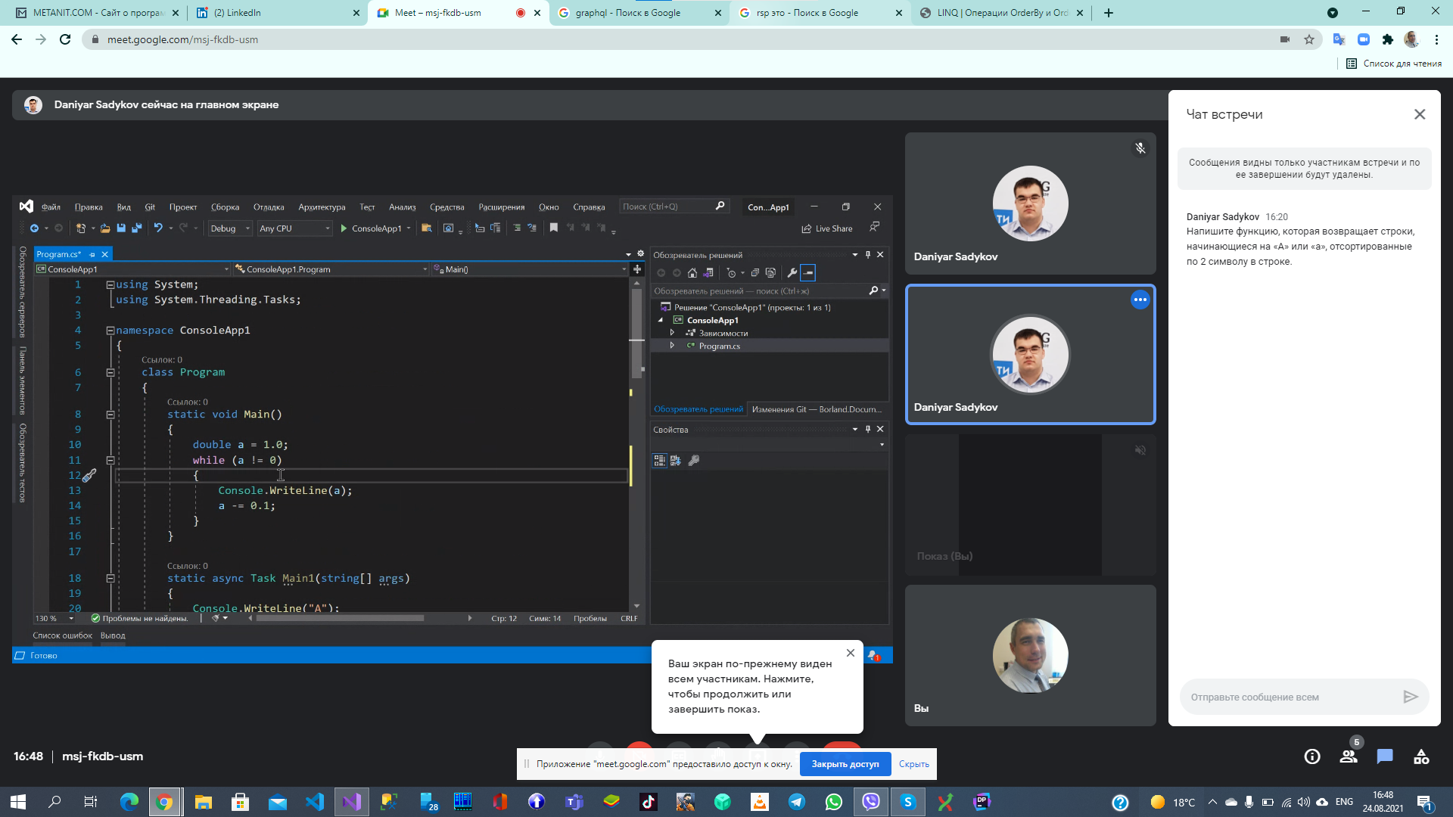

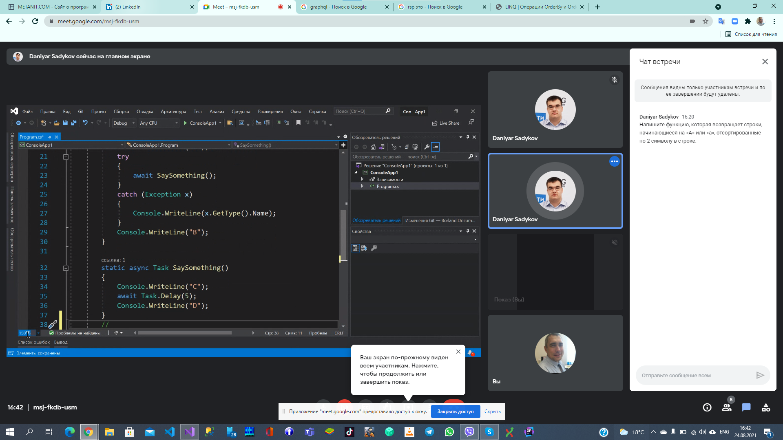col.Where(s => s.StartsWith("a") || s.StartsWith("A")).OrderBy(ss => ss[1]).ToList();

