cars_world

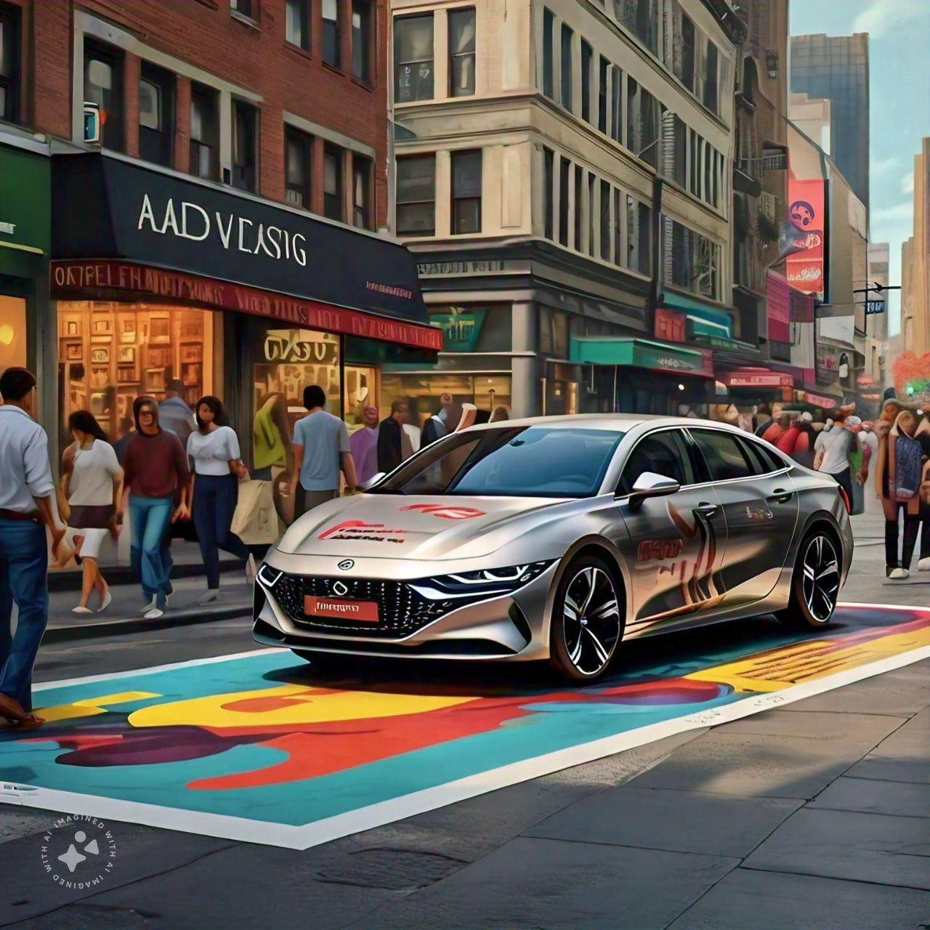

# Individual worke

# Muhsin.p

# DATASET ANALYSIS

# UNCOVERING HIDDEN INSIGHTS IN CAR DATA.

**ENTRODUCTION**

This data set contains information about cars, including their brand, model, fuel type,

price, mileage, and other features.

The goal of this analysis is to uncover insights and patterns in the data to help optimize car sales and customer satisfaction.

**DATA OVERVIEW**

- Column Name: Data Type

- Brand: varchar

- Model: varchar

- Fuel Type: varchar

- Price: int

- Mileage: int

- Features: varchar

- Color: varchar

- Transmission: varchar

- Engine Size: int

- Horsepower: int

- Fuel Economy: int

**DATA ANALYSIS**

|  |  |  |
| --- | --- | --- |
| 1 | Total Number of Cars | The total number of cars-7927 (currently available). |
| 2 | Most Popular Car Brand | The most popular car brand is Toyota, with 452 cars |
| 3 | Most Popular Fuel Type | The most popular fuel type is diesel, with 4304 cars. |
| 4 | lowest price: lowest prised car | maruti 800 ac, with one car.(limitted stock)  price of maruti 800 ac-29999 |
| 5 | Most Common Feature | He most common feature is Bluetooth Connectivity, with 7927 cars |
| 6 | Transmission Types | The most common transmission type is Automatic, with 1041 cars.  transmission types: number of mannual cars are available-6866 |
| 7 | Engine (cc)(max) | total number of maximum cc cars are available:6 maximum cc car's name:jeep wrangler 2016-2019 3.6 4*4 3604 cc |
| 8 | Engine (cc)(min)Engine (cc)(min) | total number of minimum cc cars are available:25  minimum cc cars name: tata nano 624 cc |
| 9 | imufuel types: total number of petrol cars | 3544  total number of diesel  cars:4304  total number of cngcars:25 |
| 10 | Model: latest manufacture year car is | 2023  total number of cars:6 |
| 11 | latest models | Maruti Alto 800 LXI Opt  Skoda Slavia 1.0 TSI Ambition  BMW 3 Series Gran Limousine 320Ld Luxury Line  MG ZS EV Exclusive  Tata Punch Adventure  Maruti S-Presso VXi Plus |
| 12 | model | lowest manufacture year car is: 1994  total numbers of cars:2 |
| 13 | Lowest model | Ambassador Classic 2000 DSZ AC PS  Maruti 800 AC |
| 14 | lowest priced car | Maruti 800 ac  price is: 29999 |
| 15 | luxury car | Volvo xc90 t8 excellence bsiv |
| 16 | features of luxury car | year of manufacturing-2017  selling price- 10000000  km_driven- 30000  fuel- petrol  transmission- automatic  owner- first  mileage- 42.0 kmpl  max_power- 400  torque- 640  seats- 4  currently availeble- 1 |

**QUSTIONS**

1. finding total number of cars.

SELECT COUNT(*) AS total_cars FROM table_name;

2. finding total number of most popular car brand.

select count(*) from table_name where column_name like"raw_name"

3. find the lowest price car.

SELECT , COUNT() as count

FROM table_name

WHERE column_name = (SELECT MIN(column_name) FROM table_name)

GROUP BY s_no;

4. find the total number of transmission automatic and mannual select count(*) from table_name where column_name="manual";select count(*) from table_name where column_name="automatic";

6. find the minimum cc car.

SELECT * FROM cars_world WHERE engine = (SELECT MIN(engine) FROM cars_world);

**CONCLUSION**

This analysis provides insights into the car_dekho dataset, including the most popular brand,

fuel type, features, and other patterns. These findings can help optimize car sales and customer

satisfaction by identifying trends and preferences in the data