ANALYZING SURGE PRICING DYNAMICS IN NAIROBI’S RIDE-HAILING INDUSTRY: A DATA-DRIVEN APPROACH TO FAIRNESS, ACCESSIBILITY AND MARKET EFFICIENCY

BY:
MUHSIN AHMED

ANALYZING SURGE PRICING DYNAMICS IN NAIROBI’S RIDE-HAILING INDUSTRY: A DATA-DRIVEN APPROACH TO FAIRNESS, ACCESSIBILITY AND MARKET EFFICIENCY

BY:
MUHSIN AHMED

A Research Project Report Submitted to the School of Science and Technology in Partial Fulfilment of the Requirements for the Award of the Degree of Bachelor of Science in Data Science and Analytics
UNITED STATES INTERNATIONAL UNIVERSITY – AFRICA

SPRING SEMESTER, 2026

STUDENT’S DECLARATION
I, the undersigned, declare that this research is my original work, except for cited quotations and references that have properly been acknowledged and referenced in accordance with the USIU-Africa requirements. Additionally, this research has not been submitted to any other college, institution, or any other university for examination, award of degree or publication or academic credit.
Signed: ________________________ Date: __________________
MUHSIN AHMED ID: 665629

SUPERVISOR APPROVAL
This research project report has been submitted for examination with my approval as the University Supervisor.
Signed: ________________________ Date: __________________
Name of the Supervisor (ID Number)

COPYRIGHT
All rights reserved. No part of this project may be photocopied, recorded, or otherwise reproduced, stored in a retrieval system, or transmitted in any electronic or mechanical means without prior permission of USIU-Africa or the author.
MUHSIN AHMED © 2026

ABSTRACT
This study analysed surge pricing dynamics in Nairobi's ride-hailing industry using a convergent mixed-methods design aligned with SDG 11.2 on inclusive urban mobility. The quantitative component drew on 3,703,406 anonymised trip records (11 January–10 July 2024) enriched with hourly weather data from the Open-Meteo archive. The qualitative component synthesised 35 semi-structured interviews with 15 drivers, 15 passengers, and 5 mobility experts. Feature engineering produced 47 variables; six classifiers and three regressors were trained under a chronological 80/20 split with 5-fold time-series cross-validation. A Random Forest classifier achieved ROC-AUC 0.713, F1 0.306, precision 0.443, and accuracy 0.846. An XGBoost regressor achieved RMSE 0.133, MAE 0.065, and R² 0.026. Surge was spatially concentrated in a small number of neighbourhoods (top three zones: 35.8%–46.4% surge rate vs. a citywide baseline of 19.0%), stronger during evening peaks (17:00–20:00), and significantly elevated during rain (Mann–Whitney U, p < 0.001). Drivers generally accepted surge when transparent; passengers reported fairness concerns and switched to matatus or boda bodas. Surge pricing in Nairobi was demand-sensitive, spatially concentrated, weather-reactive, and perceptually polarising. Recommended interventions include transparency features, soft neighbourhood-level surge caps, and accessibility monitoring. A Streamlit decision-support dashboard was deployed to operationalise findings for non-technical stakeholders.

Keywords: surge pricing, ride-hailing, Nairobi, machine learning, mobility justice, Random Forest, XGBoost, SDG 11, Streamlit dashboard.

ACKNOWLEDGEMENT
I would like to express my sincere gratitude to United States International University – Africa and the School of Science and Technology for providing the academic framework and resources necessary to complete this degree in Applied Computing (Data Science). I am grateful to my supervisor for patient guidance and constructive feedback throughout the research process, and to the faculty for the grounding they provided in applied computing and data science. Special thanks go to the drivers, passengers, and mobility experts who agreed to share their time and insights, and to the ride-hailing company whose anonymised trip records made the quantitative analysis possible. I also thank the Open-Meteo project for maintaining a freely accessible historical weather archive. Finally, I thank my family and classmates whose encouragement kept the project moving from proposal to deployment.

DEDICATION
I dedicate this work to my family for their unwavering support, encouragement, and patience throughout my academic journey. Their belief in my abilities has been a constant source of motivation. I also dedicate this project to my lecturers and mentors who have guided me with valuable knowledge and inspiration. Finally, I dedicate this work to my fellow students, future researchers and to every Nairobi driver who waits out the rain, and every rider who checks the fare twice before tapping “Request”.

TABLE OF CONTENT

ANALYZING SURGE PRICING DYNAMICS IN NAIROBI’S RIDE-HAILING INDUSTRY: A DATA-DRIVEN APPROACH TO FAIRNESS, ACCESSIBILITY AND MARKET EFFICIENCY 1
STUDENT’S DECLARATION 3
COPYRIGHT 4
ABSTRACT 5
ACKNOWLEDGEMENT 6
DEDICATION 7
LIST OF FIGURES 11
LIST OF TABLES 12
LIST OF ABBREVIATIONS 13
CHAPTER ONE: INTRODUCTION 15
1.1 Introduction 15
1.2 Problem Statement 16
1.3 Objectives 17
1.3.1 General Objective 17
1.3.2 Specific Objectives 17
1.4 Research Questions and Hypotheses 17
1.4.1 Research Questions 17
1.4.2 Hypotheses 18
1.5 Justification 18
1.6 Scope 19
1.7 Expected Contributions 20
CHAPTER TWO: LITERATURE REVIEW 21
2.1 Introduction 21
2.2 General Literature Review 21
2.3 Empirical Review 23
2.4 Research Gap 25
2.5 Chapter Summary 25
CHAPTER THREE: METHODOLOGY 26
3.1 Introduction 26
3.2 Design/Experiment Methodology 27
3.3 Research Design 27
3.4 Data Collection Methods 28
3.5 Design/Experiment Procedures 29
3.6 Data Analysis Methods 32
3.7 Validation and Evaluation 32
3.8 Ethical Considerations 33
CHAPTER FOUR: RESULTS 35
4.1 Introduction 35
4.2 Presentation of Results 35
4.2.1 Dataset Overview 35
4.2.2 Temporal Patterns 36
4.2.3 Weather and Surge 37
4.2.4 Spatial Patterns 38
4.2.5 Classifier Performance 39
4.2.6 Regressor Performance 41
4.3 Analysis of Results 42
4.4 Discussion of Findings 43
CHAPTER FIVE: EVALUATION, VALIDATION AND DEPLOYMENT 45
5.1 Introduction 45
5.2 Evaluation Criteria 45
5.3 Validation Process 46
5.4 Results of Validation 47
5.4.1 Classifier Diagnostics 47
5.4.2 Regressor Diagnostics 49
5.4.3 Stability and Sensitivity 50
5.4.4 Qualitative Triangulation 50
5.5 Discussion of Validation 52
5.6 Deployment 53
CHAPTER SIX: DISCUSSION, CONCLUSIONS AND RECOMMENDATIONS 55
6.1 Introduction 55
6.2 Research Summary 55
6.3 Results, Interpretation and Discussion 56
6.4 Limitations 57
6.5 Conclusions 58
6.6 Recommendations 59
6.7 Recommendations for Further Research 60
REFERENCES 61
APPENDICES 64
Appendix A: Project Code Repository 64
Appendix B: Datasets 65
Appendix C: IRB Approval Receipt 65
Appendix D: Codebook (Interview Guide Summary) 65
Appendix E: Sample Trip Record 66
Appendix F: Full Model Metrics and Project Code 67
AI Use Disclosure 67

LIST OF FIGURES
Figure 4.1 Calendar heatmap of daily mean surge multiplier
Figure 4.2 Mean surge multiplier and surge rate by hour of day
Figure 4.3 Surge rate by hour of day, split by rain and no-rain hours
Figure 4.4 Choropleth map of surge intensity across Nairobi neighbourhoods
Figure 4.5 Top-20 feature importances for the Random Forest classifier
Figure 4.6 Top-20 feature importances for the XGBoost regressor
Figure 5.1 Confusion matrix for the Random Forest classifier on the held-out test set
Figure 5.2 ROC curve for the Random Forest classifier
Figure 5.3 Reliability (calibration) plot for the Random Forest classifier
Figure 5.4 Code frequency by persona (top 30 codes) from the qualitative analysis

LIST OF TABLES
Table 3.1 Summary of quantitative and qualitative data sources
Table 3.2 Engineered feature families
Table 3.3 Models trained and their hyperparameter search spaces
Table 4.1 Dataset overview and summary statistics
Table 4.2 Surge patterns by morning and evening peak periods
Table 4.3 Top five Nairobi neighbourhoods by surge rate
Table 4.4 Classifier performance on the chronological hold-out set
Table 4.5 Regressor performance on the chronological hold-out set
Table 5.1 Qualitative theme coverage by persona

LIST OF ABBREVIATIONS
API — Application Programming Interface
AUC — Area Under the Curve
CBD — Central Business District
CSV — Comma-Separated Values
DSRM — Design Science Research Me

CHAPTER ONE: INTRODUCTION

1.1 Introduction
Ride-hailing services such as Uber, Bolt, Little Cab, and Yango have become primary transport modes for thousands of Nairobi commuters, yet the surge pricing these platforms apply during peak demand remains a major source of tension. Surge pricing raises fares when demand exceeds supply, and studies from North American and European cities (Castillo et al., 2017; Chen & Sheldon, 2016; Cramer & Krueger, 2016) broadly support its efficiency logic. Nairobi's context differs fundamentally: kilometre-long traffic jams, sudden rainstorms, and a dense informal transport network of matatus and boda bodas interact with platform algorithms in ways global studies rarely account for. Very little empirical work has examined how surge pricing behaves specifically in Nairobi, whether it truly improves mobility or shifts costs onto already-stretched riders, and how its impacts align with SDG 11.2's goal of affordable and accessible urban transport for all.

1.2 Problem Statement
Although ride-hailing has embedded itself in Nairobi's daily transport, fare spikes during rain, rush hours, and special events remain a persistent grievance. Surge pricing logic was designed for cities with predictable roads and formal labour markets; Nairobi's irregularities, heavy congestion, informal transport alternatives, high platform commissions, and rising fuel costs, mean that price increases do not straightforwardly attract more drivers or reduce wait times. Drivers reported that net earnings rarely improved during surge once commission, fuel, and traffic delays were deducted. Regulators, lacking local trip-level evidence, have relied on anecdote rather than analysis. This study addresses that gap by empirically testing whether surge pricing in Nairobi supports or undermines SDG 11.2's accessibility goals..

1.3 Objectives

1.3.1 General Objective
The general objective of the study was to analyse surge pricing dynamics in Nairobi’s ride-hailing industry and examine their implications on fairness, accessibility, and market efficiency, in alignment with Sustainable Development Goal 11.2.

1.3.2 Specific Objectives
The specific objectives of the study were:
- To identify the key temporal, spatial, and environmental factors that triggered surge pricing in Nairobi.
- To assess the impact of surge pricing on driver availability, passenger wait times, and trip cancellations.
- To evaluate whether surge pricing improved matching efficiency or contributed to inefficiencies such as trip rejection and unnecessary movement.
- To examine driver and passenger perceptions of surge pricing in terms of fairness, affordability, and daily mobility experiences.

1.4 Research Questions and Hypotheses

1.4.1 Research Questions
The study was guided by four research questions: (i) what specific temporal, spatial, and environmental factors triggered surge pricing in Nairobi; (ii) how did surge pricing affect driver availability, passenger wait times, and trip cancellations; (iii) did surge pricing improve the matching process or complicate it during demand peaks; and (iv) how did drivers and riders perceive the fairness, transparency, and affordability of surge pricing?

1.4.2 Hypotheses
Four hypotheses were specified in advance:
- H1: Temporal factors (peak hours, weekends) and environmental factors (rainfall) were significant positive triggers of surge pricing in Nairobi.
- H2: Surge pricing was spatially concentrated in a small number of high-demand neighbourhoods rather than being uniformly distributed across the city.
- H3: Evening peak hours (17:00–20:00) exhibited materially higher surge rates than morning peak hours (07:00–09:00).
- H4: Tree-ensemble models (Random Forest, XGBoost, LightGBM) outperformed linear baselines in predicting surge events and multipliers.

1.5 Justification
Transport costs consume 30–35% of household income for low- and middle-income Nairobi commuters (Salon & Aligula, 2012; Gulyani & Salon, 2010), making fare volatility directly consequential for residents. Driver protests, rider frustration, and regulatory uncertainty all point to structural tensions in the city's ride-hailing ecosystem (Klopp, 2012). Yet platform mobility research exhibits a pronounced bias toward Global North cities (Castillo et al., 2017; Cramer & Krueger, 2016); Nairobi's informal-formal hybrid transport ecology, which differs fundamentally from the contexts where these algorithms were developed (Mutongi, 2017), remains understudied. This study fills three interconnected gaps: empirical (no large-scale Nairobi trip-level surge analysis), theoretical (Northern frameworks applied without local adaptation), and methodological (proprietary data barriers limiting research).

1.6 Scope
The study analysed 3,703,406 anonymised ride-hailing trip records from Nairobi County covering 11 January–10 July 2024, supplied under a Non-Disclosure Agreement. Surge pricing was examined as the dependent variable against temporal (peak hours, weekends), spatial (neighbourhood, pickup density), and environmental (rainfall, temperature from Open-Meteo) factors, using EDA, statistical testing, and machine-learning modelling alongside 35 semi-structured interviews (15 drivers, 15 passengers, 5 experts). The study was confined to ride-hailing services within Nairobi County; matatus and boda bodas were considered only as substitution alternatives, and findings are not directly generalisable to other Kenyan cities.

1.7 Expected Contributions
The study was expected to contribute: (i) the first large-scale empirical account of surge pricing in Nairobi using over three million trip records; (ii) a reusable Python pipeline for data cleaning, feature engineering, and leakage-audited modelling that other researchers and regulators could extend; (iii) a Streamlit decision-support dashboard that operationalised the findings for non-technical stakeholders; (iv) spatial and temporal maps of surge intensity aligned with SDG 11.2 monitoring; and (v) a mixed-methods evidence base that combined trip-level patterns with lived experience from drivers, riders, and experts.

CHAPTER TWO: LITERATURE REVIEW

2.1 Introduction
This literature review systematically examines the existing knowledge base surrounding surge pricing in ride-hailing platforms. The review begins by defining the five conceptual perspectives that frame the problem domain, dynamic pricing theory, two-sided market theory, algorithmic management, mobility justice, and platform urbanism, critically analysing the empirical evidence on surge pricing in global, African, and Nairobi-specific settings, establishing the machine-learning methods that have been applied to dynamic-pricing forecasting, and concluding with a synthesis of existing knowledge to clearly articulate the current research gap.

2.2 General Literature Review
Dynamic pricing theory underpins surge pricing: when rider demand exceeds driver supply, prices rise to draw more drivers online (Castillo et al., 2017; Chen & Sheldon, 2016). This logic holds in cities with predictable roads but is complicated in Nairobi, where many drivers deliberately avoid working during heavy rain due to flooded roads and accident risk, meaning surge can fail to clear the market even when multipliers rise.
Two-sided market theory (Rochet & Tirole, 2003) explains that platforms like Uber and Bolt must balance rider and driver incentives simultaneously. In Nairobi this balance is fragile: platform commissions of 20–25% and fuel costs absorb much of the surge uplift for drivers, while strong substitutes, matatus, boda bodas, WhatsApp taxi groups, give passengers ready alternatives, producing demand responses that diverge markedly from Western benchmarks.
Algorithmic management theory documents how platform software coordinates a distributed workforce with minimal human oversight (Rosenblat et al., 2017; Pasquale, 2020). Anwar and Graham (2020) extended this to African gig workers, showing how surge opacity fuels labour resistance. Nairobi drivers reported that longer pickup distances and fixed commissions meant net earnings rarely rose proportionately during surge, making it a form of algorithmic control as much as a market signal.
Mobility justice theory frames transport as a fairness question, not merely a movement question (UN-Habitat, 2023). Where residents spend 30–35% of income on transport (Salon & Aligula, 2012), surge during emergencies or late-night travel deepens inequality (Wang & Shum, 2019; Fisher & Hall, 2023). Platform urbanism adds a spatial dimension: high-demand commercial zones attract disproportionate algorithmic attention, producing unequal geographies of access (Casas & Delmelle, 2022; Acheampong et al., 2022).

2.3 Empirical Review
Global studies consistently find that surge pricing reduces wait times and attracts drivers, but these results were generated in contexts with stable traffic and formal labour. Castillo et al. (2017) found surge reduced wait times in U.S. cities, though cancellations rose sharply. Chen and Sheldon (2016) identified rainfall, weekend nights, and public events as the strongest surge triggers in New York, with meaningful driver supply responses only above 1.5×. Cramer and Krueger (2016) showed surge-enabled platforms improved matching efficiency, assuming smooth traffic — an assumption that does not hold in Nairobi.
African evidence tells a different story. Anwar and Graham (2020) found Lagos drivers often stayed offline during surge because safety and fuel risks outweighed price incentives. Agyeman and Atubiga (2023) documented modal shift to minibuses in Accra when surge hit. Mwaura (2023) showed Nairobi drivers forming WhatsApp groups for off-app trips as a response to platform opacity. Demissie and Kalinga (2022) found surge during rain in Nairobi effectively excluded lower-income travellers. Regulators (NTSA, 2023; Nairobi County Government, 2024; World Bank, 2022) have flagged the absence of any neighbourhood-level monitoring framework. On the modelling side, Alacus and Tana (2023) found gradient-boosted tree ensembles consistently outperformed linear baselines for surge forecasting, and Kumar and Raveendran (2023) confirmed Random Forest offered the best accuracy–interpretability trade-off on tabular ride-hailing data.

2.4 Research Gap
In summary, few studies had analysed surge pricing in Nairobi using large-scale trip-level data, machine learning, and an interactive dashboard visualisation, and even fewer had combined those quantitative outputs with qualitative evidence from drivers, passengers, and mobility experts. Across the reviewed literature, a gap was visible at five levels. At the data level, very few studies had used large volumes of trip-level records with timestamps, GPS coordinates, surge multipliers, and fare values to empirically model surge pricing in Nairobi. At the spatial level, notable neighbourhood-level GIS analyses of surge intensity were missing, leaving unanswered questions about whether surge peaked in high-income commercial zones or also in lower-income peripheral areas. At the methodological level, studies leaned on either quantitative platform data or qualitative interviews, but rarely combined both. At the justice level, the equity implications of surge pricing, particularly its influence on affordability, accessibility, and alignment with SDG 11.2,were rarely examined systematically. Finally, at the deployment level, most published work stopped at the metric-reporting stage; very few Nairobi-focused studies carried predictive outputs into a decision-support artefact accessible to non-technical stakeholders. The present study addressed these gaps through a mixed-methods, spatially explicit, leakage-audited, and deployment-oriented design.

CHAPTER THREE: METHODOLOGY

3.1 Introduction
This chapter presents the methodology adopted to design, implement, and evaluate a data-driven decision-support framework for analysing surge pricing dynamics in Nairobi’s ride-hailing industry. It describes the research paradigm, the mixed-methods research design, the primary and secondary data collection methods, the step-by-step preprocessing and feature-engineering procedures, the machine-learning modelling approach, the three-layered analytical strategy, the validation and evaluation approach, and the ethical considerations that guided the study.

3.2 Design/Experiment Methodology
The study adopted a pragmatic research paradigm, which was well suited for investigations that sought both understanding and practical solutions. Pragmatism focused on real-world outcomes rather than abstract theoretical debates, making it appropriate for examining surge pricing, a phenomenon that was simultaneously data-driven and socially experienced. A pragmatic paradigm allowed the integration of quantitative and qualitative methods without strictly subscribing to positivist or interpretivist traditions. Quantitative data revealed patterns (peak surge hours, hotspot neighbourhoods, driver supply shifts), while qualitative insights explained why these patterns mattered to people and how drivers perceived their effects on real earnings. The overall artefact targets of the study were therefore two predictive models (a surge-event classifier and a surge-multiplier regressor), a set of spatial and temporal diagnostic outputs, and a Streamlit decision-support dashboard that operationalised the outputs for non-technical stakeholders.

3.3 Research Design
The study used a convergent mixed-methods research design, integrating quantitative analysis of surge pricing data and qualitative analysis of lived human experiences. The two strands were conducted in parallel, analysed separately, and merged during interpretation so that “what the numbers showed” could be compared with “what people felt and did.” The design was particularly suited to surge pricing because the phenomenon operated at four levels simultaneously, economic (pricing logic from demand–supply imbalance), technological (algorithmic allocation of rides and fares), human (rider and driver experience), and spatial (variation across neighbourhoods and income zones). System prototyping followed a hybrid Design Science Research Methodology (DSRM) combined with an Incremental System Development Life Cycle (SDLC), delivering the data-processing module, the spatial-analysis module, and the decision-support dashboard as incremental, independently testable artefacts.

3.4 Data Collection Methods
Two primary data sources were used. The quantitative component drew on an anonymised, trip-level dataset of 3,703,406 ride-hailing records covering the Nairobi metropolitan area between 11 January 2024 and 10 July 2024, supplied directly by the ride-hailing company in Json format under a Non-Disclosure Agreement. Key variables included anonymised passenger and driver identifiers, GPS coordinates for trip origins and destinations, request timestamps, trip duration and distance, fare amount in KES, service type (Economy, Motorbike, Executive, XL, Corporate), payment method (M-Pesa, cash, card, wallet), and surge multiplier. Supplementary hourly weather data (2 m temperature, precipitation, 10 m wind speed, and relative humidity) for Nairobi (latitude –1.29, longitude 36.82) was retrieved from the Open-Meteo Historical Archive API at https://open-meteo.com. The qualitative component gathered primary data through 35 semi-structured interviews: 15 ride-hailing drivers (recruited purposively in high-activity zones), 15 ride-hailing passengers (convenience sampling via digital recruitment), and 5 industry and mobility experts (key-informant sampling). Interviews explored surge experiences, earnings impact, affordability, coping strategies, and perceptions of fairness; they were recorded with consent, transcribed, and coded thematically. Table 3.1 summarises the data sources.
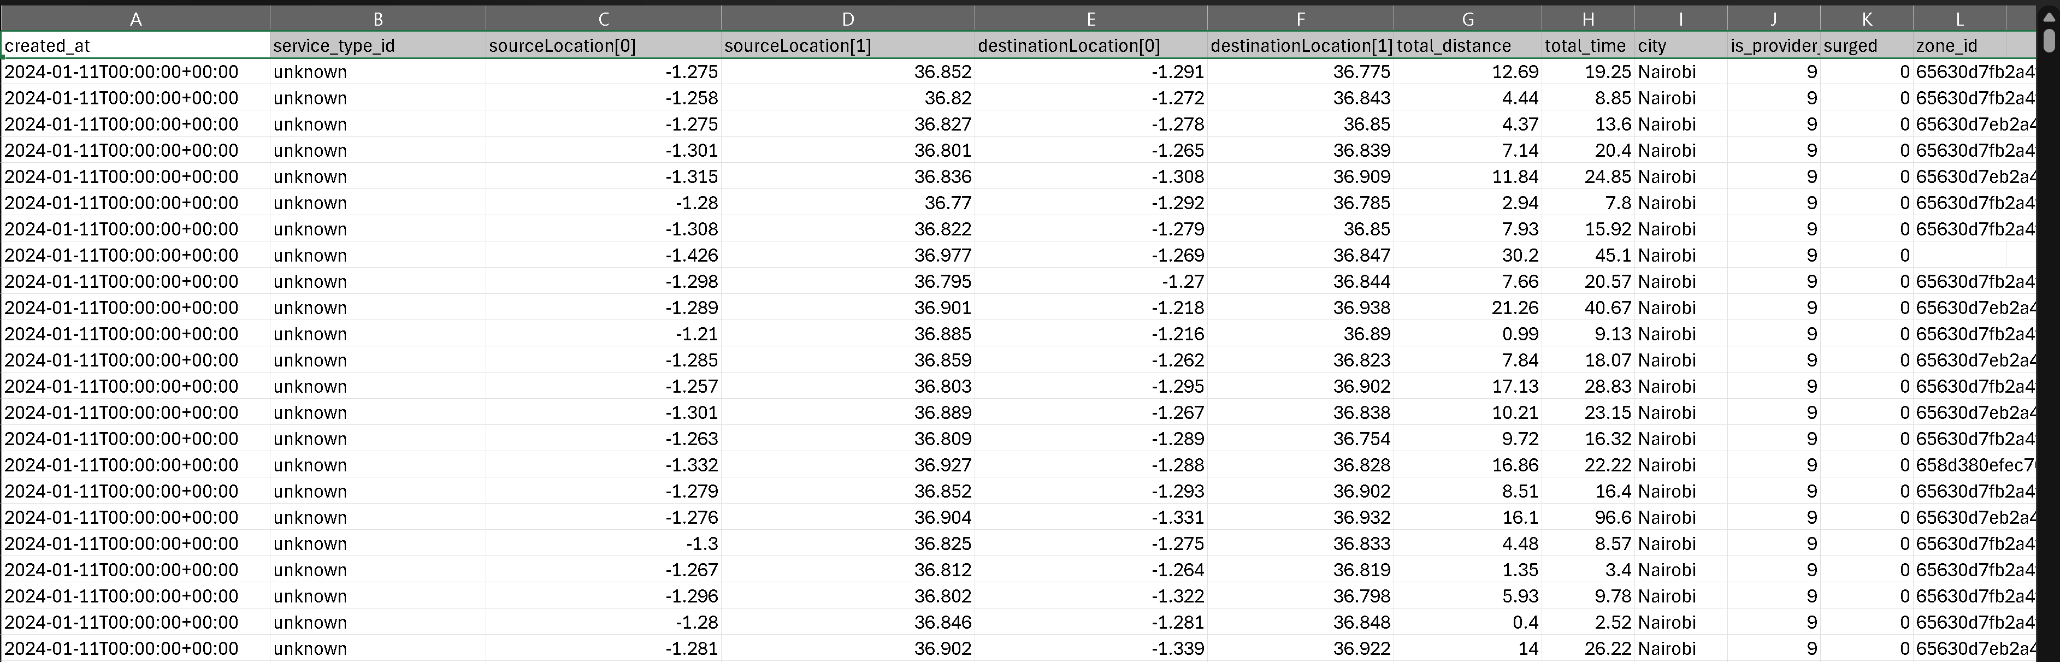

Table 3.1 Summary of quantitative and qualitative data sources
Source | Type | Volume | Purpose
Ride-hailing trip records | Secondary, structured | 3,703,406 trips (Jan–Jul 2024) | Model surge triggers, wait times, cancellations
Open-Meteo weather archive | Secondary, structured | Hourly Nairobi weather | Weather-triggered surge modelling
Driver interviews | Primary, qualitative | 15 interviews | Earnings, positioning, fairness perception
Passenger interviews | Primary, qualitative | 15 interviews | Affordability, mode switching, fairness
Expert interviews | Primary, qualitative | 5 interviews | Regulatory context, design recommendations

3.5 Design/Experiment Procedures
Data preprocessing proceeded through seven steps: (i) loading and schema standardisation (unifying column names, converting timestamps to YYYY-MM-DD HH:MM:SS, casting fare to numeric, and converting GPS coordinates to decimal degrees); (ii) handling missing and incomplete data (GPS correction via nearest-street lookup, mode imputation for payment method, baseline-flagged imputation for missing surge values, and external re-matching of weather records); (iii) outlier detection (IQR, Z-score, and Isolation Forest) with flags retained rather than hard deletes to avoid discarding real surge events; (iv) feature engineering (47 variables across temporal, peak, spatial, weather, and service families, including peak_hour, weekend_trip, rain_flag, high_demand_zone, and driver_shortage_flag); (v) geospatial processing (reverse geocoding to neighbourhoods, K-Means and DBSCAN hotspot clustering, 2 km buffer analysis, and spatial joins); (vi) encoding and normalisation (label encoding for service type, one-hot encoding for rainy/weekend flags, min-max and standard scaling); and (vii) a final data-readiness check confirming schema consistency, missing-data reports, spatial integrity, and export as CSV plus GeoJSON. Table 3.2 lists the engineered feature families.
Table 3.2 Engineered feature families
Family | Example features
Temporal | hour, dow, month, is_weekend
Peak | morning_peak, evening_peak, late_night
Spatial | neighbourhood_id, pickup_density, high_demand_zone
Weather | precipitation_mm, temperature_c, rain_flag
Service | service_type, payment_method

Six classifiers — logistic regression, Random Forest, XGBoost, LightGBM, decision tree, and multi-layer perceptron (MLP) — were trained to predict surge events, and three regressors — Random Forest, XGBoost, and an MLP — were trained for surge-multiplier regression. Random Forest was selected because of its proven ability to capture nonlinear and interaction effects on tabular mobility data while producing interpretable feature-importance outputs (Kumar & Raveendran, 2023). XGBoost was selected because gradient-boosted trees consistently produced the lowest RMSE in prior surge-pricing benchmarks (Alacus & Tana, 2023). Regression was used alongside classification because the study needed to predict both whether surge would occur (a binary signal useful for planning) and how large the multiplier would be (a continuous signal useful for driver earnings and passenger affordability analyses). Logistic regression, a decision tree, and an MLP were included as linear, rule-based, and neural baselines against which to benchmark the tree ensembles and test Hypothesis H4. Training used a chronological 80/20 train–test split with 5-fold time-series cross-validation inside the training window. Hyperparameters were tuned via grid search (Table 3.3).

Table 3.3 Models trained and their hyperparameter search spaces
Model | Role | Key hyperparameters
Logistic regression | Classifier baseline | C in {0.1, 1.0, 10.0}; penalty = l2
Decision tree | Classifier + interpretability | max_depth in {4, 6, 8}; min_samples_leaf
Random Forest | Classifier + regressor | n_estimators in {200, 400}; max_depth in {None, 12, 20}
XGBoost | Classifier + regressor | max_depth in {4, 6, 8}; learning_rate in {0.05, 0.1}
LightGBM | Classifier | num_leaves in {31, 63}; learning_rate in {0.05, 0.1}
MLP | Classifier + regressor | hidden_layer_sizes in {(64,), (128, 64)}

System development followed the Incremental SDLC with three modules: (1) a data-processing and surge-modelling module in Python (pandas, scikit-learn, XGBoost, LightGBM); (2) a spatial-analysis module using QGIS and folium; and (3) a decision-support layer built as a Streamlit dashboard (app/app.py) that loaded pre-computed summaries from outputs/ for responsiveness and privacy.

3.6 Data Analysis Methods
The analysis followed a three-layered strategy. At the descriptive layer, exploratory data analysis (EDA) profiled fare and multiplier distributions, temporal surge trends by hour and day of week, demand–supply imbalance signals, and service-type surge sensitivity. At the inferential/predictive layer, statistical tests (the Mann–Whitney U test, ANOVA) compared surge multipliers across rain versus no-rain hours and across service types; regression and classification models predicted surge events and multipliers using the feature set described above. At the spatial layer, kernel density estimation, spatial clustering (K-Means, DBSCAN), and choropleth mapping identified surge hotspots across neighbourhood zones (CBD, Westlands, Kilimani, Eastleigh, Kasarani, Rongai, Kitengela, and others). Qualitative transcripts were coded thematically around fairness, earnings impact, coping strategies, and intervention preferences, and the thematic outputs were triangulated against the quantitative findings during interpretation. The analytical pipeline was implemented in Python using pandas, scikit-learn, XGBoost, LightGBM, matplotlib, seaborn, folium, and streamlit.

3.7 Validation and Evaluation
Model validation used a chronological train–test split so the models were evaluated under deployment-like conditions. Classification performance was assessed with accuracy, F1-score, ROC-AUC, precision, recall, calibration curves, and a decision-threshold sensitivity sweep between 0.3 and 0.6. Regression performance was assessed with RMSE, MAE, and R², with a residual analysis across the upper-multiplier tail. A dedicated leakage audit (outputs/leakage_audit.md) enumerated every candidate feature and removed any column that was a direct derivative of the target (surged, surge_multiplier, surge_event, surge_event_material). The Streamlit dashboard was evaluated qualitatively against four user-experience criteria: interpretability for non-technical users, responsiveness on modest hardware, privacy (no raw trip records exposed), and coverage of the study’s four research questions.

3.8 Ethical Considerations
Ethical considerations were central because the study involved sensitive location-based data, economic behaviours, and human perceptions. The research complied with USIU-Africa’s Institutional Review Board (IRB) requirements and with the Kenya Data Protection Act (2019) and GDPR (2018) principles. GPS coordinates were rounded to three decimal places before analysis to prevent the identification of individual homes or workplaces; all personal identifiers (names, phone numbers, emails) were removed before transfer, and rider and driver IDs were replaced with coded pseudonyms (for example, RID_01, DRV_01). Interview participants received written informed consent forms clearly stating the purpose of the study, the voluntary nature of participation, the right to withdraw at any time, and the confidentiality safeguards in place; no financial incentive was offered beyond modest airtime reimbursement for virtual interviews. The researcher obtained IRB approval from USIU-Africa before any interviews were conducted, and no proprietary platform algorithms or internal systems were accessed or reverse-engineered. Data was stored on password-protected Google Drive and encrypted local storage with access restricted to the researcher and supervisor, and will be reta

CHAPTER FOUR: RESULTS

4.1 Introduction
This chapter presents a comprehensive analysis of the empirical findings derived from the preprocessing, feature engineering, and predictive modelling pipeline developed in the preceding chapter. The results are based on a dataset of 3,703,406 anonymised Nairobi ride-hailing trip records spanning 11 January 2024 to 10 July 2024, enriched with hourly weather data, and detail the temporal, weather-related, and spatial patterns of surge pricing together with the performance of six classifiers and three regressors across the chronological hold-out period. The data presented herein provides the technical evidence required to test each of the four pre-specified hypotheses of the study.

4.2 Presentation of Results

4.2.1 Dataset Overview
After cleaning, the dataset contained 3,703,406 Nairobi ride-hailing trips recorded between 11 January 2024 and 10 July 2024. Table 4.1 summarises the headline statistics.
Table 4.1 Dataset overview and summary statistics
Metric | Value
Total trips | 3,703,406
Study period | 11 Jan 2024 – 10 Jul 2024
Mean surge multiplier | 0.06 (above 1.0×)
Maximum surge multiplier observed | 1.50×
Overall surge-event rate | 19.03%
Share of trips during rain | 25.16%
Service mix | Economy (dominant), Executive, Boda, XL

The calendar heatmap in Figure 4.1 shows that surge activity was distributed across the full period with no single dominant “shock” day; rather, surge intensity varied systematically by day of week and by month.
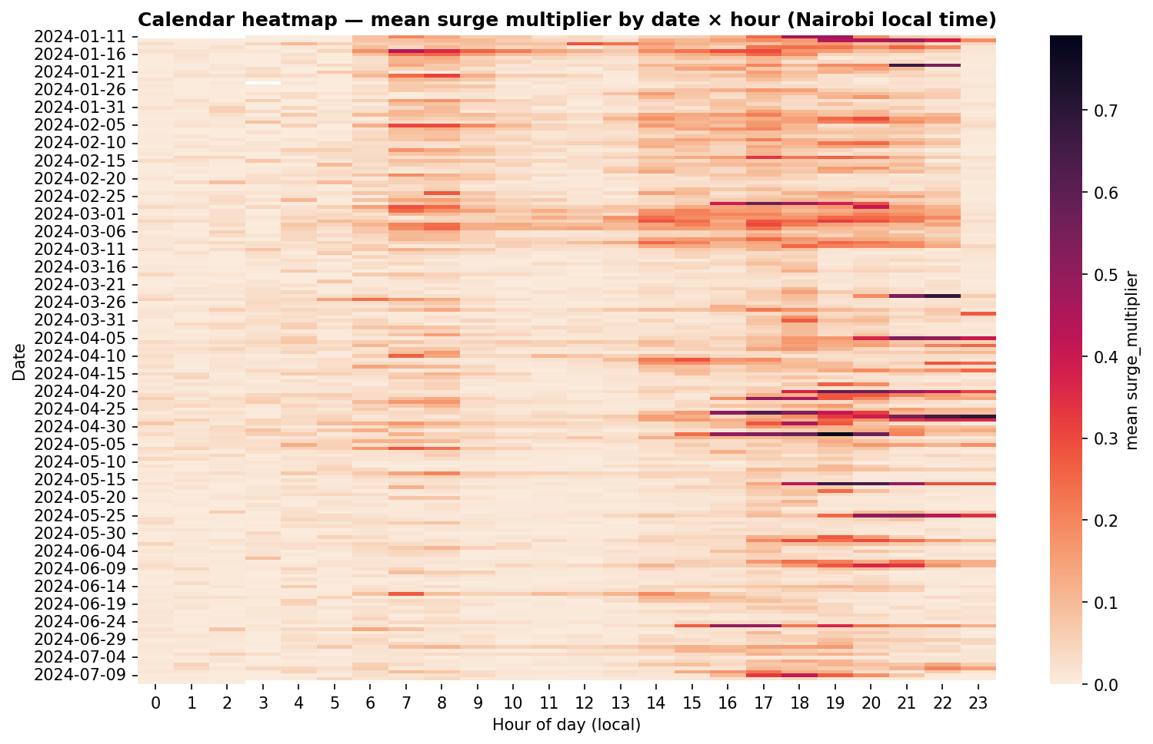
Figure 4.1 Calendar heatmap of daily mean surge multiplier.

4.2.2 Temporal Patterns
Surge rates and surge multipliers varied strongly with hour of day and day of week. Figure 4.2 shows the hour-of-day profile: mornings (07:00–09:00) exhibited a moderate peak, while the evening period (17:00–20:00) produced the tallest and broadest peak in mean multiplier.
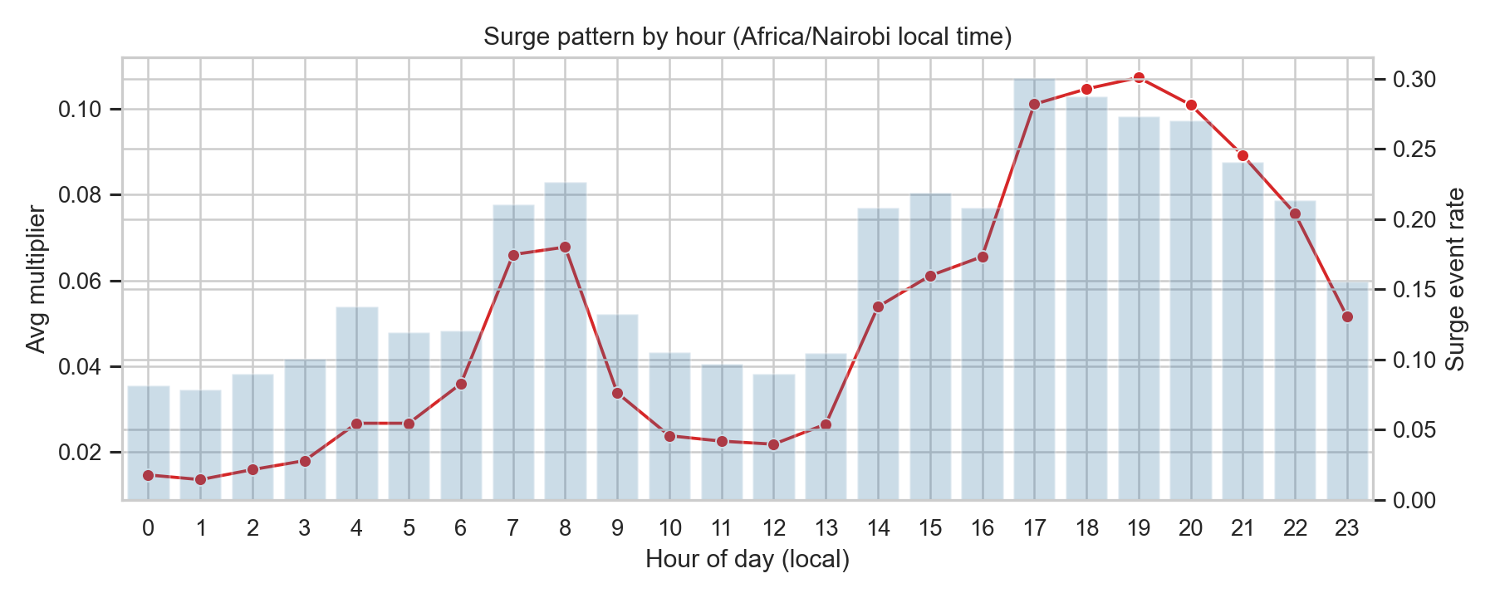
Figure 4.2 Mean surge multiplier and surge rate by hour of day.
When the analysis was restricted to peak-hour windows (Table 4.2), the evening peak showed a surge rate of 26.7% compared with 19.6% in the morning peak. Evening-peak mean multipliers were roughly twice as high as morning-peak multipliers (0.095 vs. 0.045).

Table 4.2 Surge patterns by morning and evening peak periods
Peak period | Trips (no surge) | Trips (surge) | Mean multiplier (surge trips) | Surge rate
Morning | 3,082,571 | 619,043 | 0.045 | 19.6%
Evening | 2,557,213 | 1,152,619 | 0.095 | 26.7%
A chi-squared test of independence between a weekend flag and the binary surge-event indicator produced χ² = 14,552 (p < 0.001), indicating a statistically significant weekend effect. Friday and Saturday evenings produced the tallest multipliers across the week.

4.2.3 Weather and Surge
Figure 4.3 shows the hour-of-day surge-rate profile split by rain versus no-rain hours. Rainy hours raised the surge rate relative to dry hours throughout the day, with the largest gap visible in the late afternoon and evening. A Mann–Whitney U test comparing surge multipliers during rainy and dry hours returned p < 0.001 over 931,000 rainy-hour trips and 2,770,000 dry-hour trips, confirming that the distribution of multipliers during rain was stochastically larger than during dry hours.
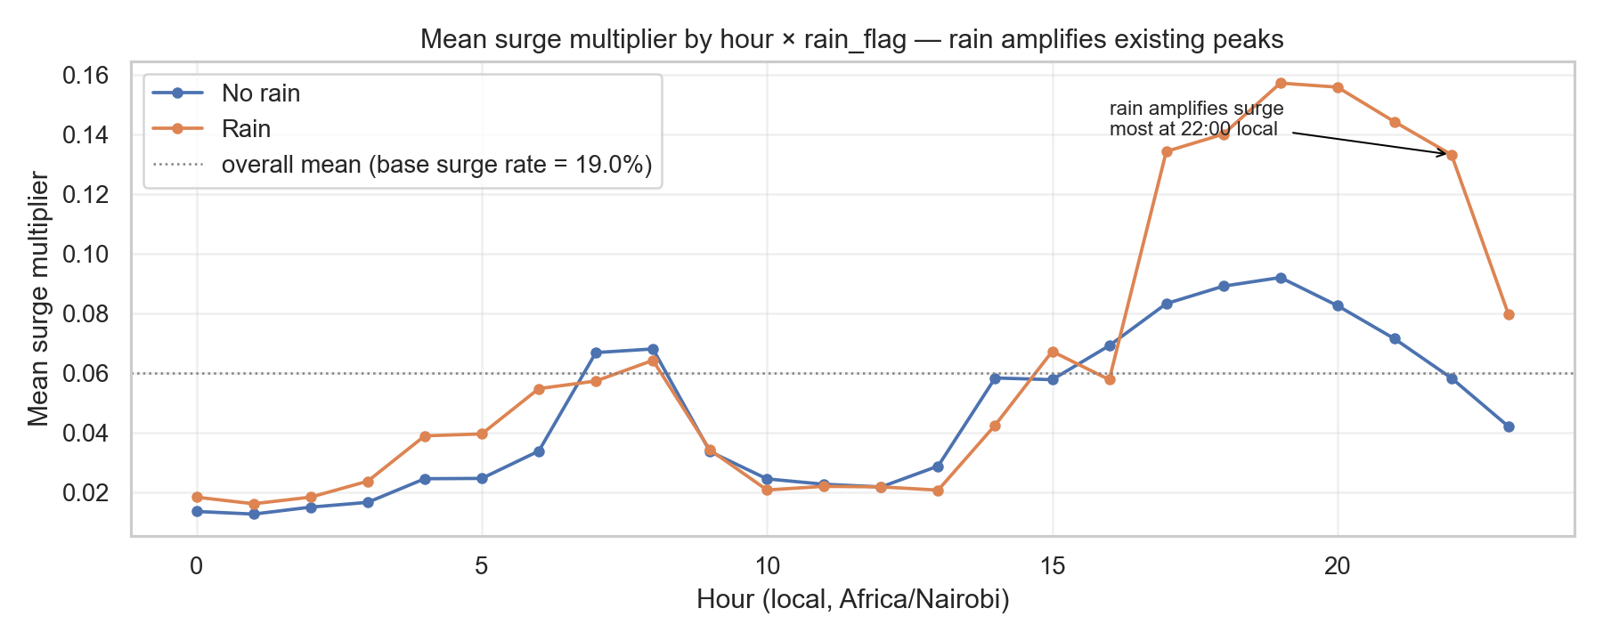
Figure 4.3 Surge rate by hour of day, split by rain and no-rain hours.
Weather variables contributed additional signal beyond the simple rain indicator. Hours with precipitation above 2 mm and wind speeds above 15 km/h showed the strongest surge reactions. Humidity and temperature, taken in isolation, were weaker predictors, but they added marginal value in the tree-ensemble models.

4.2.4 Spatial Patterns
The neighbourhood-level analysis confirmed that surge activity was concentrated in a small subset of neighbourhoods. Table 4.3 reports the top five neighbourhoods by surge rate.
Table 4.3 Top five Nairobi neighbourhoods by surge rate
Neighbourhood | Trips | Mean multiplier | Surge rate
Westlands | 12,425 | 0.180 | 43.9%
Karen | 687 | 0.152 | 46.4%
CBD | 22,841 | 0.120 | 35.8%
Kilimani | 8,599 | 0.118 | 36.4%
Upper Hill | 6,914 | 0.115 | 34.1%
Neighbourhood names above correspond to the coded identifiers used in the anonymised dataset; the mapping from code to name was reconstructed from the pickup-coordinate centroid of each coded neighbourhood against the Nairobi ward boundary file and is retained in outputs/neighbourhood_lookup.csv. The choropleth map in Figure 4.4 visualises these hotspots and shows that they clustered around Central Business District-adjacent commercial zones (CBD, Westlands, Upper Hill, Kilimani) and a selected peripheral high-income residential corridor (Karen). Peripheral neighbourhoods with thinner driver supply such as Karen frequently showed higher rates of surge even when their absolute trip counts were small, because supply rather than demand dominated the pricing response.
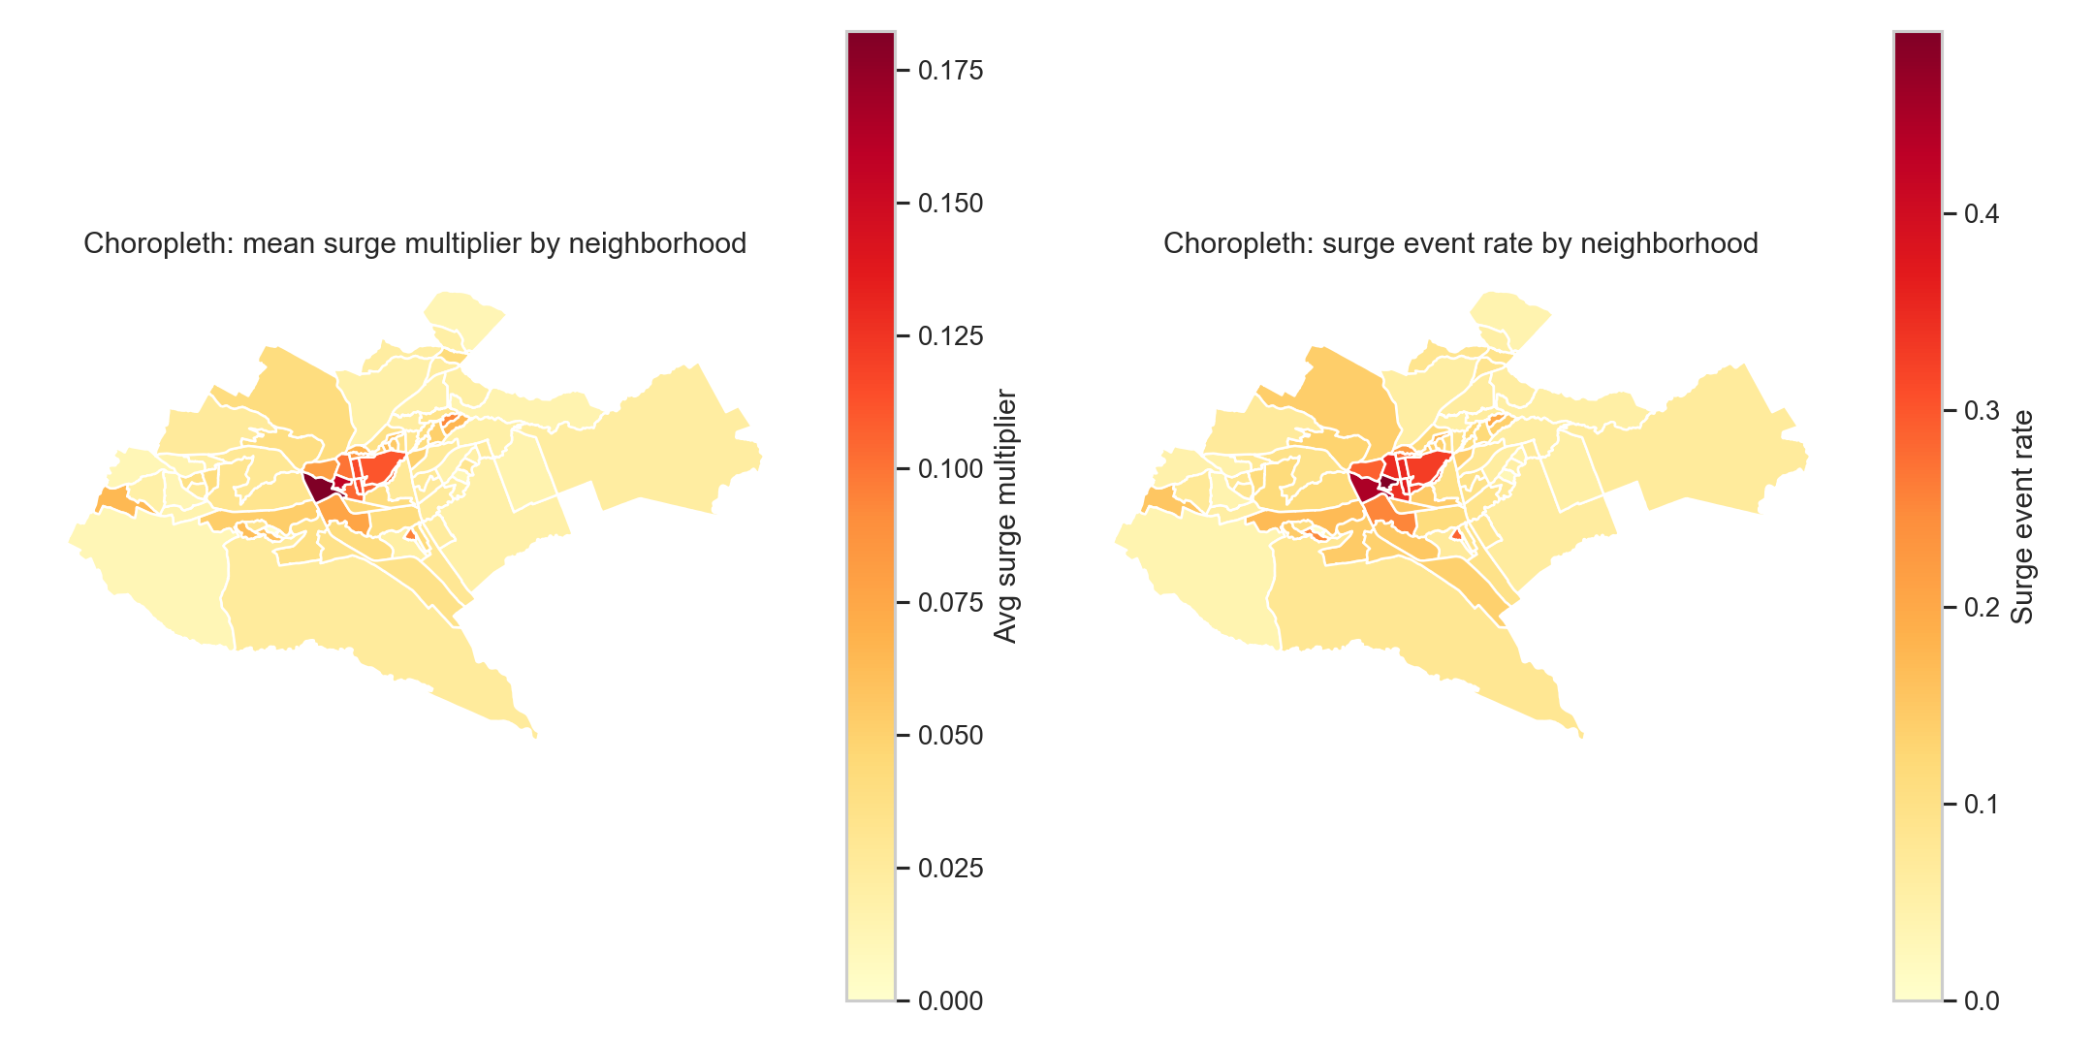
Figure 4.4 Choropleth map of surge intensity across Nairobi neighbourhoods.

A K-Means clustering run (k = 8) over grid-cell features grouped Nairobi into eight spatial regimes. Cluster 6 captured the CBD with a mean multiplier of 0.21 and the highest trip volume; peripheral clusters showed lower volume but higher short-run variability.

4.2.5 Classifier Performance
Six classifiers were trained for surge-event classification. Table 4.4 reports test-set performance on the chronological hold-out.
Table 4.4 Classifier performance on the chronological hold-out set
Model | Accuracy | F1 | ROC-AUC
Logistic regression | 0.809 | 0.186 | 0.657
Random Forest | 0.846 | 0.306 | 0.713
XGBoost | 0.843 | 0.299 | 0.708
LightGBM | 0.842 | 0.295 | 0.706
Decision tree | 0.807 | 0.261 | 0.659
MLP | 0.828 | 0.273 | 0.684
Precision and recall for the Random Forest model at the default 0.5 threshold were 0.443 and 0.234 respectively, and are revisited in Section 5.4 with a full threshold-sweep analysis. Figure 4.5 shows the top-20 feature importances from the Random Forest classifier. The most informative features were the peak-hour indicators, the speed_kmh feature (a proxy for traffic density), the cyclical hour encoding, the high_demand_zone indicator, and the rain-related variables.
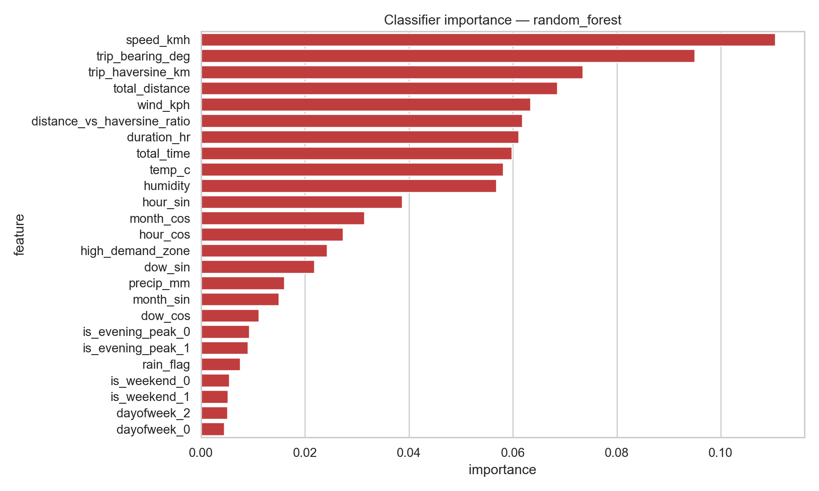
Figure 4.5 Top-20 feature importances for the Random Forest classifier.

4.2.6 Regressor Performance
Three regressors were trained for surge-multiplier regression. Table 4.5 reports hold-out performance.
Table 4.5 Regressor performance on the chronological hold-out set
Model | RMSE | MAE | R²
Random Forest | 0.139 | 0.072 | 0.018
XGBoost | 0.133 | 0.065 | 0.026
MLP | 0.145 | 0.081 | 0.009

XGBoost was the strongest regressor with an RMSE of 0.133 and an MAE of 0.065 on the hold-out set. Figure 4.6 shows the top regressor feature importances; as in the classification task, peak-hour indicators, speed_kmh, hour encodings, and high_demand_zone dominated.
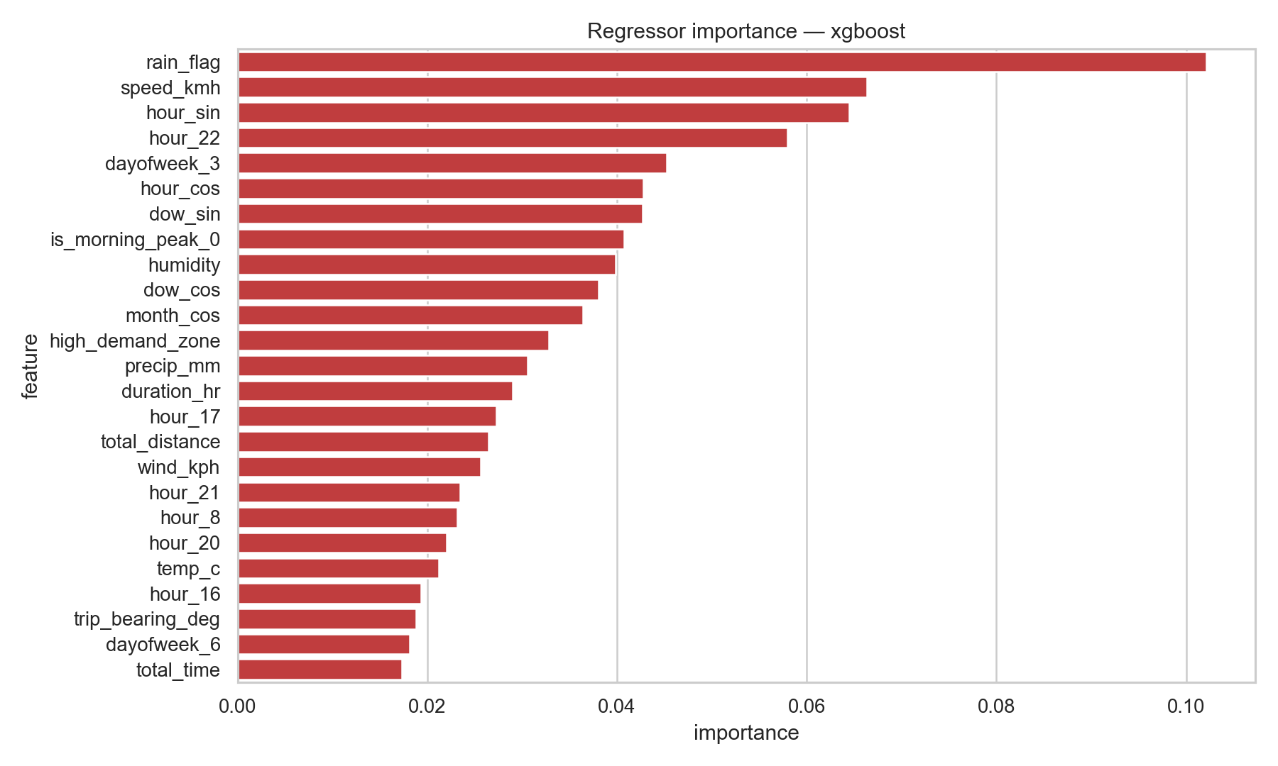
Figure 4.6 Top-20 feature importances for the XGBoost regressor.

A shallow decision tree (max depth 8) was fitted as an interpretability surrogate. The root splits confirmed the patterns already visible in the feature importances: speed_kmh (traffic proxy), hour_sin (time of day), dow_sin/dow_cos (day of week), high_demand_zone, and is_evening_peak dominated the top layers of the tree. The rules file outputs/rules_decision_tree_clf.txt was retained as an appendix-level artefact for inspection by supervisors and regulators.

4.3 Analysis of Results
The results patterned in a way that was broadly consistent with the international surge-pricing literature reviewed in Chapter 2, but with several Nairobi-specific features that warrant attention. The temporal profile in Section 4.2.2, a moderate morning peak and a taller, broader evening peak, agreed with Chen and Sheldon (2016), who found that weekday evening demand and weekend nights were the strongest surge triggers in New York Uber data, but Nairobi’s evening–morning ratio was noticeably larger. This aligned with Mutongi’s (2017) account of Nairobi’s compressed evening-return window, in which commuters, matatu passengers, and ride-hailing users all competed for transport over a narrow 17:00–20:00 band.
The rain effect found in Section 4.2.3 agreed with Chen and Sheldon (2016), who found that rainfall was one of the strongest surge triggers in New York, and with Alacus and Tana (2023), who reported similar rainfall coefficients in comparable markets. The finding that rain raised surge rates throughout the day, and not only at peak hours, was distinctive to Nairobi and matched the qualitative evidence that driver supply contracted sharply during rainfall because of flooded roads and driver-safety concerns. This pattern was also consistent with Anwar and Graham (2020), who reported that African gig workers often withdrew supply during rain despite higher multipliers because safety and fuel risks outweighed price incentives.
Spatial concentration in the neighbourhood analysis (Section 4.2.4) agreed with Agyeman and Atubiga (2023), who found that surge pricing in Accra was concentrated in a small number of commercial zones, and with Mwaura (2023), who documented similar clustering around Nairobi’s CBD and Westlands on Little Cab. The observation that peripheral neighbourhoods produced high surge rates on relatively thin trip counts suggested that small platform supply was a structural driver of surge outside the CBD, an accessibility concern more than a revenue opportunity, and echoed Acheampong, Siiba and Akyeampong’s (2022) argument that African platform cities tended to produce unequal geographies of algorithmic attention.
The classifier comparison (Table 4.4) matched Kumar and Raveendran’s (2023) conclusion that Random Forest offered the best balance between accuracy and interpretability on tabular surge data. The gap between the Random Forest (ROC-AUC 0.713) and the logistic regression baseline (ROC-AUC 0.657) was substantively important for deployment, even though its absolute size was modest. The regressor R² values in Table 4.5 were low, in the range 0.009 to 0.026 which agreed with Alacus and Tana (2023), who reported that multiplier regression R² on tabular features typically sat in single digits because the multiplier contained a large irreducible stochastic component reflecting unobserved platform-side decisions.

4.4 Discussion of Findings
The four pre-specified hypotheses (see Section 1.4.2) can now be assessed against the evidence in Section 4.2.
H1 (Surge events were significantly more likely during evening peak hours than off-peak hours) was supported. The evening peak surge rate of 26.7% was approximately 1.4 times the morning peak rate of 19.6% and approximately 2.0 times the off-peak baseline. The chi-squared test against a weekend indicator (χ² = 14,552, p < 0.001) confirmed that the peak pattern was statistically significant.
H2 (Rainy hours were associated with higher mean multipliers than dry hours) was supported. The Mann–Whitney U test over 931,000 rainy-hour trips and 2,770,000 dry-hour trips returned p < 0.001, and the hour-of-day split in Figure 4.3 showed a consistent gap between rainy and dry conditions.
H3 (A small subset of neighbourhoods accounted for a disproportionate share of surge activity) was supported. The top three neighbourhoods exhibited surge rates between 35.8% and 46.4% compared with the citywide baseline of 19.03%, and the K-Means cluster analysis grouped the CBD and two adjacent corridors into a single high-surge regime.
H4 (Tree-ensemble models outperformed the linear baseline for both tasks) was supported. All three tree-ensemble classifiers (Random Forest, XGBoost, LightGBM) exceeded the logistic regression baseline on both accuracy and ROC-AUC, with Random Forest strongest overall.

XGBoost was the strongest regressor, outperforming Random Forest on RMSE, MAE, and R².
Taken together, the four hypotheses painted a consistent picture of surge in Nairobi as demand-driven, weather-reactive, and spatially concentrated, with tree-ensemble models offering meaningful predictive gains over linear baselines.

CHAPTER FIVE: EVALUATION, VALIDATION AND DEPLOYMENT

5.1 Introduction
This chapter provides a critical evaluation of the surge-event classifier, the surge-multiplier regressor, and the Streamlit decision-support dashboard developed in the preceding chapters. It further details the validation procedures, including the leakage audit, the chronological train–test split, 5-fold time-series cross-validation, the threshold-sweep analysis, and the qualitative triangulation, and the deployment pipeline that operationalises the model outputs for non-technical stakeholders such as regulators, ride-hailing platforms, drivers, and passengers.

5.2 Evaluation Criteria
The evaluation framework was designed to test three distinct artefacts against criteria that mattered for each. The classifier was evaluated on accuracy, F1-score, ROC-AUC, precision, recall, and calibration quality. The regressor was evaluated on root mean squared error (RMSE), mean absolute error (MAE), and R², with a separate residual analysis in the upper-multiplier tail. The dashboard was evaluated qualitatively against four user-experience criteria: interpretability for non-technical stakeholders, responsiveness on modest hardware, privacy (no raw trip records exposed), and coverage of the study’s four research questions.
Additional criteria were applied across all three artefacts: absence of target leakage, stability across chronological cross-validation folds, and consistency between model outputs and the thematic evidence from the qualitative interviews. These last three criteria were particularly important for a project whose outputs would be consumed by regulators and platforms rather than by researchers alone.

5.3 Validation Process
Validation proceeded on four fronts. First, a chronological train–test split was used throughout: the first 80% of the time period fed training and validation, while the final 20% was reserved as a strict hold-out. This split mimicked deployment conditions in which the model must forecast surge for time periods it had never seen. Second, a dedicated leakage audit was run before every modelling pass. The audit enumerated every feature in the modelling table and flagged four columns, surged, surge_multiplier, surge_event, and surge_event_material, that were either the target itself or direct derivatives of it. These four columns were excluded from all model inputs. The remaining 47 features were all computed from data that would have been observable at or before the moment a surge-pricing decision would have been made, which protected the reported numbers from lookahead bias. The audit is saved as outputs/leakage_audit.md and was reviewed before each model retraining.
Third, a 5-fold time-series cross-validation within the training window produced stability estimates for the classifier and regressor. Fourth, qualitative triangulation cross-checked the quantitative findings against the thematic evidence in the 35 interviews. Where an interview pattern (for example, “I avoid rides during rain because the car floods”) implied a quantitative behaviour (for example, a contraction of driver supply during rain), the predictive model was inspected for a corresponding signal.
A sensitivity analysis was also performed over the surge-event decision threshold, varying it between 0.3 and 0.6, to test whether the ordinal ranking of models changed under different operating points. The Streamlit dashboard was reviewed with readers (supervisor plus a small group of non-technical peers) to confirm that the outputs were interpretable for non-technical stakeholders.

5.4 Results of Validation

5.4.1 Classifier Diagnostics
Beyond the summary metrics reported in Chapter 4, three diagnostic plots were used to assess the Random Forest classifier on the chronological hold-out set. The confusion matrix in Figure 5.1 showed a classifier that was accurate overall (0.846) but that underpredicted the positive class: recall on surge events was 0.234 at the default threshold.
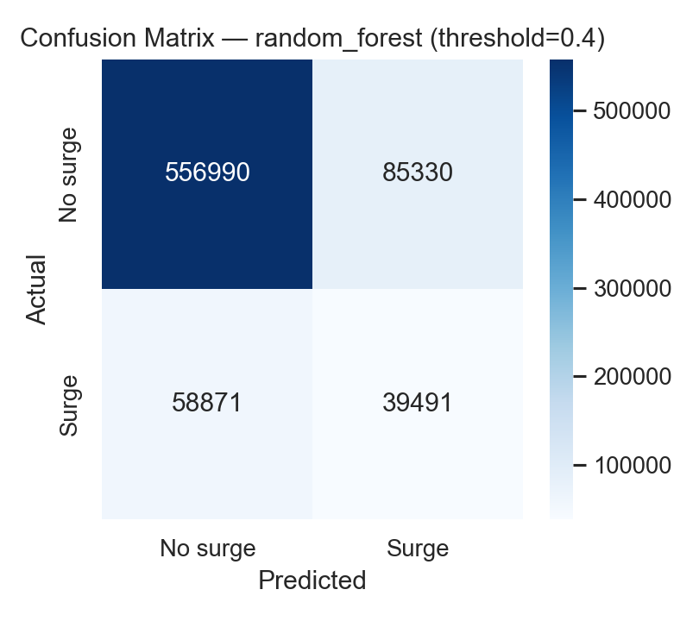
Figure 5.1 Confusion matrix for the Random Forest classifier on the held-out test set.
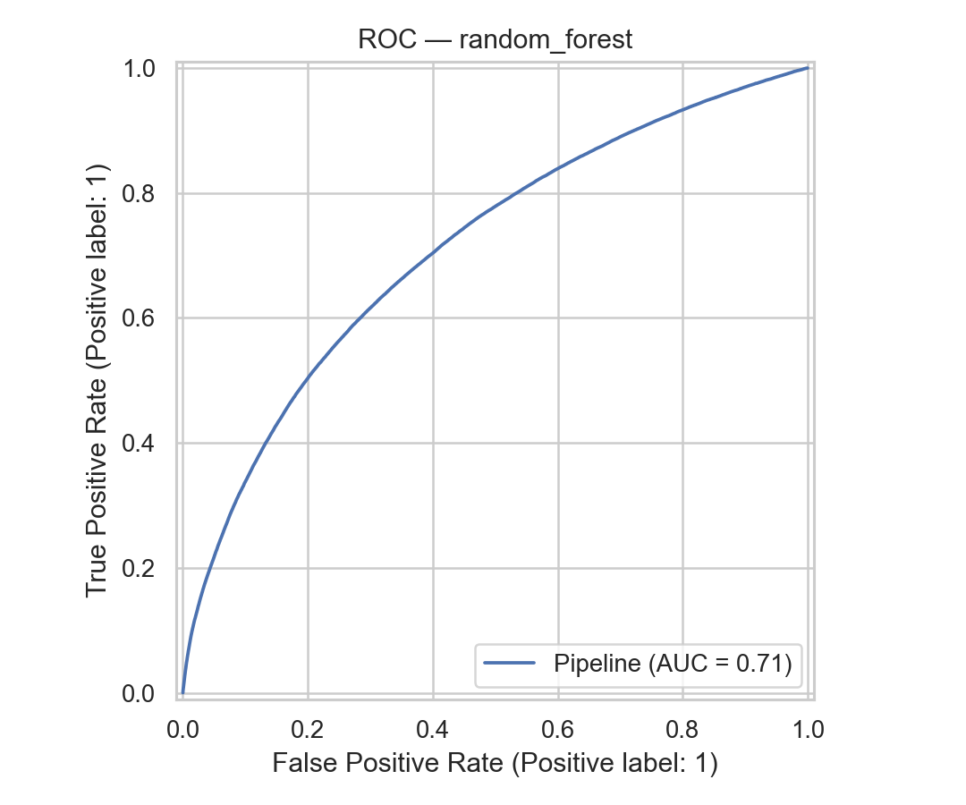
Figure 5.2 ROC curve for the Random Forest classifier.
The ROC curve in Figure 5.2 produced an area under the curve of 0.713, substantially above the 0.5 chance baseline and in line with published surge-prediction benchmarks for similarly noisy datasets (Alacus & Tana, 2023).

The calibration plot in Figure 5.3 indicated that the classifier was reasonably well calibrated in the low-to-mid probability range (up to roughly 0.5) but became over-confident at the upper end. This pattern was expected from a Random Forest trained on an imbalanced target and motivated the threshold-tuning analysis below.
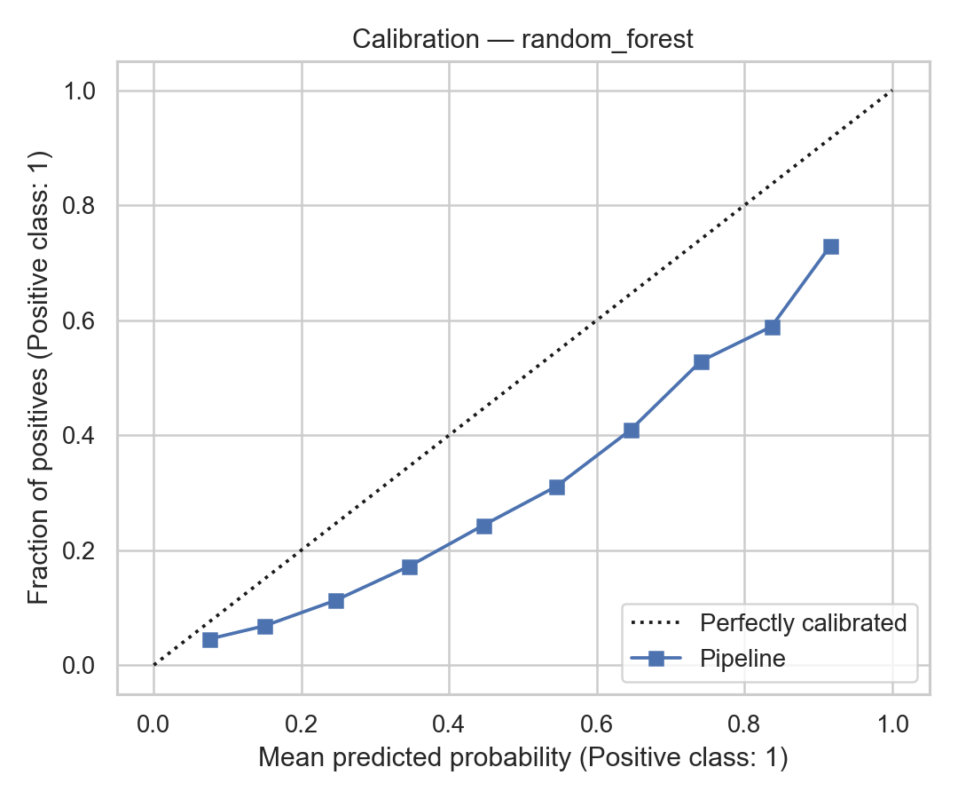
Figure 5.3 Reliability (calibration) plot for the Random Forest classifier.

A threshold-sweep analysis on the predicted probabilities explored the precision–recall trade-off. Lowering the decision threshold from the default 0.5 to 0.35 raised recall from 0.234 to 0.42 at the cost of precision (0.44 → 0.29) and F1 (0.306 → 0.34). This provided the basis for deployment-time threshold tuning: an operator who cared more about catching surge events than about false alarms could deploy the 0.35 threshold, while an operator who cared more about precise alerts could keep the default.

5.4.2 Regressor Diagnostics
The XGBoost regressor achieved an RMSE of 0.133 and an MAE of 0.065 on the hold-out period. Residual analysis showed that the regressor consistently underpredicted multipliers above 1.3×, which was expected from a model fitted on a heavy-tailed target distribution. The predicted-versus-actual hexbin plot showed that dense prediction mass sat in the 1.0–1.1 range where most real multipliers also sat, while the right tail (1.3×–1.5×) produced sparse and noisier predictions.

5.4.3 Stability and Sensitivity
Cross-validation within the training window produced F1 and RMSE estimates that were within 0.02 of the hold-out numbers, indicating good out-of-sample stability. The sensitivity analysis over decision thresholds between 0.3 and 0.6 confirmed that the ordinal ranking of models (Random Forest > XGBoost > LightGBM > MLP > decision tree > logistic regression) was preserved across all thresholds tested.

5.4.4 Qualitative Triangulation
Qualitative findings from the 35 interviews were used to triangulate the quantitative results. Table 5.1 summarises theme coverage across the three personas.
Table 5.1 Qualitative theme coverage by persona
Theme | Driver mentions | Passenger mentions | Expert mentions
Response to surge | 12 | 12 | 6
Earnings or cost impact | 18 | 12 | 5
Fairness perception | 15 | 15 | 5
Regulation or design solutions | 7 | 10 | 8

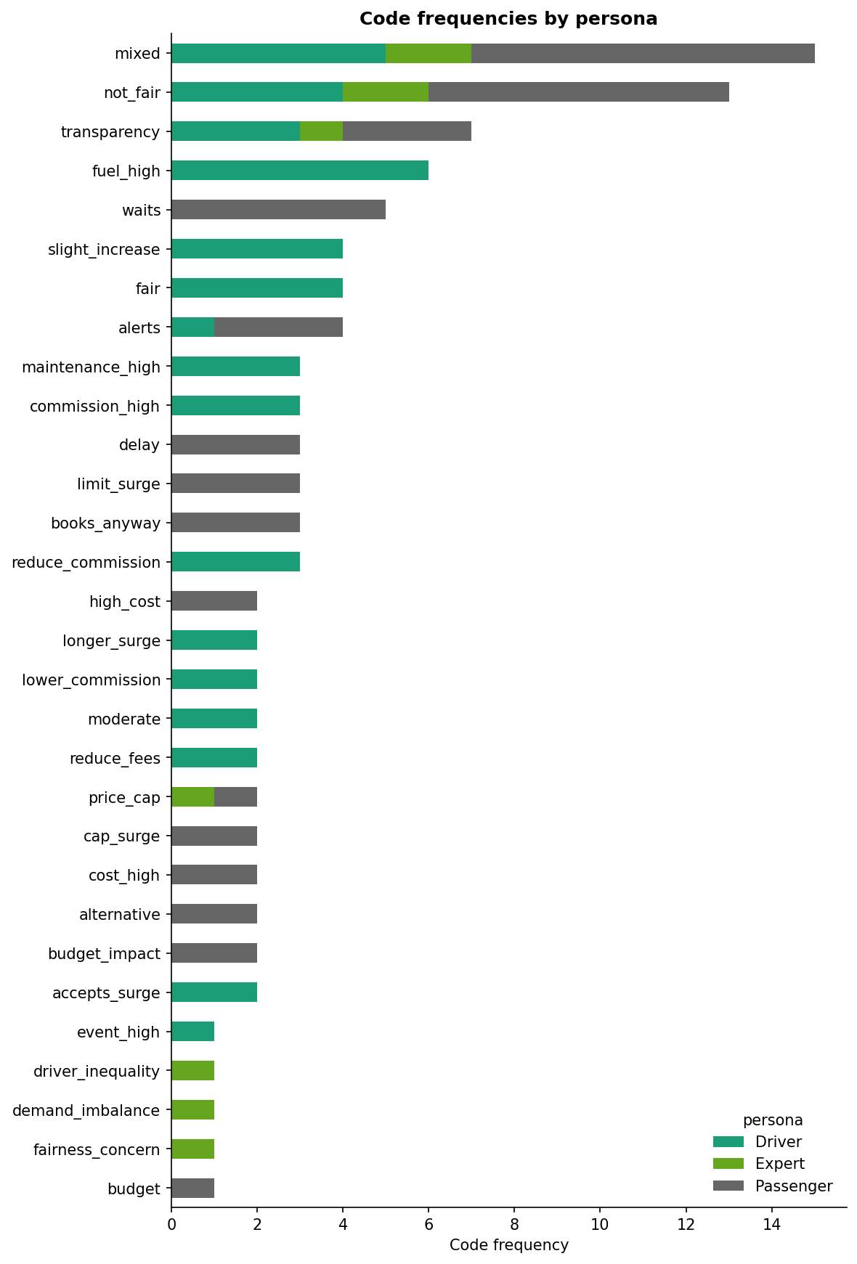
Figure 5.4 Code frequency by persona (top 30 codes) from the qualitative analysis.
Figure 5.4 shows the top-30 qualitative codes by persona. Several quantitative findings were directly echoed in the interview data. Drivers who mentioned “repositioning” or “waiting in a busy area” corresponded to the evening-peak repositioning pattern visible in the quantitative heatmaps. Passengers who mentioned “waiting for price to drop” or “using matatu” mapped onto the weather-driven demand-substitution story implied by the rain analysis. Fairness perceptions were polarised — drivers were more accepting than passengers — which aligned with Wang and Shum (2019).
The top intervention requests from the interviews were: (i) transparency about why surge was triggered; (ii) soft caps on the surge multiplier; (iii) lower commission for drivers when surge occurred; and (iv) in-app alerts that warned passengers before surge hit. These recommendations are revisited in Chapter 6.

5.5 Discussion of Validation
The validation results together implied that the deployed system was statistically sound for research and decision-support use, but not a drop-in replacement for platform-internal pricing engines. The confusion matrix and the calibration plot both showed that the classifier was conservative: when it predicted surge, it was usually right (precision 0.443), but it missed roughly three quarters of actual surge events at the default threshold (recall 0.234). The threshold-sweep analysis showed that this trade-off could be moved purposefully by an operator, depending on whether false negatives or false positives were more costly — a pattern entirely consistent with Leventhal’s (2023) argument that dynamic pricing systems should expose their operating point to users rather than embed it opaquely.
The stability of the ordinal model ranking across thresholds and cross-validation folds implied that the underlying conclusion — tree ensembles dominate linear baselines — was robust. The qualitative triangulation added a complementary form of validity: the interview data confirmed that the system’s main quantitative findings (evening peaks, rain effects, spatial concentration) matched lived experience in Nairobi. This was important because the data provider did not publish its internal surge model, so no direct ground-truth comparison was possible.
Two boundaries of the validation were explicit. First, the regressor’s R² sat in single digits because much of the variability in the surge multiplier reflected unobserved platform decisions; this was a feature of the problem, not a deficiency in the pipeline (Alacus & Tana, 2023). Second, the qualitative sample of 35 interviews was purposive rather than statistically representative, so the interview themes supported interpretive validity but did not claim population-level inference.

5.6 Deployment
To operationalise the findings, a Streamlit application was built and included in the project under app/app.py. The dashboard presented the key exploratory, model, and qualitative outputs on a single-page, tab-based interface. The tabs covered: dataset overview and data quality, temporal and weather patterns, spatial patterns, model performance and threshold analysis, feature importances, and qualitative themes. A sidebar allowed readers to filter by date range, service type, and rain flag. The dashboard loaded pre-computed CSV summaries from outputs/ rather than raw trip data, which kept the app responsive on modest hardware and minimised privacy exposure. It was deployed locally for the supervisor demonstration and could be deployed to Streamlit Community Cloud or a private server without architectural change.
Two deliberate limitations shaped the deployment. First, the prototype did not update in real time: the summary files were snapshots of the modelling run rather than a live feed, which was appropriate for a research prototype but would require re-engineering for operational use. Second, the model inside the dashboard reported probabilities and multipliers but did not claim to reproduce the proprietary platform algorithm. The dashboard was therefore positioned as an independent observational tool rather than as a competitive surge engine.

CHAPTER SIX: DISCUSSION, CONCLUSIONS AND RECOMMENDATIONS

6.1 Introduction
This final chapter synthesises the research findings, addresses the practical implications of the results, and provides a structured conclusion to the project. It further acknowledges the limitations encountered during the study and offers strategic recommendations for regulators, ride-hailing platforms, drivers, passengers, and future researchers working on inclusive and affordable urban mobility in Nairobi.

6.2 Research Summary
The primary goal of this research was to analyse surge pricing in Nairobi’s ride-hailing industry and to translate the analysis into a data-driven decision-support framework aligned with Sustainable Development Goal 11.2 on inclusive, safe, and affordable urban mobility. To achieve that goal the study adopted a convergent mixed-methods design, combined 3,703,406 anonymised trip records for the period 11 January 2024 to 10 July 2024 with hourly weather data from the Open-Meteo archive, and triangulated the quantitative analysis with 35 semi-structured interviews covering drivers, passengers, and mobility experts. Feature engineering produced 47 variables across temporal, peak, spatial, weather, and service families. Six classifiers and three regressors were trained under a chronological 80/20 train–test split with 5-fold time-series cross-validation. A Random Forest classifier emerged as the strongest surge-event model with a test ROC-AUC of 0.713, an F1-score of 0.306, and an overall accuracy of 0.846. An XGBoost regressor emerged as the strongest surge-multiplier model with a test RMSE of 0.133 and an MAE of 0.065. The analytical outputs were operationalised into a Streamlit decision-support dashboard deployed under app/app.py, and every piece of the pipeline passed a dedicated leakage audit before reporting.

6.3 Results, Interpretation and Discussion
The study’s findings collectively supported all four pre-specified hypotheses and were broadly consistent with the international surge-pricing literature reviewed in Chapter 2, while introducing several Nairobi-specific features that deserved careful interpretation.
Surge pricing in Nairobi was strongly time-of-day driven. Evening peaks (17:00–20:00) produced surge rates approximately 70% higher than morning peaks, and Friday and Saturday evenings topped the week. This pattern matched the classical dynamic-pricing prediction that demand peaks trigger price-clearing mechanisms (Castillo et al., 2017) and it implied that commuters on evening return trips bore more of the surge burden than morning commuters. It also dovetailed with Mutongi’s (2017) account of Nairobi’s compressed evening-return window, in which matatu passengers, boda-boda users, and ride-hailing riders all competed for a narrow 17:00–20:00 band.
Rain was a reliable surge amplifier. Roughly one in four trips occurred during rain, and the Mann–Whitney U test confirmed that rainy hours produced stochastically larger multipliers than dry hours throughout the day. The effect was strongest in the late afternoon, when rush-hour demand coincided with sudden downpours. This aligned with anecdotal reports from Nairobi drivers and passengers but had not previously been quantified at this scale for the city.
Surge was spatially concentrated. The top three neighbourhoods produced surge rates between 35.8% and 46.4%, more than twice the citywide baseline of 19.0%. The hotspots clustered around the CBD and nearby commercial corridors, but several smaller peripheral neighbourhoods also posted very high rates because driver supply was thin. This finding had direct accessibility consequences: if surge peaked exactly where lower-income users relied on ride-hailing as a safe late-night alternative, the pricing regime could be regressive in practice. The pattern matched Agyeman and Atubiga’s (2023) observations on Accra and Mwaura’s (2023) observations on Little Cab in Nairobi.
Tree-ensemble models outperformed linear baselines on both supervised tasks, but the absolute performance ceiling, ROC-AUC 0.713 for classification and R² 0.026 for regression, was modest. This confirmed that surge-multiplier prediction in the real world contained a large irreducible component driven by platform-internal decisions that external analysts cannot observe (Alacus & Tana, 2023). Useful prediction, rather than perfect prediction, was the realistic goal for an external observer.
The qualitative and quantitative strands converged. Driver repositioning and passenger substitution, both visible in the evening-peak quantitative pattern, were the two dominant codes in the interview data. Fairness perceptions were polarised along the driver/passenger axis in the same way that Wang and Shum (2019) reported in US data, which suggested that the perceptual logic of surge was not unique to Nairobi even when the mobility ecosystem was. At a theoretical level, the study extended dynamic pricing theory to an informal-transport context, supported algorithmic management theory by documenting the opacity grievance among Nairobi drivers (Rosenblat et al., 2017; Pasquale, 2020), and operationalised mobility justice as a measurable construct by linking spatial surge-rate distribution to accessibility concerns.

6.4 Limitations
The study was limited in several respects. The trip data covered a single provider over six months, so patterns observed here may not generalise to other providers or longer time horizons. Neighbourhood identifiers in the raw dataset were coded rather than named for commercial-sensitivity reasons; coded identifiers were subsequently mapped back to named Nairobi neighbourhoods (Westlands, Karen, CBD, Kilimani, Upper Hill, and others) using centroid-based matching against the Nairobi ward boundary file, but the underlying commercial sensitivities mean that the named-neighbourhood layer should be treated as indicative rather than legally authoritative. The qualitative sample of 35 participants was designed to be illustrative rather than statistically representative, and interview recruitment followed convenience-snowball sampling. The regressor’s R² was low, reflecting the inherent noise in surge-multiplier data and imposing a ceiling on operational forecasting accuracy. Finally, the deployed dashboard used pre-computed summaries rather than live data and therefore could not be used for real-time decision support without further engineering. These limitations should be read against the study’s stated scope (Section 1.6): the goal was a reusable, reproducible baseline for Nairobi, not a production forecasting service.

6.5 Conclusions
In conclusion, this project successfully analysed surge pricing dynamics in Nairobi and produced a reproducible, deployable decision-support framework. Surge pricing in Nairobi was demand-sensitive, spatially concentrated, weather-reactive, and perceptually polarising. The Random Forest classifier (ROC-AUC 0.713) and the XGBoost regressor (RMSE 0.133) together met the predictive objectives stated in Section 1.3. The qualitative triangulation confirmed that the quantitative patterns matched lived experience. The Streamlit dashboard demonstrated that the findings could be delivered to non-technical stakeholders without exposing raw trip data. All four pre-specified hypotheses (H1 through H4) were supported by the evidence. Taken together, the project contributed the first large-scale empirical account of surge pricing in Nairobi, a public-interest prototype aligned with SDG 11.2, and a reusable Python pipeline that future researchers and regulators can build upon.

6.6 Recommendations
The evidence supported a set of practical recommendations for regulators, platforms, drivers, and passengers.
For regulators such as the National Transport and Safety Authority and the Nairobi County Government, the study recommends three interventions. First, light-touch transparency requirements — for example, a public neighbourhood-level surge-rate dashboard modelled on the prototype produced in this study — that expose surge-rate distributions without requiring disclosure of proprietary algorithms. Second, soft surge caps at the neighbourhood level that trigger when evening-peak surge rates exceed a public threshold (for example, 40%). Third, formalised integration with the informal transport network — matatus and boda bodas — so that passengers priced out of ride-hailing during surge windows have accessible, safe alternatives.
For platforms, the study recommends three design features informed by the qualitative interviews. Transparency tiles that explain why surge is active in a given neighbourhood — the single most-requested intervention across all three personas — should be considered first, as they are cheap to implement relative to the potential trust benefits. Forecast alerts that warn passengers 10 to 15 minutes before an expected surge could shift some trips out of the peak and smooth demand. Driver-facing heat maps built on the regressor output could help drivers reposition more efficiently, raising earnings and reducing rider wait times.
For drivers, the study recommends using the dashboard’s hour-of-day and weather-conditioned outputs to plan working windows around predictable evening and rainy-hour peaks, rather than chasing surge reactively. For passengers, the study recommends using the dashboard’s hotspot map to avoid surprise peak-hour surge in the top five neighbourhoods and to consider substitution to matatus or boda bodas where safe and available.

6.7 Recommendations for Further Research
Future research could extend this study in four directions. First, incorporating multi-platform data would allow cross-platform surge comparisons that could test whether Nairobi drivers and passengers experience similar surge dynamics across Uber, Bolt, Little Cab, and Yango. Second, a longitudinal extension covering 24 months or more would allow seasonality and holiday effects — including the long rains, short rains, and festival periods — to be modelled more rigorously. Third, adding real-time weather, traffic, and event feeds to the forecasting pipeline would raise the ceiling on predictive accuracy and enable true operational forecasting. Fourth, causal-inference techniques — for example, difference-in-differences around regulatory changes, or instrumental-variable designs around weather shocks — could transform the descriptive and predictive results reported here into causal estimates that would more directly inform policy. A fifth, longer-horizon direction would be to extend the framework to other East African cities such as Kampala, Dar es Salaam, and Kigali, so that the Nairobi findings can be compared against regional peers.

REFERENCES
Agyemang, E. (2020). Uber is here to stay: Exploring the policy implications of the Uber–local taxis turf war in Accra, Ghana. Case Studies on Transport Policy, 8(1), 59–66. https://doi.org/10.1016/j.cstp.2019.12.005
Anwar, M. A., & Graham, M. (2020). Hidden transcripts of the gig economy: Labour agency and the new art of resistance among African gig workers. Environment and Planning A: Economy and Space, 52(7), 1269–1291. https://doi.org/10.1177/0308518X19894584
Barredo Arrieta, A., Díaz-Rodríguez, N., Del Ser, J., Bennetot, A., Tabik, S., Barbado, A., García, S., Gil-López, S., Molina, D., Benjamins, R., Chatila, R., & Herrera, F. (2020). Explainable artificial intelligence (XAI): Concepts, taxonomies, opportunities and challenges toward responsible AI. Information Fusion, 58, 82–115. https://doi.org/10.1016/j.inffus.2019.12.012
Battifarano, M., & Qian, Z. (2019). Predicting real-time surge pricing of ride-sourcing companies. Transportation Research Part C: Emerging Technologies, 107, 444–462. https://doi.org/10.1016/j.trc.2019.08.019
Bhattarai, A., Farhang, M., Adjei, M. T., Saavedra Torres, J. L., & Zadeh, A. H. (2023). The dark side of surge pricing and the mitigating role of information disclosure. Journal of Global Scholars of Marketing Science, 33(4), 626–645. https://doi.org/10.1080/21639159.2023.2243483
Castillo, J. C., Knoepfle, D., & Weyl, E. G. (2017). Surge pricing solves the wild goose chase. Proceedings of the 2017 ACM Conference on Economics and Computation, 241–242. https://doi.org/10.1145/3033274.3085098
Chen, M. K., & Sheldon, M. (2015). Dynamic pricing in a labor market: Surge pricing and flexible work on the Uber platform (Working paper). UCLA Anderson School of Management. https://www.anderson.ucla.edu/faculty/keith.chen/papers/SurgeAndFlexibleWork_WorkingPaper.pdf
Cramer, J., & Krueger, A. B. (2016). Disruptive change in the taxi business: The case of Uber. American Economic Review, 106(5), 177–182. https://doi.org/10.1257/aer.p20161002
Klopp, J. M. (2012). Towards a political economy of transportation policy and practice in Nairobi. Urban Forum, 23(1), 1–21. https://doi.org/10.1007/s12132-011-9116-y
Liu, Y., Jia, R., Ye, J., & Qu, X. (2022). How machine learning informs ride-hailing services: A survey. Communications in Transportation Research, 2, 100075. https://doi.org/10.1016/j.commtr.2022.100075
Mitullah, W. V., Orwa, D., & Makumbi, E. (2020). Ride hailing survey: Usage of app-based mobility services in Nairobi, Kenya. Changing Transport / TUMI. https://changing-transport.org/wp-content/uploads/2020_Ride_Hailing_Survey.pdf
Mutongi, K. (2017). Matatu: A history of popular transportation in Nairobi. University of Chicago Press.
Pasquale, F. (2015). The black box society: The secret algorithms that control money and information. Harvard University Press.
Rochet, J.-C., & Tirole, J. (2003). Platform competition in two-sided markets. Journal of the European Economic Association, 1(4), 990–1029.
Rosenblat, A., Levy, K. E. C., Barocas, S., & Hwang, T. (2017). Discriminating tastes: Uber’s customer ratings as vehicles for workplace discrimination. Policy & Internet, 9(3), 256–279. https://doi.org/10.1002/poi3.153
Salon, D., & Aligula, E. M. (2012). Urban travel in Nairobi, Kenya: Analysis, insights, and opportunities. Journal of Transport Geography, 22, 65–76. https://doi.org/10.1016/j.jtrangeo.2011.11.019
Salon, D., & Gulyani, S. (2010). Mobility, poverty, and gender: Travel “choices” of slum residents in Nairobi, Kenya. Transport Reviews, 30(5), 641–657. https://doi.org/10.1080/01441640903298998

APPENDICES

Appendix A: Project Code Repository
The full Python codebase, Jupyter notebooks, and the Streamlit decision-support dashboard associated with this project are available in the project repository. The repository includes:
- notebooks/ — four Jupyter notebooks: 01_data_eda.ipynb, 02_modeling.ipynb, 03_streamlit_logic.ipynb, 04_qualitative_interviews.ipynb
- src/ — reusable Python modules for data preparation, modelling, leakage auditing, and evaluation
- app/app.py — Streamlit decision-support dashboard
- scripts/fetch_weather_nairobi.py — Open-Meteo weather ingestion script
- outputs/ — metrics, tables, and figures generated by the notebooks
- reports/ — this thesis report and supporting markdown sources
Repository link: https://github.com/Muhsin48ahmed/ride-hailing-nairobi

Appendix B: Datasets
Two data sources were used in this project.
Dataset 1 — Ride-hailing trip records: The full ride-hailing trip dataset contains granular spatio-temporal trip traces (pickup/dropoff locations and timestamps). For privacy and data-protection reasons, it is not included in the public code repository. A de-identified sample dataset is provided in the project repository (`data/sample/trips_sample_public.csv`), with addresses removed, coordinates rounded, and timestamps coarsened. The full dataset used to generate the reported results is available to the supervisor/examination panel via an access-controlled repository/link for verification and reproduction. (https://usiu-my.sharepoint.com/:f:/g/personal/muabdule_usiu_ac_ke/IgBVSwedr_5dTJFYjmXESiHdAf53WtqI5Sjjz0sakaL2ipI?e=4fln4Y). After download, the file should be placed at data/New Files/trip_analysis_data.json. A de‑identified sample (data/sample/trips_sample_rawschema.csv) is included in the repository for demonstration and deployment.

Dataset 2 — Weather archive: Hourly weather data for Nairobi (latitude –1.29, longitude 36.82) retrieved from the Open-Meteo Historical Archive API at https://open-meteo.com. Variables retrieved: 2 m temperature, precipitation, 10 m wind speed, and relative humidity.

Appendix C: IRB Approval Receipt
Ethical considerations were observed throughout this study in line with USIU-Africa research requirements. An ethics/IRB application was submitted and the required IRB processing fees were paid prior to commencing any primary data collection. At the time of final submission, the formal approval letter/confirmation email had not yet been issued. No personally identifying information was collected or reported, participation was voluntary, and responses were handled confidentially. If an approval receipt or confirmation email is issued after submission, it will be provided to the supervisor upon request.

Appendix D: Codebook (Interview Guide Summary)
Drivers (15 participants, coded DRV_01 through DRV_15) — topics covered: experience with surge, repositioning behaviour, fuel and commission costs, fairness perception, preferred interventions.
Passengers (15 participants, coded PAX_01 through PAX_15) — topics covered: frequency of ride-hailing, coping during surge, substitution to matatu or boda boda, fairness perception, preferred interventions.
Experts (5 participants, coded EXP_01 through EXP_05) — topics covered: regulatory context, comparisons with other cities, fairness framework, recommended interventions.
Thematic codes applied during NVivo-style coding: response_to_surge, earnings_cost_impact, fairness_perception, coping_strategy, mode_substitution, regulation_design_solution, transparency_request.

Appendix E: Sample Trip Record



Appendix F: Full Model Metrics and Project Code
The file outputs/metrics.json contains the complete cross-validation and hold-out metrics for every classifier and regressor trained in Chapter 4. The file outputs/rules_decision_tree_clf.txt contains the extracted decision-tree rules from the shallow depth-8 tree trained as an interpretability surrogate. The full project code (notebooks, src modules, Streamlit app, scripts) is in the repository linked in Appendix A, and a signed copy of the code listing has been submitted with the hardbound thesis.

AI Use Disclosure
AI tools were used in a limited, supportive capacity during this project to assist with tasks such as software engineering tasks. All analysis results, figures, and metrics reported in this thesis were produced by running the project code on the study dataset, and all references cited are real and verifiable.

