Analysis of experiment 1

TSP Analysis: Average Costs for Each Method

Constructive Methods
The table below shows the average costs for constructive methods.
Construction Heuristic | Average Cost
Cheapest Insertion | 28806.27
Nearest Insertion | 29604.17
Nearest Neighbour | 29294.48

Perturbative Methods
The table below shows the average costs for perturbative methods.
Improvement Heuristic | Average Cost
2-OPT | 27583.25
Node Shift | 28704.98
Node Swap | 28666.04

TSP Analysis: Average Cost vs Node Number

This graph shows increase in path cost as node number increases

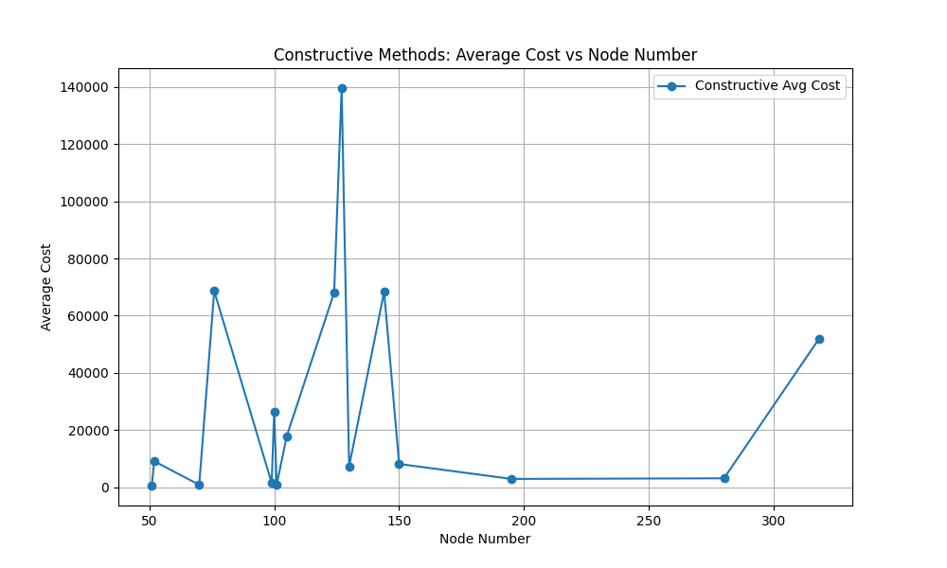

TSP Analysis: Average Cost vs Node Number
This graph shows cost after improvement through perturbative methods.It also shows Node shift has the lowest cost after improvement because of exhaustive search.

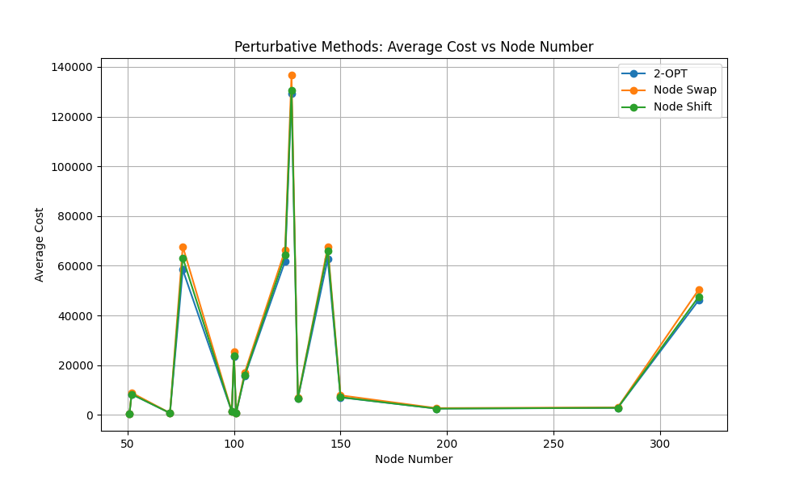

TSP Analysis: Average Construction Time vs Node

This graph and the next graph shows increase in construction time as
Node number increases.Nearest neighbour takes more time.

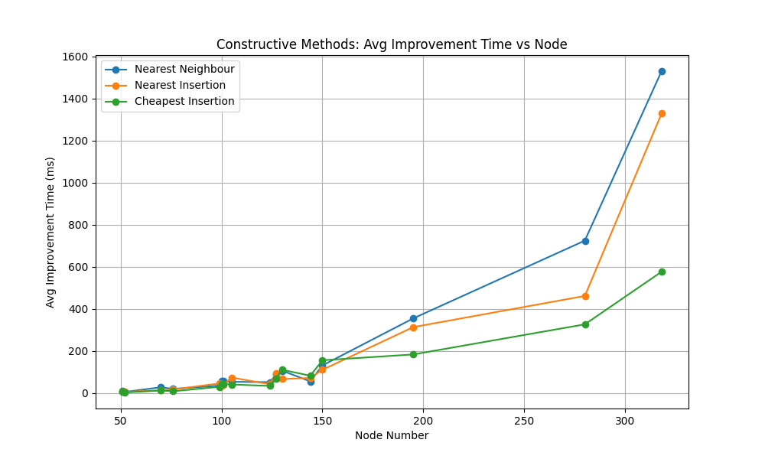

TSP Analysis: Average Improvement Time vs Node
This graph shows time taken by various perturbative methods. Node shift takes more time for improvement.

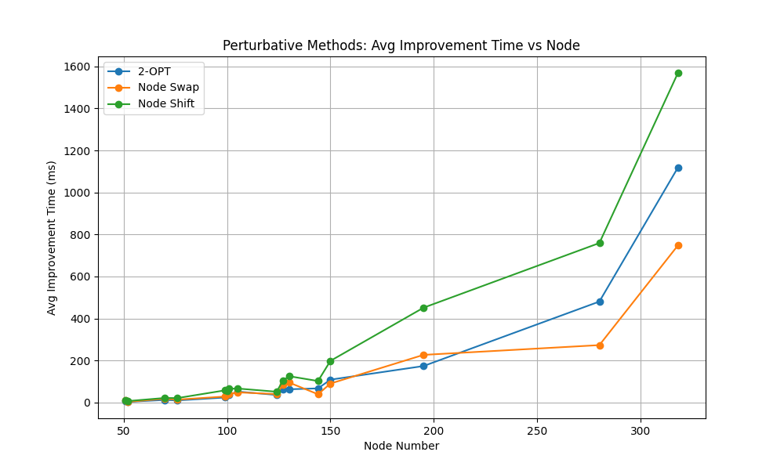

TSP Analysis: Average Cost Reduction per Time vs Node

This graph shows how each algorithm performs in less time. This graph shows 2-OPT has the highest efficiency takin less time per improvement.

