Analysis of experiment 2

TSP Analysis: Average Costs for Each Method

Constructive Methods
The table below shows the average costs for constructive methods.
Construction Heuristic | Average Cost
Cheapest Insertion | 30179.41
Nearest Insertion | 30788.06
Nearest Neighbour | 30685.43

Perturbative Methods
The table below shows the average costs for perturbative methods.
Improvement Heuristic | Average Cost
2-OPT | 29392.18
3-OPT | 28796.67
Node Shift | 29536.55

TSP Analysis: Average Cost vs Node
This graph shows average cost corresponding to increasing node number.it shows node number increment generally increases path cost .
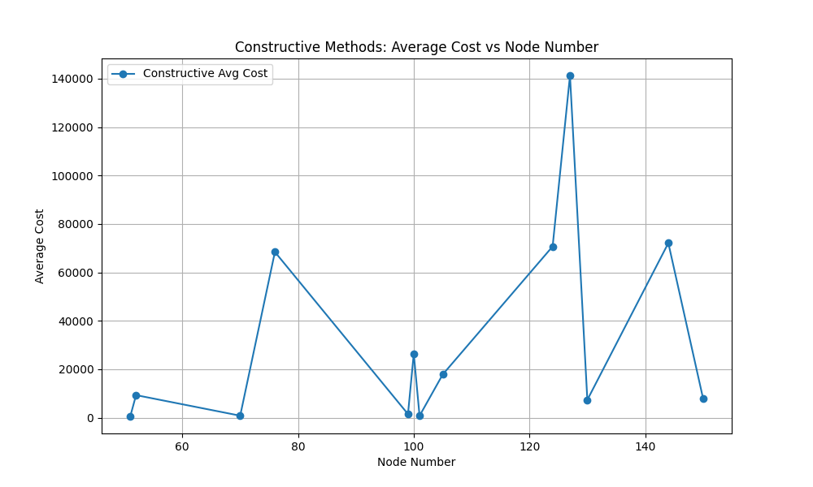

TSP Analysis: Average Improvement cost vs Node
This graph shows cost after improvement through perturbative methods.It also shows 3-opt has the lowest cost after improvement because of exhaustive search.

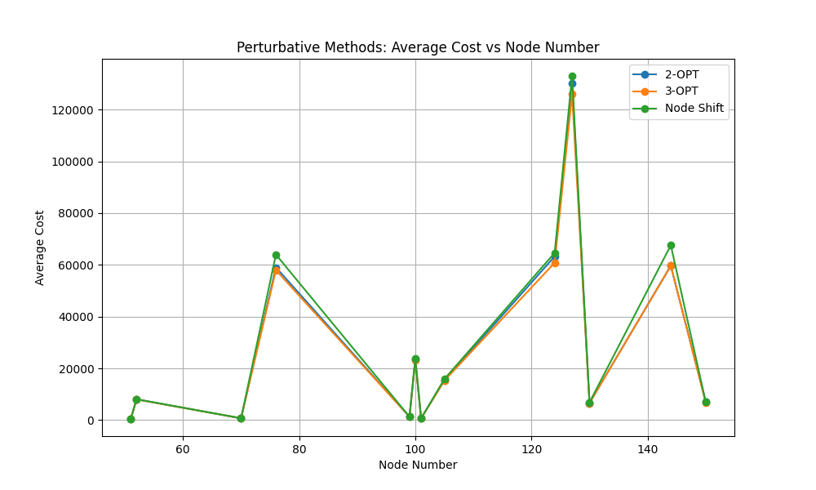

TSP Analysis: Average Construction Time vs Node
This shows increment of construction time of different constructive methods.cheapest insertion takes highest construction time.
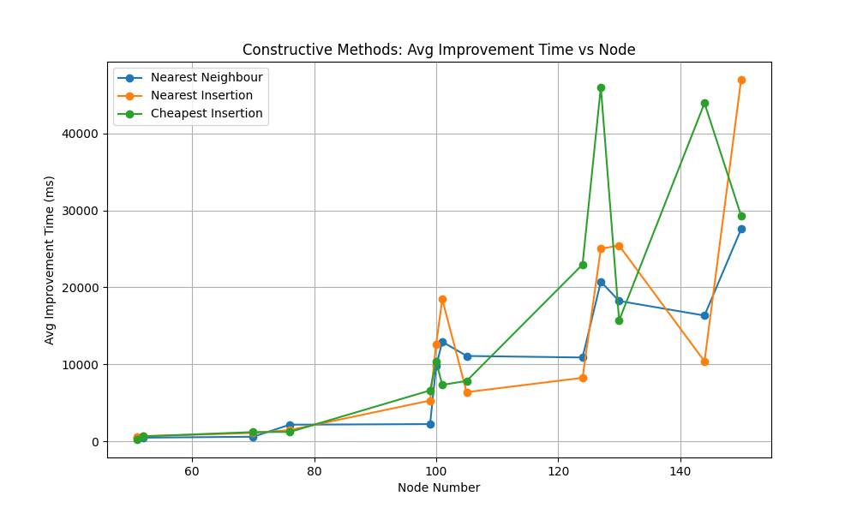

TSP Analysis: Average Improvement Time vs Node
This graph shows time taken by various perturbative methods.3-opt takes a mammoth amount of time.

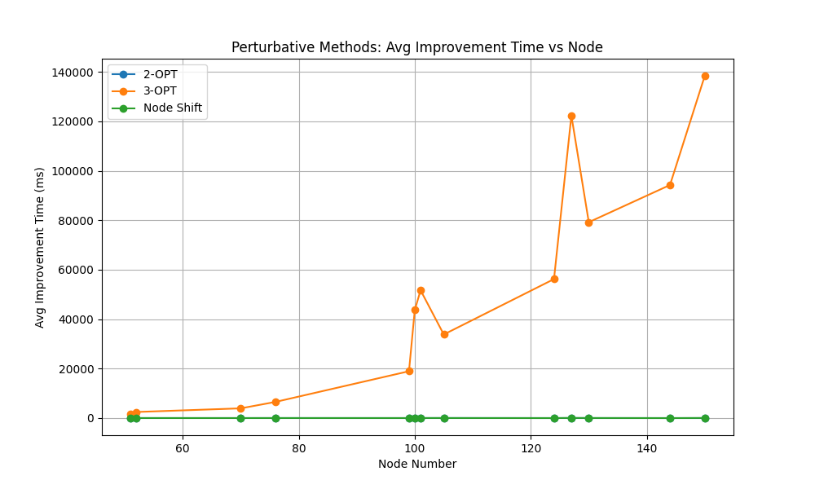

TSP Analysis: Average Cost Reduction per Time vs Node
This graph shows 2-OPT has the highest efficiency takin less time per improvement.

