**National Curriculum Development Center (NCDC)**

End of Year Sample ASSESSMENT ITEMS FOR S.1 AND S.2

BIOLOGY 2022

Senior 1 and Senior 2 Biology Sample Items

Duration: 1hour 30mins

Instructions:

Three compulsory short response items

Two extended response items. Answer One ONLY

**Guidance to teacher:**

● The end of year assessment consists of both short response items and extended response items.

Short Response Items Require learners to construct a response that is concise and focused. It may be factual, interpretive, or a combination of the two. The short response items focus on the learner’s mastery of knowledge, understanding, and skills used to perform a task or solve a problem. The scoring guide for these items should include the criteria/indicators for each score awarded.

Extended Response Items are derived from an integration of knowledge, understanding, and skills used to perform a task or solve a problem. The integration can cut across topics and subjects with related concepts. The item must have a context/problem/situation, instruction/expected output, and may include support/stimulus material. The item should focus on tasking the learner to provide a solution to a problem. The scoring guide for these items should include a grid that has relevance, coherence, accuracy, and excellence criteria with their respective indicators.

● The emphasis of the test items is to promote higher-order thinking skills.

● Refer to the teaching syllabus as a guide on what to assess in terms of the skills, knowledge, values, and understanding defined by the intended learning outcomes. Use the LO(s) to develop test items.

● The marking guide should clearly describe what a learner must do to meet the set criterion as evidence of achievement of the LO(s).

Item 1 was developed from the following Los.

● identify and describe the common observable characteristics and give examples of organisms from phylum Arthropoda including its classes.

● appreciate the useful and harmful effects of a housefly, cockroach, mosquito, bee, and butterfly.

Item 2 was developed from the content of primary integrated science and the following LO.

● Know the different methods of controlling the harmful stages of a housefly, cockroach, mosquito, and butterfly.

**Short response item (S1)**

A group of learners visited a demonstration farm to learn about living organisms. They came across the organisms shown below.

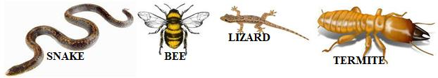

a) Classify the organisms based on their external features. Give a reason for classifying different organisms together. (4 scores)

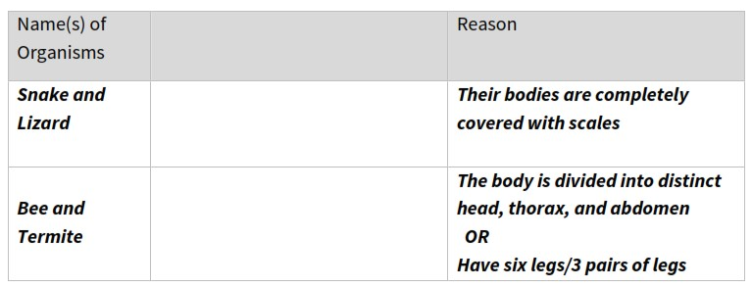

Scores 4 if places two correct organisms in each of the two groups and give a reason for each.

Scores 3 if places two correct organisms in each of the two groups and give a reason for one of the groups.

Scores 4 if places two correct organisms in one of the groups and give a reason.

Scores 1 if places two correct organisms in one group.

b) Choose any two organisms from the list above and explain the importance of that organism to a farmer (2 scores)

Snake - eats rats/rodents/birds that destroy farmers crops

Bee - pollinates the farmers crops

Lizard - eats/controls insect pests e.g. ants, aphids, grasshoppers, wasps

Termite - chicken feed/ aeration of soil/improve soil fertility by breaking down plant material

Scores 2 gives a reason that is useful to the farmer and corresponds to the organism

Scores 1 if gives a reason that is useful to the farmer

**Extended response item (S1)**

Communities that live near freshwater bodies in Uganda usually suffer from diseases caused or transmitted by organisms that live in or near water. The common diseases in such communities are Malaria and Bilharzia. The Ministry of Health would like to start a vector and disease control programme targeting people living near water bodies. Prepare a short essay advising the Ministry on how to control any one of the diseases mentioned using the knowledge of the life cycles of the organisms.

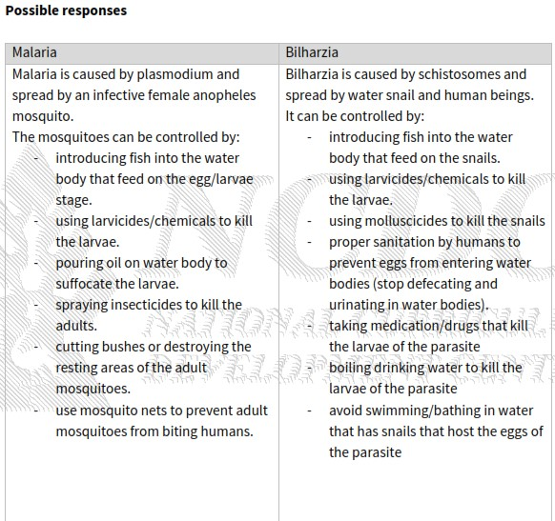

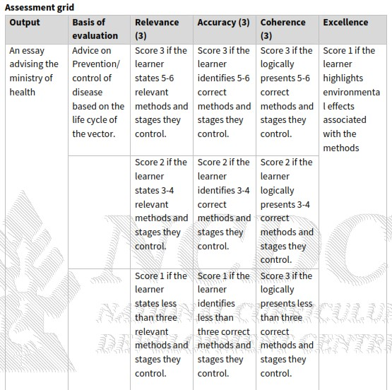

**Short response item (S2)**

In an experiment, mashed cooked potatoes were placed in five separate test tubes. Fresh saliva was poured over the potatoes in the test tube. The test tubes were then placed at different temperatures i.e., 0°C, 20°C, 30°C, 35°C, and 63°C. A sample from each tube was tested for starch using iodine solution and the time it took for the colour to change was recorded as shown in the table below.

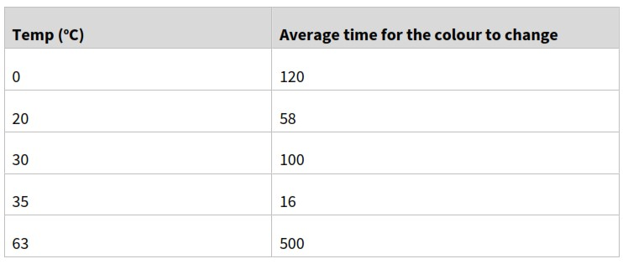

Explain the results at the following temperatures (2 scores each)

a) At 0°C

b) At 35°C

c) At 63°C

**Possible Responses**

At 0°C: The temperature is low making the enzymes in the saliva inactive and therefore it took some time for the colour to change (for the enzyme to catalyse the conversion of the starch)

At 35°C: This is the optimum/suitable temperature. Enzymes are fully activated and act on the food/starch very fast, which is why it took a very short time for the colour to change.

At 63°C: The temperature is too high. The enzymes are destroyed/denatured and

can no longer catalyse the reactions, therefore it takes a long time for the colour to change.

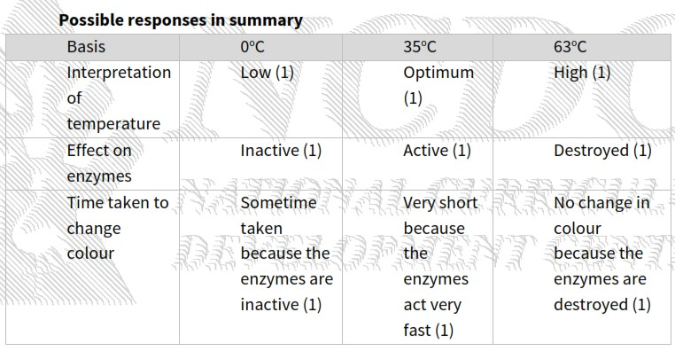

Score 3 if learner has correctly interpreted all the temperatures, explained the effect of all temps on the enzymes correctly and explained how this affects the time it takes to change colour for at least 1 of the temperatures – (7-9)

Score 2 if learner has correctly interpreted all the temperatures, explained the effect of at least 1 temperature on the enzymes correctly or explained how this affects the time it takes to change colour for at least 1 of the temperatures – (4-6)

Score 1 if the learner has been able to only interpret the temperatures, or the effect of the temperature on enzymes or the effect on change of colour (1-3)

**Extended response item (S2)**

Three farmers have gardens growing maize in the same area. As part of your study, you visited the gardens of each farmer and made the following observations as shown in the table below:

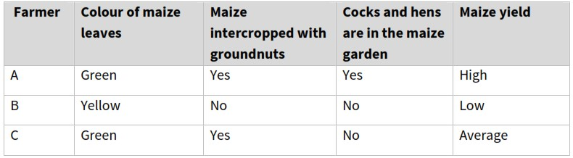

As a learner with knowledge of biology, write an essay explaining the crop yield of the three farmers.

**POSSIBLE RESPONSES**:

Farmer A: Yield is high because the leaves are green therefore plant is able to make a lot of food that is stored in several maize cobs. Green leaves indicate that the plants are growing in soil that has a lot of nutrients/nitrates/manure. The soil is rich in nutrients because the garden has legumes (groundnuts) that fix nitrogen in the soil and also the poultry droppings are a good source of nitrates/nutrients/manure.

Farmer B: Yield is low because the leaves are yellow therefore plant is not able to make enough food therefore only a few maize cobs are formed. Yellow leaves indicate that the plants are growing in soil that lacks nutrients/nitrates/manure. The soil lacks nutrients because the garden does not have legumes (groundnuts) that fix nitrogen in the soil and does not have poultry droppings that are a good source of nitrates/nutrients/manure.

Farmer C: Yield is average because leaves are green therefore the plant is able to make food that is stored in a number of maize cobs but not as many as those for farmer A. Green leaves indicate that the plants are growing in soil that has a basic amount of nutrients/nitrates/manure. The soil is basic in nutrients because the garden has legumes (groundnuts) that fix nitrogen in the soil. Since there is no poultry, the soil is therefore not as rich in nutrients as that for farmer A and that is why the yield is average.

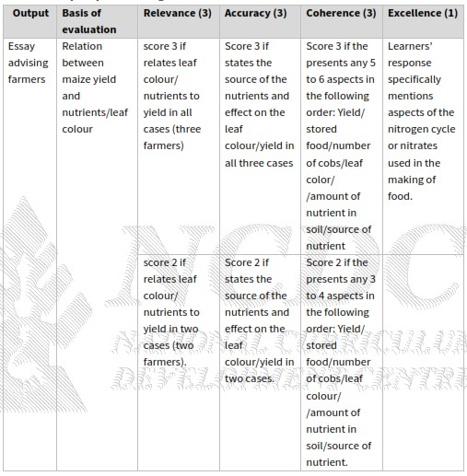

**© 2024 Uganda National Examinations Board**

553/1

BIOLOGY

Paper 1

Theory

2024

2½ hours

**INSTRUCTIONS TO CANDIDATES**:

This paper consists of seven examination items.

It has two sections; A and B.

Section A has three compulsory items.

Section B has two Parts; I and II.

Answer one item from each part.

Answer five items in all.

Any additional item(s) answered will not be scored.

**SECTION A**

Answer all the items in this section in the spaces provided.

**Item 1**

Mr. Nsamba’s cassava garden was invaded by the neighbour’s goats at the time of tuber formation. The owner of the goats has refused to compensate Mr. Nsamba, and Mr. Nsamba is worried that the yields will be poor.

Task:

(a) Identify the plant structures affected by the goats.

Leaves, and Stems.

(b) Explain how the goats affected the processes in the cassava plants.

Photosynthesis. The cassava leaves eaten by the goats are the sites for photosynthesis which prevents the manufacturing of food; Removal of leaves removes sites for entry of carbon dioxide gas which is a raw material for photosynthesis; The breaking of stems prevents transportation of another raw material for photosynthesis, water molecules, from soil to the point of food manufacturing, hence photosynthesis will not take place.

Transpiration. The rate of transpiration will greatly reduce since there are few/no leaves available which are sites for transpiration. The broken stem will cut off the transpiration pull.

Translocation. The eaten stem barks and/or broken stems destroys the phloem tissues, hindering/preventing the movement of manufactured food from the sites of manufacture to the parts where they are needed for respiration/growth/storage.

(c) Why should Mr. Nsamba be compensated even if the cassava plants were able to grow again?

Food that should have been stored in the root tubers are instead used to facilitate growth of new plant parts. This consequently affects both the size and quality of root tubers leading to poor yields hence a need to compensate Mr. Nsamba.

The roles of the affected processes are;

Photosynthesis makes food, stored in tubers, hence increasing the quality and quantity of yields.

Transpiration allows movement of water up the plant, which is a raw material for photosynthesis.

Translocation permits movement of food from sites of manufacture to other parts e.g., for growth, storage etc.

**Item 2**

John was suspended from school as a result of drinking alcohol. He engages in heavy drinking of alcohol in the nearby trading centre. One day, as John approached a swamp on his way home staggering from drinking alcohol at 6:00 pm, he encountered a snake. His heart started beating faster and his breathing rate increased. He tried to pick a nearby stick but he could not get hold of it on several attempts, so the snake escaped.

Task:

(a) Describe how John’s body coordinated to bring about his reactions from the time he encountered the snake up to when his rate of breathing increased.

The image of the snake was formed at the retina, impulses were sent to John’s brain for interpretation.

Impulses were sent to various structures e.g., adrenal glands, that released adrenaline hormone transported in blood to the heart causing the heart beat to increase. The adrenaline hormone also stimulated the intercostal muscles to increase the rate of breathing.

(b) What are the likely effects of John’s lifestyle as described in the scenario?

The likely effects of John’s lifestyle are;

Mental illness/ disorder.

Poor relationship with others.

Increased crime / reckless behaviour and isolation.

Depression and anxiety.

Organ failure e.g., malfunctioning liver.

Infections and diseases e.g., breast/throat/colon/lung cancer, liver cirrhosis, stroke, high blood pressure, diabetes, chronic bronchitis etc.

Inability to sustain financial needs.

Poor memory.

Bad company.

(c) Suggest ways in which John can change his lifestyle.

John can change his lifestyle in the following ways;

Withdraw from bad peer group.

Get professional help from a counsellor.

Stop going to places where he is tempted to drink.

Practice healthy habits to replace drinking and smoking.

Go for rehabilitation.

**Item 3**

Mrs. Kasuru had been taking her baby boy for routine immunization and the nurses kept on plotting the baby’s weight as a growth curve on the immunization card. On one of the visits, the nurses got concerned and referred the baby to the doctor, who diagnosed the baby with a genetic inherited disease. Mrs. Kasuru could not understand how her baby got the disease since both her and the father of the baby look healthy and normal. The doctor explained to her that the baby’s condition was because of genetic disease.

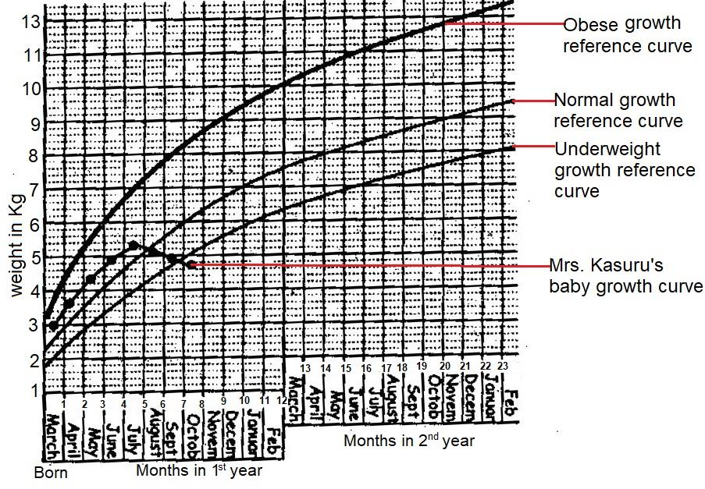

Fig.3 shows growth curve of Mrs. Kasuru’s baby.

Task:

(a) Identify the genetic disease and show how it was genetically passed on to the baby.

Both parents are heterozygous.

Let S represent the allele for normal RBC shape.

Let s represent the allele for sickle cell shaped RBC.

Parental Phenotypes: Normal male Normal female.

Parental genotypes: Ss X Ss

Meiosis Gametes Ss Ss

Random fertilization: Offspring genotypes: SS Ss Ss ss

Offspring phenotypes: Normal Carriers Sickler

There is ¼ chance of producing a child suffering from sickle cell disease. Hence the baby inherited a sickle cell gene from each of the parents. The parents look worried because they are both carriers, and carriers appear normal and do not show any physical symptom.

(b) Describe the likely appearance of Mrs. Kasuru’s baby boy.

Loss of weight / muscle wasting.

Retarded growth / stunted growth.

Difficulty in vision.

Swellings of hands / feet.

Frequent fatigue.

Reduced immunity / frequently falling sick.

(c) Suggest how the family can manage their baby’s condition.

Blood transfusion.

Frequent and rapid rehydration of the baby.

Regular checkup and medication.

Timely treating of any infection.

Preventing and treating stroke.

Proper nutrition.

**SECTION B**

**Part I**

Answer only one item from this part.

Answers should be written in the answer booklet(s) provided.

**Item 4**

In a village in western Uganda, swamps have been cleared for cattle farmlands and sand mining. The area environment officer organized a radio talk show on sustainable use of natural resources in swamps. Unfortunately, Mary a resident of the area only heard the concluding statement, “From the presentation, I kindly request everybody to use our natural resources sustainably.”

Task:

Explain to Mary the environmental problems being addressed by the environment officer and how they can be solved. Explain why the village should conserve the natural resources in the swamps.

Flooding; leads to destruction of vegetation due to water logging which prevents roots from absorbing enough oxygen or cover vegetation cutting off photosynthesis.

Silting of swamp channels / rivers as a result of destruction of swamps; This affects aquatic animals by making water turbid, hindering visibility. It may also lead to death of animals.

Destruction of natural habitats of animals e.g., frogs, snakes etc. The dangerous animals may attack human / other organisms’ settlements.

Sand mining creates deep stagnant water pools which can be risky to humans and other animals. The pools can also act as a breeding ground for vectors.

How to sustainably use the swamps.

Controlled sand mining.

Controlled harvesting of raw materials from swamps e.g., papyrus.

Planting trees in swamps to protect them from soil mass flow.

Use alternative lands / areas to graze livestock.

Desilting swamp channels.

Benefits / advantages of conserving natural resources in swamps.

Provides a good natural habitat for aquatic animals e.g., snakes, frogs etc.

The swamp is a water catchment area; hence prevent flooding in settlement areas. It also maintains a stable water table for lakes.

The swamps protect lakes and rivers from silting by filtering water before joining the main stream / water bodies.

Availability of raw materials like papyrus, reeds etc. for crafts and constructions etc.

Swamps provide water for home and industrial use.

The fish and other animals in the swamp are sources of food to man and other animals.

**Item 5**

As a result of a civil war in one of the countries neighbouring Uganda, many people entered Uganda as refugees. The local authority decided to settle the refugees on a piece of land, part of which was covered by a forest reserve next to a swamp. Several challenges arose in the community.

Task:

Explain to the community how the environmental challenges came about. Advise them on how to minimize effects of the challenges and show the value of conserving the environment in the area.

Environmental challenges in the community.

Outbreak of diseases due to congestion / overcrowding / water borne diseases.

Encroachment of natural habitats for animals, which leads to attack by wild animals.

Deforestation; in an attempt of getting firewood and wood for construction.

Destruction of natural habitats for settlement and farming.

Swamp reclamation / drainage for farming and settlement.

Hunting of wild animals for food.

Loss of biodiversity.

Poor disposal of wastes.

How to minimize the effects of the challenge.

Afforestation / planting of trees which mature in a short time.

Use alternative construction materials.

Use alternative source of fuel other than firewood.

Practice wetland edge cultivation.

Sort domestic wastes into biodegradable and non-biodegradable for recycling.

Have controlled hunting of wild animals.

Values / benefits of conserving the environment.

Forests are habitats for wild animals which are sources of food.

Swamps provide raw materials like sand for construction, clay and papyrus for crafts.

Forests release oxygen which is used by animals for respiration.

Trees / forests trap / absorb carbon dioxide from the atmosphere hence reducing pollution and global warming.

Swamps act as water catchment areas.

END

Part II

Answer only one item from this part.

Answers should be written in the answer booklet(s) provided.

**Item 6**

Two Ugandan Towns A and B each have industries that release carbon dioxide gas, smoke and dust. The levels of air pollution in the two towns are as shown in table 1. Table 1: levels of air pollution in two towns A and B. Town Level of air pollution (units) A 30 B 70 (According to American Lung Association, 2023, the normal range of air pollution is 0 – 50 units). Samuel was living in town A. He used to jog every day, and would experience normal changes in his body during and after jogging. When he shifted to town B, he continued with his usual routine of jogging. However, he started experiencing complications such as difficulty in breathing, chest pain and coughing.

Task:

Explain to Samuel his experiences while living in town A and the new ones encountered in town B. Advise Samuel on how to manage the challenges experienced in town B.

Experiences in town A.

Increased body metabolism to especially generate sufficient energy required in jogging.

Increased heart beat to circulate sufficient blood around the body to facilitate faster metabolism/respiration of food to supply energy.

Increased breathing rate to ensure quick supply of oxygen to respiring tissues and remove accumulated carbon dioxide.

Accumulation of lactic acid in the body as a result of vigorous exercise, which resulted into anaerobic respiration in the body.

Sweating so as to remove excess heat generated during the exercise.

New experiences in town B.

Reduced oxygen intake presented difficulty in breathing due to too much carbon dioxide in air / pollution.

Lung irritations causing coughing due to in halation of dust from polluted environment.

Lung infections / diseases like emphysema presented with chest pain as a result of increased inhalation of polluted air.

Advise to manage challenges experienced in town B.

Go for medication to treat the respiratory complications.

Change residence from town B to a less polluted area.

Eat a balanced diet to boost the body’s immunity to have self defense.

Perform other physical activities that may not require exposure to polluted environment.

Wear a mask, especially when not engaged in jogging since he is living in a polluted area.

**Item 7**

In preparation for an inter-house competition, Chesang, a 40kg female athlete ate a meal containing 470g of carbohydrates in the morning. She believes the meal will help her perform better during the competition. However, her young brother does not seem to understand how the meal will contribute to Chesang’s success. Chesang finally won the competition but experienced muscle cramps. She rested for 20 minutes, returned home walking but the brother wondered how she still had the strength to walk home after the competition. [The recommended daily carbohydrate intake of a 40kg female athlete is (280 – 480g)]

Task:

Explain to Chesang’ s brother the processes that the meal she ate went through to enable her win the race, be able to come back home and how her body regained the normal state.

Processes are; digestion, absorption, assimilation and respiration.

Carbohydrates were digested in the mouth by salivary amylase, and in the duodenum by pancreatic amylase to maltose.

Maltose was digested in the ileum to glucose molecules by maltase.

The glucose produced was absorbed in the walls of ileum/villi and transported in the bloodstream to the respiring tissues/body muscles.

The glucose was broken down during respiration to provide energy/ATP, water and carbon dioxide gas were produced in the process.

The produced energy was used by Chesang’s body/muscles to run and win the race.

Changes / challenges experienced by Chesang’s body were;

Accumulation of lactic acid in the muscles.

Increased oxygen demand.

Increased energy demand.

Excess heat in the tissue/cells.

Increased amount of carbon dioxide.

How Chesang came back home and her body remained in normal state.

Excess carbohydrates stored as glycogen is converted to glucose which was respired hence providing Chesang energy to go back home.

Deep breathing enabled her take excess oxygen to breakdown the accumulated lactic acid. Also to expel carbon dioxide from the body.

Increased sweating to remove excess heat.

Increased heart beat to transport the required materials and products to target organs.

**UNEB BIOLOGY PAPER 2 SAMPLE PAPER [2**½ **hours]**

**CONFIDENTIAL**

Each candidate should be provided with:

25cm³ of solution A (is prepared by crushing 125g of peeled fresh cassava, into paste, add 500ml of water, mix and decant the solution then dilute it to 1000ml using distilled water).

25cm³ of solution B (is prepared by soaking 125g of beans in water for

24 hours, pound the beans into paste and mix with 500ml of distilled water.

Decant the solution and dilute to 1000ml using distilled water).

Freshly killed housefly, labelled specimen Y.

Freshly killed worker termite, labelled specimen X.

Access to: Reagents for food tests, 2 Beakers, Hand lens, Source of heat, 6 Test tubes, Test tube holder, Test tube rack, Droppers, A thermometer.

553/2&3

BIOLOGY

Paper 2

2024

2½ hours

**INSTRUCTIONS TO CANDIDATES**:

This paper consists of two examination items. Answer all the items in the spaces

provided. Drawings should be made in the spaces provided. Use sharp pencils for your drawings. Coloured pencils or crayons should not be used. No additional sheets of writing paper are to be inserted in the booklet. Work on additional sheets will not be scored.

**Item 1**

Mary’s 5-year-old baby frequently falls sick and has to visit the hospital regularly. The doctor told her that the frequent sickness is as a result of feeding. Mary feeds her baby on food nutrients; A and B plus food supplement containing mineral salts, fats and roughages. Mary is wondering what could be missing in her baby’s food.

Task:

Carry out investigations on the food samples A and B and use your findings to advise Mary accordingly.

Expected Response:

Aim: To investigate the nutrients, present in the food samples A and B.

Hypothesis: Frequent sickness of Mary’s child is due to absence of required nutrients in food samples A and B.

List of Apparatus, reagents, solutions and Materials used: Solutions A and B. Iodine solution. Benedict’s solution. Dilute hydrochloric acid. Dilute Sodium hydroxide. DCPIP. Copper (II) sulphate solution. Heat source. Test tubes and droppers.

Procedure, Observations/data presentation:

Procedure: Sample: Observations: Deductions

To 1cm³ of food sample, add 2 drops of Iodine solution

A: Cloudy/turbid/milky solution turns black/blue-black: Starch present

B: Cloudy/turbid/milky solution turns black/blue-black: Starch present

To 1cm³ of food sample, add 1cm³ of Benedict’s solution and boil

A: Cloudy/turbid/milky solution turns blue and the blue colour persists: Reducing sugars absent

B: Cloudy/turbid/milky solution turns blue and the blue colour persists: Reducing sugars absent

To 1cm³ of food sample, add 1cm³ of dil HCl(aq) and boil, cool under tap water. Add 1cm³ dil NaOH(aq) followed by 2cm³ of Benedict’s solution and boil.

A: Cloudy/turbid/milky solution turns blue and the blue colour persists. Non reducing sugars absent

B: Cloudy/turbid/milky solution turns blue and the blue colour persists: Non reducing sugars absent

To 1cm³ of food sample, add 1cm³ of dil NaOH(aq) followed by 4 drops of CuSO₄(aq)

A: Cloudy/turbid/milky solution turns blue and the blue colour persists: Proteins absent

B: Cloudy/turbid/milky solution turns blue and then purple: Proteins present

To 1cm³ of DCPIP, add the food sample dropwise until in excess

A: Deep blue colour was discharged (if the cassava was very fresh from the garden): Vitamin C present. OR: Deep blue colour persists (if the cassava not very fresh e.g., from market): Vitamin C absent

B: Deep blue colour persists: Vitamin C absent

Conclusion / Nutrients present in the baby’s food are:

Option 1: Starch (carbohydrate), Proteins, and Vitamin C.

Option 2: Starch (carbohydrate), proteins.

Recommendations and Advice:

Option 1: The child’s food has all the required nutrients. The sickness is not due to the current food nutrients provided. The child may be sick due to other causes, hence take the child for further examination by medical personnel.

Option 2: The child’s food is lacking vitamin C, hence the frequent sickness is possibly deficiency of vitamin C. Provide the child with foods rich in Vitamin C e.g., oranges, mangoes, passion fruits etc., so as to boost the child’s immunity.

**Item 2**

Biteke Secondary School had some classroom blocks constructed using wood. After One year the head teacher realised that the poles in S1 classroom block were partly destroyed with holes in them. The school had spent a lot of money on the classroom block and did not have any money to construct another one. Specimens X and Y were some of the most common organisms that S.1 students collected from their classrooms.

Task:

(a) (i) How do the features on the organisms enable the organism to enter and survive in the classroom?

Organism Y sensed the location of the classroom and possible food source using its compound eyes and antennae respectively. It used its wings to fly and entered the classroom. It survives by using its proboscis to feed on liquid food available in the classroom.

Organism X sensed the location of food/wood in the classroom block using its antennae. It used its mandibles to dig barrows to access the classroom block and feed on the wood.

(ii) Explain to the head teacher which organism was able to cause such serious damage to the classroom block.

Organism X is responsible for the damage caused. This is because it has hard and strong pair of mandibles that are capable of cutting the timber/wood in the classroom block. It can feed on solid materials such as wood

(b) Draw and label the head of specimen X.

A drawing of the head of specimen X