**National Curriculum Development Centre (NCDC)**

End of Year Sample ASSESSMENT ITEMS FOR S.1 AND S.2 CHEMISTRY 2022

SENIOR TWO CHEMISTRY SAMPLE QUESTIONS

Guidance to Teacher:

The end-of-year assessment consists of both short response items and extended response items.

Short Response Items Require learners to construct a response that is concise and focused. It may be factual, interpretive or a combination of the two. The short response items focus on the learner’s mastery of knowledge, understanding and skills used to perform a task or solve a problem. The scoring guide for these items should include the criteria/indicators for each score awarded.

Extended Response Items are derived from an integration of knowledge, understanding and skills used to perform a task or solve a problem. The integration can cut across topics and subjects with related concepts. The item must have a context/problem/situation, instruction/expected output and may include a support/stimulus material. The item should focus on tasking the learner to provide a solution to a problem. The scoring guide for these items should include a grid that has relevance, coherence, accuracy and excellence criteria with their respective indicators.

The emphasis of the test items is to promote higher order thinking skills.

Refer to the teaching syllabus as a guide on what to assess in terms of the skills,

knowledge, values and understanding defined by the intended learning outcomes. Use

the LO(s) to develop test items.

The marking guide should clearly describe what a learner must do to meet the set

criterion as evidence of achievement of the LO(s).

Item 1 was developed from the following Los:

Explain the concept of pH as a measure of the strength of acids and alkalis (u)

Apply the knowledge of reaction between acids and alkalis

Item 2 was developed from the following Los:

Know and appreciate the impact on the environment of burning carbon-based fuels

Understand the processes of making charcoal but recognise that the use of charcoal as a fuel is cheap, efficient and sustainable only if it is made from wood that can be regrown easily.

Time: 1 hour 30 minutes

Section A: 3 items

Section B: 1 item

Section A: Short Response Items

1. The human stomach contains hydrochloric acid with a pH of about 2. The acid helps to kill any germs in our stomach. However, when the stomach walls produce too much of the acid, we suffer from stomach pains and heartburn. One way to deal with this problem is to take an antacid. The main component of antacid is sodium hydrogen carbonate.

a. Explain how the antacid helps to cure heartburn. (3 scores)

Section B: Extended Response

2. In Nakasongola, people make charcoal from burning wood. Jimmy has just migrated to Nakasongola and wants to make charcoal from wood like the rest of his neighbours. He piled pieces of wood, introduced fire underneath and left them to burn overnight. In the morning, he found a hip of ash with very little pieces of charcoal, not strong enough like what his neighbours make. As a friend to Jimmy who understands the process of charcoal making, write a letter to advise him on how to make charcoal. (10 scores)

S2 CHEMISTRY MARKING GUIDE

Section A: Short answer item

The human stomach contains hydrochloric acid with a pH of about 2. The acid helps to kill any germs in our stomach. However, when the stomach walls produce too much of the acid, we suffer from stomach pains and heartburn. One way to deal with this problem is to take an antacid. The main component of antacid is sodium hydrogen carbonate.

a. Explain how the antacid helps to cure heartburn. (3 scores)

Expected Solution

The sodium hydrogen carbonate that is introduced is a weak alkali. When it reacts with the excess acid in the stomach, it produces a salt (sodium chloride), water, and carbon dioxide gas.

The salt formed is neutral on the body, the gas is breathed out and the water is absorbed by the body making the person feel better.

SCORING GUIDE.

Score 3 if learner identifies sodium hydrogen carbonate as an alkaline substance, mentions the reaction between alkali and acid, products; and indicates that the salt formed is harmless to the body and person feels better.

Score 2 if learner identifies sodium hydrogen carbonate as an alkaline substance, mentions the reaction between alkali and acid, products; but does not indicate that the salt formed is harmless to the body and person feels better. Score 1 if learner identifies sodium hydrogen carbonate as an alkaline substance only, but does not mention the reaction between alkali and acid, products; and does not indicate that the salt formed is harmless to the body and person feels better.

Section B: EXTENDED RESPONSE

In Nakasongola, people make charcoal from burning wood. Jimmy has just migrated to

Nakasongola and wants to make charcoal from wood like the rest of his neighbours. He piled pieces of wood, introduced fire underneath and left them to burn overnight. In the morning, he found a hip of ash with very little pieces of charcoal, not strong enough like what his neighbors make. As a friend to Jimmy who understands the process of charcoal making, write a letter to advise him on how to make charcoal. (10 scores)

Response:

Key points to look out for in the letter and the flow of the points in the letter.

1. The wood is covered to limit the amount of air entering.

2. In absence of air, the wood burns to form carbon.

3. When the wood is not covered, oxygen from air reacts with the carbon to form carbon dioxide. The wood will burn out completely to form ash because of the presence of oxygen which supports burning.

Carbon + Oxygen → Carbon dioxide

4. The salts in the wood to form ash instead of the charcoal.

5. From now on, Jimmy should burn the wood in a limited supply of air to obtain the

charcoal.

6. The heap of wood should be covered with plant leaves and soil on top to limit the amount of oxygen during the burning process.

7. The wood should be left to burn for a period of about 24 hours.

Output (Letter to Jimmy)

Basis of evaluation (Procedure for making charcoal)

Relevance:

Score 3 if the letter identifies 6-7 points related to the procedure making charcoal

Score 2 if the letter identifies 3-5 points related to the procedure making charcoal

Score 1 if less than 3 points are related to the procedure making charcoal

Accuracy:

Score 3 if the letter identifies 6-7 conditions and reasons for the process of making charcoal are correct

Score 2 if 3-5 conditions and reasons in the letter are correct

Score 1 if less than 3 conditions and reasons in the letter are correct

Coherence:

Score 3 if 6-7 points in the procedure are presented logically

Score 2 if 3-5 points in the procedure are presented logically

Score 1 if less than 3 points in the procedure are presented logically

Excellence:

Score 1 when a student uses an equation to explain the combustion process and its products

**© 2024 Uganda National Examinations Board**

545/1

CHEMISTRY

Paper 1 (Sample)

2024

2 hours

INSTRUCTIONS TO CANDIDATES:

This paper consists of two sections; A and B. It has six examination items.

Section A has two compulsory items.

Section B has two Parts; I and II. Answer one item from each part.

Answer four items in all.

Answers to Section A must be written in the spaces provided while those of Section B must be written on the answer booklet(s) provided.

Any additional item(s) answered will not be scored.

SECTION A

Answer all the items from this section.

Item 1

Onyera, living in an area where they use bore hole water, slid, fell and his white shirt became dirty. He decided to use a detergent to clean his shirt. The shirt remained with some brown spots yet he had rinsed it several times.

Task:

As a chemistry learner;

(a) Point out the problem Onyera made when choosing a product.

Onyera used a soapy detergent (or soap) instead of a soapless detergent.

(02 scores).

(b) Help Onyera understand how the product works.

The dirt is held on the cloth by a layer of oil.

Detergents (soaps) facilitate the emulsification and removal of grease (02 scores).

Alternatively;

Detergents facilitate breakdown of fats into small parts. A soap molecule contains two parts; namely; the water-soluble/polar carboxylate head / hydrophilic end or

lipophobic head and non-polar tail/fat-soluble part / hydrophobic part/lipophilic part.

During washing, soap acts by lowering the surface tension between water and oil/grease/other water insoluble materials and also emulsifies them.

The hydro-carbon tail becomes attached to dirt /oil /fat while the polar head dissolves in water. With constant agitation, the dirt is pulled off the cloth and gets dispersed in water as tiny droplets which are then poured away. The cloth is then rinsed several times and dried.

(02 scores).

(c) Advise Onyera on the challenges associated with the long term use of the product.

(a) Soap contains chemicals that can cause:

Skin burns / blisters / irritation and hence pain or cancer.

Eye redness and pain; hence loss of vision - Mitigation can be done by thoroughly washing the affected areas (or irrigation of the affected areas) like skin or eyes.

(b) Soapless detergents contain phosphates which cause algae bloom/alagal bloom and hence water pollution. N.B. Algae/algal bloom already means accumulation.

(03 scores).

(a) Similarities:

Both soapy detergents and soapless detergents are salts of Organic acids of long carbon chain.

Both soapy detergents and soapless detergents are effective cleansing agents in soft water / rain water.

(b) (i) Differences; Soapy detergents:

Forms scum with hard water.

Gentle on skin during cleansing.

Sodium salts of carboxylic acid of long chains and cannot be used in strongly acidic solutions.

Biodegradable

(b) (ii) Soapless detergents:

Does not form scum with any form of water.

Not gentle on skin during washing.

Sodium salts of long chain benzene sulphonic acids and can be used in strongly acidic solutions.

Non-biodegradable.

(02 scores).

Item 2

Peter is in the process of constructing his house without affecting the environment. He wants to build a good strong house; there are various building materials of different quality and properties on the market. However, he does not know the quality of materials to use.

Peter knows that choosing quality materials depends on the nature of the material and has come to you for advice.

Task:

Use your chemistry knowledge to;

(a) Explain (i) Categories of materials.

(Substance and material with a reason).

A material is a substance or a mixture of substances that constitute an object. It can be Natural or Artificial. Natural material is God made/exists in nature and its formation is not influenced by man e.g., rocks, sand, wood, water, soil etc. Artificial material is man-made/synthetic, manufactured by man e.g., iron bars, plastics, paint, composites.

(03 scores).

(ii) The suitability of the materials.

Materials to be used for constructing a good strong house have different qualities based on their nature. A house is made up of the following:

(a) Iron;

- Very strong (can support heavy load).

- has high tensile strength (resists breakage).

- its ductile and malleable (easy to mould).

- has high melting point (resists fires).

- Galvanised iron resists rusting.

- steel has improved properties, making it suitable for many users.

(b) Aluminium;

- low density (used on top of buildings).

- strong, not easy to break/durable.

- has high melting points (resists fires).

- has bright appearance (used for doors, roofing, window frames).

- high electrical/heat conductivity (making utensils).

(c) Wood;

- Readily available so easy to get cheaply.

- Strong, so it can support heavy load.

- Light when dry so good for roofing.

- Easy to smoothen to give nice appearance.

- can rot or be eaten by termites when not treated.

(d) Mortar; Composite made of cement, sand and water;

- Hard so resists deformation.

-It is adhesive so can join bricks.

-Cushioning to spread the vertical load.

(e) Glass;

- Ordinary glass is transparent so good for windows to see through.

- tinted glass allows light to pass through it in only one direction so good for windows (visual security).

- Double-glazed glass (tampered glass) is strong, resistant to fire attack and it is not brittle.

- Glass is reflective, attractive and it adds value when put in doors and windows.

(f) Paint; This is a liquid composite made of pigment, resin, solvent and additives.

- Weather guard resists bad weather (water proof). So good for outside walls.

- Silk vinyl paint does not burn, so good for interior purposes.

- Paint can be insect repelling, light sensitive to beautify, protect walls.

(g) Plastics;

- These are man-made polymers which can undergo permanent deformation without breaking when subjected to a strong force. E.g. PVC, Polyethene, Nylon, Polyesters.

- They are flexible so can be bent easily.

- They are water prone so are good for Plumbing and roofing.

- They are light and strong, so good for shuttering purposes.

- They have low melting points so can be attacked by fires easily.

(h) Clay and Ceramics;

- They are brittle so break easily.

- They are water proof so good for flooring.

- They are good looking, so nice for Finishing purpose like floors, walls.

- They cannot be attacked by chemicals.

(i) Bricks and blocks:

- Resistant to fire so good for wall construction.

- They are strong, so can support heavy loads.

(03 scores).

(b) Advise peter on the choice of materials.

The choice of material for construction is dependent on the purpose it is meant to do and its impact to the environment.

(a) Iron;

- Making shutters for doors, windows.

- Making frames for doors windows.

- Reinforcing concrete.

- Irons used to fix/join objects like timber, iron sheets.

- Used for plumbing.

(b) Aluminium;

- Making shutters for doors, and windows.

- Making frames for doors and windows.

- Reinforcing concrete.

- Making roofing materials (struts and ties).

- electrical installations, wires.

(c) Wood;

- Used to make shutters for windows, doors.

- Making frames for doors, windows.

- Making struts and ties during roofing.

- Making poles, pillars and beams.

(d) Mortar;

- Joining and binding bricks.

- Making concrete for floors.

- Plastering walls.

(e) Glass;

- Making shutters for doors, windows.

(f) Paint;

- Beautifying (better appearance) of buildings.

- Protecting materials, from rusting.

- Enhancing durability.

(f) Plastics;

- Making pipes (water pipes) for plumbing.

- Making door and window stutters.

(h) Clay and Ceramics;

- Making bricks.

- Making Tiles (floor tiles).

- Making roofing tiles.

(i) Bricks and blocks;

- Constructing walls.

(03 scores).

Material used in construction of a house can have an impact to the environment.

(a) Iron;

- Depletes soil fertility when it accumulates.

- Being a heavy metal can cause cancer.

- Non biodegradable.

(b) Aluminium;

- Depletes soil fertility when it accumulates.

(c) Plastics;

- Non biodegradable, spoils the soil.

(d) Mortar;

- Bulky, takes long to decompose and so spoils the soil.

(02 scores).

SECTION B

Part I

Answer one item from this part.

Item 3

One of the large-scale uses of chlorine is treating water, to ensure that chlorine is readily available and at a cheaper cost. Government has cleared a local investor to set up a chlorine production plant near Lake Katwe in Kasese district. However, the community is concerned about its environmental effects and how the environmental process will occur.

The class teacher has appointed you to sensitize the other learners.

Task:

Prepare a presentation you will make during the meeting.

Raw material (Concentrated sodium chloride solution (brine) or Sodium chloride crystals (Rock salt)) (02 scores).

Chlorine from brine.

Brine is electrolysed in a cell made up of mercury cathode and graphite anode.

Brine contains Na⁺, Cl⁻, OH⁻ and H⁺.

The ions migrate to oppositely charged electrodes.

Na⁺ are discharged at the cathode by electron gain in preference to H⁺ since Na⁺ are more concentrated.

Na⁺(aq) + e⁻ → Na(s).

At the anode, chloride ions are discharged, in preference to hydroxide ions; being in higher concentration than hydroxyl ions, chlorine gas is formed.

2Cl⁻(aq) –2e⁻ → Cl₂(g/l).

The chlorine formed is collected and stored in tightly closed tanks.

The chlorine is dried, liquefied and stored.

(03 scores).

Alternative using rock salt.

Solid sodium chloride (rock salt) and little calcium chloride are fed into Down’s cell. The mixture is electrolysed using titanium or graphite anode and steel or iron cathode.

The ions migrate to oppositely charged electrodes. At the cathode, Na+ are discharged by reduction being the only ions present.

Na⁺(aq) + e⁻ → Na(s).

At the anode, Cl– are discharged by electron loss forming chlorine gas.

2Cl⁻(aq) → Cl₂(g) + 2e⁻.

The chlorine formed is collected and stored in tightly closed tanks

The Clorine is dried, liquefied and stored.

(02 scores).

Side effects of the process of production and mitigation.

(a) Air pollution by waste gases,

- acidic gases can cause acid rain which leads to crumbling of buildings, lowering soil pH and corrosion of roofs made of iron. Mitigation can be done by:

- fitting catalytic converters in exhaust pipes of machines to convert oxides of nitrogen into nitrogen and carbon monoxide to carbon dioxide.

- neutralise the acidic gases before releasing waste gases into the atmosphere.

(03 scores).

Alternative using rock salt.

(b) Leakage of Chlorine.

(c) Land degradation.

(03 scores).

Social benefits.

- Employment opportunity; improved income thus better standards of living.

- Development of infrastructure e.g., electricity lines, roads, hospitals, schools, etc.

(03 scores).

Item 4

Air which is a mixture of different components contains 21% oxygen. Due to a wide spread of respiratory illnesses caused by COVID-19, there was an increased demand for oxygen by patients in hospitals. The government supply of oxygen is not enough and is planning to set up an oxygen production plant with minimal environmental impact.

However, the science club members in your school would like to know how the process of production will be carried out.

Task:

As chemistry student, make a write up you will use during the presentation.

Raw material (Liquid air / Air) (02 scores).

Production process.

Air is passed through air filters to remove dust and smoke particles. Air is passed through concentrated sodium hydroxide solution to absorb / remove carbon dioxide, which is acidic.

2NaOH(aq) + CO₂(g) → Na₂CO₃(aq) + H₂O(l).

Air free from Carbon dioxide is now passed through Silicon (IV) oxide / silica gel

to absorb water vapour. Carbon dioxide and water vapour are removed from air before it is liquefied because they solidify and block the apparatus.

The air is now compressed at 200 atmospheres and allowed to cool by making it escape into a large space through a jet.

The process of cooling is repeated several times to obtain liquid air at about -200⁰C.

The liquid air is fractionally distilled using a fractionating column / tower.

Nitrogen boils off first because it has a lower boiling point (–196⁰C) leaving behind oxygen with a higher boiling point (-183⁰C).

Both nitrogen and oxygen obtained contain traces of noble gases. Pure oxygen is then stored under pressure in steel cylinders.

(03 scores).

Side effects of the process of production and mitigation.

(a) Explosion of oxygen cylinders due to high pressure. This can cause other materials to ignite spontaneously/catch fire. The resulting fire can cause damage to equipment and injury to people.

Mitigation can be done by:

- Regular maintenance and monitoring of cylinders.

- Keeping cylinders in cool areas / avoid exposure to heat.

(b) Exposure to liquid oxygen can cause severe skin and eye irritations and burns.

This may cause loss of vision and cancer.

Mitigation can be done by:

- Posting hazard and warning information in the working area.

- Communicating all information on the health and safety hazards of oxygen to

potentially exposed workers; for example; submerging the affected body parts in warm water.

(c) Air pollution by waste gases. Acidic gases can cause acid rain which leads to

crumbling of buildings, lowering of soil pH and corrosion of roofs made of iron.

Mitigation can be done by:

- Fitting catalytic converters in exhaust pipes of machines to convert oxides of nitrogen into nitrogen and carbon monoxide to carbon dioxide.

- Neutralise the acidic gases before releasing waste gases into the atmosphere.

(03 scores).

Social benefits.

- Employment opportunity; improved income thus better standards of living.

- Development of infrastructure e.g. electricity lines, roads, hospitals, schools etc., improved road network will facilitate trade hence improved income and better standards of living.

(03 scores).

END

Part II

Answer one item from this part.

Item 5

Natural resources have been destroyed as a result of increasing population and human activities. This has attracted the attention of the officials from the National Environment Management Authority (NEMA).

The officials are planning to create awareness to the people of the country through sensitization workshops organized in different district communities.

Task:

As a chemistry student, prepare a short presentation you will deliver during the workshop upon invitation.

Resources are classified as: Renewable and Non-renewable. Renewable resources are natural resources that can be replenished e.g., Air, water vapour, dust etc.

Non-renewable resources cannot be replenished (get used up) e.g., fossil fuels, rocks/minerals.

(03 scores).

Composition of natural resources.

Air contains Nitrogen, Oxygen, Carbon dioxide, rare gases.

Water contains Hydrogen and oxygen.

Fossil fuels contain Carbon, Hydrogen, Oxygen.

Rocks contain Iron, copper, calcium carbonate, and other minerals like Gold, Cobalt, etc.

(02 scores).

Impact of natural resources on the environment and how it occurs / chemicals and physical reactions and mitigation.

Air

- Some components of Air pollute the environment and cause global warming, carbondioxide being a greenhouse gas, traps heat in the atmosphere.

C(s) + O₂(g) → CO₂(g).

- Carbon monoxide is a poisonous gas and causes suffocation, carbon monoxide can also be converted to carbon dioxide.

2CO(g) + O₂(g) → 2CO₂(g).

Mitigation:

Increased Afforestation to replace the cut trees which absorb CO₂ from the atmosphere to reduce global warming.

Carbon monoxide effects and production can be reduced by using catalytic converters on exhaust pipes of cars and other fuel engines to reduce the poison in the environment.

Water Impact and how it occurs.

Water contains dissolved gases like O₂ and CO₂. The CO₂ in it forms carbonic acid.

H₂O(l) + CO₂(g) → H₂CO₃(aq).

The carbonic acid makes water acidic. The acid rains dissolve or deplete rocks.

H₂CO₃(aq) + CaCO₃(s) → Ca(HCO₃)₂(aq).

Water has dissolved oxygen which facilitates rusting of iron containing materials according to the following equation:

4Fe(s) + 3O₂(g) + 2xH₂O(l) → 2Fe₂O₃.xH₂O(s).

Hot water as an effluent from industries when introduced into the water bodies, increases the temperature of the water bodies affecting the life of aquatic organisms.

Water pollution caused by farming and Agriculture. So, the use of fertilizers results in Eutrophication of nearby water bodies and Algae blooms/algal bloom.

Re-afforestation to reduce the impact of acid rains.

Use of Alloys, painting, galvanising to reduce the effect of rusting.

Hot water reservoirs and effluent deposit points from factories to cool the exhaust water before introduction into the water bodies.

Use of organic fertilizers e.g., manure from both animal and plant waste which are Biodegradable and reduce on use of synthetic fertilisers.

Vehicles and machines burn fossil fuels, introducing gaseous pollutants into the atmosphere.

2C(s) + O₂(g) → 2CO(g).

CH₄(g) + 2O₂(g) → CO₂(g) + 2H₂O(l).

S(s) + O₂(g) → SO₂(g).

2SO₂(g) + O₂(g) → 2SO₃(g).

Mitigation:

Use of alternative fuel and energy sources like solar and Hydroelectric Power (HEP) from the sun and water respectively reduce on depletion of Fossils and also the decrease in gaseous pollutants.

(03 scores).

Benefits:

Air facilitates respiration, during respiration, carbohydrates combine with oxygen in order to release energy and carbon dioxide used for proper body functioning. Air facilitates photosynthesis. During photosynthesis, carbon dioxide from air combines with water in presence of sunlight trapped by chlorophyll to form glucose, carbohydrates and oxygen.

Fossil fuels are used as fuels; fossil fuels when burnt produce heat energy used to run engines and machines and for cooking.

Water is a habitat for many aquatic organisms; water bodies like lakes, rivers, swamps, dams and pools contain necessary conditions for survival of animals like fish, snails, snakes, worms, bacteria and plants e.g., blue green algae planktons which are fish foods etc.

Water bodies like; lakes, rivers, pools, as well as water vapour from plants play a crucial role in rain formation.

Water from the water bodies evaporates and eventually cools and condenses on the clouds, this results into precipitation.

Water bodies like rivers can be used to generate electricity, fast moving waters to the rivers drive turbines at waterfalls which produce kinetic energy that is converted into electrical energy.

(02 scores).

Item 6

Osukuru village in Tororo district is at the foot of Tororo rock. People of this village for a long time have practiced charcoal burning, animal husbandry, crop husbandry and stone quarrying, recently the animals have started dying and wells are drying up yet the little water available is not fresh. The locals are now wondering why all these are happening.

A sensitization workshop is to be organized to explain the existing situation in the village. The theme of the work shop is MY ENVIRONMENT MY RESPONSIBILITY.

Task:

As chemistry student, write a message you will deliver upon invitation.

Theme ‘MY ENVIRONMENT MY RESPONSIBILITY’

Resources in our environment which we use to satisfy our needs; water, air, trees, grass, rocks.

They are classified as renewable and non-renewable.

Renewable resources can be sustained e.g., air, water, grass.

Non-renewable resources can be exhausted and not replaceable e.g., fossil fuels, rocks etc.

(03 scores).

Composition of natural resources.

Air: is composed of Nitrogen, Oxygen, Carbon dioxide, rare gases, water vapour and dust in different proportions.

Water: is a compound made up of hydrogen and oxygen. It has dissolved minerals, micro-organisms and living things.

Rocks: are of different types for example igneous, sedimentary metamorphic.

They contain minerals for example limestone, iron, gold, copper, quartz, etc.

Trees and natural vegetation are made up of important elements like carbon, hydrogen, magnesium etc. (depending on the soil composition).

(02 scores).

Impact of natural resources on the environment and how it occurs / chemicals and physical reactions and mitigation.

Impact to the Environment:

Several activities impact negatively on natural resources for example:

Charcoal burning that involves cutting down of trees which leads to deforestation and loss of habitat for wild animals. It leads to increased amount of carbon dioxide in the atmosphere which contributes to climate change and global warming.

Mitigation:

Ensure sustainable fuel production using soft wood which is renewable. (Afforestation).

Use charcoal briquettes made from waste organic materials.

Stone quarrying:

Involves breaking of rocks into small stones and gravel for construction purposes. This disrupts the underground water cycle and sources hence reduced water quality, air pollution from dust, destruction of vegetation cover.

Mitigation:

Strict government policies and laws against stone quarrying. Filling up holes made during the process of quarrying, encourage population to use alternative construction materials like tiles and clay bricks.

Farming:

Involves the use of fertilisers and manure which pollutes water bodies and makes the water unsafe for use.

Mitigation:

Sensitise farmers to use controlled doses of fertilisers and manure in gardens.

Animal Husbandry:

Causes water pollution through their excreta.

Mitigation:

People should ensure proper disposal of animal excreta and also convert it into other useful products for example biogas, organic fertilisers and briquettes.

(03 scores).

Benefit / importance of natural resources.

Air is used for respiration; During respiration, carbohydrates combine with oxygen in air to release energy and carbon dioxide used for proper body functioning.

Air facilitates photosynthesis; during photosynthesis, carbon dioxide from air combines with water in presence of sunlight trapped by chlorophyll to form glucose and oxygen.

Fossil fuels are used as fuels: Fossil fuels when burnt, produce heat energy used to run engines and machines, even for cooking.

(02 scores).

END

**UNEB CHEMISTRY PAPER 2 SAMPLE PAPER [2 hours]**

**CONFIDENTIAL**

1. The description of the reagents and chemicals specified below does not necessarily correspond with the description in the question paper. Candidates must not be informed of the differences.

2. Candidates are not allowed to use reference books (i.e., text books, booklets on qualitative analysis etc.,) during examination.

3. In addition to the fittings and substances ordinarily contained in a chemistry laboratory, each candidate will require: 2 plastic beakers. 1 thermometer. 1 measuring cylinder of 50cm³ or 100cm³. 1 burette. 2 conical flasks. 6 test tubes. 1 pipette of 25.0cm³ or 20.0cm³. 1 stop clock. 5 labels. 100cm³ of distilled water. 50cm³ of BA1. 250cm³ of BA2. Easy access to: Heat source, Phenolphthalein and methyl orange indicators. BA1 is prepared by diluting 112cm³ of concentrated hydrochloric acid (1.18g/cm³, 36%) acid with distilled water to make one litre of solution. BA2 is prepared by dissolving 80g of Q, to make one litre with distilled water. Q, will be provided by UNEB.

**ITEM**

An organisation operating in fishing around Lake Kyoga organised a workshop to train local fish dealers on how to make common salt on a small scale which they can use to preserve fish fresh. This involved mixing sodium hydroxide and hydrochloric acid. During the training, a participant was randomly picked and instructed to add a prepared solution of an acid to a base solution in a container. The participant noted that the container became warmer as he kept on adding the acid. He could not understand why and how much heat had been generated. Sodium hydroxide reacts with hydrochloric acid according to the following equation. NaOH(aq) + HCl(aq) → NaCl(aq) + H₂O(l) + Heat. The heat produced varies with the volume of acid added to the base. The acid provided is labeled BA1 and the base provided is labeled BA2. Task: (a) As a learner of chemistry; (i) Design an experiment you will carry out to determine the amount of heat, produced during the reaction between BA1 and BA2 or produced when BA1 is added to BA2. (ii) Carry out the experiment and record your findings. (iii) Obtain the maximum heat produced during the reaction. (b) What can the participant deduce from your findings?

**SOLUTION**

(a) (i) A. AIM OF THE EXPERIMENT (02 scores):

An experiment to determine the maximum heat produced during reaction of sodium hydroxide and hydrochloric acid or between BA2 and BA2.

B. VARIABLES OF THE EXPERIMENT (03 scores):

(DV) Dependent variable: Temperature of solution. (IV) Independent variable: Volume of acid added. (CV) Controlled variable: Volume of base fixed/volume of base measured.

C. HYPOTHESIS (02 scores):

The reaction between sodium hydroxide and hydrochloric acid produces heat. Or Reaction between sodium hydroxide and hydrochloric acid is exothermic. (02 scores).

D. PROCEDURE OF EXPERIMENT WITH RELEVANT MATERIALS (03 scores):

20/25cm³ of BA2 is pipetted into a plastic beaker and its initial temperature noted and recorded. The initial temperature of BA1 is also noted and recorded and then filled into a burette and adjusted to the zero mark. BA1 is added to BA2 in the beaker at uniform intervals of 5cm³/10cm³ each time stirring and noting the highest temperature of the mixture for seven readings up to 35cm³/40cm³/50cm³.

E. RISKS AND MITIGATIONS (02 scores): – Swallowing of the base during pipetting. Mitigation: Use a pipette sucker or filler. Or stop sucking in as soon as solution goes past the mark. – Acid pouring on the skin or question paper. Mitigation: Put on a lab coat, gloves, closed shoes. Dry the working table as soon as it is wetted by the chemical. Clean the thermometer before using it in another solution to ensure no reaction occurs before mixing the two solutions. Handle glass ware with care to avoid accidents and breakages. – Blockage of burette. Mitigation: Pipetting the base inside of acid to avoid blockages in the burette when the base reacts with carbon dioxide forming sodium carbonate. – Breakage of thermometer. Mitigation: Putting back the thermometer in its case/container after use. – Spilling solutions on table. Mitigation: Use a filter funnel for filling the funnel.

F. PRESENTATION OF DATA (04 scores). The results are recorded in the table below. Table of Results:

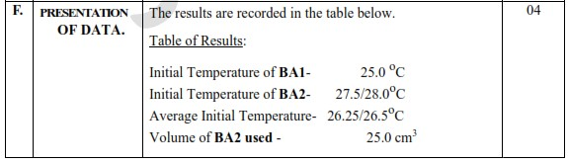

G. RECORDING OF DATA (04 scores):

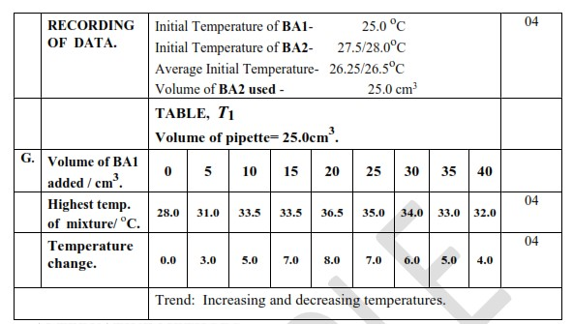

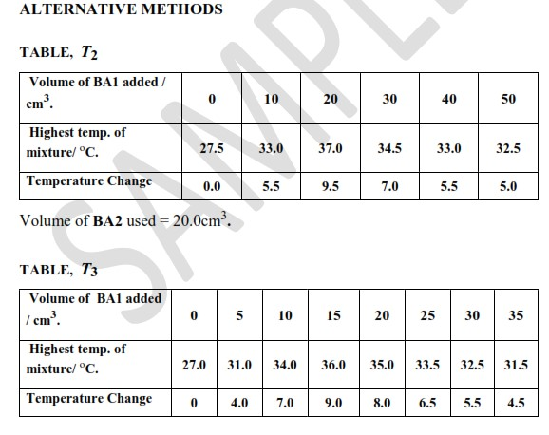

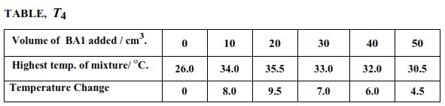

(a) (ii) H. DATA ANALYSIS AND INTERPRETATION/CREATING MEANING (03 scores):

A graph of highest temperature against volume of BA1 added was plotted as shown on graph paper. Heat evolved by reaction = Heat gained by mixture = mc∆T.

Graph 1, (G1):

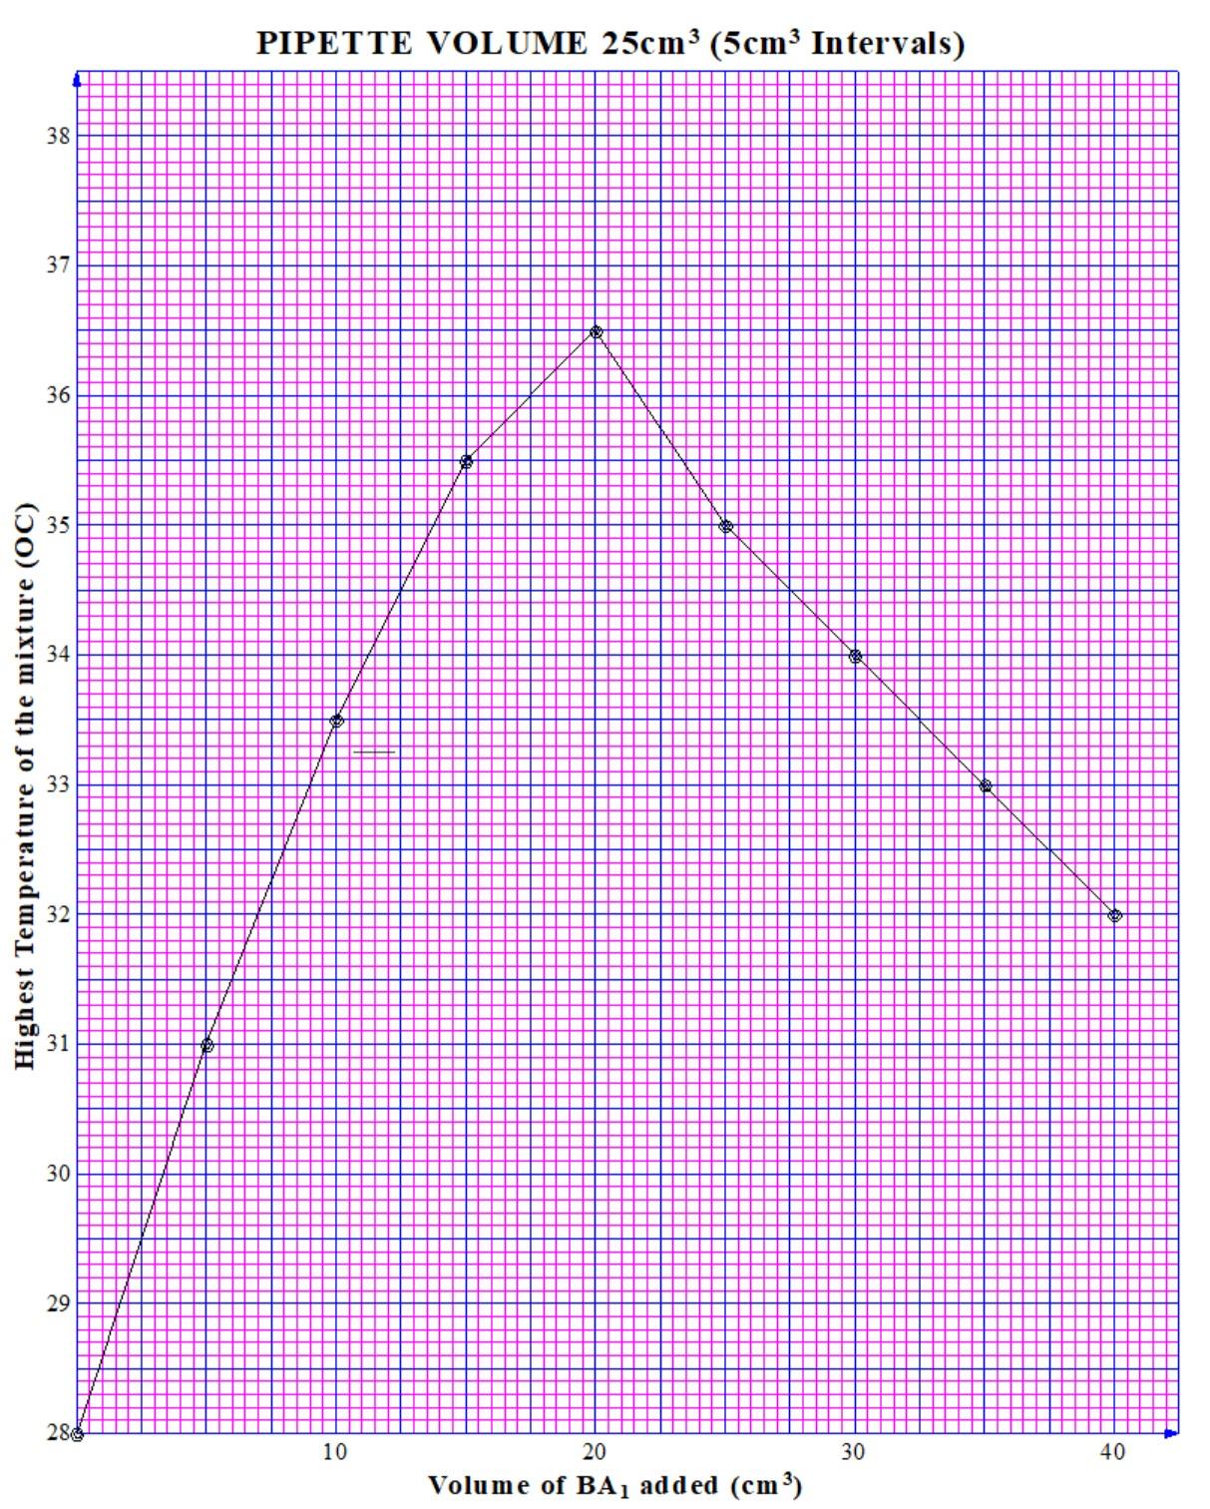

Heat evolved = (20+25)*4.2*(36.5–28.0) = –1,606.5Jmol⁻¹.

Graph 2, (G2):

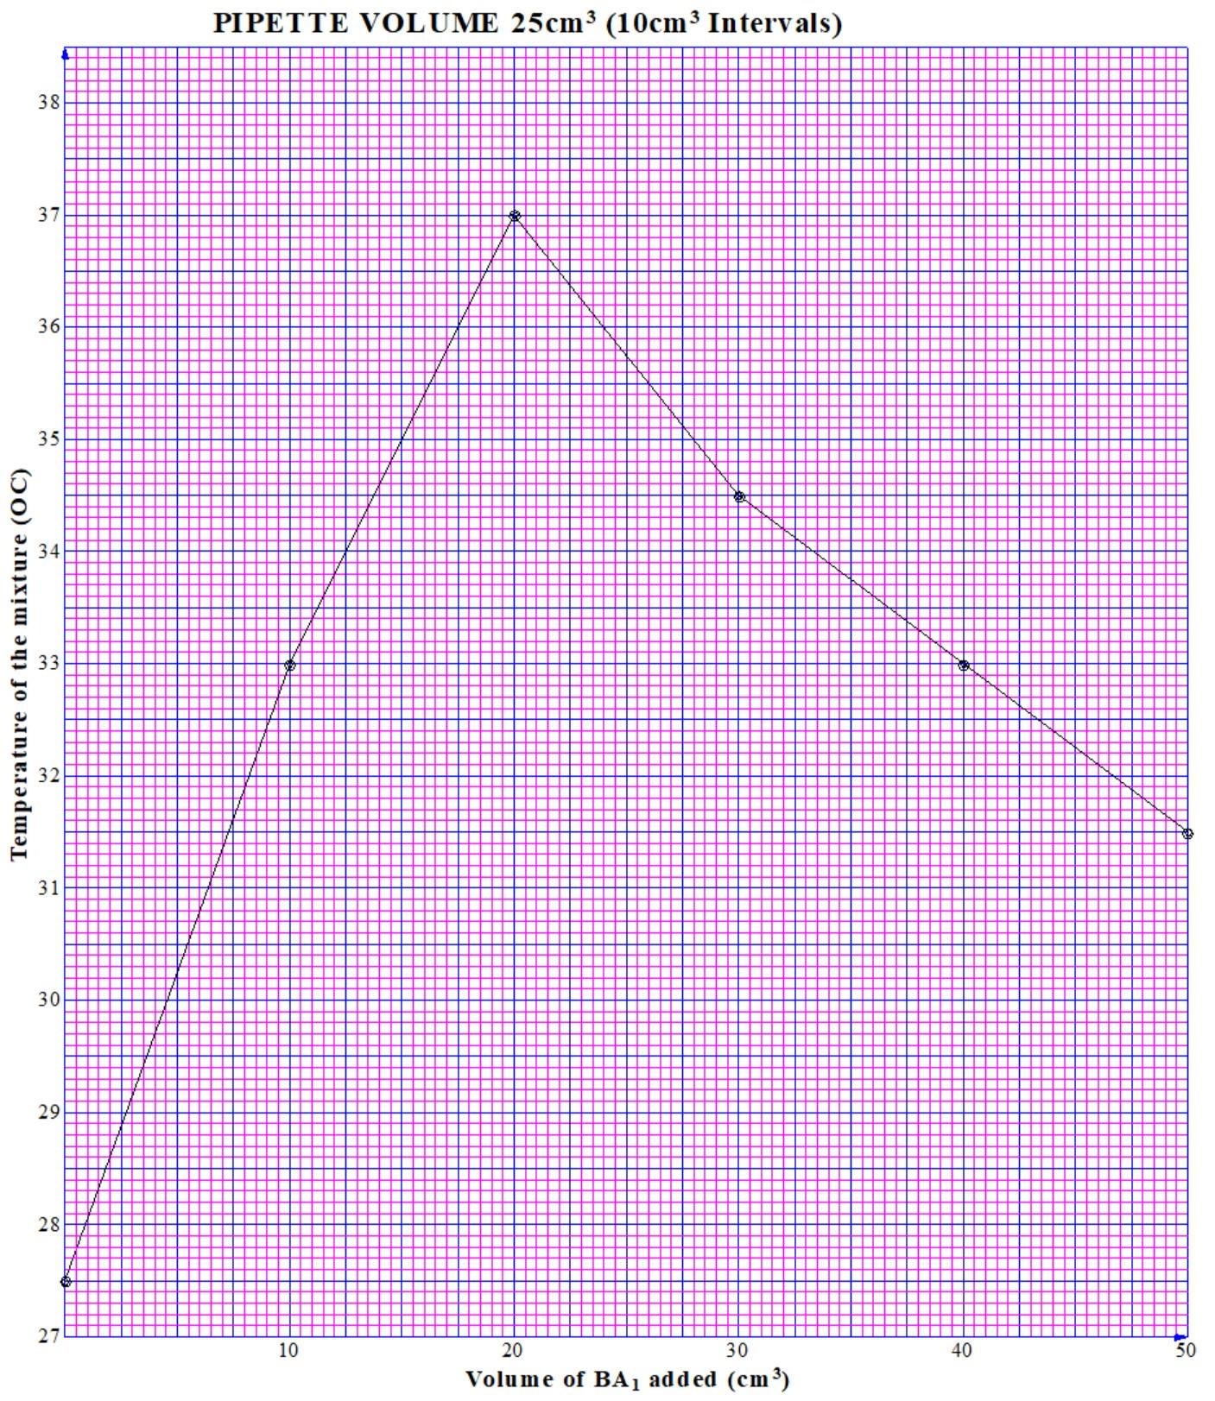

Heat evolved = (20+25)*4.2*(37.0–27.5) = –1,795.5Jmol⁻¹.

Graph 3, (G3):

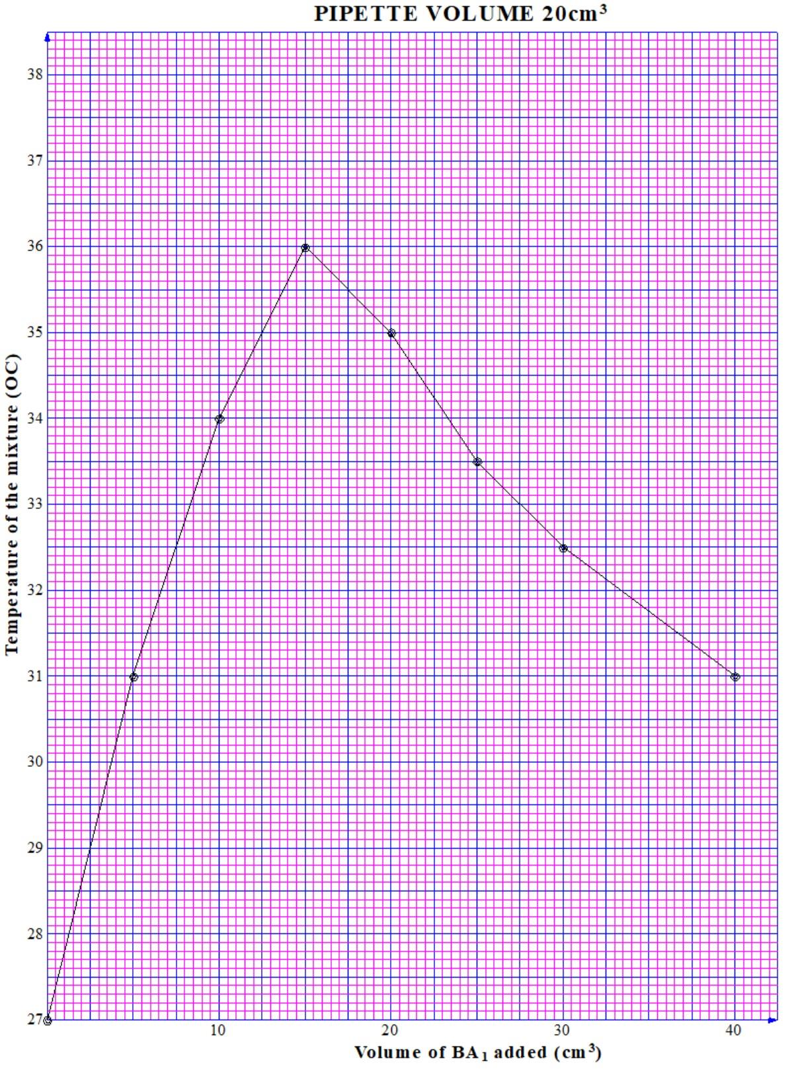

Heat evolved = (20+15)*4.2*(36.0–27.0) = –1,323Jmol⁻¹.

Graph 4, (G4):

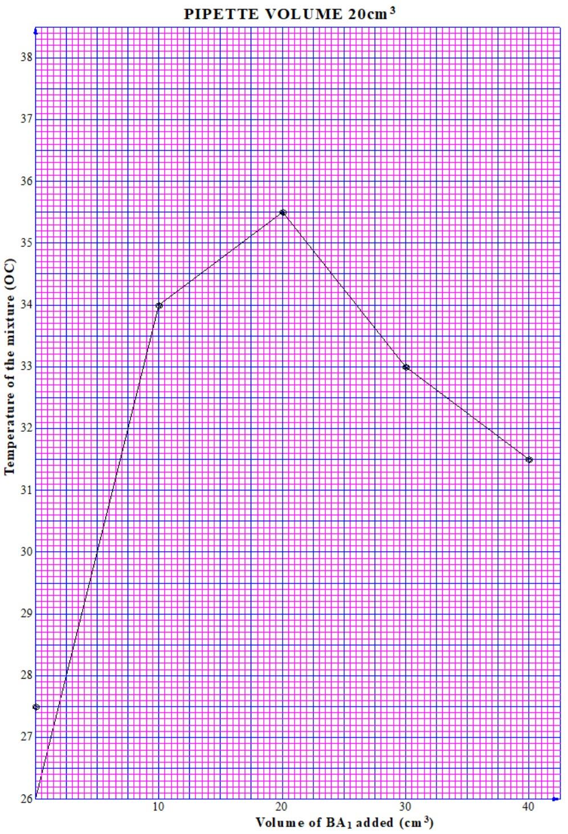

Heat evolved = (20+20)*4.2*(35.5–26.0) = –1,596Jmol⁻¹.

(b) I. CONCLUSION: Heat is evolved when sodium hydroxide reacts with hydrochloric acid. The maximum heat evolved when 25cm³ of sodium hydroxide is mixed with 20cm³ of hydrochloric acid is 1606.5Jmol⁻¹. While the calculated value is positive (indicating heat absorption based on the convention used), the magnitude is significantly smaller than the expected exothermic heat for a strong acid-strong base reaction. This suggests an underestimation of the actual heat released, likely due to factors such as heat loss to the surroundings, incomplete neutralisation because of limiting base concentration, potential variations in specific heat capacity, and minor measurement errors.

ALTERNATIVE METHOD: PROCEDURE OF EXPERIMENT (VARIABLES INTERCHANGED).

(a) All the BA1 provided (50cm³) was diluted by adding an equal volume of water (50cm³) to form 100cm³ of solution. The resultant solution was labelled BA3. Its initial temperature is noted. (b) 20cm³ of BA3 was measured using a measuring cylinder into a plastic beaker followed by 5cm³ of BA2 and the mixture stirred. The highest temperature of the mixture is noted and recorded. (c) Procedure (b) is repeated for values of BA2 equal to 10, 15, 20 and 25cm³. The results are then entered in the table below.

RECORDING OF DATA.

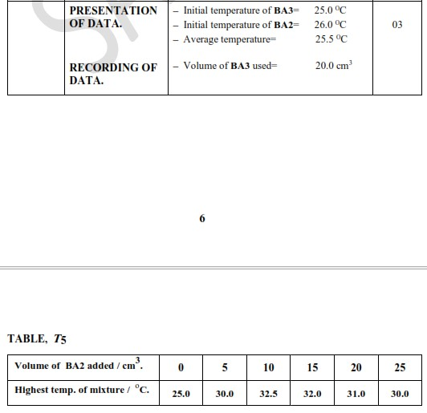

A graph of highest temperature against volume of BA2 added is plotted.

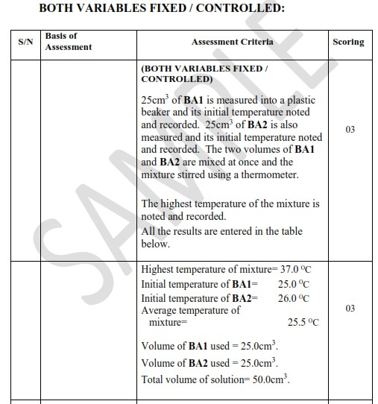

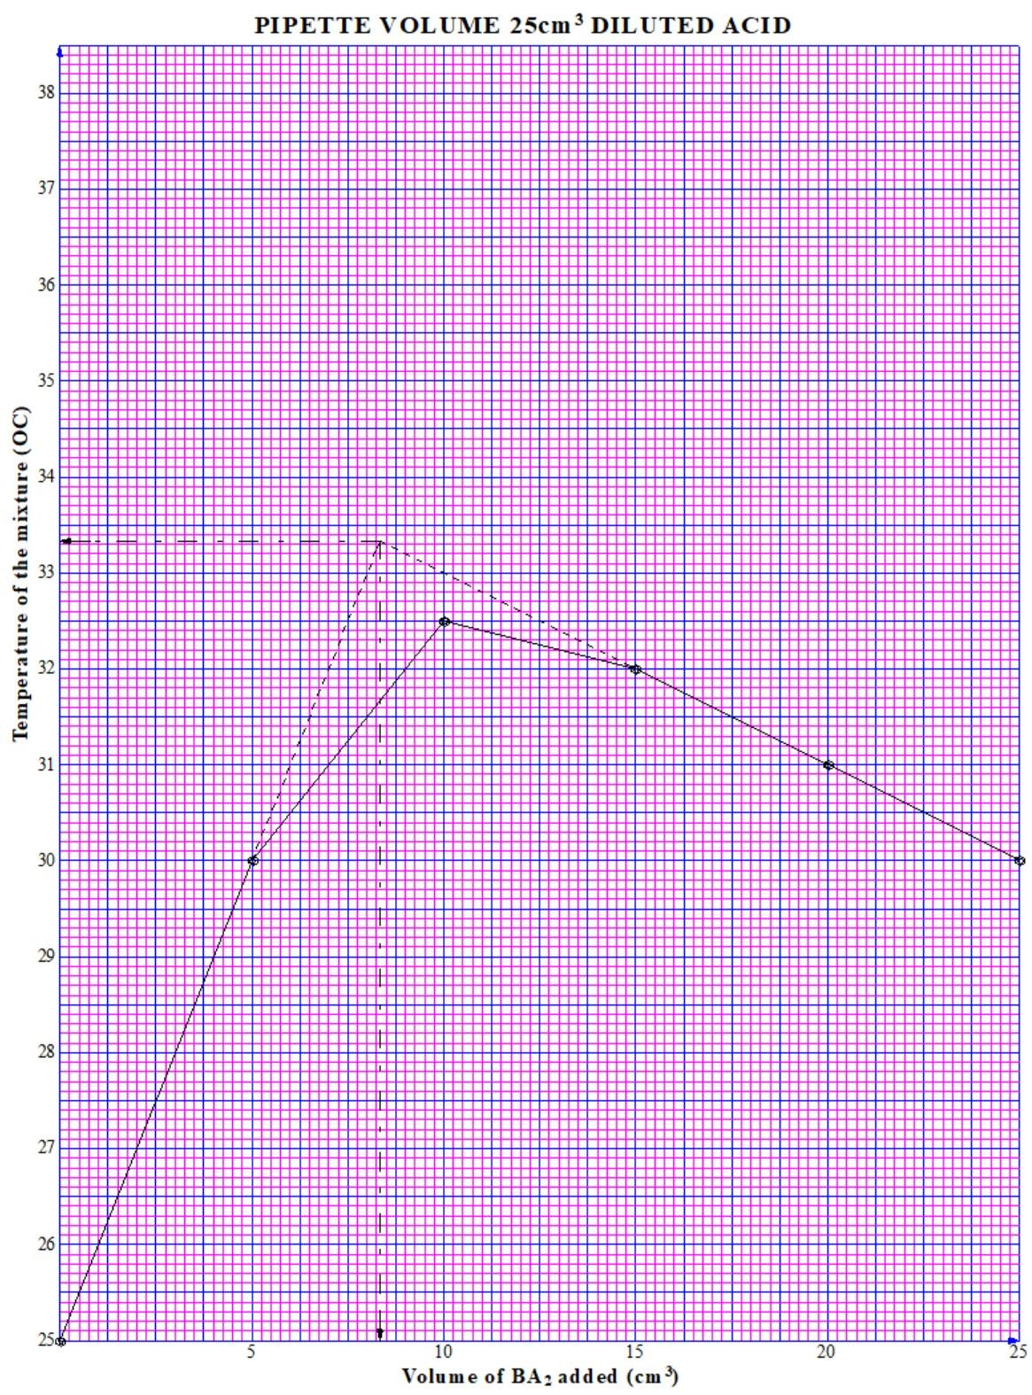

DATA ANALYSIS AND INTERPRETATION / CREATING MEANING:

Heat evolved by reaction = Heat gained by mixture = mc∆T = (50*1*4.2*(37–25.5)) = -2,415Jmol⁻¹. The alternative method with a diluted acid solution can still be used to determine the heat of neutralization. However, due to the dilution, the expected heat change might be smaller compared to using the undiluted acid. It's important to account for this dilution factor when interpreting the results and comparing them to the expected value for a strong acid-strong base reaction (around -57.3 kJ/mol).