DeKUT VirtualQ
Virtual Queue Management Mobile Application
Final Project Report

Human–Computer Interaction (HCI) Module Group Assignment
Dedan Kimathi University of Technology

Team Members: [TBD — insert names & registration numbers]
Date: [TBD]

Table of Contents

1. Introduction

1.1 Problem Statement
Students at university service points — registry, finance, clinic, and accommodation offices — routinely lose significant time standing in physical queues with no visibility into their position, expected wait time, or whether the office is even open. This creates wasted time, overcrowding at service points, and anxiety around missing one's turn. There is currently no simple mobile way for a student to join a queue remotely, track their position in real time, and be notified when it is nearly their turn.

1.2 Objectives
- Allow students to browse live queue status across multiple campus service points before deciding where and when to go.
- Let students join a queue remotely instead of waiting in person.
- Provide real-time visibility of queue position and estimated wait time, in line with Nielsen's visibility of system status heuristic.
- Notify students when their turn is approaching so they can arrive just in time.
- Give students an easy way to leave a queue or confirm service completion.
- Maintain a history of past queue visits for reference.
- Provide a parallel staff-facing tool for service points to manage and analyze queue activity.

1.3 Target Users
- University students who regularly use registry, finance, clinic, or accommodation services and want to avoid long physical waits.
- First-time / first-year students unfamiliar with how queueing at these offices works and who need clear, low-friction onboarding.
- Frequent users (e.g., final-year students handling clearance, fees, or repeated clinic visits) who prioritize speed and want minimal steps to rejoin a queue.
- Service-point staff who need an efficient way to manage active queues and review performance.

2. Methodology
The design process began with structural planning — a full system flowchart and an Information Architecture (IA) diagram — before moving into high-fidelity screen design in Figma. This structural-first approach served the same planning function that low-fidelity paper sketches typically serve: establishing navigation, screen relationships, and content grouping before visual design began.

2.1 Tooling
The assignment brief specifies Balsamiq as the default prototyping tool. The group requested and received lecturer approval to use Figma instead. Confirmation of this approval is retained in the project's docs/ folder.

2.2 Design Process Detail
Full process detail, including the team's account of sketching and early exploration, is maintained separately in docs/methodology-note.md by the team. Refer to that document for the complete and current record of the design process before final submission.

2.3 Overall Process Followed
Prototype → Usability Testing → Identify Problems → Refine Design → (Re-test)

3. User Research

3.1 Method
A written questionnaire was distributed to 5 university students spanning first through final year, covering their experiences with physical queues at Registry, Finance, Clinic, and Accommodation service points, their attitudes toward a virtual queue app, and their notification preferences.

3.2 Participant Responses (Summary)
# | Year | Service Point(s) | Typical Wait | Biggest Frustration | Notification Pref.
1 | First Year | Registry | 30-60 min | Not knowing how long the queue would take | Push
2 | Final Year | Finance | 10-30 min | Waiting when office was temporarily unavailable | Push + SMS
3 | Second Year | Clinic | Over 1 hour | Long wait, uncertainty about timing | In-app
4 | Third Year | Accommodation | 30-60 min | Slow-moving queue, limited progress info | Push
5 | Final Year | Finance & Registry | 10-30 min | Unable to use waiting time productively | SMS

3.3 Key Findings

Uncertainty about waiting time
The most consistent issue across all 5 responses. Students knew they had to wait but had little visibility into their position or how quickly the queue was progressing — one participant noted, “Sometimes you don't know how long the queue will take, so you just have to stay there and wait.”

Physical presence during waiting
Students, particularly in later years, found it inconvenient to remain physically present while other obligations (classes, assignments) went unaddressed. This directly supports the core premise of a virtual, remotely-trackable queue.

Progress visibility, not just a static number
Participants indicated that a queue number alone would not be sufficient — they need confidence that displayed information reflects real movement: “The queue can move very slowly, and sometimes you don't know whether it is actually moving or not.”

Notification preferences vary by individual
Notification Type | Participants | Observation
Push | P1, P4 | Preferred for immediate updates
SMS | P5 | Preferred as a reliable fallback when the app isn't open
Push + SMS | P2 | Wanted multiple channels for reliability
In-app | P3 | Preferred keeping notifications within the app

3.4 Implications for Design
Notably, every implication below maps to a feature already present in the existing design prior to this research being conducted — the findings function as validation of design assumptions rather than as the origin of new requirements, and are reported here honestly on that basis rather than implying the research chronologically drove the design.
Research Finding | System Feature
Uncertainty about queue duration | Queue Position / Live Queue Status
Want to know if a service point is busy before travelling | Service Point Details
Physical waiting is inconvenient | Join Queue (remote)
Concerned about missing their turn | Turn-approaching Notifications
Notification preferences differ | Configurable Notification Preferences
Want to review previous visits | Ticket History
Need a simple way to stop waiting | Leave Queue with confirmation

3.5 Link to Personas
First- and second-year respondents (P1, P3) emphasized understanding how service points work, knowing conditions before arriving, and needing a simple, reassuring interface — directly informing the anxious first-year persona (Faith). Final-year respondents (P2, P5) emphasized saving time, remote queue joining, and productive use of waiting time — directly informing the efficiency-focused final-year persona (Brian). See Section 4.

4. Personas
Both personas below are fully validated against real data: quotes are drawn from usability testing (P01–P05), and goals/frustrations are validated against the pre-design questionnaire (Section 3, 5 real respondents).

4.1 Persona 1 — The Anxious First-Year
Attribute | Detail
Name | Faith Wanjiru
Age / Year | 18, First year
Service points used | Registry, Accommodation
Tech comfort | Comfortable with everyday apps, not a power user

Background
New to campus and still learning how administrative processes work. Doesn't yet know which office handles what, or the informal norms other students have picked up.

Goals
- Understand what's happening in the queue without asking around
- Avoid wasted trips from closed or wrong offices
- Feel confident she won't miss her turn

Frustrations (validated against Section 3 findings)
- Doesn't know how long a queue really is, and has to “just stay there and wait”
- Wants to know whether a service point is busy before travelling there
- Uncertain whether a queue is actually moving with no visible progress indicator

Quote (from usability testing, P01)
“I can see my position, but I'm not immediately sure what the QR code is for.”

4.2 Persona 2 — The Efficient Final-Year
Attribute | Detail
Name | Brian Otieno
Age / Year | 22, Final year
Service points used | Finance, Registry, Clinic
Tech comfort | High — low tolerance for friction

Background
Has used these service points many times before and knows the system well. Often juggling classes, work, and project deadlines.

Goals
- Join a queue remotely to avoid wasted time
- Arrive exactly when needed, not earlier
- Track history across repeated visits

Frustrations (validated against Section 3 findings)
- Has to remain physically in the queue, unable to use that time productively
- Doesn't trust a single notification channel — prefers SMS as fallback or push+SMS together
- Wants confidence a busy office is worth visiting before travelling there

Quote (from usability testing, P04)
“I like being able to check the queue before travelling to the office.”

5. Functional & Usability Requirements

5.1 Functional Requirements (Summary)
Category | Key Requirements
Authentication | Sign up, OTP verification, login, password reset
Home & Discovery | Dashboard overview, browse service points, view details before joining
Queue Experience | Join queue remotely, digital ticket with QR code, live position tracking, leave queue, service completion
Notifications | Position change alerts, turn-approaching alerts, configurable channels (push/SMS/in-app)
History & Profile | Ticket history, profile management, logout
Feedback & Support | Rate completed service, access Help/FAQ and Contact Support
Staff-Side | Staff login, active queue management, call/verify/serve/complete flow, exceptions handling, analytics & reports

5.2 Non-Functional / Usability Requirements
Each usability requirement is mapped to a specific HCI heuristic, ensuring design decisions are grounded in established principles rather than intuition alone.
Requirement | HCI Principle
Live queue position updates within seconds, with a visible live indicator | Visibility of system status
Leave Queue / Logout require explicit confirmation | Error prevention
Consistent color coding for confirm vs. leave/cancel actions | Consistency & standards
Clear feedback on every committing action (join, verify, complete) | Visibility of system status / feedback
Identical navigation structure across all top-level screens | Consistency, recognition over recall
Digital Ticket understandable without external explanation | Learnability
Adequate touch target sizing throughout | Mobile usability / error prevention
Help/Support reachable without losing queue position | User control and freedom
Clear, specific validation errors on all forms | Error prevention & recovery
Staff flow completes a full interaction in minimal taps | Efficiency of use

6. System Design

6.1 System Flowchart
The diagram below shows the complete student and staff flow through the application, alongside the background system processes (queue management, real-time updates, notification service, database, and analytics engine) that support them.
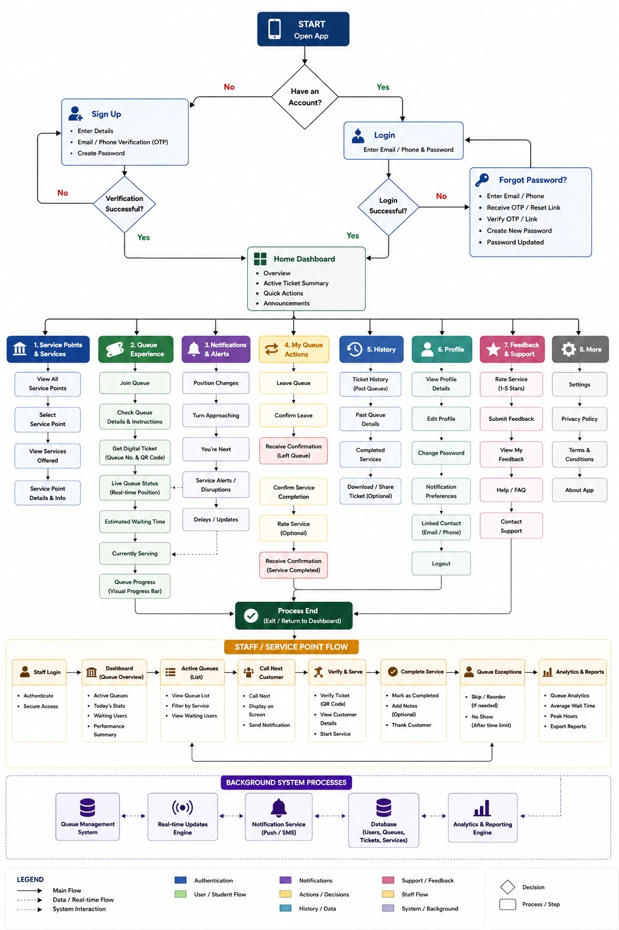
Figure 1. Full system flowchart — student flow, staff/service point flow, and background processes.

6.2 Information Architecture
The application is organized into nine top-level sections, each with numbered sub-items, plus a set of global/utility functions accessible from multiple screens.
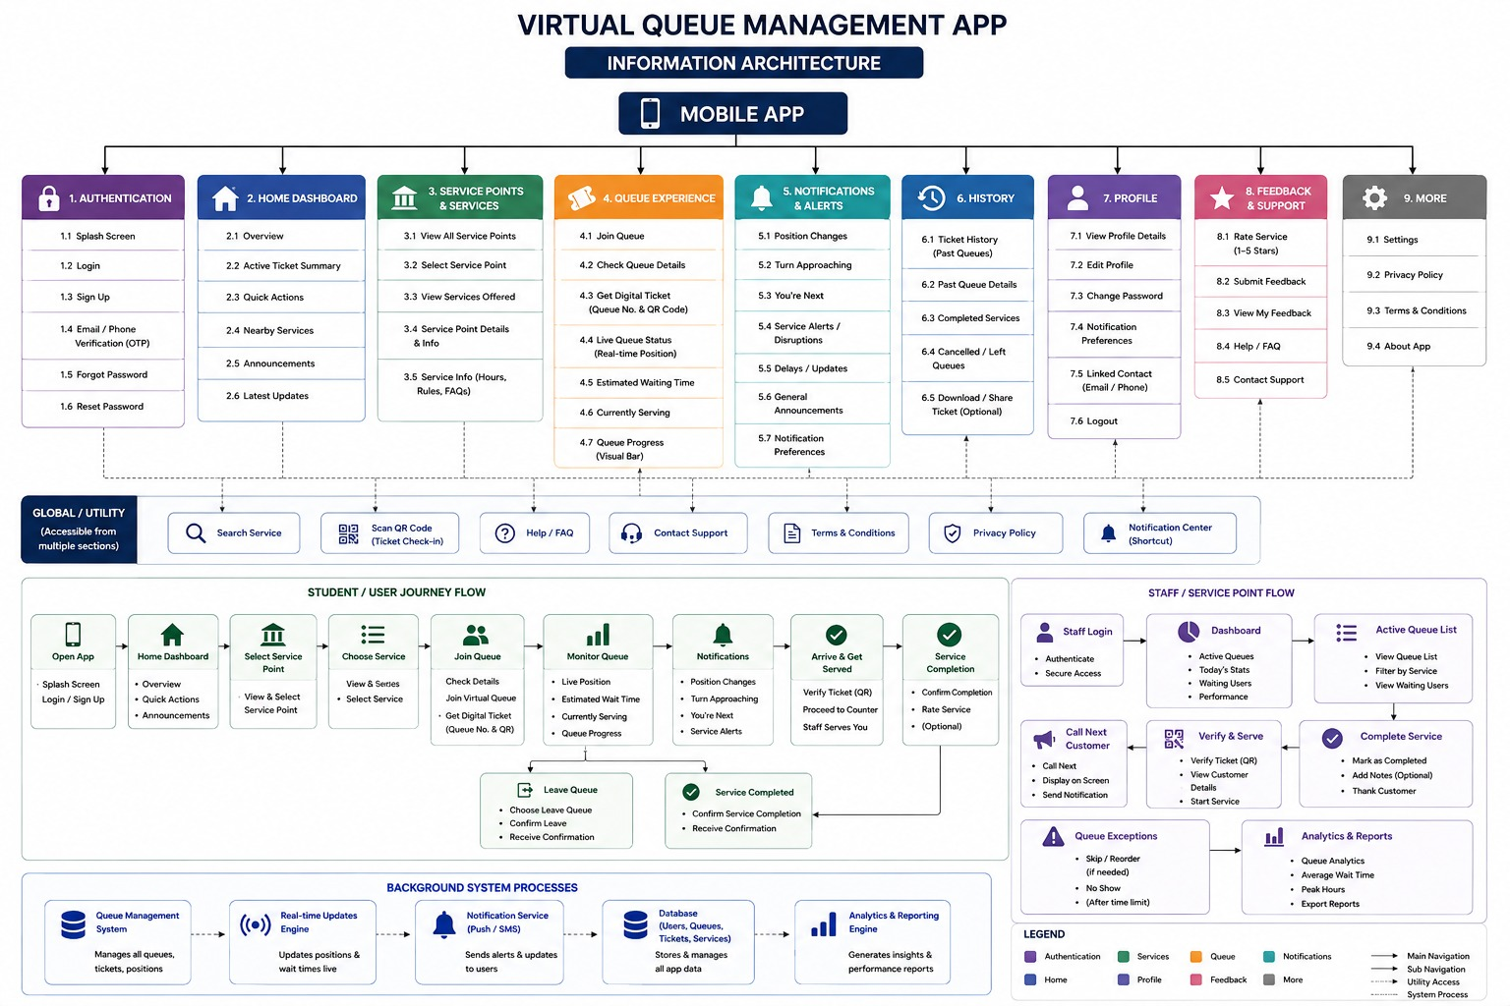
Figure 2. Information Architecture diagram — 9 top-level sections and global/utility functions.

6.3 Screen Inventory
The current Figma prototype consists of 25 linked screens spanning both the student-facing app and the staff-facing service point dashboard, comfortably exceeding the assignment's 12-screen minimum.
Section | Screens Included
1. Authentication | Splash, Login, Sign Up, Forgot/Reset Password
2. Home Dashboard | Overview, active ticket summary, quick actions, announcements
3. Service Points & Services | View all points, select, service details
4. Queue Experience | Join queue, digital ticket, live queue status, leave queue, service completion
5. Notifications & Alerts | Notification feed, preferences
6. History | Ticket history, past/completed/cancelled queues
7. Profile | View/edit profile, change password, logout
8. Feedback & Support | Rate service, submit feedback, help/FAQ, contact support
9. Staff / Service Point Flow | Staff login, dashboard, active queue, call next, verify & serve, complete, exceptions, analytics

7. Prototype
The prototype was built directly in high-fidelity Figma, using a deep-green and off-white color identity intended to read as calm and trustworthy rather than playful — appropriate for an administrative tool. Primary actions (Login, Join Queue, Confirm) use a solid green treatment; destructive or exit actions (Leave Queue, Cancel) are visually distinct so the two are never confused at a glance.
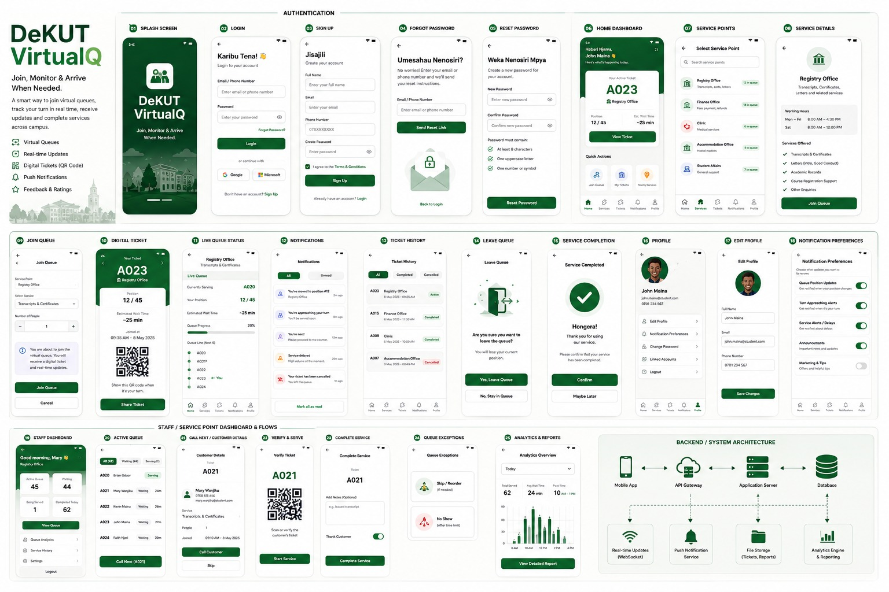
Figure 3. Selected high-fidelity screens — authentication, queue experience, staff dashboard, and system architecture.

7.1 Core Scenario Walkthrough

Scenario A — Join and Get Served
Home → Service Point Detail → Join Queue → Confirm → Digital Ticket (“You are #12”) → Live Queue Status (position updates) → Turn Notification (“You're next”) → Service Completion → Home.

Scenario B — Join Then Leave Early
Home → Service Point Detail → Join Queue → Queue Position → Leave Queue → Confirmation → Home.

Scenario C — Queue is Long, Switch Service Point
Home → Service Point Detail (long queue observed) → back to Home → alternate Service Point → Join Queue → Queue Position → later reviewed in Ticket History.

8. Usability Testing

8.1 Method
A moderated walkthrough was conducted with 5 university students using the Figma prototype in Present/Prototype mode. Each participant was given 8 tasks, one at a time, without the navigation path being explained in advance. The facilitator recorded task completion, approximate time, wrong turns, and think-aloud commentary.

8.2 Participants
Participant | Year | Tech Comfort | Service Point Experience
P01 | First Year | Moderate | Limited
P02 | Second Year | High | Moderate
P03 | Third Year | High | High
P04 | Final Year | Very High | High
P05 | First Year | Moderate | Limited

8.3 Task Performance Summary
Task | Successful | Main Observation
1. Check Queue Status | 5/5 | Generally easy
2. Join Queue | 5/5 | Clear and straightforward
3. Understand Digital Ticket | 4/5 full, 1/5 partial | QR purpose not immediately clear to some
4. Check Queue Progress | 5/5 | Easy to locate and understand
5. Leave Queue | 4/5 full, 1/5 partial | Action could be more visible
6. Configure Notifications | 3/5 full, 2/5 partial | Most significant navigation issue
7. View Ticket History | 5/5 | Easy to locate
8. Leave Rating | 5/5 | Simple and understandable

8.4 Key Findings
Issue | Participants Affected | Severity
Notification settings difficult to locate | P01, P05 (hesitation P02/P03) | Major
Leave Queue action not immediately visible | P05 (minor hesitation P01) | Major
QR code purpose unclear | P01, P02, P05 | Minor
Service point discovery required minor exploration | P01, P05 | Minor
No Critical issues were identified — every task was completed by every participant, at minimum partially.

8.5 Participant Confidence
Participant | Confidence (1–5)
P01 | 4
P02 | 4
P03 | 5
P04 | 5
P05 | 4
Average confidence rating: 4.4 / 5

8.6 Representative Quotes
- “I can see my position, but I'm not immediately sure what the QR code is for.” — P01
- “The ticket is clear, but I would probably want the QR code explanation to be visible.” — P02
- “I wasn't sure where to go when I wanted to leave the queue.” — P05
- “I like being able to check the queue before travelling to the office.” — P04

9. Design Iteration
Three design changes were made directly in response to usability testing findings, following the cycle: Prototype → Test → Identify → Refine.

9.1 Iteration 1 — Notification Preferences Discoverability
Problem: 2/5 participants struggled to locate Notification Preferences; several expected a shortcut from the active ticket screen.
Change: Added a direct shortcut to Notification Preferences from the active Digital Ticket / Live Queue Status screen, alongside the existing Profile path. Channel labels (Push / SMS / In-app) were made visually distinct.
Expected improvement: Fewer navigation steps for users adjusting notifications mid-queue.

9.2 Iteration 2 — Leave Queue Visibility
Problem: One participant did not notice the Leave Queue option at all; another hesitated before finding it.
Change: Increased visual prominence of Leave Queue on the active queue screen, positioned nearer the queue status display, while retaining the confirmation step.
Expected improvement: Users can find and use Leave Queue without hesitation, while accidental cancellation remains prevented.

9.3 Iteration 3 — QR Code Explanation
Problem: 3/5 participants could identify the QR code but were unsure of its purpose.
Change: Added a short explanatory label: “Show this QR code at the service counter.”
Expected improvement: Users understand the QR code's purpose on first exposure, without needing to guess.

9.4 Summary
Iteration | Severity Addressed | Status
1. Notification Preferences shortcut | Major | Implemented
2. Leave Queue visual prominence | Major | Implemented
3. QR code explanatory label | Minor | Implemented
All Major and Minor issues identified in testing were addressed. No Critical issues were found.

10. HCI Principles Applied
The design applies several of Nielsen's usability heuristics directly and deliberately, rather than incidentally:
Heuristic | Application in this system
Visibility of system status | Live queue position and progress bar update in near-real-time; Digital Ticket always shows current state.
Error prevention | Leave Queue and Logout require explicit confirmation before completing.
Consistency & standards | Identical bottom navigation across all top-level screens; consistent color coding for confirm vs. cancel actions.
Recognition rather than recall | Service point details, requirements, and hours are shown before commitment — students don't need to remember them.
User control and freedom | Users can leave a queue at any point, and reach Help/Support without losing their place.
Aesthetic and minimalist design | Each screen centers one clear focal action; generous white space avoids competing elements.

11. Conclusion & Reflection
The project delivered a 25-screen, high-fidelity prototype spanning both a student-facing queue management experience and a staff-facing service point dashboard, exceeding the assignment's core requirements. Usability testing with 5 real students produced an average confidence rating of 4.4/5, with no Critical issues found. The two Major issues identified — notification settings discoverability and Leave Queue visibility — along with one Minor issue (QR code clarity), were directly addressed through three documented design iterations.

11.1 Deviations from the Brief
- Figma was used in place of Balsamiq, with lecturer approval.
- Structural planning (flowchart + IA diagram) was used in place of traditional paper sketching prior to high-fidelity design — see docs/methodology-note.md for the team's full account.

11.2 Limitations & Future Work
- Pre-design user research (the written questionnaire) was completed after core design work rather than before it; findings should be used to validate or adjust existing assumptions.
- A second round of usability testing after the three iterations would strengthen confidence that the fixes resolved the original issues.
- The staff-side flow and analytics dashboard extend beyond the core student-facing requirement and could be scoped down if time is constrained.

12. Appendices

Appendix A: Full Usability Testing Task List
# | Task | Requirement
1 | Find out if the Registry office is currently busy before deciding to go. | FR-2.2, FR-2.3
2 | Join the queue for the Registry office. | FR-3.1
3 | Explain what the Digital Ticket screen is telling you. | FR-3.2, NFR-6
4 | Check how close you are to being served. | FR-3.3, FR-3.4
5 | Leave the queue. | FR-3.5, NFR-2
6 | Set notifications to SMS when your turn is close. | FR-4.3
7 | Look at your past visits to any service point. | FR-5.1
8 | Leave a rating for a good experience. | FR-6.1

Appendix B: Team Contributions
[TBD — insert each team member's name and their specific contributions: research, design, documentation, testing, report writing.]

