**Задача 2.1**

SELECT event_name, COUNT(event_name) AS number_of

FROM(

SELECT event_name, min(event_timestamp), user_pseudo_id

FROM(

SELECT event_name, event_timestamp, user_pseudo_id FROM test_table_001 WHERE event_name in ('gdpr_group_1', 'gdpr_group_2', 'gdpr_group_3', 'gdpr_group_4', 'gdpr_group_5', 'gdpr_group_6')

UNION ALL

SELECT event_name, (event_timestamp), user_pseudo_id FROM test_table_002 WHERE event_name in ('gdpr_group_1', 'gdpr_group_2', 'gdpr_group_3', 'gdpr_group_4', 'gdpr_group_5', 'gdpr_group_6')

UNION ALL

SELECT event_name, (event_timestamp), user_pseudo_id FROM test_table_003 WHERE event_name in ('gdpr_group_1', 'gdpr_group_2', 'gdpr_group_3', 'gdpr_group_4', 'gdpr_group_5', 'gdpr_group_6')

UNION ALL

SELECT event_name, (event_timestamp), user_pseudo_id FROM test_table_004 WHERE event_name in ('gdpr_group_1', 'gdpr_group_2', 'gdpr_group_3', 'gdpr_group_4', 'gdpr_group_5', 'gdpr_group_6')

UNION ALL

SELECT event_name, (event_timestamp), user_pseudo_id FROM test_table_005 WHERE event_name in ('gdpr_group_1', 'gdpr_group_2', 'gdpr_group_3', 'gdpr_group_4', 'gdpr_group_5', 'gdpr_group_6')

UNION ALL

SELECT event_name, (event_timestamp), user_pseudo_id FROM test_table_006 WHERE event_name in ('gdpr_group_1', 'gdpr_group_2', 'gdpr_group_3', 'gdpr_group_4', 'gdpr_group_5', 'gdpr_group_6')

)

GROUP BY user_pseudo_id

)

GROUP BY event_name

**Результат:**

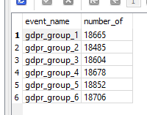

**Задача 2.2**

SELECT event_date,

COUNT(DISTINCT user_pseudo_id),

COUNT(user_pseudo_id),

COUNT(user_pseudo_id) / COUNT(DISTINCT user_pseudo_id) AS mean

FROM (

SELECT p0.user_pseudo_id,

p0.event_date,

p0.event_timestamp,

p0.event_name,

p1.event_name,

p1.event_timestamp,

(CAST(p1.event_timestamp AS int) - CAST(p0.event_timestamp AS int))/1000000 AS delta

FROM (

SELECT *

FROM (

SELECT event_date, event_timestamp, event_name, user_pseudo_id FROM test_table_001

UNION ALL

SELECT event_date, event_timestamp, event_name, user_pseudo_id FROM test_table_002

UNION ALL

SELECT event_date, event_timestamp, event_name, user_pseudo_id FROM test_table_003

UNION ALL

SELECT event_date, event_timestamp, event_name, user_pseudo_id FROM test_table_004

UNION ALL

SELECT event_date, event_timestamp, event_name, user_pseudo_id FROM test_table_005

UNION ALL

SELECT event_date, event_timestamp, event_name, user_pseudo_id FROM test_table_006

)

) AS p0

JOIN (

SELECT *

FROM (

SELECT event_date, event_timestamp, event_name, user_pseudo_id FROM test_table_001

UNION ALL

SELECT event_date, event_timestamp, event_name, user_pseudo_id FROM test_table_002

UNION ALL

SELECT event_date, event_timestamp, event_name, user_pseudo_id FROM test_table_003

UNION ALL

SELECT event_date, event_timestamp, event_name, user_pseudo_id FROM test_table_004

UNION ALL

SELECT event_date, event_timestamp, event_name, user_pseudo_id FROM test_table_005

UNION ALL

SELECT event_date, event_timestamp, event_name, user_pseudo_id FROM test_table_006

)

) AS p1 on p0.user_pseudo_id=p1.user_pseudo_id

WHERE p0.event_name='first_open' AND

p1.event_name='video_show' AND

(CAST(p1.event_timestamp AS int) - CAST(p0.event_timestamp AS int))/1000000 < 3600 AND (CAST(p1.event_timestamp AS int) - CAST(p0.event_timestamp AS int))/1000000 > 0

)

GROUP BY event_date

**Результат:**

***вопрос поставлен неоднозначно (не указано, какое значение необходимо найти сумма\среднее\медиана)

1. Сумма событий по дням (lineplot приувеличивает визуально реальную разницу)

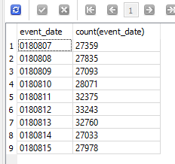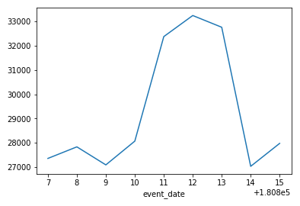

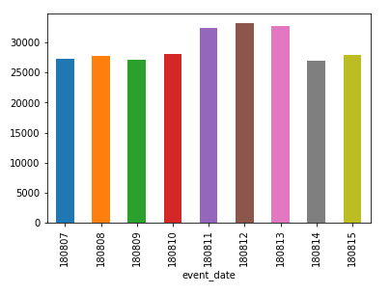

1. Среднее\Медианное значение событий по дням недели

