**Successful Profit Bookings on Algorithmic Trading**

**By**

**Student Name: ----**

**Reg No: ---**

**Institution: ---**

**Module: ---**

**Submission Date: ---**

**Table of Contents**

Abstract 4

Introduction 5

Background Information 5

Problem Statement 8

Research Aim and Objectives 8

Research Questions 8

Research Scope 9

Report Structure 9

Literature Review 11

History of Algorithmic Trading 11

Why Adopt Algorithmic Trading? 13

Applicable Strategies 14

Algorithmic Trading Requirements 16

Research Methodology 17

Methodology 17

Data Collection 19

Ethical Issues 19

Design and Implementation 22

Loading the Acquired Data 23

Data Exploration 24

Data Description 25

Correlation 26

Addition of Moving Averages to the data frame 27

Addition of “Trade Signal” 28

Calculation of Instantaneous Returns/System Returns 29

Plotting the trades on Time Series 30

Findings and Discussion 32

Conclusion and Recommendations 34

Recommendations 35

References 37

**List of Figures**

Figure 1: loading data 23

Figure 2: Data reading 24

Figure 3: Data exploration 25

Figure 4: Data description 25

Figure 5: Correlation 26

Figure 6: Heatmap 27

Figure 7: Addition of moving averages 28

Figure 8: Trade signal addition 28

Figure 9: Calculation of returns 29

Figure 10: Trade plot on time series 30

Figure 11: System performance against Customer's power 31

# **Abstract**

Algorithmic trading is also known as automated trading or black-box trading, it utilizes computer programs that are designed to follow a defined set of programmed instructions and alias algorithms to place trades. The trades are always hoped to generate profits or revenues at a given speed as well as the frequency that the human trader finds impossible. While carrying out the trading procedures, traders’ mindset, as well as their perspectives, can be unique at given timeframes, and sometimes, they can be led to emotional trading and this can result in enormous losses. Emotional trading can be described to be one of the most terrible approaches that can occur while trading. Therefore, while trading, one needs peace of mind as well as concentration and this paved the way for algorithmic trading. This type of trading combines both computer programming techniques and financial markets for it to execute the relevant trades required by the traders at precise moments. However, the trading process attempts to strip away human emotions that can be involved in the physical trades and this ensures that the execution result of the process is much more efficient; in this context, the order placement is done instantaneously the trading fees are much lowered. The main aim of the dissertation was based on finding algorithmic trading strategies that would be applied to the market space to provide success in market profit booking. However, the strategy that was used for the modeling phase was based on the problem domain and it was a trend-following strategy, most algorithmic trading strategies follow various trends available in the market space. The trend following can be based on moving market averages, price level changes, channel breakouts as well as relative technical indicators. The implementation phase was facilitated by using Jupyter Notebook since the tasks carried out were implemented via Python programming language. The notebook was identified as both client/server-based applications that enabled the researcher to edit and run the written document on any browser of choice. Observations made were based on closing day (9-day), an individual would be advised to make purchases on the opening days (21-day) of last year’s month of December as well as around February this year, 2022. However, on the current month of the year, one would incur losses and he or she would not be advised to buy or sell gold stock. In addition, the following graph outlines the system performance against the customer’s “Buy/Hold” power. It depicts that the customer’s return is outperformed by the system by (1.16%), which means that the system could cause losses at this moment.

# **Introduction**

This is the first chapter of the Algorithmic Trading dissertation and it describes the trading process. In this chapter, the author introduces algorithmic trading as an automated type of trading that utilizes computer programs that are designed to follow a defined set of programmed instructions and alias algorithms to place trades. However, in this chapter; the author provides the dissertation objectives, research questions that guided the development process of the research, the main aim of carrying out the research as well as the identified problem.

## **Background Information**

Algorithmic trading is also known as automated trading or black-box trading, it utilizes computer programs that are designed to follow a defined set of programmed instructions and alias algorithms to place trades. The trades are always hoped to generate profits or revenues at a given speed as well as the frequency that the human trader finds impossible, (Treleaven et al, 2013, pp.76-85). The defined set of programmed computer instructions is always dependent on time, price, quality, and any applicable mathematical model. In this context, apart from the generated profits for any given trader, the algorithmic trading process renders the markets to be in a more liquid nature and this allows the trading process to be more systematic for it rules out the human impact on emotions that can affect the trading activities. According to, (Hendershott and Riordan, 2013, pp.1001-1024), this type of trading combines both computer programming techniques and financial markets for it to execute the relevant trades required by the traders at precise moments. However, the trading process attempts to strip away human emotions that can be involved in the physical trades and this ensures that the execution result of the process is much more efficient; in this context, the order placement is done instantaneously the trading fees are much lowered.

There are various algorithmic trading techniques applicable in the modern days of technology and they include; trend-following strategies, index fund rebalancing as well as arbitrage opportunities. The entire trading process is usually executed dependent on the trading volume which entails volume-weighted average prices or passage of timeframe which includes the time-weighted average prices, (Boehmer et al, 2012). For an individual to get started with the algorithmic type of trading, he or she is required to acquire computer access, have fast network access, and have knowledge of financial markets as well as coding capabilities.

It is highly recommended for one to note that most of the algorithmic trading practices used in the current days of trading are known as high-frequency trading alias HFT and it makes attempts on capitalizing the placed large number of customer orders at given rapid speeds in various markets as well as across different decision parameters which are based on preprogrammed computer instructions. However, the algorithmic type of trading is utilized in different forms of trading as well as investment activities, (Chan, 2021). Some of them include the mid-to-long-term investors that involve pension funds and relative insurance organizations; in this context, algorithmic trading is used to make purchases of stocks in large quantities while not intending to cause influence the stock prices having discrete as well as large-volume investments.

On the other hand, short-term traders can be referred to as sell-aside market participants and they include market makers like brokerage houses, speculators as well as arbitrageurs who usually make benefit from the automated trade execution; in this context, the algorithmic trading process helps in the creation process of sufficient liquidity for the market sellers. The other form of algorithmic trading involves the systematic traders who are the trend followers and they can also be referred to as pairs traders. In this context, this can be termed as the neutral-market trading strategy that aims at matching the long positioned with the short positioned in pairs of the available correlated market instruments like two stocks, currencies as well as exchange-traded funds alias ETFs. Through the systematic trading strategy, it has been easily found that the process becomes more efficient while programming the trading rules as well and this facilitates the program trade automatically. Algorithmic trading can then be said to provide a much more systematic procedure that is relative to achieving active trading as compared to other methods that are based on traders’ intuitions or instincts.

The key strategies used in algorithmic trading require an identified market opportunity that is aimed at generating profits in terms of amplified earnings and reduced costs. Some of the strategies include; trend-following strategies, most algorithmic trading strategies follow various trends available in the market space, (Kissell, 2013). The trend following can be based on moving market averages, price level changes, channel breakouts as well as relative technical indicators. In this context, the trend-following strategies can be termed as the easiest as well as simplest types of strategies that can be implemented via algorithmic trading procedure since they don’t entail prediction making or market price forecasting exercises. Trades in the trend-following strategies are always initiated based on the occurrence of the desirable trend and they are found to be easy as well as straightforward in the implementation procedure since the utilized algorithms are not complex in terms of predictive analysis. The trend following strategy algorithms can use 50 days and 200 days averages which is a common and popular strategy under trend following process.

Arbitrage opportunities are another strategy used in algorithmic trading as traders buy a dual-listed stock at various lower prices in a given market as well as simultaneously sell them at a hiked price in other markets offering the price differentials as arbitrages or risk-free profits. Similar operations can be made for stocks against future instruments like price differentials that exist naturally, (Tsang et al, 2016). While following this type of strategy, its algorithmic implementation process can involve the identification of price differentials as well as order placement efficiently and this promises profitable market opportunities.

The index fund rebalancing strategy is used in algorithmic trading where index funds have to define rebalancing periods that bring the trader’s holdings to par terms with the relative benchmark indices. In this context, there is the creation of profitable opportunities that are used by the algorithmic traders who generally capitalize on the expected market trades offering 20 to 80 base points on the profits with dependency on the stocks number available in the index fund before the exercise on fund rebalancing, (Dayanandan and Lam, 2015, pp.79-92). In addition, such market traders are always initiated through algorithmic trading systems focusing on timely execution as well as the best market prices.

Trading range alias mean reversion is an algorithmic trading strategy that is based on the theory that describes the prices of an asset are always in temporal nature while reverting to their average value in a given period, (Li et al, 2013, pp.1-38). The asset prices in this case could either be low or high. Price range identification, as well as definition and the entire implementation process of an algorithm that produces the required results, is always based on the market trades placed in an automatic nature when the asset price breaks in and out of the defined range respectively. The time-weighted average price also known as TWAP is an algorithmic trading strategy that generally breaks up large market orders as well as releases dynamic determined market orders in smaller chunks to the market, therefore, utilizing the available fractions of time slots that could be labeled between the start as well as end time. The main aim of this strategy is always based on executing the orders that are close to the price average between the time fractions, therefore, minimizing the impact of the market.

## **Problem Statement**

While carrying out the trading procedures, traders’ mindset, as well as their perspectives, can be unique at given timeframes, and sometimes, they can be led to emotional trading and this can result in enormous losses. Emotional trading can be described to be one of the most terrible approaches that can occur while trading. Therefore, while trading, one needs peace of mind as well as concentration and this paved the way for algorithmic trading. This type of trading combines both computer programming techniques and financial markets for it to execute the relevant trades required by the traders at precise moments. However, the trading process attempts to strip away human emotions that can be involved in the physical trades and this ensures that the execution result of the process is much more efficient; in this context, the order placement is done instantaneously the trading fees are much lowered.

## **Research Aim and Objectives**

The main aim of the dissertation was based on finding algorithmic trading strategies that would be applied to the market space to provide success in market profit booking. The main objectives of the project are outlined below;

1. To understand what is algorithmic trading and all strategies applicable,
2. To analyze the current market space of the chosen organizational data,
3. To investigate how the market space can utilize algorithmic trading strategies to maximize and customize the market share and profits,
4. To understand how algorithmic trading reduces human errors,
5. To understand how to trade in a correct timeframe.

## **Research Questions**

The researcher utilized the following questions that aided in narrowing down the scope;

1. What is algorithmic trading and how does it affect marketing?
2. What are the strategies used in algorithmic trading?
3. How can organizations or individuals utilize algorithmic trading?

## **Research Scope**

Algorithmic trading procedure combined both computer programming techniques and financial markets for it to execute the relevant trades required by the traders at precise moments. However, the trading process attempted to strip away human emotions that would be involved in the physical trades and this ensures that the execution result of the process is much more efficient; in this context, the order placement is done instantaneously the trading fees are much lowered. The project used trend following strategy as it was based on moving market averages, price level changes, channel breakouts as well as relative technical indicators. In this context, the trend-following strategies can be termed as the easiest as well as simplest types of strategies that can be implemented via algorithmic trading procedure since they don’t entail prediction making or market price forecasting exercises. Trades in the trend-following strategies were initiated based on the occurrence of the desirable trend and they were found to be easy as well as straightforward in the implementation procedure since the utilized algorithm was not complex in terms of predictive analysis. The trend following strategy algorithms used 9 days and 21 days averages which is a common and popular strategy under trend following process.

## **Report Structure**

The report structure entailed different chapters that are the introduction, literature review, research methodology, design/implementation, evaluation, and conclusion.

**Introduction:** It was the first chapter of the Algorithmic Trading dissertation and it describes the trading process. In this chapter, the author introduces algorithmic trading as an automated type of trading that utilizes computer programs that are designed to follow a defined set of programmed instructions and alias algorithms to place trades. However, in this chapter; the author provides the dissertation objectives, research questions that guided the development process of the research, the main aim of carrying out the research as well as the identified problem.

**Literature Review:** This is the second chapter of the dissertation; the researcher provided the theoretical framework on the subject of algorithmic trading. The chapter covers the basic history of algorithmic trading, the reasons why one needs to try algorithmic trading, all the applicable strategies, and the trading requirements.

**Methodology:** This was the third chapter of the dissertation, and it stipulated the required structure of the processes that facilitated the research development. It outlined the overall research design, the data collection procedure as well as how the collected data was analyzed. Based on the project’s nature, was based on investigating how one could make profits by utilizing algorithmic trading strategies to avoid losses.

**Implementation:** This is the fourth chapter of the dissertation. In this chapter, the researcher illustrated more on the data analysis process, which entailed several activities such as processing as well as the transformation of the collected data via the yahoo finance data API before feeding it to the stock marketing model. It is through this chapter, that there has been the generation of actionable insights that can be said to be helpful to both individuals and organizations in making further informed decisions about stock markets. Through this chapter, the researcher was enabled to reduce the inherent risks that could affect the stock market decision-making procedure as well as provide powerful insights as presented via graphs.

**Discussion:**  This was the fifth chapter that provided the overall findings and the respective discussion on the results attained from the implementation chapter. However, the results were evaluated against the research’s objectives and whether they were fulfilled.

# **Literature Review**

This is the second chapter of the dissertation; the researcher provided the theoretical framework on the subject of algorithmic trading. The chapter covers the basic history of algorithmic trading, the reasons why one needs to try algorithmic trading, all the applicable strategies, and the trading requirements.

## **History of Algorithmic Trading**

Before algorithmic trading gained popularity, various events had to happen to create the required way in the financial markets. These events were initiated by the launch of the initial trading rule-based fund in 1949 by an American-based trader known as Richard Donchian under a company known as Future, Inc. His company was publicly holding commodity funds that were used in the trading process for the futures markets, (Foucault, 2012). The launched fund became the initial to utilize a set of defined rules that were relative in generating the actual market trading buy as well as sell signals. However, the fund was said to have utilized a mathematical-based system to move the averages associated with the commodity market prices. The only problem that was experienced during this era was that no internet access would support the fund and this forced the developers to use data provided by ticker tapes to manually chart the markets. Through its feature on rules, it was the earliest trial that attempted to automate the trading procedure.

In 1950, Max Markowitz introduced a computation-based model known as Markowitz Model. The model was based on computing finance as this would provide a reliable solution to the faced problem of portfolio selection. The Markowitz model became the foundation of the applied modern portfolio theory alias MPT and it was featured in a finance-based journal in 1952. The finance-based journal was known as “The journal of finance”. However, Max is referred to be the initiator of quantitative analysis, (Yadav, 2015). Later on, in 1960 there was the introduction of the first arbitrage trade that utilized computers. The arbitrage trade was launched after hedge fund managers partnered with Max Markowitz to develop a computer-based program that facilitated the arbitrage trading process. The two Hedge fund managers who led the partnership were known to be Ed Thorp and Michael Goodkin. The late 1970s, as well as early 1980s, recorded the introduction of personal computers and this facilitated the development process of computational-based applications that dealt with finance applications as well as market signals processing procedures like time series analysis and profit optimization.

In 1967, Jerome and Herbert developed the Instinet trading system that became one of the ancient electronic communications networks to ever exist on wall street. The introduction of the trading system was a trading enabler to the large institutional-based investors as they traded on a pink sheet and this meant that they were enabled to trade directly with their peers in an electronic-based setup. This made the Instinet trading system to be a major competitor to the New York stock exchange which had commenced its operations in 1965. Later on, in 1971, there was the formation of Nasdaq which offered fully automated trading which was referred to as an over-the-counter type of trading. During the early days of its formation, Nasdaq offered only quotations and down the line, as days passed, it offered electronic trading which made it famous in offering online trading, (Boehmer et al, 2012). In 1978, there was the launch of a more advanced Intermarket trading system alias ITS; the system was developed based on the previously launched system known as Nasdaq. The later system became a major game-changer in the trading industry. It was more than a network as it was under the management of Security Industry Automation Corporation alias SIAC. It was utilized as an electronic network that stipulated reliable links between the trading floors of different exchanges and also it facilitated a real-time type of communication between the trading floors. However, the network allowed any broker on the trading floors to take part in the entire trading process as they could respond to real-time market price changes as well as place orders which were under coordination management of the system.

In 1984, New York Stock Exchange launched a computerized order flow; this was an advancement from the one that they had initially launched in the early 1970s. This was referred to be the turning point of the system as it became a super system known as “designated order turnaround”. The initial system functioned by routing orders in an electronic form to various proper trading posts which later had to execute the orders in a manual procedure. The latter super system took over the market order transmission process from firm members to the New York stock exchange trading floors for execution procedures, (Burgess, 2019). In this context, it only meant that once the orders were executed on the floors, the firm members got immediate order confirmation notifications. However, the super system had recorded a significant advancement in trade equities execution processes which entailed speed as well as volume and this meant that up to 2, 000 shares orders would be routed to a specialist in an electronic form.

In 1993, Thomas Peterffy launched a firm known as Interactive Brokers. This firm pioneered digital trading as it popularized what had been developed by Timber Hill and it was applicable for electronic networks as well as trading execution processes to clients. It is highly recommended to note that before Thomas launched the Interactive Brokers firm, in 1987, he had developed a fully automated algorithmic trading system; this system used an IBM machine to extract data and information from Nasdaq terminals which were connected to it and through this, it was able to trade in an automated nature. Later on, in 1998, the United States Securities and Exchange Commission alias SEC accepted the existence of alternative trading systems; through this, it was much easier for electronic exchanges led to the development of a computerized high-frequency trading process, (Johnston and Petacchi, 2017, pp.1128-1155). The SEC's new rules as well as amendments on alternative trading systems facilitated the decision-making process on whether members would register as broker-dealers or as national securities exchanges. They were required to comply with additional needs as stipulated by the regulatory body based on their core activities as well as trading volumes. The regulation by SEC resulted in market credibility as well as transparency towards the new field of trading that was facilitated by algorithms. This fostered the growth of the entire market.

The mass adoption of algorithmic trading was also fostered by the United States Decimalization completion process that was recorded in 2001. The process recorded a transformation of the market’s minimum tick size which was earlier sold at $0.0625 to $0.01 per single share. Through this, new trading transformations towards the market structure allowed extra minor differences to exist between the bid prices and the offer prices. As the transformation caused a switch towards the respective practices in standard international trading, the market investors also benefited from the process change. The investors were enabled to carry out an identification process on the transforming price quotations as well as respond to them respectively.

## **Why Adopt Algorithmic Trading?**

Algorithmic trading utilizes computer programs that are designed to follow a defined set of programmed instructions and alias algorithms to place trades. The trades are always hoped to generate profits or revenues at a given speed as well as the frequency that the human trader finds impossible, (Hu et al, 2015, pp.534-551). The defined set of programmed computer instructions is always dependent on time, price, quality, and any applicable mathematical model. In this context, apart from the generated profits for any given trader, the algorithmic trading process renders the markets to be in a more liquid nature and this allows the trading process to be more systematic for it rules out the human impact on emotions that can affect the trading activities. This type of trading combines both computer programming techniques and financial markets for it to execute the relevant trades required by the traders at precise moments, (Upson and Van Ness, 2017, pp.49-68). However, the trading process attempts to strip away human emotions that can be involved in the physical trades and this ensures that the execution result of the process is much more efficient; in this context, the order placement is done instantaneously the trading fees are much lowered.

## **Applicable Strategies**

The key strategies used in algorithmic trading require an identified market opportunity that is aimed at generating profits in terms of amplified earnings and reduced costs. Some of the strategies include; trend-following strategies, most algorithmic trading strategies follow various trends available in the market space. The trend following can be based on moving market averages, price level changes, channel breakouts as well as relative technical indicators. In this context, the trend-following strategies can be termed as the easiest as well as simplest types of strategies that can be implemented via algorithmic trading procedure since they don’t entail prediction making or market price forecasting exercises. Trades in the trend-following strategies are always initiated based on the occurrence of the desirable trend and they are found to be easy as well as straightforward in the implementation procedure since the utilized algorithms are not complex in terms of predictive analysis. The trend following strategy algorithms can use 50 days and 200 days averages which is a common and popular strategy under trend following process.

Arbitrage opportunities are another strategy used in algorithmic trading as traders buy a dual-listed stock at various lower prices in a given market as well as simultaneously sell them at a hiked price in other markets offering the price differentials as arbitrages or risk-free profits. Similar operations can be made for stocks against future instruments like price differentials that exist naturally. While following this type of strategy, its algorithmic implementation process can involve the identification of price differentials as well as order placement efficiently and this promises profitable market opportunities.

The index fund rebalancing strategy is used in algorithmic trading where index funds have to define rebalancing periods that bring the trader’s holdings to par terms with the relative benchmark indices. In this context, there is the creation of profitable opportunities that are used by the algorithmic traders who generally capitalize on the expected market trades offering 20 to 80 base points on the profits with dependency on the stocks number available in the index fund before the exercise on fund rebalancing. In addition, such market traders are always initiated through algorithmic trading systems focusing on timely execution as well as the best market prices.

Trading range alias mean reversion is an algorithmic trading strategy that is based on the theory that describes the prices of an asset are always in temporal nature while reverting to their average value in a given period. The asset prices in this case could either be low or high. Price range identification, as well as definition and the entire implementation process of an algorithm that produces the required results, is always based on the market trades placed in an automatic nature when the asset price breaks in and out of the defined range respectively. The time-weighted average price also known as TWAP is an algorithmic trading strategy that generally breaks up large market orders as well as releases dynamic determined market orders in smaller chunks to the market, therefore, utilizing the available fractions of time slots that could be labeled between the start as well as end time. The main aim of this strategy is always based on executing the orders that are close to the price average between the time fractions, therefore, minimizing the impact of the market.

Percentage of volume trading strategy alias POV is based on the operation until the market trade orders are fulfilled, it then operates by sending partial market orders following the predefined ratio of participation as well as the markets’ volume of trade. This means that the relative steps strategy generally sends market orders at various user-defined percentages of the available market volumes. Through this, the strategy can cause an increase or decrease in the rate of participation in cases where market stock prices peak at the user-defined level.

Another strategy used in algorithmic trading is known as implementation shortfall which aims to reduce the order execution cost via trading off the available real-time market. In this context, an individual or an organization benefits by saving the order cost execution process. While using this type of strategy in the market, amplifies the targeted rate of participation in cases where the market stock prices record favorable moves. In this context, it can decrease the targeted rate of participation in cases where the market stock prices record adverse moves.

## **Algorithmic Trading Requirements**

Algorithm trading implementation via a programmed computer program is referred to as the last phase in the entire online trading process as it is usually accompanied by backtesting which attempts the developed algorithm based on the past historical trading events about the stock market performance as it aids in identifying whether the algorithm will be profitable. The main challenge with algorithm trading is always based on transforming the defined strategy to exist as an integrated computer-based procedure that entails the trading account access that can be utilized to place orders. However, there are always requirements that facilitate the entire trading process and they include computer-based programming understanding and knowledge that can be integrated with the chosen strategy, (Kirilenko and Lo, 2013, pp.51-72). The computer programs can be developed by hired programmers or one can utilize the available pre-made trading software programs. However, for the process to be effective and efficient enough; good network connectivity, as well as access to the relevant trading platforms, is always crucial. The trading platforms allow one to place market stock orders. In addition, reliable access to the stock market information feeds to be monitored by the developed algorithm to facilitate the identification of opportunities relative to order placement is a key requirement.

# **Research Methodology**

This was the third chapter of the dissertation, and it stipulated the required structure of the processes that facilitated the research development. It outlined the overall research design, the data collection procedure as well as how the collected data was analyzed. Based on the project’s nature, was based on investigating how one could make profits by utilizing algorithmic trading strategies to avoid losses.

## **Methodology**

Algorithmic trading being a data science project, it had to follow guidelines and phases provided by the cross-industry standard process for data mining also known as CRISP-DM. The framework was found to be useful since it was open source and it fitted the data mining project, (Schröer et al, 2021, pp.526-534). However, its phases are not rigid and anyone utilizing it can trace back the phases’ activities. This means that the framework phases always provide a learning experience based on the business question being handled.

The application of the framework required a business understanding of the problem for it paved the way for what was to be achieved. The business understanding of the problem domain was found to utilize a defined set of programmed computer instructions which were dependent on time, price, quality, and applicable to a mathematical model. While carrying out the trading procedures, traders’ mindset, as well as their perspectives, can be unique at given timeframes, and sometimes, they can be led to emotional trading and this can result in enormous losses. Emotional trading can be described to be one of the most terrible approaches that can occur while trading. Therefore, while trading, one needs peace of mind as well as concentration and this paved the way for algorithmic trading. This type of trading combines both computer programming techniques and financial markets for it to execute the relevant trades required by the traders at precise moments. However, the trading process attempts to strip away human emotions that can be involved in the physical trades and this ensures that the execution result of the process is much more efficient; in this context, the order placement is done instantaneously the trading fees are much lowered. In addition, a clear understanding of the project’s business question required the formation of business objectives that would support the entire implementation process of the project.

The second step required a clear understanding of the data that was used for the project. In this phase, the researcher focused on finding the relevance in the data that would support the business understanding of the entire project. This phase required the researcher to acquire the data from a yahoo API (application programming interface) which provided a gold standard for market stock data that were found to be relevant for both individuals as well as enterprise-level users. However, the yahoo finance API was found fit to be used for this project since it was free and reliable and it also stipulated access to at least five years of price data on daily OHLC. After getting the data from the API, the researcher carried out a data description as it was meant to provide a thorough examination of the data’s format, row and column number, available data features as well as field identities. Data exploration was also carried out under the data understanding phase to find out the available relationship between the features, (Schröer et al, 2021, pp.526-534). It is through the exploration task that the researcher was able to visualize the diagrams that verified the business question based on the project. It is through the verification exercise that the researcher determined the quality of the data to be past the required threshold.

The third phase of the framework required the researcher to carry out data preparation. It was noted that this phase was very important in the lifecycle of the project since it prepared the data for the effective modeling phase afterward. However, the process of data transformation involved different activities that aimed at converting the data from a given format to other formats. Keeping in mind that Python programming language was used for the project development, some of the data transformation activities included the calculation of moving stock averages via the rolling () procedure. The procedure provided rolling windows over the supplied data and therefore it was easy to apply the mean function over the other windows to calculate the stock moving averages. Other activities in this phase included the addition of extra columns that were found relevant after calculations of the data.

After the successful data preparation phase, the researcher was required to model the prepared data above. The modeling phase was found to be short compared to the data preparation phase. In this phase, the researcher had to apply machine learning techniques that would model the data to give out the desired output on stock prices. The modeling phase included the calculation of returns using a machine learning linear regression model. The returns were plotted on time series. However, the strategy that was used for the modeling phase was based on the problem domain and it was a trend-following strategy, most algorithmic trading strategies follow various trends available in the market space. The trend following can be based on moving market averages, price level changes, channel breakouts as well as relative technical indicators. In this context, the trend-following strategies can be termed as the easiest as well as simplest types of strategies that can be implemented via algorithmic trading procedure since they don’t entail prediction making or market price forecasting exercises, (Schröer et al, 2021, pp.526-534). Trades in the trend-following strategies are always initiated based on the occurrence of the desirable trend and they are found to be easy as well as straightforward in the implementation procedure since the utilized algorithms are not complex in terms of predictive analysis. The trend following strategy algorithms can use fifty days and two hundred days averages which is a common and popular strategy under trend following process.

Later on, the modeling phase results were evaluated with due respect to the framework phases; this stage involved the model and strategy evaluation process as this was a major concern for the project’s business indicator as well as the next steps.

## **Data Collection**

This research relied upon the collected quantitative data from yahoo API. The yahoo API (application programming interface) provided a gold standard for market stock data that were found to be relevant for both individuals as well as enterprise-level users, (Kingaby, 2022). However, the yahoo finance API was found fit to be used for this project since it was free and reliable and it also stipulated access to at least five years of price data on daily OHLC.

## **Ethical Issues**

1. Does the study involve vulnerable participants or those unable to give informed consent (e.g., children, people with learning disabilities, your own students)?

**YES  NO**

1. Will the study require the permission of a gatekeeper for access to participants (e.g., schools, self-help groups, residential homes)?

**YES  NO**

1. Will it be necessary for participants to be involved without consent (e.g., covert observation in non-public places)?

**YES  NO**

1. Will the study involve sensitive topics (e.g., obtaining information about sexual activity, and substance abuse)?

**YES  NO**

1. Will blood, tissue samples, or any other substances be taken from participants?

**YES  NO**

1. Will the research involve intrusive interventions (e.g., the administration of drugs, hypnosis, physical exercise)?

**YES  NO**

1. Will financial or other inducements be offered to participants (except reasonable expenses or small tokens of appreciation)?

**YES  NO**

1. Will the research investigate any aspect of illegal activity (e.g., drugs, crime, underage alcohol consumption, or sexual activity)?

**YES  NO**

1. Will participants be stressed beyond what is considered normal for them?

**YES  NO**

1. Will the study involve participants from the NHS (patients or staff) or will data be obtained from NHS premises?

**YES  NO**

# **Design and Implementation**

This is the fourth chapter of the dissertation. In this chapter, the researcher illustrated more on the data analysis process, which entailed several activities such as processing as well as the transformation of the collected data via the yahoo finance data API before feeding it to the stock marketing model. It is through this chapter, that there has been the generation of actionable insights that can be said to be helpful to both individuals and organizations in making further informed decisions about stock markets. Through this chapter, the researcher was enabled to reduce the inherent risks that could affect the stock market decision-making procedure as well as provide powerful insights as presented via graphs. The main reason why the implementation phase was carried out was based on enabling various individuals and organizations in developing concrete strategies that would optimize their respective stock marketing campaigns through the utilization of machine learning procedures and tools, (Rojas et al, 2017). The implemented project attempts to strip away human emotions that can be involved in the physical trades and this ensures that the execution result of the process is much more efficient; in this context, the order placement is done instantaneously the trading fees are much lowered. The implementation phase was facilitated by using Jupyter Notebook since the tasks carried out were implemented via Python programming language. The notebook was identified as both client/server-based applications that enabled the researcher to edit and run the written document on any browser of choice. The Notebook document was executed on the researcher’s computer and it required internet access for it to fetch the data from the API. After executing the Notebook document, the application stipulated a dashboard known as a control panel and it was utilized by the researcher to display the generated results and also re-running the notebook document whenever any change was made on the Notebook document. It was discovered that the Jupyter Notebook application was made up of several features like the Notebook kernel that carried out the computation exercises to execute the developed code about the project, (Randles et al, 2017). However, Jupyter Notebook depicted its powerful features by displaying the results from the computations designed on the project code. The implementation phase was also facilitated by installing python version 3.10 libraries as they facilitated the execution process of the Notebook document.

## **Loading the Acquired Data**

This task required the researcher to acquire the data from a yahoo API (application programming interface) which provided a gold standard for market stock data that were found to be relevant for both individuals as well as enterprise-level users. However, the yahoo finance API was found fit to be used for this project since it was free and reliable and it also stipulated access to at least five years of price data on daily OHLC. The figure below shows how the data was loaded from the API to the Notebook document. However, before loading the data to the document, the researcher imported the required python 3.10 libraries.

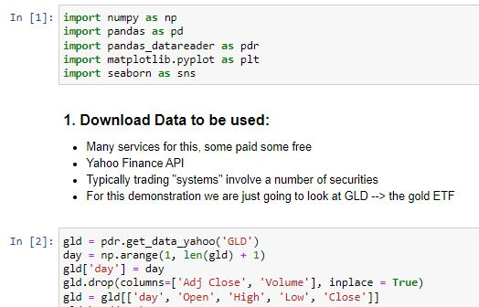

Figure 1: loading data

After loading the data from the API, the researcher had to verify its relevance by reading it and displaying the initial hundred rows of the data via gld. head (100) line of code. The displayed results were as shown in the figure below;

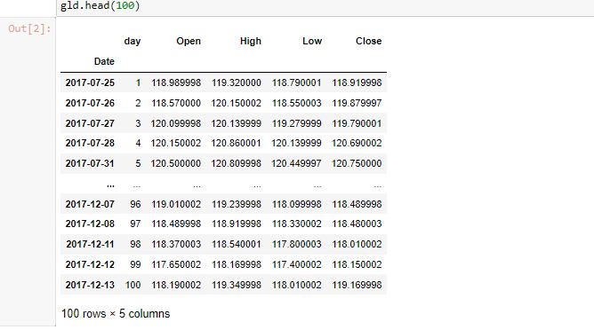

Figure 2: Data reading

The project utilized exploratory type data analysis and through this the researcher analyzed the data provided via the yahoo API and also summarized the data characteristics. This was achieved via the visualization procedures and it had a great impact on the modeling process of the project’s model. However, this technique allowed the researcher to identify the presence of errors if they could be in the dataset and all relations in the stock market data. In addition, the data was analyzed using this procedure and there were no duplicate values or outliers; throughout the procedure, the produced results were found fit to the real-world application based on the project aim, goals, and objectives. The produced results would then aid any investor to make decisions on stock market prices and the investment process. Several tasks were carried out in this procedure and they included; data exploration, data description, checking for null values, and visualizing the relative graphs.

## **Data Exploration**

After getting the data from the API, the researcher carried out a data description as it was meant to provide a thorough examination of the data’s format, row and column number, available data features as well as field identities. The Dtype column specified data value types. This activity was implemented as shown in the figure below;

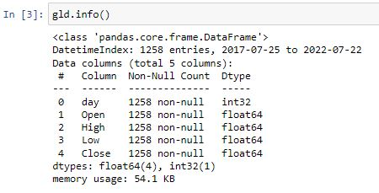

Figure 3: Data exploration

## **Data Description**

Since the project was implemented in python, the data description procedure described the basic features available in the data used for the project. It is through this procedure; the researcher was able to know the summary of the data sample as well as the measures relative to it. The measures were count, mean, standard deviation, min, and max as shown in the figure below;

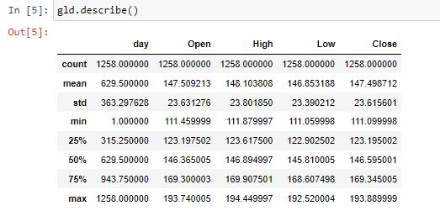

Figure 4: Data description

## **Correlation**

The correlation process was implemented since it was identified that it is a statistical measure that would express the level at which the data variables were linearly related to one another. However, through the implementation of this process, the attributes found in the data would change at constant rates. Data correlation procedure was also found to be common when any researcher wants to have a clear description of the attribute’s data relationship containing no word statements about effects and all relative causes. In addition, the researcher found out that data correlation would speed up the model’s execution time and this created a recommendation for one to always practice implementing it for it saves the execution time of the data attributes. The results of the data correlation procedure were recorded in a tabular format with several numbers representing the relevance level of attributes and their relationships in the supplied data. The tabular format records vary from a negative one to a positive one; a positive one outlines that there is an immediate one-on-one relationship and this is referred to be a perfect type of data correlation. The recorded observations from this process are represented in the figure below;

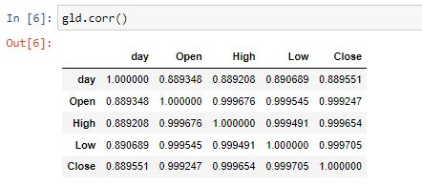

Figure 5: Correlation

In addition, the researcher went ahead and plotted the correlation heatmap that depicted the 2-D correlation matrix. The correlation matrix outlined the relationship between the attributes in the data supplied. The generated heatmap utilized colored cells to show the required demonstration of the API data at a monochromatic scale level. From the recorded observations, the heatmaps’ initial dimensions were outlined as respective data rows of the API data while the second dimension on the heatmap outlined the respective data columns. The generated heatmap for this project is shown in the figure below;

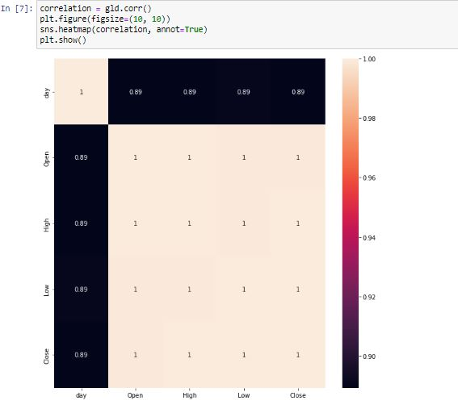

Figure 6: Heatmap

## **Addition of Moving Averages to the data frame**

Since the researcher used a trend-following strategy for the project implementation, it was identified that the strategy always initiates trades based on the occurrence of the desirable trend and they are found to be easy as well as straightforward in the implementation procedure since the utilized algorithms are not complex in terms of predictive analysis. The trend following strategy algorithm used 9 days and 21 days averages which were to be a common and popular strategies under the trend following process. This was implemented as shown in the figure below;

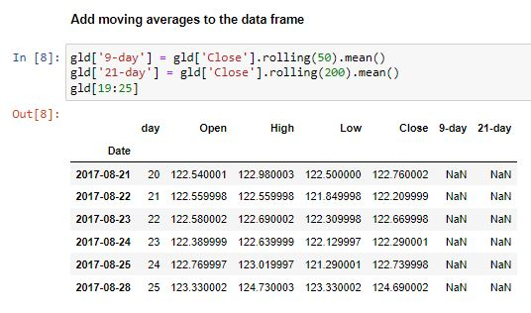

Figure 7: Addition of moving averages

## **Addition of “Trade Signal”**

The trade signal was utilized as a trigger that would facilitate the buy or sell actions on the stock as generated by the trade analysis model, (Luo and Chen, 2013, pp.806-816). The analysis in this context was generated by a mathematical algorithm as it was based on the available stock market action. The trade signal was found to be helpful to the bond traders who could use it to adjust their portfolio’s duration by either selling one maturity or purchasing different maturities. However, the trade signal would help in the allocation of asset classes like money shifting among stocks and gold. This was implemented as shown in the figure below;

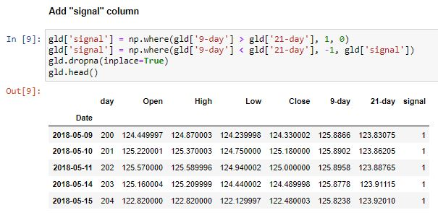

Figure 8: Trade signal addition

## **Calculation of Instantaneous Returns/System Returns**

The rate of return alias ROR was described to be the net value gain or loss that the gold market investment would incur over various periods. The calculation of the rates used in this project was based on determining the change from the initial of any given period until the end of a specified period. The rate was expressed as a percentage of the gold’s investment initial cost. The ROR metric as used in this project was utilized on gold stocks. However, it can be utilized for other varieties of assets including bonds, and real estate, among others. Generally, its utilization of rate of return measures the profit or loss levels of any given investment over a specified period, and therefore in case of inflation effects on the market, they are not considered in simple calculations of the rate of return, rather, they are included in the real calculation of the rate of returns. An internal rate of return alias IRR always considers the time value as well as money. This task was implemented as shown below;

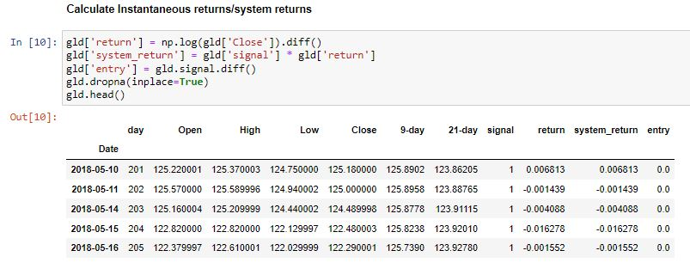

Figure 9: Calculation of returns

## **Plotting the trades on Time Series**

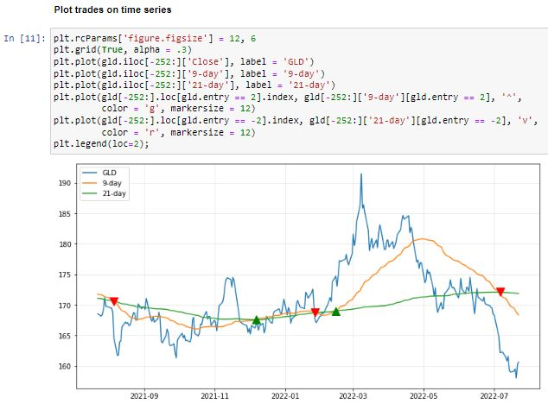

Figure 10: Trade plot on time series

From the above figure, observations can be made that based on closing day (9-day), an individual would be advised to make purchases on the opening days (21-day) of last year’s month of December as well as around February this year, 2022. However, on the current month of the year, one would incur losses and he or she would not be advised to buy or sell gold stock. In addition, the following graph outlines the system performance against the customer’s “Buy/Hold” power. It depicts that the customer’s return is outperformed by the system by (1.16%), which means that the system could cause losses at this moment.

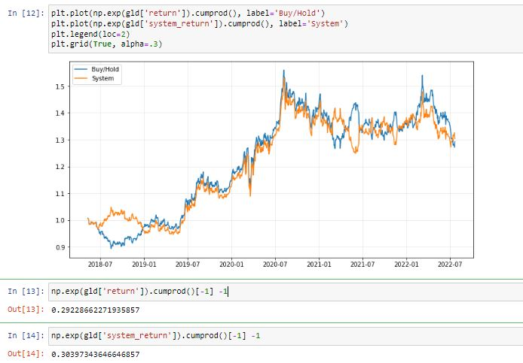

Figure 11: System performance against Customer's power

# **Findings and Discussion**

While carrying out the trading procedures, traders’ mindset, as well as their perspectives, can be unique at given timeframes, and sometimes, they can be led to emotional trading and this can result in enormous losses. Emotional trading can be described to be one of the most terrible approaches that can occur while trading. Therefore, while trading, one needs peace of mind as well as concentration and this paved the way for algorithmic trading. This type of trading combines both computer programming techniques and financial markets for it to execute the relevant trades required by the traders at precise moments. However, the trading process attempted to strip away human-based emotions that can be involved in the physical trades and this ensures that the execution result of the process is much more efficient; in this context, the order placement would be done instantaneously and the trading fees are much lowered.

Algorithmic trading utilizes computer programs that are designed to follow a defined set of programmed instructions and alias algorithms to place trades. The trades are always hoped to generate profits or revenues at a given speed as well as the frequency that the human trader finds impossible. The defined set of programmed computer instructions is always dependent on time, price, quality, and any applicable mathematical model. In this context, apart from the generated profits for any given trader, the algorithmic trading process renders the markets to be in a more liquid nature and this allows the trading process to be more systematic for it rules out the human impact on emotions that can affect the trading activities. This type of trading combines both computer programming techniques and financial markets for it to execute the relevant trades required by the traders at precise moments. However, the trading process attempts to strip away human emotions that can be involved in the physical trades and this ensures that the execution result of the process is much more efficient; in this context, the order placement is done instantaneously the trading fees are much lowered.

Algorithm trading implementation via a programmed computer program is referred to as the last phase in the entire online trading process as it is usually accompanied by backtesting which attempts the developed algorithm based on the past historical trading events about the stock market performance as it aids in identifying whether the algorithm will be profitable. The main challenge with algorithm trading is always based on transforming the defined strategy to exist as an integrated computer-based procedure that entails the trading account access that can be utilized to place orders. However, there are always requirements that facilitate the entire trading process and they include computer-based programming understanding and knowledge that can be integrated with the chosen strategy. The computer programs can be developed by hired programmers or one can utilize the available pre-made trading software programs. However, for the process to be effective and efficient enough; good network connectivity, as well as access to the relevant trading platforms, is always crucial. The trading platforms allow one to place market stock orders. In addition, reliable access to the stock market information feeds to be monitored by the developed algorithm to facilitate the identification of opportunities relative to order placement is a key requirement.

The returns were plotted on time series. However, the strategy that was used for the modeling phase was based on the problem domain and it was a trend-following strategy, most algorithmic trading strategies follow various trends available in the market space. The trend following can be based on moving market averages, price level changes, channel breakouts as well as relative technical indicators. In this context, the trend-following strategies can be termed as the easiest as well as simplest types of strategies that can be implemented via algorithmic trading procedure since they don’t entail prediction making or market price forecasting exercises. Trades in the trend-following strategies are always initiated based on the occurrence of the desirable trend and they are found to be easy as well as straightforward in the implementation procedure since the utilized algorithms are not complex in terms of predictive analysis. The trend following strategy algorithms can use fifty days and two hundred days averages which is a common and popular strategy under trend following process. Observations made were based on closing day (9-day), an individual would be advised to make purchases on the opening days (21-day) of last year’s month of December as well as around February this year, 2022. However, on the current month of the year, one would incur losses and he or she would not be advised to buy or sell gold stock. In addition, the following graph outlines the system performance against the customer’s “Buy/Hold” power. It depicts that the customer’s return is outperformed by the system by (1.16%), which means that the system could cause losses at this moment.

# **Conclusion and Recommendations**

There are various algorithmic trading techniques applicable in the modern days of technology and they include; trend-following strategies, index fund rebalancing as well as arbitrage opportunities. The entire trading process is usually executed dependent on the trading volume which entails volume-weighted average prices or passage of timeframe which includes the time-weighted average prices. For an individual to get started with the algorithmic type of trading, he or she is required to acquire computer access, have fast network access, and have knowledge of financial markets as well as coding capabilities.

It is highly recommended for one to note that most of the algorithmic trading practices used in the current days of trading are known as high-frequency trading alias HFT and it makes attempts on capitalizing the placed large number of customer orders at given rapid speeds in various markets as well as across different decision parameters which are based on preprogrammed computer instructions. However, the algorithmic type of trading is utilized in different forms of trading as well as investment activities. Some of them include the mid-to-long-term investors that involve pension funds and relative insurance organizations; in this context, algorithmic trading is used to make purchases of stocks in large quantities while not intending to cause influence the stock prices having discrete as well as large-volume investments.

On the other hand, short-term traders can be referred to as sell-aside market participants and they include market makers like brokerage houses, speculators as well as arbitrageurs who usually make benefit from the automated trade execution; in this context, the algorithmic trading process helps in the creation process of sufficient liquidity for the market sellers. The other form of algorithmic trading involves the systematic traders who are the trend followers and they can also be referred to as pairs traders. In this context, this can be termed as the neutral-market trading strategy that aims at matching the long positioned with the short positioned in pairs of the available correlated market instruments like two stocks, currencies as well as exchange-traded funds alias ETFs. Through the systematic trading strategy, it has been easily found that the process becomes more efficient while programming the trading rules as well and this facilitates the program trade automatically. Algorithmic trading can then be said to provide a much more systematic procedure that is relative to achieving active trading as compared to other methods that are based on traders’ intuitions or instincts.

## **Recommendations**

Utilizing other strategies relative to algorithmic trading would also be beneficial depending on the problem domain. Some of them include; Arbitrage opportunities are another strategy used in algorithmic trading as traders buy a dual-listed stock at various lower prices in a given market as well as simultaneously sell them at a hiked price in other markets offering the price differentials as arbitrages or risk-free profits. Similar operations can be made for stocks against future instruments like price differentials that exist naturally. While following this type of strategy, its algorithmic implementation process can involve the identification of price differentials as well as order placement efficiently and this promises profitable market opportunities.

The index fund rebalancing strategy is used in algorithmic trading where index funds have to define rebalancing periods that bring the trader’s holdings to par terms with the relative benchmark indices. In this context, there is the creation of profitable opportunities that are used by the algorithmic traders who generally capitalize on the expected market trades offering 20 to 80 base points on the profits with dependency on the stocks number available in the index fund before the exercise on fund rebalancing. In addition, such market traders are always initiated through algorithmic trading systems focusing on timely execution as well as the best market prices. Trading range alias mean reversion is an algorithmic trading strategy that is based on the theory that describes the prices of an asset are always in temporal nature while reverting to their average value in a given period. The asset prices in this case could either be low or high. Price range identification, as well as definition and the entire implementation process of an algorithm that produces the required results, is always based on the market trades placed in an automatic nature when the asset price breaks in and out of the defined range respectively. The time-weighted average price also known as TWAP is an algorithmic trading strategy that generally breaks up large market orders as well as releases dynamic determined market orders in smaller chunks to the market, therefore, utilizing the available fractions of time slots that could be labeled between the start as well as end time. The main aim of this strategy is always based on executing the orders that are close to the price average between the time fractions, therefore, minimizing the impact of the market.

However, it is always required for the individual or organization to have clear knowledge and understanding on;

1. What is algorithmic trading and all strategies applicable,
2. Analyzing the current market space of the chosen organizational data,
3. Investigating how the market space can utilize algorithmic trading strategies to maximize and customize the market share and profits,
4. How algorithmic trading reduces human errors,
5. How to trade in a correct timeframe.

# **References**

Treleaven, P., Galas, M. and Lalchand, V., 2013. Algorithmic trading review. *Communications of the ACM*, *56*(11), pp.76-85.

Hendershott, T. and Riordan, R., 2013. Algorithmic trading and the market for liquidity. *Journal of Financial and Quantitative Analysis*, *48*(4), pp.1001-1024.

Boehmer, E., Fong, K. and Wu, J., 2012, March. International evidence on algorithmic trading. In *AFA 2013 San Diego Meetings Paper*.

Chan, E.P., 2021. *Quantitative trading: how to build your own algorithmic trading business*. John Wiley & Sons.

Kissell, R.L., 2013. *The science of algorithmic trading and portfolio management*. Academic Press.

Tsang, C.K., Wong, W.K. and Horowitz, I., 2016. Arbitrage opportunities, efficiency, and the role of risk preferences in the Hong Kong property market. *Studies in Economics and Finance*.

Dayanandan, A. and Lam, M., 2015. Portfolio Rebalancing–Hype or Hope? *The Journal of Business Inquiry*, *14*(2), pp.79-92.

Li, B., Hoi, S.C., Zhao, P. and Gopalkrishnan, V., 2013. Confidence weighted mean reversion strategy for online portfolio selection. *ACM Transactions on Knowledge Discovery from Data (TKDD)*, *7*(1), pp.1-38.

Foucault, T., 2012. Algorithmic trading: Issues and preliminary evidence. *Market Microstructure (Part I Economic Microstructure Theory)*.

Yadav, Y., 2015. How algorithmic trading undermines efficiency in capital markets. *Vand. L. Rev.*, *68*, p.1607.

Boehmer, E., Fong, K. and Wu, J., 2012, March. International evidence on algorithmic trading. In *AFA 2013 San Diego Meetings Paper*.

Burgess, N., 2019. An Introduction to Algorithmic Trading: Opportunities & Challenges within the Systematic Trading Industry. *Available at SSRN 3466213*.

Johnston, R. and Petacchi, R., 2017. Regulatory oversight of financial reporting: Securities and Exchange Commission comment letters. *Contemporary Accounting Research*, *34*(2), pp.1128-1155.

Hu, Y., Liu, K., Zhang, X., Su, L., Ngai, E.W.T. and Liu, M., 2015. Application of evolutionary computation for rule discovery in stock algorithmic trading: A literature review. *Applied Soft Computing*, *36*, pp.534-551.

Upson, J. and Van Ness, R.A., 2017. Multiple markets, algorithmic trading, and market liquidity. *Journal of Financial Markets*, *32*, pp.49-68.

Kirilenko, A.A. and Lo, A.W., 2013. Moore's law versus murphy's law: Algorithmic trading and its discontents. *Journal of Economic Perspectives*, *27*(2), pp.51-72.

Schröer, C., Kruse, F. and Gómez, J.M., 2021. A systematic literature review on applying CRISP-DM process model. *Procedia Computer Science*, *181*, pp.526-534.

Kingaby, S.A., 2022. The Stock Market API. In *Data-Driven Alexa Skills* (pp. 387-404). Apress, Berkeley, CA.

Luo, L. and Chen, X., 2013. Integrating piecewise linear representation and weighted support vector machine for stock trading signal prediction. *Applied Soft Computing*, *13*(2), pp.806-816.

Rojas, J.A.R., Kery, M.B., Rosenthal, S. and Dey, A., 2017, October. Sampling techniques to improve big data exploration. In *2017 IEEE 7th symposium on large data analysis and visualization (LDAV)* (pp. 26-35). IEEE.

Randles, B.M., Pasquetto, I.V., Golshan, M.S. and Borgman, C.L., 2017, June. Using the Jupyter notebook as a tool for open science: An empirical study. In *2017 ACM/IEEE Joint Conference on Digital Libraries (JCDL)* (pp. 1-2). IEEE.