Assignment Two Strategy

DTSC13-305



Muiz Murad

13599863

Contents

**Introduction** 3

**Strategy Explanation** 3

**Why Should It Work?** 4

**Results** 4

**Critiquing The Strategy** 4

**Conclusion And Improvements** 6

**Bibliography** 7

**Appendix A – Code** 8

**Appendix B – Strategy Report** 11

# **Introduction**

The world of investments and finance has an abundant number of strategies, algorithms, and methods for making money, All the strategies and algorithms have the same common end goal, to be profitable and be robust. An algorithm is a method of stock trading that uses mathematical models and formulas to run intense and autonomous financial transactions simulations within the market to provide the highest profit. The ability of algorithms to be autonomous and be executed at set times, has resulted in 60-73% of the overall US Market’s equity trading (Mordor Intelligence, n.d.).

There are many types of algorithms, but we will classify them into two groups being long/short algorithms or rotational algorithms. A rotational algorithm is one in which there is no economical justification for the symmetry of a factor for both the long and short positions and hence strives t0 create some sort of profitability using asymmetric factors as mentioned in the lecture content.

This report looks at the F-Score algorithm which is based on the Piotroski F-Score. This metric looks at the 9 key ratios of a company in 3 main categories being Profitability, Funding and Efficiency, and each is ranked from a scale 1 – 9 and the overall sum of all the ratios then make up the Piotroski F Score where usually a um of 8-9 is considered ‘good’ and anything below 1 is considered ‘bad’. He found that investing in companies that had a high F-Score produced average yearly outperformance of 13.4% over a 20-year period from 1976 to 1996 (Greenblatt, 2014).

This report will look at making use of this strategy and classifying the high and low scores as per the original guidelines of high being 8 to 9 and 0 to 1 being low. The market we will test on is the US market using the SPY equity.

# **Strategy Explanation**

The F-Score is a compilation of nine financial ratios and measures the financial strength of a company. A stock is valued between 0 and 1, as the numbers suggest we invest in any stock with a value of 1 meaning it is beneficial and 0 for any stocks that don’t seem profitable. The ratios are derived from three parts of the balance sheet being the profitability scores, productivity, and efficiency scores (Mohr).

The profitability scores:

* Positive net income
* Positive operating cash flow (current year)
* Return on Assets (ROA) (previous to current year)
* Cash flows from operations larger than ROA

The productivity scores:

* Long-term ratio
* Debt ratio (current to previous year)
* Higher current ratio
* Number of shares being issued

The efficiency scores:

* Gross margin (current to previous year)
* Asset turnover ratio (current to previous year)

Each score is then cumulatively summed up to produce an overall score out of 9 which is then used to value the company as good or bad within the market and if it is worthwhile investing in. In Joseph Piotroki’s paper, (PIOTROSKI, 2000), he showed that the F-Score can significantly improve the returns when integrated into a simple investment strategy like the one we will be looking at, eg. buying low P/B ratio stocks. Piotroski also mentioned that value investing is beneficial however, stocks are cheaper due to their weakness within the market. Piotroski was able to produce annual returns of 23% which at the time was seen to beat the market by a large extent.

# **Why Should It Work?**

The F-Score strategy was built upon research from Ou and Penman and Frankel and Lee that showed historical accounting information was able to predict future stock returns. Piotroski showed that the F-Score was valuable in identifying early signals for winners deep in the market. Piotroski was able to show that top 20% of high book to price ratio, high F-Score stocks outperformed all stocks by 7.5% pa. The signals were very noticeable for small stocks with a lower share turnover and no analyst coverage which was interesting. However, higher F-Score stocks were seen to produce higher and more positive reactions to the market to various announcements which were directly impacting the source of the ratios and company announcements. The KPI of the F-Score could be determined by this and it was seen to be the information transfer speed from announcement to market and was evident in company announcements (Hyde, The Piotroski F Score in the Australian Market, 2015).

The F-Score strategy has seen to be one of the most robust trading strategies with its ability to perform well within emerging markets, Euro Zone markets and in global emerging markets which were all looked at in the first assignment and can be referred to. Piotroski F-Score is seen as a layover on a value strategy that can filter out and remove those value stocks that are cheap due to them being financially distressed and are seen to not recover, therefore are most likely to produce negative returns over time.

The F-Score cannot determine the accurate value of every single stock selection, but on average, it is an efficient method of choosing stock that are financially strong or weak. Piotroski’s key insight was that quantitatively analysed financial statements could improve performance. The F-Score was made to remove low performing stocks. Piotroski saw that the value investing portfolios performed better than the market. The F-Score helps detect beforehand, any underperforming stocks and eliminates them from portfolios early on to make sure only high value and long-term high return stocks are kept (Davidson, 2020).

# **Results**

The report for the strategy can be found in Appendix B. Over the 12-year period the strategy had a net profit of $249,685,48, with an annual compounding return of 10.349% and a total return of 246.87%. Any graphs or diagrams used for explanation are explicitly detailed in the report itself.

# **Critiquing The Strategy**

The code used for this algorithm was collated from the QuantConnect community website and can be found in Appendix A (Gilman, 2018). Before looking at the results of the strategy some key information should be considered:

1. The time frame is from 2008 to 2020 to allow for various economic crises and downturns.
2. All securities that are removed are liquidated

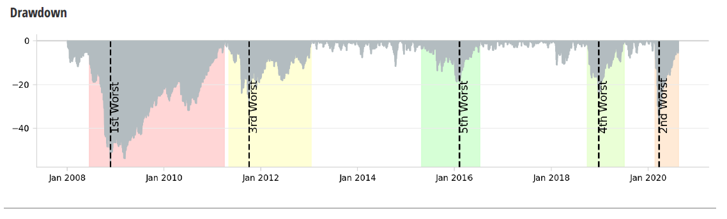

The figure above shows the 5 worst max drawdowns, which is a key measure for the strategy risk analysis part. It indicates how long the strategy will take to recover any future losses. Four of the five max drawdowns are seen to fully recover with in the first year of impact. However, the worst draw down takes nearly 2 years to recover, if not more. This is due to the low volatility of the stocks, as when the return is below the x-axis it represents a longer period for the return to be big enough to reach the breakeven point again. Despite this, the net drawdown is only 55% indicating this strategy does not show many occurrences of recovering from future losses despite the time it was also tested over.

The beta value was -0.124, which is very low and as a result the strategy does not contain much systematic risk, which is expected due to the way the strategy is calculating the returns based on the health of stocks in the market. This is a large plus as systematic cannot be taken away or diffused.

Another key statistic we can look at is the Sharpe Ratio. The Sharpe Ratio is a measurement of the average return more than the risk-free rate against the per unit total risk. In simple terms, it is the risk adjusted return in comparison to the risk-free assets. However, the higher the Sharpe ratio the better. The overall Sharpe Ratio was 0.517, showing that the standard deviation was large in comparison to the excess market returns the F-Score Factor was earning. We can look further into this by looking at the Sharpe Ratio graph,

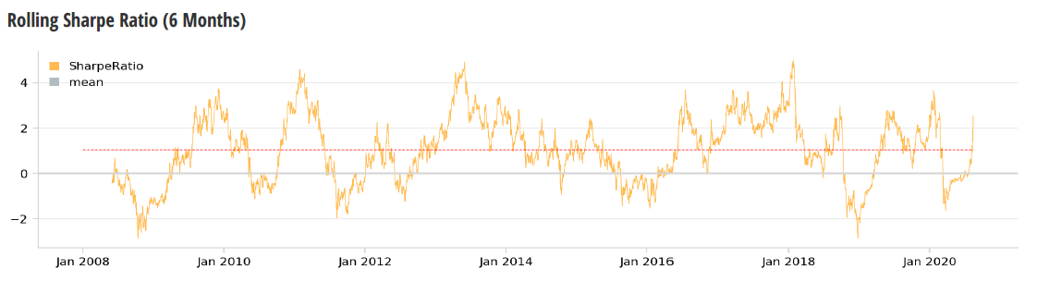

The graph above shows many fluctuations and movements over the 12-year time frame. The annual standard deviation of 21% can explain the shape of the graph above as in terms of profitability and growth the Sharpe Ratio was starkly greater than the Sharpe Ratio in times of downturn and loss as can be seen in the middle of 2008 (loss) and Jan 2011 (growth and profit).

We can also look at the information ratio, which is the measurement of portfolio returns against index or benchmark of some sort (Murphy, 2020). It can account for volatility making it a beneficial ratio to investigate. The strategy produced a Information Ratio of 0.054 which is quite small indicating that there is not much excess return in comparison to the index/benchmark it was compared to to however this ratio is not to be taken into serious consideration but rather as a supplementary ratio to help understand profitability and returns much more.

The strategy conducted many trades and showed positive results. It accounted for the COVID Pandemic and the Global Financial Crisis where it still showed strong results, this was mainly due to the information transfer as mentioned earlier and how companies were performing over that time. As companies came out of the economic crisis, they were showing periods of increased growth and were showing market confidence, increasing their position within the market which in turn had a large impact on company health and efficiency.

# **Conclusion And Improvements**

After implementing the strategy into a Quantconnect and studying the results, a suitability test was conducted. It was concluded from the results section that the strategy beat the had an alpha of 12%. It was also seen that the strategy had a strong performance throughout the multiple economic downturns and periods of no growth when looked at against the benchmark. It was indicated that the overall risk of the strategy was relatively low but when looking at the strategy’s risk to its overall return it was evident that the risk return was not beneficial. In Australia, it is seen that the F-Score only generates beneficial long/short returns but not meaningful alpha values. It is seen that only portfolios of very small stocks and equally weighted show meaningful alpha values. This would be due to the lack of liquidity within the market and extremely regulated market for economic and investment information being spread to the market.

High F-score stocks have been seen to have higher analyst coverage in Australia than low F-score stocks, in the US. Less investors question using the F-score signal by itself and are more likely to use it in combination with other common trading factors such as value, momentum, and low risk. More research and simulation is needed to determine the relationship between the F-Score signal and the other factors that are commonly being used to make investment decisions. It would also be needed to test the F-Score signal in more and more markets globally as not enough research has been conducted for this already. This would enable the integration of the F-Score signal into more multi factor models, strategies, and algorithms. More filters being added to the F-Score would maybe enhance the possibility of producing higher risk-adjusted excess weekly returns that would also be prone to transaction costs and liquidity restrictions

‘

# **Bibliography**

Davidson, T. (2020). *Spotlight on: The FS_Score vs. Piotroski’s F-score.* Quant Investing .

Eremenko, E. (2018). *Quantitative Fundamentals. Application of Piotroski F-Score on non-US markets.* WorldQuant University: SSRN.

Gilman, A. (2018). *Piotroski F-Score Fundamental Filter / Value Screen*. Retrieved from https://www.quantconnect.com/forum/discussion/3214/piotroski-f-score-fundamental-filter-value-screen/p1

Greenblatt, J. (2014, September 3). *THIS ACADEMIC CAN HELP YOU MAKE BETTER INVESTMENT DECISIONS – PIOTROSKI F-SCORE*. Retrieved from Quant Investment : https://www.quant-investing.com/blogs/general/2014/09/03/this-academic-can-help-you-make-better-investment-decisions-piotroski-f-score#:~:text=Buying%20only%20those%20companies%20that,over%20the%20market%20of%2013.4%25.

Hyde, C. (2013). *An Emerging Markets Analysis of the Piotroski F Score.* Sydney: Metisq Capital.

Hyde, C. (2015). *The Piotroski F Score in the Australian Market.* NZ Superannuation Fund .

MFIE Capital. (2020, Ocober 26). *Piotroski F-Score*. Retrieved from Value Signals: https://www.valuesignals.com/Glossary/Details/Piotroski_F_Score

Mohr, J.-H. M. (n.d.). *Utility of Piotroski F-Score for predicting GrowthStock Returns.* Frankfurt.

Mordor Intelligence. (n.d.). *ALGORITHMIC TRADING MARKET - GROWTH, TRENDS, AND FORECASTS (2020 - 2025)*. Retrieved from Mordor Intelligence: https://www.mordorintelligence.com/industry-reports/algorithmic-trading-market

Murphy, C. B. (2020, October 1). *IR*. Retrieved from Investopedia: https://www.investopedia.com/terms/i/informationratio.asp

PIOTROSKI, J. D. (2000). *Value Investing: The Use of Historical Financial Statement Information to Separate Winners from Losers.* USA.

Walkshäusl, C. (2020). *Piotroski’s FSCORE: international evidence.* Regensburg,: Journal of Asset Management.

# **Appendix A – Code**

from System.Collections.Generic import List

from QuantConnect.Data.UniverseSelection import

import operator

from math import ceil,floor

from scipy import stats

import numpy as np

from datetime import timedelta

class PiotroskiFscoreAlgorithm(QCAlgorithm):

def Initialize(self):

self.SetStartDate(2008,1,1) #Set Start Date

self.SetEndDate(2020,8,15) #Set End Date

self.SetCash(100000) #Set Strategy Cash

self.flag1 = 1

self.flag2 = 0

self.flag3 = 0

self.UniverseSettings.Resolution = Resolution.Daily

self.AddUniverse(self.CoarseSelectionFunction, self.FineSelectionFunction)

self.AddEquity("SPY", Resolution.Minute)

self.SetBenchmark("SPY")

self.__numberOfSymbols = 200

self.__numberOfSymbolsFine = 30

self.__changes = None

self.Schedule.On(self.DateRules.MonthStart("SPY"), self.TimeRules.AfterMarketOpen("SPY"), Action(self.Rebalancing))

def CoarseSelectionFunction(self, coarse):

if self.flag1:

CoarseWithFundamental = [x for x in coarse if (x.HasFundamentalData) and (float(x.Price) > 5)]

sortedByDollarVolume = sorted(CoarseWithFundamental, key=lambda x: x.DollarVolume, reverse=True)

top = sortedByDollarVolume[:self.__numberOfSymbols]

return [i.Symbol for i in top]

else:

return []

def FineSelectionFunction(self, fine):

if self.flag1:

self.flag1 = 0

self.flag2 = 1

filtered_fine = [x for x in fine if x.FinancialStatements.IncomeStatement.NetIncome.TwelveMonths and

x.FinancialStatements.CashFlowStatement.CashFlowFromContinuingOperatingActivities.TwelveMonths and

x.OperationRatios.ROA.ThreeMonths and x.OperationRatios.ROA.OneYear and

x.FinancialStatements.BalanceSheet.ShareIssued.ThreeMonths and x.FinancialStatements.BalanceSheet.ShareIssued.TwelveMonths and

x.OperationRatios.GrossMargin.ThreeMonths and x.OperationRatios.GrossMargin.OneYear and

x.OperationRatios.LongTermDebtEquityRatio.ThreeMonths and x.OperationRatios.LongTermDebtEquityRatio.OneYear and

x.OperationRatios.CurrentRatio.ThreeMonths and x.OperationRatios.CurrentRatio.OneYear and

x.OperationRatios.AssetsTurnover.ThreeMonths and x.OperationRatios.AssetsTurnover.OneYear and x.ValuationRatios.NormalizedPERatio]

sortedByfactor1 = [x for x in filtered_fine if FScore(x.FinancialStatements.IncomeStatement.NetIncome.TwelveMonths,

x.FinancialStatements.CashFlowStatement.CashFlowFromContinuingOperatingActivities.TwelveMonths,

x.OperationRatios.ROA.ThreeMonths, x.OperationRatios.ROA.OneYear,

x.FinancialStatements.BalanceSheet.ShareIssued.ThreeMonths, x.FinancialStatements.BalanceSheet.ShareIssued.TwelveMonths,

x.OperationRatios.GrossMargin.ThreeMonths, x.OperationRatios.GrossMargin.OneYear,

x.OperationRatios.LongTermDebtEquityRatio.ThreeMonths, x.OperationRatios.LongTermDebtEquityRatio.OneYear,

x.OperationRatios.CurrentRatio.ThreeMonths, x.OperationRatios.CurrentRatio.OneYear,

x.OperationRatios.AssetsTurnover.ThreeMonths, x.OperationRatios.AssetsTurnover.OneYear).ObjectiveScore() > 6]

sortedByNormalizedPE = sorted(sortedByfactor1, key=lambda x: x.ValuationRatios.NormalizedPERatio, reverse = False)

topFine = sortedByNormalizedPE[:self.__numberOfSymbolsFine]

self.flag3 = self.flag3 + 1

self.topFine = [i.Symbol for i in topFine]

return [i.Symbol for i in topFine]

else:

return []

def OnData(self, data):

if self.flag3 > 0:

if self.flag2 == 1:

self.flag2 = 0

# if we have no changes, do nothing

if self._changes == None: return

# liquidate removed securities

for security in self._changes.RemovedSecurities:

if security.Invested:

self.Liquidate(security.Symbol)

for security in self.topFine:

self.SetHoldings(security, 1.0/float(len(self.topFine)))

self._changes = None;

def OnSecuritiesChanged(self, changes):

self._changes = changes

def Rebalancing(self):

self.flag1 = 1

class FScore(object):

def __init__(self, netincome, operating_cashflow, roa_current,

roa_past, issued_current, issued_past, grossm_current, grossm_past,

longterm_current, longterm_past, curratio_current, curratio_past,

assetturn_current, assetturn_past):

self.netincome = netincome

self.operating_cashflow = operating_cashflow

self.roa_current = roa_current

self.roa_past = roa_past

self.issued_current = issued_current

self.issued_past = issued_past

self.grossm_current = grossm_current

self.grossm_past = grossm_past

self.longterm_current = longterm_current

self.longterm_past = longterm_past

self.curratio_current = curratio_current

self.curratio_past = curratio_past

self.assetturn_current = assetturn_current

self.assetturn_past = assetturn_past

def ObjectiveScore(self):

fscore = 0

fscore += np.where(self.netincome > 0, 1, 0)

fscore += np.where(self.operating_cashflow > 0, 1, 0)

fscore += np.where(self.roa_current > self.roa_past, 1, 0)

fscore += np.where(self.operating_cashflow > self.roa_current, 1, 0)

fscore += np.where(self.longterm_current <= self.longterm_past, 1, 0)

fscore += np.where(self.curratio_current >= self.curratio_past, 1, 0)

fscore += np.where(self.issued_current <= self.issued_past, 1, 0)

fscore += np.where(self.grossm_current >= self.grossm_past, 1, 0)

fscore += np.where(self.assetturn_current >= self.assetturn_past, 1, 0)

return fscore

‘

# **Appendix B – Strategy Report**

Strategy Description

|  |  |  |  |  |  |
| --- | --- | --- | --- | --- | --- |
| **Key Characteristics** |  |  | **Key Statistics** |  | **Monthly Returns** |
| Significant Period |  |  | CAGR | 10.35% |  |
| Significant Trading |  |  | Drawdown | 55.0% |  |
| Diversified |  |  | Sharpe Ratio | 0.517 |  |
| Risk Control | ✕ |  | Information Ratio | 0.054 |  |
| Markets | Equity |  | Trades Per Day | 0.990236 |  |

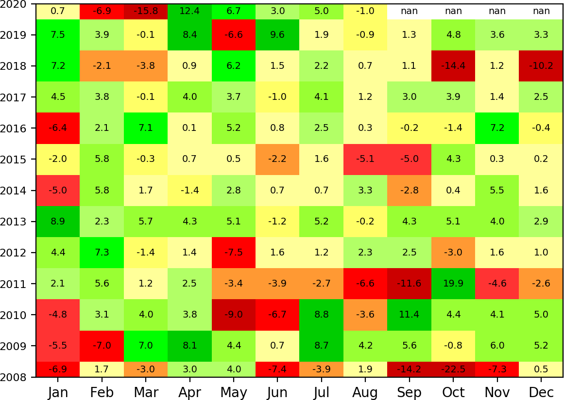Cumulative Returns

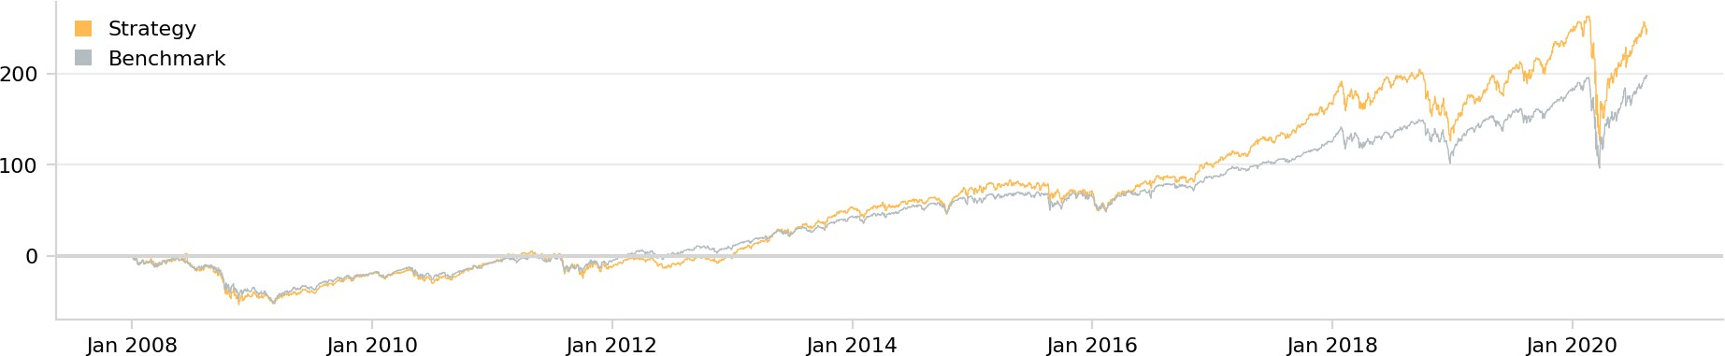

Annual Returns Return Histogram Asset Allocation

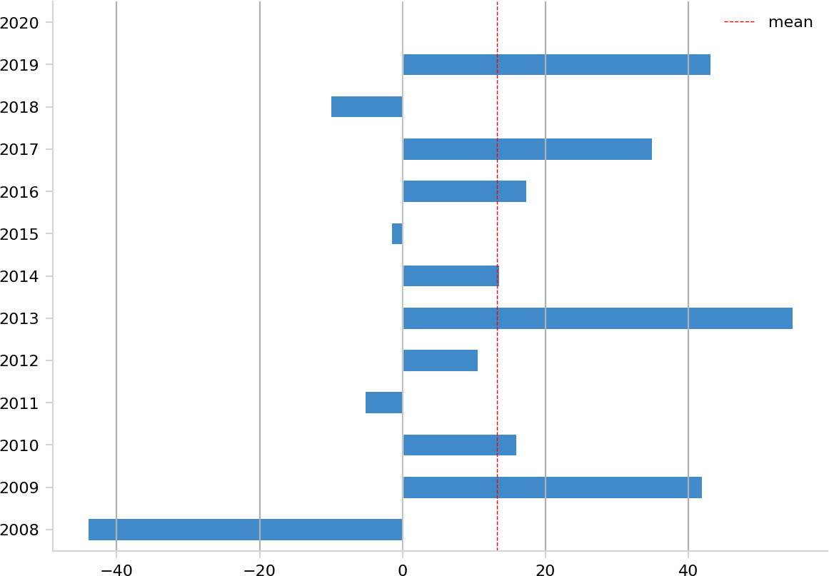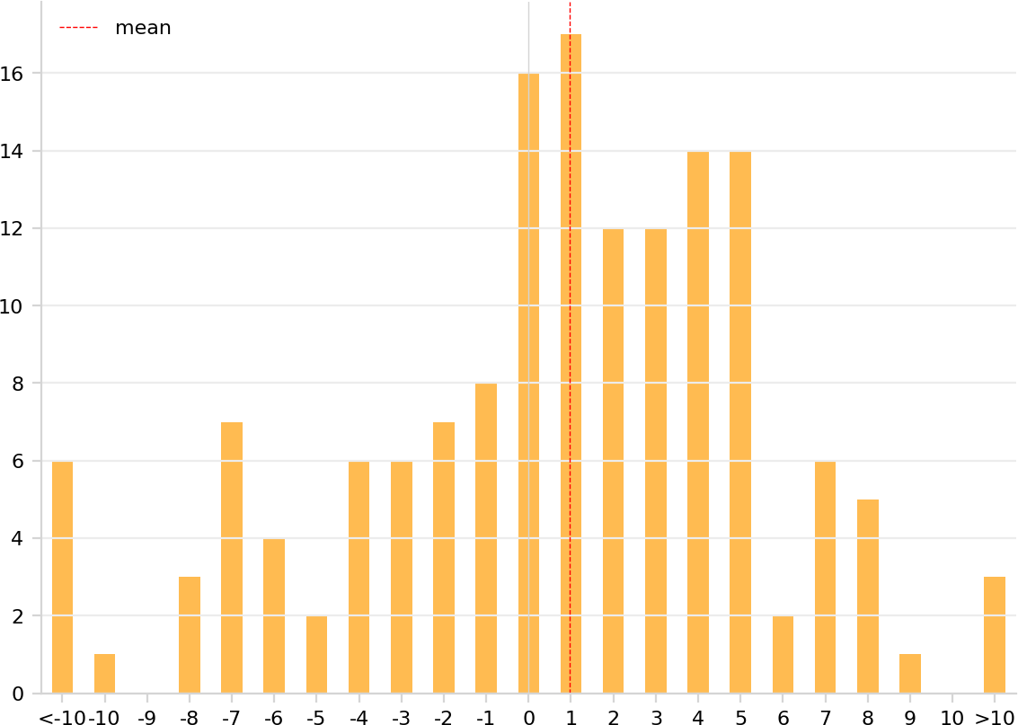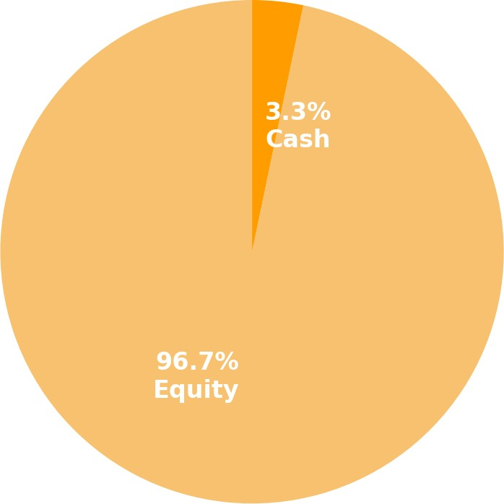

Drawdown

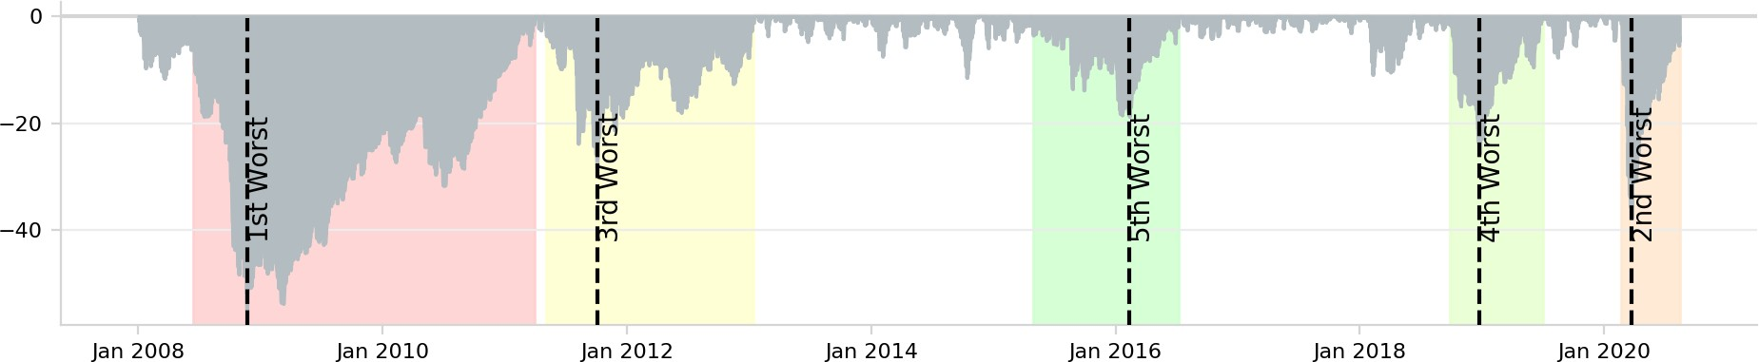

Daily Returns

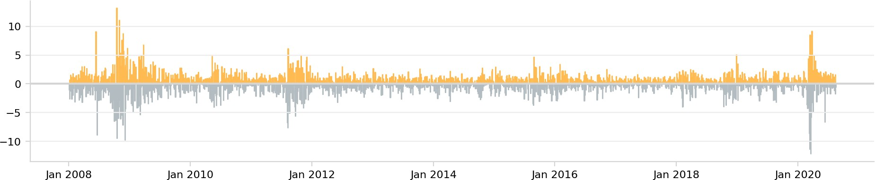

Rolling Portfolio Beta to Equity

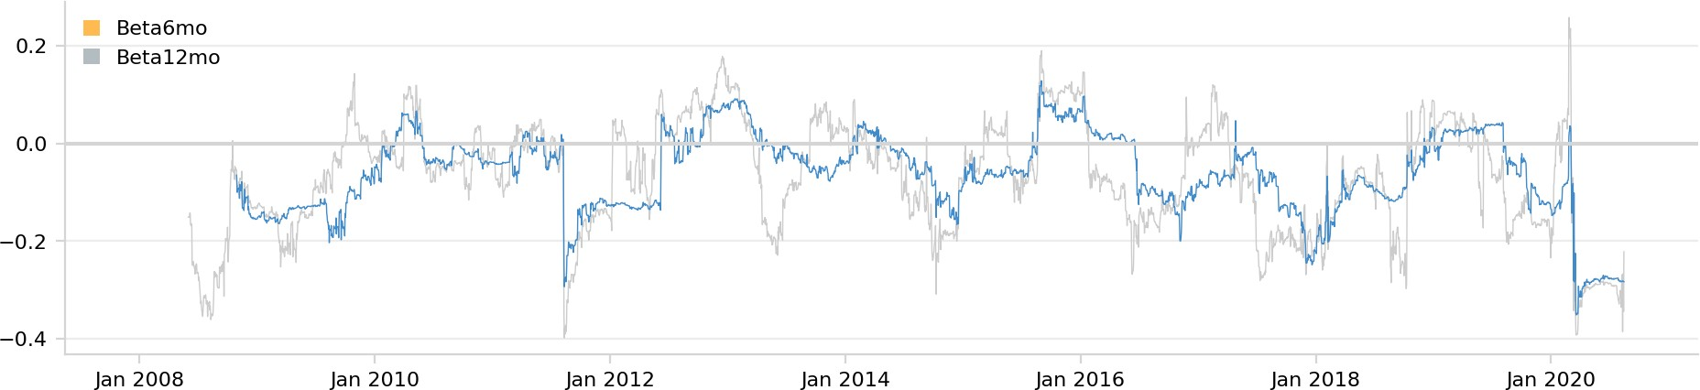

Rolling Sharpe Ratio (6 Months)

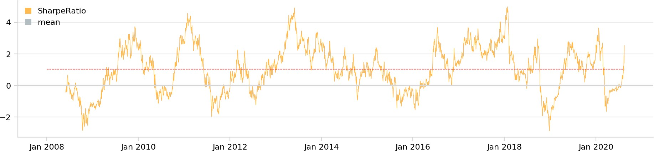

Net Holdings

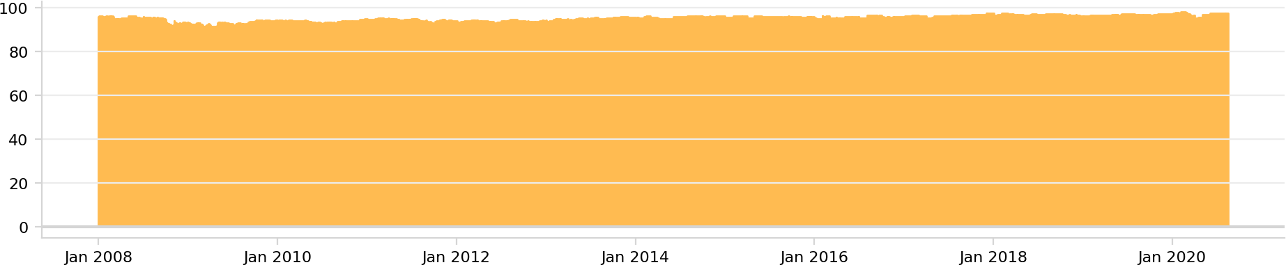

Leverage

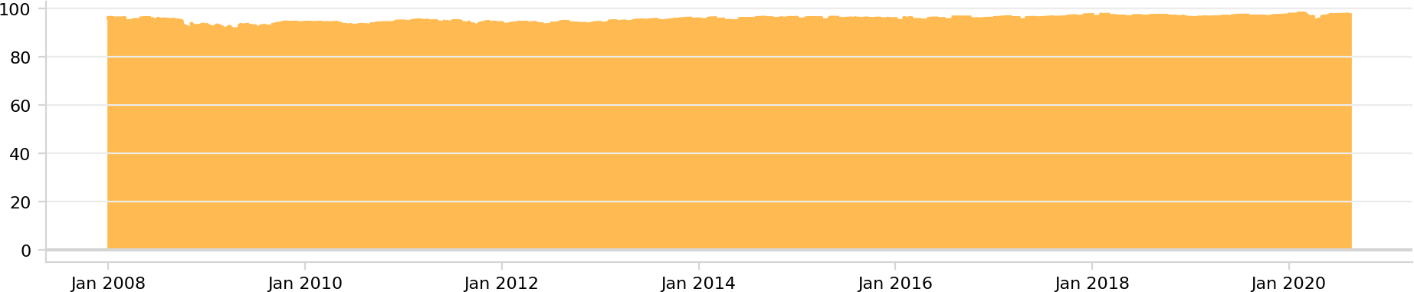

Crisis Lehman Brothers Crisis Flash Crash Crisis Mar08

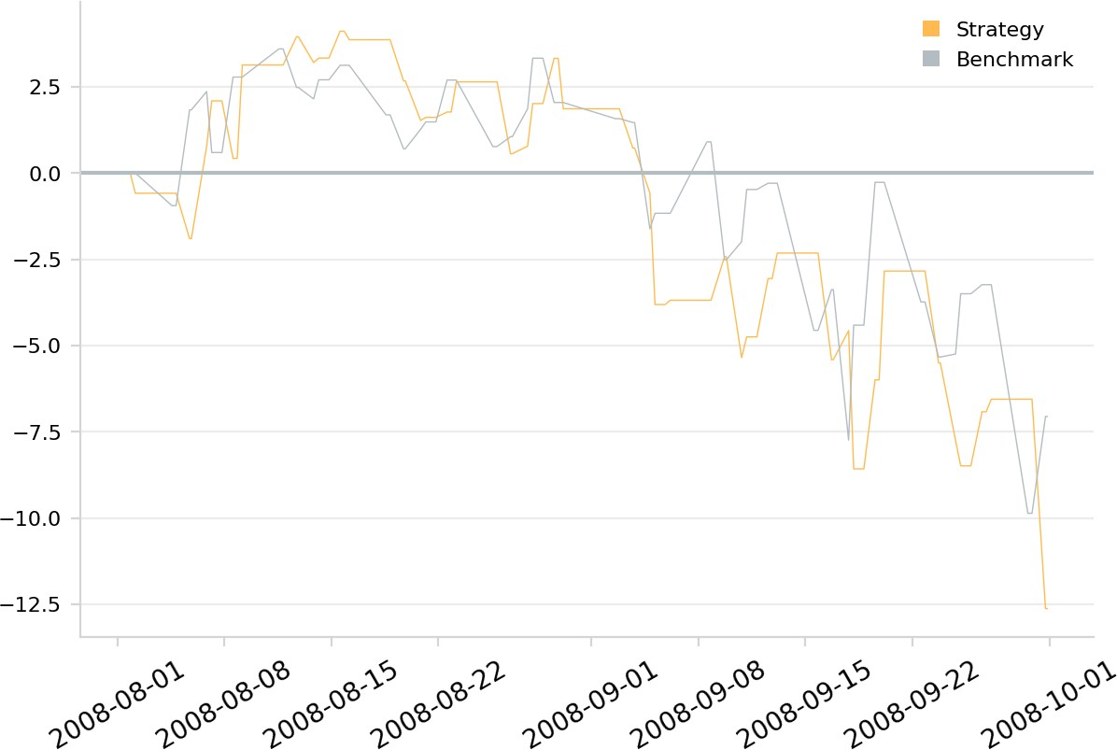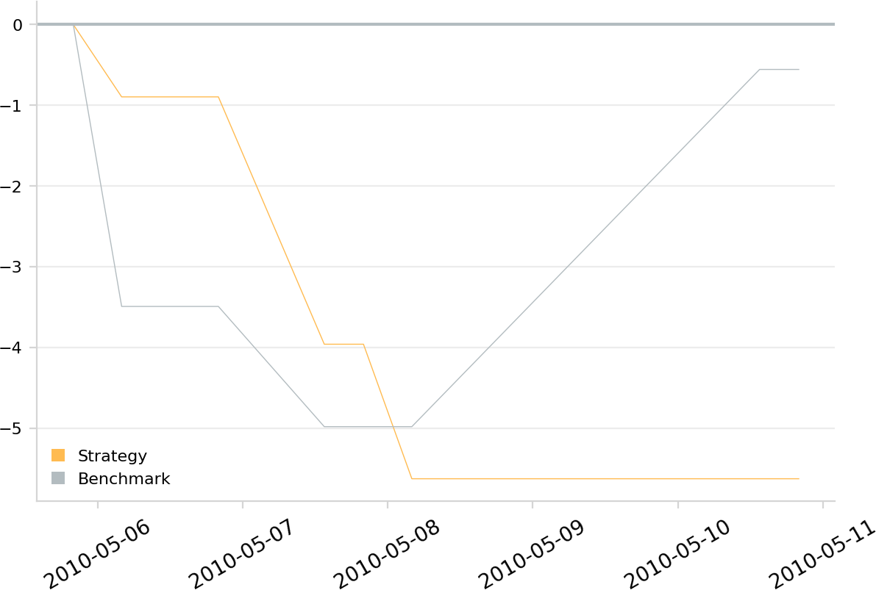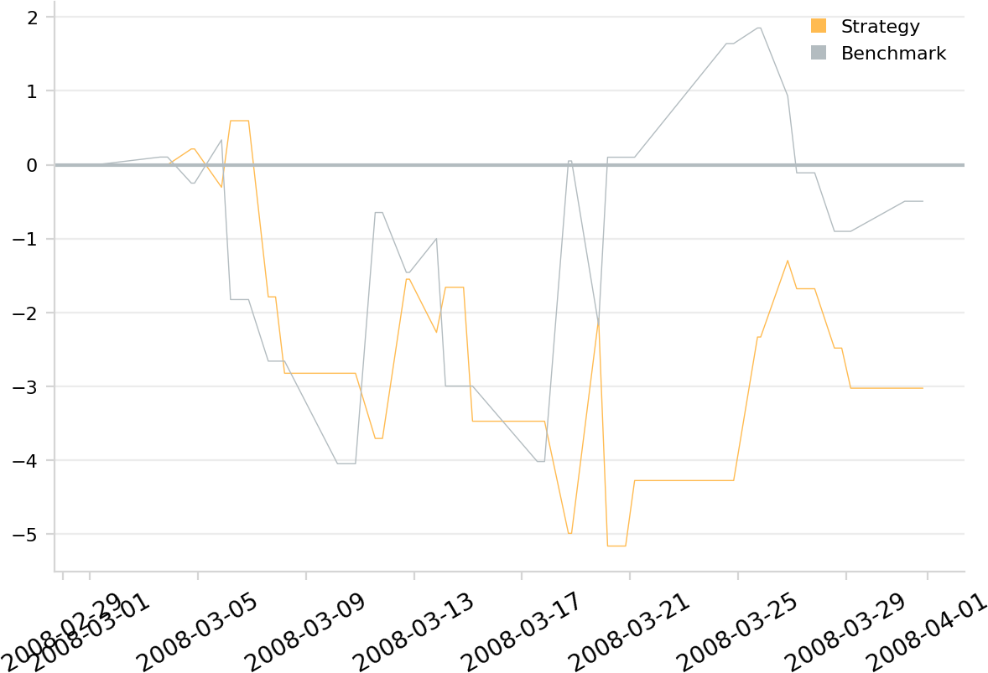

Crisis Sept08 Crisis 2009Q1 Crisis 2009Q2

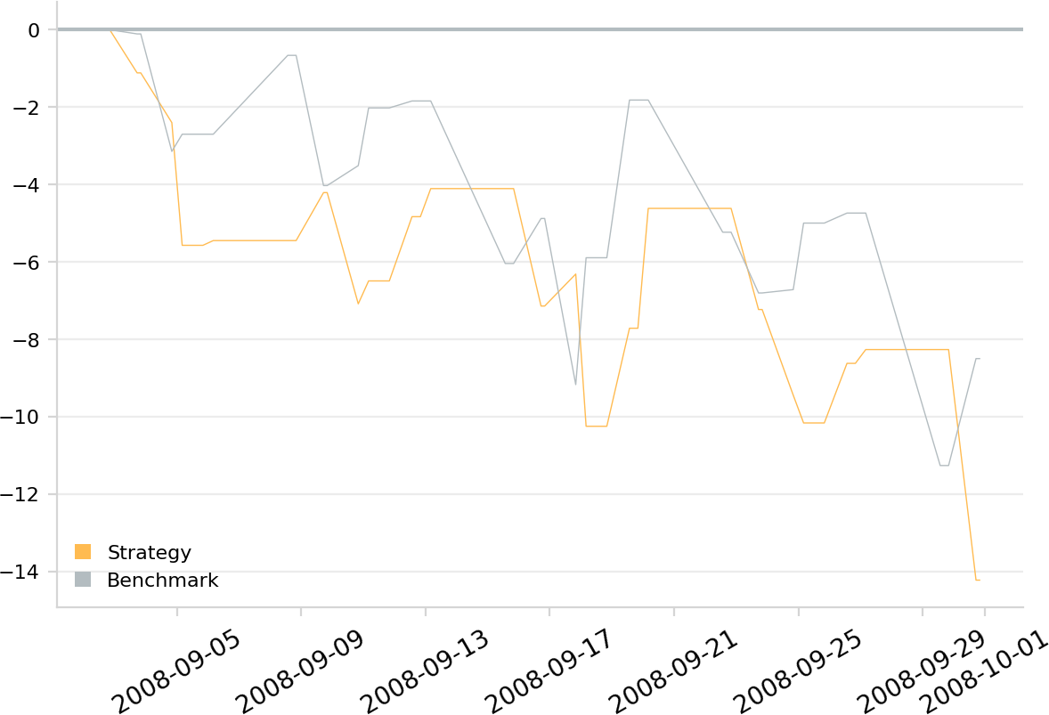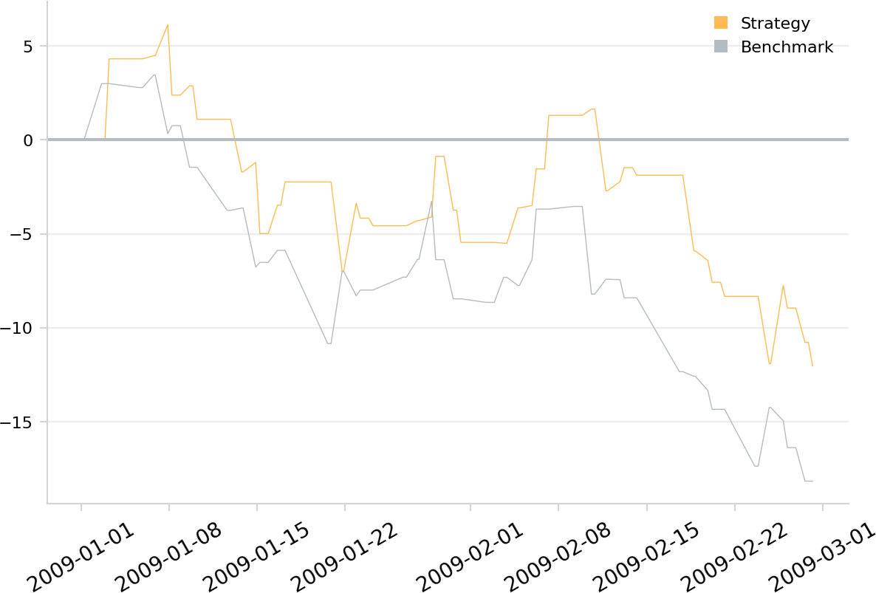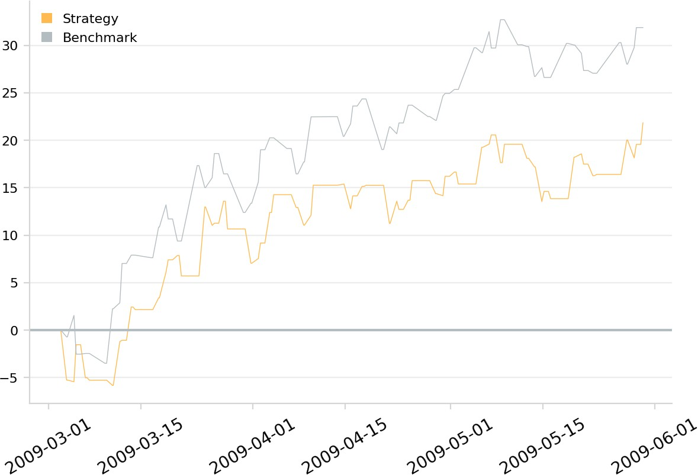

Crisis US Downgrade-European Debt Crisis Crisis ECB IR Event 2012 Crisis Oct14

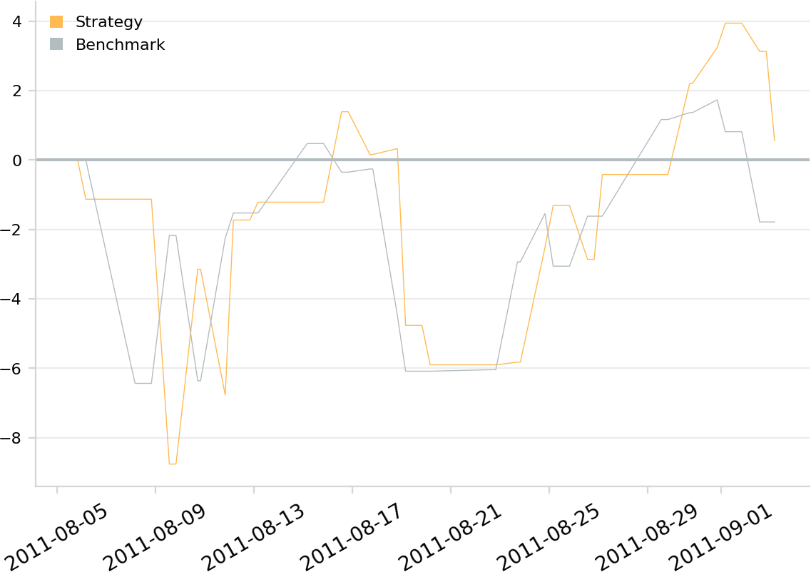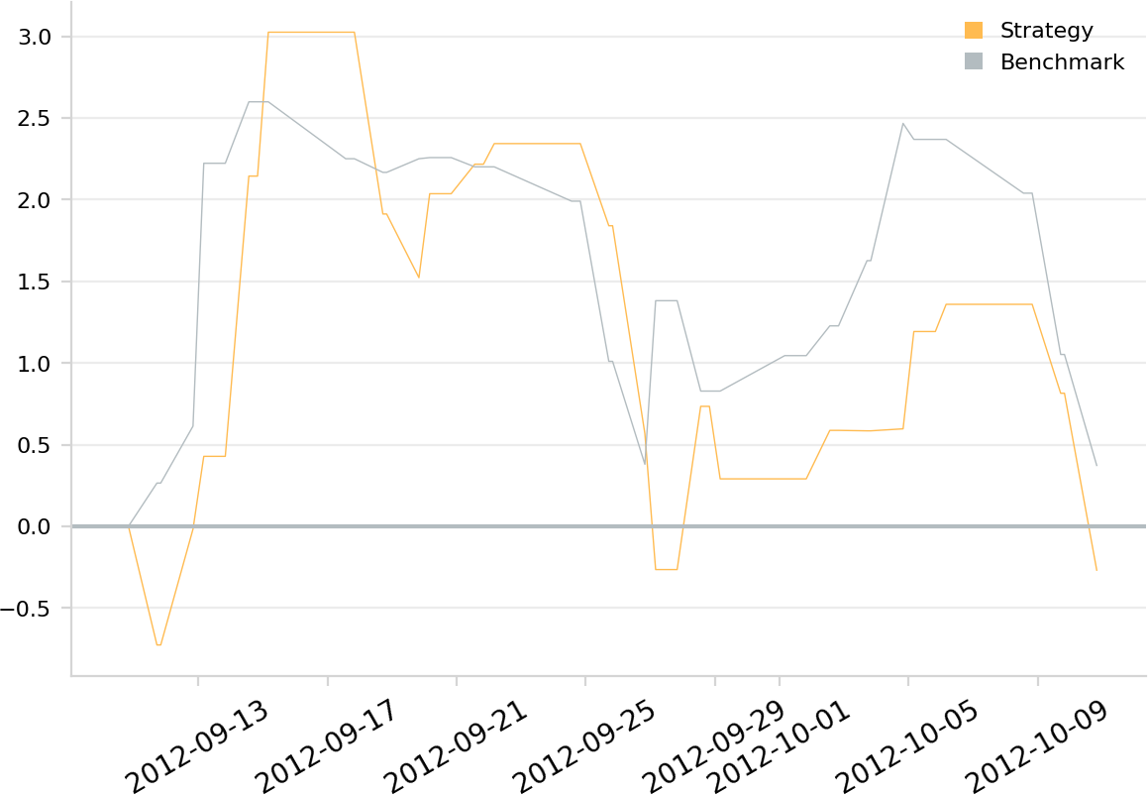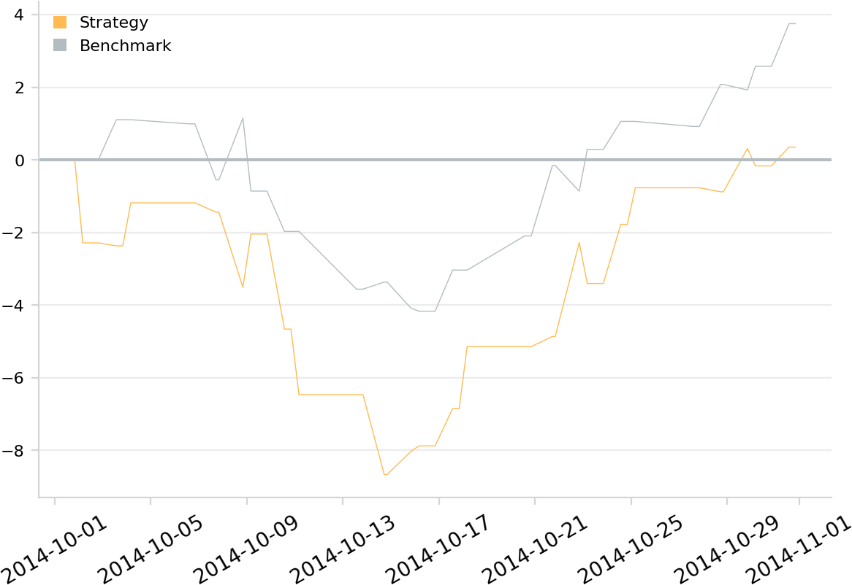

Crisis Fall2015 Crisis GFC Crash Crisis Recovery

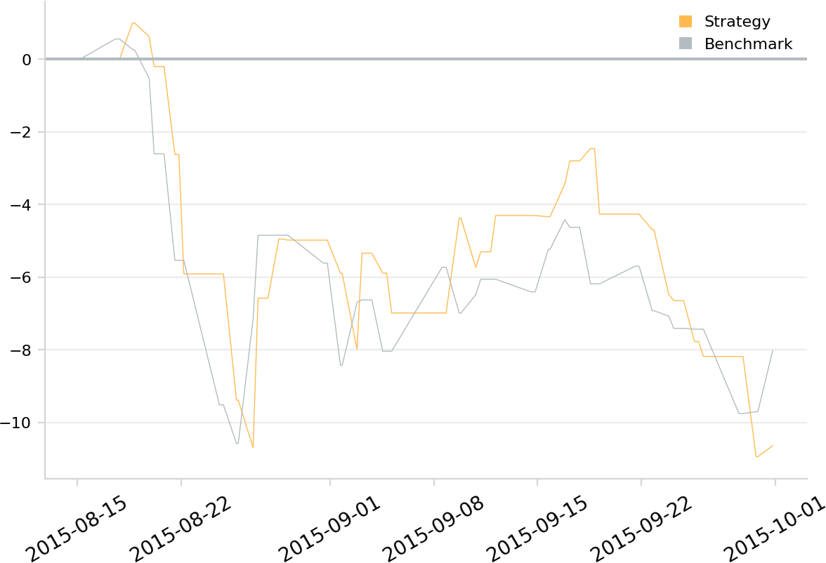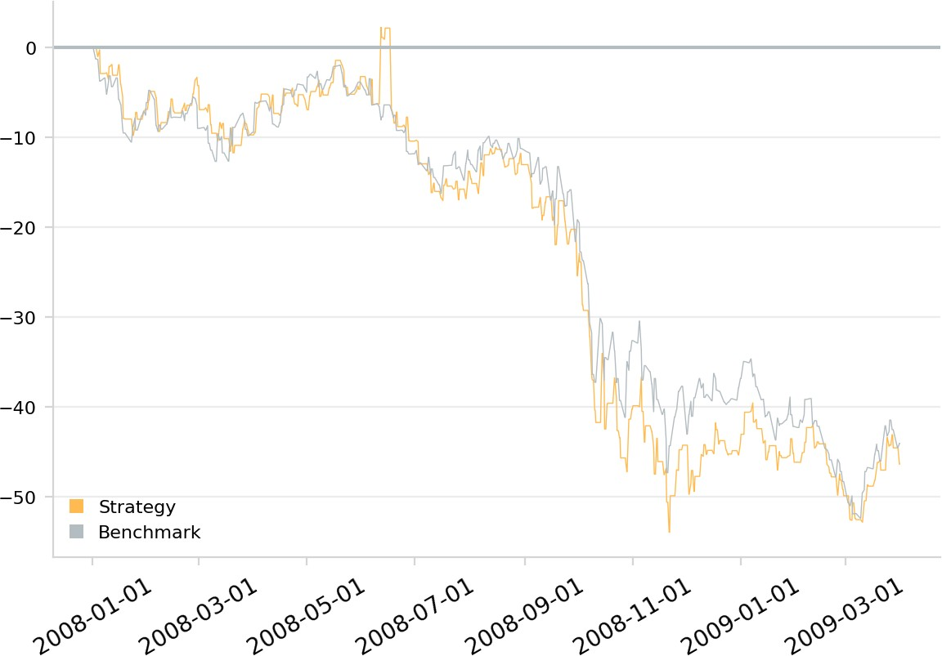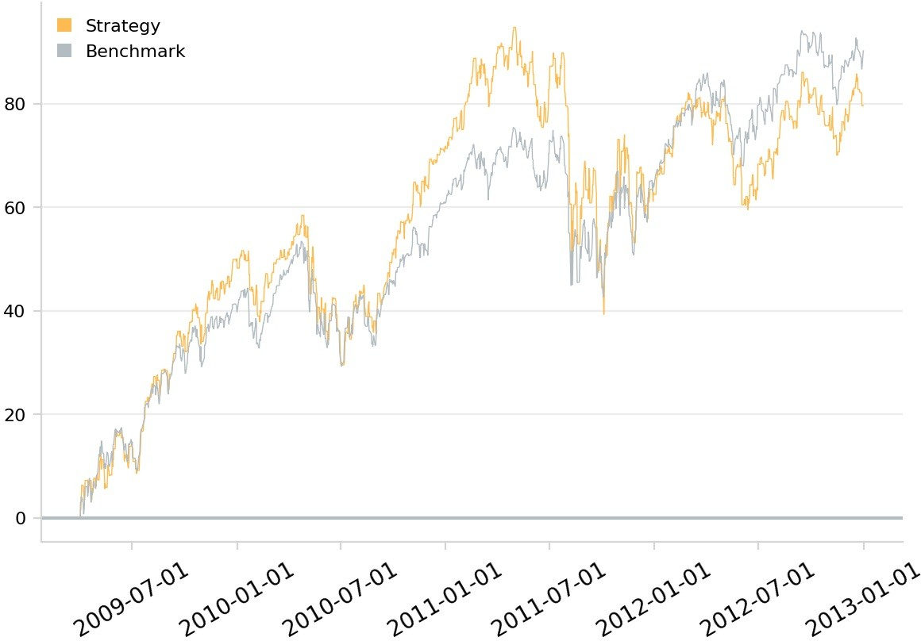

Crisis New Normal

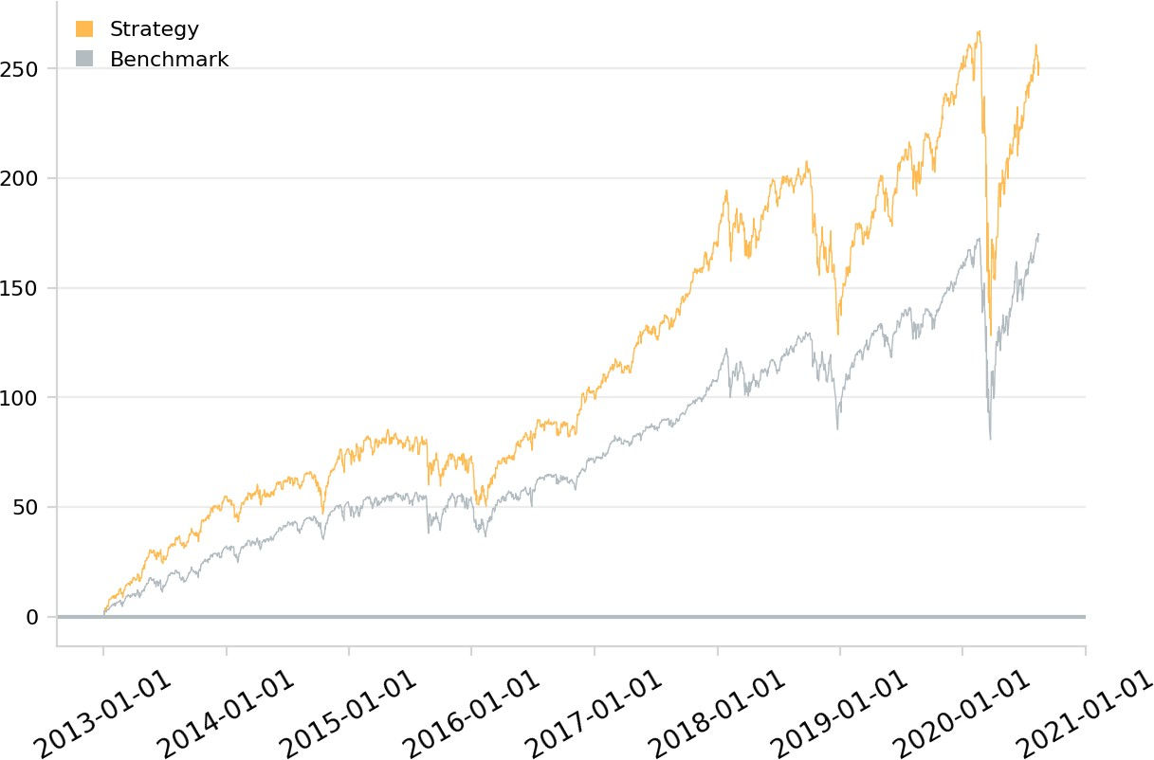

Equity

