PROJECT:ECOMMERENCE

**GROUP**

MOIZ KHAN JADOON FA17-BCS-035

MUHAMMAD ZUBAIR FA17-BCS-032

MUHAMMAD TALHA KHAN FA17-BCS-009

SEIKH HASSAAN RASHID FA17-BCS-091

MUHAMMAD FAHEEM FA17-BCS-028

KASFIM MANZOOR Fa17-BCS-033

**Teacher**

**Sir MUKHTAIR ZAMIN**

Chapter #1

# **Proposal:**

Our Group have decided to make a E-commerce. In which a user can buy and sell item from the Application. In this user can make a account and then upload the picture of the item and the other user can select the item from the dashboard of the application

## Tools:

Kotlin

Firebase

Androidstudio

Chapter #2

# **Problem**:

To build a ecommerce App From which a user can buy and sell things

# **Abstract:**

In this Project we will build a ecommerce App. From this app User will be able to sell its products online. This app basically consist on two panel (Admin panel and Customer panel).If a user wants to see his things he will make a account as Admin and if the Person wants to Sell the Items then he would make the account as the User.

# **Group Discussion**

We did our group meeting via MS Teams

**Solution**:

So we divided this project in 3 Modules

# **First** **Module**:

Firebase Authentication , Storing Data and Uploading Files To the Firebase Storage

# **Second Module:**

Developing the Adding and Displaying of Products, Developing Product Details Screen And Developing Cart ,Cart Overview and Details

# **Third Module**

Adding The Checkout Activity ,Allowing The User To Add Addresses And Building the Order Screen

|  |  |  |
| --- | --- | --- |
| **First** **Module**: | **Second Module** | **Third Module** |
| Faheem | Moiz | Faheem, Hassaan |
| Kashif | Talha | Muizz,Talha |
| Hassaan | Zubair | Kashif,Zubair |

# User Interface:

# 

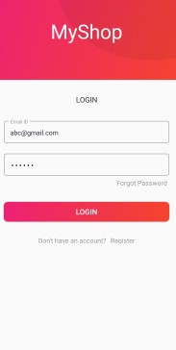

## Created:

SEIKH HASSAAN RASHID

## Reviewed:

Moiz

Zubair

Talha

Faheem

Kashif

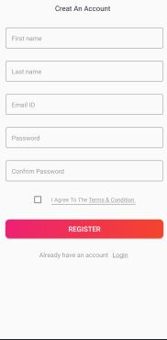

# Created:

Faheem

## Reviewed:

Zubair

Talha

Moiz

Kashif

Hassaan

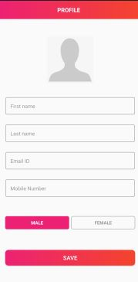

## Created:

Talha Khan

## Reviewed

Zubair

Moiz

Faheem

Kashif

Hassaan

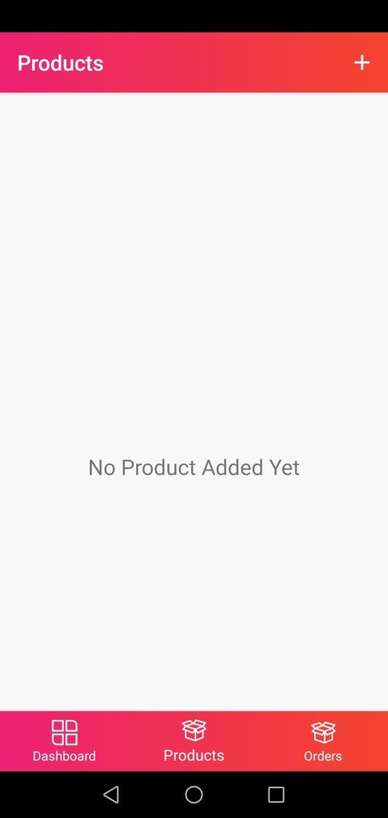

## Created:

Moiz Khan

## Reviewed

Zubair

Talha

Faheem

Kashif

Hassaan

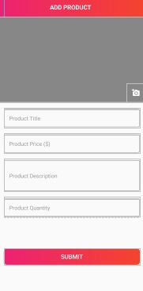

## Created:

Moiz

## Reviewed

Zubair

Talha

Faheem

Kashif

Hassaan

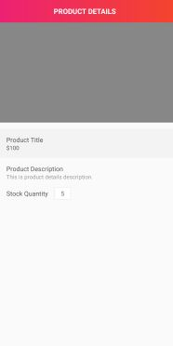

## Created:

Moiz

## Reviewed

Zubair

Talha

Faheem

Kashif

Hassaan

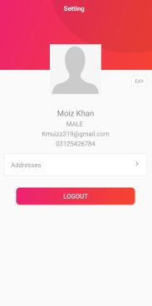

## Created:

Zubair

## Reviewed

Moiz

Talha

Faheem

Kashif

Hassaan

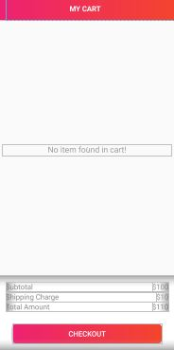

## Created:

Zubair

## Reviewed

Moiz

Talha

Faheem

Kashif

Hassaan

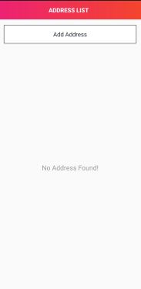

## Created:

Zubair

## Reviewed

Moiz

Talha

Faheem

Kashif

Hassaan

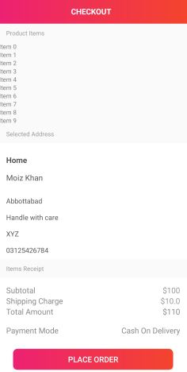

## Created:

Talha

## Reviewed

Moiz

Zubair

Faheem

Kashif

Hassaan



## Created:

Talha

## Reviewed

Moiz

Zubair

Faheem

Kashif

Hassaan

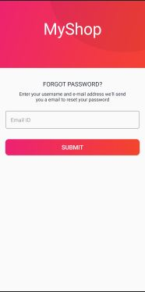

## Created:

Kashif

## Reviewed

Moiz

Zubair

Faheem

Talha

Hassaan