SAMS
IEEE-Style Logical Software Design Specification
Software Requirements Specification (SRS) and Logical Design Document
For future development, maintenance, testing, and onboarding
Prepared for Verified RCM
Version 1.0 | 11 August 2026

Document control
Item | Value
System | SAMS — Attendance, Leave, Payroll, and RCM Operations Platform
Document type | IEEE-style SRS and logical software design specification
Primary audience | Future developers, technical leads, QA engineers, architects, and support engineers
Status | Baseline logical documentation
Evidence date | Public application export and public guide reviewed 11 August 2026
Confidentiality | Internal technical documentation; do not include production credentials or customer data

Revision history
Version | Date | Author | Change
1.0 | 11 Aug 2026 | Verified RCM / Codex | Initial logical specification based on public route contract, public UI guide, and page metadata.

Important evidence boundary
Verified versus inferred: Requirements marked “Observed” are supported by public SAMS pages, its client-visible Laravel/Ziggy route manifest, or the public user guide. Logical entities, field lists, service boundaries, state names, and implementation patterns marked “Design recommendation” are developer-oriented inferences, not claims about the current private codebase.

Table of contents
1. Introduction
2. Overall description
3. System context and logical architecture
4. User classes and authorization
5. Functional requirements
6. Core business workflows and state models
7. Logical data model
8. Interface and route contract
9. Non-functional requirements
10. Security, privacy and auditability
11. Error handling and operational rules
12. Testing and acceptance criteria
13. Deployment, maintenance and extension guidance
Appendix A. Traceability inventory
Appendix B. Glossary

1. Introduction

1.1 Purpose
This specification establishes a stable logical baseline for SAMS. It describes what the platform must do, the rules that govern it, the interfaces exposed to the web client, and a recommended model for evolving it without breaking tenant isolation, payroll correctness, approval integrity, or RCM workflows.

1.2 Scope
SAMS is a multi-tenant workforce platform for organization onboarding, identity and access management, attendance, leave, overtime, payroll, reporting, notifications, and optional RCM productivity and claims operations. A separate platform administration area approves or rejects organization registrations.

1.3 Definitions
Term | Meaning
Tenant / organization | An independently configured customer organization with isolated users, data, policy, holidays, teams, and payroll configuration.
Org Admin | Customer-organization administrator with broad authority; distinct from a platform Super Admin.
Super Admin | Verified RCM platform administrator who administers SAMS and approves/rejects organization registration.
Final approver | Manager or HR (or Org Admin, where permitted) whose decision makes a request effective.
Practice | An RCM operational unit to which claims, users, metrics, and reporting can be scoped.
Observed | Directly evidenced in public source/UI.
Design recommendation | Logical design intended to guide future implementation.

2. Overall description

2.1 Product perspective
Observed: public pages identify a Laravel/Inertia-style web application. Client-visible routes use named route conventions and HTTP verbs; the UI bundle is served from build assets. The landing page describes isolated organization subdomains and a Super Admin activation gate. The following architecture is therefore the recommended logical model, not a source-code reconstruction.

2.2 Product functions
Domain | Capability summary | Evidence
Platform administration | Super Admin login, password reset, organization approval/rejection. | Observed
Tenant lifecycle | Registration, organization lookup by work email, tenant-specific login and invitation-led onboarding. | Observed
Identity & teams | Roles, invitations, user termination, password reset, team membership, shifts, profile. | Observed
Time & attendance | Check-in/out, reports, digest, policy preview, corrections and audit. | Observed
Leave & overtime | Submission, approve/deny workflow, actual overtime capture. | Observed
Payroll | Salary, deductions, tax brackets, payroll calculation/run, payslip access. | Observed
Notifications | Notification list, polling, mark one/all as read, browser notifications. | Observed
Productivity & RCM | Practices, metrics, daily reporting, analytics, bonus/scoring, RCM imports, claim queue, verification, review, reports. | Observed route inventory

2.3 Constraints and assumptions
- Each request and record must be tenant-scoped. Cross-tenant reads or writes are security defects.
- Business calculations must be reproducible from immutable input snapshots, especially payroll and scoring.
- Customer-role access is constrained by both role and team membership; HR and Org Admin act organization-wide.
- The public route manifest represents a client-facing contract. Route names/verbs should be versioned or preserved when refactoring.
- No public evidence establishes the current database schema, queue provider, mail provider, cloud host, retention period, or exact calculation formulas.

3. System context and logical architecture

3.1 Context
External actors are Super Admins, organization users, browser clients, email delivery, desktop/browser notifications, and (where enabled) RCM source-file uploads. The platform persists tenant data and produces downloadable CSV reports. A recommended trust boundary separates the public registration/home surface, authenticated tenant surface, and Super Admin surface.

3.2 Recommended logical components
Component | Responsibilities | Key dependencies
Web client | Inertia pages, forms, navigation, client-side validation, notification polling. | Named routes, CSRF/session auth, JSON/page props.
Identity & tenant resolver | Resolve subdomain/organization, authenticate user, enforce status and role/team scope. | Session store, users, organizations, invitations.
Workforce service | Attendance, leave, overtime, corrections, policy evaluation. | Policy, shifts, holidays, approvals, notifications.
Approval service | Route requests through lead/final steps, prevent self-review, preserve decision trail. | Identity, team hierarchy, notifications, audit log.
Payroll service | Salary, attendance deductions, tax, custom deductions, monthly payroll snapshots. | Workforce data, policies, tax brackets, audit log.
Productivity/RCM service | Metrics, reporting, score/bonus, practices, imports, claims and review queues. | Assignments, imports, reporting, AI/test integration if enabled.
Notification service | In-app records, polling responses, email/browser event delivery, reminder jobs. | Queue/scheduler, user preferences.
Audit service | Append-only changes to payroll-affecting and privileged data. | All write services.
Background scheduler | Auto checkout, digest, approval chasing, report subscriptions, recalculation. | Queue, clock, tenant config.

3.3 Logical request flow
Browser → tenant resolver → authentication/authorization middleware → controller/page action → domain service → transactionally persisted aggregate + audit event + outbox notification → response. Background workers consume the outbox/scheduled jobs and deliver notifications or create reports. Payroll and scoring operations should use explicit calculation snapshots rather than mutable live data.
Design recommendation: Use a transaction plus outbox pattern for domain changes that trigger notifications. It prevents a successful approval from being saved without a durable notification event, or vice versa.

4. User classes and authorization
User class | Scope | Principal capabilities
Super Admin | Platform | Approve/reject tenants; platform login and password recovery.
Org Admin | Entire organization | All organization administration, payroll authority, overrides; cannot approve own attendance correction.
HR | Entire organization | Users, teams, policy, holidays, tax brackets, audit log, final request approval.
Manager | Assigned team(s) | Final approval, attendance digest/report, employee/team invitation, pay and productivity controls.
Team Lead | Assigned team(s) | First-step reviews, employee invitations, shift/practice management.
Employee | Self | Clocking, profile, requests, personal payroll/productivity visibility.

4.1 Authorization rules
AUTH-001 (Observed): Every customer request shall operate in the current organization context; organization data shall remain isolated from other organizations.
AUTH-002 (Observed): A customer user shall sign in through the organization-specific address; the platform login is reserved for Super Admin users.
AUTH-003 (Observed): No user shall approve their own request at any approval stage.
AUTH-004 (Observed): Team Lead and Manager actions shall be restricted to their team scope; HR and Org Admin have organization-wide scope.
AUTH-005 (Observed): Org Admin may override an already decided request; this override shall be audit logged.
AUTH-006 (Design recommendation): Enforce authorization in server-side policies/services, never solely in route visibility or front-end controls.

5. Functional requirements

5.1 Tenant lifecycle and identity
FR-TEN-001: The system shall allow an organization and initial administrator to register.
FR-TEN-002: The system shall require Super Admin approval before a new organization can operate.
FR-TEN-003: The system shall allow a Super Admin to approve or reject a pending organization.
FR-TEN-004: The system shall provide a work-email-based organization lookup to send the appropriate sign-in link.
FR-ID-001: The system shall support tenant user invitations for Managers, HR, Team Leads, and Employees according to role authority.
FR-ID-002: An invitation link shall expire after 24 hours (Observed public guide) and be reissuable.
FR-ID-003: Authorized users shall be able to terminate users and force password reset.
FR-ID-004: Users shall be able to update permitted profile fields and profile pictures; organization-controlled identity attributes shall not be self-editable.

5.2 Teams, holidays and shifts
FR-ORG-001: Authorized users shall create, rename, assign managers/leads to, and delete teams.
FR-ORG-002: Authorized users shall add and delete organization holidays.
FR-ORG-003: Authorized users shall assign a user to a team.
FR-ORG-004: Authorized roles shall set an individual shift start and end time.
BR-SHF-001 (Observed): With no individual shift, the documented default is 06:00–15:00 (9 hours).
BR-SHF-002 (Observed): Shift start is the basis for lateness and shift end is the basis for forgotten clock-out closure and overtime-rate context.

5.3 Attendance and corrections
FR-ATT-001: An authenticated active user shall check in and check out.
FR-ATT-002: The system shall support more than one work session in a day and aggregate the sessions.
FR-ATT-003: The system shall deduct unpaid break once per day, not once per session.
FR-ATT-004: The system shall produce an attendance report and CSV export for authorized roles.
FR-ATT-005: The system shall provide a daily digest of in/late/absent status to Managers.
FR-COR-001: A user shall submit an attendance correction with requested times and reason.
FR-COR-002: A reviewer shall approve, approve with adjusted times, request changes, or deny a correction.
FR-COR-003: The system shall support bulk approval only where authorization and scope validation are applied per record.
BR-COR-001 (Observed): Employee correction window defaults to 24 hours; HR and Org Admin are exempt.
BR-COR-002 (Observed): Payroll may be blocked while attendance corrections remain unresolved.

5.4 Leave, overtime and approvals
FR-LVE-001: A user shall submit full-day and short/half-day leave requests.
FR-OT-001: A user shall submit overtime requests before performing overtime and later record actual overtime.
FR-APR-001: Requests shall normally receive first-step Team Lead review and final Manager-or-HR decision.
FR-APR-002: A Manager or HR user may act at the first stage to avoid a stalled workflow.
FR-APR-003: If no Team Lead applies, or the requester is the Team Lead, the request shall route directly to a final approver.
FR-APR-004: A final approval shall make the request effective; first-step approval alone shall not.
FR-APR-005: The final approver shall set authorized overtime minutes; actual minutes shall remain separately recorded.
FR-APR-006: The system shall notify requester and applicable reviewers as request state changes.

5.5 Policy and payroll
FR-POL-001: HR and Org Admin shall configure attendance policy, including working week, break, leave allowance, lateness, correction and approval-chase controls.
FR-POL-002: The system shall provide a policy preview endpoint/action before policy update is committed.
FR-PAY-001: Authorized roles shall define employee salary and custom deduction items.
FR-PAY-002: Authorized roles shall create and delete progressive tax brackets.
FR-PAY-003: The system shall calculate and run payroll by user and period.
FR-PAY-004: Employees shall be able to view their own payroll/payslip data.
BR-PAY-001 (Observed): Payroll cannot run for an employee without salary data.
BR-PAY-002 (Design recommendation): Every payroll run shall store source attendance, policy, tax, salary, deduction, and formula-version snapshots.

5.6 Notifications
FR-NOT-001: The system shall list notifications, expose unread count, mark an individual notification read, and mark all read.
FR-NOT-002: The client shall be able to poll the notification endpoint.
FR-NOT-003: The system shall create approval-chase reminders after the configured SLA; the public guide identifies 48 hours as default.
FR-NOT-004: The system shall support manager daily digest generation.

5.7 Productivity and RCM operations
FR-PRD-001: Authorized roles shall enable/disable productivity and configure productivity settings.
FR-PRD-002: Authorized roles shall manage practices, assignments, metrics, benchmarks, daily summaries, dashboards, analytics and insights.
FR-PRD-003: Users shall submit daily productivity reporting and additional reporting entries.
FR-PRD-004: Users shall request reopening of locked reporting periods; authorized users shall approve or deny reopen requests.
FR-PRD-005: Authorized roles shall grant bonuses and manage scoring settings/tiers; scores shall support recalculate, approve, and unapprove actions.
FR-RCM-001: Authorized roles shall import RCM files, map an import batch, approve/reject batch imports, and inspect batch details.
FR-RCM-002: Authorized roles shall manage claim queues, eligibility, authorizations, payer data, claim actions, assignment, visibility, history, verification, and review feedback.
FR-RCM-003: Authorized roles shall configure AI instructions and execute a test action; production AI calls shall be observable, permission-gated, and safe against PHI leakage.
FR-RCM-004: The system shall support report subscriptions and report CSV export.

6. Core business workflows and state models

6.1 Generic approval workflow
Recommended normalized states: DRAFT → SUBMITTED → PENDING_LEAD (if lead applies) → PENDING_FINAL → APPROVED | DENIED | CHANGES_REQUESTED | CANCELLED. An approval record is appended for every actor action. A correction approved with modified times preserves both requested and approved values.
Transition | Actor | Guard / result
Submit | Requester | Validate period and input; reject self-review routing.
First-stage approve | Lead / Manager / HR | If allowed, advance to PENDING_FINAL; do not apply business effect.
Final approve | Manager / HR / Org Admin | Apply effect atomically; record decision and notify.
Deny | Eligible reviewer | Set DENIED; preserve reason and notify.
Request changes | Eligible reviewer | Set CHANGES_REQUESTED; requester may edit/resubmit.
Override | Org Admin | Create override decision; never mutate prior decision history.

6.2 Attendance calculation workflow
- Resolve organization, active user, calendar day, user shift, attendance policy and holiday/working-day status.
- Create a clock session at check-in or close the active session at check-out.
- Aggregate daily session minutes and subtract configured unpaid break once when applicable.
- Classify day: present, late, short leave, absent, holiday/non-working, or policy-defined alternative.
- Record calculated attributes with policy version/reference. Schedule auto-checkout for active sessions past shift-end plus configured grace.
- If a correction becomes final, recalculate the affected attendance day and mark dependent payroll periods for recalculation/review.

6.3 Payroll workflow
- Lock or snapshot relevant attendance, approved leave, approved actual overtime, salary, tax brackets and deduction items for employee and period.
- Validate salary exists and block if unresolved corrections are prohibited by policy.
- Calculate gross pay, attendance/leave deductions, overtime earnings, tax, custom deductions, bonus, and net pay using a versioned formula.
- Persist a payroll run and immutable line-item/snapshot detail in one transaction.
- Expose payslip to authorized viewer; any rerun creates a distinct revision or explicit supersession trail.
Design recommendation: Avoid recalculating historical payslips from current policy or current salary values. Payroll must be explainable from the values in effect at run time.

6.4 Import-to-claim workflow
Recommended states: UPLOADED → MAPPING_REQUIRED → MAPPED → VALIDATING → PENDING_APPROVAL → APPROVED | REJECTED → PROCESSED. Keep raw source file metadata, mapping version, validation errors, approver, timestamp and idempotency key. Imported claims enter a practice-scoped queue; claim actions, assignment and hide/unhide operations append history events.

7. Logical data model
The following entities are a logical model derived from observable capabilities. The actual physical schema may differ. Every tenant-owned table should include organization_id (or enforce equivalent tenant scoping) and standard created/updated timestamps; privileged and payroll-relevant mutations should emit audit events.
Entity | Key relationships / minimum logical attributes
Organization | id, name, subdomain, status, settings; owns users, teams, policy, holidays, payroll, practices.
User | id, organization_id, role, team scope, employment/profile fields, status, shift fields.
Team | organization_id, name; many-to-many managers/leads; has users.
Invitation | organization_id, email, intended role/team, token hash, expires_at, accepted_at, inviter_id.
AttendanceSession | organization_id, user_id, started_at, ended_at, source, auto_closed flag.
AttendanceDay | organization_id, user_id, date, minutes, classification, policy snapshot/version, derived flags.
AttendanceCorrection | attendance day/user, requested/approved times, reason, state, submitter; has approvals.
LeaveRequest / OvertimeRequest | organization_id, requester, dates/minutes/type/reason/state; has approvals; overtime has actual minutes.
ApprovalDecision | approvable_type/id, stage, actor_id, decision, reason, before/after data, decided_at.
AttendancePolicy | organization_id, version, working days, break, grace, late/leave/correction/reminder controls.
Holiday | organization_id, date, name.
Salary / TaxBracket / DeductionItem | organization_id plus user or policy scope; effective date/version as needed.
PayrollRun / PayrollLine | employee, period, revision, state, totals, calculation snapshot and line explanations.
Notification | organization_id, user_id, type, payload, read_at, delivered_at.
AuditEvent | organization_id, actor, subject type/id, action, before/after, timestamp, correlation id.
Practice / Assignment / Metric / DailyReport | organization-scoped productivity data, user-practice links, metric values, period state.
ImportBatch / Claim / ClaimAction | source metadata, mapping, validation, practice, lifecycle, assignments and event history.
Score / Bonus / BonusTier | employee/practice/period, inputs snapshot, calculation version, approval status.
ReportSubscription | organization/user, report type, schedule, delivery target, enabled status.

7.1 Integrity rules
- Unique organization subdomain; never reuse a subdomain without controlled archival/redirect policy.
- At most one active attendance session per user at a time, unless product requirements explicitly permit overlapping work sessions.
- At most one AttendanceDay per user/date/organization; sessions and corrections feed it.
- An approver decision must be unique per approvable/stage/actor where duplicate clicks are possible.
- Use foreign keys, tenant-aware unique indexes, optimistic locking or version fields for concurrent admin edits, and idempotency keys for imports/payroll runs.

8. Interface and route contract
Observed public client route inventory uses named Laravel-style routes. The implementation may serve Inertia pages and form actions, but backend validation, authorization, and stable response semantics remain mandatory. Do not publish sensitive data in client route manifests or page props.
Route group | Representative observed routes | Contract expectations
Public/platform | GET /, POST /find-organization, GET/POST /register, GET/POST /super-admin/login, POST /admin/organizations/{id}/approve|reject | CSRF protection; rate-limit lookup/login; validate tenant registration lifecycle.
Identity/organization | POST /managers/invite, /employees/invite, /hr/invite, /team-leads/invite; GET /users; POST user termination/reset/team/shift; CRUD /teams, /holidays | Policy authorization + team/tenant checks; invitation expiry and revocation.
Attendance | GET /attendance, POST /attendance/check-in, /check-out, GET /attendance/report, GET /digest, PATCH /attendance/settings, POST /api/attendance/settings/preview | Idempotent check transitions; timezone-aware date handling; report authorization.
Corrections/requests | CRUD-ish /attendance/corrections, /leave, /overtime; approve/deny/request-changes/record-actual actions | State transition guards, self-approval prevention, immutable approval history.
Payroll | GET /payroll, /payroll/{user}; POST salary, deduction item, payroll run; CRUD tax brackets | Period locking/snapshot; deterministic calculation; strict payroll authorization.
Notifications | GET /notifications, GET /api/notifications/poll, POST read/mark-all-read | No cross-user notification access; bounded polling response.
Productivity | /productivity/settings, practices, metrics, benchmarks, daily-summary, dashboard, analytics, reporting, bonuses, reports | Scope by organization/practice/user and enforce configured module status.
RCM | /rcm/imports, queue, claims actions/assign/hide/history, verification, review, feedback, AI instructions, scores, subscriptions | Validate upload/mapping; audit claim actions; protect PHI and outbound AI/report delivery.

8.1 API design rules
- Use precise HTTP semantics: GET read-only; POST create/action; PATCH partial update; PUT replacement; DELETE irreversible removal only when retention policy allows.
- Return machine-readable validation errors and stable error codes. Support field errors for forms and conflict responses for stale state.
- Require anti-forgery controls for browser state-changing requests; enforce authentication and tenant context server side.
- For action endpoints, return updated resource state, current version/ETag where useful, and a correlation ID for support tracing.

Use case
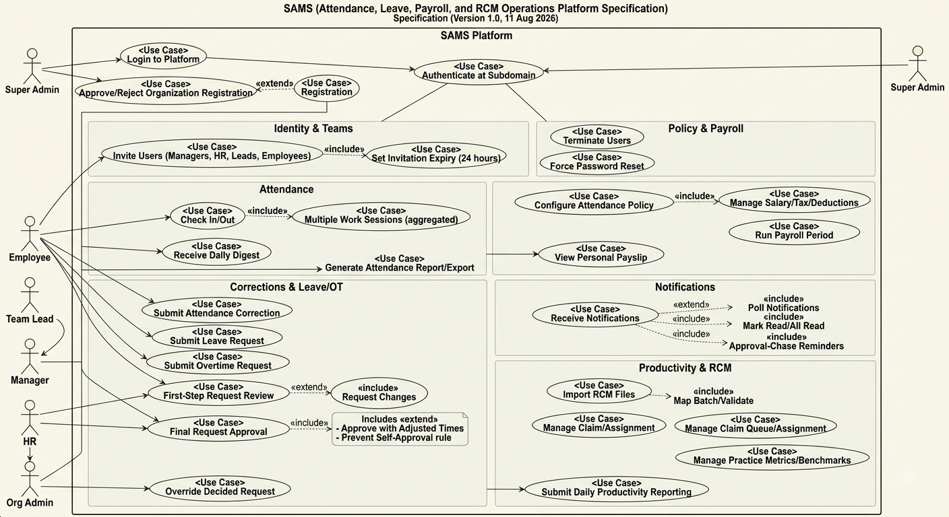

Entity Relationship Diagram (ERD)
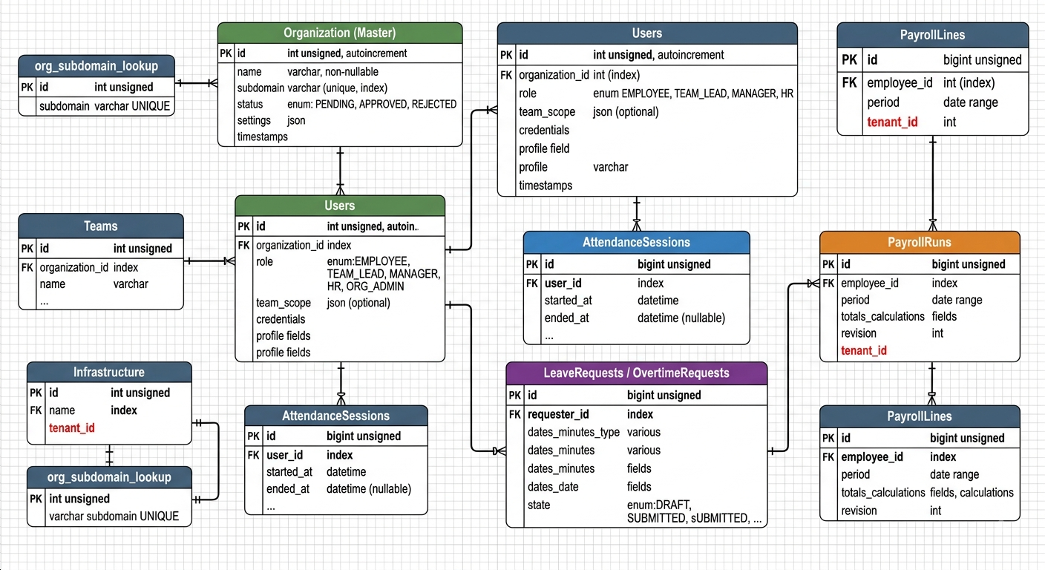

Architecture
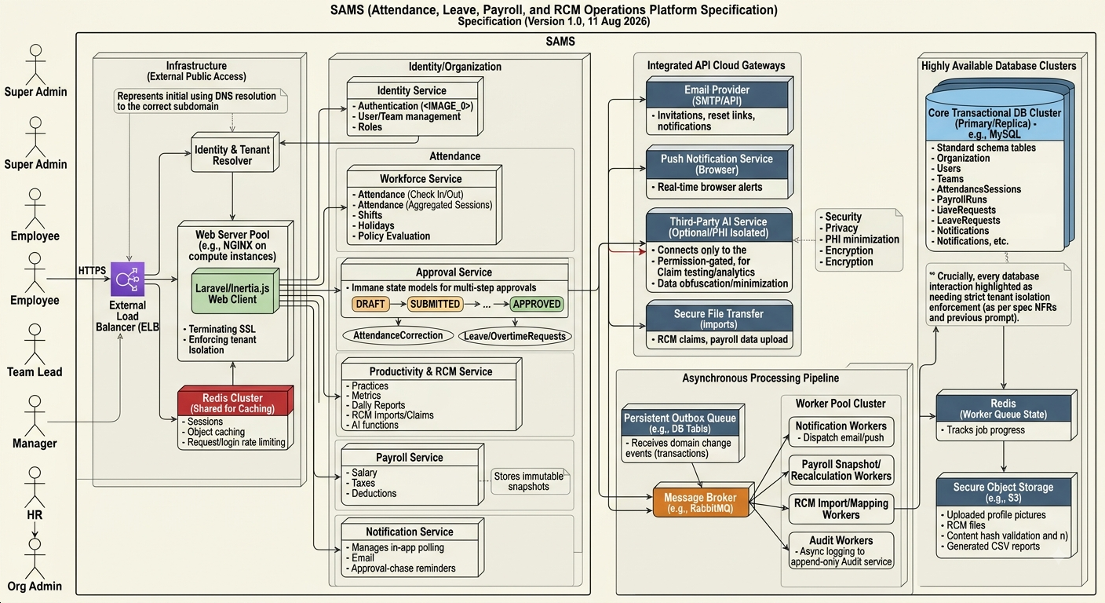

Context Diagram
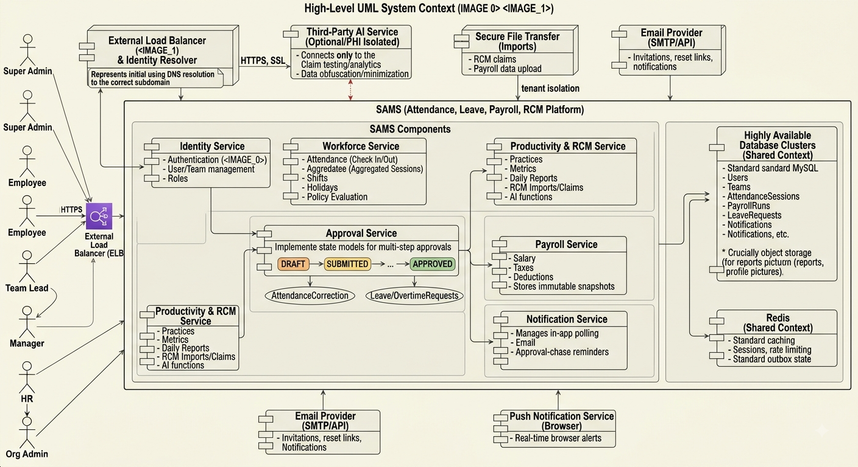

Data Flow Diagram

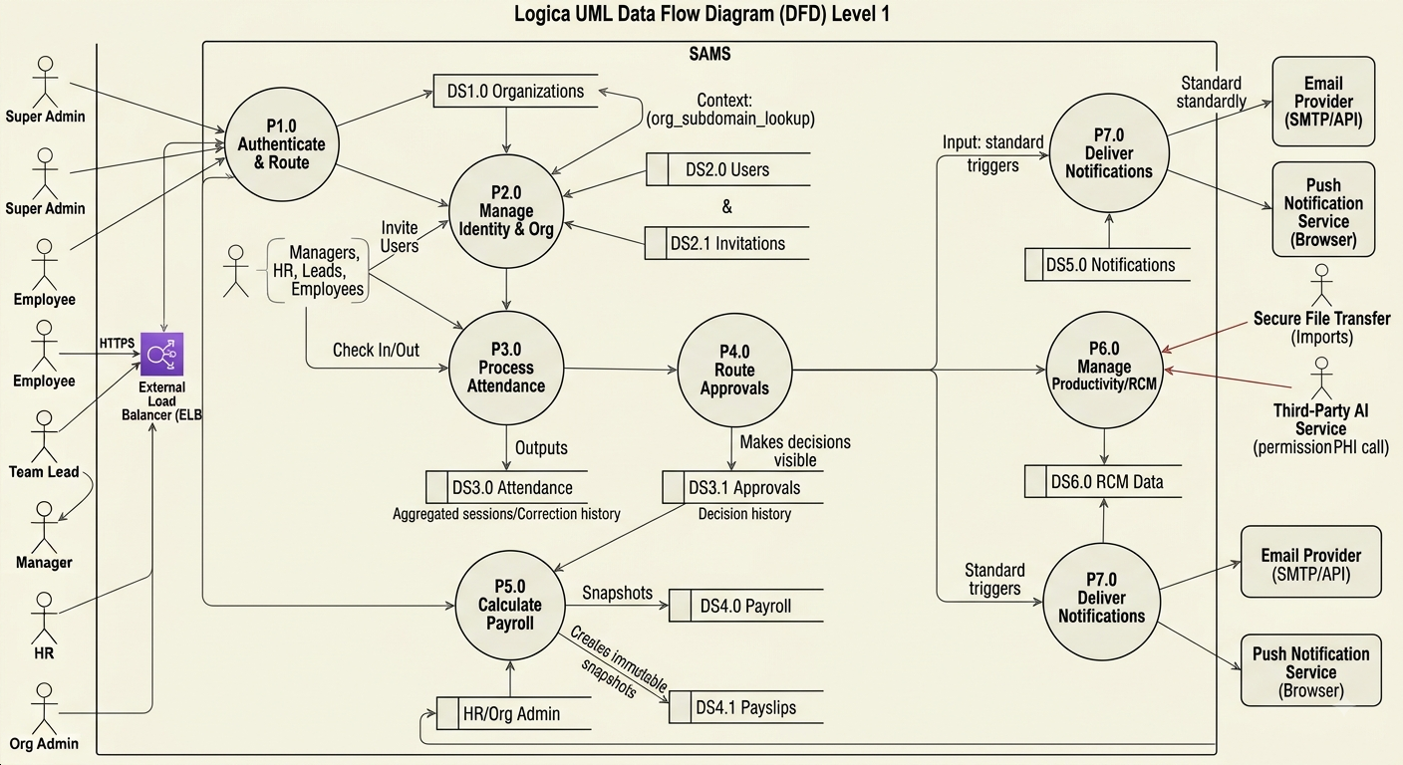

Activity Diagram

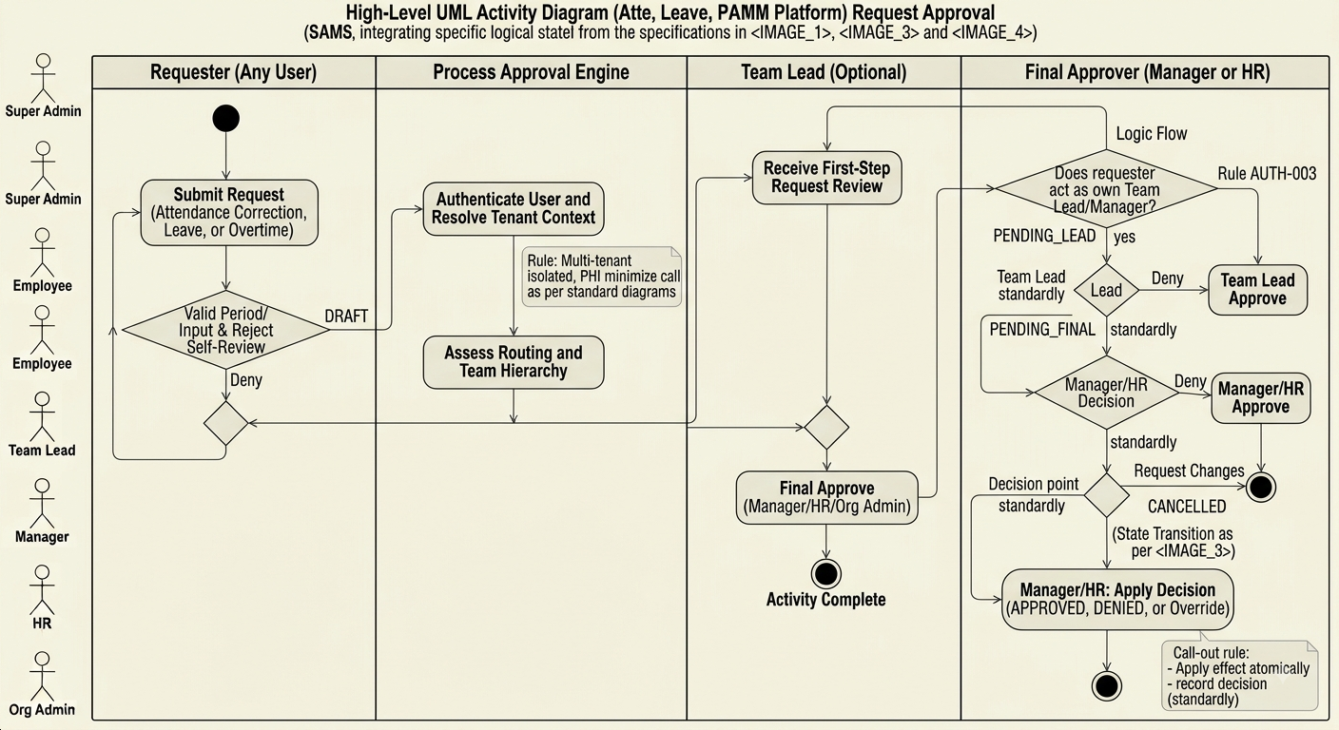

Sequence Diagram
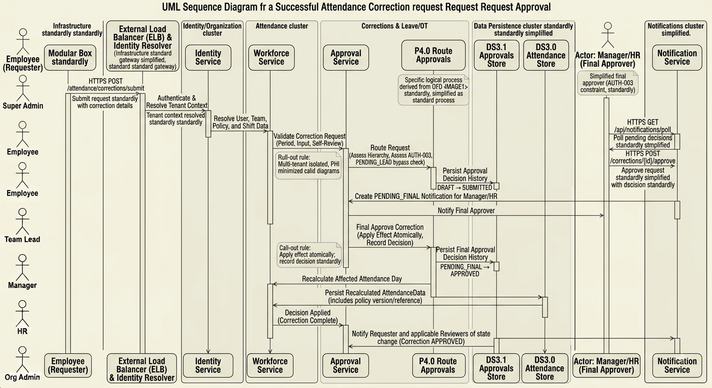

9. Non-functional requirements
ID | Requirement
NFR-SEC-001 | Tenant isolation shall be enforced in query construction/policies and verified by automated negative tests.
NFR-SEC-002 | Passwords shall be stored only with modern adaptive hashes; reset/invitation tokens shall be single-use, time-bound and stored hashed.
NFR-REL-001 | Payroll runs, final approvals, corrections and imports shall be transactional and idempotent.
NFR-REL-002 | Background jobs shall be retry-safe and emit observable failure events; repeated delivery must not duplicate payroll or approval effects.
NFR-PERF-001 | Notification polling and dashboard/report queries shall be paginated/bounded and indexed by tenant/user/date.
NFR-PERF-002 | Long-running import, export, scoring and report generation shall execute asynchronously with visible job status.
NFR-AUD-001 | Privileged, policy, payroll and request-decision changes shall be attributable to actor, time, tenant and before/after values.
NFR-USE-001 | All workflow states shall be clear to users and include actionable validation/denial reasons.
NFR-MNT-001 | Business rules and formula versions shall be encapsulated in domain services and covered by scenario tests, not scattered across controllers/UI.
NFR-PRV-001 | RCM/health-related data shall be minimized, access-restricted, encrypted in transit and at rest, and never sent to unapproved third parties or AI services.

10. Security, privacy and auditability

10.1 Security controls
- Resolve tenant by trusted host/subdomain mapping and reject unknown, suspended, or unapproved organizations before page/data access.
- Use role + scope authorization for every record access. Never accept organization_id, user_id, practice_id, or approver identity from the client without server-side ownership validation.
- Rate-limit login, password reset, organization lookup, invitation resend, import upload, and AI test endpoints.
- Validate upload file size/type, scan where infrastructure permits, store outside web root, and retain a content hash.
- Use secure session cookies, HTTPS, CSRF protection, security headers, input validation and output encoding.

10.2 Audit policy
Audit events should be append-only and include organization_id, actor_id/system actor, action, subject type/id, before and after values (redacted as needed), timestamp, source IP/user-agent or request metadata where lawful, and correlation ID. Audit at minimum: policy changes, shift changes, salary/tax/deduction changes, payroll runs/revisions, request approvals/overrides, user termination, team changes, imports, claim actions, AI instruction changes and privilege changes.

10.3 Privacy/PHI note
High-risk domain: Routes for RCM claims, eligibility, authorizations and payer operations may process protected health information. Before production use or any AI integration, perform a formal security/privacy review, define data classification and retention, execute vendor agreements as required, and implement least-privilege logging/redaction. This document does not certify regulatory compliance.

11. Error handling and operational rules
Scenario | Required behavior
Duplicate check-in/check-out | Return current state safely; do not create overlapping active sessions.
Expired invitation/reset | Reject token, show safe recovery path, allow authorized resend.
Unapproved/suspended organization | Deny customer access with non-enumerating message; preserve Super Admin workflow.
Unauthorized approval | Return 403; write security-relevant audit event where appropriate; do not reveal request data beyond scope.
Concurrent request decision | Use row version/transaction guard; one decision succeeds and the other gets a conflict/current state.
Payroll validation failure | Do not create a partial payroll run; return reasons such as missing salary or unresolved corrections.
Import mapping failure | Retain batch in actionable failed/mapping-required state with row-level errors; do not create partial claims unless explicitly designed.
Notification delivery failure | Keep durable notification/event; retry delivery separately without repeating domain action.
AI/test failure | Return sanitized error; do not expose secrets or PHI in logs/client response; preserve correlation ID.

12. Testing and acceptance criteria

12.1 Test layers
- Unit tests: policy calculations, late/leave thresholds, approval transition guards, overtime formula, tax brackets, payroll line calculation, score calculations.
- Service/integration tests: tenant resolver, authorization policies, transactional outbox, import mapping, CSV export, job retry/idempotency.
- Feature tests: all observed route groups and role-based success/forbidden scenarios.
- End-to-end tests: registration to approval, invitation, daily clock workflow, correction, leave, overtime, payroll, productivity reporting, RCM import to claim action.
- Security tests: cross-tenant ID substitution, self-approval, team-scope bypass, invitation replay, file upload validation, authorization on API endpoints.

12.2 Minimum acceptance scenarios
ID | Scenario | Pass condition
AT-001 | Tenant isolation | User A cannot read/write any Organization B object even with known IDs/routes.
AT-002 | Approval integrity | Team Lead approval does not apply leave; Manager/HR final approval does; requester cannot approve own request.
AT-003 | Attendance | Two sessions aggregate correctly; one unpaid break applied; auto-close follows configured shift/policy.
AT-004 | Correction | Correction respects deadline, preserves requested/approved values, and recalculates attendance only after final approval.
AT-005 | Payroll reproducibility | Run stores calculation snapshot; later policy/salary edit does not alter completed run.
AT-006 | Policy safety | Preview does not persist; policy update creates audit event; unresolved correction policy blocks payroll when enabled.
AT-007 | Invitation security | Expired/reused invitation token fails; invite accepted only by intended email or defined verified flow.
AT-008 | RCM import | Invalid rows are traceable; approval/rejection is auditable; duplicate upload is idempotently detected or intentionally versioned.
AT-009 | Notification reliability | Approval remains correct when notification delivery is retried or temporarily fails.

13. Deployment, maintenance and extension guidance
- Document and version environment configuration: app URL/domain, tenant domain rules, mail, queue, scheduler, storage, database, encryption keys, and external AI integration settings.
- Run migrations forward only; back up before schema changes that affect payroll or audit records. Never silently rewrite historical payroll data.
- Make scheduled commands explicitly tenant-aware. Test auto-checkout, digest, reminders, report subscriptions and recalculations across multiple tenants.
- Provide observability: structured logs with correlation/tenant IDs, metrics for queue failure and job latency, audit search, health checks, and alerting for payroll/import failures.
- Before adding a role or workflow, update authorization matrix, route policy, approval state machine, audit coverage, tests, and this specification.
- Before exposing new RCM/AI capability, complete threat modeling and privacy review; gate feature rollout per organization.

Appendix A. Traceability inventory
Observed source artifacts available in the workspace: SAMS/index.html (landing content), SAMS/guide.html (role, process, policy and permissions guide), SAMS/register.html (client-visible named route manifest and registration page metadata), SAMS/super-admin/login.html, SAMS/super-admin/forgot-password.html, and SAMS/build/assets application bundle. Routes were used as capability evidence only; no authenticated private data or source code was accessed.
Trace source | Specification sections
Public landing page | Tenant isolation, registration/approval, high-level modules, support.
Public guide | Role matrix, two-step approvals, clocking, correction, leave/overtime, policy defaults, setup, payroll/RCM usage.
Client-visible route manifest | Route groups, module inventory, HTTP action patterns, RCM/claims/productivity capability traceability.

Appendix B. Glossary
Term | Definition
Auto-checkout | System closure of an active attendance session after configured time past shift end.
Correction | Request to amend recorded attendance times, subject to workflow approval.
Digest | Manager-facing daily summary of attendance status.
Outbox | Durable event record written with domain transaction and delivered asynchronously.
Policy preview | Non-persisting calculation/validation of proposed attendance settings.
Practice | Operational unit used by the RCM/productivity domain.
Tenant isolation | Guarantee that an organization’s data and controls cannot be accessed by another organization.

