# CS 255 System Design Document

**Ahmet Mujanovic 10/16/2022 Project Two**

## UML Diagrams

### UML Use Case Diagram

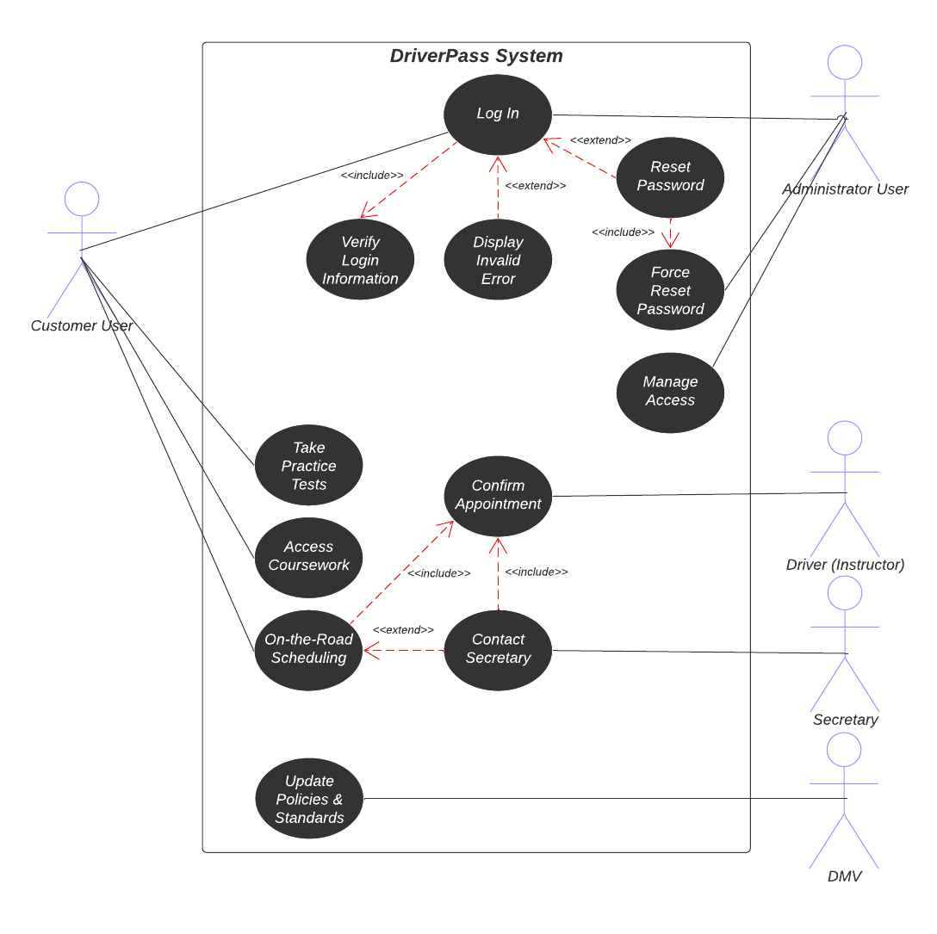

### UML Activity Diagrams

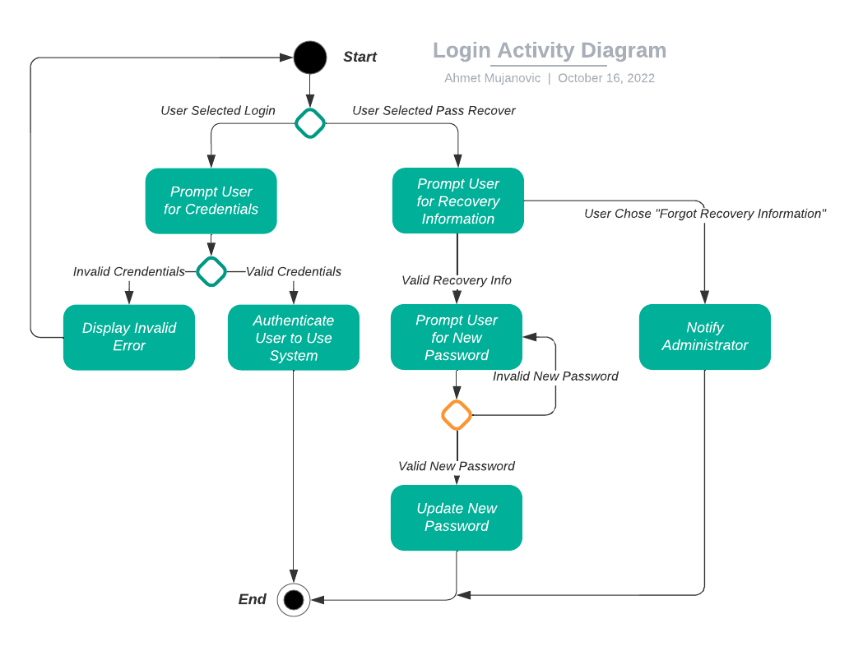

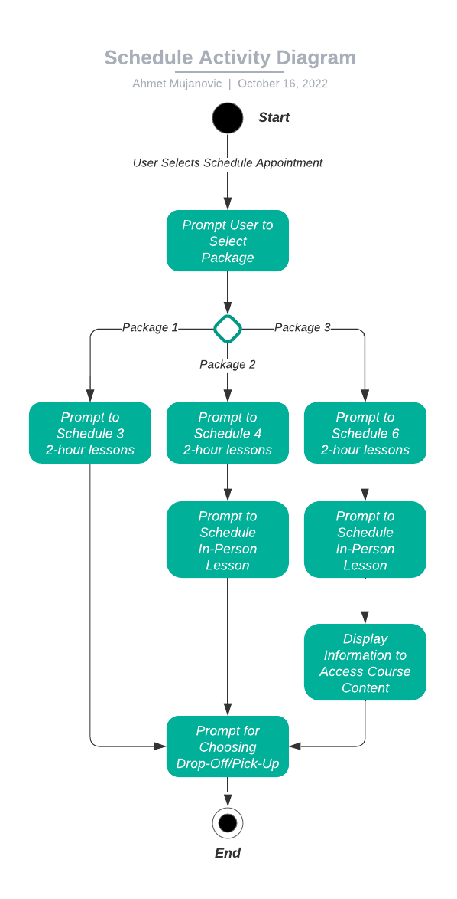

### UML Sequence Diagram

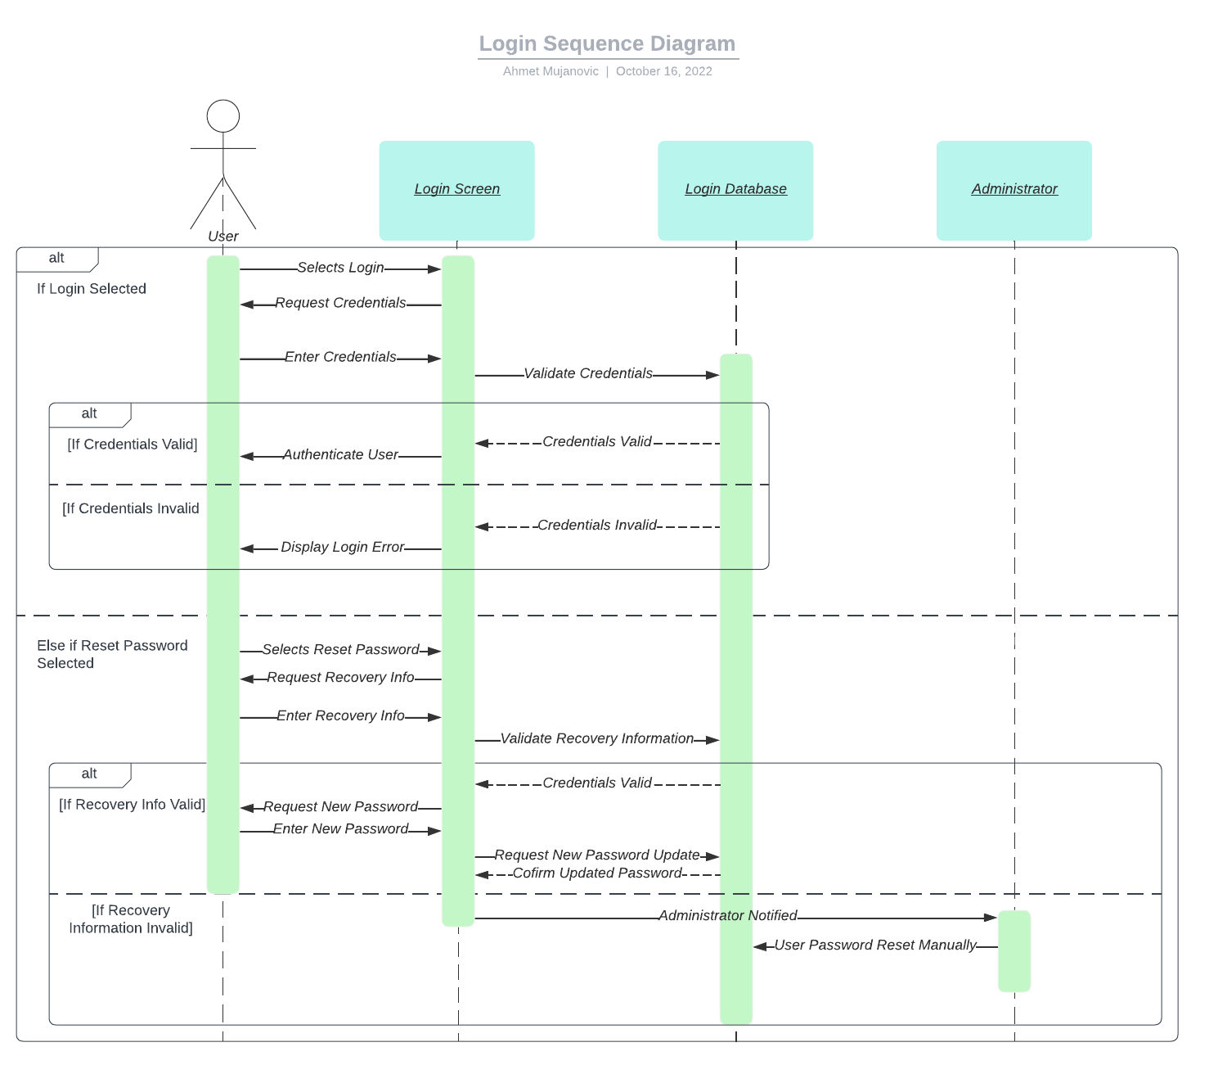

### UML Class Diagram

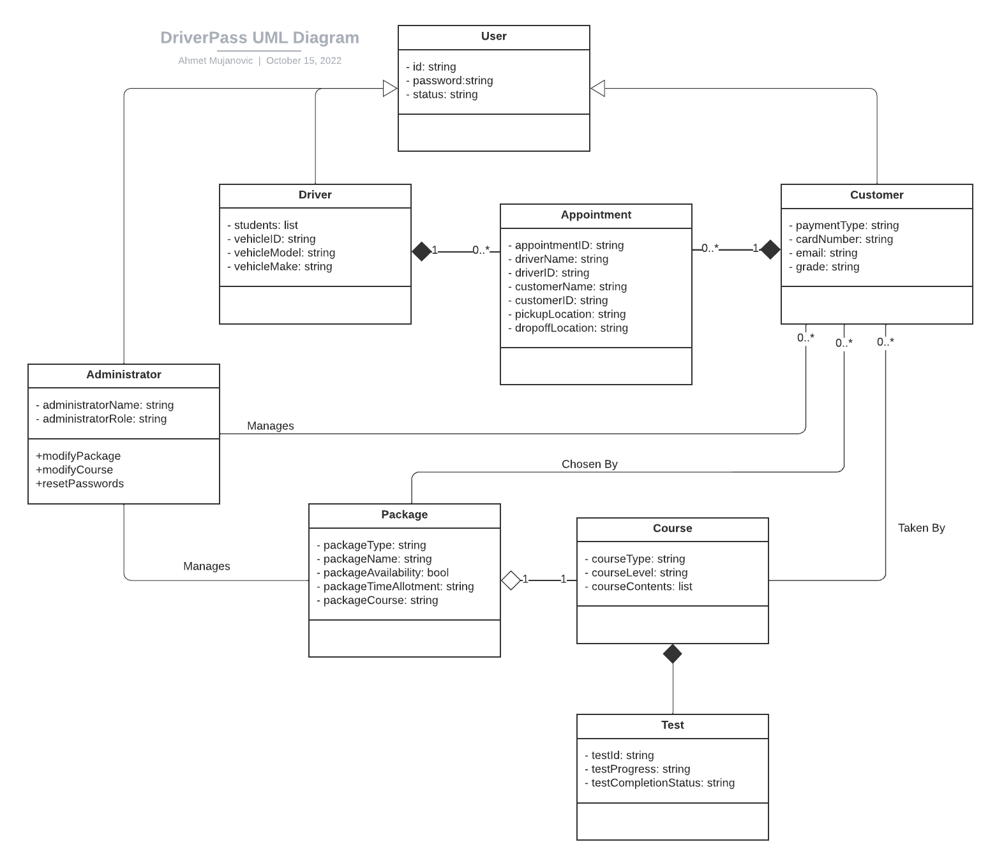

## Technical Requirements

*Hardware*

* *Because the DriverPass system is to be hosted in a cloud-based architecture, the cloud provider is to handle procuring and utilizing the necessary hardware for the system to function. This could include:*
  + *Servers to handle web resources and databases*
    - *Components may include appropriate server grade hardware such as processors to manage load, storage devices, and error-correcting random-access memory*
    - *Potentially a server rack to hold physical hardware*
  + *Proper networking infrastructure like routers and networking cables to host the system and manage incoming connections*
* *GPS devices to manage company vehicles while on the road.*

*Software*

* *Server operating system on each server device to host all appropriate data. Linux is a sensible option due to its open source nature and no propriety hardware requirement.*
* *Database management software to store and manipulate all user data.*
* *An HTTP server application to handle HTTP requests from users.*
* *Scripting languages to support server side scripting development.*
* *Proper security measures such a traffic encryption and password hashing in databases.*

*Location Related*

* *Application needs an API to handle location data for customer drop-off/pick-ups, as well as to manage where drivers are on their routes with the company vehicles.*
* *Servers should be located in appropriate environments conducive to efficient operation such as close to DriverPass area of operations and in temperature controlled rooms.*