**OBJECTIVE**

# Abnam Zaheer

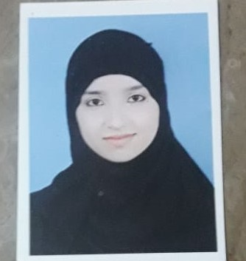+92-03-4570801



[abrishjutt82@gmail.com](mailto:abrishjutt82@gmail.com)

Seeking an entry-level position to begin my career in a high-level professional environment.

# PERSONAL

|  |  |  |
| --- | --- | --- |
| **Name**  **Father Name Religion** | **:**  **:**  **:** | Abnam Zaheer  Zaheer Ahmed  Islam |
| **Marital Status** | **:** | Married |
| **D.O.B** | **:** | 1 June,2000 |
| **Languages**  **Address** | **:-**  **:-** | Urdu, English  Pakki Kotli P/O Box Same Tehsil & District Sialkot |

**ACADEMIC BACKGROUND**

|  |  |  |  |
| --- | --- | --- | --- |
| **Degree** | **Year** | **Division** | **Board/University** |
| Matric | 2016 | 2nd | Board Gujranwala |

# SOFT SKILLS

|  |  |
| --- | --- |
| * Self-Motivated * Communication Skill * Teamwork | * Confident * Flexible * Positive Attitude |

**HOBBIES**

* Self-Learning
* Self-Improvement Study
* Photography

**Experience**

* Teaching at Pakki Kotli School System (1 Year Experience )