**PROJECT**

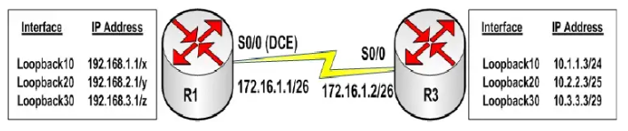

**Task 1:**

 Configure the hostname on R1 and R3 devices as illustrated in the network topology.

**Task 2:**

 Configure the Loopback interfaces on R3 as illustrated in the network topology.

**Task 3:**

 Configure a SINGLE static route on R1 for the three 10.x.x.x subnets on R3. Do NOT use a default route. This route should be as specific as possible. Do NOT use 10.0.0.0/16 as the static route.

**Task 4:**

 Configure the Loopbacks on R1 as follows:

For Loopback10, replace x with a subnet mask that can support 59 hosts

For Loopback20, replace y with a subnet mask that can support 22 hosts

For Loopback30, replace z with a subnet mask that can support 5 host

For Hints follow the following link.

<https://www.academia.edu/9936198/01_CCNA_Labs_with_solutions>