Objectives
Motivated software engineer looking to pursue a successful career in software development at your Company, where I can help in the delivery of state-of-the-art software solutions. Experience includes coding, testing, and consulting for my own personal projects while at University of Sargodha. Relevant skills include MERN Stack, Data Structures, Design Patterns, and OOP.

Experience

Vinoxa, Sargodha
2020-2022
I have sound experience in website frontend development and website re-designing. I used to develop responsive and eye-catching website designs and also I worked as a freelancer in front-end development.

MERN Stack development, FYP
2021-continued
Working to develop a platform to help users to create new websites using minor technical knowledge. We provide many categories and predefined templates with multiple dynamic themes. Users have a separate admin panel to manage his/her website after launching it.

Website Redesigning, fiverr.com
2018-continued
Working as a frontend developer, website re-designer, and MERN Stack developer at fiverr.com. I have earned a good reputation at fiverr.com in my profession. It also helped me to polish my communication skills with foreign clients.

Skills
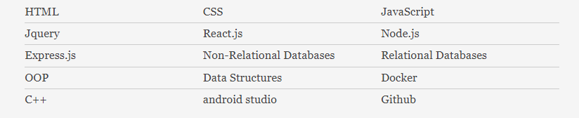

Education

University of Sargodha, Sargodha, Pakistan
Bachelor of Science in Software Engineering
3.6+CGPA

