This is just the simple added test A simple courier service page. The quick brown fox jumps over the lazy daog

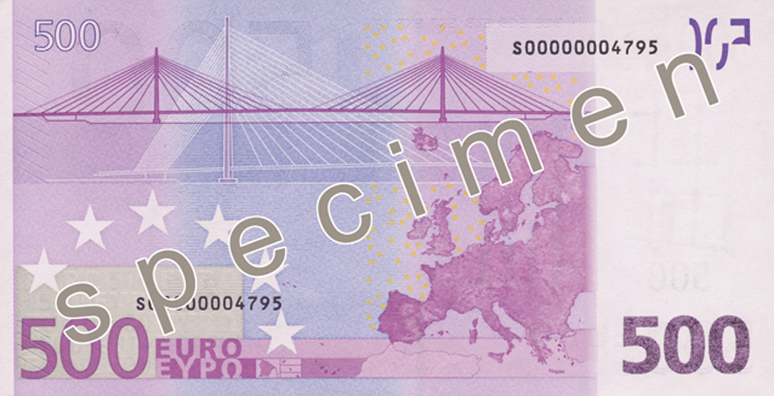

Create a user

remove a user

|  |  |  |  |  |  |  |
| --- | --- | --- | --- | --- | --- | --- |
| First | second | third | fourth | fifth | sixth | eight |
| Sdf | Sf | sfas | ddfs | dsf | sdf | sdf |
| sdf | sfd | sf | sdf | fsd | Sdf sd f | dfsf |

This is the first paragraph

This one is just easing first skill

Testing the other doc file with the source code. first skill

With PHPWord, you can create DOCX, ODT, or RTF documents dynamically using your PHP 5.3+ scripts. Below are some of the things that you can do with PHPWord library:

* Set document properties, e.g. title, subject, and creator.
* Create document sections with different settings, e.g. portrait/landscape, page size, and page numbering
* Create header and footer for each sections
* Set default font type, font size, and paragraph style
* Use UTF-8 and East Asia fonts/characters
* Define custom font styles (e.g. bold, italic, color) and paragraph styles (e.g. centered, multicolumns, spacing) either as named style or inline in text
* Insert paragraphs, either as a simple text or complex one (a text run) that contains other elements
* Insert titles (headers) and table of contents
* Insert text breaks and page breaks
* Insert and format images, either local, remote, or as page watermarks
* Insert binary OLE Objects such as Excel or Visio
* Insert and format table with customized properties for each rows (e.g. repeat as header row) and cells (e.g. background color, rowspan, colspan)
* Insert list items as bulleted, numbered, or multilevel
* Insert hyperlinks
* Insert footnotes and endnotes
* Insert drawing shapes (arc, curve, line, polyline, rect, oval)
* Insert charts (pie, doughnut, bar, line, area, scatter, radar)
* Insert form fields (textinput, checkbox, and dropdown)
* Create document from templates
* Use XSL 1.0 style sheets to transform main document part of OOXML template
* ... and many more features on progress

With PHPWord, you can create DOCX, ODT, or RTF documents dynamically using your PHP 5.3+ scripts. Below are some of the things that you can do with PHPWord library:

* Set document properties, e.g. title, subject, and creator.
* Create document sections with different settings, e.g. portrait/landscape, page size, and page numbering
* Create header and footer for each sections
* Set default font type, font size, and paragraph style
* Use UTF-8 and East Asia fonts/characters
* Define custom font styles (e.g. bold, italic, color) and paragraph styles (e.g. centered, multicolumns, spacing) either as named style or inline in text
* Insert paragraphs, either as a simple text or complex one (a text run) that contains other elements
* Insert titles (headers) and table of contents
* Insert text breaks and page breaks
* Insert and format images, either local, remote, or as page watermarks
* Insert binary OLE Objects such as Excel or Visio
* Insert and format table with customized properties for each rows (e.g. repeat as header row) and cells (e.g. background color, rowspan, colspan)
* Insert list items as bulleted, numbered, or multilevel
* Insert hyperlinks
* Insert footnotes and endnotes
* Insert drawing shapes (arc, curve, line, polyline, rect, oval)
* Insert charts (pie, doughnut, bar, line, area, scatter, radar)
* Insert form fields (textinput, checkbox, and dropdown)
* Create document from templates
* Use XSL 1.0 style sheets to transform main document part of OOXML template
* ... and many more features on progress

With PHPWord, you can create DOCX, ODT, or RTF documents dynamically using your PHP 5.3+ scripts. Below are some of the things that you can do with PHPWord library:

* Set document properties, e.g. title, subject, and creator.
* Create document sections with different settings, e.g. portrait/landscape, page size, and page numbering
* Create header and footer for each sections
* Set default font type, font size, and paragraph style
* Use UTF-8 and East Asia fonts/characters
* Define custom font styles (e.g. bold, italic, color) and paragraph styles (e.g. centered, multicolumns, spacing) either as named style or inline in text
* Insert paragraphs, either as a simple text or complex one (a text run) that contains other elements
* Insert titles (headers) and table of contents
* Insert text breaks and page breaks
* Insert and format images, either local, remote, or as page watermarks
* Insert binary OLE Objects such as Excel or Visio
* Insert and format table with customized properties for each rows (e.g. repeat as header row) and cells (e.g. background color, rowspan, colspan)
* Insert list items as bulleted, numbered, or multilevel
* Insert hyperlinks
* Insert footnotes and endnotes
* Insert drawing shapes (arc, curve, line, polyline, rect, oval)
* Insert charts (pie, doughnut, bar, line, area, scatter, radar)
* Insert form fields (textinput, checkbox, and dropdown)
* Create document from templates
* Use XSL 1.0 style sheets to transform main document part of OOXML template
* ... and many more features on progress

With PHPWord, you can create DOCX, ODT, or RTF documents dynamically using your PHP 5.3+ scripts. Below are some of the things that you can do with PHPWord library:

* Set document properties, e.g. title, subject, and creator.
* Create document sections with different settings, e.g. portrait/landscape, page size, and page numbering
* Create header and footer for each sections
* Set default font type, font size, and paragraph style
* Use UTF-8 and East Asia fonts/characters
* Define custom font styles (e.g. bold, italic, color) and paragraph styles (e.g. centered, multicolumns, spacing) either as named style or inline in text
* Insert paragraphs, either as a simple text or complex one (a text run) that contains other elements
* Insert titles (headers) and table of contents
* Insert text breaks and page breaks
* Insert and format images, either local, remote, or as page watermarks
* Insert binary OLE Objects such as Excel or Visio
* Insert and format table with customized properties for each rows (e.g. repeat as header row) and cells (e.g. background color, rowspan, colspan)
* Insert list items as bulleted, numbered, or multilevel
* Insert hyperlinks
* Insert footnotes and endnotes
* Insert drawing shapes (arc, curve, line, polyline, rect, oval)
* Insert charts (pie, doughnut, bar, line, area, scatter, radar)
* Insert form fields (textinput, checkbox, and dropdown)
* Create document from templates
* Use XSL 1.0 style sheets to transform main document part of OOXML template
* ... and many more features on progress

With PHPWord, you can create DOCX, ODT, or RTF documents dynamically using your PHP 5.3+ scripts. Below are some of the things that you can do with PHPWord library:

* Set document properties, e.g. title, subject, and creator.
* Create document sections with different settings, e.g. portrait/landscape, page size, and page numbering
* Create header and footer for each sections
* Set default font type, font size, and paragraph style
* Use UTF-8 and East Asia fonts/characters
* Define custom font styles (e.g. bold, italic, color) and paragraph styles (e.g. centered, multicolumns, spacing) either as named style or inline in text
* Insert paragraphs, either as a simple text or complex one (a text run) that contains other elements
* Insert titles (headers) and table of contents
* Insert text breaks and page breaks
* Insert and format images, either local, remote, or as page watermarks
* Insert binary OLE Objects such as Excel or Visio
* Insert and format table with customized properties for each rows (e.g. repeat as header row) and cells (e.g. background color, rowspan, colspan)
* Insert list items as bulleted, numbered, or multilevel
* Insert hyperlinks
* Insert footnotes and endnotes
* Insert drawing shapes (arc, curve, line, polyline, rect, oval)
* Insert charts (pie, doughnut, bar, line, area, scatter, radar)
* Insert form fields (textinput, checkbox, and dropdown)
* Create document from templates
* Use XSL 1.0 style sheets to transform main document part of OOXML template
* ... and many more features on progress