# CE_SALES

Checking candidate rows:

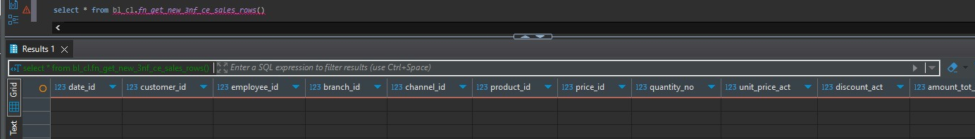

This query returns **zero rows**, it means that all sales records from source tableshave already been loaded into the target table. After calling the loader twice and checking the log we get:

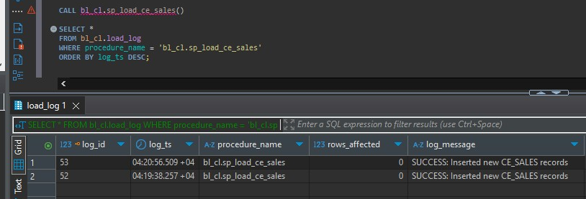

And this confirsm that there were no new rows to be inserted from the beginning.

DIM_SALES

Checking insertable rows:

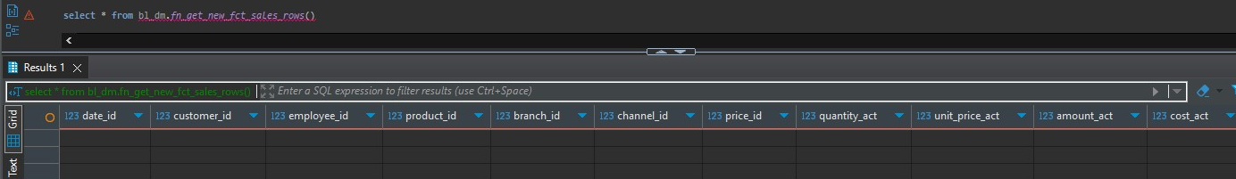

We get that there are no rows to be inserted even tho there is no data inside the fct_sales. I think there is smething wrong with my deduplication logic and I couldn’t find the solution for a whole day, so I decided to upload whatever I did and I will correct it tomorrow.

There is no need to call the function because we will get 0 rows inserted.