Contents

Museum Database – Business Document 1

1. Purpose 1

2. Database Name 1

3. logical schema 2

4. Description of the tables 2

Table: storage 2

Table: item 3

Table: exhibition 4

Table: item_exhibition 4

Table: employee 5

Table: visitor 6

Table: item_storage 6

Table: visitor_transaction 7

# Museum Database – Business Document

## 1. Purpose

This document outlines the logical structure and business purpose of the Museum Database, designed for managing museum operations including artifact management, exhibitions, visitor tracking, and storage logistics.

## 2. Database Name

Database: museum_db

Schema: museum_schema

## 3. logical schema

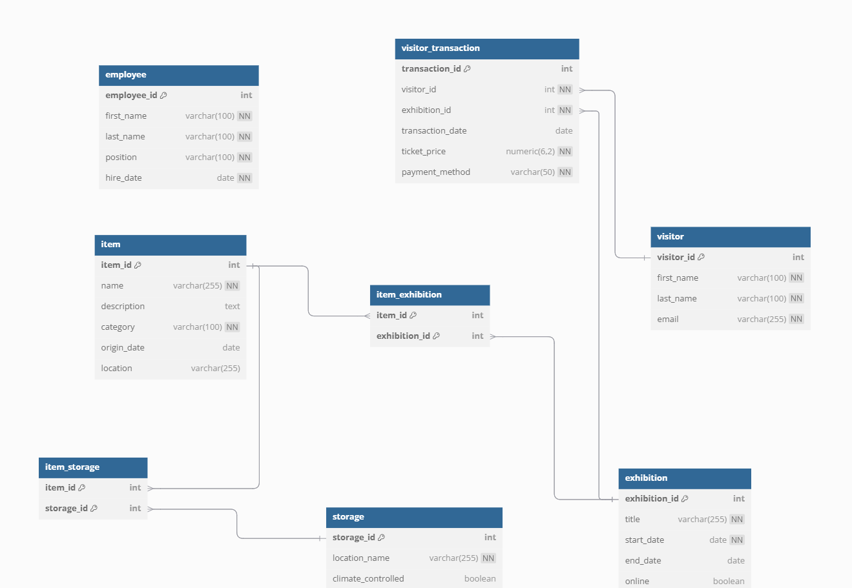

## 4. Description of the tables

## Table: storage

Purpose: Stores information about physical storage locations for museum items.

|  |  |  |
| --- | --- | --- |
| **Column Name** | **Data Type** | **Constraint** |
| storage_id | SERIAL | PRIMARY KEY |
| location_name | VARCHAR(255) | NOT NULL |
| climate_controlled | BOOLEAN | DEFAULT FALSE |

Sample Data:

|  |  |  |
| --- | --- | --- |
| **storage_id** | **location_name** | **climate_controlled** |
| 1 | Tbilisi Central Storage | TRUE |
| 2 | Batumi Warehouse | FALSE |

Relations: One-to-Many: Linked with item_storage.

## Table: item

Purpose: Represents museum artifacts, artworks, historical objects, and specimens.

|  |  |  |
| --- | --- | --- |
| **Column Name** | **Data Type** | **Constraint** |
| item_id | SERIAL | PRIMARY KEY |
| name | VARCHAR(255) | NOT NULL |
| description | TEXT | NULLABLE |
| category | VARCHAR(100) | NOT NULL |
| origin_date | DATE | CHECK (origin_date > '1000-01-01') |
| location | VARCHAR(255) | DEFAULT 'Unknown' |

Sample Data:

|  |  |  |  |  |  |
| --- | --- | --- | --- | --- | --- |
| **item_id** | **name** | **description** | **category** | **origin_date** | **location** |
| 1 | Kvevri Wine Vessel | Ancient Georgian wine vessel | Artifact | 1700-01-01 | Tbilisi Central Storage |
| 2 | Medieval Icon of St. George | Religious artwork | Artwork | 1450-01-01 | Batumi Warehouse |

Relations: Many-to-Many: Linked with exhibition via item_exhibition. Many-to-Many: Linked with storage via item_storage.

## Table: exhibition

Purpose: Information about museum exhibitions.

|  |  |  |
| --- | --- | --- |
| **Column Name** | **Data Type** | **Constraint** |
| exhibition_id | SERIAL | PRIMARY KEY |
| title | VARCHAR(255) | NOT NULL |
| start_date | DATE | NOT NULL |
| end_date | DATE | CHECK (end_date > start_date) |
| online | BOOLEAN | DEFAULT FALSE |

Sample Data:

|  |  |  |  |  |
| --- | --- | --- | --- | --- |
| **exhibition_id** | **title** | **start_date** | **end_date** | **online** |
| 1 | Treasures of Ancient Colchis | 2025-01-15 | 2025-04-15 | FALSE |
| 2 | Virtual Tour of Georgian Art | 2025-02-01 | 2025-05-01 | TRUE |

Relations: Many-to-Many: Linked with item via item_exhibition. One-to-Many: Linked with visitor_transaction.

## Table: item_exhibition

Purpose: Associates items with exhibitions.

|  |  |  |
| --- | --- | --- |
| **Column Name** | **Data Type** | **Constraint** |
| item_exhibition_id | SERIAL | PRIMARY KEY |
| item_id | INTEGER | FOREIGN KEY -> item(item_id) |
| exhibition_id | INTEGER | FOREIGN KEY -> exhibition(exhibition_id) |

Sample Data:

|  |  |  |
| --- | --- | --- |
| **item_exhibition_id** | **item_id** | **exhibition_id** |
| 1 | 1 | 1 |
| 2 | 2 | 2 |

Relations: Many-to-One: Links item and exhibition.

## Table: employee

Purpose: Tracks museum employees and their roles.

|  |  |  |
| --- | --- | --- |
| **Column Name** | **Data Type** | **Constraint** |
| employee_id | SERIAL | PRIMARY KEY |
| first_name | VARCHAR(100) | NOT NULL |
| last_name | VARCHAR(100) | NOT NULL |
| position | VARCHAR(100) | NOT NULL |
| hire_date | DATE | CHECK (hire_date > '2000-01-01') |

Sample Data:

|  |  |  |  |  |
| --- | --- | --- | --- | --- |
| **employee_id** | **first_name** | **last_name** | **position** | **hire_date** |
| 1 | Nino | Beridze | Curator | 2023-06-01 |
| 2 | Giorgi | Melikishvili | Archivist | 2024-02-15 |

Relations: No direct foreign key relations but useful for organizational structure.

## Table: visitor

Purpose: Registers museum visitors.

|  |  |  |
| --- | --- | --- |
| **Column Name** | **Data Type** | **Constraint** |
| visitor_id | SERIAL | PRIMARY KEY |
| first_name | VARCHAR(100) | NOT NULL |
| last_name | VARCHAR(100) | NOT NULL |
| email | VARCHAR(255) | UNIQUE NOT NULL |

Sample Data:

|  |  |  |  |
| --- | --- | --- | --- |
| **visitor_id** | **first_name** | **last_name** | **email** |
| 1 | Ana | Tsereteli | ana.tsereteli@example.ge |
| 2 | Nikoloz | Shvelidze | nikoloz.shvelidze@example.ge |

Relations: One-to-Many: Linked with visitor_transaction.

## Table: item_storage

Purpose: Tracks storage history of items.

|  |  |  |
| --- | --- | --- |
| **Column Name** | **Data Type** | **Constraint** |
| item_storage_id | SERIAL | PRIMARY KEY |
| item_id | INTEGER | FOREIGN KEY -> item(item_id) |
| storage_id | INTEGER | FOREIGN KEY -> storage(storage_id) |

Sample Data:

|  |  |  |
| --- | --- | --- |
| **item_storage_id** | **item_id** | **storage_id** |
| 1 | 1 | 1 |
| 2 | 2 | 2 |

Relations: Many-to-One: Links item and storage.

## Table: visitor_transaction

Purpose: Records visitor ticket purchases.

|  |  |  |
| --- | --- | --- |
| **Column Name** | **Data Type** | **Constraint** |
| transaction_id | SERIAL | PRIMARY KEY |
| visitor_id | INTEGER | FOREIGN KEY -> visitor(visitor_id) |
| exhibition_id | INTEGER | FOREIGN KEY -> exhibition(exhibition_id) |
| transaction_date | DATE | DEFAULT CURRENT_DATE |
| ticket_price | NUMERIC(10,2) | CHECK (ticket_price >= 0) |
| payment_method | VARCHAR(50) | CHECK (payment_method IN ('Cash', 'Credit Card', 'Online')) |

Sample Data:

|  |  |  |  |  |  |
| --- | --- | --- | --- | --- | --- |
| **transaction_id** | **visitor_id** | **exhibition_id** | **transaction_date** | **ticket_price** | **payment_method** |
| 1 | 1 | 1 | 2025-02-05 | 15.00 | Credit Card |
| 2 | 2 | 2 | 2025-03-10 | 12.00 | Cash |

Relations: Many-to-One: Links visitor and exhibition.