CE_SALES
Checking candidate rows:
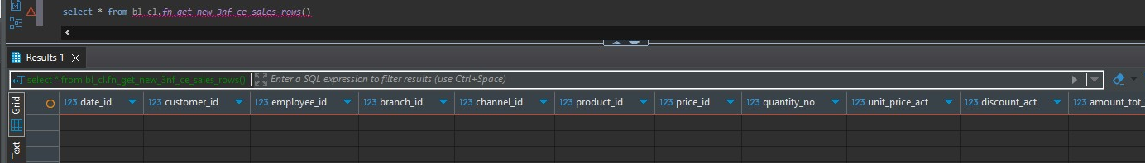
This query returns zero rows, it means that all sales records from source tableshave already been loaded into the target table. After calling the loader twice and checking the log we get:
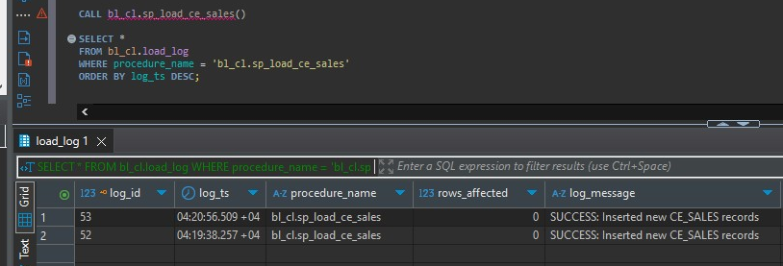
And this confirsm that there were no new rows to be inserted from the beginning.

DIM_SALES
Checking insertable rows:
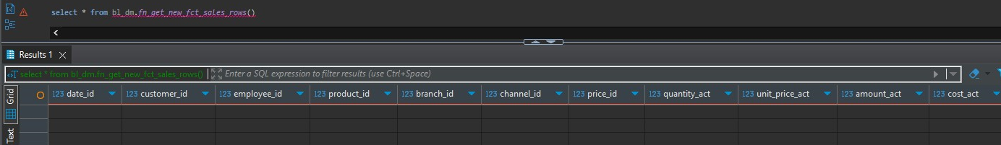
We get that there are no rows to be inserted even tho there is no data inside the fct_sales. I think there is smething wrong with my deduplication logic and I couldn’t find the solution for a whole day, so I decided to upload whatever I did and I will correct it tomorrow.
There is no need to call the function because we will get 0 rows inserted.

