1. CREATING SIMPLE DAX EXPRESSIONS

1.1 CALCULATED COLUMN

YearMonthLabel = FORMAT(DimDate[FullDateAlternateKey], "yyyy - MMM")

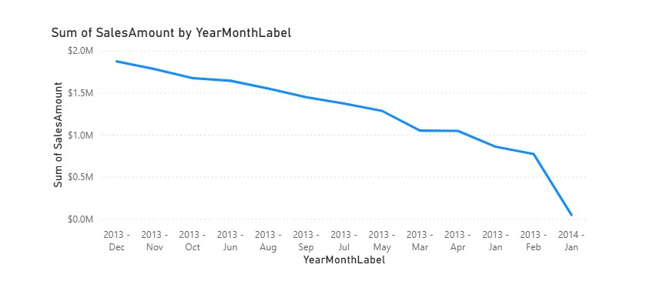

1.2 MEASURE

(1-5)
Today Date = TODAY()
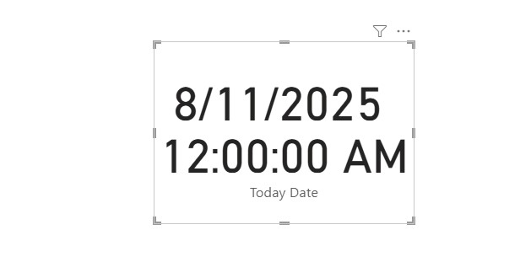
After changing to short date:
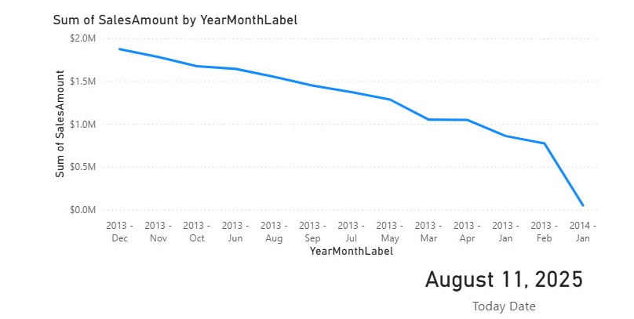

(6-9)
OrderQuantity = SUM ( FactInternetSales[OrderQuantity] )
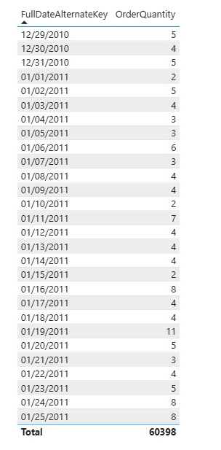

OrderQuantityYTD =
CALCULATE (
[OrderQuantity],
DATESYTD ( DimDate[FullDateAlternateKey].[DATE] )
)

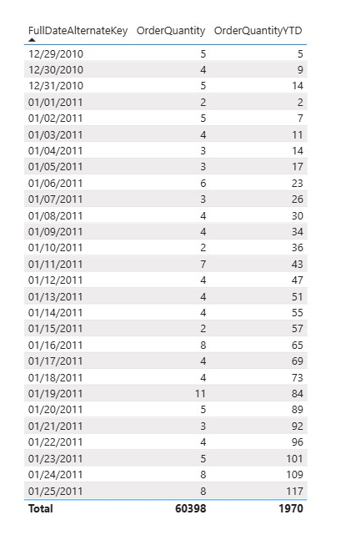

2. LAB REPORT

1) Add ONE line chart that displays both Order Quantity YTD line and Order Quantity YTD for Previous Year. Create measures for these calculations using DAX.

2) Add the same chart for Sales Amount.

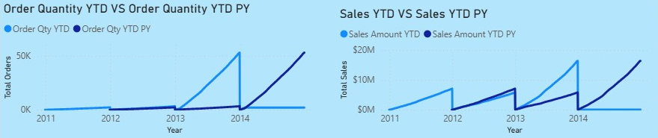

Order Quantity:
Order Qty = SUM(FactInternetSales[OrderQuantity])
Order Qty YTD =
CALCULATE (
[Order Qty],
DATESYTD ( DimDate[FullDateAlternateKey].[DATE] )
)
Order Qty YTD PY =
CALCULATE (
[Order Qty],
DATESYTD ( DATEADD ( DimDate[FullDateAlternateKey].[Date], -1, YEAR ) )
)

Sales Amount:
Sales Amount =
SUM ( FactInternetSales[SalesAmount] )
Sales Amount YTD =
CALCULATE (
[Sales Amount],
DATESYTD ( DimDate[FullDateAlternateKey].[Date] )
)
Sales Amount YTD PY =
CALCULATE (
[Sales Amount],
DATESYTD ( DATEADD ( DimDate[FullDateAlternateKey].[Date], -1, YEAR ) )
)

3) On top of the report display current username and current date in the format:
Welcome, [Current User]
Current Date is: [Current Date]

Welcome Text = "Welcome, " & USERPRINCIPALNAME()
Current Date Text = "Current Date is: " & FORMAT(TODAY(), "dd MMM yyyy")
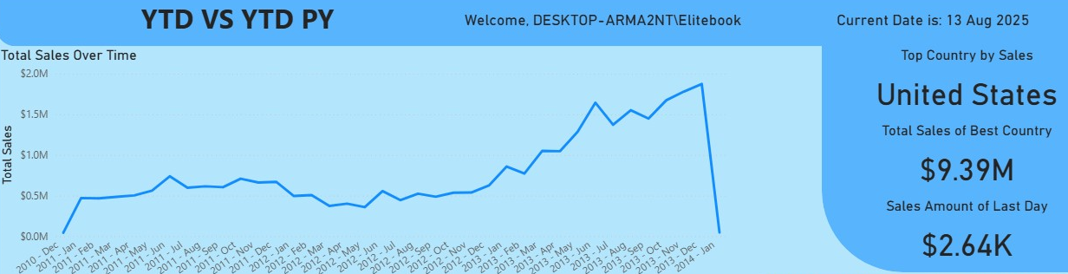

4) Add a table that shows Year-Month label that was created during lab work, Product Name, Color, Order Quantity and % of total Order quantity by Year Month Label and Color (see the screenshot below).

Order Qty % of Total =
DIVIDE(
[Order Qty],
CALCULATE( [Order Qty], ALL( DimProduct[EnglishProductName] ) )
)

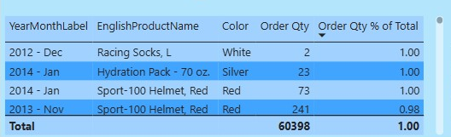

5) Create a DAX measure and use it in a chart that always shows Sales Amount for maximum OrderDate available. In Word file, explain why you chose this method of displaying information.

For this visual, I chose a simple card, because as the date changes, it will show what we are looking for directly without any extra effort.



6) Create a DAX measure that shows the country with the highest sales in all years and display the result with a visual. In Word file, explain why you chose this method of displaying information.

Once again I chose two cards and placed them near each other to display the value clearly.

Top Country by Sales (Name) =
VAR T =
TOPN(
1,
SUMMARIZE(
ALL ( DimSalesTerritory[SalesTerritoryCountry] ),
DimSalesTerritory[SalesTerritoryCountry],
"Amt", CALCULATE ( [Sales Amount], ALL ( DimDate ) )
),
[Amt], DESC,
DimSalesTerritory[SalesTerritoryCountry], ASC
)
RETURN
CONCATENATEX( T, DimSalesTerritory[SalesTerritoryCountry], ", " )

Top Country by Sales (Amount) =
VAR T =
ADDCOLUMNS(
ALL ( DimSalesTerritory[SalesTerritoryCountry] ),
"Amt", CALCULATE ( [Sales Amount], ALL ( DimDate ) )
)
RETURN MAXX( TOPN(1, T, [Amt], DESC), [Amt] )

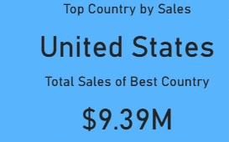

7) Use DAX to calculate the ranks of ProductCategory by Sales Amount. In Word file, explain why you chose this particular way to get the result.
Rank Category by Sales =
RANKX(
ALL ( DimProductCategory[EnglishProductCategoryName] ),
CALCULATE ( [Sales Amount], ALL ( DimDate ) ),
,
DESC,
DENSE
)

RANKX compares each category against all categories (we remove the category filter) using total sales (ignoring date filters). DENSE gives 1,2,3… without gaps. I also filtered the values to not include Blank category and used a simple table to show ranks directly.
