Task 2.1

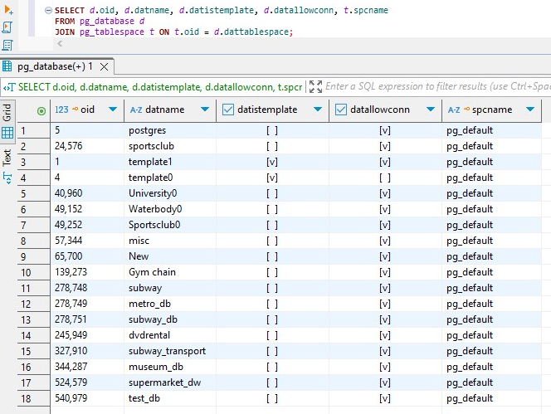
This query showed all 18 databases currently present in your PostgreSQL instance and that all of them are using the default tablespace (pg_default), including the newly created one: test_db. The [v] in datallowconn shows all these databases are open for connections. Some databases (like template1, template0, University0, etc.) have [v] in datistemplate, meaning they can be used as a source template when creating new databases.

Task 2.2
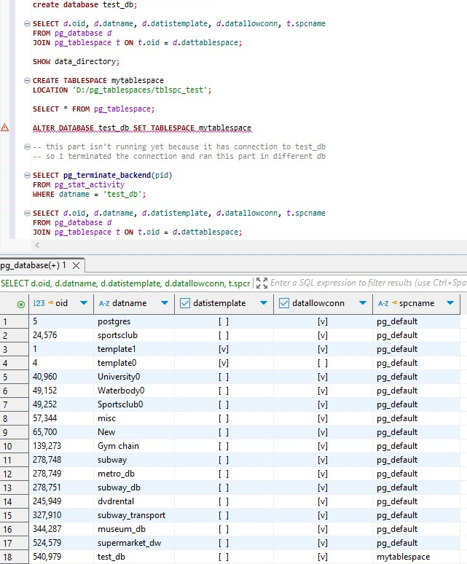

Task 3.1
Before running queries:
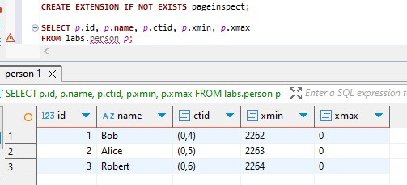
This shows each row's:
ctid: physical tuple location (like (page, row))
xmin: transaction that created the row
xmax: transaction that deleted the row
At this point, all visible rows are active, meaning:
xmax = 0 (not deleted), xmin reflects the transaction ID that inserted them (2262, 2263, 2264)
At first I inserted rows by calling the schema and table and I deleted it with 2261st transaction.
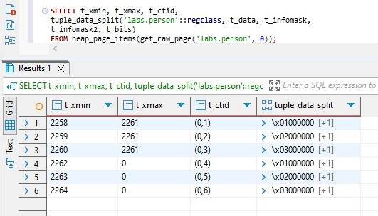
1)After running
INSERT INTO labs.person VALUES (4, 'John');
PostgreSQL appends a new tuple to the labs.person heap file.
The new row has: fresh ctid, xmin = 2265, xmax = 0. Now the row is visible to all future transactions.

2) After running
UPDATE labs.person SET name = 'Alex' WHERE id = 2;
UPDATE is implemented as DELETE + INSERT. Old version (id=2, name='Alice') is marked with:
xmin = 2263 and xmax = 2266 as the previous row was deleted by 2266th transaction.
New version (id=2, name='Alex') is created with: new ctid (e.g., (0,6)) xmin = 2266, xmax = 0

3) After running
DELETE FROM labs.person WHERE id = 3;
In this process third row where xmin = 2264 is deleted to xmax is updated to 2267 and we have new live row.

4) After running
INSERT INTO labs.person VALUES (999, 'Test');
DELETE FROM labs.person WHERE id = 999;

PostgreSQL creates a tuple with:
xmin = 2269 xmax = 2269.
The row is created and deleted in the same transaction. As a result, this tuple is never visible to any other transaction — not even the one that reads committed data after commit.

After running all of them we get this result:
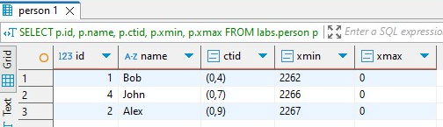
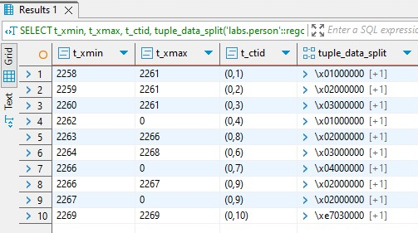

Task 3.2
1) After vacuum:
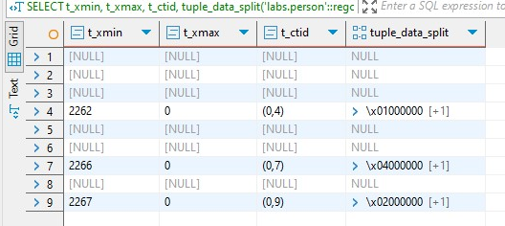
PostgreSQL marks dead tuples as reusable, but does not physically remove them or shrink the table file. It only updates visibility maps and frees up dead space for reuse in future inserts. Because of this, dead rows still appear in heap_page_items(...) inspection. PostgreSQL can now reuse space occupied by dead tuples in future writes.

2) After insertion:
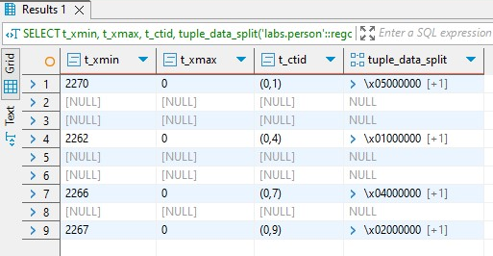
PostgreSQL checks the free space from the visibility map. If there is a slot where a dead tuple (like id = 3 or 999) was stored, it will reuse that same physical location (ctid) for the new row. Because of it new row gets the ctid of a previously deleted one.

3) After vacuum full:
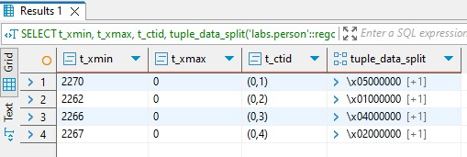
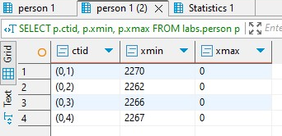
VACUUM FULL performs a full table rewrite, copies all live rows to a new physical file, deletes the old file with dead/obsolete rows. CTIDs of all rows are changed (because their physical positions change) and disk space is actually reclaimed (file size shrinks)After all, all dead tuples are gone. Inspection with heap_page_items shows only four live rows.

