- AWS Lambda service
Create your first Lambda and show how you will parse test JSON using Response or Function logs. The name mask of Lambda should be <your_name_surname>_<anything_else>. Example of the result:

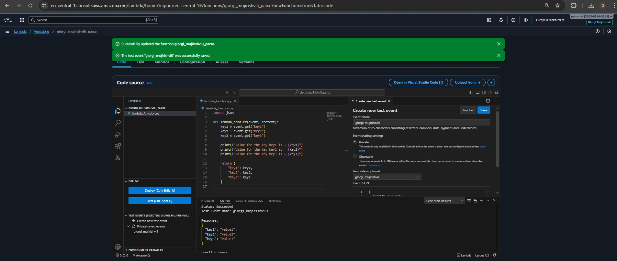

https://eu-central-1.console.aws.amazon.com/lambda/home?region=eu-central-1#/functions/giorgi_mujirishvili_parse?tab=code

- AWS Step Function service
Note: To connect to Redshift, please assign to Lambda a Layer, VPC, subnets, and security group. You can find respective names in the Lambda function epam-aleh-shylin-test-lambda.
  - Create a Step Function that will have the following steps:
    - Perform the first test for the table from Redshift using AWS Lambda.
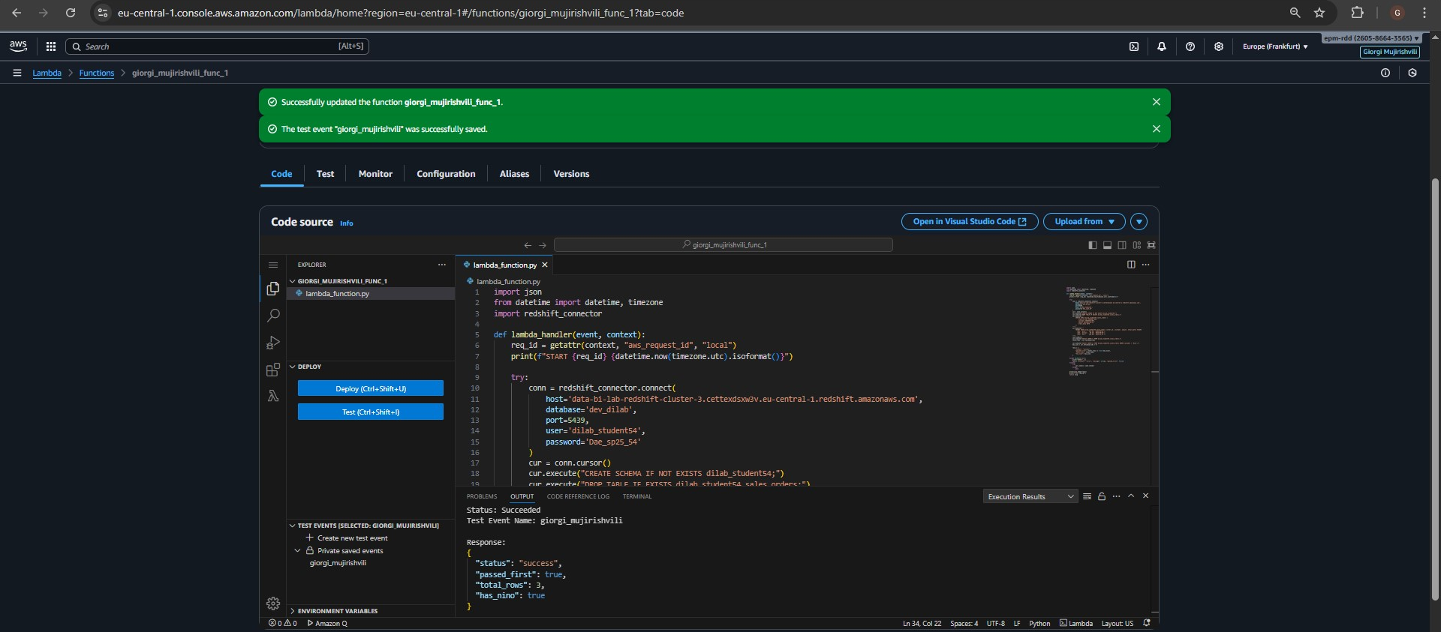
https://eu-central-1.console.aws.amazon.com/lambda/home?region=eu-central-1#/functions/giorgi_mujirishvili_func_1?tab=code

    - Change data in the Redshift table using AWS Lambda.
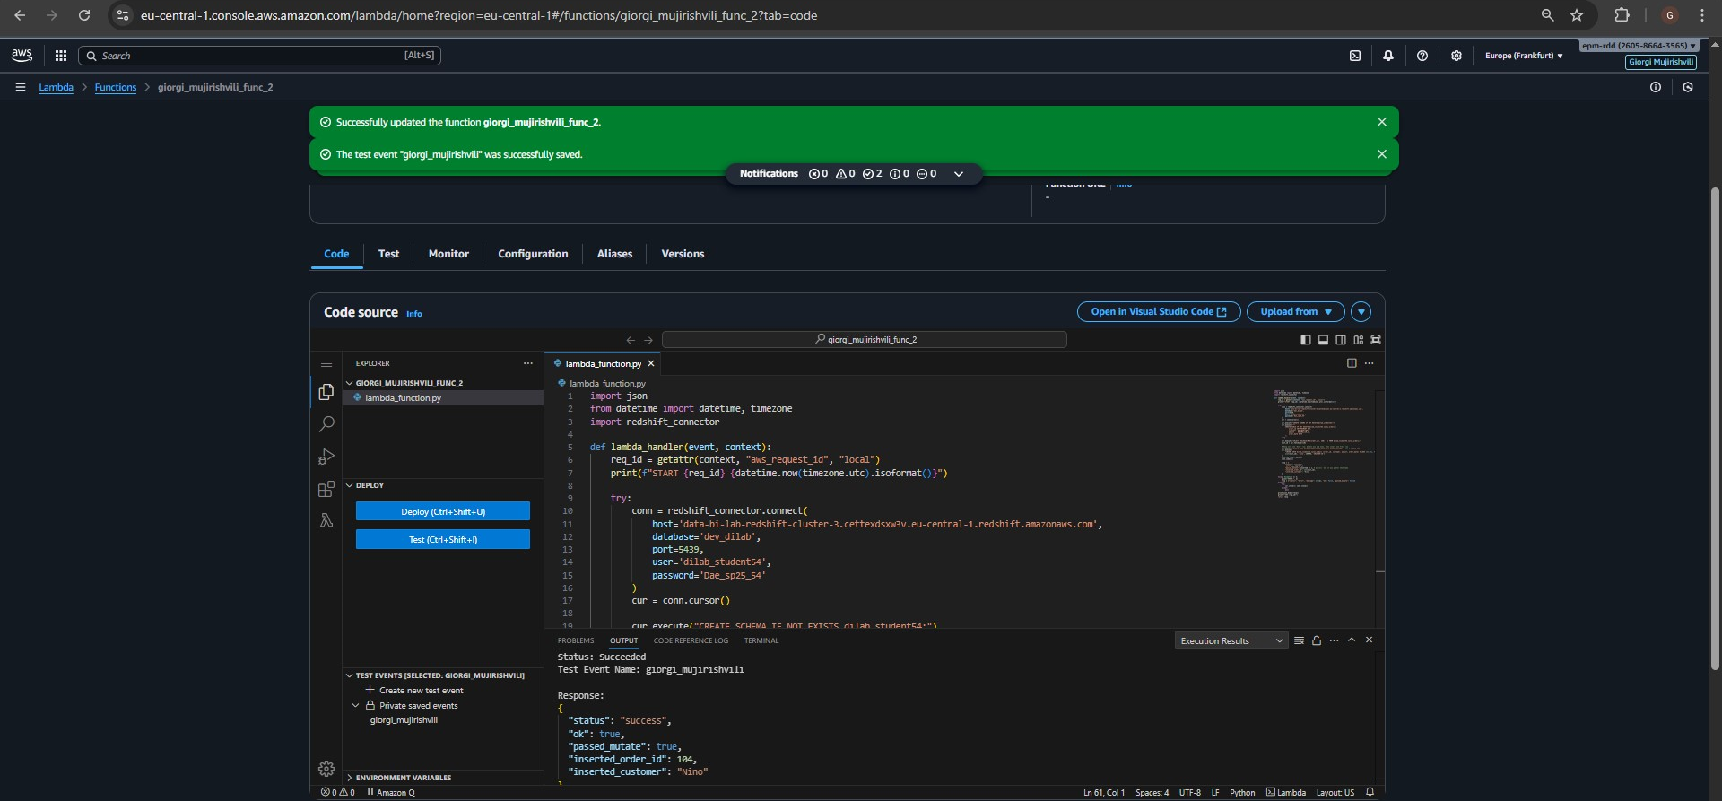
https://eu-central-1.console.aws.amazon.com/lambda/home?region=eu-central-1#/functions/giorgi_mujirishvili_func_2?tab=code
    - Perform a second test for the same table from Redshift using AWS Lambda
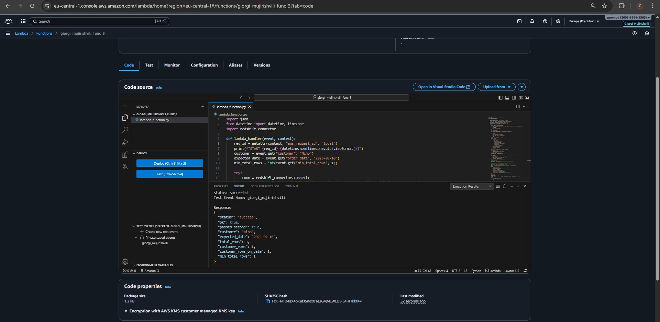
https://eu-central-1.console.aws.amazon.com/lambda/home?region=eu-central-1#/functions/giorgi_mujirishvili_func_3?tab=code

    - If the first and third steps are passed then Step Function completes successfully, otherwise – Step Function fails.

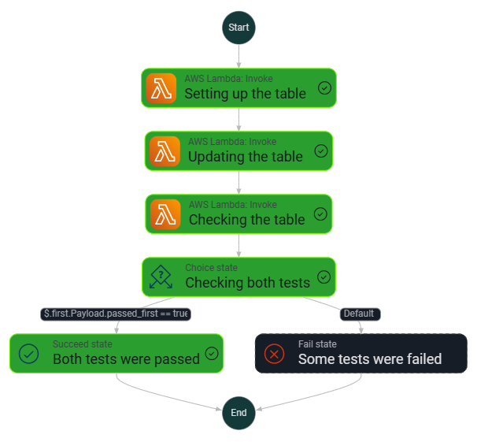
https://eu-central-1.console.aws.amazon.com/states/home?region=eu-central-1#/v2/statemachines/edit/arn%3Aaws%3Astates%3Aeu-central-1%3A260586643565%3AstateMachine%3Agiorgi_mujirishvili?referrerPage=WorkflowStudioCreate

The code for it:
{
"Comment": "First test -> Change -> Second test -> Check both ",
"StartAt": "Setting up the table",
"States": {
"Setting up the table": {
"Type": "Task",
"Resource": "arn:aws:states:::lambda:invoke",
"Parameters": {
"FunctionName": "arn:aws:lambda:eu-central-1:260586643565:function:giorgi_mujirishvili_func_1:$LATEST",
"Payload.$": "$"
},
"ResultPath": "$.first",
"Retry": [
{
"ErrorEquals": [
"Lambda.ServiceException",
"Lambda.AWSLambdaException",
"Lambda.SdkClientException"
],
"IntervalSeconds": 2,
"MaxAttempts": 2,
"BackoffRate": 2
}
],
"Next": "Updating the table"
},
"Updating the table": {
"Type": "Task",
"Resource": "arn:aws:states:::lambda:invoke",
"Parameters": {
"FunctionName": "arn:aws:lambda:eu-central-1:260586643565:function:giorgi_mujirishvili_func_2:$LATEST",
"Payload.$": "$"
},
"ResultPath": "$.change",
"Retry": [
{
"ErrorEquals": [
"Lambda.ServiceException",
"Lambda.AWSLambdaException",
"Lambda.SdkClientException"
],
"IntervalSeconds": 2,
"MaxAttempts": 2,
"BackoffRate": 2
}
],
"Next": "Checking the table"
},
"Checking the table": {
"Type": "Task",
"Resource": "arn:aws:states:::lambda:invoke",
"Parameters": {
"FunctionName": "arn:aws:lambda:eu-central-1:260586643565:function:giorgi_mujirishvili_func_3:$LATEST",
"Payload.$": "$"
},
"ResultPath": "$.second",
"Retry": [
{
"ErrorEquals": [
"Lambda.ServiceException",
"Lambda.AWSLambdaException",
"Lambda.SdkClientException"
],
"IntervalSeconds": 2,
"MaxAttempts": 2,
"BackoffRate": 2
}
],
"Next": "Checking both tests"
},
"Checking both tests": {
"Type": "Choice",
"Choices": [
{
"And": [
{
"Variable": "$.first.Payload.passed_first",
"BooleanEquals": true
},
{
"Variable": "$.second.Payload.ok",
"BooleanEquals": true
}
],
"Next": "Both tests were passed"
}
],
"Default": "Some tests were failed"
},
"Both tests were passed": {
"Type": "Succeed"
},
"Some tests were failed": {
"Type": "Fail",
"Error": "ValidationFailed",
"Cause": "One or both Redshift tests did not pass"
}
}
}

