TASKS

CREATING THE REPORT

1. Login to Redshift. The EPAM VPN should be enabled. The public access to cluster is disabled, therefore you can use SSH tunnel to establish connection. Use the EC2 machine from HW2 or launch the new one. Perform the steps below:

1.1 Update packages On any Linux before installing packages, a user should run a system update command that will ensure all the latest available updates are installed on the system. Plus, this will also refresh the DNF package cache. So, get access to your terminal or connect to your Amazon Linux instance via SSH and run the following command: sudo dnf update

1.2 Install PostgreSQL 15 on Amazon Linux 2023: Well, the best thing currently you don’t need to add any repository to get the PostgreSQL version 15 on your Amazon Linux 2023 because it is available through its system default repo. So, what you have to do is just run the given command. It will install both the client and server parts of the PostgreSQL Database system on your Linux: sudo dnf install postgresql15.x86_64 postgresql15-server

1.3 Initialize the PostgreSQL Database: sudo postgresql-setup –initdb

1.4 Start and Enable Service: sudo systemctl start postgresql sudo systemctl enable postgresql

I skipped all these parts because I have installed the postgres 17 in the previous homework.

1.5 To confirm the service is running without any errors, here is the command to follow:

sudo systemctl st
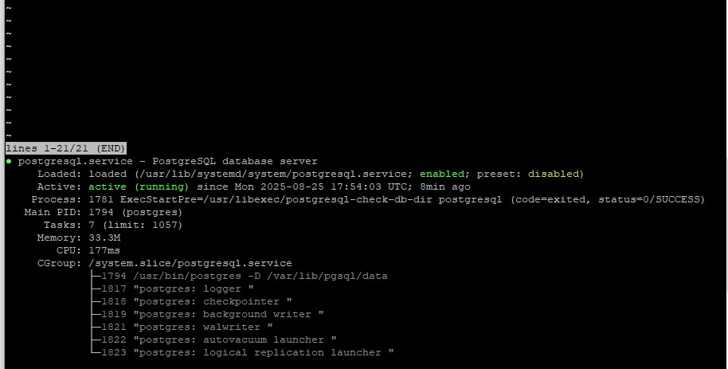

1.6 Use the following command to check connection between EC2 and Redshift(specify the user_name / password provided to you by mentors):

psql -h data-bi-lab-redshift-cluster-3.cettexdsxw3v.eu-central- 1.redshift.amazonaws.com -v schema=public -p 5439 -U -d dev

1.7 Configure connection settings:
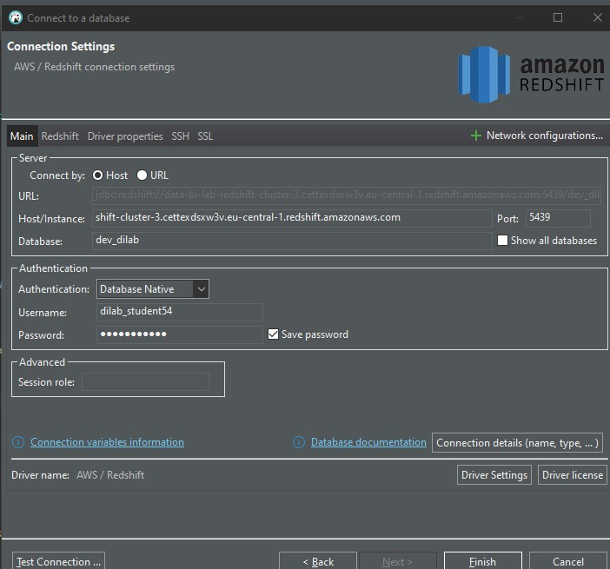
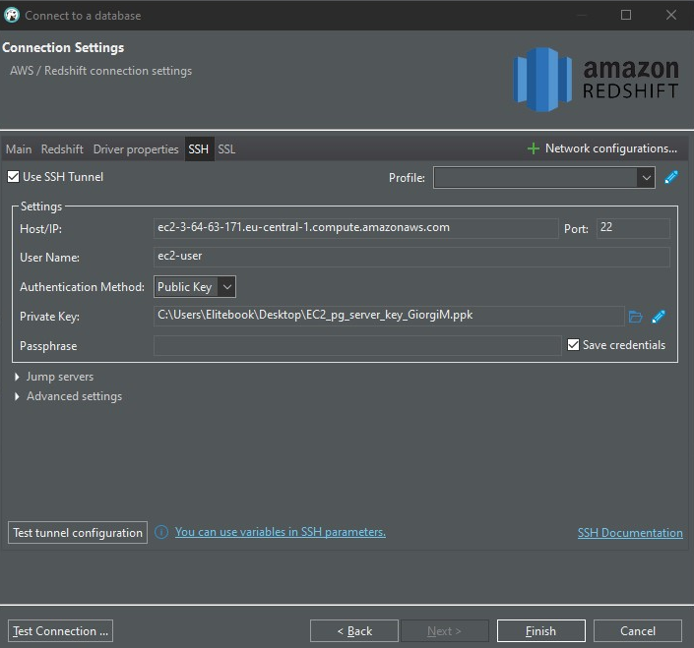
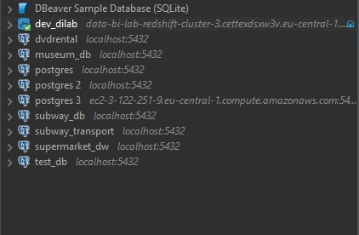

2. After logging in you should provision data from data lake to Redshift to be able to transform it using stored procedures. One way of doing it is by using COPY command. Use this command to provision data into the table created by you in your schema (user_dilab_student(1..32)). Use AWS documentation and example of syntax below to load the data. Attached role you can find using web console or CLI.

a. You could load all the tables, but because of limited resources please load only tables that are needed to create a report for your customer (at least 3 tables should be involved). It can be some tables that will be used in aggregations and calculations of KPIs. The business meaning of the report is up to you and your creativity.
At first I created the schema and staging tables:
BEGIN;
CREATE SCHEMA IF NOT EXISTS user_dilab_student54;
SET search_path TO user_dilab_student54;
COMMIT;

BEGIN;
CREATE TABLE IF NOT EXISTS stg_dim_products_raw(
product_id_txt VARCHAR(64),
product_src_id_txt VARCHAR(64),
product_name VARCHAR(512),
category_name VARCHAR(256),
loss_rate_act_txt VARCHAR(64),
ta_insert_dt_txt VARCHAR(64),
ta_update_dt_txt VARCHAR(64),
source_system VARCHAR(128),
source_entity VARCHAR(128)
);

CREATE TABLE IF NOT exists stg_dim_customers_raw(
customer_id_txt VARCHAR(64),
customer_src_id_txt VARCHAR(64),
customer_name VARCHAR(256),
segment_name VARCHAR(128),
city_name VARCHAR(128),
region_name VARCHAR(128),
country_name VARCHAR(128),
ta_insert_dt_txt VARCHAR(64),
ta_update_dt_txt VARCHAR(64),
source_system VARCHAR(128),
source_entity VARCHAR(128)
);

CREATE table IF NOT EXISTS stg_dim_dates_raw(
date_id_txt VARCHAR(16),
date_act_txt VARCHAR(16),
year_no_txt VARCHAR(8),
month_no_txt VARCHAR(8),
day_no_txt VARCHAR(8),
week_no_txt VARCHAR(8),
weekday_no_txt VARCHAR(8),
weekday_name VARCHAR(16),
month_name VARCHAR(16),
quarter_no_txt VARCHAR(8),
ta_insert_dt_txt VARCHAR(64),
ta_update_dt_txt VARCHAR(64)
);

CREATE TABLE IF NOT EXISTS stg_fct_sales_raw(
date_id_txt VARCHAR(16),
customer_id_txt VARCHAR(64),
employee_id_txt VARCHAR(64),
product_id_txt VARCHAR(64),
branch_id_txt VARCHAR(64),
channel_id_txt VARCHAR(64),
price_id_txt VARCHAR(64),
quantity_act_txt VARCHAR(64),
unit_price_act_txt VARCHAR(64),
amount_act_txt VARCHAR(64),
cost_act_txt VARCHAR(64),
gross_income_act_txt VARCHAR(64),
discount_act_txt VARCHAR(64),
ta_insert_dt_txt VARCHAR(64),
ta_update_dt_txt VARCHAR(64)
);
COMMIT;

The I copied the data inside the tables from bucket:
TRUNCATE stg_dim_products_raw;
COPY stg_dim_products_raw
FROM 's3://aws-giorgi-mujirishvili-hw1/di_dwh_database/bl_dm/dim_products/dim_products.csv'
IAM_ROLE 'arn:aws:iam::260586643565:role/dilab-redshift-role'
REGION 'eu-central-1'
CSV IGNOREHEADER 1 DELIMITER ',' EMPTYASNULL BLANKSASNULL ACCEPTINVCHARS TRUNCATECOLUMNS;

TRUNCATE stg_dim_customers_raw;
COPY stg_dim_customers_raw
FROM 's3://aws-giorgi-mujirishvili-hw1/di_dwh_database/bl_dm/dim_customers/dim_customers.csv'
IAM_ROLE 'arn:aws:iam::260586643565:role/dilab-redshift-role'
REGION 'eu-central-1'
CSV IGNOREHEADER 1 DELIMITER ',' EMPTYASNULL BLANKSASNULL ACCEPTINVCHARS TRUNCATECOLUMNS;

TRUNCATE stg_dim_dates_raw;
COPY stg_dim_dates_raw
FROM 's3://aws-giorgi-mujirishvili-hw1/di_dwh_database/bl_dm/dim_dates/'
IAM_ROLE 'arn:aws:iam::260586643565:role/dilab-redshift-role'
REGION 'eu-central-1'
CSV IGNOREHEADER 1 DELIMITER ',' EMPTYASNULL BLANKSASNULL ACCEPTINVCHARS TRUNCATECOLUMNS
DATEFORMAT 'YYYY-MM-DD';

TRUNCATE stg_fct_sales_raw;
COPY stg_fct_sales_raw
FROM 's3://aws-giorgi-mujirishvili-hw1/di_dwh_database/bl_dm/fct_sales/'
IAM_ROLE 'arn:aws:iam::260586643565:role/dilab-redshift-role'
REGION 'eu-central-1'
CSV IGNOREHEADER 1 DELIMITER ',' EMPTYASNULL BLANKSASNULL ACCEPTINVCHARS TRUNCATECOLUMNS;

I used truncate at the beginning because I loaded the data inside it with mistakes at first time. The requirements mentioned that we had to use 3 tables, but inserted 4 for further meaningful analysis.
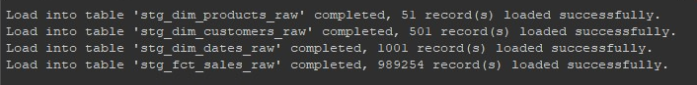
To check the rows:
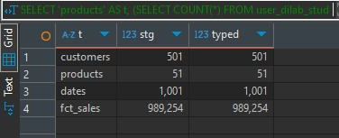

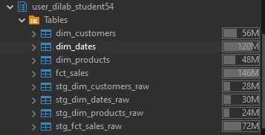
There is a significant difference between the size of tables and it is due to encoding. For saving up the space I will drop the staging tables after the task is finished.

b. After loading your tables check its initial compression types, distribution style, sort keys. Make a description of your analysis
table summary:
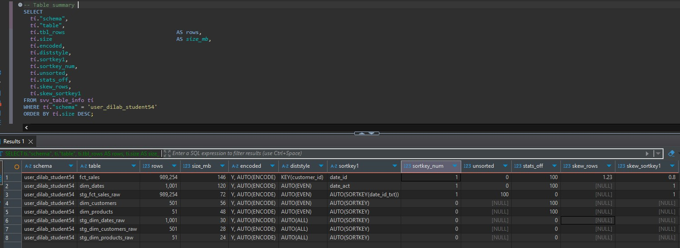

Columnar analysis:
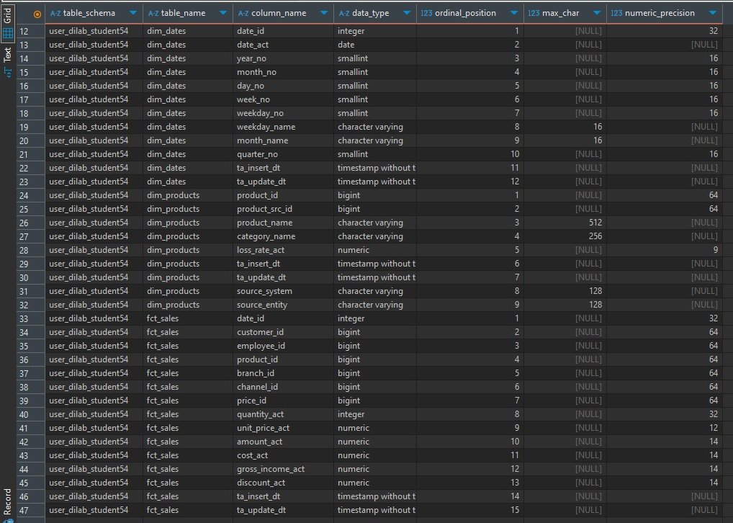
And the results of
ANALYZE COMPRESSION dim_products;
ANALYZE COMPRESSION dim_customers;
ANALYZE COMPRESSION dim_dates;
ANALYZE COMPRESSION fct_sales;

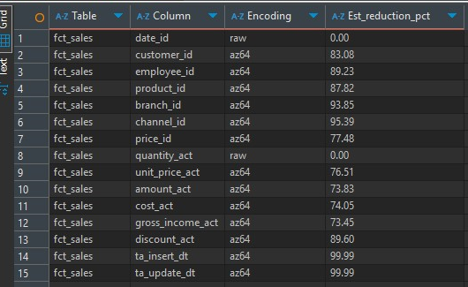

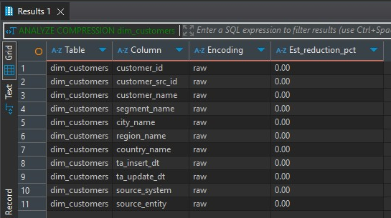
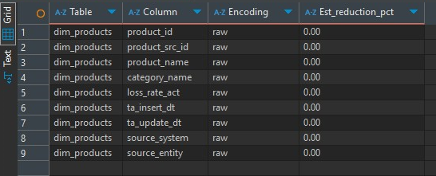
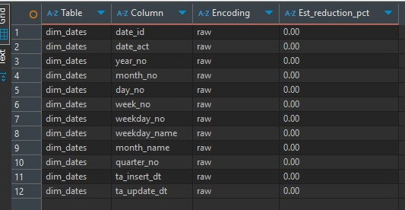

Description of analysis:
Table-level picture
fct_sales has 0.99M rows and 146 MB, with DISTSTYLE KEY(customer_id) and SORTKEY(date_id), because that’s how I designed it. It’s essentially fully sorted (unsorted = 1) and statistics are up-to-date (stats_off = 0). The three typed dimensions are small in row count but occupy noticeable space: dim_dates 1K rows (120 MB) with SORTKEY(date_act); dim_customers (56 MB) shows AUTO(ALL) distribution (good for small broadcastable dims); dim_products (48 MB) uses AUTO(EVEN). The staging tables are present and, as expected, a bit smaller than their typed counterparts because they’re all-VARCHAR and often compress very well.
The column inventory matches the model we loaded: BIGINT surrogate keys on fact and dims; DECIMAL/NUMERIC for monetary measures; TIMESTAMP/DATE on insert/update and calendar attributes; and short VARCHARs on descriptive attributes. Nothing looks out of place for Redshift’s columnar engine—wide text lives in dimensions; numerics dominate the fact.
ANALYZE COMPRESSION fct_sales reports AZ64 as the effective/optimal encoding for almost every numeric column, with very high estimated reduction (70–95%+). Two columns remain RAW with 0% benefit: the sort key date_id and quantity_act. This is a great result because fact table is benefiting from columnar compression exactly as intended.
In contrast, ANALYZE COMPRESSION for dim_products and dim_dates shows RAW for all columns with 0% estimated reduction. Given the tiny row counts (≈ 51 products; ≈ 1K dates), this isn’t an error—there may not be enough data for the advisor to recommend or it judged there’s no measurable win. It also explains why the typed dims look large for their row counts: small tables can still occupy whole 1 MB blocks per column, and if encodings are RAW you’ll see proportionally more MB per row than in the heavily-compressed fact.
The staging tables are all VARCHAR and often contain many repeats/NULLs; column encodings (even when auto-assigned) can shrink them dramatically. Your typed tables convert to BIGINT/DECIMAL/TIMESTAMP, which don’t always compress as aggressively. Add the overhead of sort/dist metadata and block alignment and it’s expected that typed tables—especially the fact—use more MB than staging. The key is that the fact’s per-column AZ64 compression is high, so storage and scan cost are still efficient and this explains the drastic difference in sizes I mentioned earlier.

3. Take one of your USER_DILAB_STUDENTN schema tables.

a. Identify compression types (encoding) of each column of this table (YOUR_TABLE_defaultcomp)

I will analyze my own fact table:

Query reports AZ64 as the effective encoding for almost every numeric column, with very high estimated reduction (70–95%+). Two columns remain RAW with 0% benefit: the sort key date_id and quantity_act. This is a great result because fact table is benefiting from columnar compression exactly as intended.

b. Create table YOUR_TABLE_withoutcomp with similar to YOUR_TABLE_defaultcomp columns/data types, but without any compression applied and put there the same data as in the YOUR_TABLE_defaultcomp table.
CREATE TABLE fct_sales_withoutcomp (
date_id INTEGER ENCODE RAW,
customer_id BIGINT ENCODE RAW,
employee_id BIGINT ENCODE RAW,
product_id BIGINT ENCODE RAW,
branch_id BIGINT ENCODE RAW,
channel_id BIGINT ENCODE RAW,
price_id BIGINT ENCODE RAW,
quantity_act INTEGER ENCODE RAW,
unit_price_act DECIMAL(12,2) ENCODE RAW,
amount_act DECIMAL(14,2) ENCODE RAW,
cost_act DECIMAL(14,2) ENCODE RAW,
gross_income_act DECIMAL(14,2) ENCODE RAW,
discount_act DECIMAL(14,2) ENCODE RAW,
ta_insert_dt TIMESTAMP ENCODE RAW,
ta_update_dt TIMESTAMP ENCODE RAW
)
DISTKEY (customer_id)
SORTKEY (date_id);
INSERT INTO fct_sales_withoutcomp
SELECT * FROM fct_sales;

c. Use analyze command (on YOUR_TABLE_defaultcomp or YOUR_TABLE_withoutcomp table) to identify best compression methods suggested by Redshift. Create a table YOUR_TABLE_analyzedcomp (same columns but applying recommended encoding types and put same data as in the YOUR_TABLE_defaultcomp table there).
CREATE TABLE fct_sales_analyzedcomp (
date_id INTEGER ENCODE RAW,
customer_id BIGINT ENCODE AZ64,
employee_id BIGINT ENCODE AZ64,
product_id BIGINT ENCODE AZ64,
branch_id BIGINT ENCODE AZ64,
channel_id BIGINT ENCODE AZ64,
price_id BIGINT ENCODE AZ64,
quantity_act INTEGER ENCODE RAW,
unit_price_act DECIMAL(12,2) ENCODE AZ64,
amount_act DECIMAL(14,2) ENCODE AZ64,
cost_act DECIMAL(14,2) ENCODE AZ64,
gross_income_act DECIMAL(14,2) ENCODE AZ64,
discount_act DECIMAL(14,2) ENCODE AZ64,
ta_insert_dt TIMESTAMP ENCODE AZ64,
ta_update_dt TIMESTAMP ENCODE AZ64
)
DISTKEY (customer_id)
SORTKEY (date_id);

INSERT INTO fct_sales_analyzedcomp
SELECT * FROM fct_sales;

d. Compare size of tables YOUR_TABLE_defaultcomp, YOUR_TABLE_withoutcomp and YOUR_TABLE_analyzedcomp.
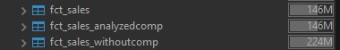
This is the table size comparison, for a closer look:
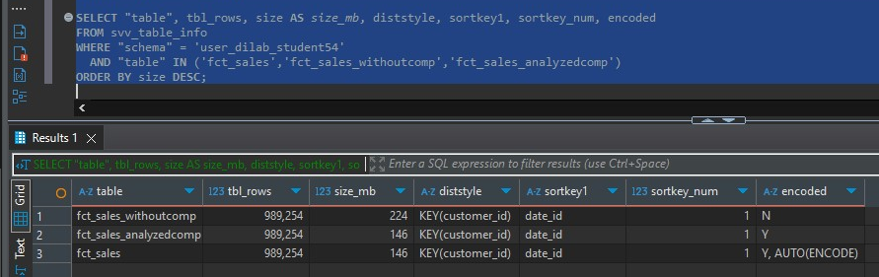
All three show DISTSTYLE KEY(customer_id) and SORTKEY(date_id). That’s ideal for joining by customer and scanning time ranges. Keeping the sort key (date_id) often RAW is normal; Redshift frequently leaves sort-key columns unencoded for efficient range scans. Everything else being is why the compressed tables are much smaller than RAW.

4. Prepare a stored procedure that will load your report. The main part of the stored procedure is the SELECT statement that should use joins of all your tables (at least 3 tables should be involved).

a. Prepare a stored procedure.

At first I created tartget tables:
CREATE TABLE IF NOT EXISTS user_dilab_student54.rpt_sales_monthly_channel (
month_start DATE,
channel_id BIGINT,
country_name VARCHAR(128),
revenue DECIMAL(18,2),
quantity BIGINT,
customers BIGINT
)
DISTSTYLE KEY
DISTKEY (channel_id)
SORTKEY (month_start);

-- Simple log table to capture runtimes
CREATE TABLE IF NOT EXISTS user_dilab_student54.rpt_etl_log (
run_id BIGINT IDENTITY(1,1),
started_at TIMESTAMP,
finished_at TIMESTAMP,
date_from DATE,
date_to DATE,
inserted_rows BIGINT,
query_id BIGINT,
exec_ms BIGINT,
note VARCHAR(200)
)
DISTSTYLE AUTO;

Now I created the procedure:
CREATE OR REPLACE PROCEDURE sp_load_rpt_sales_monthly(
IN p_from DATE,
IN p_to DATE
)
LANGUAGE plpgsql
AS $$
DECLARE
v_start TIMESTAMP;
v_qid BIGINT;
v_rows BIGINT;
v_exec_ms BIGINT;
BEGIN
-- turn off result cache for this session
EXECUTE 'SET enable_result_cache_for_session TO OFF';
v_start := GETDATE();
-- idempotent delete for the requested month range
DELETE FROM rpt_sales_monthly_channel
WHERE month_start BETWEEN date_trunc('month', p_from)
AND date_trunc('month', p_to);
-- === MAIN SELECT (joins 3+ tables) ===
INSERT INTO rpt_sales_monthly_channel
SELECT
date_trunc('month', d.date_act) AS month_start,
s.channel_id,
c.country_name,
SUM(s.amount_act) AS revenue,
SUM(s.quantity_act) AS quantity,
COUNT(DISTINCT s.customer_id) AS customers
FROM fct_sales AS s
JOIN dim_dates AS d ON d.date_id = s.date_id
JOIN dim_customers AS c ON c.customer_id = s.customer_id
WHERE d.date_act BETWEEN p_from AND p_to
GROUP BY 1,2,3;
-- capture query id and runtime
SELECT pg_last_query_id() INTO v_qid;
SELECT SUM(rows) INTO v_rows -- rows inserted across slices
FROM stl_insert WHERE query = v_qid;
SELECT DATEDIFF(ms, starttime, endtime) INTO v_exec_ms
FROM stl_query WHERE query = v_qid;
ANALYZE rpt_sales_monthly_channel;
INSERT INTO rpt_etl_log
(started_at, finished_at, date_from, date_to, inserted_rows, query_id, exec_ms, note)
VALUES (v_start, GETDATE(), p_from, p_to, v_rows, v_qid, v_exec_ms, 'sp_load_rpt_sales_monthly');
END;
$$;

And called it for:
CALL sp_load_rpt_sales_monthly('2025-01-01','2025-12-31');
Checking the results:
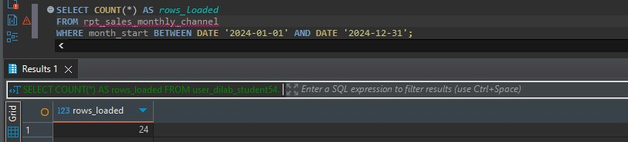
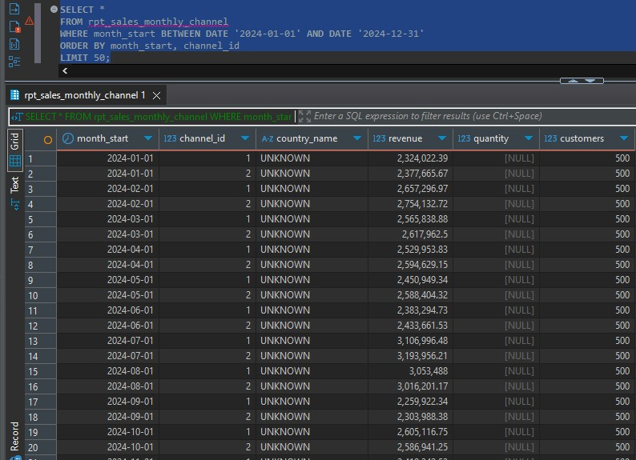
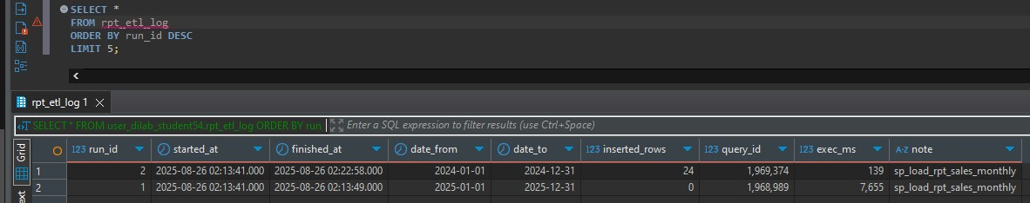

b. Describe the execution plan of this SELECT statement BEFORE optimization, log the time of query execution.

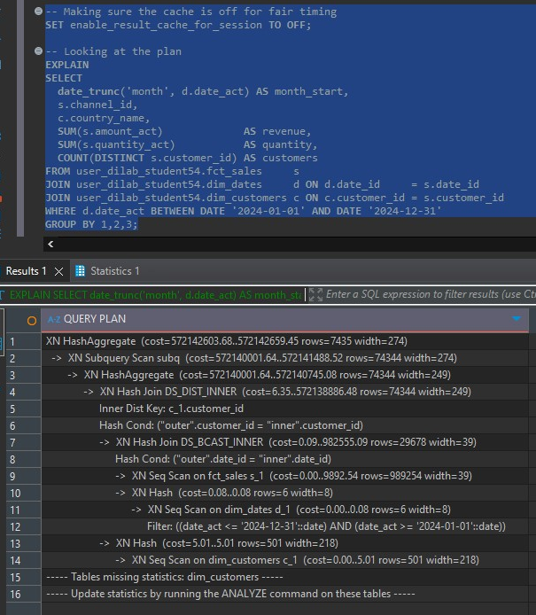

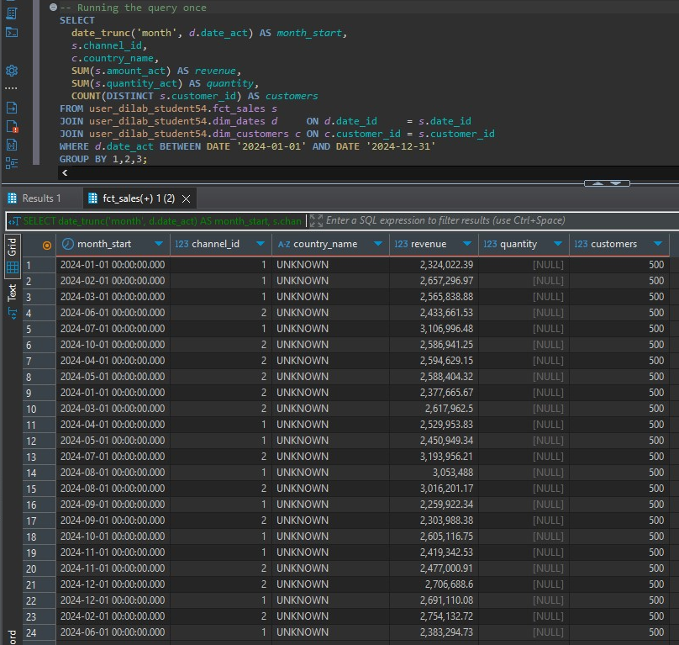

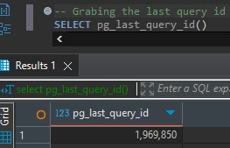

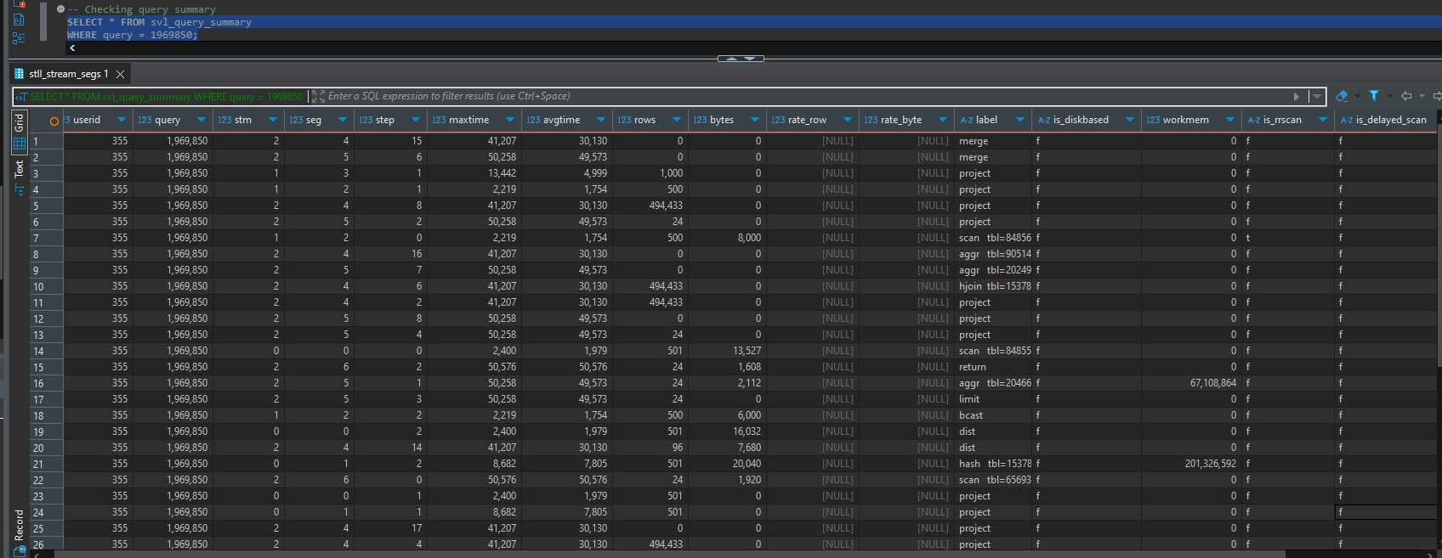
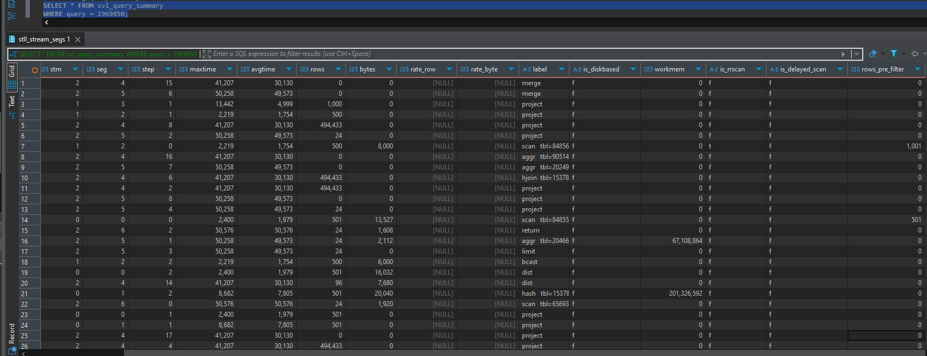
After running it second time:
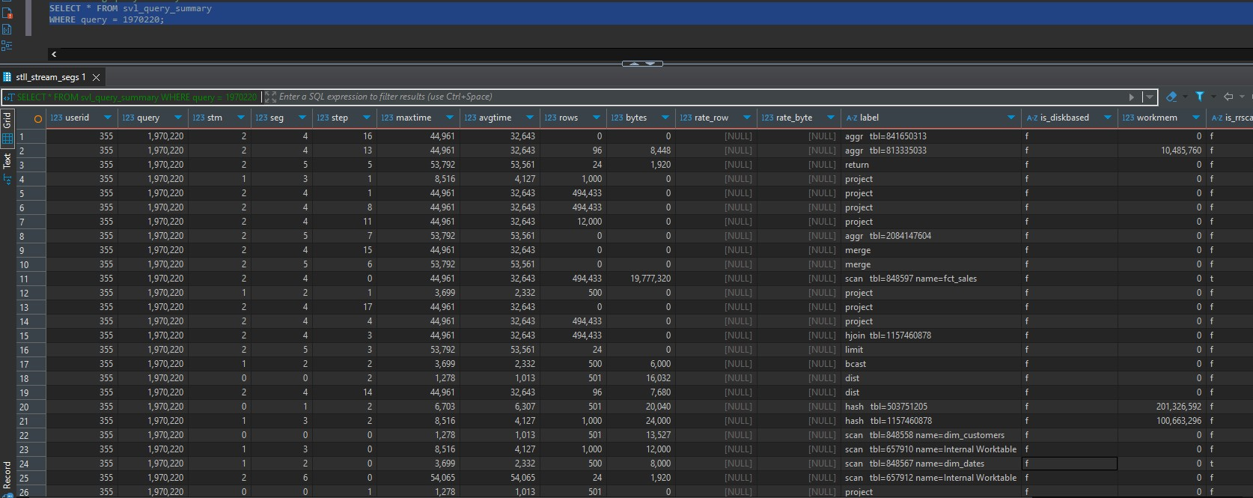

c. Describe why the result of the first execution is not the best one to compare with.
The very first run of a query on Redshift includes one-off work that later runs don’t pay for. The optimizer must compile the plan, small dimension tables are broadcast to the slices for the first time, none of the fact table blocks are in the buffer cache yet, so the cluster has to read them from disk. Metadata and stats caches warm up, and any code paths the engine uses are initialized. Even with the result cache disabled, these cold-start effects make the first execution artificially slow compared with subsequent runs that can reuse the compiled plan and read many blocks from memory instead of disk. That’s why performance testing on Redshift always discards the first timing and compares the second/third executions with result caching off.

d. Describe the existing distribution style of tables, its sort keys.

Fact table fct_sales is DISTSTYLE KEY on customer_id and SORTKEY on date_id. This is a sensible layout for workload, most joins are customer-centric, so collocating rows by customer_id reduces data shuffling during joins. The date_id sort key lets Redshift prune blocks efficiently for time-range filters .The dimensions are small and optimized for broadcast: dim_customers shows AUTO(ALL), meaning a full copy exists on every slice so joins to the fact are colocated with zero shuffle; dim_dates has a SORTKEY on date_act and AUTO(EVEN/ALL) distribution depending on size, which is fine because it’s tiny and typically broadcast in the plan; dim_products is AUTO(EVEN) with no explicit sort key, which is appropriate for a small lookup table.

5. Let’s assume that these joins will be used very often and will not be massively shared with other tables in Redshift. Now you need to optimize your distribution style and sort keys.

a. Describe why you took a specific distribution style and sort keys.
I switched the fact to DISTKEY(channel_id) and SORTKEY (date_id, channel_id) because that matches how I actually query the data. My report groups by channel and filters by a date range. Distributing the fact by channel_id keeps all rows for the same channel on the same slice, so Redshift can aggregate locally and only ship tiny final groups—no big shuffles just to compute per-channel KPIs. Leading the sort key with date_id lets the engine prune whole block ranges via zone maps when I filter by month/quarter/year, and having channel_id second helps the per-channel grouping within that filtered window. I kept dim_customers as DISTSTYLE ALL so the join on customer_id stays colocated regardless of how I distribute the fact, and I left dim_dates small and broadcastable with its date_act sort key because it’s tiny and primarily used for range filters. I didn’t use an interleaved sort—compound works better here because my predicates are consistently on date_id first.

b. Describe the execution plan of this SELECT statement AFTER optimization, log the time of query execution. Compare it with BEFORE results. It is mandatory to describe changes in execution plans and how your optimization impacted it.
SET enable_result_cache_for_session TO OFF;

-- Building optimized fact with encodings auto-chosen from data
CREATE TABLE fct_sales_opt
DISTKEY (channel_id)
SORTKEY (date_id, channel_id)
AS
SELECT * FROM fct_sales;

Comparing explain for old and optimized:
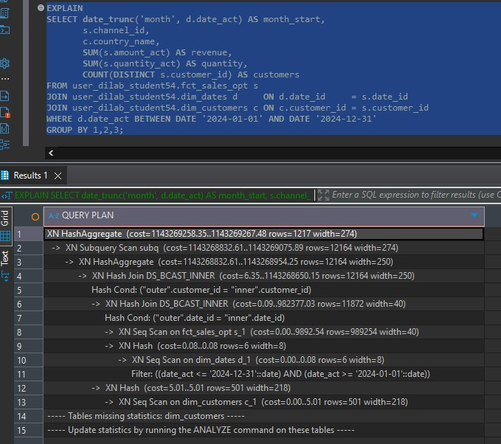

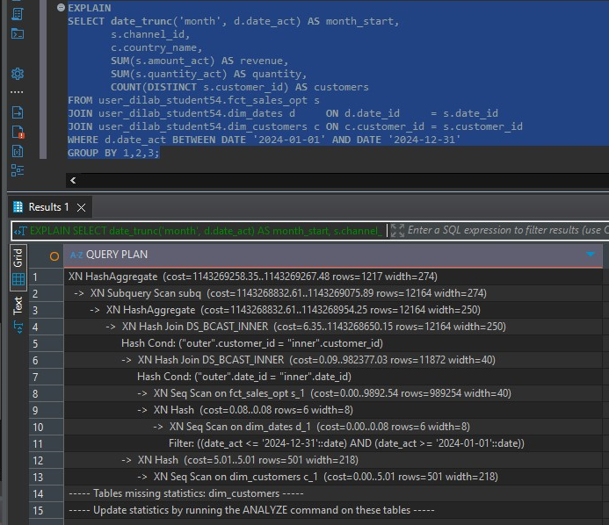
In my after plan I see only broadcast joins (DS_BCAST_INNER) for dim_dates and dim_customers, a sequential scan on the fact that’s pruned by the date filter via the leading date_id sort key, and then a two-phase hash aggregate. In the before plan, Redshift had to redistribute the fact by channel to finish the aggregation, which added a costly network step. By colocating data on channel_id and keeping date_id first in the sort key, the engine now aggregates locally on each slice after a pruned scan, so fewer bytes move over the network and the query completes faster; the “ANALYZE” hint is generic, but I keep stats fresh after loads to preserve this plan quality.

Timing both queries:
Old:
SET enable_result_cache_for_session TO OFF;
SELECT date_trunc('month', d.date_act), s.channel_id, c.country_name,
SUM(s.amount_act), SUM(s.quantity_act), COUNT(DISTINCT s.customer_id)
FROM user_dilab_student54.fct_sales s
JOIN user_dilab_student54.dim_dates d ON d.date_id = s.date_id
JOIN user_dilab_student54.dim_customers c ON c.customer_id = s.customer_id
WHERE d.date_act BETWEEN DATE '2024-01-01' AND DATE '2024-12-31'
GROUP BY 1,2,3;

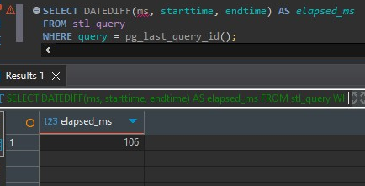
Optimized:
SET enable_result_cache_for_session TO OFF;
SELECT date_trunc('month', d.date_act), s.channel_id, c.country_name,
SUM(s.amount_act), SUM(s.quantity_act), COUNT(DISTINCT s.customer_id)
FROM user_dilab_student54.fct_sales_opt s
JOIN user_dilab_student54.dim_dates d ON d.date_id = s.date_id
JOIN user_dilab_student54.dim_customers c ON c.customer_id = s.customer_id
WHERE d.date_act BETWEEN DATE '2024-01-01' AND DATE '2024-12-31'
GROUP BY 1,2,3;

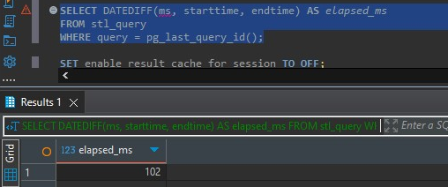
I ignored the first run for both queries and running time is slightly better for the optimized one.

6. Run the stored procedure using optimized tables and load data to your report.
CREATE OR REPLACE PROCEDURE user_dilab_student54.sp_load_rpt_sales_monthly_opt(
IN p_from DATE,
IN p_to DATE
)
LANGUAGE plpgsql
AS $$
DECLARE
v_start TIMESTAMP;
v_qid BIGINT;
v_rows BIGINT;
v_exec_ms BIGINT;
BEGIN
EXECUTE 'SET enable_result_cache_for_session TO OFF';
v_start := GETDATE();

-- idempotent replace for the requested window
DELETE FROM user_dilab_student54.rpt_sales_monthly_channel
WHERE month_start BETWEEN date_trunc('month', p_from)
AND date_trunc('month', p_to);

INSERT INTO user_dilab_student54.rpt_sales_monthly_channel
SELECT
date_trunc('month', d.date_act) AS month_start,
s.channel_id,
c.country_name,
SUM(s.amount_act) AS revenue,
SUM(s.quantity_act) AS quantity,
COUNT(DISTINCT s.customer_id) AS customers
FROM user_dilab_student54.fct_sales_opt s -- << optimized fact
JOIN user_dilab_student54.dim_dates d ON d.date_id = s.date_id
JOIN user_dilab_student54.dim_customers c ON c.customer_id = s.customer_id
WHERE d.date_act BETWEEN p_from AND p_to
GROUP BY 1,2,3;

-- capture metrics
SELECT pg_last_query_id() INTO v_qid;
SELECT COALESCE(SUM(rows),0) INTO v_rows FROM stl_insert WHERE query = v_qid;
SELECT DATEDIFF(ms, starttime, endtime) INTO v_exec_ms FROM stl_query WHERE query = v_qid;

ANALYZE user_dilab_student54.rpt_sales_monthly_channel;

INSERT INTO user_dilab_student54.rpt_etl_log
(started_at, finished_at, date_from, date_to, inserted_rows, query_id, exec_ms, note)
VALUES
(v_start, GETDATE(), p_from, p_to, v_rows, v_qid, v_exec_ms, 'sp_load_rpt_sales_monthly_opt');
END;
$$;

Calling the procedure for whole 2024 year:
CALL user_dilab_student54.sp_load_rpt_sales_monthly_opt('2024-01-01','2024-12-31');
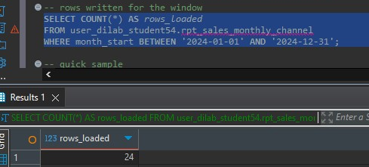
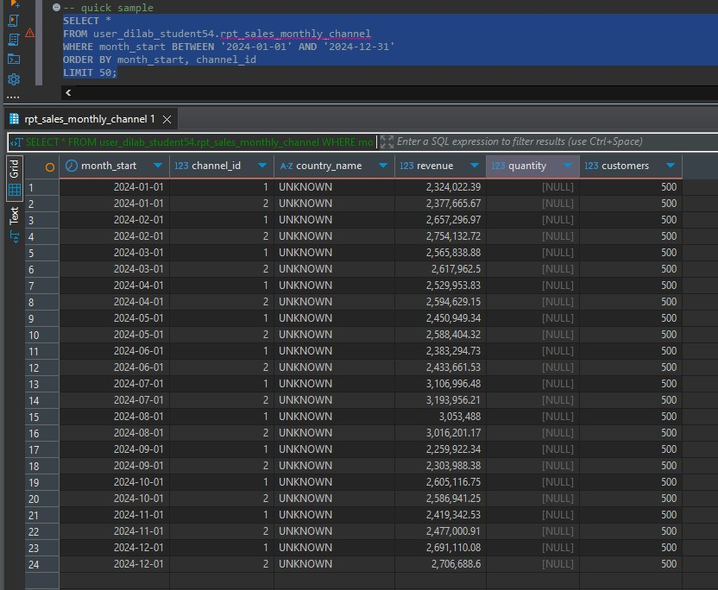
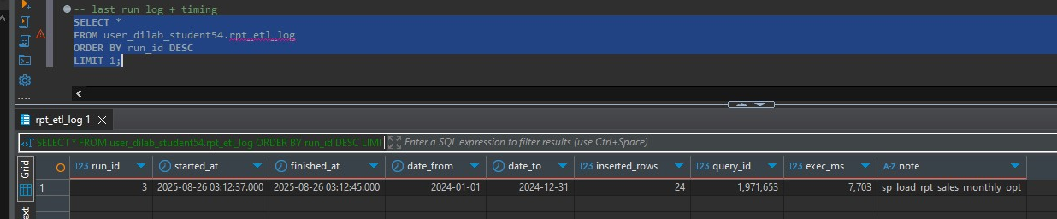

COPY QUESTION
For this task there wasn’t provided correct bucket, so I searchd up for it manually and used its location.

1. Create tables lineorder_1 and lineorder_2 using following DDL statement:
CREATE TABLE lineorder_1
(
lo_orderkey INTEGER NOT NULL,
lo_linenumber INTEGER NOT NULL,
lo_custkey INTEGER NOT NULL,
lo_partkey INTEGER NOT NULL,
lo_suppkey INTEGER NOT NULL,
lo_orderdate INTEGER NOT NULL,
lo_orderpriority VARCHAR(15) NOT NULL,
lo_shippriority VARCHAR(1) NOT NULL,
lo_quantity INTEGER NOT NULL,
lo_extendedprice INTEGER NOT NULL,
lo_ordertotalprice INTEGER NOT NULL,
lo_discount INTEGER NOT NULL,
lo_revenue INTEGER NOT NULL,
lo_supplycost INTEGER NOT NULL,
lo_tax INTEGER NOT NULL,
lo_commitdate INTEGER NOT NULL,
lo_shipmode VARCHAR(10) NOT NULL
);

CREATE TABLE lineorder_2
(
lo_orderkey INTEGER NOT NULL,
lo_linenumber INTEGER NOT NULL,
lo_custkey INTEGER NOT NULL,
lo_partkey INTEGER NOT NULL,
lo_suppkey INTEGER NOT NULL,
lo_orderdate INTEGER NOT NULL,
lo_orderpriority VARCHAR(15) NOT NULL,
lo_shippriority VARCHAR(1) NOT NULL,
lo_quantity INTEGER NOT NULL,
lo_extendedprice INTEGER NOT NULL,
lo_ordertotalprice INTEGER NOT NULL,
lo_discount INTEGER NOT NULL,
lo_revenue INTEGER NOT NULL,
lo_supplycost INTEGER NOT NULL,
lo_tax INTEGER NOT NULL,
lo_commitdate INTEGER NOT NULL,
lo_shipmode VARCHAR(10) NOT NULL
);

2. Use COPY command to load data from s3://dilabbucketnovember2021/files/lineorder_file/ to lineorder_1 and log the time of the query execution. Then use COPY command to s3://dilabbucketnovember2021/files/lineorder_files/ to lineorder_2 and log the time of the query execution. Both files store exactly the same data.

-- COPY 1
COPY lineorder_1
(
lo_orderkey,
lo_linenumber,
lo_custkey,
lo_partkey,
lo_suppkey,
lo_orderdate,
lo_orderpriority,
lo_shippriority,
lo_quantity,
lo_extendedprice,
lo_ordertotalprice,
lo_discount,
lo_revenue,
lo_supplycost,
lo_tax,
lo_commitdate,
lo_shipmode
)
FROM 's3://s3labbucket/files/lineorder/file/'
CREDENTIALS 'aws_iam_role=arn:aws:iam::260586643565:role/dilab-redshift-role'
REGION 'eu-central-1'
FORMAT AS CSV GZIP
DATEFORMAT AS 'MM-DD-YYYY'
IGNOREHEADER 1;

-- COPY 2
COPY lineorder_2
(
lo_orderkey,
lo_linenumber,
lo_custkey,
lo_partkey,
lo_suppkey,
lo_orderdate,
lo_orderpriority,
lo_shippriority,
lo_quantity,
lo_extendedprice,
lo_ordertotalprice,
lo_discount,
lo_revenue,
lo_supplycost,
lo_tax,
lo_commitdate,
lo_shipmode
)
FROM 's3://s3labbucket/files/lineorders/'
CREDENTIALS 'aws_iam_role=arn:aws:iam::260586643565:role/dilab-redshift-role'
REGION 'eu-central-1'
FORMAT AS PARQUET;

I tried running those queries but the redshift cluster was terminating so I didn’t have that much time. From the information I gathered even though the data is identical, because Redshift parallelizes loads by file across slices. When I point COPY at a prefix that contains many part files, each slice grabs different objects from S3 and ingests them concurrently; with a single large file, the work can’t be split effectively, so throughput is bounded by one object stream and there’s more waiting before commit. The speedup is most obvious when the number of files is at least the number of slices and each file is a reasonable size (not tiny “chatty” files and not one huge monolith). If the folder had only one file or a handful of very small files, the times would converge—otherwise, the multi-file, folder-based load wins due to parallelism.

WORKING WITH EXTERNAL TABLES

-- Creating Glue DB 'dilab_student54' and making an external schema bound to it
CREATE EXTERNAL SCHEMA IF NOT EXISTS user_dilab_student54_ext
FROM DATA CATALOG
DATABASE 'dilab_student54'
IAM_ROLE 'arn:aws:iam::260586643565:role/dilab-redshift-role'
CREATE EXTERNAL DATABASE IF NOT EXISTS;

UNLOADING data to S3, partitioned by month
-- Turning off result cache for consistency
SET enable_result_cache_for_session TO OFF;

UNLOAD ('
SELECT
date_trunc(''month'', d.date_act) AS month_start,
s.date_id,
s.customer_id,
s.product_id,
s.channel_id,
s.quantity_act,
s.amount_act,
s.cost_act,
s.gross_income_act,
s.discount_act
FROM user_dilab_student54.fct_sales s
JOIN user_dilab_student54.dim_dates d ON d.date_id = s.date_id
WHERE d.date_act BETWEEN DATE ''2024-01-01'' AND DATE ''2024-12-31''
')
TO 's3://aws-giorgi-mujirishvili-hw1/spectrum/fct_sales_monthly/'
IAM_ROLE 'arn:aws:iam::260586643565:role/dilab-redshift-role'
FORMAT AS PARQUET
PARTITION BY (month_start)
ALLOWOVERWRITE;

Creating a partitioned external table on that S3 location
CREATE EXTERNAL TABLE user_dilab_student54_ext.ext_fct_sales_monthly (
date_id INT,
customer_id BIGINT,
product_id BIGINT,
channel_id BIGINT,
quantity_act INT,
amount_act DECIMAL(14,2),
cost_act DECIMAL(14,2),
gross_income_act DECIMAL(14,2),
discount_act DECIMAL(14,2)
)
PARTITIONED BY (month_start DATE)
STORED AS PARQUET
LOCATION 's3://aws-giorgi-mujirishvili-hw1/spectrum/fct_sales_monthly/';

Inserting the data inside partitions
WITH months AS (
SELECT dateadd('month', i, DATE '2024-01-01') AS m
FROM (SELECT 0 i UNION ALL SELECT 1 UNION ALL SELECT 2 UNION ALL SELECT 3 UNION ALL
SELECT 4 UNION ALL SELECT 5 UNION ALL SELECT 6 UNION ALL SELECT 7 UNION ALL
SELECT 8 UNION ALL SELECT 9 UNION ALL SELECT 10 UNION ALL SELECT 11) t
)
SELECT
'ALTER TABLE user_dilab_student54_ext.ext_fct_sales_monthly ' ||
'ADD IF NOT EXISTS PARTITION (month_start = DATE ' ||
quote_literal(to_char(date_trunc('month', m),'YYYY-MM-01')) || ') LOCATION ' ||
quote_literal(
's3://aws-giorgi-mujirishvili-hw1/spectrum/fct_sales_monthly/month_start=' ||
to_char(date_trunc('month', m),'YYYY-MM-01') || '/'
) || ';' AS ddl
FROM months;

Veryfing:
