Business Intelligence Group



Report

Page 1: General Overview
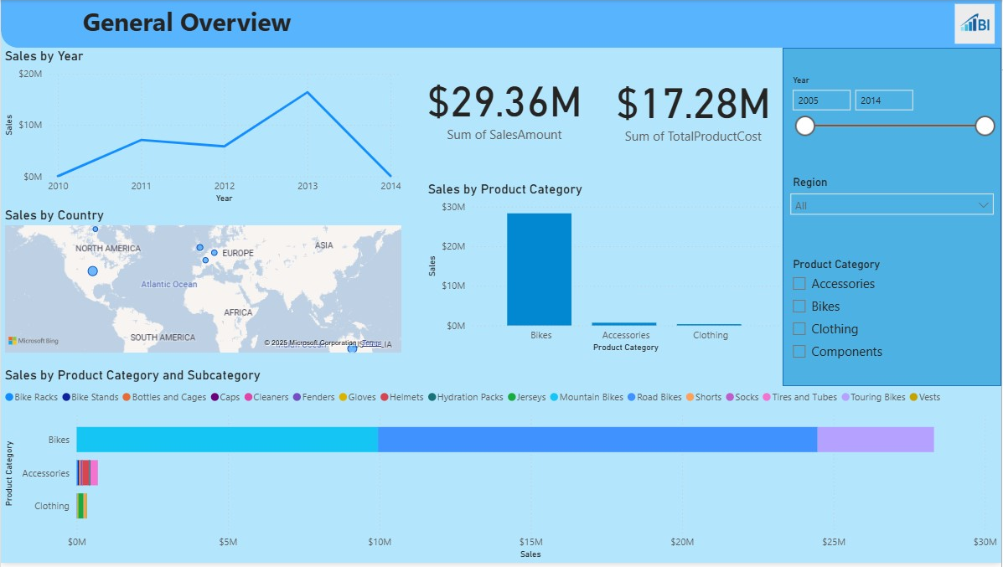
The General Overview page gives a quick and clear picture of AdventureWorks Internet Sales performance. It shows important numbers, trends over time, sales by location, and sales by product type.
At the top left, the Sales by Year line chart shows how sales changed from 2009 to 2014. This makes it easy to see if sales are going up, down, or staying steady. In the center, there are two cards: one shows the total sales amount of $29.36M, and the other shows the total product cost of $17.28M. These cards give quick, important numbers without needing to look at a chart.
Under the line chart, the Sales by Country map shows where the sales are coming from. This helps spot the best and weakest regions quickly. To the right, the Sales by Product Category column chart compares the main product categories—Bikes, Accessories, and Clothing. This makes it clear that Bikes bring in the most revenue.
At the bottom, the Sales by Product Category and Subcategory stacked bar chart breaks each main category into smaller product types. This shows both the total sales for each category and how much each subcategory contributes. On the right, the slicers let users filter by year, region, and product category.

Page 2: Product and Promotion Analysis
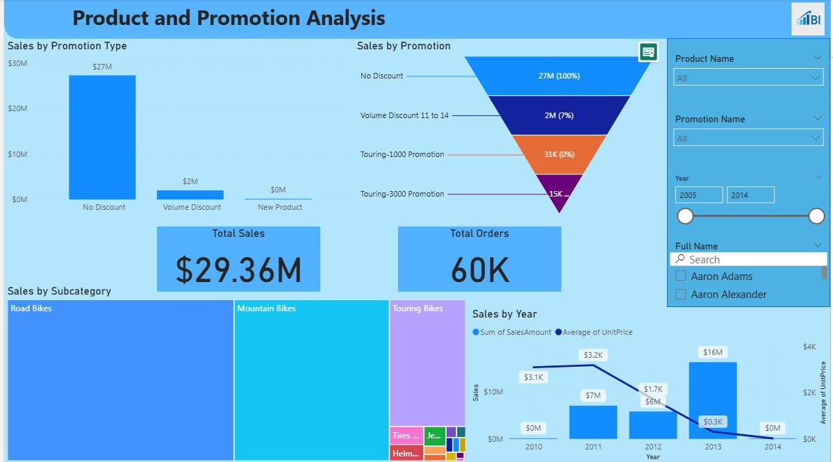
The Product and Promotion Analysis page focuses on understanding how different products and promotions affect sales and orders. On the top left, the Sales by Promotion Type column chart shows total sales for each type of promotion. This makes it easy to see that most sales ($27M) came from orders without any discount, while volume discounts and new product promotions generated much smaller amounts.
Next to it, the Sales by Promotion funnel shows each promotion as a stage in a funnel, with the width representing sales volume and the percentage of total sales shown alongside. This type of chart is used because it gives a clear visual comparison of how much each promotion contributed to the total sales, in both absolute and percentage terms, making it very easy to spot which promotions worked best.
In the middle of the page, two cards display key figures: total sales ($29.36M) and total orders (60K). At the bottom left, the Sales by Subcategory treemap shows which product subcategories brought in the most revenue, making it clear that Road Bikes, Mountain Bikes, and Touring Bikes dominate the product mix.
At the bottom right, the Sales by Year combination chart shows both the total sales amount (columns) and the average unit price (line) for each year. This allows viewers to see how sales volume and pricing trends relate to each other over time. On the right-hand side, there are multiple slicers for Product Name, Promotion Name, Year, and Customer Name (with search enabled). These slicers let users filter the data quickly to focus on specific products, promotions, time periods, or customers, making the page interactive and adaptable for different analysis needs.

Page 3: Customer and Territory Analysis
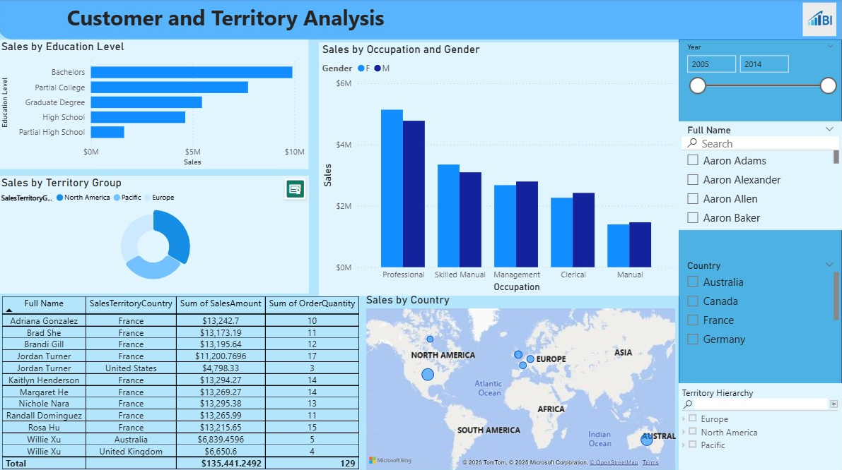
The Customer and Territory Analysis page focuses on understanding sales performance by customer demographics and geographical regions. It explores how different factors such as education level, occupation, and location affect sales. On the top left, the Sales by Education Level horizontal bar chart shows total sales grouped by the customer’s education level. This makes it easy to see which education segments generate the most revenue, with Bachelors and Partial College being the top contributors. On the top right, the Sales by Occupation and Gender clustered bar chart compares male and female sales within each occupation type. This chart allows for a quick understanding of both the occupation-based sales differences and gender patterns within those groups.
In the middle left, the Sales by Territory Group rose chart shows the share of sales for each high-level territory group: North America, Pacific, and Europe. The custom rose chart provides a simple, clear breakdown of proportions without taking much space. Also it allows us to match the color of the parts to the theme we desire.
Below it, the customer table lists the top 10 individual customers, their country, total sales amount, and order quantity. This detailed view helps identify top customers and their contribution to sales.
At the bottom right, the Sales by Country map visual displays does exactly the same thing as it did on first page. For this page, the interaction between the Full Name slicer and the Sales by Occupancy and Gender chart has been turned off so that the chart always shows the overall sales picture, even when a single customer is selected. For example:
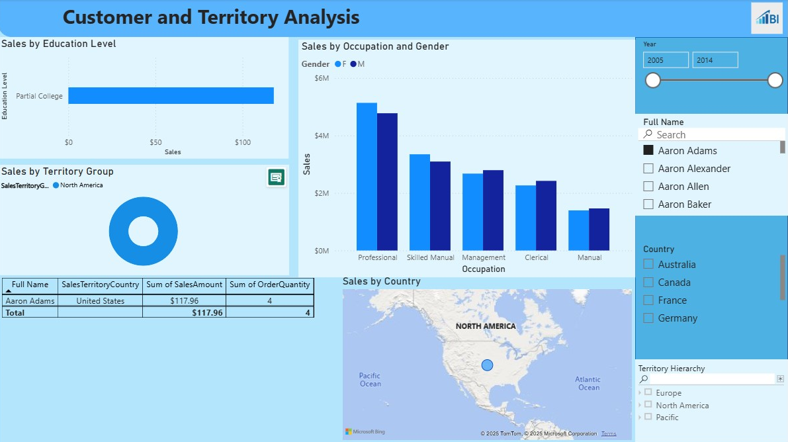

On the right side, the slicer panel includes a Full Name slicer with search for easy filtering of customers, a Country slicer for selecting specific markets, and a custom Hierarchy Slicer for Territory Hierarchy (Group → Region → Country). The custom hierarchy slicer was chosen because it allows users to drill down step-by-step from broad geographic areas to more specific regions without adding multiple separate slicers. This makes filtering more intuitive and saves space on the page.

Mobile Layout for Each Page:
For the mobile layout, I chose the simplest way of designing, slicers at the top, followed by cards, and after that, visuals ranked by their information value. The main difference between desktop and mobile layouts is that almost all visuals in the mobile layout have a background for clarity, even if they didn’t have one in the desktop layout.

Publishing the Report:
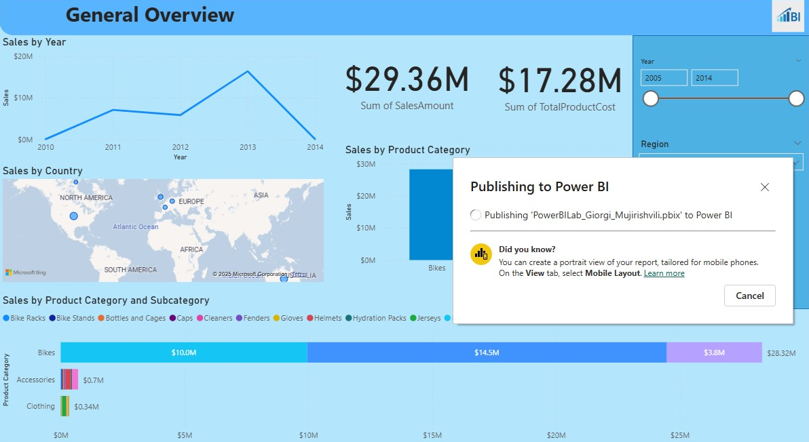
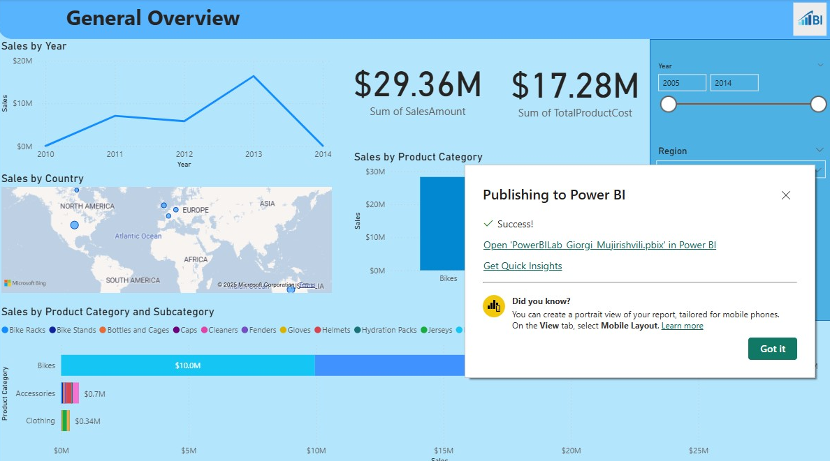

Installing Gateway and Setting Refresh:
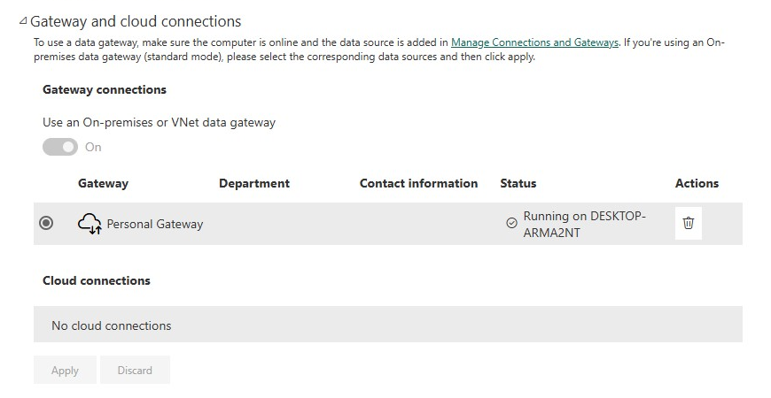
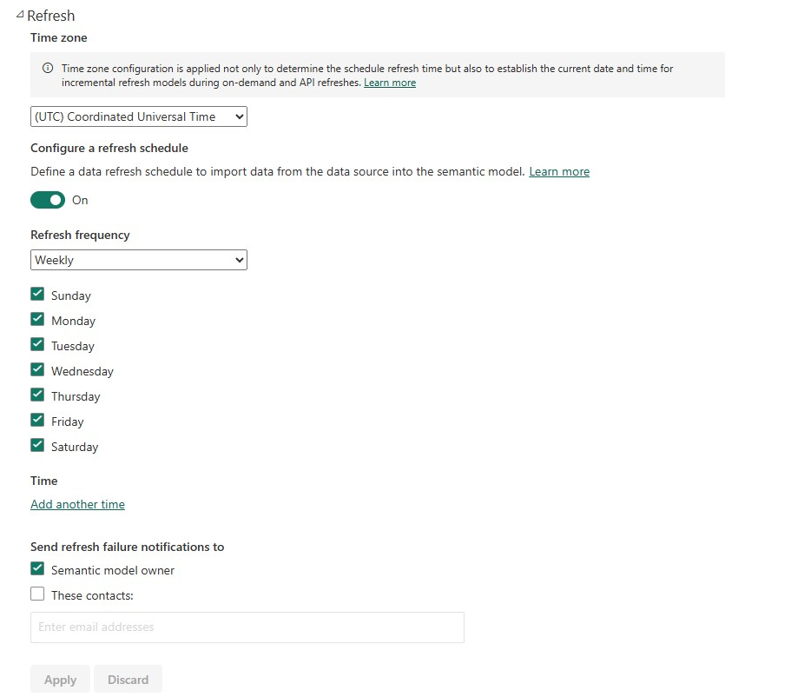

Link to the filtered report:
https://app.powerbi.com/groups/me/reports/981c227d-6d9e-4043-b855-d6641697141c/af651f81073949a5b300?experience=power-bi

(sales of Bikes in UK)

