1. Configure RLS based on a chosen security pattern. Give short description of your security groups and make screenshots of how it was configured in Power BI Desktop and Power BI Online Service.

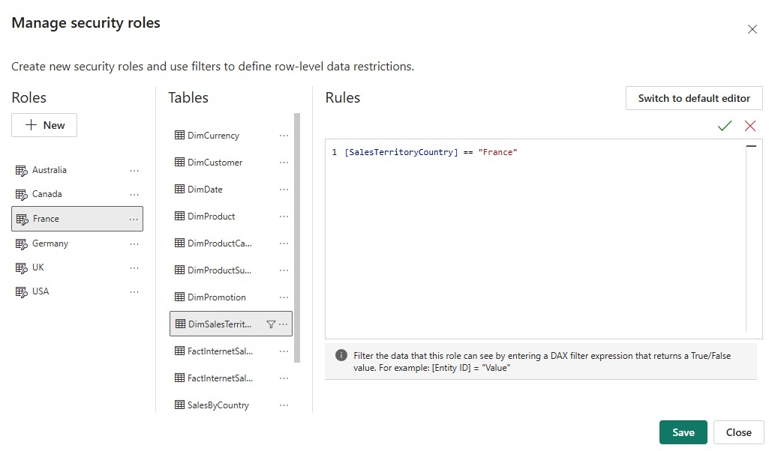
I added 6 new roles using DAX, with simmilar syntax. Filtering the Sales Territory by country names. I published this report separately and every role is shown at the powerbi service. After inserting the valid Azure emails the roles will be assigned to people.
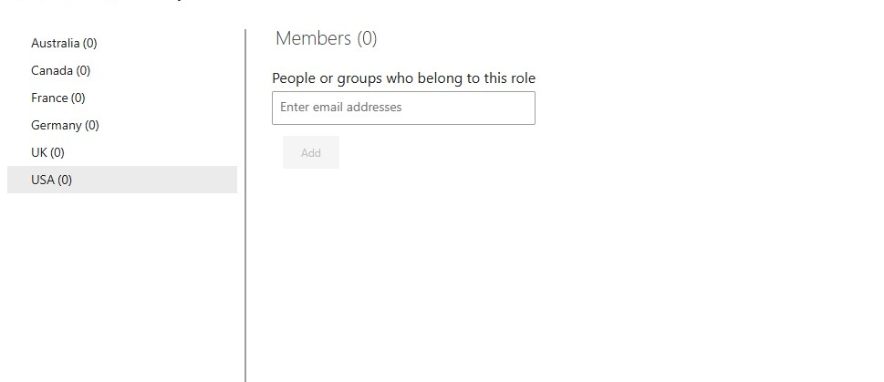

2) Using bookmarks and buttons create a functionality to switch between bar chart and a map visual that are positioned in the same area. Give short description of you work.

I used the Selection pane to maintain two visuals (Map and Bar) in the same position and created two bookmarks, Map View and Bar View, that capture only visibility for the selected visuals with Data turned off to preserve slicers. I then added buttons and mapped their actions to the bookmarks. Users can now switch between a geographic and categorical view instantly by holding Ctrl and selecting the button without losing their current filters.
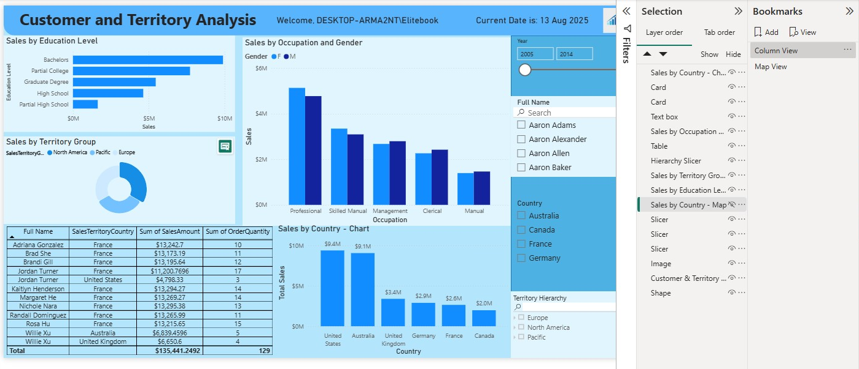
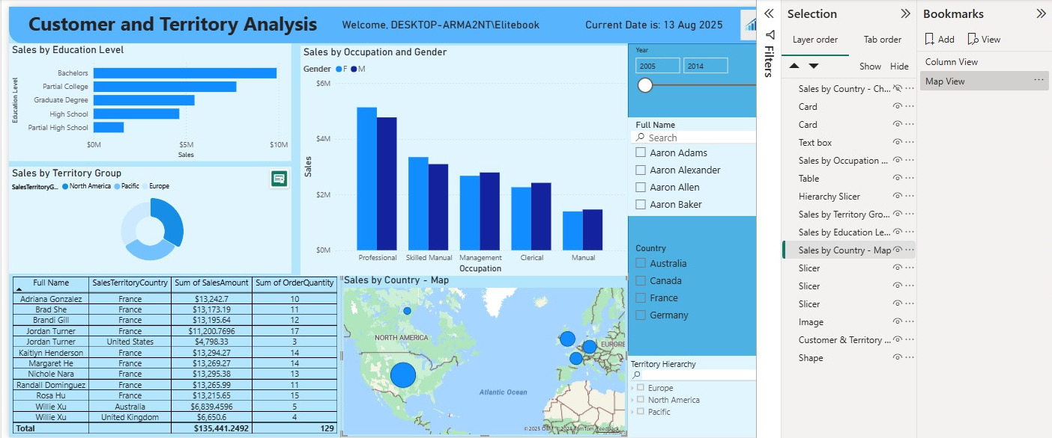

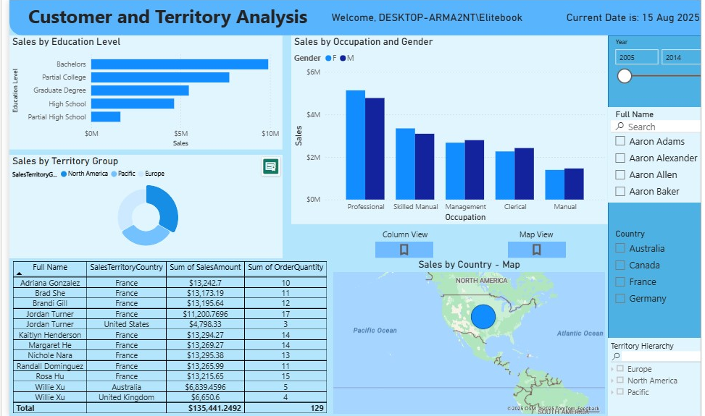

3) On the page with YTD calculation created in previous lab work, add the possibility to switch between MTD, QTD and YTD views for the user. You can use different ways of implementation, so add a description of the method you used and specify why you choose this logic.

On the YTD vs YTD PY page, I implemented the ability for users to toggle between Year-to-Date (YTD), Quarter-to-Date (QTD), and Month-to-Date (MTD) views using bookmarks.
I created three separate DAX measures:
Sales Amount YTD =
CALCULATE(
SUM(FactInternetSales[SalesAmount]),
DATESYTD(DimDate[FullDateAlternateKey].[Date])
)
Sales Amount QDT =
CALCULATE(
SUM(FactInternetSales[SalesAmount]),
DATESQDT(DimDate[FullDateAlternateKey].[Date])
)
Sales Amount MTD =
CALCULATE(
SUM(FactInternetSales[SalesAmount]),
DATESMTD(DimDate[FullDateAlternateKey].[Date])
)

I duplicated the main sales chart twice so there were three stacked visuals each one displaying only one of the above measures. Using the Selection Pane, I set the visibility so only one chart is visible at a time. I then created three bookmarks with Data turned Off and Display turned On, capturing only the visibility state of the three charts.
For the X-axis, I adjusted the field to show a continuous Year-Month progression (instead of the full date hierarchy) so that each time period calculation displayed different cumulative patterns:
YTD accumulates from January to the current month.
QTD resets each quarter.
MTD resets every month.
Finally, I added three buttons linked to the bookmarks, allowing users to switch between YTD, QTD, and MTD views without changing their filter or slicer selections. This gives a dynamic and interactive way to explore the data across different time frames.
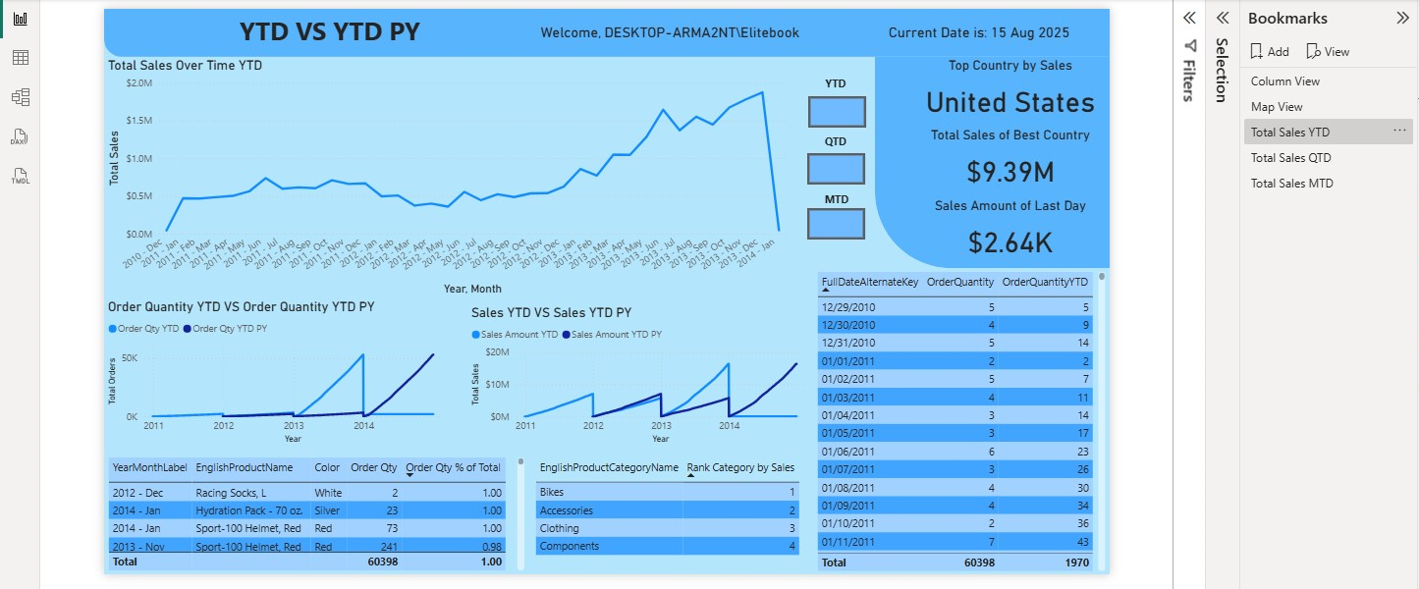
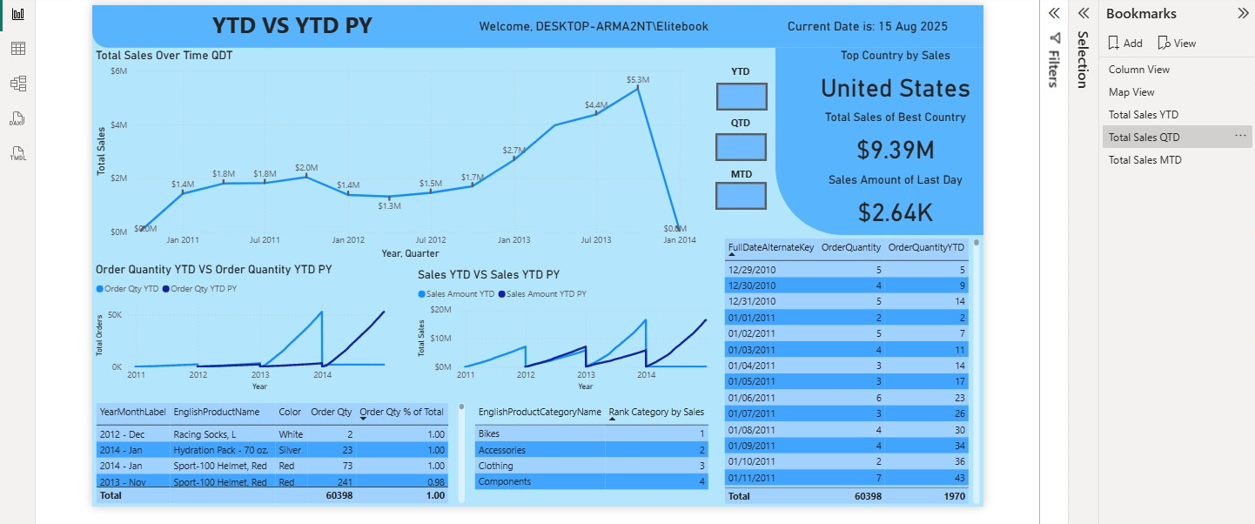
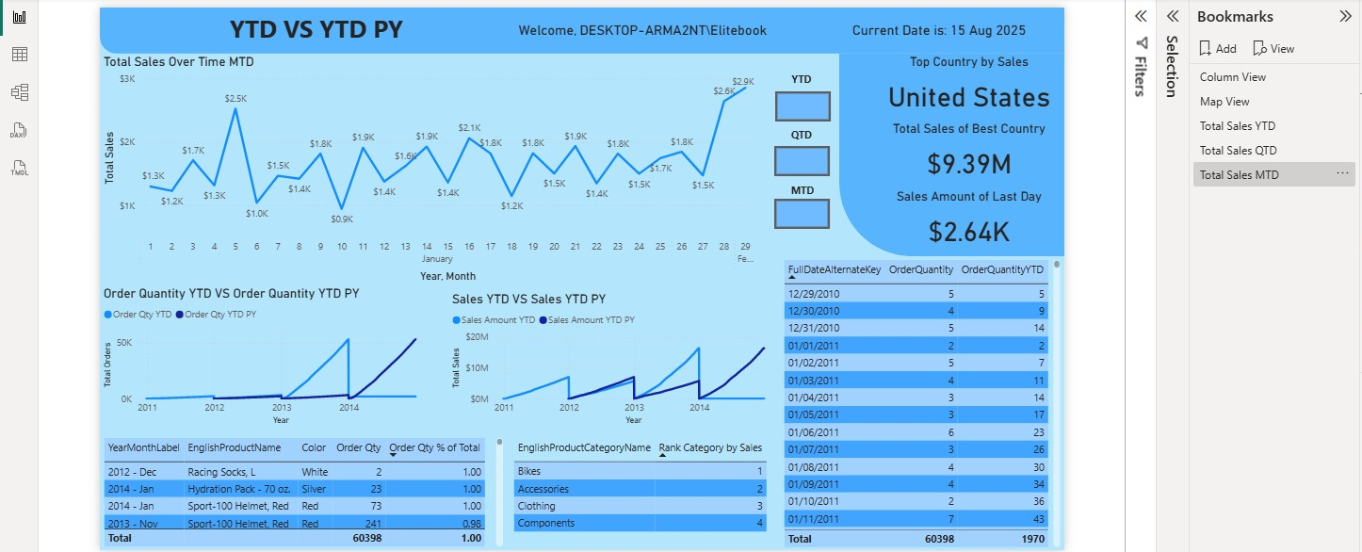

4) Create a decomposition tree visual with at least 3 independent variables. Give short description of you work.

On a new page titled Decomposition Tree, I created an interactive visual to explore Sales Amount across multiple independent dimensions. The Analyze field was set to my Sales Amount measure. In the Explain by, I added:
EnglishProductCategoryName – Product Category
EnglishProductSubcategoryName – Product Subcategory
EnglishPromotionType – Promotion Type
SalesTerritoryCountry – Sales Territory Country
DimCustomer[Gender] – Customer Gender
This setup allows users to start at the total sales level and drill into any dimension in any order. The visual supports AI splits (High/Low value) to automatically choose the next best dimension when performing root-cause analysis.
I enabled Data labels, Header icons, and Tooltips for better readability. Since the tree itself wasn’t analyzed based on dates, I decided to put a year filter on the page.
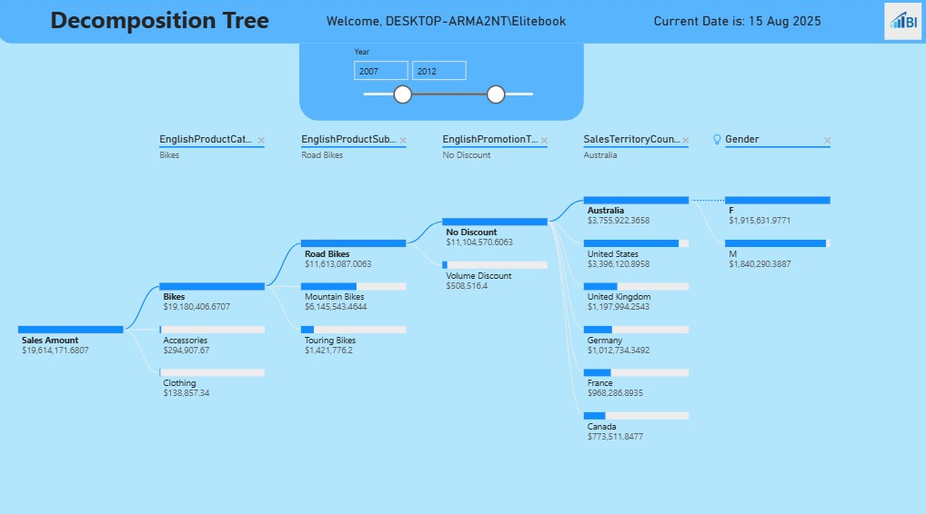

5) Add a tooltip for the selected visual. Give short description of you work.

I created a simple tooltip that shows total orders and total profit using a DAX formula, where I simply found the difference between sales and product costs. Below those two cards, there is a bar chart that shows sales distribution over the years.

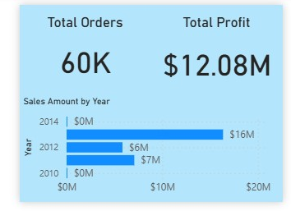
Example:

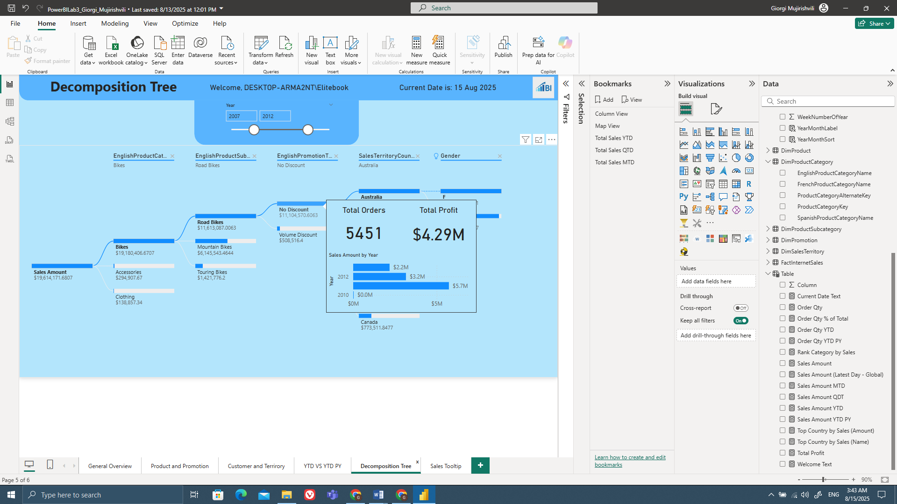

6) *Try to create Custom visual in Power BI Desktop. Add description of the method you choosed and explain what the usage of your visual is and what opportunities the visual you created gives you in comparison with the default visuals.

I’m very late on the homework by itself so I don’t have a time to create my own visual.

