4.2 Basic Transformation

1) check that all the selected tables were loaded.


2) Create a column with full Customer name:
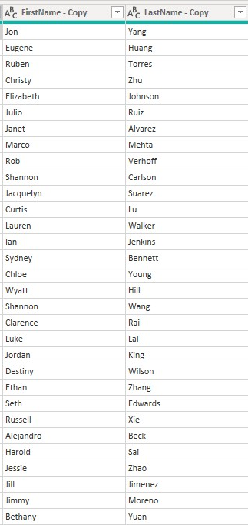
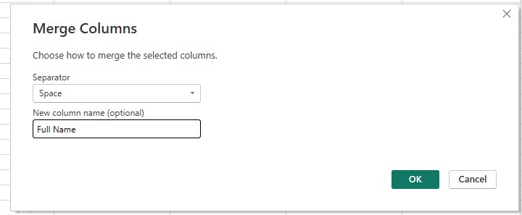
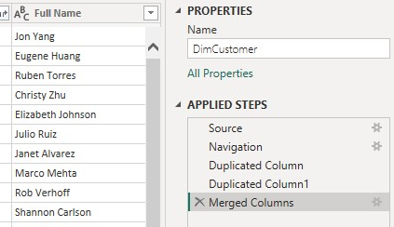

3) Change column type:

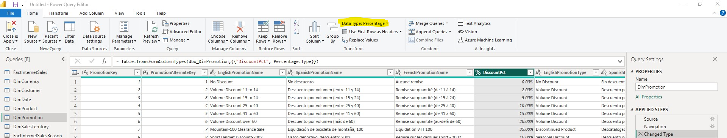
I just changed the data type from the higlighted field.

4) Calculate the length of Promo campaign:
I chose the option 1
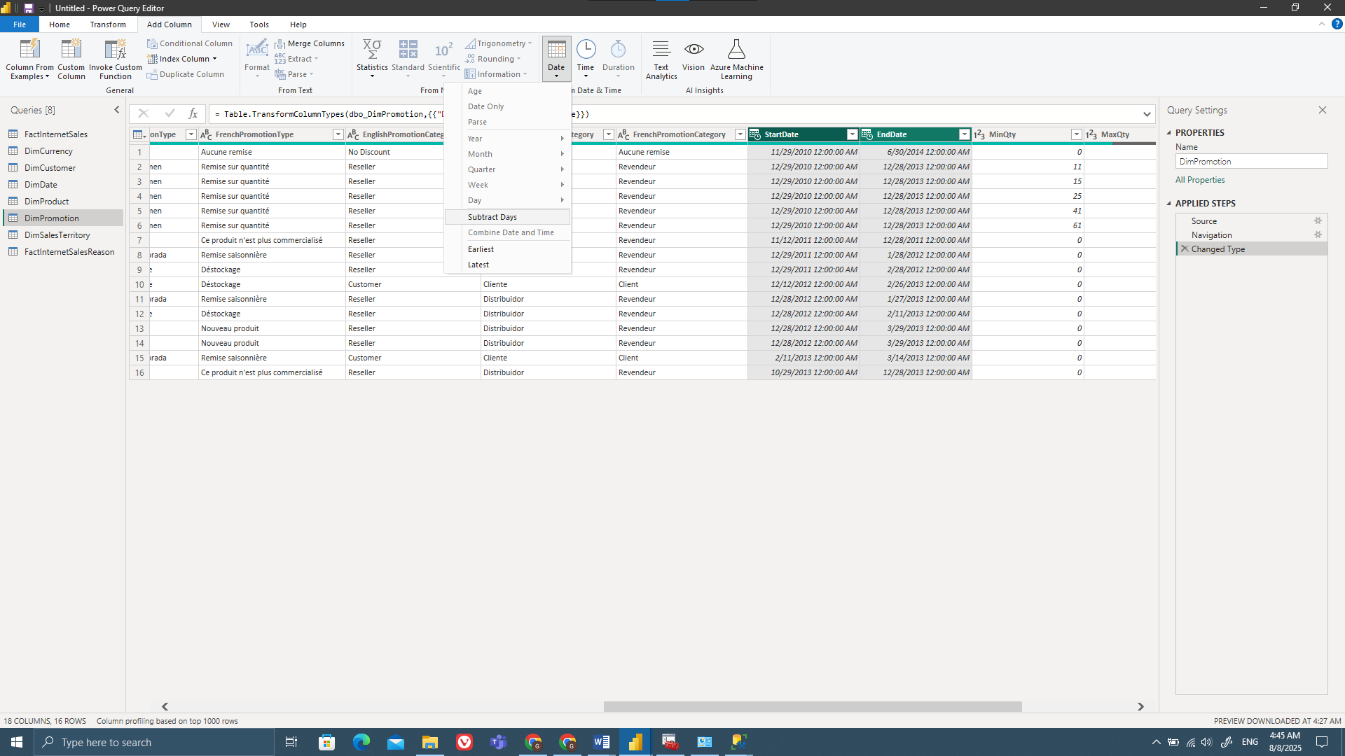
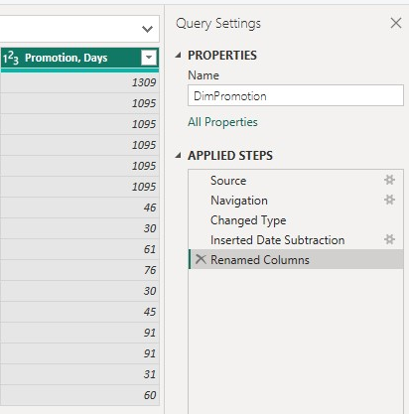

4.3 Adding new tables
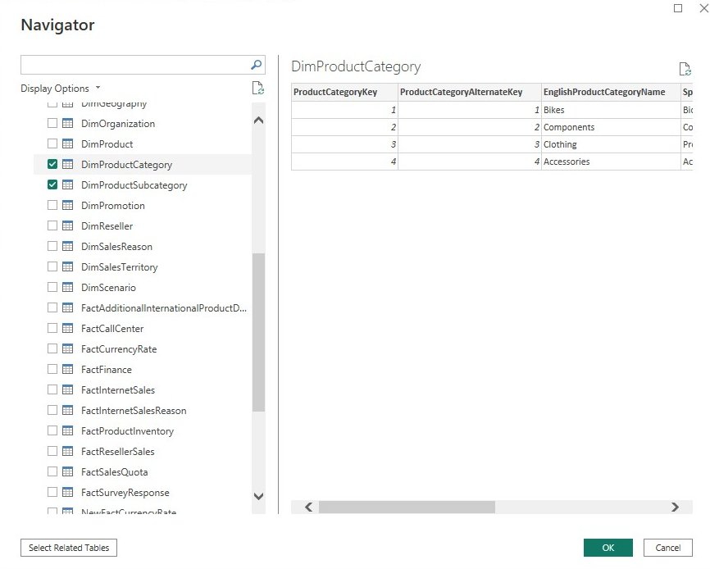


4.4 Data Profiling
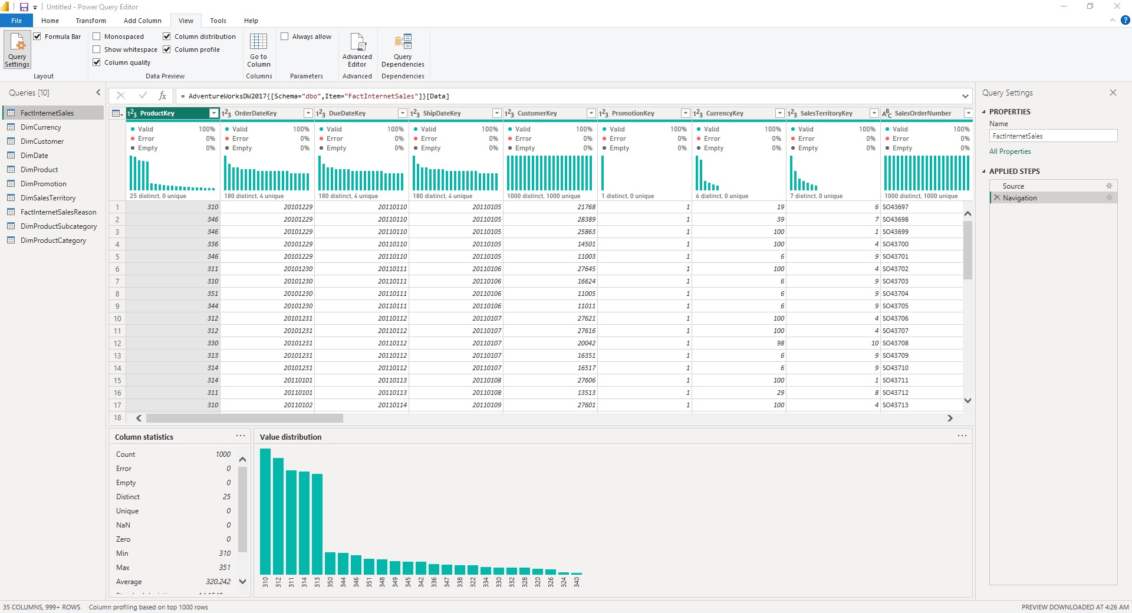

4.5 Pivot Column

1) Create column ‘Order Year’ based on the ‘OrderDate’ column in the table ‘FactInternetSales’:
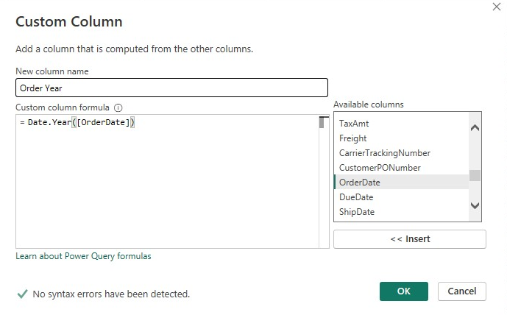
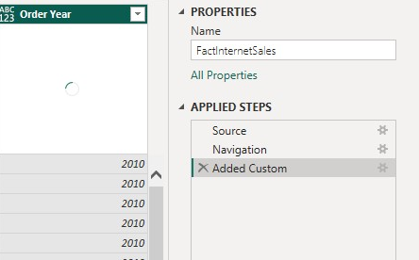

2) Create a new table based on ‘FactInternetSales’:
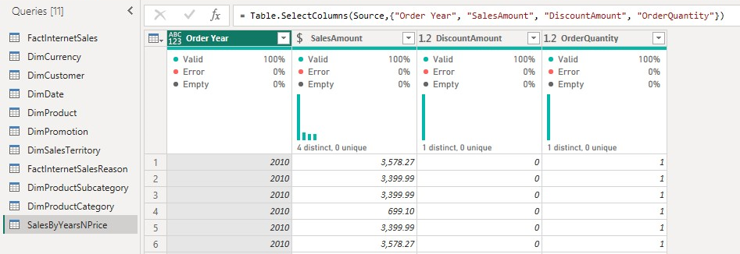

3) Choose column ‘Order Year’ (‘SalesByYearsNPrice’ table), navigate on the Transform tab and click on Pivot Column

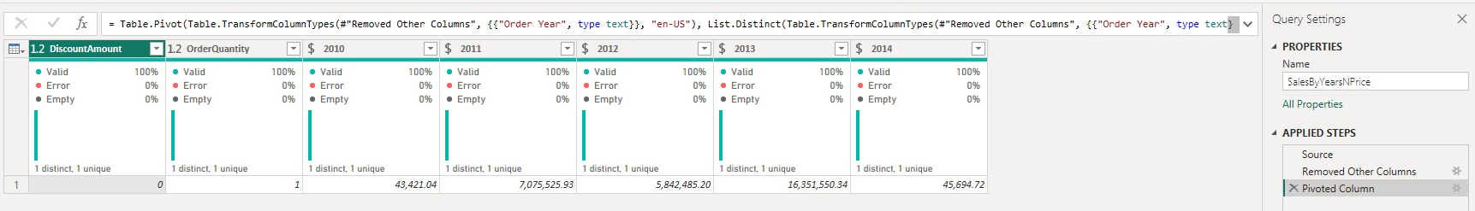

4.6 Table Joining

Create a new table ‘SalesByCountry’ in a way you did it in the task 4.5.
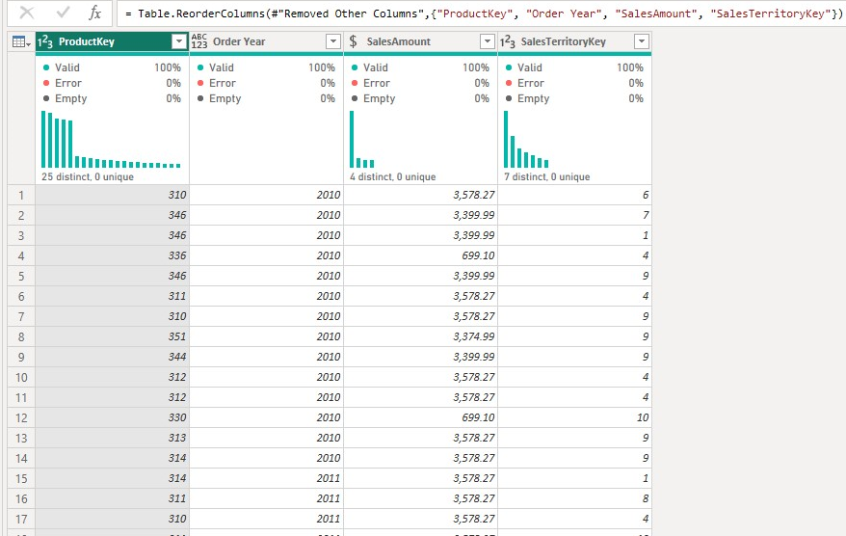

Join ‘SalesByCountry’ and ‘DimSalesTerritory’ tables:

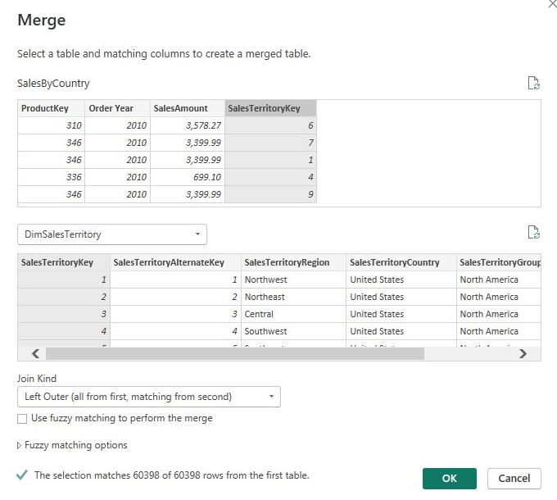

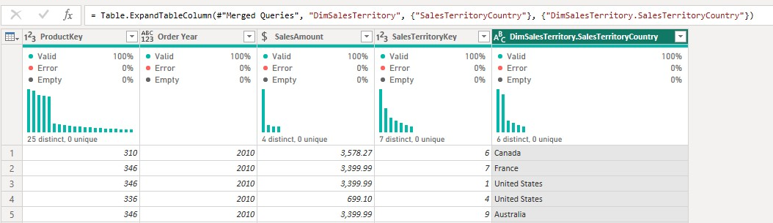

Join DimProductCategory[EnglishProductCategory] column in the same way.

Joining SalesByCountry and Products by ProductKey and expanding to see ProductSubcategoryKey

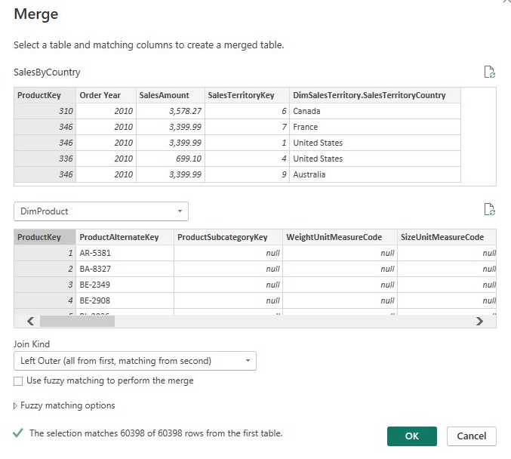

Then joining SalesByCountry and DimProductSubcategory by ProductSubcategoryKey and expanding to see ProductCategoryKey
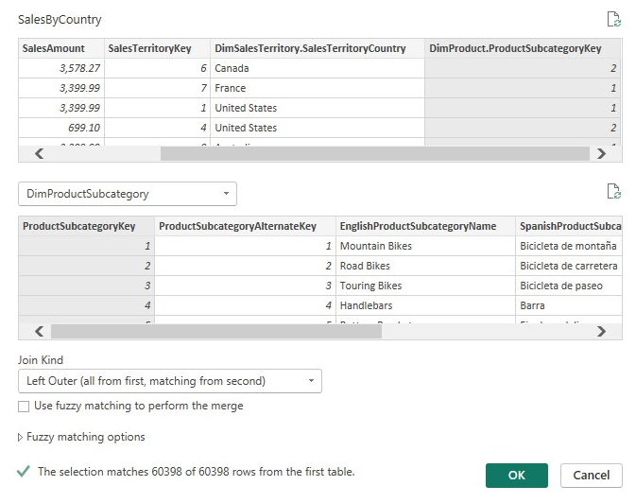
And then joining SalesBycountry to DimProduct by Product Key and expanding to see EnglishProductCategory
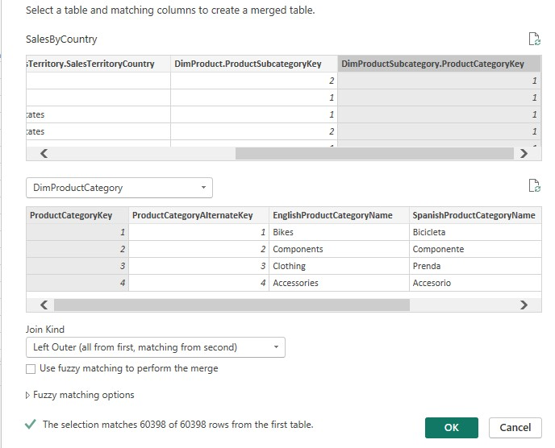
The result:
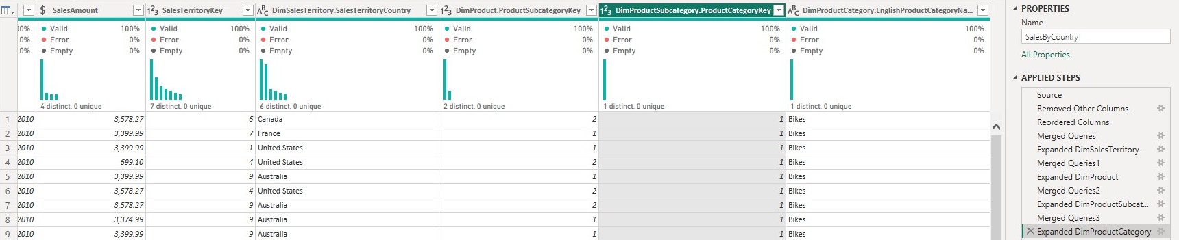

4.7 Grouping Data
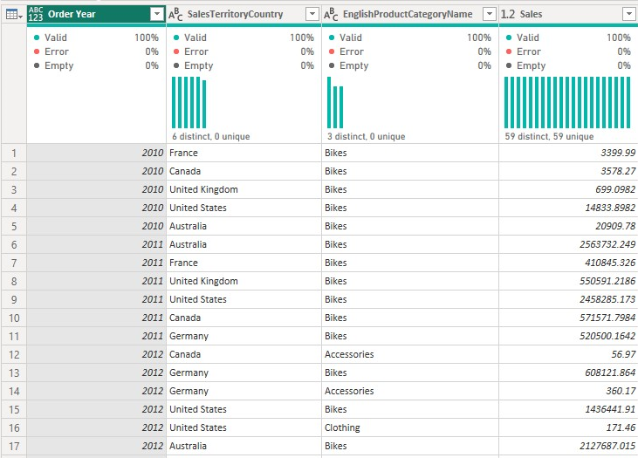

This result shows how much sales certain products generate in a certain country in a designated year. The table is sorted in ascending order, so it will show the sales amount from 2010 to 2017 for each year.

4.8 Load Data
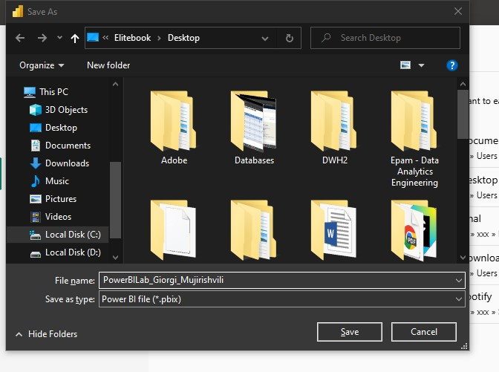

4.9 Import VS Direct Query

Create a new .pbix file and connect to the source using Direct query.

Describe the difference between an Import and a Direct query based on the results.

In Power BI Import mode loads data is loaded into Power BI’s in-memory storage, meaning reports run very fast because all queries are executed locally on a compressed dataset. However, the results reflect the state of the data only at the last refresh, so scheduled or manual refreshes are needed to stay up to date. DirectQuery mode does not store the data in Power BI, instead, every visual or filter sends a live query to the source system. This ensures that results always show the most current data without the need for refreshes, but performance depends on the source’s speed and can be slower than Import mode. In short, Import offers speed and offline analysis with snapshot data, while DirectQuery offers real-time results but relies on the performance of the underlying data source.

4.10 Working with Power BI Model

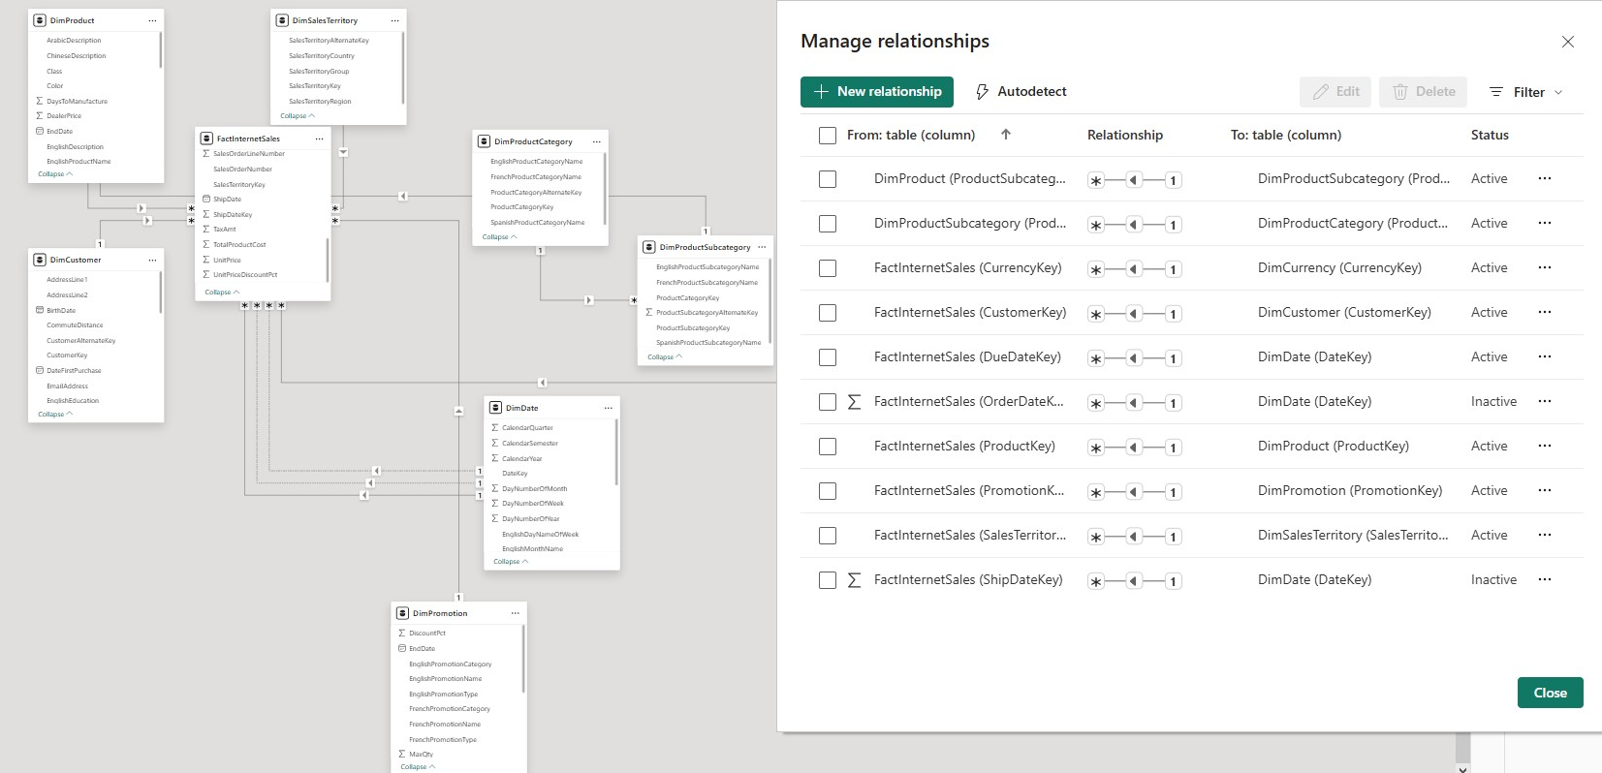
After removing extra relationships:
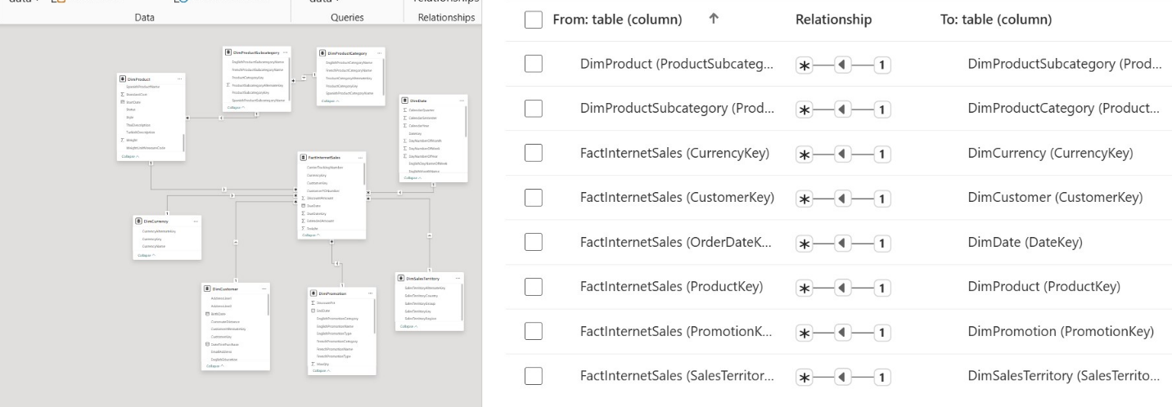
Every cross filter and cardinality is correct

