CE_ADDRESSES

Checking insertable rows:
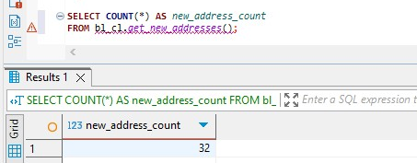
After calling the procedure, we check the log:
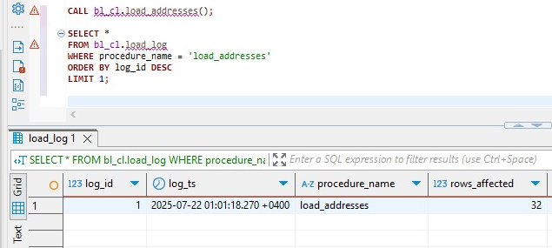
After we rerun the procedure, we get that rows affected will be 0, because we didn’t have new rows
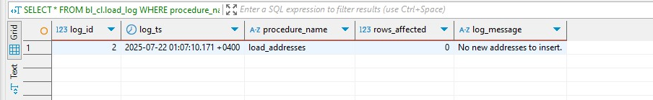

CE_CUSTOMERS

Checking insertable rows:

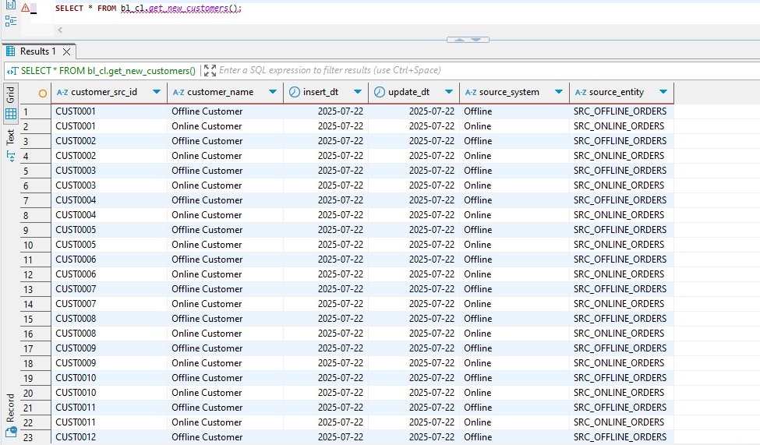
There are 1000 rows. After calling the procedure:

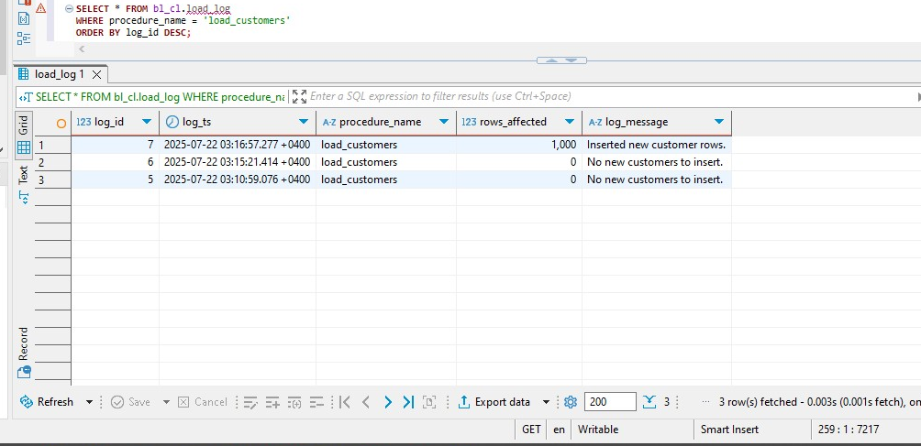
My procedure failed twice, because the data types of bl_3nf.ce_customers and the same column in the source file didn’t match, one was integer and other VARCHAR respectively. After rerunning the procedure we get
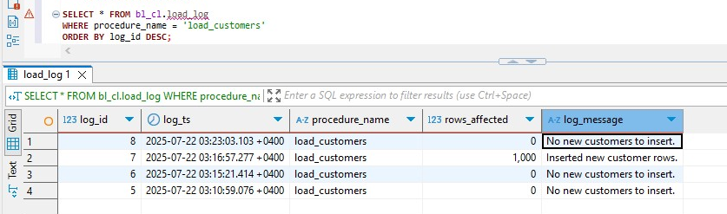
And this shows that all rows were inserted properly and there are no new rows to be inserted.

CE_EMPLOYEES
Checking insertable rows:
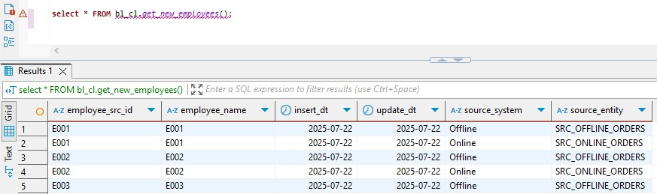
There are 40 rows to be inserted. After calling the procedure
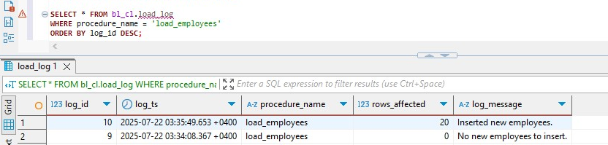
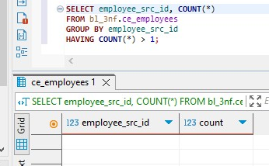
Same issue here, incorrect data types and after correcting it, rows were inserted. As I mentioned there were 40 rows to be inserted, but there were duplicates, E001 exist in both, offline and online sales, so the deduplication method got rid of half of them. After everything I checked for duplicates and got 0, which showed that everything worked properly:
Rerunning procedure shows
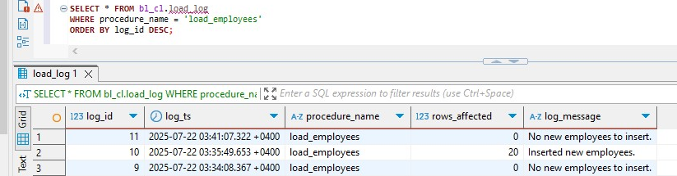
And once again everything worked just fine.

CE_BRACNHES
Checking insertable rows:
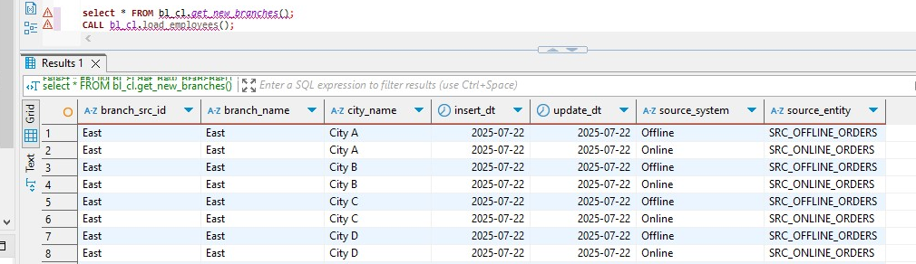
We get 32 insertable rows but there are duplicates so only 16 should be inserted.
This screenshot shows results after running procedure twice, at first it insrted the rows and at the second time it didn’t because there were no rows left to insert.
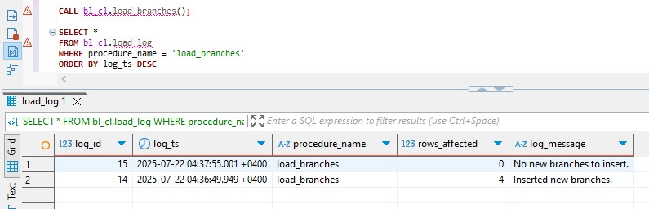
To verify that there are no moer candidates
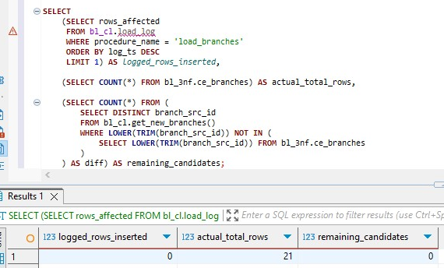

CE_CHANNELS
Checking insertable rows:
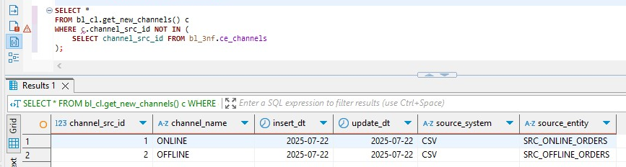
After calling the procedure twice and checking the status:
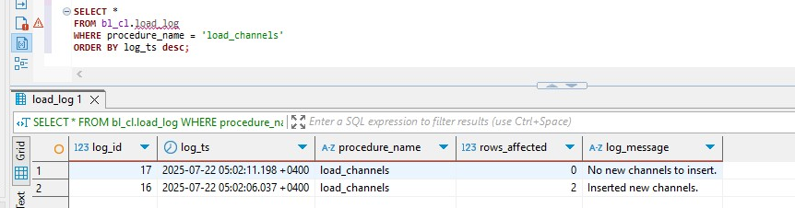
It shows that first call inserted both rows and there is nothing left. To recheck it
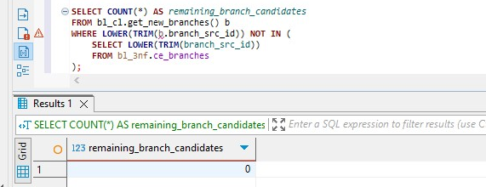

CE_PRODUCTS
Checking insertable rows:
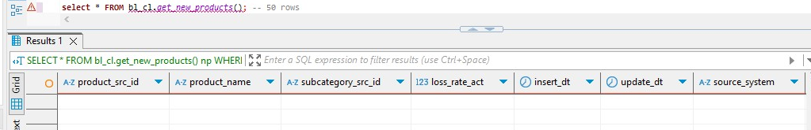
this query returns no rows because the filtering logic in get_new_products() checks whether product_src_id already exists in ce_products, no new candidates remain, so the function returns 0 rows. That’s why log shows that each call inserted 0 rows.
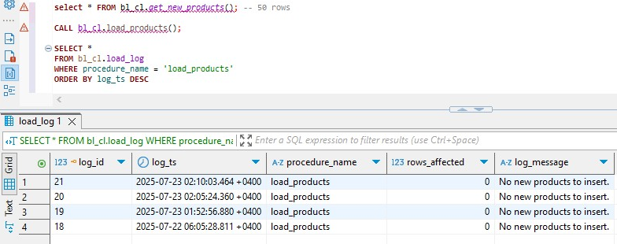
To recheck it
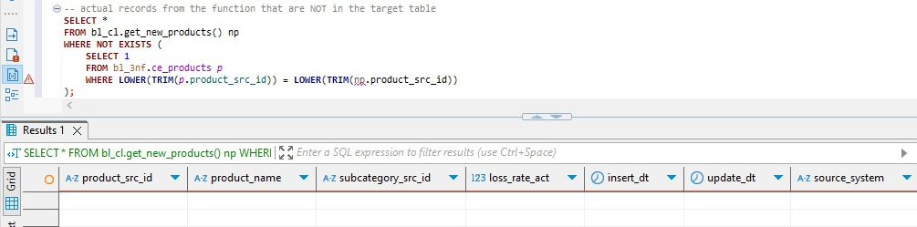

CE_PRODUCT_CATEGORIES
Checking insertable rows:
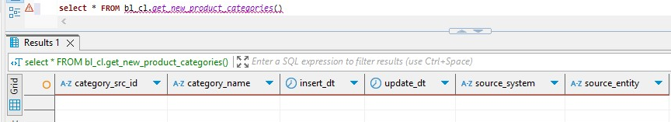
The same thing happens here that was for products table and that’s why there are no candidates to insert. After calling the procedure and checking the log we see that:
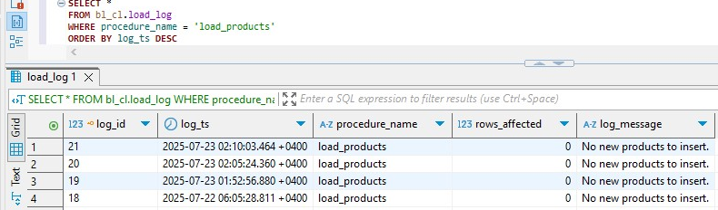
I ran the procedure multiple times because I thought I was doing something wrong but turns out it was correct from the beginning.
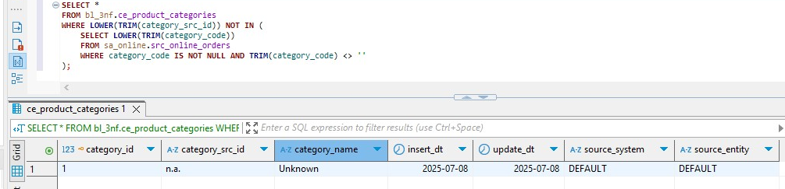
This query and result shows that only row that is inside of a 3NF table and isn’t in source file is default row.

CE_PRODUCT_SUBCATEGORIES
Checking insertable rows:
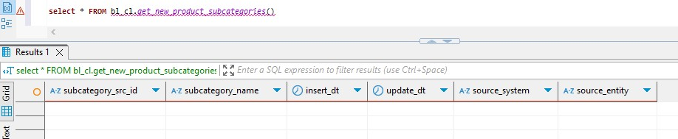
Once again there are no insertable rows. Since my dataset was generated it did a bad job and I didn’t have product subbcategory, so in DWH_TASK_6 I used category code as for both subcategories and categories. This makes subcategories redundant for now but it will be an usefull table later when new data will be inserted. After calling the procedur and checking the log we see
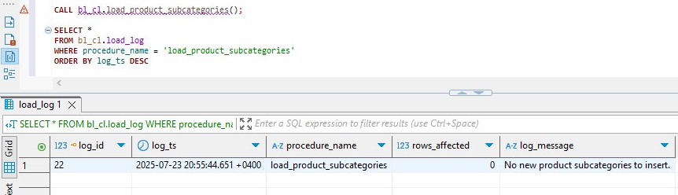
And this confirms that there were no rows to insert.
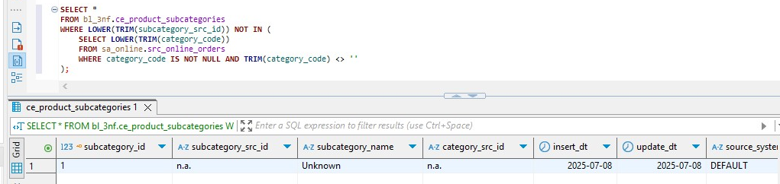
This query shows the identical result as it did to product categories, because I used category_code clumn from source to identify subcategories and categories, plus I didn’t have that column in offline sales so I only used online source.

CE_PRODUCT_PRICE_SCD
Checking insertable rows:
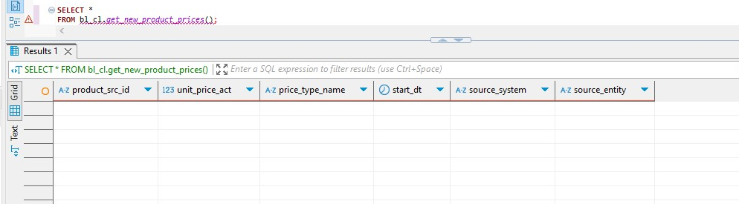
Same thing happens for product prices, there are no new rows to be inserted, so after calling the procedure we get
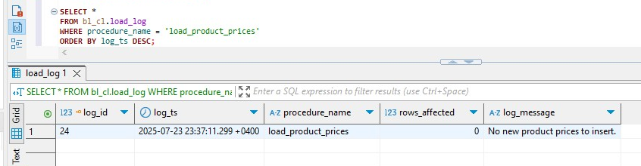
To rechek it
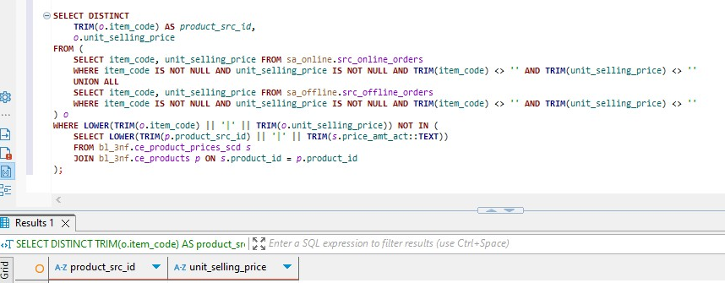
This query shows that there are indeed no new rows to be inserted.

