Fresh Supermarket
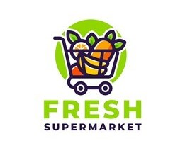

Business Model
Company Name & Logo:
The company is named Fresh Supermarket, represented by a logo of a shopping cart filled with fresh fruits. The logo’s green, orange, and purple colors inspired the report’s design palette.
Field of Activity:
Fresh Supermarket operates in the retail grocery sector, focusing on online and offline sales of fast-moving consumer goods. The business emphasizes competitive pricing, customer satisfaction, and efficient sales operations.
Business Process Analyzed:
The report focuses on the sales and profitability process, tracking how products are sold, how customers purchase over time, how employees contribute to revenue, and how product prices evolve.
Purpose of the Report:
The primary purpose of this Power BI report is to provide a view of sales performance, enabling decision-makers to identify the best-performing products, customers, employees, and time periods. It also helps uncover pricing trends and profitability drivers.

End Users of the Report:
- Executives and Store Managers → to make pricing, inventory, and promotion decisions.
- Sales & Marketing Teams → to identify top customers and plan loyalty programs.
- Finance Analysts → to evaluate profitability and gross income contributions.

Business Questions & Problems Solved:
- Which products are the top sellers and most profitable?
- How are sales trending month by month, and which periods perform best?
- Which customers contribute the most revenue, and what is their purchase pattern?
- How do employees contribute to overall sales and gross income?
- What are the pricing trends for key products, and when do highest prices occur?
- Which areas of the business need attention for profitability (discounts, low-margin products)?

Detailed Page-by-Page Explanation

Page 1 – Sales Overview
This page provides executives with a high-level summary. The donut chart shows sales by product, allowing managers to see proportional contributions. A clustered bar chart presents sales by branches, making branch-level performance comparable. KPIs such as gross income, average price of unit, total quantity sold, and total sales give immediate numeric insights. A clustered column chart shows sales by year and month in chronological sorting. Finally, a donut chart shows sales by channel distinguishing online and offline revenue.

Page 2 – Sales Performance
KPI cards highlight the highest GI product, the best-selling product, and its sales value using measures created with TOPN logic over fact sales table. A line chart shows sales over months, emphasizing seasonality. A Pareto chart combines bars for total sales per product with a line for Pareto %, highlighting the 80/20 rule. A heatmap matrix shows weekday performance by month, providing operational insight. A scatter plot shows avg unit price vs discount % vs sales to find outliers.
Tooltips applied: The Pareto chart uses Product Tooltip, showing KPIs and trendlines when hovering a product.

Page 3 – Customer Insights
KPI cards summarize total customers active customers, average spend per customer, and top customer by sales. A bar chart shows top customers by sales, while a line chart shows customer count and sales trend month by month. A scatter plot links total quantity vs total sales with bubble size = gross income. A table lists Top 10 customers with their KPIs.
Tooltips applied: The clustered column chart for customers uses Product Tooltip, letting analysts see product-level KPIs behind customer purchases.

Page 4 – Product Analysis
KPIs show total products, the best-selling product, the highest price product, and the price value. A bar chart ranks sales by products. A line chart visualizes price changes of the best-selling product over time. A detailed table lists products with average price, quantity, sales, and gross income. A column chart shows gross income by products.
Tooltips applied: The column chart uses Product Tooltip, displaying product-level metrics and trendline context when hovering.

Page 5 – Employee Performance
KPIs summarize total employees, the top employee by sales (TOPN), and average sales per employee. A line chart shows the sales trend of top 3 employees across months. A horizontal bar chart highlights gross income by employees, while a vertical bar chart ranks sales by employees overall. Finally, a table shows detailed employee KPIs: sales, quantities, gross income, and avg price. This helps managers decide which employees excel and where training or incentives may be needed.

Tooltips Pages (Supporting Pages)
- Product Tooltip: Shows total sales, average price, gross income, and a sparkline of monthly sales for a product.
- Customer Tooltip: Shows customer ID, total sales, total quantity, gross income, and trendline.

Calculated Columns & Measures
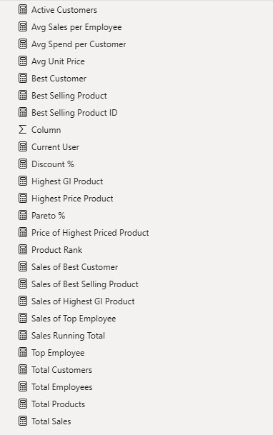
Almost all these measures were used while designing the report.
Since the DWH had insufficient data in many fields, the report lacks the use of bookmarks and buttons.

