- The cheapest way of creating a database in Cloud - take just a virtual machine (EC2 in our case) and install database by your own. Let’s do it.
- Create EC2 t2.micro instance (EBS volume size should be not more than 10GB and security group should be “dilab-training”) and add AWS_EC2_full_access_S3 role to it to allow S3 access for your EC2 machine. Name of the instance as always should be recognizable. As an Important security requirement ensure that Metadata Service Version 2 is enabled: on Launch an instance page click Advanced details and ensure that Metadata accessible is set to Enabled and Metadata version set to V2 only.

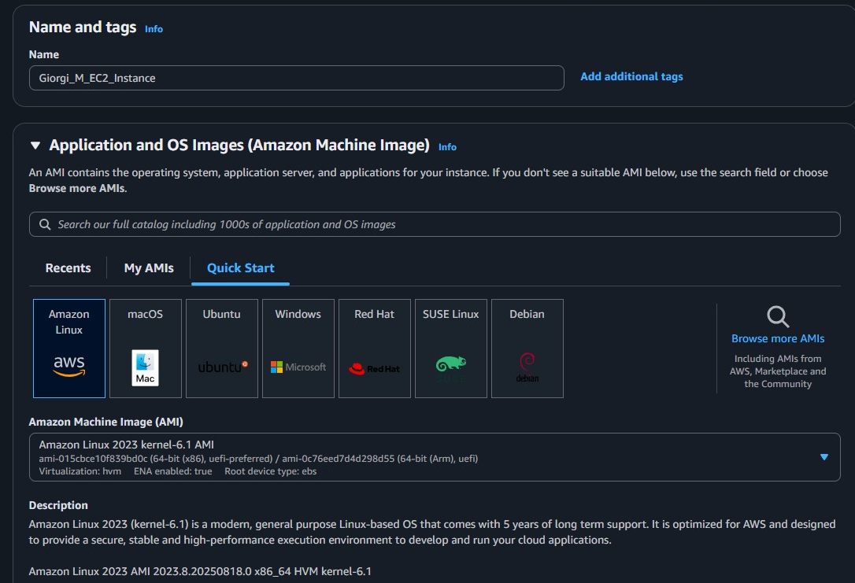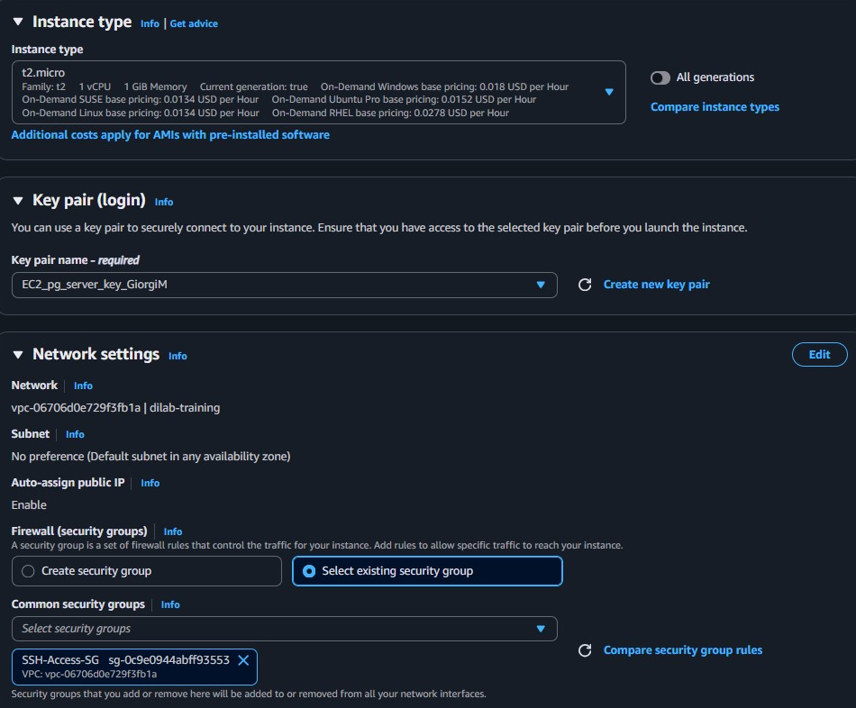

Connected to instance using putty:
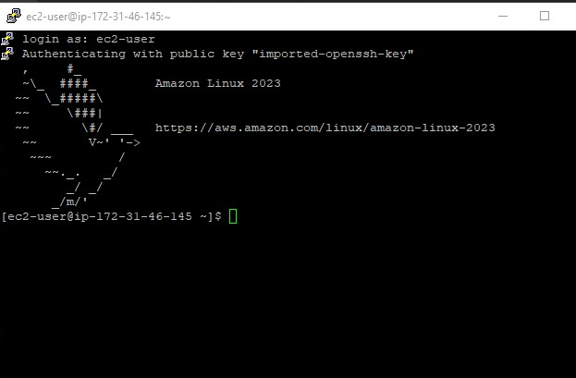
I used following commands:
sudo tee /etc/yum.repos.d/pgdg.repo > /dev/null << 'EOF' [pgdg17] name=PostgreSQL 17 for RHEL/CentOS 9 - x86_64 baseurl=https://download.postgresql.org/pub/repos/yum/17/redhat/rhel-9-x86_64 enabled=1 gpgcheck=0 EOF
sudo yum makecache,
sudo dnf install postgresql17-server postgresql17 -y,
sudo /usr/bin/postgresql-setup initdb,
sudo systemctl enable postgresql --now,
systemctl status postgresql,
sudo su - postgres,
psql -c "ALTER USER postgres WITH PASSWORD '<specify_your_psswrd>'" (then 'exit' command),
sudo yum install mc,
sudo su - postgres,
mc (then I modified 2 files mentioned in the video; be aware of the '#' character at the beginning of lines u modify),
sudo systemctl restart postgresql,
ss -tulpn | grep postgres

- Install Oracle/ or PostgreSQL/ or MySQL on the EC2.
- Connect to this database from any SQL client (e.g. DBeaver - very useful IDE because of community edition and possibility to work with almost all most famous databases).
- Insert your connection configuration (host, database, user, password) for mentors to check the connectivity, screens that you have connected to the db on your EC2 into the Report

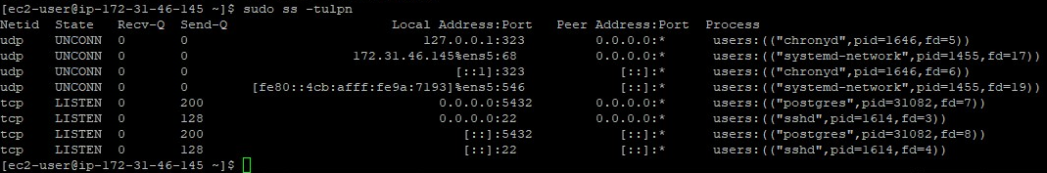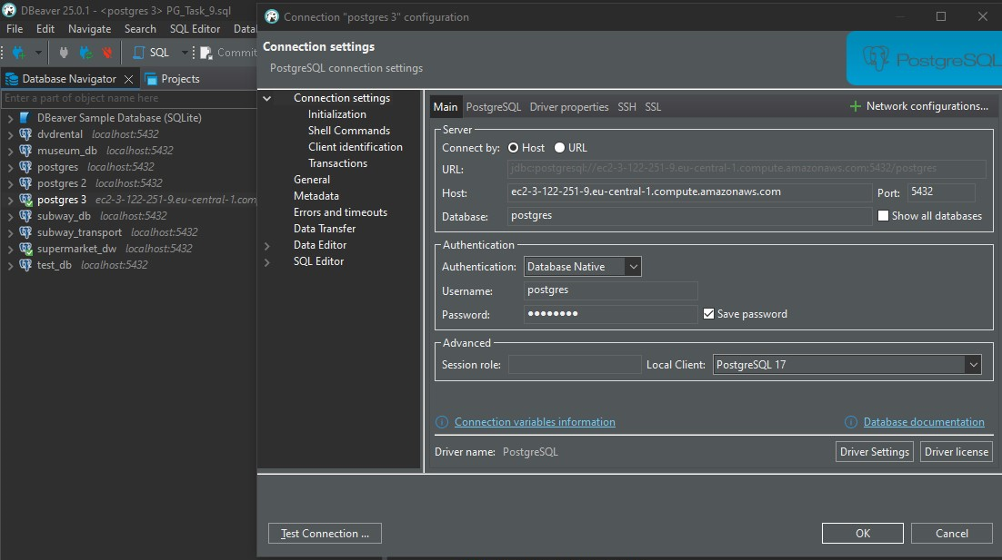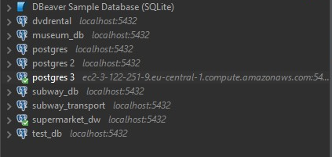
Additionally I created a snapshot and an image for this to connect easier in the future.
- Create several objects in the created database ( at least one table, view, procedure ).
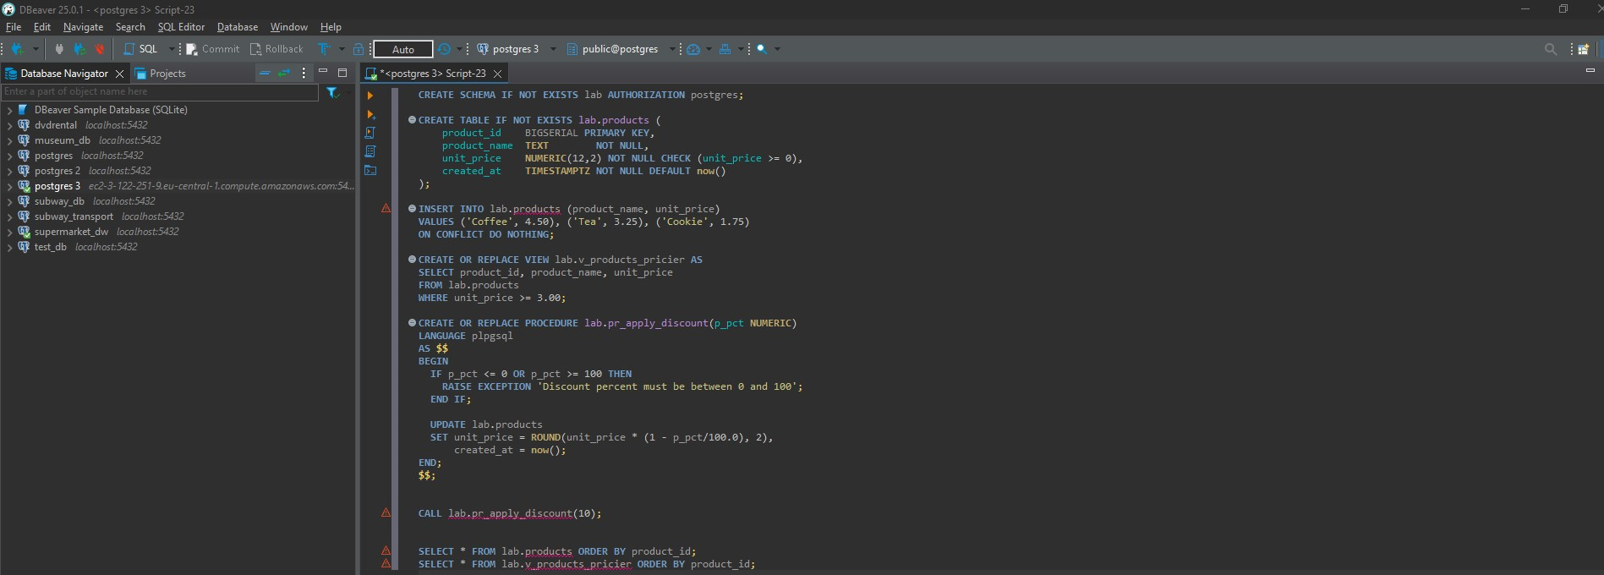

- Take any file from your S3 bucket and copy it into the EC2 using AWS_EC2_full_access_S3 role that has been attached to the virtual machine on the first step. Screen of the files inside the EC2 into the Report.
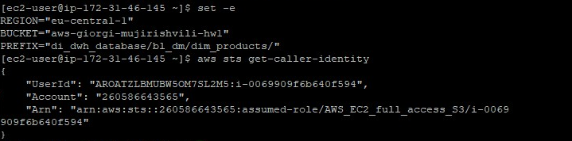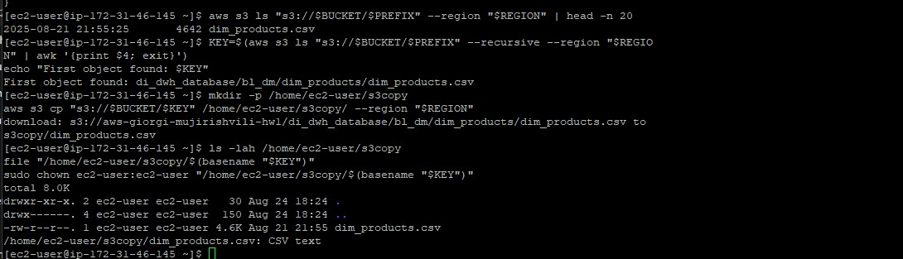

- For you EC2 a separate EBS volume was allocated. Let’s create snapshot of this EBS volume. Afterwards, let’s create AMI (identifiable name) from the created previously snapshot. It will be a copy (image) of your EC2 machine.

I have also created an image in the first task,but since I copied objects a bit later I launched a new one.
- From the image (AMI) you've made on the step 3, raise a copy of the EC2. As an Important security requirement ensure that Metadata Service Version 2 is enabled: on Launch an instance page click Advanced details and ensure that Metadata accessible is set to Enabled and Metadata version set to V2 only.
Show that the data file you put to the EC2 on the step 2 has been saved into the server copy as well. Save the screen into your Report.
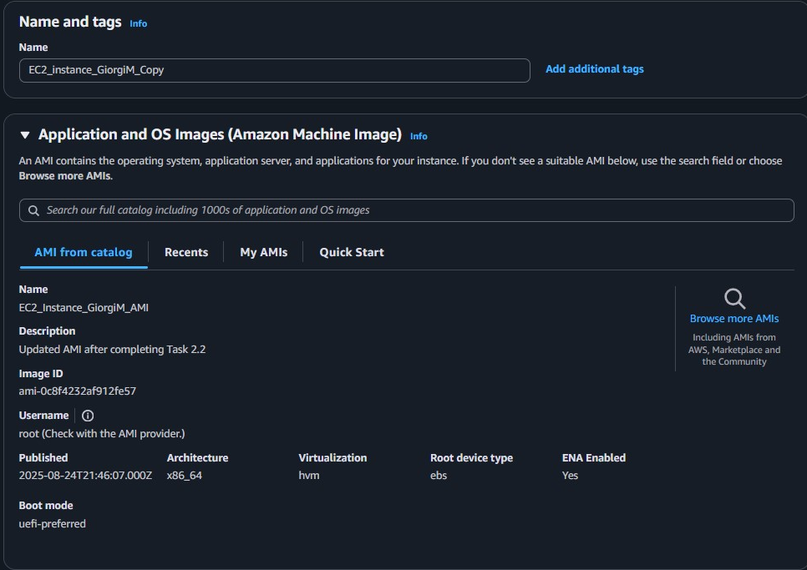

- Create your first web page, install apache web server and push any html to the standard directory /var/www/html (apache web server installation and html example will be in the general folder).
Check that the page is available by IP address from the browser and insert link to this page and screens into the Report. Using link mentors should have a possibility to see your web page.

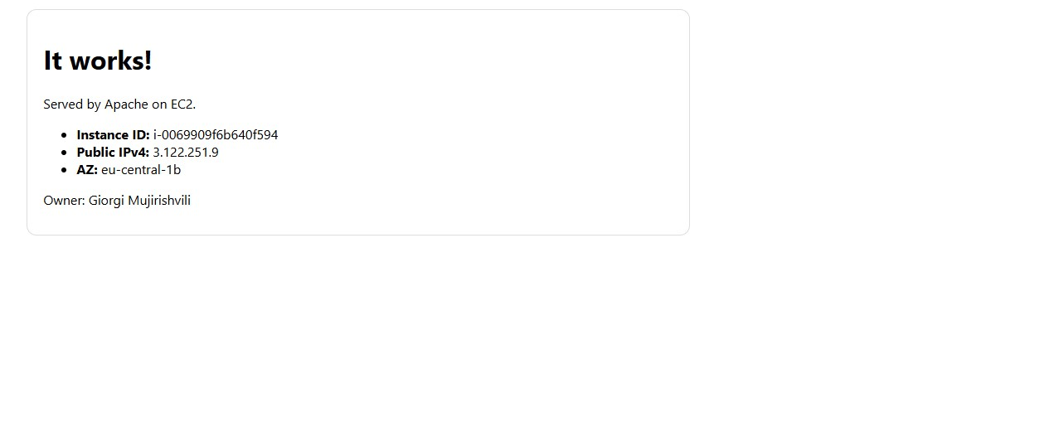
- You will have the rights to create SNS notifications.
Create Senseful CloudWatch Alarm for any events exceeding your EC2 resources and create your own SNS queue, that will send the results to your email (you specify email when creating SNS). Appropriate screens to the Report.
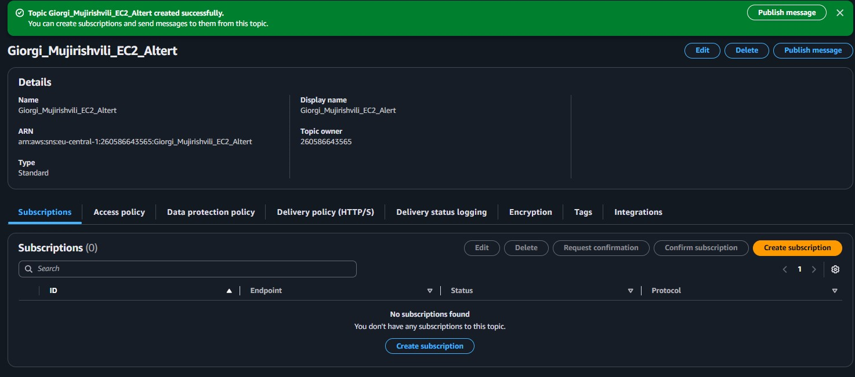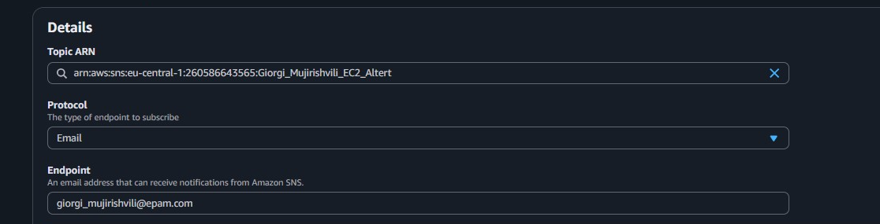

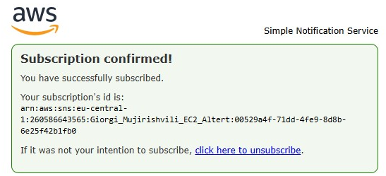

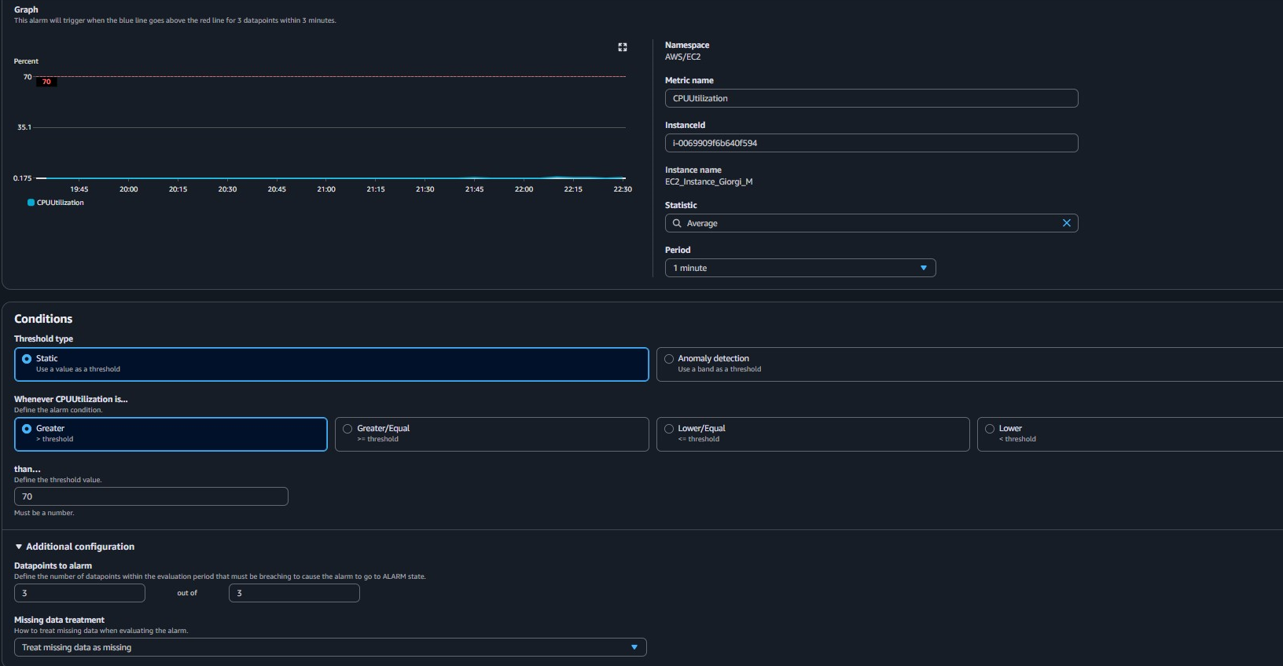
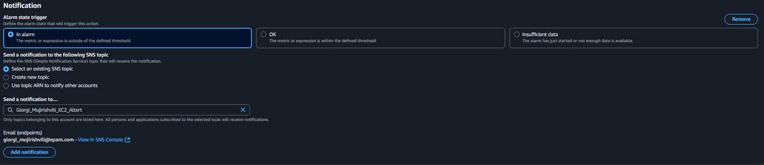
The name is EC2-CPU-High-(i-xxxx)

- Try to create same EC2 virtual machine using a CloudFormation script. Save the script into your bucket and to the Report.

The script I used is in the bucket.
Sample page:
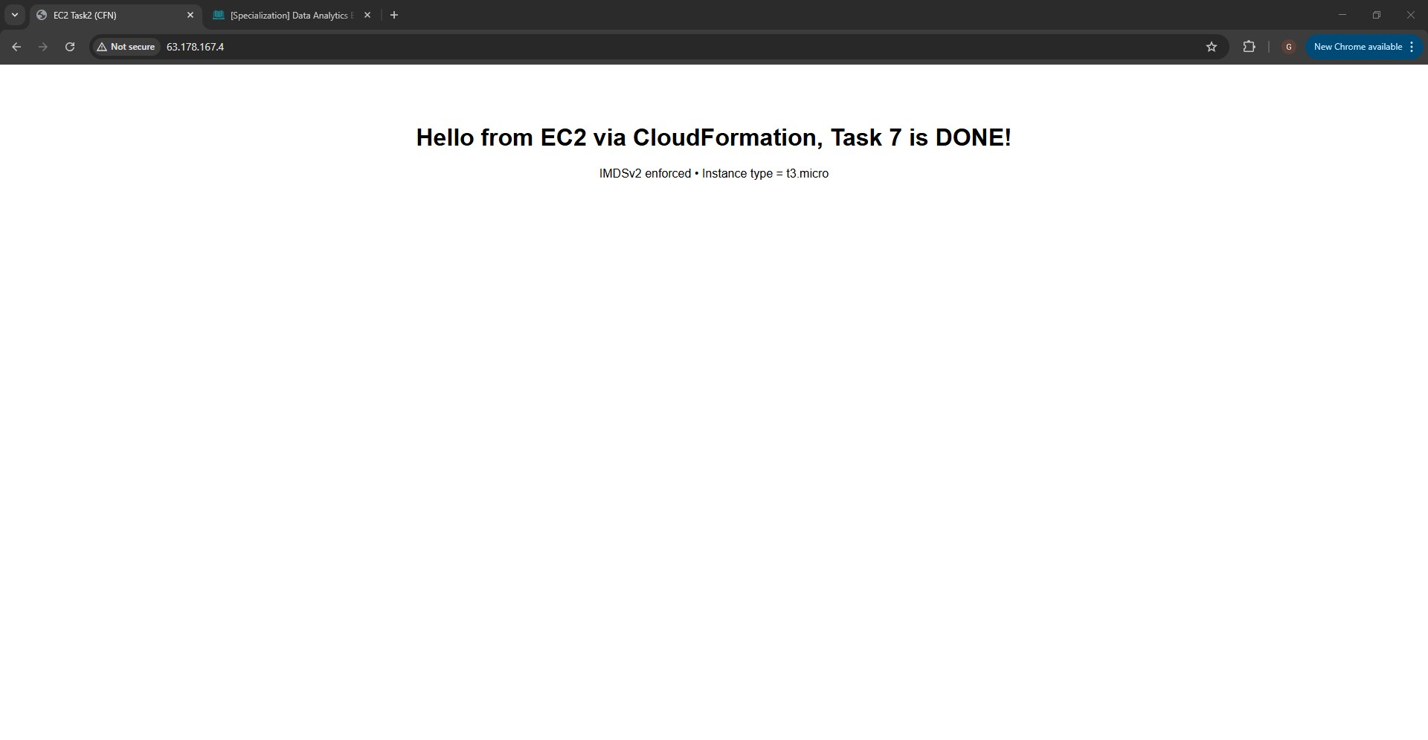
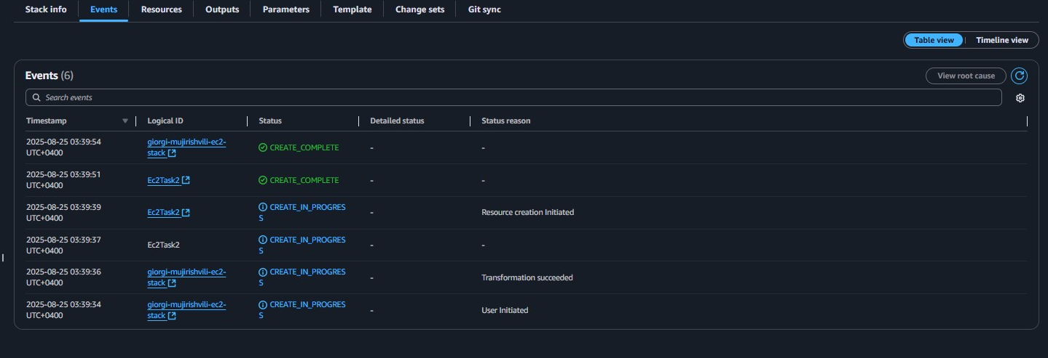

- Extra tasks:
  - * Install any database or any program in EC2 using docker and provide access to this service from the outside.
  - * Schedule any .sh script (or any other script) using cron for executing something on the docker service created by you (just simple sql call to the database for example).

To install docker:
sudo dnf -y install dnf-plugins-core
sudo dnf config-manager --add-repo https://download.docker.com/linux/centos/docker-ce.repo

sudo dnf -y install docker-ce docker-ce-cli containerd.io docker-buildx-plugin docker-compose-plugin –allowerasing

sudo systemctl enable --now docker

systemctl status docker --no-pager
docker --version
sudo docker run --rm hello-world

Creating Table:
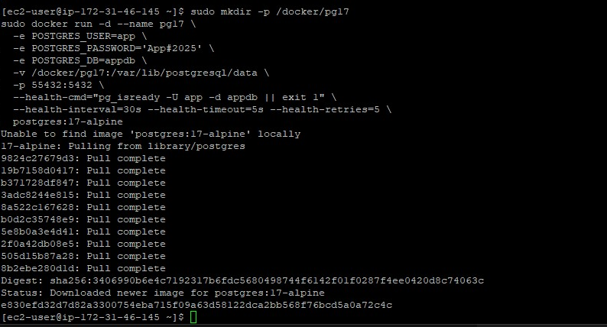

Script for cron cron:
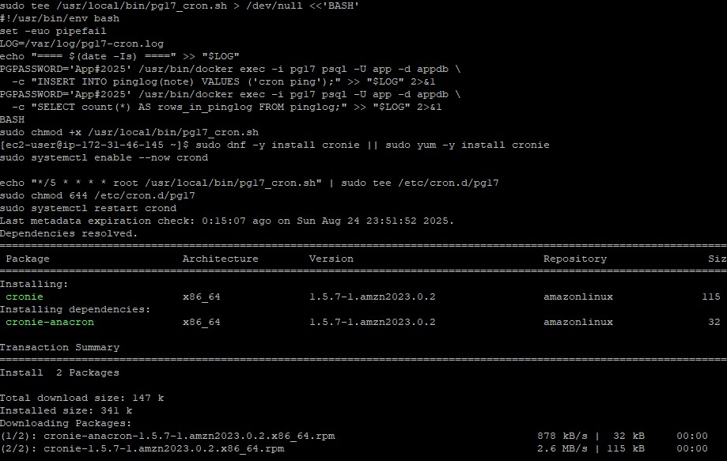
Enabling cron and testing it:
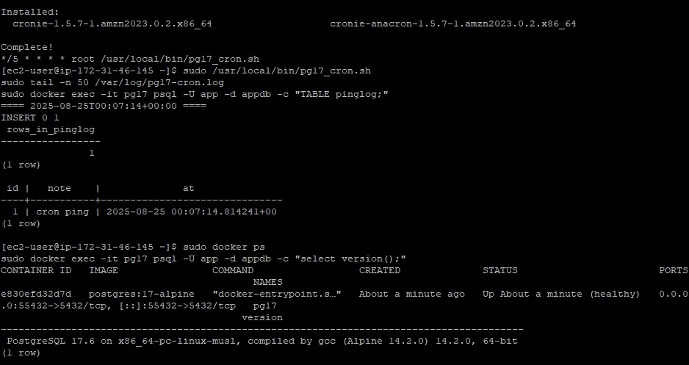

Proving that it works:
