Tasks:

1) Establish connection to AWS account:
  - a)Login AWS Console with SSO using link provided in the email from Auto EPM-CSUP Notification
  - Choose “User” to login AWS Console
  - After you logged in the console in the right upper corner click drop down button
  - Click “Switch role” button
  - Account name – 260586643565
Role – students-role
Display Name (optional) – Fill in the name you like.
Color (optional) – Chose the one you like.

Output after all this:

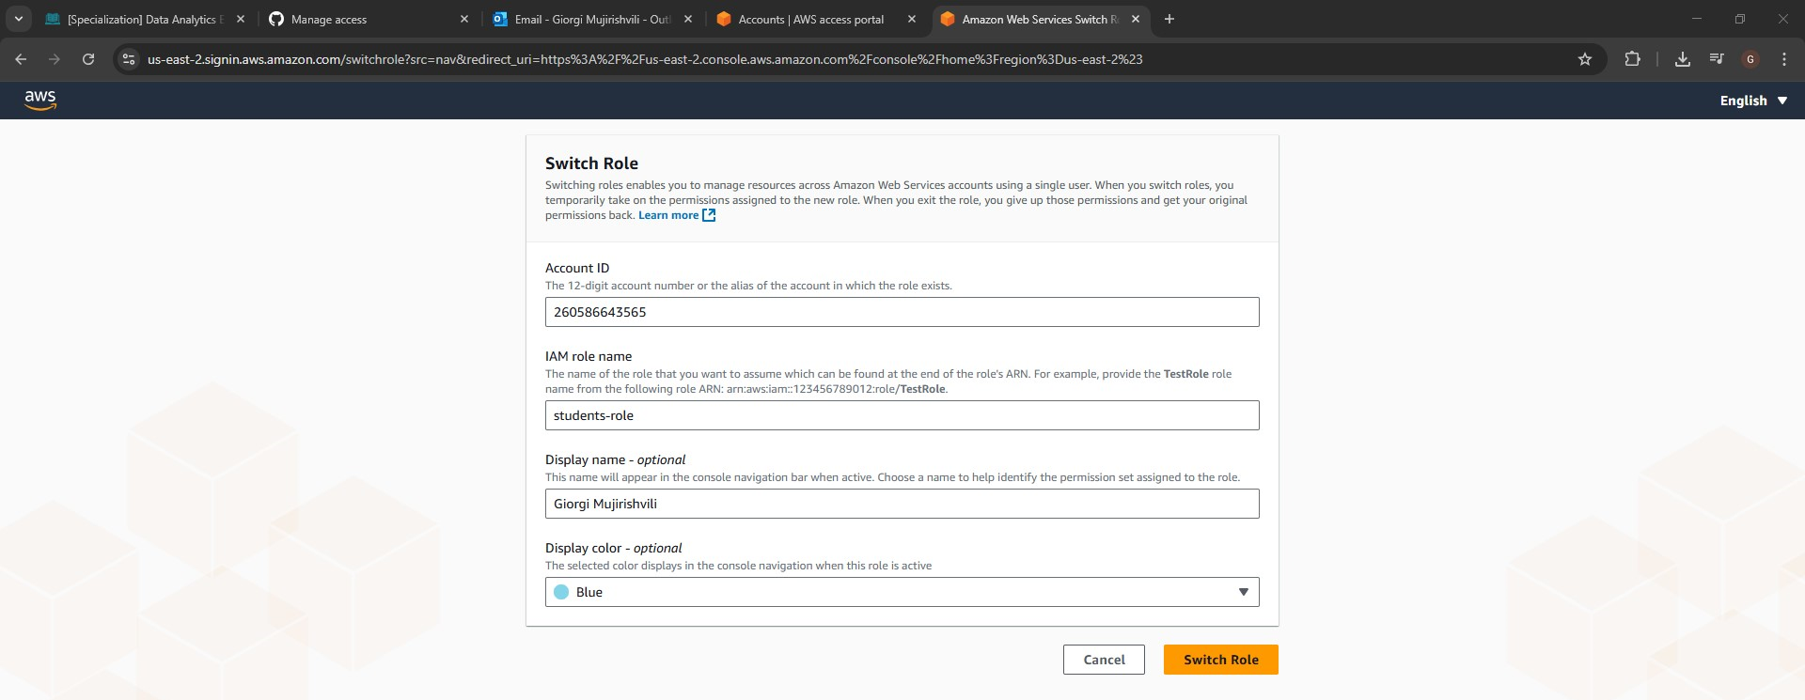
f. To use AWS CLI please firstly install the client (NB: PLEASE INSTALL VERSION 2 ONLY) https://docs.aws.amazon.com/cli/latest/userguide/getting-started-install.html and after that open SSO link from point b and choose “Access keys”
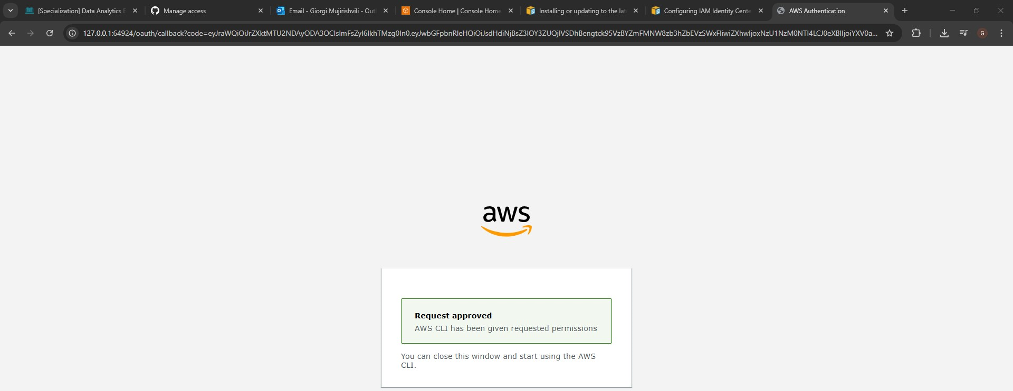
g. Run aws configure sso command https://docs.aws.amazon.com/cli/latest/userguide/sso-configure-profile-token.html:
SSO session name = user-role
SSO start URL = https://epam.awsapps.com/start#
SSO region = us-east-1
SSO registration scopes – keep blank and press enter
A window in your browser will be opened, enter or verify the code and press continue:
CLI default client Region = eu-central-1
CLI default output format - keep blank and press enter
CLI profile name – user-role-260586643565
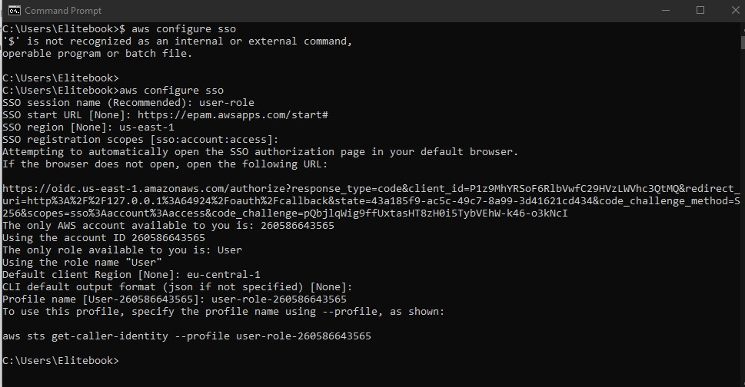
h. Check your aws config file. The config file is located at ~/.aws/config on Linux or macOS, or at C:\Users\USERNAME\.aws\config on Windows. https://docs.aws.amazon.com/cli/latest/userguide/cli-chap-configure.html
You should have something like:
[profile user-role-260586643565]
sso_session = user-role
sso_account_id = 260586643565
sso_role_name = User
region = eu-central-1
[sso-session user-role]
sso_start_url = https://epam.awsapps.com/start#/
sso_region = us-east-1
sso_registration_scopes = sso:account:access

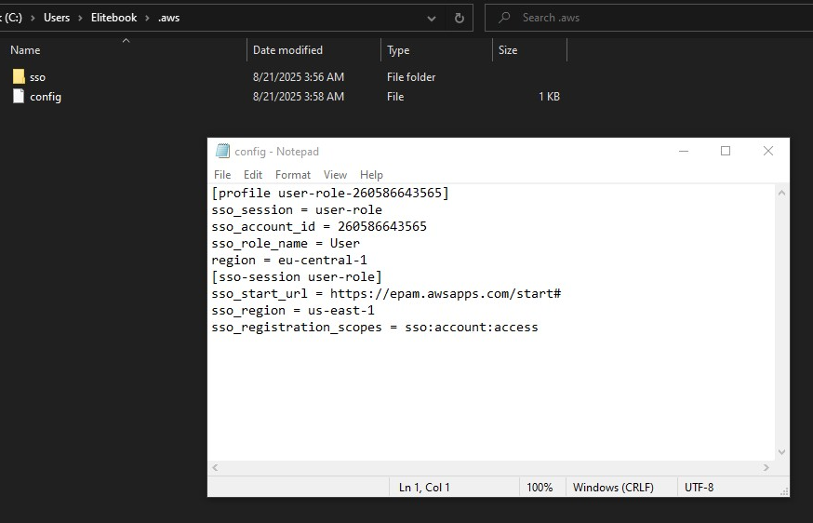
i. Now assume students-role from user-role-260586643565, as only students-role has necessary permissions. To do this add new profile for students-role into config file. Here is documentation how you could do this https://docs.aws.amazon.com/cli/latest/userguide/cli-configure-files.html [IAM Role section].
Profile name should be students-role, region = eu-central-1

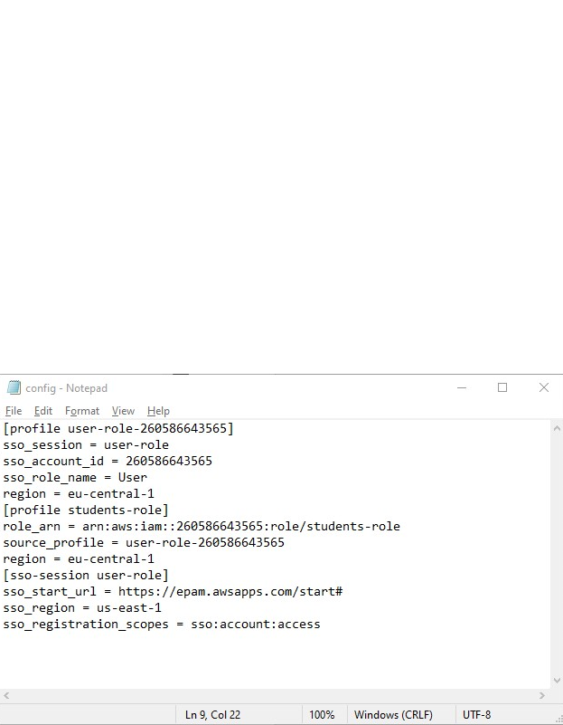

j. Now run aws sts get-caller-identity --profile students-role in case you did all right you should see something like
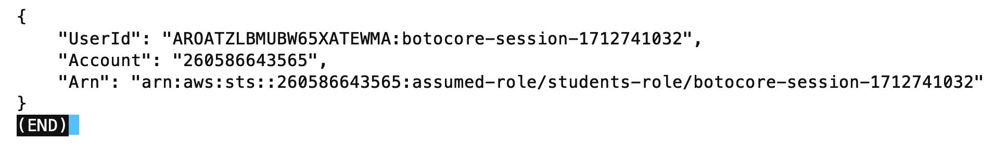

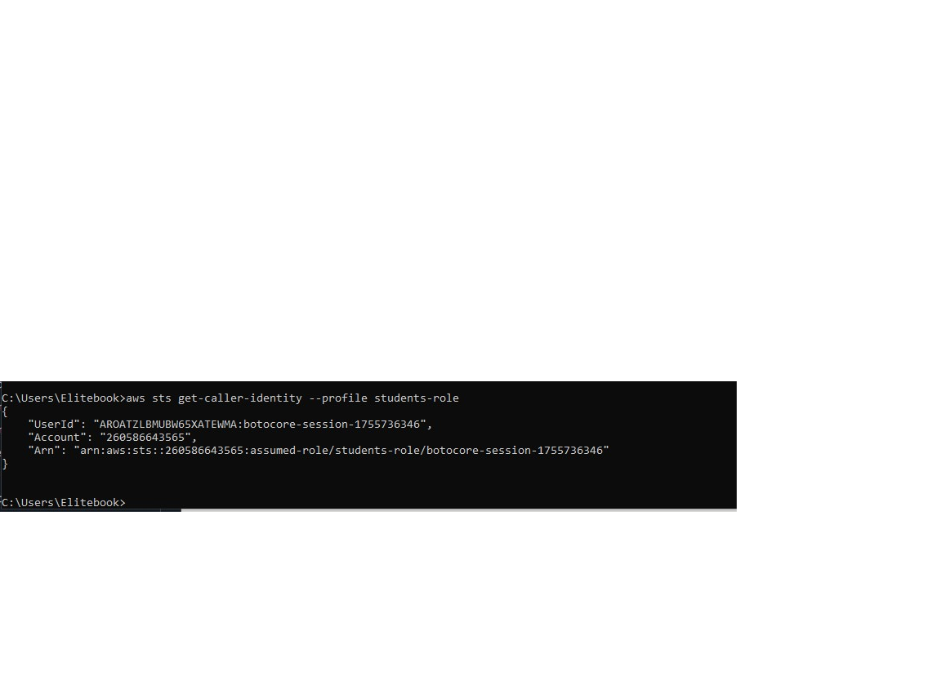

2. Working with AWS services:
- Create your own bucket with recognizable naming (to see who the owner from the name).

- Use students-profile to run any aws cli command for s3: at least to put files using api call from local PC to the Cloud.
- Upload you tables from you previously created oracle BL_DM schema to S3 bucket with appropriate with next folders hierarchy:

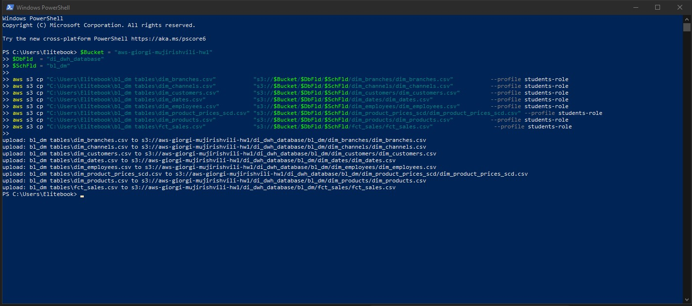
- Add path to your tables ( <your_bucket>/<folder_di_dwh_database>/<folder_schema_bl_dm>/… ) into existing Glue Crawler or create your own Crawler to find your tables in buckets and put them into the Glue DataCatalog Database. Run not very simple select on the tables from your s3 path, i.e. execute query in Athena. Don't forget about limits of 10000 ... 50000 rows. Show us properties of the tables, query results.

Creating a crawler:

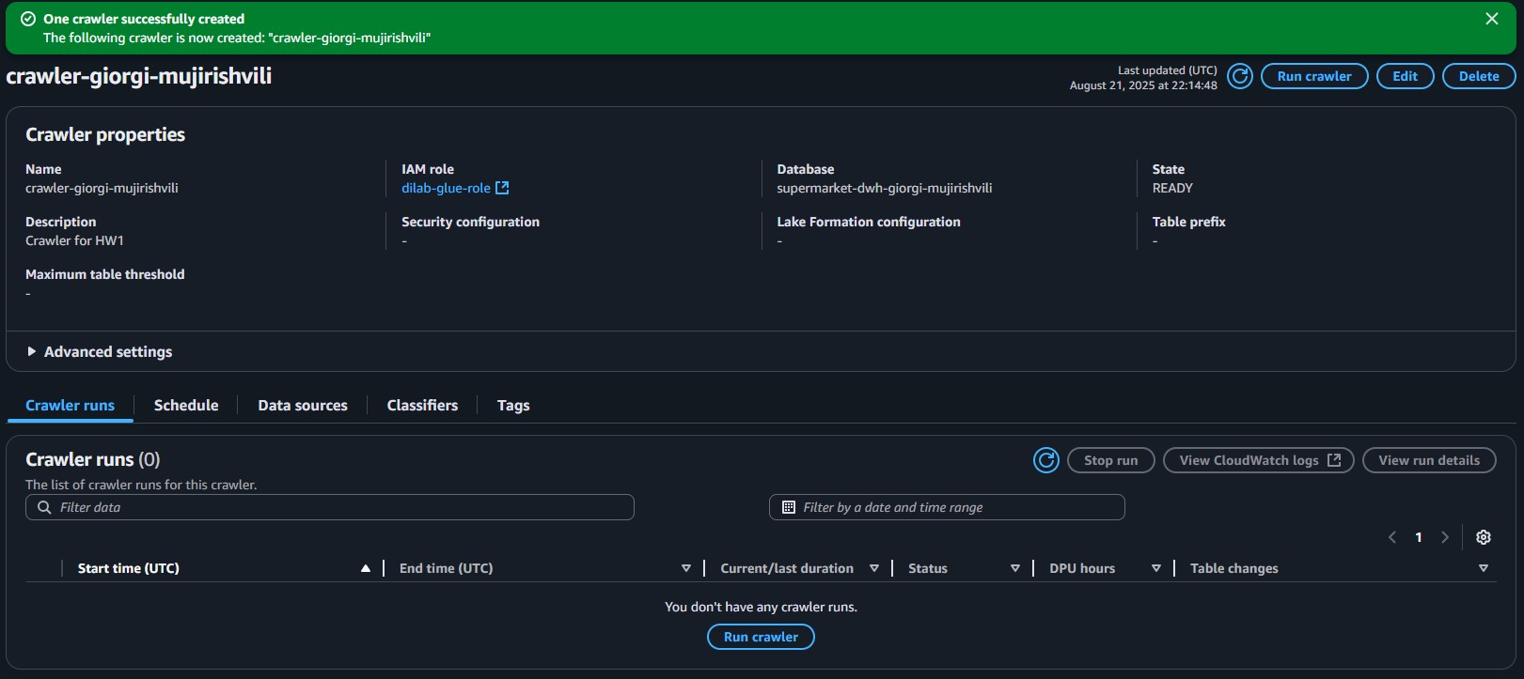

Running it:
Verifying that tables are there:
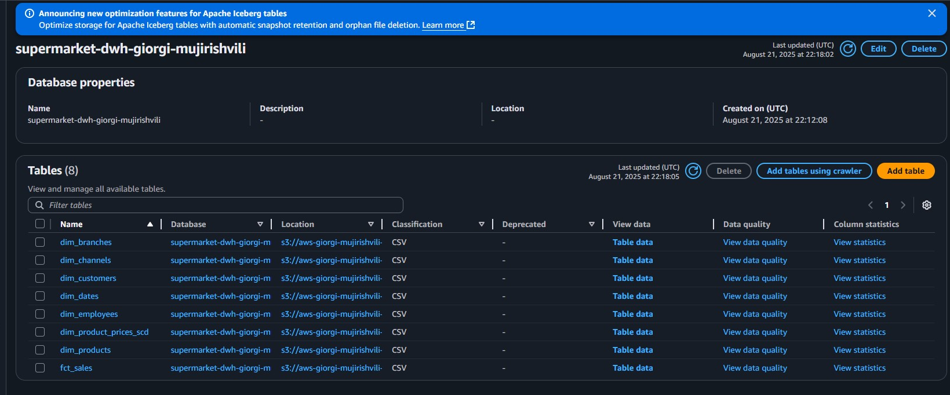
Running sample queries:
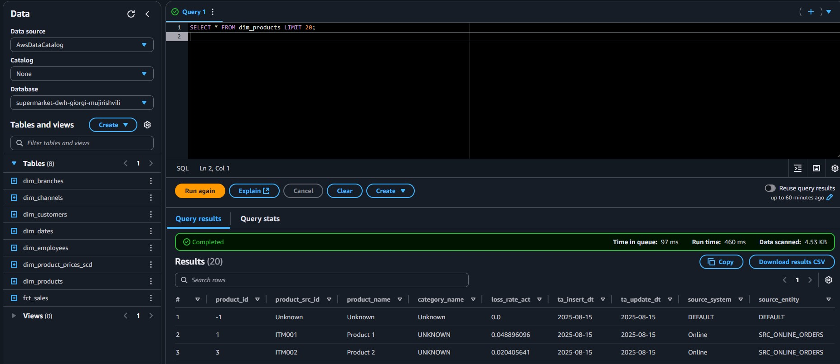
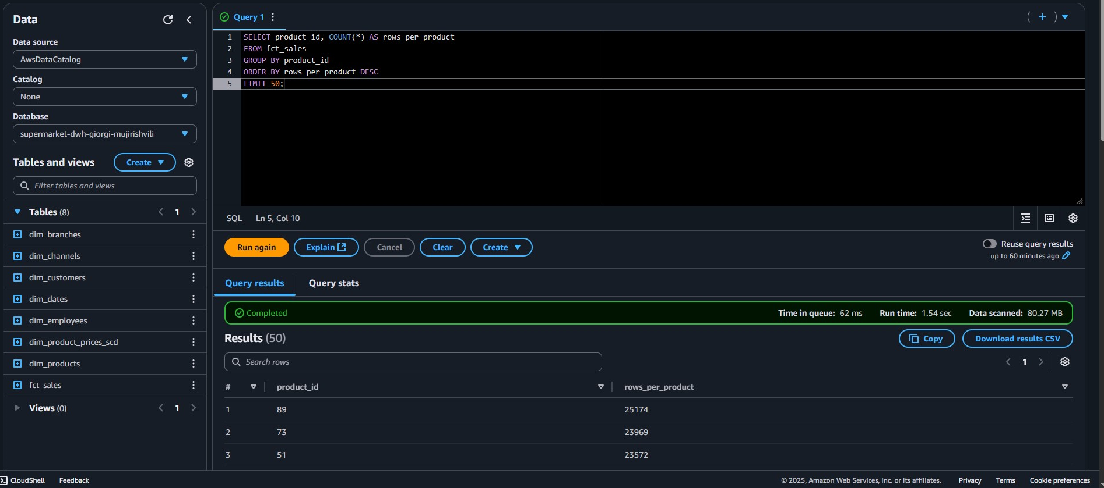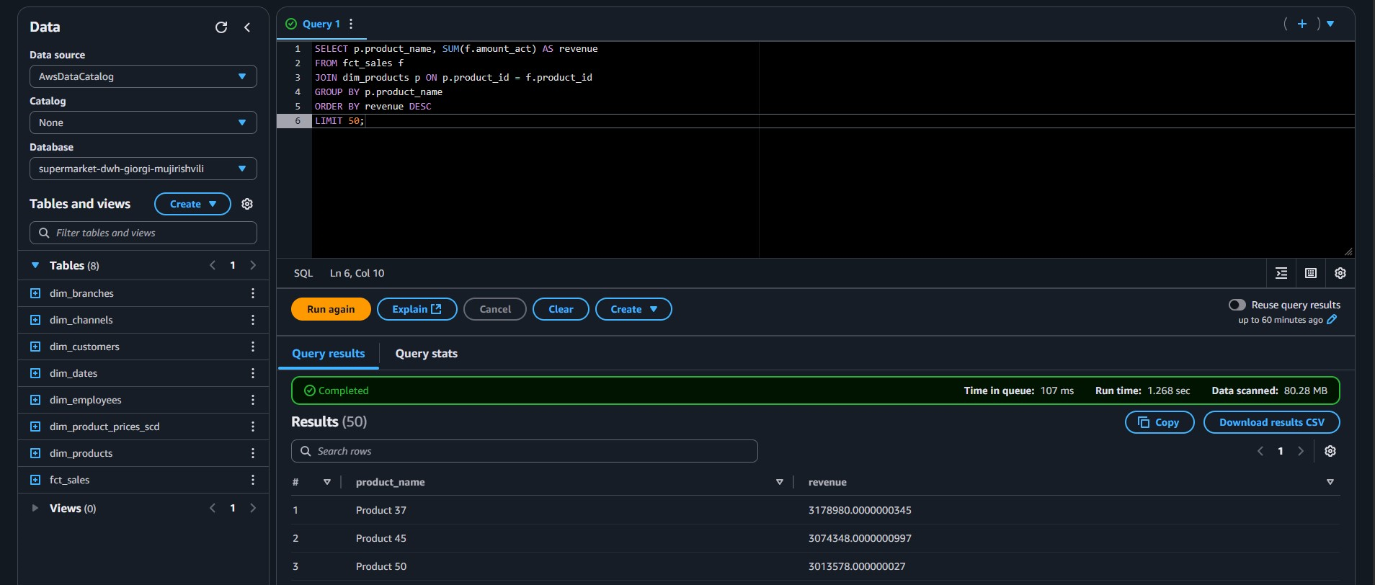

Uploading this file to the bucket:
