Name: Mujtaba Ahmed

***LabTask 2***

Reg no: CSU-F17-128

BSCS – SEM 3

Q:Write a program to make calculator by switch statement.

# include <iostream>

using namespace std;

int main()

{

char op;

float num1, num2;

cout << "Enter operator either + or - or * or /: ";

cin >> op;

cout << "Enter two operands: ";

cin >> num1 >> num2;

switch(op)

{

case '+':

cout << num1+num2;

break;

case '-':

cout << num1-num2;

break;

case '*':

cout << num1*num2;

break;

case '/':

cout << num1/num2;

break;

default:

cout << "Error! operator is not correct";

break;

}

}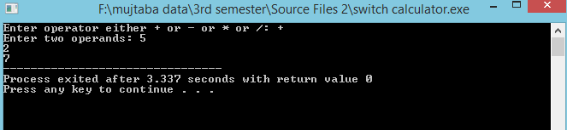

Q:Write a program to find factorial.

#include <iostream>

using namespace std;

int main()

{

unsigned int n;

unsigned long long factorial = 1;

cout << "Enter a positive integer: ";

cin >> n;

for(int i = 1; i <=n; ++i)

{

factorial *= i;

}

cout << "Factorial of " << n << " = " << factorial;

}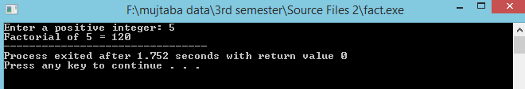

Q:Write a program to print 1,12,123,1234..

#include<iostream>

using namespace std;

int main()

{

for(int i=1; i<=5; i++)

{

for(int j=1; j<=i; j++)

{

cout<<j ;

}

cout<<endl;

}

system("pause");

return 0;

}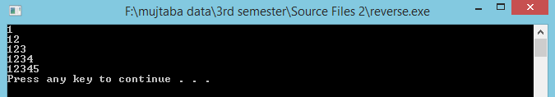

Q: write a program to using loop and continue statement to sum of even number..

#include <iostream>

using namespace std;

int main(){

int N, counter, sum=0;

cout << "Enter a positive number\n";

cin >> N;

for(counter=1; counter <= N; counter++){

if(counter%2 == 1){

continue;

}

sum+= counter;

}

cout <<"Sum of all even numbers from 1 to " <<N<<" = "<< sum;

return 0;

}

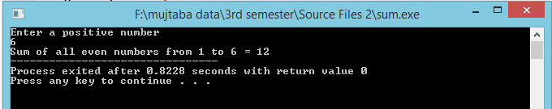

Q:Write a program to print reverse number.

#include<iostream>

using namespace std;

int main()

{

int num, rev=0, rem;

cout<<"Enter a number : ";

cin>>num;

while(num!=0)

{

rem=num%10;

rev=rev*10+rem;

num=num/10;

}

cout<<"Reverse = "<<rev;

}

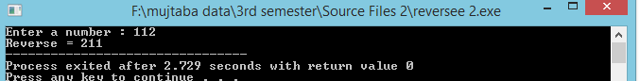

Q:Write a program the digit of the number..

#include<iostream>

using namespace std;

int main()

{

int val, num, sum = 0;

cout << "Enter the number : ";

cin >> val;

num = val;

while (num != 0)

{

sum = sum + num % 10;

num = num / 10;

}

cout << "The sum of the digits of "

<< val << " is " << sum;

}

