Prediction of missed monthly rainfall time series by using python-based ANNs( A case study of Porvoonjoki watershed, Finland)
- Introduction
Artificial Neural networks(ANNs) application in hydro-climatological studies has been one of the main and growing approaches in modeling, prediction, and processing of long-term time-series such as rainfall-runoff processes across the hydrological units of different sizes such as Basin, watershed, and catchment areas (Salas et al.2000; Karamouz et al. 2008; Mahmoud Zemzami 2016). In this task, we will evaluate the ANNs performance in the forecasting of Monthly precipitation time series-which will be supposed to be missed or ungagged quantity of interest – through a training, validation, and testing scenario of ANNs (Nkuna, T.R., Odiyo and J. O 2011; Canchala-Nastar et al. 2019). Extracted time-series are used by other python-based Hydrological models, dependent on time-series data (D.J. Lampert, M. Wu 2015).
- Problem Formulation(Definition)
Rainfall data as the primary input of hydrological models in different temporal accuracies could be containing missed or ungagged values during some observation periods (Mohamed-Aymen Ben Aissia et al., 2017). So, in this task, we will try to formulate simple ANNs to evaluate their performance in predicting missed precipitation data on the monthly scale by using collected data from official hydro-climatological stations (Mislan et al., 2015). Also, we have selected the Porvoonjoki watershed -situated in the south region of Finland -and its three nearby meteorological stations as the study area.
- Method
  - Study area and data collection
Meteorological data collected for this task belongs to the Porvoonjoki watershed (Fig 1), located in the south area of Finland (Veijalainen et al., 2010).
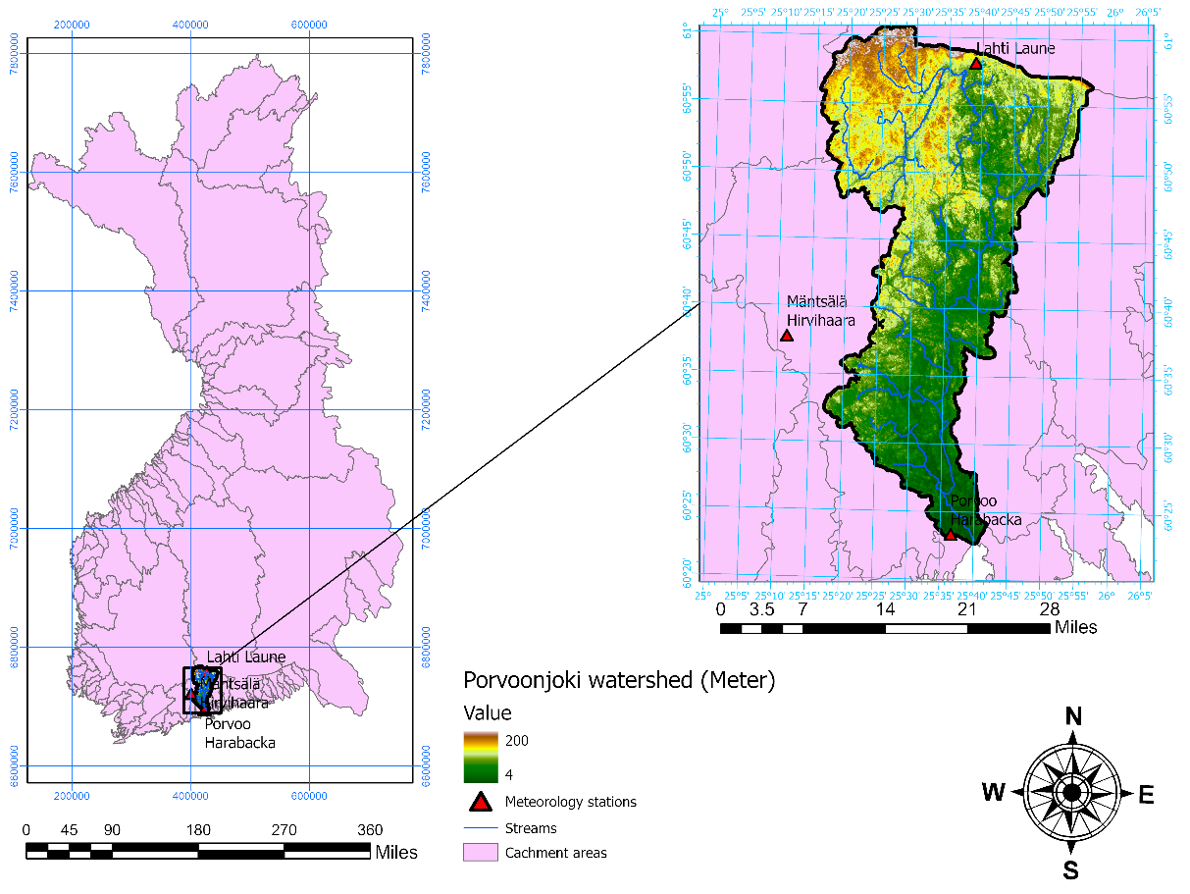
Fig 1: Location of Porvoonjoki watershed
Precipitation data used in this task has been collected from the database of three meteorological stations of Finish Meteorological Institute (FMI), including observed daily rainfall in mm. The location of stations has been selected according to data availability and distance from the Porvoonjok watershed (Table 1).
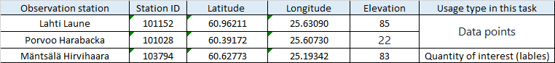
Table 1: observation Station used in this task.
  - Artificial neural networks
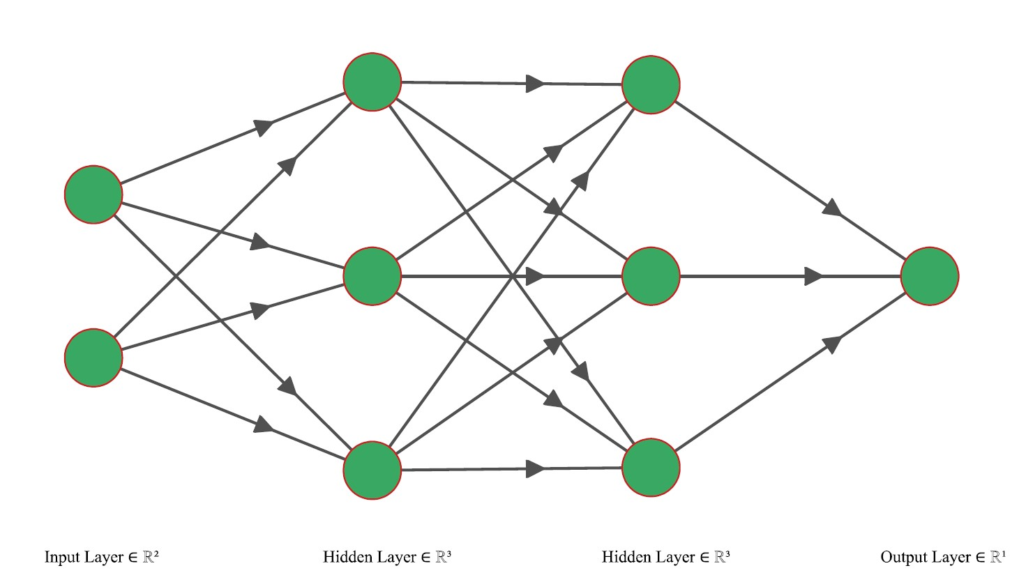
The machine-learning algorithm used in this task is an ANNs consisting of two hidden layers, including three neurons, and an output layer, including one neuron (Fig 2).
Fig2: the architecture of the neural network used in the task.
  - Preprocessing and Python
Original precipitation data gotten from the database of FMI was containing data gaps and was unformal to handle and import into Python. Therefore part of Pre-processing has been accomplished using Arc GIS and excel, and some others were left to be conducted through python programming. Libraries used to write the python codes were pandas, NumPy, Matplotlib, TensorFlow, seaborn, and Scikit-learn.
  - Training, validation, and testing
In this task, daily rainfall data from 2001-2020 has been utilized for training, validating, and testing the machine learning algorithm. After data preprocessing, this data has been resampled to monthly data by Pandas in Python, and finally, we have 240 months (data point) to implement in the project. This total data point has been divided into three parts for each learning step (training, validation, and testing) using the Scikit-learn library. Finally, we have 150 data points for training,50 data points for validation, and 40 for the testing step.

- Results
  - Training
In this task, training of selected ANNs has been accomplished by the TensorFlow and the Keras library for the first 150 months (training data set) from 1/31/2001 to 6/30/2013. Obtained results for 500 epochs are as the flowing Fig 3 and Table 2:
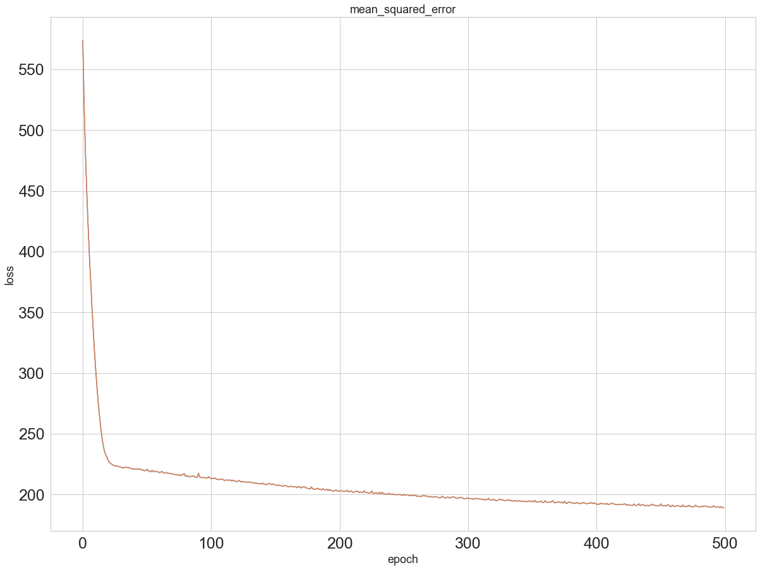
Fig 3: optimization results for trained ANNs.

Layer (type) Output Shape Param #
=================================================================
hidden (3) 9
_________________________________________________________________
hidden (3) 12
_________________________________________________________________
output (1) 4
=================================================================
Total params: 25
Trainable params: 25
Non-trainable params: 0

Table 2: obtained results for trained ANNs.
  - Validation
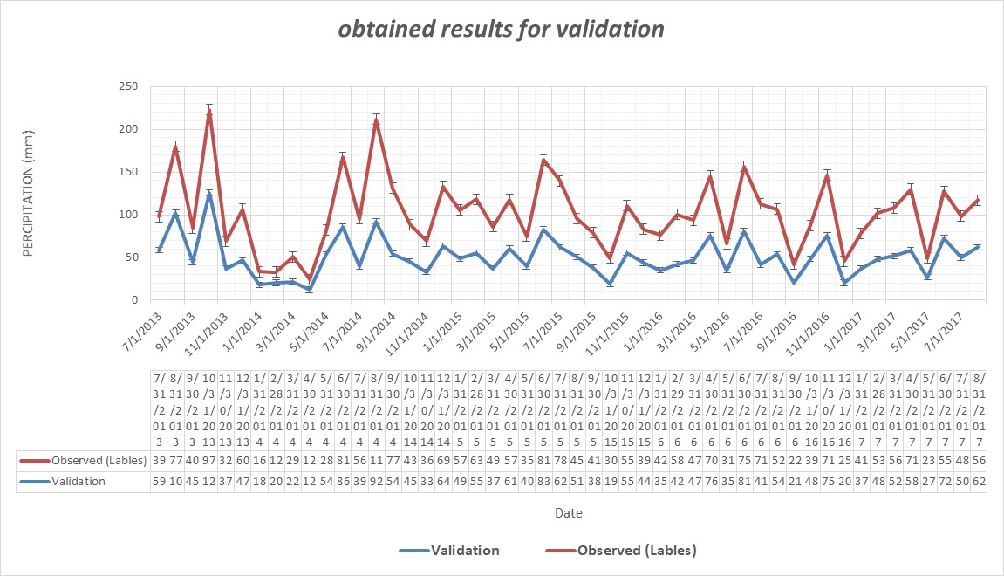
during the validation stage, monthly rainfall values from 7/31/2013 to 8/31/2017(50 data points) have been inserted into the algorithm as input data. Obtained results are depicted by (Fig 4).
Fig 4: Obtained results for validation.
  - Test
during the testing stage, monthly rainfall values from 9/30/2017 to 12/31/2020 (40 data points) have been inserted into the algorithm as input data. Obtained results are depicted in (Fig 5).
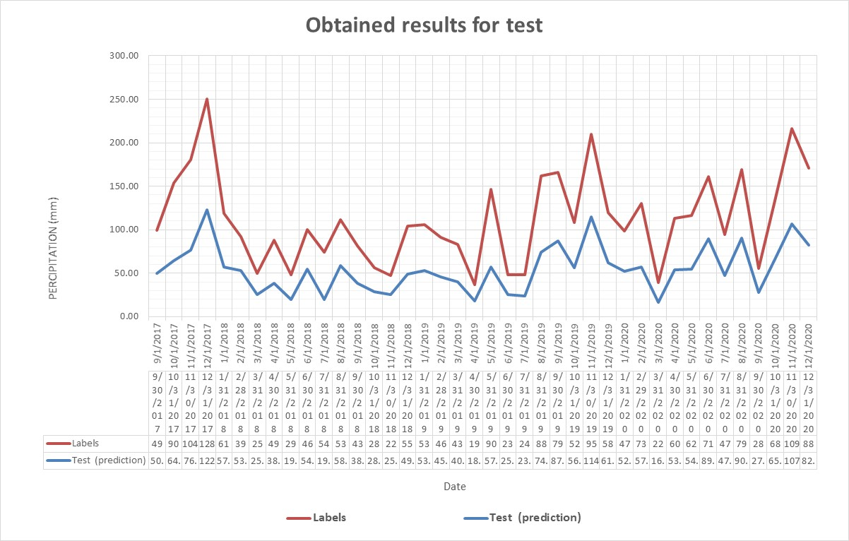
Fig 5: Obtained results for the test.

- Conclusion
The task had aimed to evaluate and examine the application of ANNs to predict the missed time series of a watershed area located in the south region of Finland(Coşkun Hamzaçebi 2008). Fig 6 is depicting the entire time series for 240 months during the study period. According to obtained results, the model can approximately predict the target values (labels). The obtained results can be improved by selecting more complex ANNs and other scenarios(Zeynep Idil Erzurum Cicek et al.2021; Hansika Hewamalage et al.2021).
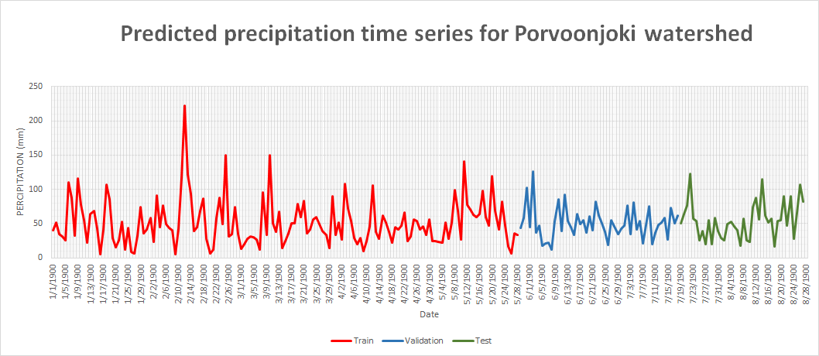
Fig 6: predicted precipitation time series of Porvoonjoki watershed
References
- Salas, J.D., Markus, M., and Tokar, A.S., 2000. Streamflow forecasting based on artificial neural networks. Artificial neural networks in hydrology. Water Science and Technology Library, Springer, 36, 23–51.
- Mahmoud Zemzami. (2016) Flow forecasts in a non-perennial river of an arid basin using neural networks. Journal of Applied Water Engineering and Research 4:2, pages 92-101.
- Karamouz, M., Razavi, S., and Araghinejad, S., 2008. Long-lead seasonal rainfall forecasting using time-delay recurrent neural networks: a case study. Hydrological Processes, 22, 229–241. doi:10.1002/(ISSN)1099-1085.
- Nkuna, T.R., Odiyo, J.O. Filling of missing rainfall data in Luvuvhu River Catchment using artificial neural networks, Physics and Chemistry of the Earth, Volume 36, Issue 14-15, 2011.
- Canchala-Nastar et al.Estimation of missing data of monthly rainfall in southwestern Colombia using artificial neural networks, Data in Brief, Volume 26, October 2019.
- D.J. Lampert, M. Wu, Development of an open-source software package for watershed modeling with the Hydrological Simulation Program in Fortran, Environmental Modelling & Software, Volume 68, 2015, Pages 166-174, ISSN 1364-8152.
- Mohamed-Aymen Ben Aissia, Fateh Chebana, Taha B.M.J. Ouarda, Multivariate missing data in hydrology – Review and applications, Advances in Water Resources, Volume 110, 2017, Pages 299-309, ISSN 0309-1708.
- Mislan, Haviluddin, Sigit Hardwinarto, Sumaryono, Marlon Aipassa, Rainfall Monthly Prediction Based on Artificial Neural Network: A Case Study in Tenggarong Station, East Kalimantan - Indonesia, Procedia Computer Science, Volume 59, 2015, Pages 142-151, ISSN 1877-0509.
- Noora Veijalainen, Eliisa Lotsari, Petteri Alho, Bertel Vehviläinen, Jukka Käyhkö, National scale assessment of climate change impacts on flooding in Finland, Journal of Hydrology, Volume 391, Issues 3–4, 2010, Pages 333-350, ISSN 0022-1694.
- Coşkun Hamzaçebi, Improving artificial neural networks’ performance in seasonal time series forecasting, Information Sciences, Volume 178, Issue 23, 2008, Pages 4550-4559, ISSN 0020-0255.
- Zeynep Idil Erzurum Cicek, Zehra Kamisli Ozturk, Optimizing the artificial neural network parameters using a biased random key genetic algorithm for time series forecasting, Applied Soft Computing, Volume 102, 2021, 107091, ISSN 1568-4946.
- Hansika Hewamalage, Christoph Bergmeir, Kasun Bandara, Recurrent Neural Networks for Time Series Forecasting: Current status and future directions, International Journal of Forecasting, Volume 37, Issue 1,2021, Pages 388-427, ISSN 0169-207.

